Chapter 7. Case Study: A Billiards Game

Purpose of Chapter
The purpose of this chapter is to once again illustrate the design of a program as a universe of interacting agents working together to produce the desired outcome.

Picture of Billiards Table
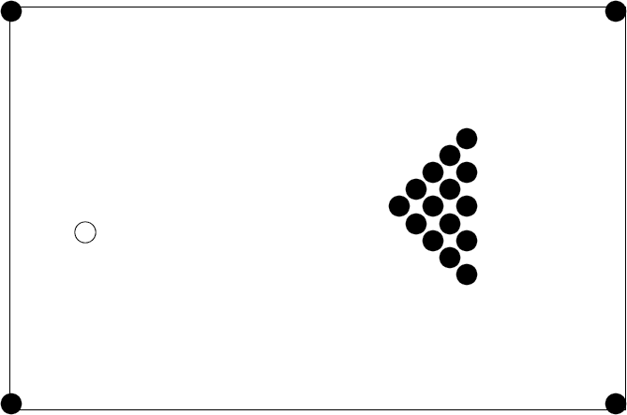

The Wall Object Class
TWall = class(TObject)
public
constructor create
(ix, iy, iw, ih : Integer; cf : Real; ilink : TWall);
procedure draw (canvas : TCanvas);
function hasIntersected(aBall : Tball) : Boolean;
procedure hitBy (aBall : TBall);
private
x, y : Integer;
height, width : Integer;
convertFactor : Real;
link : TWall;
end;

constructor TWall.create
(ix, iy, iw, ih : Integer; cf : Real; ilink : Twall);
begin
x := ix;
y := iy;
height := ih;
width := iw;
convertFactor := cf;
link := ilink;
end;

procedure TWall.draw(canvas: TCanvas);
begin
with canvas do begin
Brush.Style := bsSolid;
Brush.Color := clBlack;
fillRect(Rect(x, y, x + width, y + height));
end;

procedure TWall.hitBy (aBall : TBall);
begin
f bounce the ball o_ the wall g
aBall.direction := convertFactor - aBall.direction;
end;

The Hole Object Class

THole = class(TObject)
public
constructor create (ix, iy : Integer; ilink : THole);
procedure draw (canvas : TCanvas);
function hasIntersected(aBall : TBall) : Boolean;
procedure hitBy (aBall : TBall);
private
x, y : Integer;
link : THole;
end;

constructor THole.create(ix, iy : Integer; ilink : THole);
begin
x := ix;
y := iy;
link := ilink;
end;

procedure THole.draw(canvas : TCanvas);
begin
with canvas do begin
Brush.Style := bsSolid;
Brush.Color := clBlack;
Ellipse(x-5, y-5, x+5, y+5);
end;
end;

procedure THole.hitBy (aBall : TBall);
begin
{ drain enery from ball }
aBall.energy := 0.0;
{ move ball }
if aBall = CueBall then
aBall.setCenter(50, 100)
else begin
saveRack := saveRack + 1;
aBall.setCenter (10 + saveRack _ 15, 250);
end;
end;

The ball graphical object
TBall = class(TObject)
public
constructor create (ix, iy : Integer; iLink : TBall);
procedure draw (canvas : TCanvas);
function hasIntersected(aBall : Tball) : Boolean;
procedure hitBy (aBall : TBall);
procedure update;
procedure setCenter (nx, ny : Integer);
procedure setDirection (nd : Real);
private
x, y : Integer;
direction : Real;
energy : Real;
link : TBall;
end;

constructor TBall.create(ix, iy : Integer; iLink : TBall);
begin
setCenter(ix, iy);
setDirection(0.0);
energy := 0.0;
link := iLink;
end;

procedure TBall.setDirection(nd : Real);
begin
direction := nd;
end;

procedure TBall.draw(canvas : TCanvas);
begin
with canvas do begin
Brush.Style := bsSolid;
if (self = cueBall) then
Brush.Color := clWhite
else
Brush.Color := clBlack;
Ellipse(x-5, y-5, x+5, y+5);
end;
end;

procedure TBall.update;
var
hptr : THole;
wptr : TWall;
bptr : TBall;
dx, dy : integer;
begin
if energy > 0.5 then begin
ballMoved := true;
{ decrease energy }
energy := energy - 0.05;
{ move ball }
dx := trunc(5.0 _ cos(direction));
dy := trunc(5.0 _ sin(direction));
x := x + dx;
y := y + dy;
{ see if we hit a hole }
hptr := listOfHoles;
while (hptr <> nil) do
if hptr.hasIntersected(self) then begin
hptr.hitBy(self);
hptr := nil;
end
else
hptr := hptr.link;
{ see if we hit a wall }
wptr := listOfWalls;
while (wptr <> nil) do
if wptr.hasIntersected(self) then begin
wptr.hitBy(self);
wptr := nil;
end
else
wptr := wptr.link;
{ see if we hit a ball }
bptr := listOfBalls;
while (bptr <> nil) do
if (bptr <> self) and bptr.hasIntersected(self) then begin
bptr.hitBy(self);
bptr := nil;
end else
bptr := bptr.link;
end;
end;

procedure TBall.hitBy (aBall : TBall);
var
da : real;
begin
{ cut the energy of the hitting ball in half }
aBall.energy := aBall.energy / 2.0;

{ and add it to our own }
energy := energy + aBall.energy;

{ set our new direction }
direction := hitAngle(self.x - aBall.x, self.y - aBall.y);

{ and set the hitting balls direction }
da := aBall.direction - direction;
aBall.direction := aBall.direction + da;

{ continue our update }
update;
end;

function hitAngle (dx, dy : real) : real;
const PI = 3.14159;
var
na : real;
begin
if (abs(dx) < 0.05) then
na := PI / 2
else
na := arctan (abs(dy / dx));
if (dx < 0) then
na := PI - na;
if (dy < 0) then
na := - na;
hitAngle := na;
end;

Comments on Project3 source code.

- program execution -

- global objects (wall, spheres ) are created at the beginning of the program execution
- initialization : setup() is called. ( the location and size of wall and spheres, and other informations are set up. )
- The function Display(float timeDelta) : is called repeatedly.
For each call of Display function, one frame of screen image is drawn.
Therefore, in the function Display, we need to update the location of each object and draw each object (wall, spheres).
We also need to program the collision test of objects to update the direction and location of spheres in Display function.
(This can be done by adding member functions hasIntersected(...), hitBy(...) for wall and sphere classes)
For each call of Display, the location of spheres may change or may not change depending on user input (pressing space, mouse move,...)
- User input : We have to handle user input (keyboard input , mouse input).
those user input is handled in WndProc function.
You have to add your code in "case VK_SPACE:" which will be executed when space key is pressed.
You have to give some amount of energy(acceleration) to a white ball to a specified direction.

Mouse input is already implemented in "case WM_MOUSEMOVE:" part.
Especially, look at the part of
if (LOWORD(wParam) & MK_LBUTTON) { ... } // executed if left button of mouse is being pressed while mouse is moving

if (LOWORD(wParam) & MK_RBUTTON) { ... } // executed if right button of mouse is being pressed while mouse is moving

- The direction of white ball can be specified by moving blue ball using mouse.

