[Assignment6]

**Text Function**

**[Introduction]**

Make a program that performs various text functions. At first, user gets sentences from a file only once while the program is running and the number of sentences to be entered may be several. **(Not used Enter key(\n) in file)**

And you have to implement 4 different menus in total.

1. If user enters the number 1, print the sentences.

2. If user enters the number 2, type the text that user wants to find.

If the sentences contain the text, highlight the text with “[[[“, “]]]”.

The program should also print out how many times the text appears.

**(The search is performed in case-insensitive. For example, if user types the text “foo”, the program have to highlight all text like “Foo”, ”FOO” and other variation)**

3. If user enters the number 3, type the two texts. First text is Word before modification and second text is word after modification. All first texts in sentences must be modified to the second text. The modification also performed in case-insensitive.

**(After the modification, the modified sentence should be displayed when executing menu 1)**

4. If user enters the number 4, quit the program. Repeat until you enter Menu 4.

**[Example]**

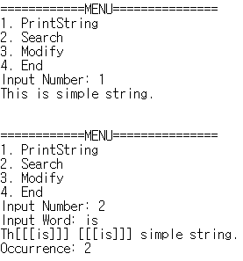

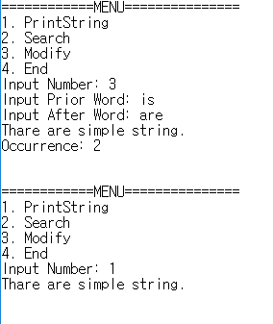

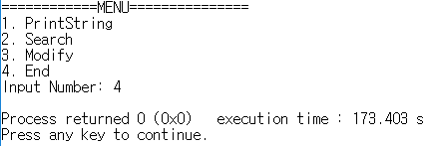

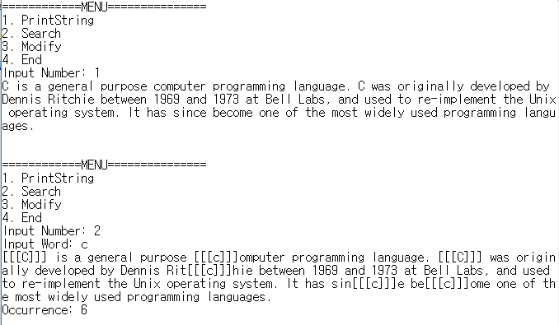

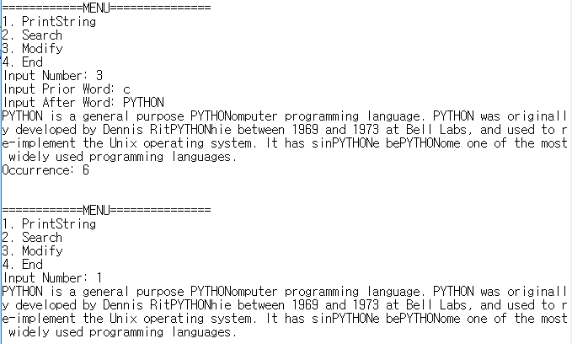

**[Rating]**

* Total point is 100 points.
  + The program executes the menu repeatedly. (5 points)
  + The program prints out Strings. (10 points) – menu 1
    - Print out the sentences that were initially entered (10 points)
  + The program finds the text well. (40 points) – menu 2
    - The program prints out the highlighted string (25 points) – If there is something that is not found, the score of this item is zero.
    - The search is performed in case-insensitive(10 points)
    - The program prints out how many times the text appears (5 points)
  + The program modifies the text well (40 points) – menu 3
    - Modify all text within sentences. The revision should be applied when menu 1 is executed (25 points) – If there is something that cannot be modified, the score of this item is zero.
    - The modification is performed in case-insensitive(10 points)
    - The program prints out how many times the text appear (5 points)
  + The program is normally terminated when the menu 4 is executed(5 points)
* Delay penalty: 15points deducted per day. After 3 days, get 0 point.
* You should submit a source code file on i-campus. The source code should be compiled successfully.