SECURECORP
Cybersecurity Assessment Capstone
Final Submission Report
Junior Cybersecurity Consultant • Controlled Training Laboratory

1. Executive Summary
This engagement assessed a controlled SecureCorp training environment from offensive and defensive perspectives. The completed evidence establishes the lab, DVWA availability, Nmap discovery, attacks and Wazuh Cloud monitoring with an active Ubuntu WSL agent. The target exposes a broad legacy service surface. Unsupported attack successes are not claimed.
1. This project was a security assessment using
Wsl(attacker)
Metasploitable2(DVWA)
Wazuh.(To see logs)
2. Nmap was used to identify open ports and services running on the target system.
3. Different attacks were tested, including brute force, SQL injection, XSS, command injection, FTP and SSH attacks.
4. Additional DVWA tests such as file upload, CSRF, file inclusion and blind SQL injection were also performed.
5. Screenshots and log evidence were collected during this process.
6. Wazuh was used for security log monitoring, and recommendations were prepared based on the findings.

2. Scope and Rules of Engagement
Only the controlled lab was considered. Password testing was limited to self-created lab accounts. Evidence was required for findings. The assessment followed Build → Discover → Attack → Log → Detect → Investigate → Assess → Remediate → Report.
1. The assessment was performed only on the controlled lab environment created for this project.
2. Metasploitable2 and DVWA were used as the main targets for security testing.
3. The testing included network scanning, web application testing and controlled authentication attacks.
4. Only the services and applications available in the lab were tested.
5. The tests were performed for learning and security assessment purposes without targeting external systems.
6. Screenshots, command outputs and relevant logs were collected as evidence for the final report.

3. Lab Architecture
WSL Ubuntu 26.04 acted as attacker/analyst; Metasploitable2 hosted DVWA as target; Wazuh Cloud provided monitoring. The successfully enrolled Wazuh agent was on WSL Ubuntu, not on Metasploitable2.

4. Asset Inventory
Metasploitable2, DVWA, WSL Ubuntu, Wazuh Cloud, lab network and security evidence were assessed as relevant assets.
1.Metasploitable2, DVWA and Wazuh are the assets used in this lab.
2. Metasploitable2 is an intentionally vulnerable application, we tried some attacks on it as a part of testing.
3. The attacks were actually done on DVWA, which is running inside metasploitable2.
4. Wazuh is used for collecting logs (security related) from the lab space.
5. I performed attacks during the assignment which violates CIA-triad (CONFIDENTIALITY-INTEGRITY-AVAILABILITY).
6. These vulnerabilities will become a problem when exposed to the real world.

Asset | Type | Owner / Department | Why It Matters
Metasploitable2 | Hardware/Software* | Security / IT | Vulnerable lab system used for security testing
DVWA | Software | Security / IT | Used for web vulnerability testing
Wazuh | Software | Security / IT | Used for security log monitoring
Testing Machine | Hardware/Software* | Security Team | Used to perform security assessment
Network Connection | Connectivity | IT / Network Team | Allows communication between systems

5. CIA Analysis
High confidentiality/integrity were assigned to the target, DVWA, monitoring and evidence assets; availability was rated high or medium depending on the asset.
Asset | Confidentiality | Integrity | Availability
DVWA | Prevent unauthorized access to application data | Prevent unauthorized changes | Application should remain accessible for users
Metasploitable2 | Protect information stored on the system | Prevent unauthorized changes | System and services should remain available
Wazuh | Protect security logs | Logs should not be modified | Monitoring should remain available
Testing Machine | Protect assessment data | Prevent unauthorized changes | Available for security testing
Network Connection | Prevent unauthorized network access | Data should not be modified during transfer | Network communication should remain available

6. Network Discovery
Nmap identified a broad exposed surface including FTP 21, SSH 22, Telnet 23, SMTP 25, DNS 53, HTTP 80, Samba 139/445, NFS 2049, ProFTPD 2121, MySQL 3306, PostgreSQL 5432, VNC 5900 and X11 6000, plus other legacy services.

7. Application Security Assessment
Nmap Reconnaissance
I used Nmap to check the target system and find the open ports and running services.
The scan was performed using the following command:
nmap -Pn -sV -p 8080 localhost
The scan showed port 8080 open with Apache HTTP server running.
This helped me identify the web service before starting the security testing.

- I opened the DVWA Brute Force page and set the security level to Low. I tried multiple username and password combinations using a small list. After a few attempts, the correct login details worked and the application showed the successful login message. I saved a screenshot as evidence.
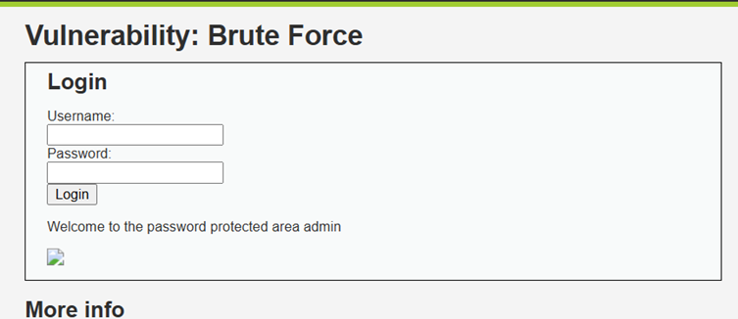

2. I opened the SQL Injection section in DVWA and kept the security level at Low. I entered the payload `1' OR '1'='1` in the input field. The application returned multiple user records instead of showing only one result. This showed that the
input was not properly handled and could be used to access database information. I saved a screenshot of the payload and the result as evidence.
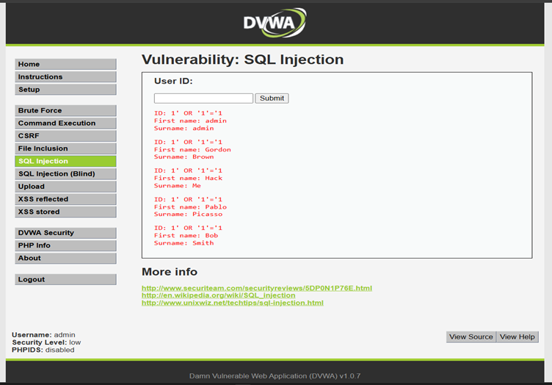

3. I opened the XSS section in DVWA and kept the security level at Low. I entered a simple script in the input field. The script was executed and an alert box appeared on the screen. This showed that the application was not properly filtering the input. I saved a screenshot of the successful result as evidence.
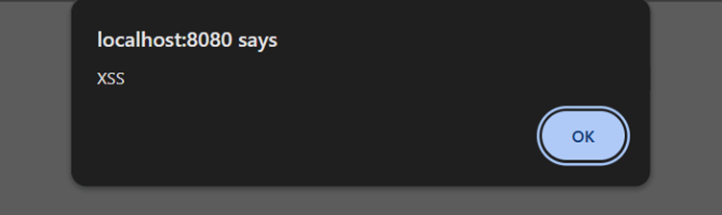

4. I opened the Command Execution section in DVWA and kept the security level at Low. I entered [127.0.0.1; whoami] in the input field. The application returned the result of the [whoami] command and showed [www-data]. This confirmed that an additional system command could be executed through the application. I saved a screenshot of the result as evidence.
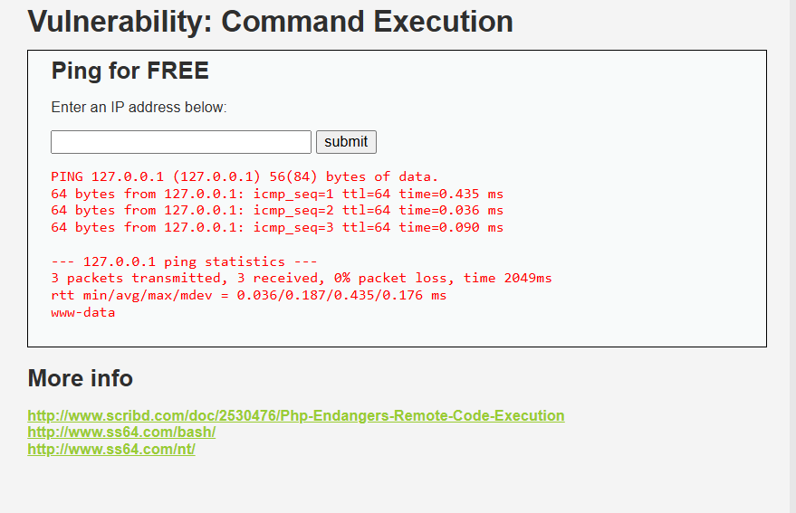
5. File inclusion-
I tested File Inclusion in DVWA with the security level set to Low.
I used the payload ../../../../../etc/passwd to access a local file.
The application displayed entries from the /etc/passwd file.
This showed that the application could be used to access local files without proper validation.
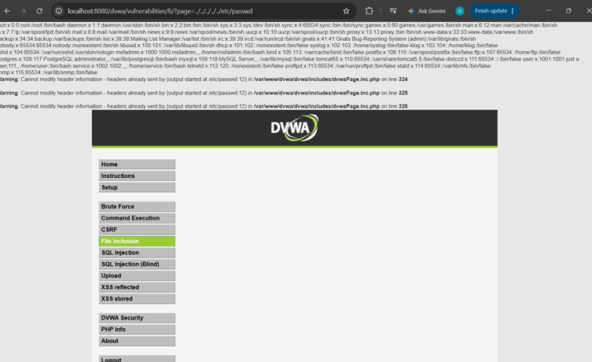

8. Wazuh Monitoring
Wazuh Cloud was created and the SecureCorp-WSL agent was shown Active. Local agent state reported connected. Target-side Wazuh monitoring was not established in the captured evidence.

9. Risk Assessment
Highest priorities are command injection risk in vulnerable web applications, legacy exposed services, exposed databases, remote administration services, and insufficient target-side monitoring.
1. I tested some vulnerabilities which are intensional in it and reviewed according to their damage impact on the application.
2. Sql injection- Exposure of user’s data in database.
3. XSS- Risk of harmful scripts that can affect user’s data.
4.Command injection- Risk of running unwanted commands.
5.File inclusion-Risk of accessing unwanted files.
6.File upload-Risk of uploading unwanted files.
7.Bruteforce/SSH/FTP- Risk of unauthorized login.

Asset | Threat | Vulnerability | Impact | Risk Rating | Recommendation
DVWA | SQL Injection | Poor input validation | Database information may be exposed | High | Use input validation and parameterized queries
DVWA | XSS | Improper input handling | Harmful scripts may affect users | Medium | Sanitize input and encode output
DVWA | Command Injection | Unsafe command handling | Unauthorized commands may be executed | High | Validate input and avoid direct command execution
DVWA | File Inclusion | Unsafe file path handling | Private system files may be accessed | High | Restrict file paths and validate input
DVWA | File Upload | Weak file upload validation | Unwanted files may be uploaded | Medium | Validate file type, size and extension
DVWA | Brute Force | Weak login protection | Unauthorized login may occur | High | Use strong passwords and login rate limiting
Metasploitable2 | FTP Brute Force | Weak FTP authentication | Unauthorized FTP access may occur | High | Use strong passwords and limit login attempts
Metasploitable2 | SSH Brute Force | Weak SSH authentication | Unauthorized system access may occur | High | Use strong authentication and rate limiting

10. Recommendations
Restrict inbound services; remove/isolate Telnet, VNC, X11, unused FTP/RPC/NFS; patch obsolete software; enforce strong authentication/MFA; secure web inputs; install target-side Wazuh/log collection; improve detection rules; maintain tested backups; train users.
The security assessment identified several vulnerabilities in the six main attacks.The recommendations below focus on reducing the risk of these attacks.Each recommendation is based on the findings observed during the testing.
The priority shows how quickly the security issue should be addressed.

Area | Current State | Recommendation | Priority
DVWA Brute Force | Multiple login attempts were possible. | Add login rate limiting and account lockout after repeated failed attempts. | High
SQL Injection | SQL Injection was successfully performed on DVWA. | Use parameterized queries and validate user input before processing it. | High
XSS | Stored XSS was successfully performed. | Validate user input and properly encode output before displaying it. | High
Command Injection | User input was used to execute system commands. | Do not pass user input directly to system commands. Validate and restrict input. | High
FTP Brute Force | Multiple FTP login attempts were possible. | Use strong passwords, limit login attempts and replace FTP with SFTP where possible. | High
SSH Brute Force | SSH login attempts could be performed. | Use strong passwords or SSH keys, disable weak authentication and limit failed login attempts. | High

11. Incident / Investigation Conclusion
No confirmed compromise is asserted. The next investigation cycle should establish target-side telemetry and replay each Week 2 activity with timestamps, source/target IPs, evidence and Wazuh rule references.

12. Final Submission Status
The report is submission-ready as an evidence-based capstone package. Items without sufficient practical evidence are explicitly marked Not Verified rather than fabricated.

Evidence Gallery
Wazuh environment
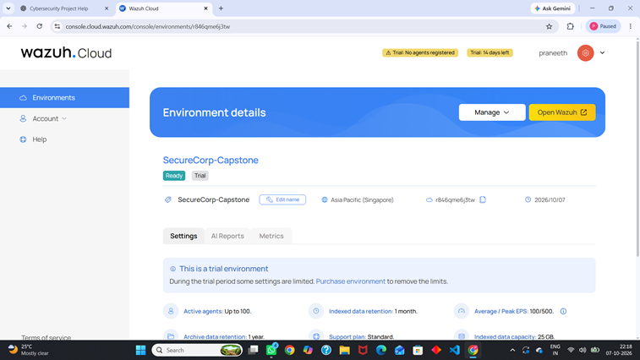
Agent deployment
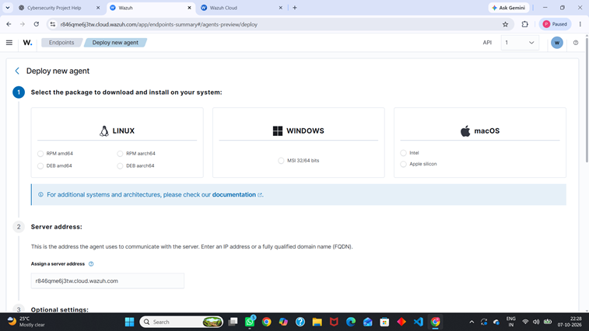

Active agent
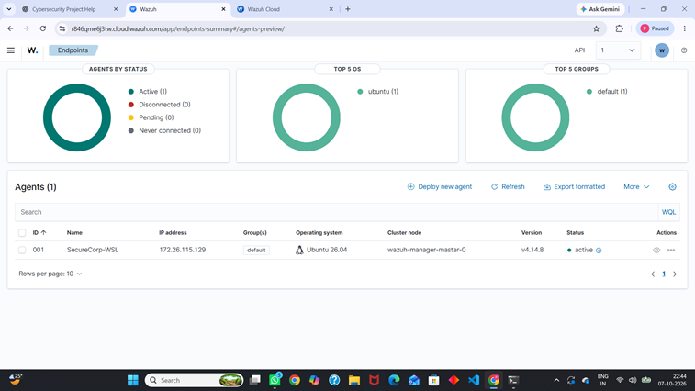
Wazuh overview
