Supporting the mental health of secondary school students

  - With young people facing many challenges to their wellbeing, Good Thinking gives education professionals across London tips on how to help them.

One in five children and young people in England, aged between eight to 25 have a probable mental disorder. Among 17 to 19-year olds, the figure is 23.3%, and among 20 to 25-year-olds, it’s 21.7%.
Schools have a vital role to play in supporting young people’s mental health but often lack the training, staff and resources to do this confidently or effectively.
In this article, we explore the different elements of supporting your students with their mental health and wellbeing so that you can consider your school’s provision. The Good Thinking team has also created a comprehensive lesson pack to use in school with your students to deliver health education statutory objectives.
CtA – download the Good Thinking mental health teaching resources



Concertina menu:
> Provide a supportive environment
> Create safe spaces
> Foster positive relationships
> Encourage open dialogue
> Offer training for teachers
> Incorporate mental health in the curriculum
> Find information and support

Provide a supportive environment
It’s important to get the foundations right when providing mental health support in your setting. This starts with your school’s culture and ethos so you might like to focus on:
- Encouraging a culture that values kindness, respect and inclusion
- Celebrating diversity and promoting a sense of belonging
- Acknowledging students’ achievements and efforts in various areas, including academic work, sport, creative arts and personal growth
Doing this will help your students to feel safe, supported and valued, which is the basis for good mental wellbeing.
As well as promoting a sense of belonging and pride in one’s identity, your school should seek to create opportunities to develop other ‘protective factors’ in students – this might include physical health, physical activity and attributes such as resilience, adaptability and problem solving.
You can build opportunities to enhance these protective factors into the school day in different ways and weave them through the curriculum.
Routines and familiarity also support good mental health so it’s important to maintain routines and structure relating to the school day, rules and policies, school staff and the physical buildings and resources.

Create safe spaces
Have you ever considered whether your students feel safe and comfortable at school? Have you asked them whether there are areas in school where they feel unsafe or less safe?
The physical environment can positively contribute to supporting young people’s mental health. Speak with your young people to learn about their experiences and consider how you can ensure they feel safe wherever they are in school.
It’s a good idea to designate areas in the school building or in the school grounds where your students can go to relax and feel safe, such as a wellness room or quiet zone, and to make sure your young people know where they are, who can use them and when they can be used. These spaces can offer a refuge for students experiencing stress or anxiety.
You could also think about the sort of equipment and display resources to place in these areas:
- Comfortable, flexible seating feels welcoming.
- Fidget or stress-reliever toys might be useful for some students.
- Posters on the walls could provide prompts and tips to support wellbeing – check out Good Thinking’s Five Ways to Wellbeing posters.

Foster positive relationships

Teacher-to-student relationships

Build trust
Building positive relationships with your students takes time, patience and positivity. A young person struggling with their mental health needs someone to listen to them, but they won’t open up if they don’t feel safe.

Understand challenging behaviour
It’s important to remember that a student experiencing mental health difficulties may present with challenging behaviour – if they don’t understand what’s going on in their life or can’t cope with their emotions, they may ‘act out’ in other ways.

Get to know your students
Getting to know your students better not only builds trust but puts you and your colleagues in a stronger position to be able to recognise the triggers or early warning signs that indicate a young person is struggling with their mental health.

Student-to-student relationships

Nurture friendships
To help your students build friendships and feel connected to their peers, you could organise group projects, extracurricular activities and sports events or clubs that promote collaboration and teamwork.

Set up support programmes
Your school could also establish a peer mentoring or buddy programme where older students support younger ones. These kinds of programmes can help by providing relatable role models and a sense of community.


Encourage open dialogue
It’s important to foster an environment where your students feel comfortable discussing their feelings and concerns. Encourage open dialogue through regular check-ins, classroom discussions, and access to specific members of staff, such as SENDCos and school therapists or counsellors.
Through discussions and conversations about mental health, your school can:
- ‘Usualise’ common mental health conditions.
- Help remove the stigma and address misconceptions young people may have about mental health conditions.
- Provide your students with the right knowledge and language to discuss their mental wellbeing.
- Give your students the confidence to speak up and seek help when they need it.
This extends beyond the school walls, of course. Consider how you communicate with families too and share information on the school’s health curriculum and provisions relating to mental health and wellbeing.

Offer training for teachers
Where possible, devote time and funding to training teachers and other colleagues to recognise signs of poor mental health and provide appropriate support.
In-house staff training can take place using high-quality information and resources found online. These training sessions should cover:
- School policies
- Creating a safe learning environment
- Strategies for fostering positive relationships
- Procedures and practices related to supporting students’ mental health
- Recommended resources available to staff and students
- Delivering health education lessons
All teachers should be given time to complete the relevant Department for Education (DfE) training modules, which include a section on mental wellbeing.
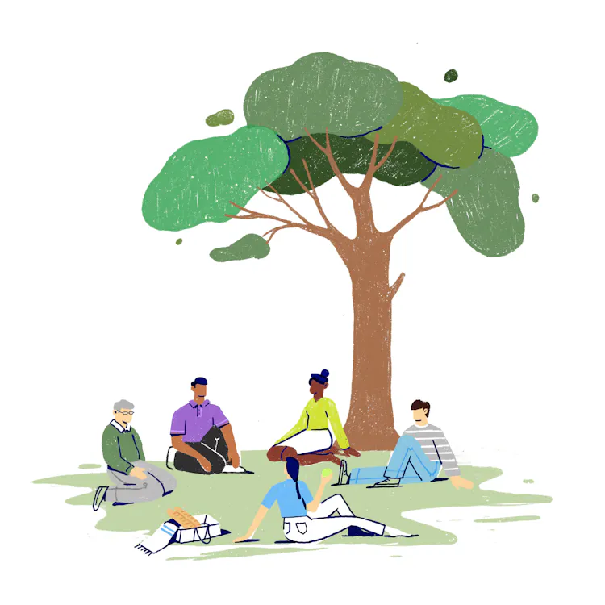

Incorporate mental health in the curriculum

Plan to deliver health education
Supporting your young people’s knowledge and understanding of mental health and wellbeing requires explicit teaching. This area of the curriculum must be given the time it needs. Timetable and plan for mental health and wellbeing education through:
- Form time
- Assemblies
- Allocated PSHE lessons

Review, update and publish your curriculum
Your school should have an up-to-date Relationships, Sex and Health Education (RSHE) curriculum, which is publicly available on the school website.
Statutory health education sets out what students should be taught by the end of secondary school. The PSHE Association also provides a programme of study for schools to follow to ensure all students adequately cover the necessary objectives relating to mental health.
It should be noted that aspects of the RSHE guidance are currently under review. The draft guidance proposes specific mentions of suicide, self-harm, eating disorders and loneliness, with guidance on when to first introduce these topics.

Find useful resources
There are lots of resources available to support health education, including mental health education, many of which are free to schools. A designated member of staff should be given time to research and gather suitable resources to share with colleagues. As a starting point:
- Every Mind Matters offers a huge range of flexible, ready-to-use content co-created with teachers and young people to help schools teach mental wellbeing topics.
- The Good Thinking website contains valuable resources specifically created for young people.
- The Good Thinking site also offers links to podcasts, videos and webinars.
- You can find a list of recommended apps to support young people with their mental health on the Good Thinking site, too.

Promote healthy lifestyles
Physical health is closely linked to mental wellbeing so promoting healthy habits can support your students’ overall mental health. Encourage physical activity, healthy eating and sufficient sleep through your health education provision.
The Good Thinking site contains information and support relating to:
- Sleep
- Anxiety
- Low mood
- Stress
- Grief


Teach conflict resolution skills
Equip your students with skills to manage conflicts constructively. Teaching problem-solving and negotiation skills can help prevent and resolve interpersonal issues. These skills can be taught in any lesson and young people should be provided with ample opportunities to put them into practice.

Integrate Social-Emotional Learning (SEL)
SEL can strengthen your students' ability to build positive relationships. Try to integrate SEL programmes into the curriculum to help young people develop skills such as empathy, emotional regulation and effective communication.

Find information and support

Mental health support in school
Initial signposting is likely to be to a designated member of staff in school but it’s important for all staff to know what support is out there and when and how to signpost your students to other services available to them. This starts with clear, transparent school policies and procedures that are widely shared among staff.

External support for mental health
When it comes to signposting your students to additional, external support, you can find a list of free apps and an article containing details of support organisations in Good Thinking's guidance for young people. Support organisations include Shout, YoungMinds, The Mix and the NHS 24/7 helplines in every London borough.


Call to Action – download the Good Thinking lesson packs
Good Thinking: An Introduction to Mental Health and Wellbeing for Secondary School Students is a set of 10 flexible lessons that has been developed to use with young people aged 11 to 18, utilising high-quality, NHS-approved resources from London’s digital mental wellbeing service.
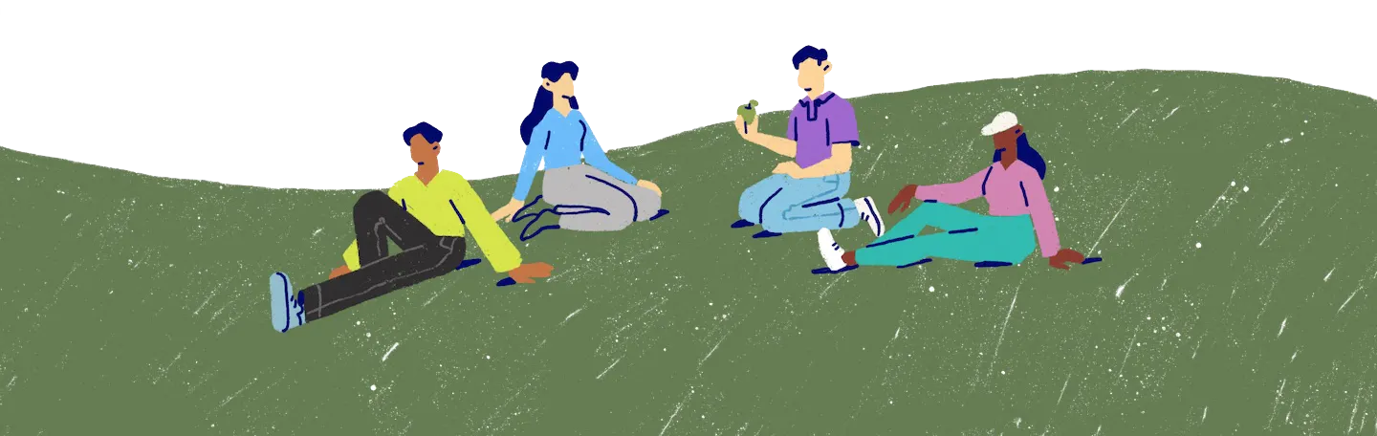

The Mental Health of Children and Young People in England 2023 Report, published by NHS England, Nov 2023

