GOOD THINKING COMMS TOOLKIT
Mental wellbeing and Judaism

Using this document

This toolkit contains information about the Good Thinking mental wellbeing resources co-created with members of the Jewish community, including the Five ways to good mental wellbeing and Judaism guide. It will support you in raising awareness of the free, NHS-approved resources available through the Good Thinking service to help support positive mental health and wellbeing in your community.

If you have any questions, please contact the Good Thinking team at:
info@good-thinking.uk

The toolkit contains:

- An introduction to the Good Thinking service

- A link to the Good Thinking Judaism resources webpage, where you’ll find:
- Links to the Five ways to good mental wellbeing and Judaism booklet for you to share online or print as needed
- A link to the Judaism and bereavement booklet
- Signposting to other useful websites for the Jewish community
- Videos produced by members of the Christian community offering tips and advice to help with stress, anxiety and low mood that are in line with the Christian tradition

- A newsletter/bulletin/intranet article for you to use to raise awareness of the resources with your community

- Social media content (including copy, graphics, videos and animation) for you to use to promote the toolkit to your community via WhatsApp and on your X (formerly Twitter), Instagram, LinkedIn and Facebook pages. You can also tag us using: @GoodThinkingUK

- Printable Good Thinking resources for communal areas
- Links to printable posters and flyers, and information about how to request professionally printed flyers and A3 posters directly from the Good Thinking team

1. The Good Thinking service

What is Good Thinking and how do we support Londoners?
Good Thinking is a digital service that helps Londoners look after their mental health and wellbeing in a way that works for them. We provide personalised advice, support and resources to help people struggling with:
- Stress
- Anxiety
- Low mood
- Sleep
- Other mental health concerns, such as trauma, bereavement and eating disorders

Our service is:
- Free of charge
- NHS-approved
- Available 24/7 on any device
- Completely anonymous

What resources are available through Good Thinking?
Good Thinking provides a range of resources to help Londoners improve their mental wellbeing, including:
- Free apps (NHS-approved and independently assessed)
- Quick quizzes which give tailored support recommendations
- Printable workbooks and guides
- Advice articles with tips to boost mental health
- Blogs and personal stories
- Podcasts
- Videos and webinars

Why is it important that Good Thinking services are personalised?
Londoners have told Good Thinking that there is no ‘one size fits all’ solution when it comes to their mental health – they want information and support that reflects how they live and what their values are.

So, Good Thinking has been working with a variety of organisations, faith communities, academics, charities, and many others to create tailored, impactful content. Everyone’s mental health is different – we are here to help Londoners find their own path to improve their wellbeing.

2. Good Thinking Judaism resources

Good Thinking have a range of resources tailored for the Jewish community available at https://www.good-thinking.uk/faith-and-belief-communities/judaism.

You’ll find:
- Good Thinking’s Five ways to good mental wellbeing and Judaism booklet for you to share online or print as needed.
- A link to the Judaism and bereavement booklet; a guide to help members of the Jewish community across London who have lost a loved one as well as health and care professionals who are supporting terminally ill patients of the Jewish faith.
- Signposting to other useful websites for the Jewish community.

- Videos produced by members of the Jewish community offering tips and advice to help with stress, anxiety and low mood that are in line with Jewish beliefs and traditions.

- Newsletter/bulletin copy

Good Thinking – digital mental health support for London’s Jewish community

Good Thinking, London’s free, NHS-approved digital mental health and wellbeing service, has collaborated with members of London’s Jewish community to create mental wellbeing resources that align with the beliefs and teachings of Judaism.

Five ways to good mental wellbeing and Judaism
Developed in collaboration with Jewish communities across the capital and Jami, and in consultation with Rabbi Miriam Berger and Rabbi Daniel Epstein and with the support of The London Jewish Forum, Maccabi GB and the London Borough of Barnet, Good Thinking’s five ways to wellbeing guide provides advice on looking after your mental health and wellbeing based on NHS advice and in line with Jewish beliefs and traditions:

- Connect with other people
- Be physically active
- Learn something new each day
- Give to others
- Pay attention to the present moment and how you feel

Explore the full range of resources
Visit Good Thinking to download the guide (a printable version of the booklet is also available) and explore the full range of resources tailored for the Jewish community including a guide to Judaism and bereavement, signposting to useful websites for the Jewish community and videos offering tips and advice to help with stress, anxiety and low mood.

For more information about the service and to access free NHS-approved support and resources, visit Good Thinking.

-Ends-

- Social media content

Please show your support on social media, encouraging people to visit the Good Thinking website for support.

Facebook goodthinkinguk
LinkedIn goodthinkinguk
Instagram www.instagram.com/goodthinkinguk
X (Twitter) @GoodThinkingUK

Please find below some example posts that can be posted on your social channels. Remember to tag us in when you can @GoodThinkingUK

Suggested content for social media

Copy for X (formerly Twitter) | Graphic - Download graphics here
Londoners want support that reflects their lifestyles and values.  @GoodThinkingUK have a range of resources co-created with members of the #Jewish community to help you manage your mental wellbeing in line with Jewish beliefs and traditions.  👉 https://www.good-thinking.uk/faith-and-belief-communities/judaism | Download graphics here  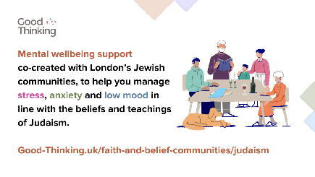
Explore @GoodThinkingUK’s Five Ways to Wellbeing and Judaism guide!  Co-created with members of the #Jewish community to help you manage your #MentalHealth and wellbeing in line with Jewish beliefs and traditions:  👉 https://goodthinking-strapi.s3.eu-west-2.amazonaws.com/JC_0308_Five_Ways_Wellbeing_Judiasm_Sept23_Amends_V1_80c22d6e9b.pdf?updated_at=2023-10-05T13:55:49.382Z | 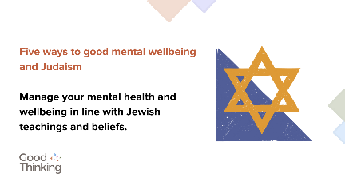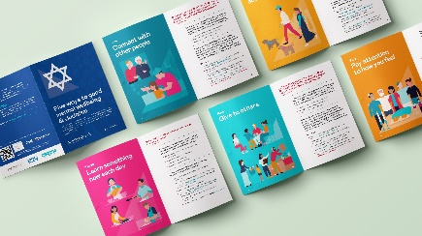
#MentalHealth isn’t one size fits all.  @GoodThinkingUK have a range of resources co-created with members of the #Jewish community to help you manage your mental wellbeing in line with Jewish beliefs and traditions.  👉 https://www.good-thinking.uk/faith-and-belief-communities/judaism | 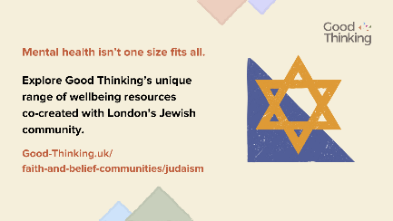

Copy for Instagram | Graphic - Download graphics here
Londoners want support that reflects their lifestyles and values.  @goodthinkinguk have a range of resources co-created with members of the #Jewish community to help you manage your mental wellbeing in line with Jewish beliefs and traditions.  👉 https://www.good-thinking.uk/faith-and-belief-communities/judaism | Download graphics here  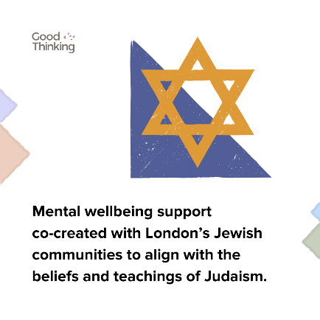
Explore @goodthinkinguk’s Five Ways to Wellbeing and Judaism guide!  Co-created with members of the #Jewish community to help you manage your #MentalHealth and wellbeing in line with Jewish beliefs and traditions:  👉 https://goodthinking-strapi.s3.eu-west-2.amazonaws.com/JC_0308_Five_Ways_Wellbeing_Judiasm_Sept23_Amends_V1_80c22d6e9b.pdf?updated_at=2023-10-05T13:55:49.382Z | 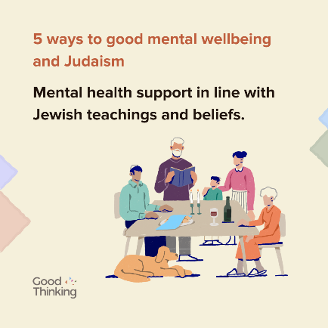
#MentalHealth isn’t one size fits all.  @goodthinkinguk have a unique range of resources co-created with members of the #Jewish community to help you manage your mental wellbeing in line with Jewish beliefs and traditions.  👉 https://www.good-thinking.uk/faith-and-belief-communities/judaism | 

Copy for Facebook / LinkedIn | Graphic - Download graphics here
Londoners want support that reflects their lifestyles and values.  @goodthinkinguk have a range of resources co-created with members of the #Jewish community to help you manage your mental wellbeing in line with Jewish beliefs and traditions.  👉 https://www.good-thinking.uk/faith-and-belief-communities/judaism | Download graphics here  
Explore @goodthinkinguk’s Five Ways to Wellbeing and Judaism guide!  Co-created with members of the #Jewish community to help you manage your #MentalHealth and wellbeing in line with Jewish beliefs and traditions:  👉 https://goodthinking-strapi.s3.eu-west-2.amazonaws.com/JC_0308_Five_Ways_Wellbeing_Judiasm_Sept23_Amends_V1_80c22d6e9b.pdf?updated_at=2023-10-05T13:55:49.382Z | 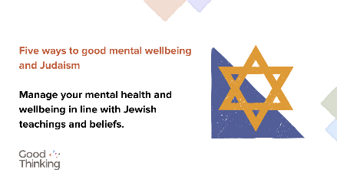
#MentalHealth isn’t one size fits all.  @goodthinkinguk have a unique range of resources co-created with members of the #Jewish community to help you manage your mental wellbeing in line with Jewish beliefs and traditions.  👉 https://www.good-thinking.uk/faith-and-belief-communities/judaism | 

Content for WhatsApp

Copy

In the Jewish tradition, mental health is a very important aspect in a person’s wellbeing, as it is essential to living a healthy and balanced life.

We have created the Five ways to Wellbeing and Judaism to give you some tips on how to maintain your wellbeing, please share this video:

https://youtu.be/oWb4AFgvDO4

For those of us who may be facing mental health issues, or are coping with anxiety and negativity, one of the many ways that we may try to overcome these challenges, is to take a balanced approach of both spirituality and practicality.

We have created the Five ways to Wellbeing and Judaism to provide some tips on how to maintain that balance, please share this video: https://youtu.be/oWb4AFgvDO4.

For more information, visit www.good-thinking.uk/judaism

èPlease share widely

The issue of mental health is real and should not be taken lightly. For those who are facing any kind of mental health issues, do not be afraid and seek professional help. There is no harm and shame in doing this, there’s always help around the corner.

For more information, visit www.good-thinking.uk/judaism

èPlease share widely

NHS 5 Ways to Wellbeing – a Jewish Perspective

✅Developed by Good Thinking working with Jewish communities
✅Lots of excellent resources; short inspiring videos, animations and translated resources too

https://youtu.be/oWb4AFgvDO4

èPlease share widely

Listen to Laurie Rackind, Chief Executive at Jami, sharing how connecting with other people can improve your mental health. https://youtu.be/5YTRgnlOIps

èPlease share widely

Listen to Rabbi Daniel Epstein of Western Marble Arch Synagogue, sharing how being physically active can improve your mental wellbeing. https://youtu.be/p-nBWDv9rrE

èPlease share widely

Listen to Rabbi Miriam Berger of Finchley Reform Synagogue and the Wellspring Project, sharing how learning something new every day can improve your mental wellbeing. https://youtu.be/V7fPJM9NxEw

èPlease share widely

Listen to Emma Dorman, Senior Education Coordinator at Jami, sharing how giving to others can improve your mental wellbeing. https://youtu.be/i0cp7yAPBk4

èPlease share widely

Listen to Philippa Carr, Education Manager at Jami, sharing how paying attention to the present moment can improve your mental wellbeing. https://youtu.be/sXposgDsMik

èPlease share widely

Videos – Five ways to good mental wellbeing and Judaism

We’ve uploaded several short videos to YouTube to help promote Five Ways to Wellbeing and Judaism. Produced by members of the Jewish community, the videos talk about common concerns that people may face in relation to their mental health and wellbeing, such as anxiety, low mood and stress. The videos also offer techniques that may help to overcome these concerns that are in line with the Jewish tradition.

Please share these videos across your social media channels with members of your community. The video links are below:

Video link | Description
https://www.youtube.com/watch?v=oWb4AFgvDO4 | Councillor Caroline Stock, Chair of the Barnet Health and Wellbeing Board and former Mayor of Barnet, shares the importance of looking after your mental health and wellbeing.
https://www.youtube.com/watch?v=5YTRgnlOIps | Laurie Rackind, Chief Executive at Jami, shares how connecting with other people can improve your mental wellbeing.
https://www.youtube.com/watch?v=p-nBWDv9rrE | Rabbi Daniel Epstein of Western Marble Arch Synagogue, shares how being physically active can improve your mental wellbeing.
https://www.youtube.com/watch?v=V7fPJM9NxEw&feature=youtu.be | Rabbi Miriam Berger of Finchley Reform Synagogue and the Wellspring Project, shares how learning something new every day can improve your mental wellbeing.
https://www.youtube.com/watch?v=i0cp7yAPBk4 | Emma Dorman, Senior Education Coordinator at Jami, shares how giving to others can improve your mental wellbeing.
https://www.youtube.com/watch?v=sXposgDsMik | Philippa Carr, Education Manager at Jami, shares how paying attention to the present moment can improve your mental wellbeing.

Animations and assets for social media

We’ve developed a range of animations (Mp4 video files) that you can use to support us in promoting the Five ways to good mental wellbeing and Judaism guide.

These are available to download here.

- Printable Good Thinking resources

Good Thinking have a range of printable posters, flyers and guides available to download via the Campaign Hub.

If you would like to request professionally printed postcard flyers and/or A3 posters please contact info@good-thinking.uk detailing the number required and postal address.

Flyer:
- Good Thinking flyer

Posters:
- Good Thinking poster 1 (A4)
- Good Thinking poster 2 (A4)
- Good Thinking poster 3 (A4)
- Good Thinking poster 4 (A4)
- Good Thinking poster 1 (A3)
- Good Thinking poster 2 (A3)

Your support in sharing the Good Thinking service is greatly appreciated.

Please feel free to share this toolkit amongst your colleagues and networks as far and wide as possible.

