GOOD THINKING COMMS TOOLKIT
Mental wellbeing and Rastafari

Using this document

This toolkit contains information about the Good Thinking mental wellbeing resources co-created with members of the Rastafari community, including the Seven ways to good mental wellbeing and Rastafari guide. It will support you in raising awareness of the free, NHS-approved resources available through the Good Thinking service to help support positive mental health and wellbeing in your community.

If you have any questions, please contact the Good Thinking team at:
info@good-thinking.uk

The toolkit contains:

- An introduction to the Good Thinking service

- A link to the Good Thinking Rastafari resources webpage, where you’ll find:
- Links to the Seven ways to good mental wellbeing and Rastafari booklet for you to share online or print as needed
- Videos produced by members of the Rastafari community offering tips and advice to help with stress, anxiety and low mood that are in line with the Rastafari tradition

- A newsletter/bulletin/intranet article for you to use to raise awareness of the resources with your community

- Social media content (including copy, graphics, videos and animation) for you to use to promote the toolkit to your community via WhatsApp and on your X (formerly Twitter), Instagram, LinkedIn and Facebook pages. You can also tag us using: @GoodThinkingUK

- Printable Good Thinking resources for communal areas
- Links to printable posters and flyers, and information about how to request professionally printed flyers and A3 posters directly from the Good Thinking team

1. The Good Thinking service

What is Good Thinking and how do we support Londoners?
Good Thinking is a digital service that helps Londoners look after their mental health and wellbeing in a way that works for them. We provide personalised advice, support and resources to help people struggling with:
- Stress
- Anxiety
- Low mood
- Sleep
- Other mental health concerns, such as trauma, bereavement and eating disorders

Our service is:
- Free of charge
- NHS-approved
- Available 24/7 on any device
- Completely anonymous

What resources are available through Good Thinking?
Good Thinking provides a range of resources to help Londoners improve their mental wellbeing, including:
- Free apps (NHS-approved and independently assessed)
- Quick quizzes which give tailored support recommendations
- Printable workbooks and guides
- Advice articles with tips to boost mental health
- Blogs and personal stories
- Podcasts
- Videos and webinars

Why is it important that Good Thinking services are personalised?
Londoners have told Good Thinking that there is no ‘one size fits all’ solution when it comes to their mental health – they want information and support that reflects how they live and what their values are.

So, Good Thinking has been working with a variety of organisations, faith communities, academics, charities, and many others to create tailored, impactful content. Everyone’s mental health is different – we are here to help Londoners find their own path to improve their wellbeing.

2. Good Thinking Rastafari resources

Good Thinking have a range of resources tailored for the Rastafari community available at https://www.good-thinking.uk/faith-and-belief-communities/rastafari.

You’ll find:
- Good Thinking’s Seven ways to good mental wellbeing and Rastafari booklet for you to share online or print as needed.
- Videos produced by members of the Rastafari community offering tips and advice to help with stress, anxiety and low mood that are in line with the Rastafari way of life.

- Newsletter/bulletin copy

Good Thinking – digital mental health support for London’s Rastafari community

Good Thinking, London’s free, NHS-approved digital mental health and wellbeing service, has collaborated with members of London’s Rastafari community to create mental wellbeing resources that align with the beliefs and teachings of Rastafari.

Seven ways to good mental wellbeing and Rastafari
Developed in collaboration with Rastafari communities across the capital and endorsed by Sistahs and Elders from the Rastafari Movement UK and the National Nyabinghi Council UK, Good Thinking’s seven ways to wellbeing guide provides advice on looking after your mental health and wellbeing in line with the Rastafari tradition focusing on:

- Spiritual wellbeing
- Physical wellbeing
- Educational wellbeing
- Universal (Iniversal) wellbeing
- Food and wellbeing
- Social wellbeing
- Economic wellbeing

Explore the full range of resources
Visit Good Thinking to download the guide (a printable version of the booklet is also available) and explore the full range of resources tailored for the Rastafari community including videos offering tips and advice to help with stress, anxiety and low mood.

For more information about the service and to access free NHS-approved support and resources, visit Good Thinking.

-Ends-

- Social media content

Please show your support on social media, encouraging people to visit the Good Thinking website for support.

Facebook goodthinkinguk
LinkedIn goodthinkinguk
Instagram www.instagram.com/goodthinkinguk
X (Twitter) @GoodThinkingUK

Please find below some example posts that can be posted on your social channels. Remember to tag us in when you can @GoodThinkingUK

Suggested content for social media

Copy for X (formerly Twitter) | Graphic - Download graphics here
Londoners want support that reflects their lifestyles and values.  @GoodThinkingUK have a range of resources co-created with members of the #Rastafari community to help you manage your mental wellbeing in line with Rastafari beliefs and traditions.  👉 https://www.good-thinking.uk/faith-and-belief-communities/rastafari | Download graphics here  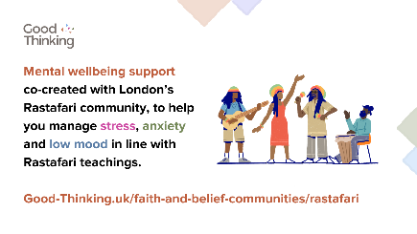
Explore @GoodThinkingUK’s 7 Ways to Wellbeing and Rastafari guide!  Co-created with members of the #Rastafari community to help you manage your #MentalHealth and wellbeing in line with Rastafari beliefs and traditions:  👉 https://goodthinking-strapi.s3.eu-west-2.amazonaws.com/Five_Ways_Wellbeing_Rastafari_v6_ed627e7426.pdf?updated_at=2023-10-04T11:59:31.611Z | 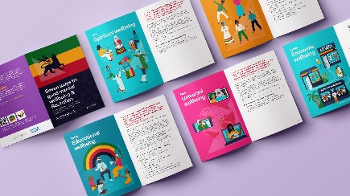  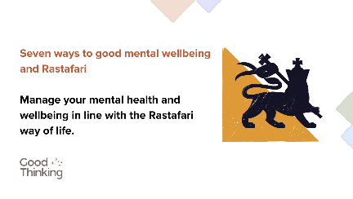
#MentalHealth isn’t one size fits all.  @GoodThinkingUK have a range of resources co-created with members of the #Rastafari community to help you manage your mental wellbeing in line with Rastafari beliefs and traditions.  👉 https://www.good-thinking.uk/faith-and-belief-communities/rastafari | 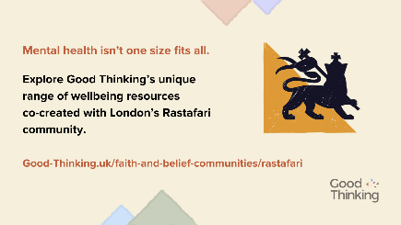

Copy for Instagram | Graphic - Download graphics here
Londoners want support that reflects their lifestyles and values.  @goodthinkinguk have a range of resources co-created with members of the #Rastafari community to help you manage your mental wellbeing in line with Rastafari beliefs and traditions.  👉 good-thinking.uk/faith-and-belief-communities/rastafari | Download graphics here  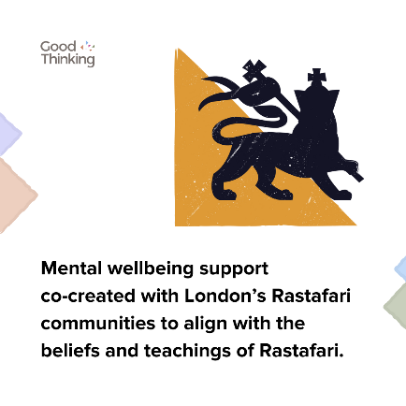
Explore @goodthinkinguk’s 7 Ways to Wellbeing and Rastafari guide!  Co-created with members of the #Rastafari community to help you manage your #MentalHealth and wellbeing in line with Rastafari beliefs and traditions.  Copy and paste the link below into your browser:  👉 https://goodthinking-strapi.s3.eu-west-2.amazonaws.com/Five_Ways_Wellbeing_Rastafari_v6_ed627e7426.pdf?updated_at=2023-10-04T11:59:31.611Z | 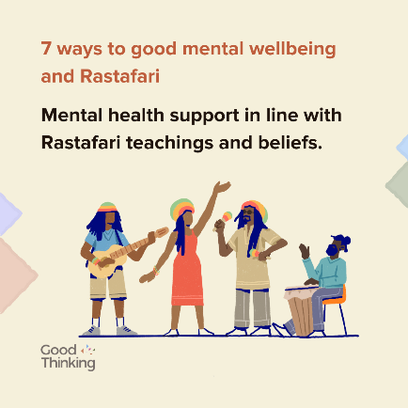
#MentalHealth isn’t one size fits all.  @goodthinkinguk have a range of resources co-created with members of the #Rastafari community to help you manage your mental wellbeing in line with Rastafari beliefs and traditions.  👉 good-thinking.uk/faith-and-belief-communities/rastafari | 

Copy for Facebook / LinkedIn | Graphic - Download graphics here
Londoners want support that reflects their lifestyles and values.  @goodthinkinguk have a range of resources co-created with members of the #Rastafari community to help you manage your mental wellbeing in line with Rastafari beliefs and traditions.  👉 https://www.good-thinking.uk/faith-and-belief-communities/rastafari | Download graphics here  
Explore @goodthinkinguk’s 7 Ways to Wellbeing and Rastafari guide!  Co-created with members of the #Rastafari community to help you manage your #MentalHealth and wellbeing in line with Rastafari beliefs and traditions:  👉 https://goodthinking-strapi.s3.eu-west-2.amazonaws.com/Five_Ways_Wellbeing_Rastafari_v6_ed627e7426.pdf?updated_at=2023-10-04T11:59:31.611Z |   
#MentalHealth isn’t one size fits all.  @goodthinkinguk have a range of resources co-created with members of the #Rastafari community to help you manage your mental wellbeing in line with Rastafari beliefs and traditions.  👉 https://www.good-thinking.uk/faith-and-belief-communities/rastafari | 

Copy for individual 7 ways to wellbeing | Graphic - Download graphics here
In the #Rastafari tradition, physical wellbeing is essential to good #MentalHealth and wellbeing. Starting the day early, using natural products and spending time in nature are simple ways you can look after yourself.  More advice and tips:  👉 https://goodthinking-strapi.s3.eu-west-2.amazonaws.com/Five_Ways_Wellbeing_Rastafari_v6_ed627e7426.pdf?updated_at=2023-10-04T11:59:31.611Z | Download graphics here  
Spiritual wellness is at the heart of #Rastafari way of life. Prayer, volunteering and serving the community can all help to improve #MentalWellbeing.  Take a look at @goodthinkinguk’s 7 Ways to Wellbeing and #Rastafari for more useful tips:  👉 https://goodthinking-strapi.s3.eu-west-2.amazonaws.com/Five_Ways_Wellbeing_Rastafari_v6_ed627e7426.pdf?updated_at=2023-10-04T11:59:31.611Z | 
Education is at the heart of the #Rastafari community. Learning about Rastafari history and culture or developing a new skill can help you to grow mentally stronger.  Explore @goodthinkinguk’s 7 Ways to Wellbeing and #Rastafari for more useful tips:  👉 https://goodthinking-strapi.s3.eu-west-2.amazonaws.com/Five_Ways_Wellbeing_Rastafari_v6_ed627e7426.pdf?updated_at=2023-10-04T11:59:31.611Z | 
Community prosperity is at the heart of the #Rastafari way of life. Join business support networks and support local shops to help your local community thrive.  Take a look at @goodthinkinguk’s 7 Ways to Wellbeing and #Rastafari for more useful tips:  👉 https://goodthinking-strapi.s3.eu-west-2.amazonaws.com/Five_Ways_Wellbeing_Rastafari_v6_ed627e7426.pdf?updated_at=2023-10-04T11:59:31.611Z | 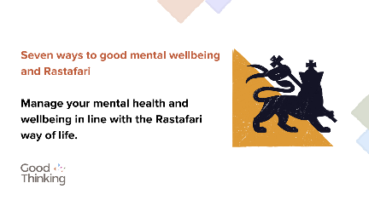
Mindfulness can help to bring about a sense of peace and appreciation, generating a more positive mindset and improving #MentalHealth and wellbeing.  Explore @goodthinkinguk’s 7 Ways to Wellbeing and #Rastafari for more useful tips:  👉 https://goodthinking-strapi.s3.eu-west-2.amazonaws.com/Five_Ways_Wellbeing_Rastafari_v6_ed627e7426.pdf?updated_at=2023-10-04T11:59:31.611Z | 

Content for WhatsApp

Copy

In the Rastafari tradition, mental health is a very important aspect in a person’s well-being, as it is essential to living a healthy and balanced life.

We have created the Seven Ways to Wellbeing and Rastafari to give you some tips on how to maintain your wellbeing, please share this link:

https://www.good-thinking.uk/rastafari/

For those of us who may be facing mental health challenges or coping with stress and anxiety, taking a balanced approach of both spirituality and practicality can help us to face these challenges head on and manage them more effectively.

We have created the Seven Ways to Wellbeing and Rastafari to provide some tips on how to maintain that balance, please share this link:

https://www.good-thinking.uk/rastafari/

èPlease share widely

If you’re facing any kind of mental health concerns, don’t be afraid to seek professional help. There’s no harm or shame in doing this - there’s always someone who can help just around the corner.

For more information, visit https://www.good-thinking.uk/rastafari/

èPlease share widely
NHS 7 Ways to Wellbeing – a Rastafari Perspective

✅Developed by Good Thinking working with the Rastafari community
✅Lots of excellent resources; short inspiring videos, animations and translated resources too

https://www.good-thinking.uk/rastafari/

èPlease share widely

Videos – Seven ways to good mental wellbeing and Rastafari

We’ve uploaded several short videos to YouTube to help promote Seven Ways to Wellbeing and Rastafari. Produced by members of the Rastafari community, the videos talk about common concerns that people may face in relation to their mental health and wellbeing, such as anxiety, low mood and stress. The videos also offer techniques that may help to overcome these concerns that are in line with the Rastafari way of life.

Please share these videos across your social media channels with members of your community. The video links are below:

Video link | Description
https://youtu.be/01Wl_3ooHcE | Ras Akila Kedan and Sistah Azuka talk about the importance of spiritual wellbeing
https://youtu.be/VCjM9Eop6uY | Ras Akila Kedan and Sistah Azuka talk about the importance of physical wellbeing
https://youtu.be/HZp7R1FOFRg | Ras Akila Kedan and Sistah Azuka talk about the importance of educational wellbeing
https://youtu.be/cWFFDEwML14 | Ras Akila Kedan and Sistah Azuka talk about the importance of universal wellbeing
https://youtu.be/eSee0iwfNwg | Ras Akila Kedan and Sistah Azuka talk about the importance of food and wellbeing
https://youtu.be/8VFvUeIcXJg | Ras Akila Kedan and Sistah Azuka talk about the importance of social wellbeing
https://youtu.be/548pILFNRNw | Ras Akila Kedan and Sistah Azuka talk about the importance of economic wellbeing

Animations and assets for social media

We’ve developed a range of animations that you can use to support us in promoting the Seven ways to good mental wellbeing and Rastafari guide. These include:

- Mp4 video files (available in both portrait and landscape layouts)

These are available to download here.

- Printable Good Thinking resources

Good Thinking have a range of printable posters, flyers and guides available to download via the Campaign Hub.

If you would like to request professionally printed postcard flyers and/or A3 posters please contact info@good-thinking.uk detailing the number required and postal address.

Flyer:
- Good Thinking flyer

Posters:
- Good Thinking poster 1 (A4)
- Good Thinking poster 2 (A4)
- Good Thinking poster 3 (A4)
- Good Thinking poster 4 (A4)
- Good Thinking poster 1 (A3)
- Good Thinking poster 2 (A3)

Your support in sharing the Good Thinking service is greatly appreciated.

Please feel free to share this toolkit amongst your colleagues and networks as far and wide as possible.

