GOOD THINKING COMMS TOOLKIT
Mental wellbeing and Sikhi

Using this document

This toolkit contains information about the Good Thinking mental wellbeing resources co-created with members of the Sikh community, including the Five ways to good mental wellbeing and Sikhi guide. It will support you in raising awareness of the free, NHS-approved resources available through the Good Thinking service to help support positive mental health and wellbeing in your community.

If you have any questions, please contact the Good Thinking team at:
info@good-thinking.uk

The toolkit contains:

- An introduction to the Good Thinking service

- A link to the Good Thinking Sikhi resources webpage, where you’ll find:
- Links to the Five ways to good mental wellbeing and Sikhi booklet for you to share online or print as needed (various translated versions of the guide are available)
- A link to the Sikhi and bereavement booklet
- Signposting to useful websites for the Sikh community
- Videos produced by members of the Sikh community offering tips and advice to help with stress, anxiety and low mood that are in line with the Sikhi tradition

- A newsletter/bulletin/intranet article for you to use to raise awareness of the resources with your community

- Social media content (including copy, graphics, videos and animation) for you to use to promote the toolkit to your community via WhatsApp, X (formerly Twitter), Instagram, LinkedIn and Facebook pages. You can also tag us using: @GoodThinkingUK

- Printable Good Thinking resources for communal areas
- Links to printable posters and flyers, and information about how to request professionally printed flyers and A3 posters directly from the Good Thinking team

1. The Good Thinking service

What is Good Thinking and how do we support Londoners?
Good Thinking is a digital service that helps Londoners look after their mental health and wellbeing in a way that works for them. We provide personalised advice, support and resources to help people struggling with:
- Stress
- Anxiety
- Low mood
- Sleep
- Other mental health concerns, such as trauma, bereavement and eating disorders

Our service is:
- Free of charge
- NHS-approved
- Available 24/7 on any device
- Completely anonymous

What resources are available through Good Thinking?
Good Thinking provides a range of resources to help Londoners improve their mental wellbeing, including:
- Free apps (NHS-approved and independently assessed)
- Quick quizzes which give tailored support recommendations
- Printable workbooks and guides
- Advice articles with tips to boost mental health
- Blogs and personal stories
- Podcasts
- Videos and webinars

Why is it important that Good Thinking services are personalised?
Londoners have told Good Thinking that there is no ‘one size fits all’ solution when it comes to their mental health – they want information and support that reflects how they live and what their values are.

So, Good Thinking has been working with a variety of organisations, faith communities, academics, charities, and many others to create tailored, impactful content. Everyone’s mental health is different – we are here to help Londoners find their own path to improve their wellbeing.

2. Good Thinking Sikhi resources

Good Thinking have a range of resources tailored for the Sikh community available at https://www.good-thinking.uk/faith-and-belief-communities/sikhi.

You’ll find:
- Good Thinking’s Five ways to good mental wellbeing and Sikhi booklet for you to share online or print as needed (a translated version of the guide is available in Punjabi).
- A link to the Sikhi and bereavement booklet; a guide to help Sikhs across London who have lost a loved one as well as health and care professionals who are supporting terminally ill patients of the Sikh faith.
- Videos produced by members of the Sikh community offering tips and advice to help with stress, anxiety and low mood that are in line with the Sikhi tradition.

- Newsletter/bulletin copy

Good Thinking – digital mental health support for London’s Sikh community

Good Thinking, London’s free, NHS-approved digital mental health and wellbeing service, has collaborated with members of London’s Sikh community to create mental wellbeing resources that align with the beliefs and teachings of Sikhi.

Five ways to good mental wellbeing and Sikhi
Developed in collaboration with Sikhs across the capital and endorsed by Basics of Sikhi, Sikh Council UK, Sikh Your Mind and Taraki, Good Thinking’s five ways to wellbeing guide provides advice on looking after your mental health and wellbeing in line with the Sikh tradition:

- Connect with the Divine and other people
- Be physically active
- Learn something new each day
- Give to others
- Pay attention to the present moment

Explore the full range of resources
Visit Good Thinking to download the guide (translation in Punjabi and a printable version of the booklet is also available) and explore the full range of resources tailored for the Sikh community including a guide to Sikhi and bereavement and videos offering tips and advice to help with stress, anxiety and low mood.

For more information about the service and to access free NHS-approved support and resources, visit Good Thinking.

-Ends-

- Social media content

Please show your support on social media, encouraging people to visit the Good Thinking website for support.

Facebook goodthinkinguk
LinkedIn goodthinkinguk
Instagram www.instagram.com/goodthinkinguk
X (Twitter) @GoodThinkingUK

Please find below some example posts that can be posted on your social channels. Remember to tag us in when you can @GoodThinkingUK

Suggested content for social media

Copy for X (formerly Twitter) | Graphic - Download graphics here
Londoners want support that reflects their lifestyles and values.  @GoodThinkingUK have a range of resources co-created with members of the #Sikh community to help you manage your mental wellbeing in line with Sikhi beliefs and traditions.  👉 https://www.good-thinking.uk/faith-and-belief-communities/sikhi | Download graphics here  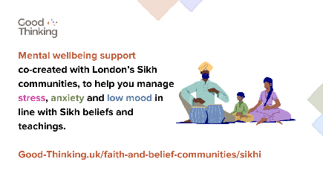
Explore @GoodThinkingUK’s Five Ways to Wellbeing and Sikhi guide!  Co-created with members of the #Sikh community to help you manage your #MentalHealth and wellbeing in line with Sikhi beliefs and traditions:  👉 https://goodthinking-strapi.s3.eu-west-2.amazonaws.com/Five_Ways_Wellbeing_Sikhi_Final_e9a294adea.pdf?updated_at=2023-10-04T12:02:14.706Z | 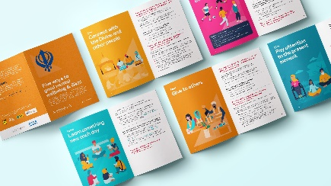  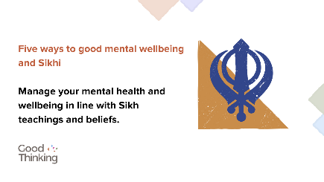
#MentalHealth isn’t one size fits all.  @GoodThinkingUK have a range of resources co-created with members of the #Sikh community to help you manage your mental wellbeing in line with Sikhi beliefs and traditions.  👉 https://www.good-thinking.uk/faith-and-belief-communities/sikhi | 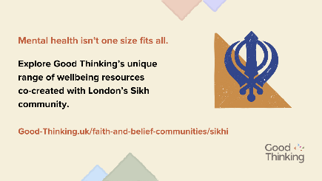

Copy for Instagram | Graphic - Download graphics here
Londoners want support that reflects their lifestyles and values.  @goodthinkinguk have a range of resources co-created with members of the #Sikh community to help you manage your mental wellbeing in line with Sikhi beliefs and traditions.  👉 good-thinking.uk/faith-and-belief-communities/sikhi | Download graphics here  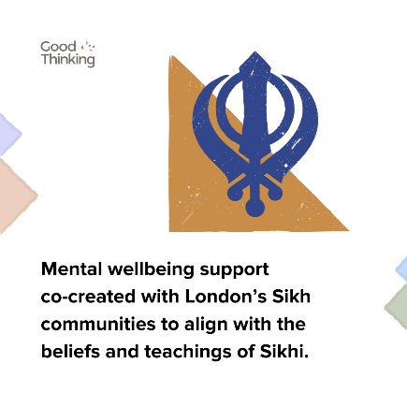
Explore @goodthinkinguk’s Five Ways to Wellbeing and Sikhi guide!  Co-created with members of the #Sikh community to help you manage your #MentalHealth and wellbeing in line with Sikhi beliefs and traditions.  Copy and paste the link below into your browser:  👉 https://goodthinking-strapi.s3.eu-west-2.amazonaws.com/Five_Ways_Wellbeing_Sikhi_Final_e9a294adea.pdf?updated_at=2023-10-04T12:02:14.706Z | 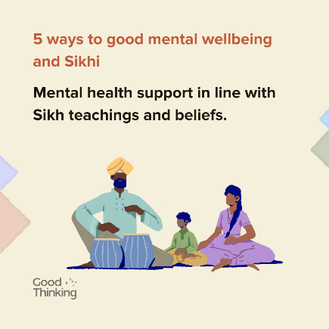
#MentalHealth isn’t one size fits all.  @goodthinkinguk have a range of resources co-created with members of the #Sikh community to help you manage your mental wellbeing in line with Sikhi beliefs and traditions.  👉 good-thinking.uk/faith-and-belief-communities/sikhi | 

Copy for Facebook / LinkedIn | Graphic - Download graphics here
Londoners want support that reflects their lifestyles and values.  @goodthinkinguk have a range of resources co-created with members of the #Sikh community to help you manage your mental wellbeing in line with Sikhi beliefs and traditions.  👉 https://www.good-thinking.uk/faith-and-belief-communities/sikhi | Download graphics here  
Explore @goodthinkinguk’s Five Ways to Wellbeing and Sikhi guide!  Co-created with members of the #Sikh community to help you manage your #MentalHealth and wellbeing in line with Sikhi beliefs and traditions:  👉 https://goodthinking-strapi.s3.eu-west-2.amazonaws.com/Five_Ways_Wellbeing_Sikhi_Final_e9a294adea.pdf?updated_at=2023-10-04T12:02:14.706Z |   
#MentalHealth isn’t one size fits all.  @goodthinkinguk have a range of resources co-created with members of the #Sikh community to help you manage your mental wellbeing in line with Sikhi beliefs and traditions.  👉 https://www.good-thinking.uk/faith-and-belief-communities/sikhi | 

Copy for individual 5 ways to wellbeing | Graphic - Download graphics here
Staying physically active can improve stress, anxiety and help you sleep better.  @goodthinkinguk’s 5 Ways to Wellbeing and #Sikhi offers advice on staying active in line with Sikhi beliefs and traditions.  👉 https://goodthinking-strapi.s3.eu-west-2.amazonaws.com/Five_Ways_Wellbeing_Sikhi_Final_e9a294adea.pdf?updated_at=2023-10-04T12:02:14.706Z | Download graphics here  
Connecting with the Divine, and with other people can help you to achieve a more positive mindset.  Take a look at @goodthinkinguk’s 5 Ways to Wellbeing and #Sikhi for more useful tips:  👉 https://goodthinking-strapi.s3.eu-west-2.amazonaws.com/Five_Ways_Wellbeing_Sikhi_Final_e9a294adea.pdf?updated_at=2023-10-04T12:02:14.706Z | 
Learning a new skill helps your mind stay active, boosting your self-confidence and helping you to gain a sense of purpose for better #MentalHealth.  Take a look at @goodthinkinguk’s 5 Ways to Wellbeing and #Sikhi for more useful tips:  👉 https://goodthinking-strapi.s3.eu-west-2.amazonaws.com/Five_Ways_Wellbeing_Sikhi_Final_e9a294adea.pdf?updated_at=2023-10-04T12:02:14.706Z | 
Seva, or selfless service is highly valued in the #Sikh tradition. Serving others is a form of service to the Divine and can help you adopt a more positive mindset.  Explore @goodthinkinguk’s 5 Ways to Wellbeing and #Sikhi for more useful tips:  👉 https://goodthinking-strapi.s3.eu-west-2.amazonaws.com/Five_Ways_Wellbeing_Sikhi_Final_e9a294adea.pdf?updated_at=2023-10-04T12:02:14.706Z | 
Mindfulness can help to bring about a sense of peace and appreciation, generating a more positive mindset and improving #MentalHealth and wellbeing.  Explore @goodthinkinguk’s 5 Ways to Wellbeing and #Sikhi for more useful tips:  👉 https://goodthinking-strapi.s3.eu-west-2.amazonaws.com/Five_Ways_Wellbeing_Sikhi_Final_e9a294adea.pdf?updated_at=2023-10-04T12:02:14.706Z | 

Content for WhatsApp

Copy

In the Sikh tradition, mental health is a very important aspect in a person’s well-being, as it is essential to living a healthy and balanced life.

We have created the Five Ways to Wellbeing and Sikhi to give you some tips on how to maintain your wellbeing, please share this video:

https://www.youtube.com/watch?v=OcWsbt1uJZ0

For those of us who may be facing mental health challenges or coping with stress and anxiety, taking a balanced approach of both spirituality and practicality can help us to face these challenges head on and manage them more effectively.

We have created the Five Ways to Wellbeing and Sikhi to provide some tips on how to maintain that balance, please share this video:

https://www.youtube.com/watch?v=OcWsbt1uJZ0

For more information, visit: https://www.good-thinking.uk/faith-and-belief-communities/sikhi

èPlease share widely

If you’re facing any kind of mental health concerns, don’t be afraid to seek professional help. There’s no harm or shame in doing this - there’s always someone who can help just around the corner.

For more information, visit https://www.good-thinking.uk/faith-and-belief-communities/sikhi

èPlease share widely
NHS 5 Ways to Wellbeing – a Sikh Perspective

✅Developed by Good Thinking working with the Sikh community
✅Lots of excellent resources; short inspiring videos, animations and translated resources too

https://www.good-thinking.uk/faith-and-belief-communities/sikhi

èPlease share widely

Videos – Five ways to good mental wellbeing and Sikhi

We’ve uploaded several short videos to YouTube to help promote Five Ways to Wellbeing and Sikhi. Produced by members of the Sikh community, the videos talk about common concerns that people may face in relation to their mental health and wellbeing, such as anxiety, low mood and stress. The videos also offer techniques that may help to overcome these concerns that are in line with the Sikhi tradition.

Please share these videos across your social media channels with members of your community. The video links are below:

Video link | Description
https://www.youtube.com/watch?v=K5_7qtJ1ZJw | Bhai BaljitSingh, a Pracharak (Sikh Educator), on how anxiety is spoken about in the Sikh Way of Life.
https://www.youtube.com/watch?v=Fp9FYphBfus | Bhai BaljitSingh, a Pracharak (Sikh Educator), on the importance of mindfulness.

Animations and assets for social media

We’ve developed a range of animations that you can use to support us in promoting the Five ways to good mental wellbeing and Sikhi guide. These include:

- Mp4 video files (available in both portrait and landscape layouts)

These are available to download here.

- Printable Good Thinking resources

Good Thinking have a range of printable posters, flyers and guides available to download via the Campaign Hub.

If you would like to request professionally printed postcard flyers and/or A3 posters please contact info@good-thinking.uk detailing the number required and postal address.

Flyer:
- Good Thinking flyer
Posters:
- Good Thinking poster 1 (A4)
- Good Thinking poster 2 (A4)
- Good Thinking poster 3 (A4)
- Good Thinking poster 4 (A4)
- Good Thinking poster 1 (A3)
- Good Thinking poster 2 (A3)

Your support in sharing the Good Thinking service is greatly appreciated.

Please feel free to share this toolkit amongst your colleagues and networks as far and wide as possible.

