Mental Health Awareness Week 2023:
Good Thinking’s anxiety
communications guide

Mental Health Awareness Week 2023: Anxiety

This year’s Mental Health Awareness Week takes place from 15 to 21 May 2023. The week is run by the Mental Health Foundation, which started it in 2001. The theme for the week this year is anxiety.

It’s natural to feel anxious, worried or scared in certain situations but it can sometimes be difficult to control these feelings. The NHS defines anxiety as “a feeling of unease, such as worry or fear, that can be mild or severe” and notes that it could lead to specific conditions, such as generalised anxiety disorder and panic disorder.

Symptoms of anxiety vary from person to person and can be both physical and psychological. They might include a fast heartbeat, headaches and feeling shaky. Anxiety can also lead to sleep problems, poor concentration, irritability and changes in appetite. In more severe cases, it might result in panic attacks, feeling unable to see people or carry out your job and generally not enjoying life.

This communications guide includes:

- an introduction to the Good Thinking digital mental wellbeing service and its advice and support for anxiety;
- suggested copy for social media posts that can be shared across your channels during Mental Health Awareness Week to raise awareness of Good Thinking and signpost to free resources available to Londoners;
- links to printable and digital assets for you to use to promote Good Thinking across your channels and in communal spaces;
- link to a PowerPoint slide deck that can be slotted into presentations or used for digital displays as appropriate.

If you have any questions, please contact the Good Thinking team at:
info@good-thinking.uk

What is Good Thinking?

Good Thinking is a free NHS-approved digital service that has helped over 730,000 Londoners look after their mental health and wellbeing in a way that works for them. Good Thinking is available 24/7 on any device, completely anonymous and provides personalised advice, support and resources to help people struggling with:
- stress;
- anxiety;
- low mood;
- sleep;
- other mental health concerns such as trauma, bereavement and eating disorders.

What resources are available through Good Thinking to help Londoners cope with anxiety?

Good Thinking provides a range of resources to help Londoners improve their mental wellbeing, including:
- free apps (NHS-approved and independently assessed);
- a clinically validated anxiety self-assessment tool powered by DoctorLink;
- a quick anxiety quiz which gives tailored support recommendations;
- printable workbooks and guides;
- advice articles with tips to boost mental health;
- podcasts, videos and webinars.

Suggested social media posts
for Mental Health Awareness Week

Help us spread the word about Good Thinking by sharing these posts across your channels. The graphics are all available to download at: https://drive.google.com/drive/u/1/folders/1KDmpPB2hUx_wj9As3wPTfkZw7R8QfLx1
Copy | Suggested graphic
It’s natural to feel anxious or worried sometimes.  If you’re struggling to control these feelings visit @GoodThinkingUK for free NHS-approved support and resources to help you cope:  www.good-thinking.uk/anxiety  #MentalHealthAwarenessWeek #ToHelpMyAnxiety | 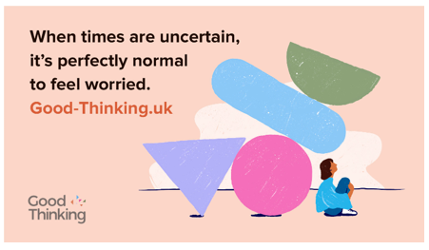  (Click the image to access the Google drive and download)
Feeling anxious or overwhelmed and not sure where to get help?  For advice and free NHS-approved apps and resources to help you deal with anxiety visit www.good-thinking.uk/anxiety.  We’ve got you. @GoodThinkingUK  #MentalHealthAwarenessWeek #ToHelpMyAnxiety | 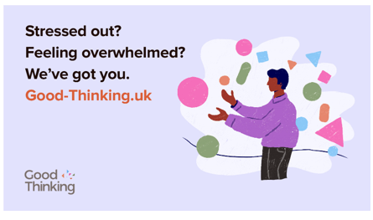  (Click the image to access the Google drive and download)
The theme of this year’s #MentalHealthAwarenessWeek is anxiety.  Understanding our triggers and recognising symptoms can be the first step to better #MentalHealth. Explore @GoodThinkingUK’s guide to the effects anxiety can have on your mind and body:  https://www.good-thinking.uk/symptoms-anxiety | 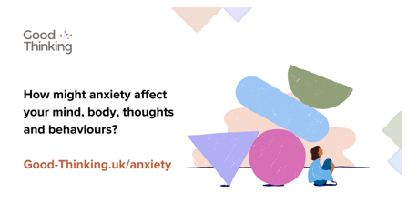  (Click the image to access the Google drive and download)
Apps are a great way to take care of your #MentalWellbeing whenever and wherever works best for you.  Check out @GoodThinkingUK’s range of free NHS-approved apps proven to help reduce anxiety and stress:  https://www.good-thinking.uk/free-apps-for  #MentalHealthAwarenessWeek #ToHelpMyAnxiety | 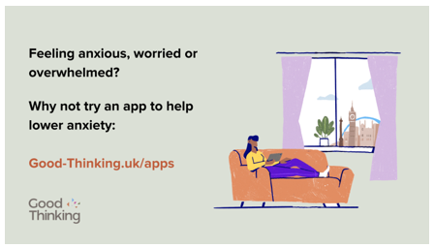  (Click the image to access the Google drive and download)
Feeling anxious? Why not try a workbook?  @GoodThinkingUK’s range of free workbooks combine expert advice with activities and exercises you can do at home to help you understand and manage symptoms of anxiety:  https://www.good-thinking.uk/workbooks  #MentalHealthAwarenessWeek #ToHelpMyAnxiety | 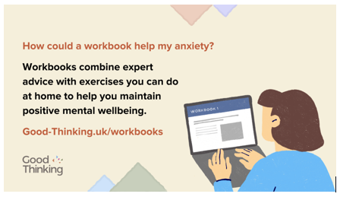  (Click the image to access the Google drive and download)

Digital and printable assets

We’ve developed a range of assets and resources that you can use to share the free NHS-approved Good Thinking tools with your network of contacts and stakeholders. These are available to download using the links below:

Digital assets

Anxiety graphics for Mental Health Awareness Week: https://drive.google.com/drive/u/1/folders/1KDmpPB2hUx_wj9As3wPTfkZw7R8QfLx1

Additional Good Thinking graphics which can be used on social media, in newsletters and other internal channels: https://drive.google.com/drive/folders/1A-QcbmAUo1Rbxi6IUAS8kYGzBxUlZm3Z?usp=sharing

PowerPoint slide deck that can be slotted into presentations or used for digital displays as appropriate: https://drive.google.com/drive/u/1/folders/1oMF7Tw8kWr4CMbV_xhsfFIZn2MPdURMa

Printable assets

Printable A4 posters, flyers and guides which can be displayed in communal areas:
- Poster 1
- Poster 2
- Poster 3
- Poster 4
- Postcard flyer
- Printable wellbeing guides
- Printable workbooks

Please do keep in touch for the latest updates from Good Thinking!

Sign up to our monthly newsletter and follow Good Thinking on social media to stay up to date on new advice and resources:

Facebook goodthinkinguk
LinkedIn goodthinkinguk
Instagram www.instagram.com/goodthinkinguk
Twitter @GoodThinkingUK

Your support in sharing the Good Thinking service is greatly appreciated. Please feel free to share this toolkit amongst your colleagues and networks as far and wide as possible.

