CHRIST (Deemed to be University)
Department of Computer Science
LAB EXERCISE – 2 | HTML5 APIs INTEGRATION
To develop a responsive web application using HTML5 semantic
elements, Tailwind CSS, JavaScript, and relevant HTML5 APIs based on
the selected domain requirements.

Project Title:
EcoCycle – E-Waste Collection Portal HTML5 API’s Integration
Domain:
Sustainability
Submitted By:
Sohom Chakraborty (Register No – 2647250)
Course:
Master of Computer Applications (MCA) [SECTION 1 MCA-B]
Academic Year:
2026
DOMAIN INFORMATION:
Domain:
Sustainability
Project Title:
EcoCycle – E-Waste Collection Portal
Problem Statement:
Develop an interactive and responsive E-Waste Collection Portal named EcoCycle using HTML5 semantic elements, Tailwind CSS, JavaScript, and HTML5 APIs. The application should promote sustainable e-waste management by allowing users to explore recycling services, schedule e-waste pickups, locate collection centers, upload images of electronic waste, access awareness content, and interact with various HTML5 API-based features.
Target:
To design and develop a responsive and user-friendly E-Waste Collection Portal that integrates multiple HTML5 APIs to enhance functionality, interactivity, and user engagement. The project aims to encourage responsible e-waste disposal and showcase the practical use of HTML5 technologies in solving sustainability-related challenges.

Expected Outcome:
- A fully responsive web application developed using Tailwind CSS.
- Successful integration of multiple HTML5 APIs.
- Improved user interaction through dynamic features and API-based functionalities.
- Enhanced awareness regarding sustainable e-waste management.
- Demonstration of modern front-end development concepts including responsive design, browser APIs, JavaScript event handling, and local data storage.
- A deployable and maintainable web application suitable for educational and sustainability initiatives.

- Source Code (index.html):

<!DOCTYPE html>
<html lang="en">
<head>
<meta charset="UTF-8">
<meta name="viewport" content="width=device-width, initial-scale=1.0">
<title>EcoCycle - E-Waste Collection Portal</title>

<script src="https://cdn.tailwindcss.com"></script>

<style>
html{
scroll-behavior:smooth;
}
@keyframes fadeIn{
from{
opacity:0;
transform:scale(0.9);
}

to{
opacity:1;
transform:scale(1);
}

}
.animate-fadeIn{
animation:fadeIn .3s ease;
}
</style>
</head>

<body class="bg-gray-100 text-gray-800">

<!-- ================= HEADER ================= -->

<header class="bg-green-700 text-white shadow-lg sticky top-0 z-50">

<nav class="max-w-7xl mx-auto px-6 py-4 flex justify-between items-center">

<h1 class="text-3xl font-bold">
♻ EcoCycle
</h1>

<ul class="hidden md:flex gap-6 font-medium">

<li>
<a href="#home"
class="hover:text-green-200 transition">
Home
</a>
</li>

<li>
<a href="#about"
class="hover:text-green-200 transition">
About
</a>
</li>

<li>
<a href="#services"
class="hover:text-green-200 transition">
Services
</a>
</li>

<li>
<a href="#gallery"
class="hover:text-green-200 transition">
Gallery
</a>
</li>

<li>
<a href="#apis"
class="hover:text-green-200 transition">
APIs
</a>
</li>

<li>
<a href="#contact"
class="hover:text-green-200 transition">
Contact
</a>
</li>

</ul>

<button
onclick="openModal()"
class="bg-white text-green-700 px-5 py-2 rounded-lg font-semibold hover:scale-105 hover:bg-green-100 transition duration-300">

Schedule Pickup

</button>

</nav>

</header>

<!-- ================= HERO SECTION ================= -->

<section id="home"
class="bg-gradient-to-r from-green-700 to-emerald-500 text-white">

<div class="max-w-7xl mx-auto px-6 py-24 flex flex-col md:flex-row items-center gap-10">

<div class="flex-1">

<h2 class="text-4xl md:text-6xl font-bold mb-6 leading-tight">

Recycle Electronics Responsibly

</h2>

<p class="text-lg mb-8">

Join EcoCycle and contribute to a cleaner environment
through responsible e-waste disposal and recycling.

</p>

<div class="flex flex-wrap gap-4">

<a href="#services"
class="bg-white text-green-700 px-6 py-3 rounded-lg font-semibold hover:scale-105 transition">

Get Started

</a>

<a href="#about"
class="border border-white px-6 py-3 rounded-lg hover:bg-white hover:text-green-700 hover:scale-105 transition">

Learn More

</a>

</div>

</div>

<div class="flex-1 overflow-hidden rounded-2xl shadow-2xl">

<img
src="https://images.unsplash.com/photo-1518770660439-4636190af475?auto=format&fit=crop&w=900&q=80"

class="w-full hover:scale-110 transition duration-700"

alt="E-Waste">

</div>

</div>

</section>

<!-- ================= ABOUT SECTION ================= -->

<section id="about" class="py-20">

<div class="max-w-6xl mx-auto px-6">

<h2 class="text-4xl font-bold text-center mb-8">

Why E-Waste Recycling Matters

</h2>

<p class="text-center text-gray-600 max-w-4xl mx-auto">

Electronic waste contains hazardous materials that can harm
the environment if disposed improperly. Responsible recycling
helps recover valuable resources while reducing pollution.

</p>

</div>

</section>

<!-- ================= BENEFITS SECTION ================= -->

<section class="pb-20">

<div class="max-w-6xl mx-auto px-6">

<div class="grid grid-cols-1 md:grid-cols-3 gap-8">

<div class="bg-white p-8 rounded-xl shadow-lg hover:-translate-y-2 hover:shadow-2xl transition">

<div class="text-5xl mb-4">🌍</div>

<h3 class="text-2xl font-semibold mb-3">

Environmental Protection

</h3>

<p>

Reduce pollution and protect ecosystems through
responsible disposal practices.

</p>

</div>

<div class="bg-white p-8 rounded-xl shadow-lg hover:-translate-y-2 hover:shadow-2xl transition">

<div class="text-5xl mb-4">🔋</div>

<h3 class="text-2xl font-semibold mb-3">

Resource Recovery

</h3>

<p>

Recover metals and reusable materials from
discarded electronics.

</p>

</div>

<div class="bg-white p-8 rounded-xl shadow-lg hover:-translate-y-2 hover:shadow-2xl transition">

<div class="text-5xl mb-4">♻️</div>

<h3 class="text-2xl font-semibold mb-3">

Sustainable Future

</h3>

<p>

Promote environmental sustainability and
responsible consumption.

</p>

</div>

</div>

</div>

</section>

<!-- ================= SERVICES ================= -->

<section id="services" class="bg-white py-20">

<div class="max-w-6xl mx-auto px-6">

<h2 class="text-4xl font-bold text-center mb-12">

Our Services

</h2>

<div class="grid grid-cols-1 md:grid-cols-3 gap-8">

<div class="bg-green-50 p-8 rounded-xl shadow hover:shadow-xl transition">

<h3 class="text-2xl font-semibold mb-3">

🚚 Doorstep Pickup

</h3>

<p>

Schedule electronic waste pickup from your home.

</p>

</div>

<div class="bg-green-50 p-8 rounded-xl shadow hover:shadow-xl transition">

<h3 class="text-2xl font-semibold mb-3">

📍 Collection Centers

</h3>

<p>

Locate nearby certified recycling facilities.

</p>

</div>

<div class="bg-green-50 p-8 rounded-xl shadow hover:shadow-xl transition">

<h3 class="text-2xl font-semibold mb-3">

🎁 Green Rewards

</h3>

<p>

Earn rewards for participating in recycling drives.

</p>

</div>

</div>

</div>

</section>

<!-- ================= IMPACT STATS ================= -->

<section class="py-20">

<div class="max-w-6xl mx-auto px-6">

<h2 class="text-4xl font-bold text-center mb-12">

Our Impact

</h2>

<div class="grid grid-cols-2 md:grid-cols-4 gap-6 text-center">

<h3 id="devicesCounter" class="text-4xl font-bold text-green-700">0</h3>
<p>Devices Recycled</p>

<h3 id="usersCounter" class="text-4xl font-bold text-green-700">0</h3>
<p>Users</p>

<h3 id="wasteCounter" class="text-4xl font-bold text-green-700">0</h3>
<p>E-Waste Collected</p>

<h3 id="carbonCounter" class="text-4xl font-bold text-green-700">0</h3>
<p>Carbon Reduction</p>

</div>

</div>

</section>
<section class="py-20 bg-green-50">

<div class="max-w-6xl mx-auto px-6">

<h2 class="text-4xl font-bold text-center mb-12">
Eco Dashboard
</h2>

<div class="grid md:grid-cols-4 gap-6">

<div class="bg-white p-6 rounded-xl shadow text-center">
<h3 class="text-3xl font-bold text-green-700" id="pickupCount">0</h3>
<p>Total Pickups</p>
</div>

<div class="bg-white p-6 rounded-xl shadow text-center">
<h3 class="text-3xl font-bold text-blue-700" id="rewardPoints">0</h3>
<p>Reward Points</p>
</div>

<div class="bg-white p-6 rounded-xl shadow text-center">
<h3 class="text-3xl font-bold text-purple-700">12 Tons</h3>
<p>Waste Collected</p>
</div>

<div class="bg-white p-6 rounded-xl shadow text-center">
<h3 class="text-3xl font-bold text-red-700">20%</h3>
<p>Carbon Saved</p>
</div>

</div>

</div>

</section>
<!-- ================= GALLERY ================= -->

<section id="gallery" class="bg-white py-20">

<div class="max-w-6xl mx-auto px-6">

<h2 class="text-4xl font-bold text-center mb-12">

Gallery

</h2>

<div class="grid grid-cols-1 md:grid-cols-3 gap-8">

<img
src="img1.jpg"
class="rounded-xl shadow-lg hover:scale-105 transition duration-500">

<img
src="img2.jpg"
class="rounded-xl shadow-lg hover:scale-105 transition duration-500">

<img
src="img3.webp"
class="rounded-xl shadow-lg hover:scale-105 transition duration-500">

</div>

</div>

</section>

<!-- ================= TYPOGRAPHY SECTION ================= -->

<section class="py-20 bg-gray-50">

<div class="max-w-4xl mx-auto px-6">

<div class="bg-white rounded-2xl shadow-lg p-8 md:p-12">

<h2 class="text-4xl font-bold text-center mb-8">

Understanding E-Waste Recycling

</h2>

<article class="space-y-6 text-gray-700 leading-8">

<p>
Electronic waste includes discarded electronic devices such as
mobile phones, batteries, chargers, laptops and computers.
</p>

<p>
Proper recycling helps recover valuable materials while reducing
environmental pollution and supporting sustainability initiatives.
</p>

<h3 class="text-2xl font-semibold">
Benefits of E-Waste Recycling
</h3>

<ul class="list-disc pl-6">
<li>Reduces pollution</li>
<li>Conserves natural resources</li>
<li>Promotes sustainability</li>
<li>Encourages responsible disposal</li>
</ul>

</article>

</div>

</div>

</section>

<!-- ================= HTML5 APIs START HERE ================= -->

<section id="apis" class="py-20 bg-green-700 text-white">

<div class="max-w-6xl mx-auto text-center">

<h2 class="text-5xl font-bold">

HTML5 APIs Integration

</h2>

<p class="mt-4">

Interactive Features Added

</p>

</div>
<button
onclick="sendNotification()"
class="bg-purple-700 text-white px-6 py-3 rounded-lg">

Enable Notifications

</button>
</section>
<!-- ===================================================== -->
<!-- 1. GEOLOCATION API -->
<!-- ===================================================== -->

<section class="py-20 bg-white">

<div class="max-w-5xl mx-auto px-6">

<div class="bg-gray-50 rounded-xl shadow-lg p-8">

<h2 class="text-3xl font-bold text-green-700 mb-4">
📍 Geolocation API
</h2>

<p class="mb-6 text-gray-600">
Find your current location and locate nearby e-waste collection centers.
</p>

<button
onclick="getLocation()"
class="bg-green-700 text-white px-6 py-3 rounded-lg hover:scale-105 transition">

Get My Location

</button>

<div id="locationResult"
class="mt-6 p-4 bg-white rounded-lg shadow">
Location will appear here...
</div>

</div>

</div>

</section>

<!-- ===================================================== -->
<!-- 2. LOCAL STORAGE API -->
<!-- ===================================================== -->

<section class="py-20 bg-gray-100">

<div class="max-w-5xl mx-auto px-6">

<div class="bg-white rounded-xl shadow-lg p-8">

<h2 class="text-3xl font-bold text-blue-700 mb-4">
💾 Local Storage API
</h2>

<p class="mb-6 text-gray-600">
Save your pickup address locally in the browser.
</p>

<input
type="text"
id="pickupAddress"
placeholder="Enter Pickup Address"
class="w-full border p-3 rounded-lg mb-4">

<div class="flex flex-wrap gap-4">

<button
onclick="saveAddress()"
class="bg-blue-600 text-white px-6 py-3 rounded-lg">

Save Address

</button>

<button
onclick="loadAddress()"
class="bg-gray-700 text-white px-6 py-3 rounded-lg">

Load Address

</button>

</div>

<div
id="savedAddress"
class="mt-5 p-4 bg-gray-50 rounded-lg">

Saved address will appear here.

</div>

</div>

</div>

</section>

<!-- ===================================================== -->
<!-- 3. FILE API -->
<!-- ===================================================== -->

<section class="py-20 bg-white">

<div class="max-w-5xl mx-auto px-6">

<div class="bg-gray-50 rounded-xl shadow-lg p-8">

<h2 class="text-3xl font-bold text-purple-700 mb-4">
📁 File API
</h2>

<p class="mb-6 text-gray-600">
Upload an image of your electronic waste item.
</p>

<input
type="file"
id="fileInput"
accept="image/*"
onchange="previewImage(event)"
class="mb-6">

<div>

<img
id="imagePreview"
class="rounded-xl shadow-lg max-h-96 hidden">

</div>

</div>

</div>

</section>

<!-- ===================================================== -->
<!-- 4. CANVAS API -->
<!-- ===================================================== -->

<section class="py-20 bg-gray-100">

<div class="max-w-5xl mx-auto px-6">

<div class="bg-white rounded-xl shadow-lg p-8">

<h2 class="text-3xl font-bold text-green-700 mb-4">
🎨 Canvas API
</h2>

<p class="mb-6 text-gray-600">
Drawing the EcoCycle logo using HTML5 Canvas.
</p>

<canvas
id="ecoCanvas"
width="700"
height="250"
class="border rounded-lg bg-white">
</canvas>

</div>

</div>

</section>

<!-- ===================================================== -->
<!-- 5. DRAG AND DROP API -->
<!-- ===================================================== -->

<section class="py-20 bg-white">

<div class="max-w-5xl mx-auto px-6">

<div class="bg-gray-50 rounded-xl shadow-lg p-8">

<h2 class="text-3xl font-bold text-orange-700 mb-4">
🖱️ Drag and Drop API
</h2>

<p class="mb-8 text-gray-600">
Drag electronic items into the recycling bin.
</p>

<div class="flex flex-wrap gap-6 mb-8">

<div
id="mobile"
draggable="true"
ondragstart="drag(event)"
class="bg-blue-500 text-white px-6 py-4 rounded-lg cursor-move">

📱 Mobile Phone

</div>

<div
id="battery"
draggable="true"
ondragstart="drag(event)"
class="bg-red-500 text-white px-6 py-4 rounded-lg cursor-move">

🔋 Battery

</div>

<div
id="laptop"
draggable="true"
ondragstart="drag(event)"
class="bg-green-500 text-white px-6 py-4 rounded-lg cursor-move">

💻 Laptop

</div>

</div>

<div
id="dropZone"
ondrop="drop(event)"
ondragover="allowDrop(event)"
class="border-4 border-dashed border-green-600 rounded-xl p-12 text-center text-xl bg-green-50">

♻️ Drop Items Here

</div>

</div>

</div>

</section>

<!-- ===================================================== -->
<!-- 6. AUDIO API -->
<!-- ===================================================== -->

<!-- AUDIO API -->

<section class="py-20 bg-gray-100">

<div class="max-w-5xl mx-auto px-6">

<div class="bg-white rounded-xl shadow-lg p-8">

<h2 class="text-3xl font-bold text-indigo-700 mb-4">
🎵 Audio API
</h2>

<p class="mb-6 text-gray-600">
Learn about sustainable recycling and effective e waste disposal through audio content.
</p>

<audio
id="ecoAudio"
controls
class="w-full mb-6">

<source
src="audio.mp3"
type="audio/mpeg">

</audio>

<div class="flex flex-wrap gap-4">

<button
onclick="playAudio()"
class="bg-green-600 text-white px-5 py-2 rounded">

Play

</button>

<button
onclick="pauseAudio()"
class="bg-red-600 text-white px-5 py-2 rounded">

Pause

</button>

<button
onclick="muteAudio()"
class="bg-gray-700 text-white px-5 py-2 rounded">

Mute

</button>

<button
onclick="unmuteAudio()"
class="bg-blue-600 text-white px-5 py-2 rounded">

Unmute

</button>

</div>

<div class="mt-6">

<label class="font-semibold">
Volume Control
</label>

<input
type="range"
min="0"
max="1"
step="0.1"
value="1"
oninput="changeVolume(this.value)"
class="w-full">

</div>

</div>

</div>

</section>

<!-- ===================================================== -->
<!-- 7. VIDEO API -->
<!-- ===================================================== -->
<!-- VIDEO API -->

<section class="py-20 bg-white">

<div class="max-w-5xl mx-auto px-6">

<div class="bg-gray-50 rounded-xl shadow-lg p-8">

<h2 class="text-3xl font-bold text-red-700 mb-4">
🎥 Video API
</h2>

<p class="mb-6 text-gray-600">
Watch an awareness video about recycling, effective disposal of E-Waste and sustainability.
</p>

<video
id="ecoVideo"
controls
class="rounded-xl shadow-lg w-full mb-6">

<source
src="video.mp4"
type="video/mp4">

</video>

<div class="flex flex-wrap gap-4">

<button
onclick="playVideo()"
class="bg-green-600 text-white px-5 py-2 rounded">

Play

</button>

<button
onclick="pauseVideo()"
class="bg-red-600 text-white px-5 py-2 rounded">

Pause

</button>

<button
onclick="fullscreenVideo()"
class="bg-purple-600 text-white px-5 py-2 rounded">

Fullscreen

</button>

<button
onclick="restartVideo()"
class="bg-orange-600 text-white px-5 py-2 rounded">

Restart

</button>

</div>

<div class="mt-6">

<label class="font-semibold">

Playback Speed

</label>

<select
onchange="changeSpeed(this.value)"
class="border p-2 rounded">

<option value="0.5">0.5x</option>
<option value="1" selected>1x</option>
<option value="1.5">1.5x</option>
<option value="2">2x</option>

</select>

</div>

</div>

</div>

</section>

<!-- ===================================================== -->
<!-- CLIPBOARD API -->
<!-- ===================================================== -->

<section class="py-20 bg-gray-100">

<div class="max-w-5xl mx-auto px-6">

<div class="bg-white rounded-xl shadow-lg p-8">

<h2 class="text-3xl font-bold text-pink-700 mb-4">
📋 Clipboard API
</h2>

<p class="mb-6 text-gray-600">
Copy pickup information with one click and paste as you like.
</p>

<input
type="text"
id="copyText"
value="EcoCycle Pickup Request Submitted Successfully"
class="w-full border p-3 rounded-lg mb-4">

<button
onclick="copyPickupText()"
class="bg-pink-600 text-white px-6 py-3 rounded-lg">

Copy Text

</button>

<div
id="copyStatus"
class="mt-4 text-green-700 font-semibold">
</div>

</div>

</div>

</section>
<!-- ===================================================== -->
<!-- CONTACT SECTION -->
<!-- ===================================================== -->

<section id="contact" class="py-20 bg-green-700 text-white">

<div class="max-w-5xl mx-auto px-6 text-center">

<h2 class="text-4xl font-bold mb-6">

Contact EcoCycle

</h2>

<p class="text-lg mb-8">

Join our mission to make e-waste disposal safer and more sustainable.

</p>

<div class="grid grid-cols-1 md:grid-cols-3 gap-8">

<div class="bg-green-600 p-6 rounded-xl shadow-lg">
<h3 class="text-2xl font-semibold mb-2">📧 Email</h3>
<p>support@ecocycle.com</p>
</div>

<div class="bg-green-600 p-6 rounded-xl shadow-lg">
<h3 class="text-2xl font-semibold mb-2">📞 Phone</h3>
<p>+91 9876543210</p>
</div>

<div class="bg-green-600 p-6 rounded-xl shadow-lg">
<h3 class="text-2xl font-semibold mb-2">📍 Location</h3>
<p>Bangalore, India</p>
</div>

</div>

</div>

</section>
<!-- ==========================================
SCHEDULE PICKUP MODAL
========================================== -->

<div
id="pickupModal"
class="fixed inset-0 bg-black bg-opacity-50 hidden items-center justify-center z-50">

<div
class="bg-white rounded-2xl shadow-2xl w-11/12 md:w-1/2 lg:w-1/3 p-8 relative animate-fadeIn">

<button
onclick="closeModal()"
class="absolute top-3 right-4 text-2xl font-bold text-gray-500 hover:text-red-600">

&times;

</button>

<h2 class="text-3xl font-bold text-green-700 mb-6 text-center">

♻ Schedule E-Waste Pickup

</h2>

<form id="pickupForm" class="space-y-4">

<input
type="text"
placeholder="Full Name"
class="w-full border p-3 rounded-lg">

<input
type="email"
placeholder="Email Address"
class="w-full border p-3 rounded-lg">

<input
type="tel"
placeholder="Phone Number"
class="w-full border p-3 rounded-lg">

<input
type="date"
class="w-full border p-3 rounded-lg">

<select
class="w-full border p-3 rounded-lg">

<option>Select E-Waste Type</option>
<option>Mobile Phone</option>
<option>Laptop</option>
<option>Battery</option>
<option>Computer Accessories</option>
<option>Mixed Electronics</option>

</select>

<textarea
rows="4"
placeholder="Pickup Address"
class="w-full border p-3 rounded-lg">
</textarea>

<button
type="button"
onclick="submitPickup()"
class="w-full bg-green-700 text-white py-3 rounded-lg hover:bg-green-800 transition">

Submit Pickup Request

</button>

</form>

</div>

</div>
<section class="py-20 bg-white">

<div class="max-w-6xl mx-auto px-6">

<h2 class="text-4xl font-bold text-center mb-12">

Recent Activities

</h2>

<div id="activityLog"
class="bg-gray-50 p-8 rounded-xl shadow">

No activities yet.

</div>

</div>

</section>
<!-- ===================================================== -->
<!-- FOOTER -->
<!-- ===================================================== -->

<footer class="bg-gray-900 text-white py-10">

<div class="max-w-6xl mx-auto px-6">

<div class="grid grid-cols-1 md:grid-cols-3 gap-10">

<!-- Logo and About -->

<div>

<h3 class="text-2xl font-bold mb-4">
♻ EcoCycle
</h3>

<p class="text-gray-400">
Promoting sustainable e-waste management through technology,
awareness, and responsible recycling practices.
</p>

</div>

<!-- Quick Links -->

<div>

<h3 class="text-xl font-semibold mb-4">
Quick Links
</h3>

<ul class="space-y-2 text-gray-400">

<li>
<a href="#home" class="hover:text-white transition">
Home
</a>
</li>

<li>
<a href="#about" class="hover:text-white transition">
About
</a>
</li>

<li>
<a href="#services" class="hover:text-white transition">
Services
</a>
</li>

<li>
<a href="#gallery" class="hover:text-white transition">
Gallery
</a>
</li>

<li>
<a href="#apis" class="hover:text-white transition">
HTML5 APIs
</a>
</li>

<li>
<a href="#contact" class="hover:text-white transition">
Contact
</a>
</li>

</ul>

</div>

<!-- Contact -->

<div>

<h3 class="text-xl font-semibold mb-4">
Contact
</h3>

<p class="text-gray-400">
📧 ecocycle@example.com
</p>

<p class="text-gray-400 mt-2">
📞 +91 98765 43210
</p>

<p class="text-gray-400 mt-2">
📍 Bangalore, India
</p>

</div>

</div>

<hr class="border-gray-700 my-8">

<div class="text-center text-gray-500">

© 2026 EcoCycle | E-Waste Collection Portal | Developed using HTML5, Tailwind CSS, HTML5 APIs, Javascript

</div>

</div>

</footer>

<!-- ===================================================== -->
<!-- JAVASCRIPT SECTION -->
<!-- ===================================================== -->

<script>

/* ==========================================
GEOLOCATION API
========================================== */

function getLocation(){

const output = document.getElementById("locationResult");

if(navigator.geolocation){

navigator.geolocation.getCurrentPosition(

function(position){

output.innerHTML = `
<strong>Latitude:</strong> ${position.coords.latitude}<br>
<strong>Longitude:</strong> ${position.coords.longitude}
`;

},

function(){

output.innerHTML =
"Unable to retrieve location.";
}

);

}

else{

output.innerHTML =
"Geolocation not supported.";

}

}

/* ==========================================
LOCAL STORAGE API
========================================== */

function saveAddress(){

const address =
document.getElementById("pickupAddress").value;

localStorage.setItem(
"pickupAddress",
address
);

alert("Address Saved Successfully!");

}

function loadAddress(){

const saved =
localStorage.getItem("pickupAddress");

document.getElementById(
"savedAddress"
).innerHTML =
saved || "No address saved.";

}

/* ==========================================
FILE API
========================================== */

function previewImage(event){

const file =
event.target.files[0];

if(file){

const reader =
new FileReader();

reader.onload =
function(e){

const img =
document.getElementById(
"imagePreview"
);

img.src =
e.target.result;

img.classList.remove(
"hidden"
);

};

reader.readAsDataURL(file);

}

}

/* ==========================================
CANVAS API
========================================== */

window.onload = function(){

const canvas =
document.getElementById(
"ecoCanvas"
);

const ctx =
canvas.getContext("2d");

/* Green Circle */

ctx.beginPath();

ctx.arc(
120,
120,
70,
0,
Math.PI * 2
);

ctx.fillStyle =
"#16a34a";

ctx.fill();

/* White Recycling Symbol */

ctx.fillStyle =
"white";

ctx.font =
"50px Arial";

ctx.fillText(
"♻",
95,
140
);

/* EcoCycle Text */

ctx.fillStyle =
"#166534";

ctx.font =
"bold 40px Arial";

ctx.fillText(
"EcoCycle",
240,
135
);

};

/* ==========================================
DRAG AND DROP API
========================================== */

function allowDrop(event){

event.preventDefault();

}

function drag(event){

event.dataTransfer.setData(
"text",
event.target.id
);

}

function drop(event){

event.preventDefault();

const data =
event.dataTransfer.getData(
"text"
);

const item =
document.getElementById(
data
);

event.target.appendChild(
item
);

}

/* ==========================================
CLIPBOARD API
========================================== */

function copyPickupText(){

const text =
document.getElementById(
"copyText"
).value;

navigator.clipboard
.writeText(text)
.then(function(){

document.getElementById(
"copyStatus"
).innerHTML =
"✔ Text copied successfully!";

});

}
/* ==========================================
MODAL FUNCTIONS
========================================== */

function openModal(){

document
.getElementById("pickupModal")
.classList.remove("hidden");

document
.getElementById("pickupModal")
.classList.add("flex");

}

function closeModal(){

document
.getElementById("pickupModal")
.classList.add("hidden");

document
.getElementById("pickupModal")
.classList.remove("flex");

}

function submitPickup(){

let pickups=
localStorage.getItem("pickups");

pickups=pickups?parseInt(pickups):0;

pickups++;

localStorage.setItem("pickups",pickups);

document.getElementById(
"activityLog"
).innerHTML+=
"<p>✔ Pickup Scheduled Successfully</p>";
let points=
localStorage.getItem("points");

points=points?parseInt(points):0;

points+=50;

localStorage.setItem("points",points);

document.getElementById("rewardPoints").innerText=points;

alert(
"Pickup Scheduled Successfully!\nReward Points +50"
);

closeModal();

}
/* ==========================================
AUDIO API FUNCTIONS
========================================== */

const audio =
document.getElementById("ecoAudio");

function playAudio(){
audio.play();
}

function pauseAudio(){
audio.pause();
}

function muteAudio(){
audio.muted = true;
}

function unmuteAudio(){
audio.muted = false;
}

function changeVolume(value){
audio.volume = value;
}

/* ==========================================
VIDEO API FUNCTIONS
========================================== */

const video =
document.getElementById("ecoVideo");

function playVideo(){
video.play();
}

function pauseVideo(){
video.pause();
}

function restartVideo(){

video.currentTime = 0;
video.play();

}

function fullscreenVideo(){

if(video.requestFullscreen){

video.requestFullscreen();

}

}

function changeSpeed(speed){

video.playbackRate = speed;

}
function animateCounter(id,target){
let count=0;
const element=document.getElementById(id);
const speed=target/100;
const interval=setInterval(()=>{
count+=speed;
if(count>=target){
count=target;
clearInterval(interval);
}
element.innerText=Math.floor(count);
},20);}
animateCounter("devicesCounter",15000);
animateCounter("usersCounter",7500);
animateCounter("wasteCounter",12);
animateCounter("carbonCounter",20);
function sendNotification(){
if(Notification.permission==="granted"){
new Notification(
"EcoCycle Pickup Reminder"
);
}
else{
Notification.requestPermission()
.then(permission=>{
if(permission==="granted"){
new Notification(
"Notifications Enabled"
);}});}}
</script></body>
</html>

- Screenshots (API Integrations):

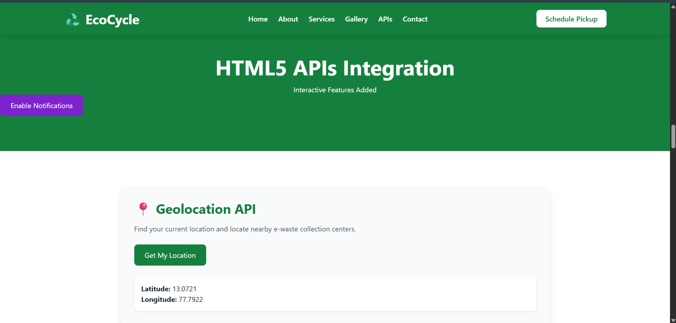

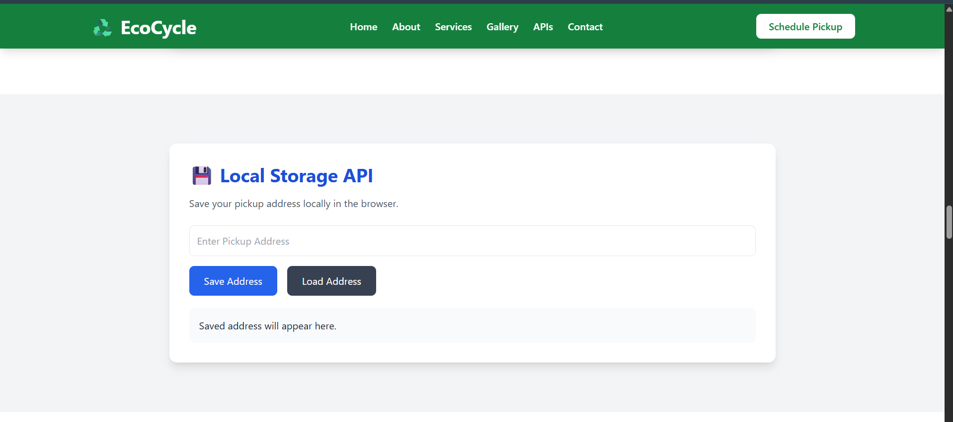

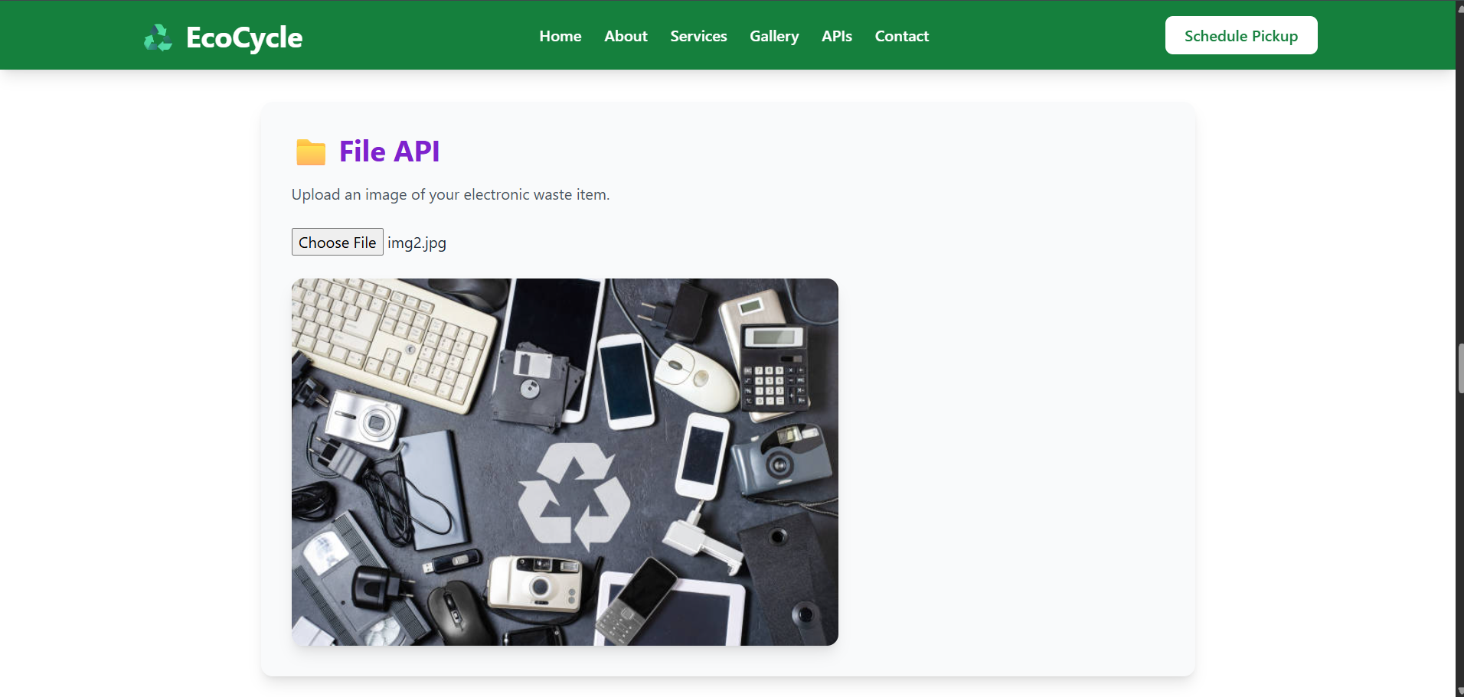

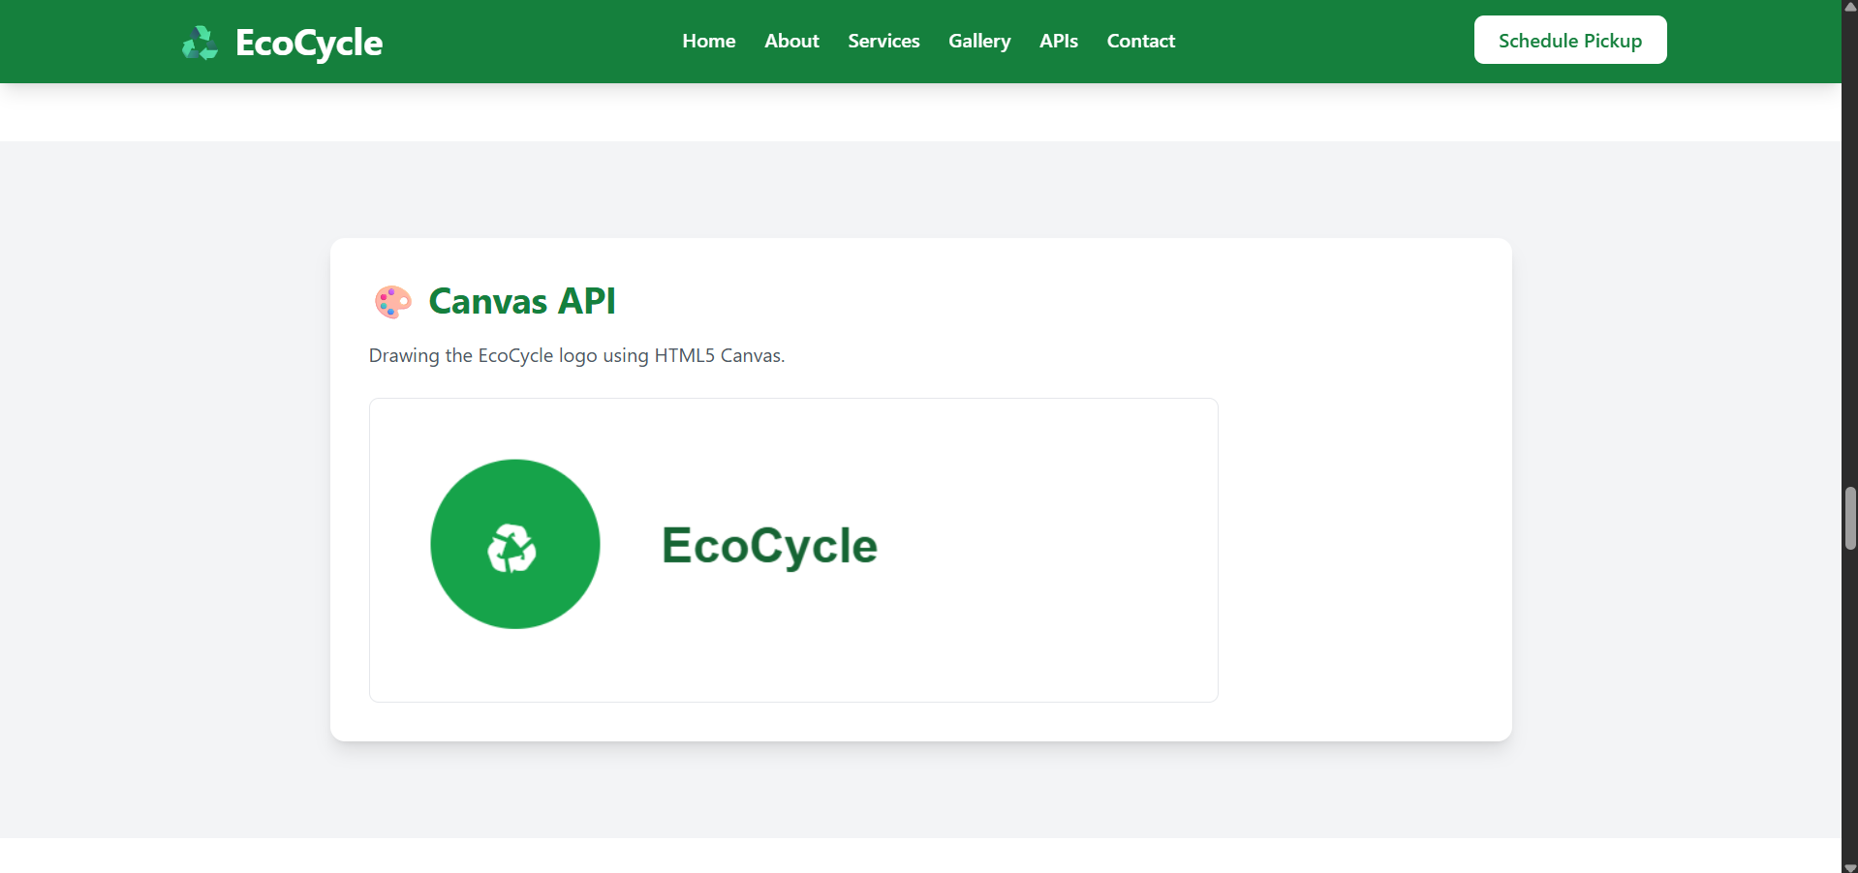

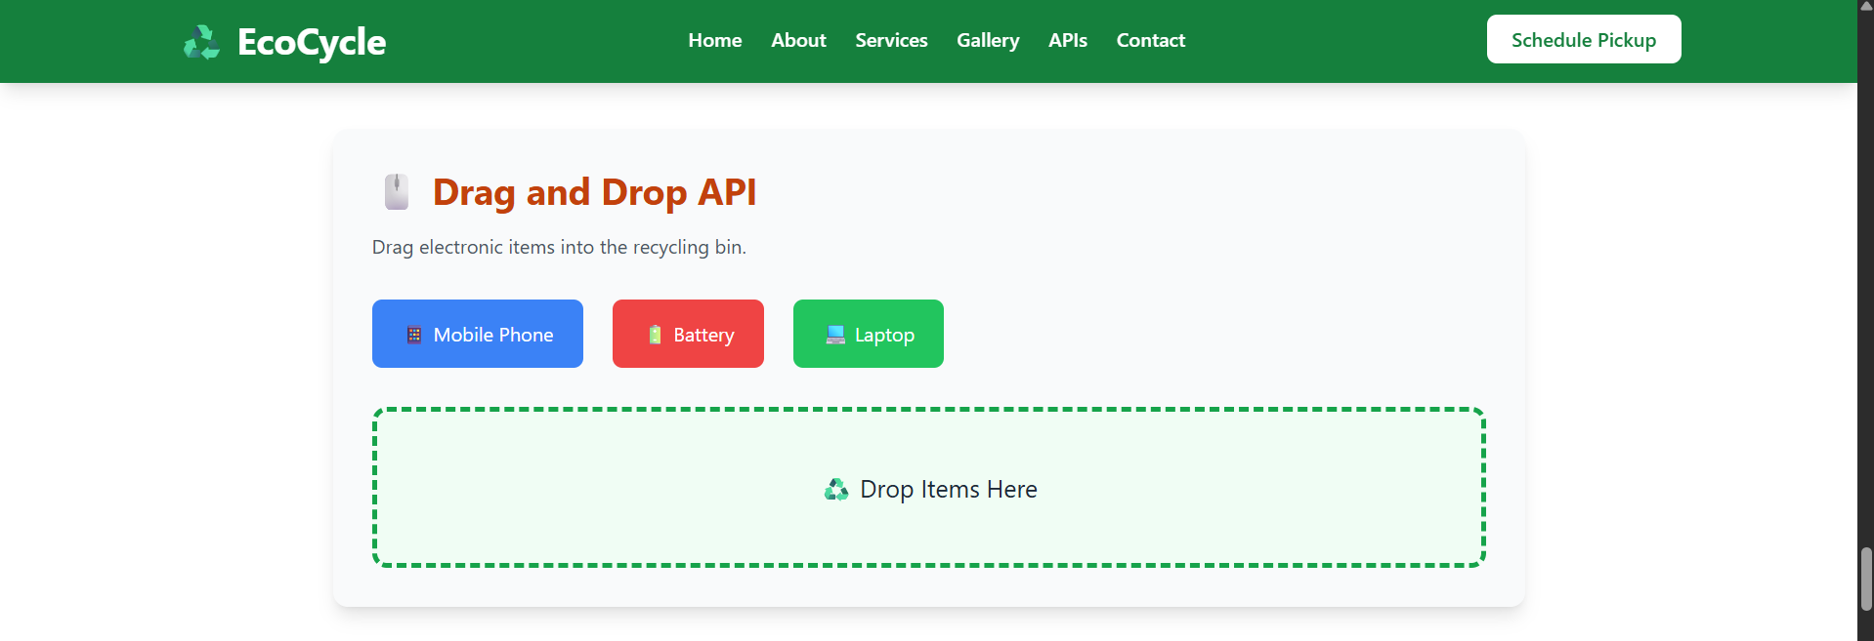

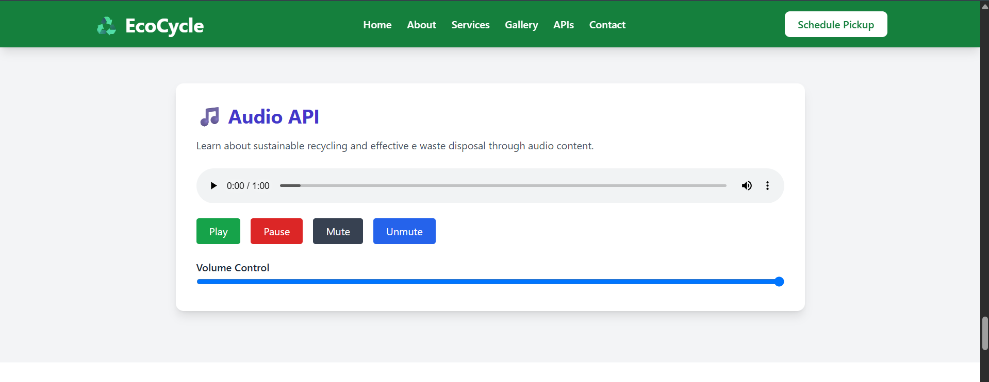

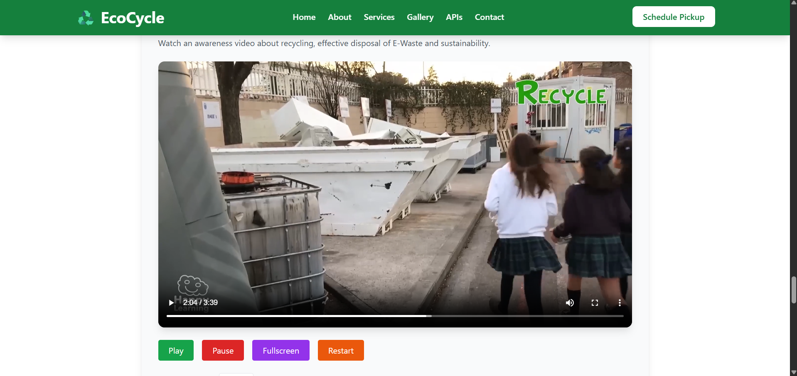

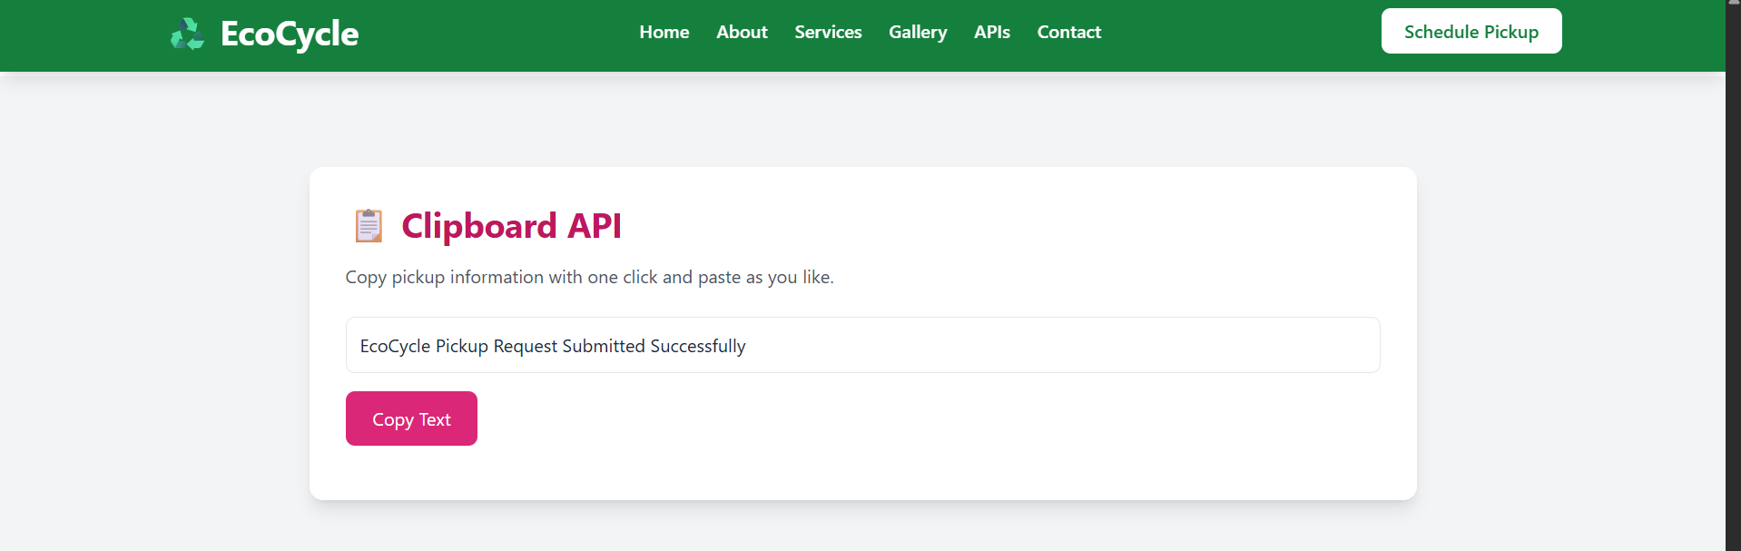

3. HTML5 APIs Used
API | Purpose
Geolocation API | Detect user location and display coordinates
Local Storage API | Save pickup addresses locally in browser
File API | Upload and preview e-waste images
Canvas API | Draw EcoCycle logo dynamically
Drag and Drop API | Simulate e-waste recycling interaction
Audio API | Play recycling awareness audio
Video API | Display awareness videos with controls
Clipboard API | Copy pickup-related information
Total APIs Used: 8

- GitHub Repository Link (GitHub Repository URL)
Repository Name:
FSD_LAB-2_EcoCycle_API
Repository Link:
https://github.com/sohom09/FSD_LAB-2_EcoCycle_API.git
Deployment Link (Through Vercel):
https://fsd-lab-2-eco-cycle-api.vercel.app/
- AI Usage Declaration (AI Tools and Purpose of usage)
AI Tool Used: ChatGPT
Purpose of Usage:
- Understanding Tailwind CSS concepts and utility classes.
- Assistance in designing a responsive webpage layout.
- Guidance on implementing HTML5 APIs using JavaScript.
- Code optimization and debugging support.
- Understanding semantic HTML structure.
- Learning responsive design principles.
- Preparing documentation, GitHub README, and viva preparation materials.

