A Major Project Report

( ETMJ-100 ) on

**ENVIROMENTAL DISASTER MONITORING IN HIGH-SPEED-RAILWAY IoT**

Submitted to

Amity University Kolkata



In partial fulfilment of the requirements for the award of the degree of

**Bachelors of Computer Application**

By

**Sohon Kumar Das ( A91404819011 )**

Under the guidance of

**Dr. Abhijit Paul**

**Assistant Professor & Program Leader**

**Amity Institute of Information Technology**

DEPARTMENT OF INFORMATION TECHNOLOGY

AMITY INSTITUTE OF INFORMATION TECHNOLOGY

AMITY UNIVERSITY KOLKATA

KOLKATA ( W.B )

2022

**DECLARATION**

I, SOHON KUMAR DAS, a student of Bachelor of Computer Application with the Enrolment Number A91404819011 do hereby declare that the seminar titled “ENVIROMENTAL DISASTER MONITORING IN HSR-IoT” which is submitted by me to Department of Information Technology, Amity Institute of Information Technology, Amity University Kolkata, West Bengal, in partial fulfilment of requirement for the award of the degree of Bachelor of Computer Application, has not been previously formed the basis for the award of any degree, diploma or other similar title or recognition.

Kolkata

Date:

Sohon Kumar Das

(A91404819011)

**CERTIFICATE**

On the basis of declaration submitted by Sohon Kumar Das, student of Bachelor of Computer Application with the Enrolment Number A91404819011, I hereby certify that the seminar titled “ENVIROMENTAL DISASTER MONITORING IN HSR-IoT” which is submitted to Department of Information Technology, Amity Institute of Information Technology, Amity University Kolkata, West Bengal, in partial fulfilment of the requirement for the award of the degree of Bachelor of Computer Application , is an original contribution with existing knowledge and faithful record of work carried out by him/them under my guidance and supervision. To the best of my knowledge this work has not been submitted in part or full for any Degree or Diploma to this University or elsewhere.

Kolkata

Date:

Dr. Abhijit Paul

Assistant Professor & Program Leader

DEPARTMENT OF INFORMATION TECHNOLOGY

AMITY INSTITUTE OF INFORMATION TECHNOLOGY

AMITY UNIVERSITY KOLKATA

KOLKATA (W.B)

**AKNOELEDGEMENT**

I would like to thank Dr. Abhijit Sir for his guidance and kind co- operation in giving me this major work. He has been a constant support on the same in thick and thins every time.

I would also like to thank my senior, Priyadarshi Guha for his kind support throughout the project. He has helped me in gaining a lot of knowledge by researching for me.

I would also like to thank my parents without whose support this would never have been possible or completely unattainable.

I would also like to thank my senior Sukanya Das, for her help and support throughout the project. She was there to help me whenever I seeked.

Lastly, I would also like to thank Google and IEEE. Without the help of these, this would have been a nightmare.

**FEEDBACK BY EXAMINERS**

1. **COMMENT FROM SEMINAL GUIDE**
2. **COMMENT FROM EXTERNAL EXAMINER**

**CONTENTS**

**ITEMS PAGE NO.**

1. Declaration 1

2. Certificate 2

3. Acknowledgement 3

4. Feedback By Examiners 4

5. Contents 5

6. Abstract 6

7. Introduction 7

8. Role of IoT in HSR 9

9. Tools Used 10

10. Role of technology in disaster management 11

11. Comprehensive natural disaster monitoring

System for safe operation of HSR 13

12. Parameters for Performance Evaluation of Networks 14

13. IoT Based Disaster Management 15

14. Disaster Management System for Rainfall 16

15. Disaster Management System for Temperature 19

16. Disaster Management System for Earthquake 22

17. Disaster Management System for Flood 25

18. Disaster Management System for Landslide 29

19. Conclusion 33

**ABSTRACT**

The proposed disaster management system prototype leverages the Internet of Things (IoT) to detect atmospheric changes and upload the data to a cloud server. IFTTT SaaS sends out alerts through Gmail and Telegram when catastrophic occurrences occur. Actuators such as fans and sprinklers are used to prevent calamities such as fire and severe heat. The Government of India's Smart Cities Mission is an urban redevelopment and retrofitting programme with the goal of developing 100 cities across the country that are both citizen-friendly and sustainable. Natural or man-made disasters have widespread human, material, economic, and environmental consequences that must be addressed. This proposed system uses interconnected smart modules to enable centralised data acquisition using Internet of Things ( IOT ) and Wireless Sensor Networks ( WSN ) sensing and communication technologies to coordinate disaster management at the national and local levels in collaboration with relevant agencies and raise disaster risk awareness in real time. This system can be operated and monitored from a distance, and it can provide real-time notifications based on data analysis and processing without the need for human participation. The information gathered can be used to forecast future dangers. Internet of Things, Disaster Management, and IFTTT are all index terms.

**INTRODUCTION**

The high-speed railway ( HSR ) has emerged as the primary mode of transportation for the development of the world's transportation industry, ushering humanity into a new era as a safe, dependable, fast, comfortable, large carrying capacity, low-carbon, and environmentally friendly mode of transportation. Natural disasters such as gales, rainstorms, heavy snow, earthquakes, geology disasters, thunder, and lightning have a low probability but cause considerable damage in the safe functioning of HSR. HSR's early warning system for natural disasters requires extensive research to ensure its social and economic viability.

Many countries around the world place a high priority on disaster prevention and HSR safety monitoring. Some industrialised countries, the most noteworthy of which are Japan and France, have performed research in the field of railway disaster prevention and safety monitoring for many years, with favourable results. Along the Shinkansen line, Japan has deployed surveillance equipment in areas where foreign materials and natural disasters are likely to occur. The foreign substance is first relayed back to the control centre via the monitoring system, ensuring that the system is extremely secure. Shibayama offered an overview of Japan's national-level transportation planning schemes and addressed how they interact with natural disaster recovery. Because France is situated at the confluence of two continental plates, earthquakes and other natural calamities are common, French engineers have erected protection nets at all HSR tunnel openings and points where foreign bodies frequently invade the limit. To receive signals, the protective nets use twin cable sensors, which can monitor the safety of railway traffic. When the train is in danger, it might be switched off to preserve the safety of the passengers. Despite the fact that research on the natural environment's impact on HSR began earlier in other countries, China's early warning system for natural disasters on HSR trains is continually being developed, ensuring the trains' safety. The Beijing-Tianjin Intercity Transportation System has set up a disaster monitoring system, including a monitoring subsystem for wind, rain, snow, and other disasters, as well as reserving other essential interfaces for earthquake and foreign body incursion monitoring at a later time. A catastrophe prevention and safety monitoring system, consisting of monitoring equipment and accompanying monitoring units, is installed on the Wuhan-Guangzhou HSR. Along the railway, wind, rain, and foreign substance incursion monitoring equipment is deployed. However, studies suggest that most HSR detection systems in China lack an early warning capacity for earthquakes and typhoons. Because the rainfall alarm is sensitive to train vibration, even if filtering processes are used, vibration cannot be prevented in some lines with large vibration amplitude, and the rainfall value alarm will occur even if there is no rain. As a result, the seismic warning system for HSR safe operation will be investigated in this research.

The support vector machine (SVM) was introduced by Cortes, C., et al. as a revolutionary universal machine learning approach based on statistical theory and structural risk minimization concepts. The least square support vector machine ( LSSVM ) replaces the insensitive loss function in classic SVM with a quadratic loss function. As a result, the typical vector machine's quadratic programming problem is changed into a problem of solving linear equations, which can increase the model's accuracy. As a result, this article examines early warning of natural disasters in the safe operation of the HSR, mostly through real-time monitoring of natural disasters and emergencies that affect train operating safety, using SVM based on two multiplications. In addition, the paper compiles data from various monitoring devices in order to achieve distributed acquisition, centralised management, and comprehensive application of HSR monitoring data, as well as a thorough understanding of natural disaster dynamics and the provision of timely and accurate disaster alarm and early warning functions. The study's findings recommend quick emergency measures based on the severity of the disaster in order to decrease or eliminate natural disaster losses, prevent future catastrophes, and provide a theoretical framework for the HSR's safe operation and protection. It also comprises a database for modifying the HSR operation plan, issuing traffic control, emergency rescue, maintenance, and other responsibilities, making it a critical component of the HSR transportation system.

**Role of IoT in HSR**

The HSR IoT is designed to boost industrial efficiency while reducing labour intensity and ensuring operational safety. The following are the functions of HSR IoT:

* Transportation safety that is digitalized: - HSR physical information is converted into digital data by technologies in order to realise HSR's detailed assessment and judgement, equipment, operators, and environmental factors, among others, and to be aware of the current status of all linkages and elements, HSR mobility, laying the groundwork for the future, and safe and efficient transportation management.
* Interconnected Networks: - Things are intelligently connected using HSR IoT solutions. It develops an interactive system of people, things, ideas, and the environment that generates data and establishes a relationship between people, objects, and the environment. This improves the safety and dependability of the train system, as well as its timely and effective operation, maintenance, and communication. It also provides passengers with high-quality, interactive information through a network of integrated construction, operation, and maintenance services, as well as mobile services and maintenance.
* Services for intelligent operations: - By combining publicly available data, intelligent monitoring, augmented reality, perception, and technology for video understanding and fault prediction, HSR IoT necessitates massive data, artificial intelligence, and microservice architecture with other technologies. This is capable of providing comprehensive and extensive information, accurate forecasts, decision-making, and service recommendations. This should result in proactive safety prevention and control, maintenance, and smart operations management, as well as anticipatory operation and intelligent HSR travel services.

**Tools Used**

Proteus: - Proteus Design Set is a proprietary software tool suite for electronic design automation. Electronic design experts and technicians use the programme to develop schematics and electronic prints for manufacturing printed circuit boards.

It was created by Labcenter Electronics Ltd in Yorkshire, England, and is accessible in English, French, Spanish, and Chinese.

PC B, the initial version of what is now the Proteus Design Suite, was built for DOS in 1988 by the company's chairman, John Jameson. In 1990, Schematic Capture support was added, followed by a migration to the Windows environment shortly after.

Mixed-mode mode SPICE simulation was originally implemented in Proteus in 1996, followed by microcontroller simulation in 1998.

In 2002, shape-based auto routing was enabled, and 3D Board Visualisation was added in 2006.

In 2011, a specialised IDE for simulation was added, and in 2015, MCAD import / export was added.

In 2017, support for high-speed design was added.

Feature-led product releases are usually released every two years, whereas maintenance-based service packs are released as needed.

**Role of technology in disaster management**

There is a large body of literature available on field studies of disaster relief activities ( Jiang et al. 2004 ). These studies included observation of training exercises, first hand experience of genuine occurrences, conducting interviews, and recursive development of original prototypes as their technique. Kyng et al. ( 2006 ) recognised issues linked to victims, experts, and IT. The study's goal was to come up with a way to identify and monitor patients in an emergency situation. To address the stated issues, the authors developed a design paradigm and studied many prototypes to develop guidelines for the implementation of such systems. Medical equipment communicating over wireless medium, such as a wireless bio-monitoring system, is required to address victim-related difficulties. The experts' concerns led to the creation of a real-time video model that uses a video camera, GPS, and digital compass to provide situational awareness. IT related challenges suggest that gadgets designed to manage emergency reactions should also be used for daily work, otherwise experts may fail to use them successfully.

In the emergency medical service, Kristensen ( 2006 ) stressed the use of participatory design. This is a collaborative and recursive process in which practitioners and researchers collaborate to create and evaluate a system. As a result of this study, a set of concepts for aiding emergency medical services was developed. Two of the proposed ideas, one for remote access display and the other for wireless bio-monitors, are important for our work. These paradigms' key objectives are enabling remote access to data acquired by various sensors and inferring situational awareness regarding victims and accessible relief resources. In the context of emergency relief services, Jiang et al. ( 2004 ) identified the following design issues: situation assessment using multiple sources of information, resource allocation, resource and people accountability, and communication assistance. To address the stated design difficulties, the authors proposed a conceptual prototype. Their findings revealed the following: first, in the event of a disaster, efforts should be focused on people and the environment; and second, redundancy is a critical design element for increasing communication reliability and ensuring efficient safety.

Several studies in the literature have examined the need of proper situation awareness and appropriate decision-support systems for addressing emergency circumstances in catastrophes ( Anparasan and Lejeune 2017 ). This emphasised the importance of developing emergency-response information systems ( EISs ). EIS should be able to provide appropriate situational knowledge to first responders so that the relief effort can be better planned. The lack of situational awareness and intelligent decision support systems can be blamed for human decision-making mistakes during the terrible events of Bhopal ( Endsley 1999 ) and the deaths of rescue personnel after 9 / 11 ( Son et al. 2007 ). The importance of computerised assistance systems for emergency decision making was investigated by Dai et al. ( 1994 ). A number of research studies in the area of EIS development have explored the importance of boosting first responder situational awareness in order to improve their ability to make appropriate decisions. Important research ( Dai et al. 1994 ) that offered technological models for disaster relief response have emphasised the ability of information support to provide insight into the circumstances faced by responders so that an effective EIS can be designed. However, unlike the information system for office usage, such systems do not require simply static information. Because these EISs are designed to operate in a highly dynamic environment, they require real time information regarding disaster impacts as well as the locations of individuals and resources assigned to relief efforts.

**Comprehensive natural disaster monitoring system**

**for safe operation of HSR**

A comprehensive natural disaster monitoring system for safe HSR operation should be built to prevent possible natural catastrophes (such as wind, rain, lightning, temperature, debris flow, earthquake, and others) from affecting the normal operation of the HSR. Wind, rain, lightning, temperature, geological disasters, earthquakes, and other natural calamities all have early warning systems. On-site monitoring sites along the line (wind, rain, snow, earthquake, geology disaster, and lightning disaster monitoring equipment), an early warning unit, an early warning centre, and the related system interface make up HSR's natural disaster early warning system. It provides real-time monitoring, alarm, and early warning features for natural disasters and emergencies on the HSR, allowing for emergency disaster disposal and catastrophe minimization to avoid subsequent disasters. The early warning system's principal functions include real-time monitoring, alert speed restriction prompting, emergency disposal, and query and statistics functions, among others. This enables data interchange and interconnection between each disaster monitoring system, as well as data sharing with adjacent departments' disaster monitoring and alarm information and related systems both inside and outside the HSR.

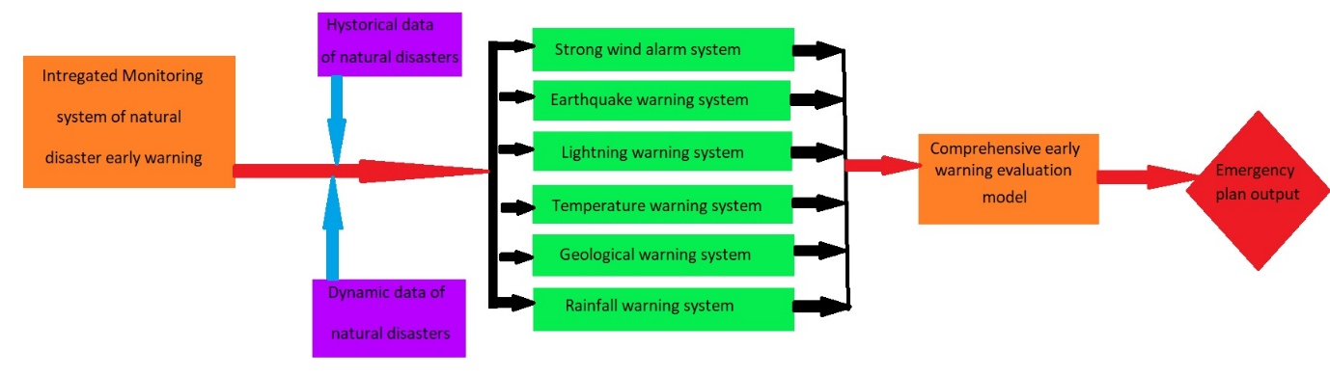

The HSR network layout, emergency response equipment selection, HSR emergency monitoring system setup, emergency response equipment selection, and an emergency response monitoring system are all part of the comprehensive monitoring system. The system may share and exchange relevant basic data as well as monitoring data. Relevant staff can supervise and guide the operation of the disaster prevention and safety early warning system for HSR lines, as well as monitor and alarm natural disasters and equipment application status. It can provide decision support services for the creation of an early warning system for HSR disaster prevention by analysing HSR disaster monitoring data.

**Parameters for Performance Evaluation of Networks**

Many indicators, such as Packet Delivery Ratio ( PDR ), Routing Overhead, End to End Delay ( E2E delay ), Packet Loss Ratio ( PLR ), average energy consumption, and average throughput, can be used to assess overall network performance.

* PDR: - It is defined as the ratio of the number of packets sent by the source node to the number of packets received by the destination node. The value of PDR can be calculated using the equation below.

PDR ( % )= ( ∑ No. of packets received / ∑ No. of packets sent ) x 100

* Routing Overhead: - Routing overhead is the total amount of routing (control) packets generated by the routing protocol during simulation. The overhead routing value can be calculated using the equation below.

Routing Overhead= No. of routing packets / ( No. of routing packets + No. of data packets sent )

* E2E Delay: - The average time it takes for data packets to be successfully transported from source to destination across a network.

E2E Delay ( sec )= ∑ ( arrival time sent time ) / ∑ No. of packets

* PLR: - The difference between the number of packets sent and the number of packets received divided by the total number of packets sent is the ratio.

PLR ( % )= ( ( No. of packets sent-No. of packets received ) / No. of packets sent ) x 100

* Average Energy Consumption: - It's the ratio of a network node's overall energy consumption to the beginning energy available.

Average Energy Consumption= ∑ Energy consumed by each node / Initial Network Energy

* Average Throughput: - It's calculated as the average ratio of correctly received data packets to the overall time spent on the simulation. The average throughput can be calculated using the calculation below.

Average Throughput= No. of Bytes received x 8 x Simulation time x 1000kbps

**IoT Based Disaster Management**

The movement of Asian countries toward smart cities and digitization has been visible in recent days. The historical vulnerability of India cannot be overstated. Earthquakes threaten 57 percent of the earth's surface. Twelve percent of the system is vulnerable to extreme earthquakes, sixty-eight percent of the area is vulnerable to drought, twelve percent of the forest ecosystem is vulnerable to collapse, eight percent of the land is vulnerable to typhoons, and many Asian cities are vulnerable to chemical, agricultural, and artificial hazards. Disaster management is a term used to describe a situation that has the potential to significantly disrupt a community's social information. We may not be able to completely prevent harm through disaster management, but we may reduce the risk by providing early warning. Natural and man-made disasters are the two types of disasters. Earthquakes, landslides, floods, stream erosion, cyclones, tsunamis, and fire are examples of natural catastrophes. Nuclear, chemical, mining, and biological disasters are all examples of artificial disasters. The Internet of Things (IOT) is a relatively new connectivity model that envisions a near future in which everyday objects are equipped with microcontrollers, transmitting data transceivers, and appropriate protocol stacks that allow them to interact and transform an important part of the Internet to a corresponding degree. As a result, the IOT framework aims to make the web more immersive and omnipresent. To effectively deal with potentially disastrous events, knowledge must be shared via exchanging expertise and/or experience and organising acts, decisions, and activities, for example. Furthermore, during the associate degree crises, specific abilities and competence had to be unified in order to carry out difficult operations like evacuating a crisis zone and completing procedures by actuators. Foul management is aided by the lack of interconnected channels and transportation infrastructure to aid in the development of knowledge.

The study is centered on numerous areas of disaster planning, with an emphasis on disaster management in the service, volcanic, floods, forest fires, landslides, earthquakes, residential, and agricultural sectors. The victim's location and positioning are also investigated in this part. Finally, there have been debates concerning the terrorist incident and its aftermath.

**Disaster Management Systems for Rainfall**

A rain gauge is the most important item in the rainfall monitoring system since it collects local rainfall data.

Continuous severe rain or rainstorms may cause HSR subgrade collapse or debris flow dangers, which could jeopardise the HSR's safe operation. Passive monitoring and alert, as well as the HSR rainfall warning system, are often unnecessary for ballastless track and HSR with a high share of bridges and tunnels.

**Proposed Model**

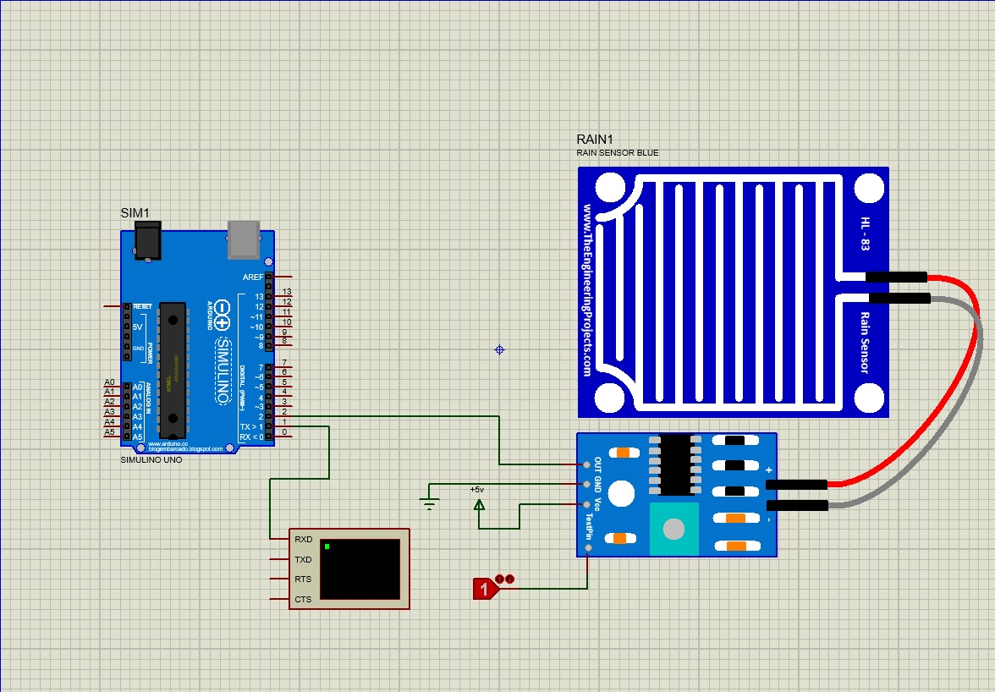

Result Analysis

From the above experimentation the result obtained can be interpreted as first, when it rains If rain falls on the Rain Sensor, the senser will send a signal to the device, which can be shown on the screen to show whether or not rain is falling. If there is no rain, it will display "No Rain," and if there is rain, it will display "Its Raining."

Devices Used: - 1 ) SIMULINO UNO

2 ) RAIN SENSOR

3 ) LOGICSTATE

Terminals Used: - 1 ) POWER

2 ) GROUND

Instruments Used: - 1 ) VIRTUAL TERMINAL

**Code Snippet**

void setup()

{

Serial.begin (9600);

pinMode (2 , INPUT);

}

void loop()

{

int rain = digitalRead(2);

if(rain==1)

{

Serial.println("Its Raining");

delay(500);

}

else if(rain==0)

{

Serial.println("No Rain");

delay(500);

}

}

**Disaster Management System for Temperature**

The HSR natural catastrophes temperature early warning system consists primarily of a high-temperature early warning system and a low-temperature early warning system. To ensure the safe functioning of the HSR, the high-temperature early warning system is mostly employed in high-temperature locations (e.g. deserts in Xinjiang, China, where summer temperatures reach 60°C) and low-temperature areas (e.g. Northeast China, where winter temperatures are below 50°C).

High temperatures produce rail expansion, whereas cold temperatures cause rail contraction. The track temperature monitoring system should be installed where the ballasted track curve radius is less than 6 000 m and the continuous bridge end has a high temperature span or several bridges. Snowstorms have a significant influence on high-speed rail operations in particularly frigid places. Continuous snowfall and bitter cold can overload catenary and electrical supply cables, preventing the switch from being switched. As a result, effective monitoring is required in order to construct a snow disaster early warning system for HSR.

**Proposed System**

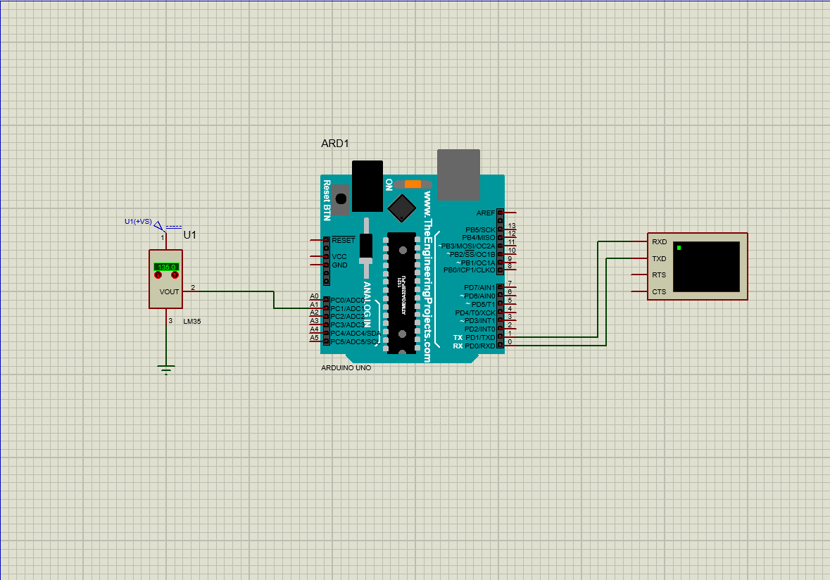

Result Analysis

From the above experimentation the result obtained can be interpreted as first, the sensor detects the temperature and sends it to the device, which then checks how much temperature is there and displays the results on the screen.

Devices Used: - 1 ) ARDUINO UNO R3

2 ) LM35

Terminals Used: - 1 ) GROUND

Instruments Used: - 1) Virtual Terminal

**Code Snippet**

int val;

int tempPin = 1; //A1

void setup() {

Serial.begin(9600);

}

void loop() {

val = analogRead(tempPin);

float mv = ( val/1024.0)*5000;

float cel = mv/10;

Serial.print("TEMPERATURE = ");

Serial.print(cel);

Serial.print("*C");

Serial.println();

delay(1000);

}

**Disaster Management Systems for Earthquakes**

The earth's surface resembles a massive jigsaw puzzle made up of enormous rough parts known as tectonic plates. These plates are always shifting, slowly yet steadily, but with enormous force. Earthquakes and volcanoes are caused by tectonic plate movement. The earth trembles when these plates glide past one other or a part is abruptly fractured, and this is known as an earthquake. The earth trembles violently every now and then, causing structures to crumble. Lines of fault are where tectonic plates collide. When a platform moves suddenly, the plates on either side of the fault press against each other due to the high power arrangement. It generates floor shaking by sending shock waves through the floor. The focal point of an earthquake is the location along the fault line where the plates are moving. The epicenter is the location on the earth that falls directly above the concentration.

Earth shakes are measured in two ways by the researchers: by force and by magnitude. Magnitude refers to the strength of the shock waves, which is usually measured on the Richter scale. The earth shake's effects are estimated using the Mercalli intensity scale. Seismographs are used by geologists to measure the strength of earth tremors. The scale uses a number to represent the magnitude of an earthquake. The seismic hazards map of India places Uttarakhand, which is located in the Himalayan area, in zones 4 and 5. According to the seismic map, these areas are particularly vulnerable to earthquakes. On October 20, 1991, the Himalayan region was struck by a powerful earthquake with its epicenter at Maneri ( Uttarkashi ). More than 1500 individuals were killed or their property was destroyed. Large tracts of agricultural land are also destroyed by earthquakes. An earthquake causes buildings and other public and private structures to collapse.

**Proposed Model**

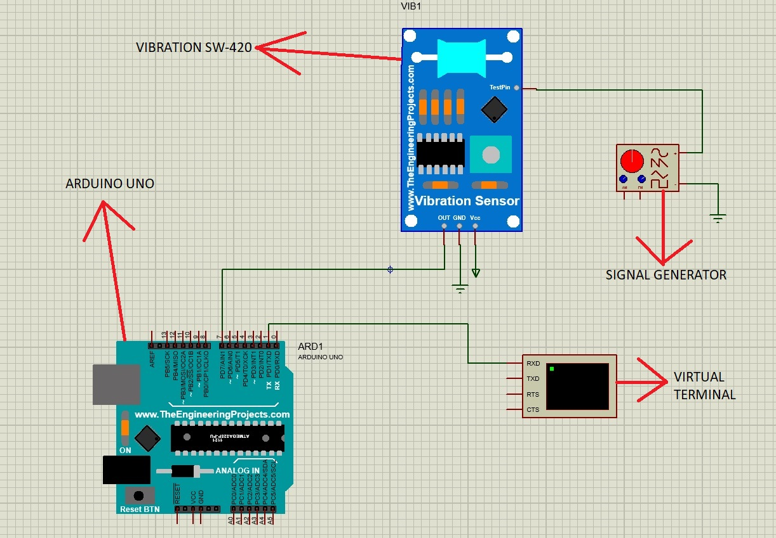

Result Analysis

From the above experimentation the result obtained can be interpreted as first, when an earthquake occurs, the screen or terminal will display "Earthquake Occurs," and when the situation is steady, it will display "Earthquake Not Occurs." In this device, I've built one signal generator through which we may generate any form of seismic signal.

Devices Used: - 1 ) Arduino Uno R3

2 ) Vibration SW 420

Terminals Used: - 1 ) Power

2 ) Ground

Instruments Used: - 1 ) Signal Generator

2 ) Virtual RS 232

**Code Snippet**

int vib_pin = 7;

int val;

void setup() {

Serial.begin(9600);

pinMode(vib_pin , INPUT);

}

void loop() {

val = digitalRead(vib_pin);

if(val == 1)

{

Serial.println(" Vibration Found ");

}

else

{

Serial.println(" Vibration Not Found ");

}

}

**Disaster Management System for Flood**

Many studies of the flood tragedy are managed by independent scholars. Sood et al. present the big Data-HPC Integration IoT Flood Management Method as an example of IoT's usability and efficacy, as well as a comprehensive description of our style, algorithms, metrics, performance, and experiment analysis. Their flood risk management service will drive IoT, Big Data, and HPC integration, as well as additional successful alarm systems and analysis. It delivers early-warning geoinformatics to the Internet of Things ( e.g., remote sensing ( RS ), GIS, and GPS ). Associate in Nursing innovative snowmelt flood technique using the internet and cloud technologies. Cloud data storage, control system, software, and utilities, as well as IoT technologies and infrastructures, are all included. Perumal et al. offer an IoT-based water monitoring system that tracks water activity in real time. Our proposal is based on the idea that when it comes to flood events, especially in disaster-prone locations, the water level is an extremely important element. The goal threshold will be detected by the water level sensor element, and if the amount of water exceeds the variable, the message will be sent in real time. Similarly, the saviours' IoT technology has the potential to improve SAR operations. Another option for flood disaster management is to use post-flood management in metropolitan areas with the use of new IoT and AI technology. We can improve flood management efficiency and effectiveness by rescuing flood victims utilizing the smart IoT architecture suggested in this study.

**Proposed Model**

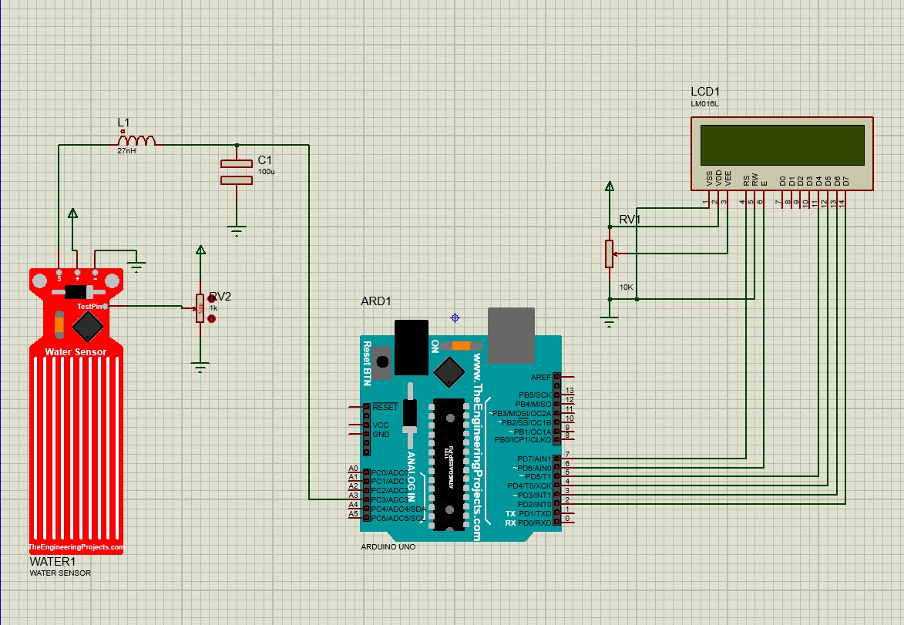

Result Analysis

From the above experimentation the result obtained can be interpreted as first, there is a 330L water tank in this system; if the water level falls below 100L, the system will display "Empty". If the water level is between 100 and 300 litres, the indicator will read "Low". "Medium" will appear if the water level is greater than 300L but less than 330L. Finally, if the water level reaches 330L, the display will show "High".

Devices Used: - 1 ) 3214G-1-103E

2 ) ARDUINO UNO R3

3 ) CAPACITOR

4 ) INDUCTOR

5 ) LM016L (Alphanumeric Display)

6 ) POT-HG

7 ) WATER SENSOR

Terminals Used: - 1 ) POWER

2 ) GROUND

**Code Snippet**

#include <LiquidCrystal.h>

// initialize the library with the numbers of the interface pins

LiquidCrystal lcd(7, 6, 5, 4, 3, 2);

int resval = 0; // holds the value

int respin = A3; // sensor pin used

void setup() {

// set up the LCD's number of columns and rows:

lcd.begin(16, 2);

// Print a message to the LCD.

lcd.print(" WATER LEVEL : ");

}

void loop() {

// set the cursor to column 0, line 1

lcd.setCursor(0, 1);

resval = analogRead(respin); // Read data from analog pin and store it to resval variable

if (resval<=100){ lcd.println(" Empty "); }

else if (resval>100 && resval<=300){ lcd.println(" Low "); }

else if (resval>300 && resval<=330){ lcd.println(" Medium "); }

else if (resval>330){ lcd.println(" High "); }

delay(1000);

}

**Disaster management system for Landslide**

A landscape along an inclined area of the planet could be made up of rock, soil, or dust. The landslide was caused by an earthquake, a volcano, or other events that made the hillside unstable. Landslides are often described as a type of mass loss by geologists, who study Earth's physical formations. The victimization of the IoT approach by landslide has been studied extensively. Internet communication networks provide an important communication infrastructure. The Internet of Things capability allows the landslide early detection system to accommodate a wireless sensor network. However, as Sofwan explains, the system would collect data from a variety of sensors using an Arduino AT Mega 2560 microcontroller. The physical parameter is measured and the actual is obtained, indicating that the system has equipped the discovered information. Moulat et al. identified landslide-prone locations using a variety of methods, including weights of proof and Logistic Regression (LR). These types of area units are well-designed and sensitive. The mission to save many lives is unquestionably critical. This is why, in the event of looming danger, there is a tendency to build a strong observance model for population evacuation. It is made up of simple field sensing devices that use data collection systems to acquire sensor measurements, perform machine-driven processing, and consider current conditions, usually via the Internet of Things (IoT). This design could be used to create a grounded distant observation system. In short, Moulat et al. offer a brand-new way to pursuing when hillslopes are primed for slickness and will signal fast and dangerous movement early on. This also keeps track of current or historical observance data, provides timely information on land-lifting activities, simplifies our understanding of land-life events, and allows for more cost-effective technology and pre-planning.

Wireless-sensing element networks (WSN) are critical in a variety of applications, including landslide detection, trash management, and water quality monitoring in rivers and reservoirs. Intelligent grids from WSN are one of the most important technology solutions. The main problem with this setup is that it is unreliable since equipment failure is unpredictable. The first causes of energy failures are energy shortages and a lack of data about energy supply and consumption constraints. This will raise the cost of power consumption and provide the impression that electricity is not cheap. The blending and security concerns integrating IoT into the good grid are the focus of Viswanathan et al. A reflector is included in the good town Framework, which is a building community equipped with an electrical phenomena system that may exchange electricity based on the management station's decision. In this way, the excellent grid model is effective in meeting native energy demands by utilising a variety of renewable energy generators.

**Proposed Model**

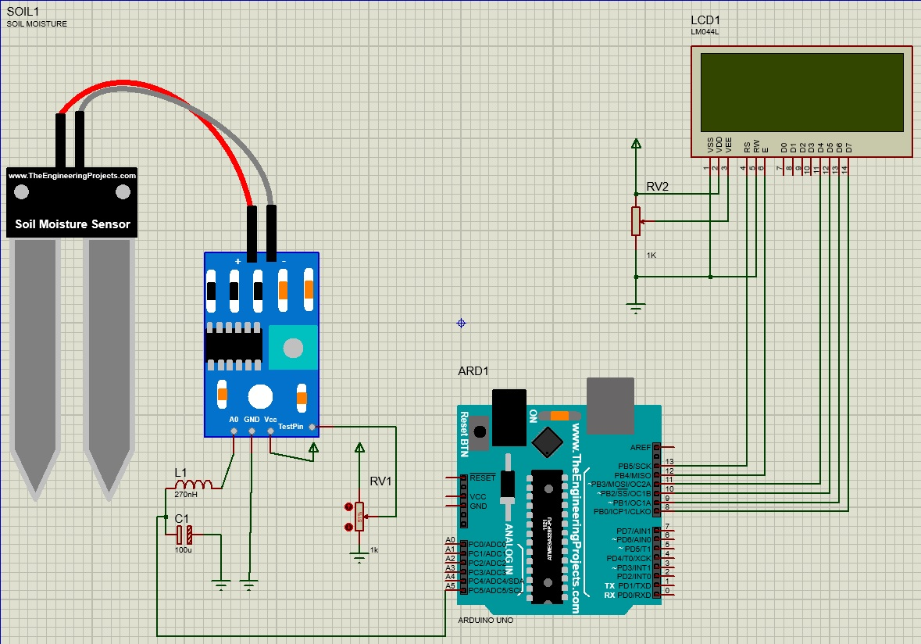

Result Analysis

From the above experimentation the result obtained can be interpreted as first, when the Soil Moisture Sensor is placed in the soil, it checks the moisture content and sends the results to the screen, allowing us to determine whether or not a landslide will occur based on the soil moisture.

Devices Used: - 1 ) ARDUINO UNO R3

2 ) SOIL MOISTURE SENSOR

3 ) LM044L (Alphanumeric Display)

4 ) 1210-271K (Coil)

5 ) 3005P-1-102 (POT 1K OHM)

6 ) A700V107M002ATE028 (CAP AO TYPE 100uF)

7 ) POT-HG

Terminals Used: - 1 ) POWER

2 ) GROUND

**Code Snippet**

#include <LiquidCrystal.h>

// initialize the library with the numbers of the interface pins

LiquidCrystal lcd(13, 12, 11, 10, 9, 8);

int SensorPin = A5;

void setup() {

// set up the LCD's number of columns and rows:

lcd.begin(20, 4);

// Print a message to the LCD.

lcd.setCursor(0,0);

lcd.print("----INFOTAINMENT----");

lcd.setCursor(0,1);

lcd.print("SOIL MOISTURE LEVEL.");

lcd.setCursor(2,2);

lcd.print("Analog Value: ");

lcd.setCursor(2,3);

lcd.print("Output: ");

}

void loop() {

int SensorValue = analogRead(SensorPin);

float SensorVolts = analogRead(SensorPin)*0.0048828125;

lcd.setCursor(16, 2);

lcd.print(SensorValue);

lcd.setCursor(9, 3);

lcd.print(SensorVolts);

lcd.print("V");

delay(1000);

}

**CONCLUSIONS**

HSR's early warning system for natural disasters can perform data sharing, connectivity, and other activities. To increase the safety of high-speed rail operations, this article established an early warning system for natural disasters on HSR. The HSR natural disaster early warning system's reliability design is represented not only in the redundant configuration of system hardware, but also in the setting of alarm thresholds. The supplied warning threshold value is the suggested value in this study. In order to realize the goal of system early warning, the alarm threshold value of the HSR must be dynamically modified according to the actual operating situation of the HSR.

Numerous modern technology and effective methods are utilized to assess and monitor geological catastrophe activities and the dynamic changes of various triggered factors in order to ensure the safe operation of the HSR. This article used the LSSVM's parameter optimization to simulate natural disaster early warning of HSR safe operation, and provided management measures and methodologies for HSR safety operation during natural disasters. The problem of HSR emergency decision-making can be solved with the comprehensive and speedy evaluation model of HSR natural catastrophe early warning.

The HSR early warning system for natural disasters is critical to China's railway growth. The natural disaster system must be designed with the natural catastrophe and the railway's geographic location in mind. The architecture of the placement points and the maintenance of the later people are not taken into account by some of the monitoring methods proposed in this research. In future study, this will be improved even more. At the same time, the authors believe that research into the early warning system of HSR in the event of natural disasters, such as gales, heavy rain, thunder, earthquakes, and so on, in order to eliminate the impact of these natural disasters on equipment alarm errors, has high requirements for monitoring system materials, installation technology, and power optimization.

**References**

1. Guo BB, Ke JC. The impacts of high-speed rail on sustainable economic development: evidence from the central part of China. Sustainability. 2020; 12:1–19.
2. Church RL, Antunes AP, Repolho HM et al. Optimal location of railway stations: the Lisbon–Porto high-speed rail line. Transport Sci. 2013; 47:330–343.
3. Zhou Y, Zhou LS, Wang Y et al. A practical model for the train-set utilization: the case of Beijing-Tianjin passenger dedicated line in China. PLoS One. 2017; 12:1–24.
4. Shibayama T. Japan's transport planning at national level, natural disasters, and their interplays. Eur Transp Res Rev. 2017; 9:44.
5. Chuang HC, Chen CC, Li ST. Incorporating monotonic domain knowledge in support vector learning for data mining regression problems. Neural Comput Appl. 2020; 32:11791–11805.
6. Manju S, Helenprabha K. A structured support vector machine for hyperspectral satellite image segmentation and classification based on modified swarm optimization approach. J Amb Intell Human Comput. 2019;1–10.
7. Kao SP, Chen CN, Huang HC et al. Using a least squares support vector machine to eastimate a local geometric geoid model. Bol Ciencias Geodes. 2014; 20:427–443.
8. Safakhoo N, Sohrabi MR, Khalili M et al. Enhancement spectral resolution for the prediction amount of sofosbuvir and ledipasvir using least squares support vector machine and artificial neural networks in pharmaceutical formulation. J Chil Chem Soc. 2019; 64:4310–4323.
9. "Length Matching". Labcenter Electronics. Retrieved 13 February 2018.
10. Sinha, A., Kumar, P., Rana, N. P., Islam, R., & Dwivedi, Y. K. (2017). Impact of internet of things (IoT) in disaster management: a task-technology fit perspective. Annals of Operations Research. doi:10.1007/s10479-017-2658-1
11. Khan, Amina; Gupta, Sumeet; Gupta, Sachin Kumar (2020). Multi-hazard disaster studies: Monitoring, detection, recovery, and management, based on emerging technologies and optimal techniques. International Journal of Disaster Risk Reduction, 47(), 101642–. doi:10.1016/j.ijdrr.2020.101642
12. L. Spalazzi, G. Taccari, and A. Bernardini, “An internet of things ontology for earthquake emergency evaluation and response,” in Proceedings of the 2014 International Conference on Collaboration Technologies and Systems, CTS, pp. 528–534, Minneapolis, MN, USA, May 2014.
13. M. E. Moulat, O. S. Debauche, and F. Lebeau, “system using internet of things for potential landslides,” Procedia Computer Science, vol. 134, pp. 26–34.
14. A. Viswanathan, N. B. Sai Shibu, S. N. Rao, and M. V. Ramesh., “Security challenges in the integration of IoT with WSN for smart grid applications,” in Proceedings of the 2017 IEEE International Conference on Computational Intelligence and Computing Research, ICCIC 2017, pp. 1–4, Coimbatore, India, December 2018.
15. Hu Qizhou, Fang Xin, Bian Lishuang Transportation Safety and Environment, Volume 3, Issue 4, December 2021, tdab019, https://doi.org/10.1093/tse/tdab019