

University of Information Technology

India-Myanmar Centre for Enhancement of IT Skills

Internship Program in Cyber Security



AEGIS

1st Batch

(May, 2026 to July, 2026)



Information and Communication Technology Research Centre
India-Myanmar Centre for Enhancement of IT Skills

India-Myanmar Centre for Enhancement of IT Skills

India-Myanmar Centre for Enhancement of IT Skills

A Project Report On
AEGIS

Submitted in Partial Fulfillment for the Award of

Internship Program in Cyber Security with GNS3
Batch - 1 (May, 2026 to July, 2026)
Guided by: Dr. Htay Htay Yi

Presented by:
Mg Si Thu Phyo 052601 (Leader)
Mg Paing Thant Kyaw 05260

ABSTRACT
This project presents AEGIS (Automated Enforcement and Guardian Intelligence System), a real-time Security Operations Center (SOC) dashboard designed and implemented for a simulated corporate network environment. AEGIS integrates multi-source security event ingestion, AI-powered threat analysis, automated firewall defense, and live network visualization into a unified web-based platform.
The system monitors four core company servers — a web server (Apache2), a DNS server (BIND9), a customer database (MySQL), and an LDAP authentication server (OpenLDAP) — alongside network-level intrusion detection through pfSense/Suricata IDS. Security events from Fail2ban, SSH logs, application logs, and Suricata EVE JSON are forwarded in real time by the AEGIS Forwarder Agent to a centralized Express.js API server backed by Supabase (PostgreSQL).
The dashboard, built with React and Vite, provides a live threat map, event feed, defense rule engine, AI threat briefing via Groq (LLaMA 3.3-70B), automated report generation, and Telegram push notifications. The auto-defense engine evaluates incoming events against configurable rules and dispatches firewall commands to pfSense and Ubuntu VMs without human intervention.
The entire infrastructure is virtualized in GNS3 using a layered network topology with separate DMZ, Internal, and Management VLANs managed by a pfSense firewall. Attack simulations using Kali Linux tools (nmap, hydra, sqlmap,) successfully triggered detection, alerting, and automated response across all monitored services.
Keywords: SOC, IDS, SIEM, Auto-defense, GNS3, pfSense, Suricata, Fail2ban, React, Supabase, Groq AI, Network Security, Intrusion Detection

ACKNOWLEDGEMENTS
First and foremost, I would like to express my deepest and most sincere gratitude to my project supervisor, Dr. Htay Htay Yi, for her exceptional guidance, continuous encouragement, and invaluable technical insights throughout every phase of this project. Her constructive feedback and unwavering support were instrumental in shaping the direction and quality of this work.
I am also profoundly grateful to Dr. Thiri Thitsar Khaing for her dedicated teaching, academic mentorship, and patient guidance in helping me understand the theoretical foundations of network security and system design that underpin this project.
My sincere appreciation also goes to Dr. Thu Zar San for her thoughtful advice, encouragement throughout the research process, and for sharing her expertise in cybersecurity concepts and best practices that greatly enriched the depth and rigor of this work.
I am deeply thankful to my internship organization for providing the necessary resources, virtual machine infrastructure, and technical mentorship that made the implementation of a real-world SOC environment possible.
Special thanks go to the open-source communities behind Suricata, Fail2ban, pfSense, React, Supabase, and GNS3, whose free tools formed the backbone of this system.
Finally, I would like to thank my family and friends for their moral support and encouragement throughout this challenging yet rewarding project.

TABLE OF CONTENTS
Abstract ........................................................ i
Acknowledgements ............................................... ii
Table of Contents ............................................. iii
List of Figures ................................................. v
List of Tables ................................................. vi
List of Abbreviations ......................................... vii

CHAPTER 1: INTRODUCTION ......................................... 1
1.1 Background ............................................... 1
1.2 Problem Statement ........................................ 1
1.3 Objectives ............................................... 2
1.4 Scope of the Project ..................................... 3
1.5 Report Organization ...................................... 4
1.6 Research Methodology ..................................... 4

CHAPTER 2: LITERATURE REVIEW .................................... 5
2.1 Security Operations Center (SOC) ......................... 5
2.2 Intrusion Detection Systems (IDS) ........................ 6
2.3 Security Information and Event Management (SIEM) ......... 7
2.4 Network Virtualization with GNS3 ......................... 8
2.5 AI in Cybersecurity ...................................... 8
2.6 Related Works ............................................ 9

CHAPTER 3: SYSTEM ANALYSIS AND DESIGN .......................... 10
3.1 Functional Requirements ................................. 10
3.2 Non-Functional Requirements ............................. 11
3.3 Overall System Architecture ............................. 11
3.4 Network Topology Design ................................. 12
3.5 Database Schema Design .................................. 13
3.6 API Architecture ........................................ 15
3.7 Dashboard UX Design ..................................... 16

CHAPTER 4: IMPLEMENTATION ...................................... 17
4.1 Development Environment ................................. 17
4.2 GNS3 Network Infrastructure ............................. 18
4.3 Company Server Setup .................................... 20
4.4 Security Sensors Configuration .......................... 23
4.5 AEGIS Forwarder Agent ................................... 26
4.6 API Server Implementation ............................... 30
4.7 Auto-Defense Engine ..................................... 33
4.8 Dashboard Frontend ...................................... 36
4.9 AI Threat Analysis Integration .......................... 41
4.10 Notification System (Telegram) .......................... 43

CHAPTER 5: TESTING AND RESULTS ................................. 44
5.1 Test Environment Setup .................................. 44
5.2 Attack Scenarios and Results ............................ 45
5.3 Auto-Defense Validation ................................. 48
5.4 Performance Analysis .................................... 49

CHAPTER 6: LIMITATIONS AND FUTURE WORK ......................... 50
6.1 Current Limitations ..................................... 50
6.2 Future Enhancements ..................................... 51
6.3 Ethical Considerations and Data Privacy ................. 52
6.4 Scalability and Maintenance ............................. 53

CHAPTER 7: CONCLUSION .......................................... 54

REFERENCES ..................................................... 53

APPENDIX A: Installation and Setup Guide ....................... 55
APPENDIX B: API Endpoint Reference ............................. 57
APPENDIX C: Configuration Reference ............................ 58

LIST OF FIGURES
Figure 3.1 Overall AEGIS System Architecture ............... 12
Figure 3.2 GNS3 Network Topology Diagram ................... 13
Figure 3.3 Database Entity-Relationship Diagram ............ 14
Figure 3.4 API Server Request-Response Flow ................ 15
Figure 4.1 GNS3 Topology — v4 Final Layout ................. 19
Figure 4.2 pfSense Interface Configuration Screenshot ...... 20
Figure 4.3 Company Web Server Apache2 Setup ................ 21
Figure 4.4 BIND9 DNS Zone Configuration .................... 22
Figure 4.5 Fail2ban Jail Configuration on company-web-server ... 24
Figure 4.6 Suricata IDS EVE JSON Output Sample ............. 25
Figure 4.7 AEGIS Forwarder Agent Thread Architecture ....... 28
Figure 4.8 Auto-Defense Engine Pipeline Diagram ............ 34
Figure 4.9 AEGIS Dashboard — Main Overview Page ............ 37
Figure 4.10 AEGIS Dashboard — Live Threat Map .............. 38
Figure 4.11 AEGIS Dashboard — Defense Center Page .......... 39
Figure 4.12 AEGIS Dashboard — Events Page with AI Analysis ... 40
Figure 4.13 AEGIS Dashboard — Reports Page ................. 42
Figure 4.14 Telegram Notification Sample ................... 43
Figure 5.1 Kali Linux Attack Execution — Hydra SSH Brute Force ... 46
Figure 5.2 AEGIS Dashboard — Brute Force Detection Alert ... 46
Figure 5.3 sqlmap SQL Injection Attack Result .............. 47
Figure 5.4 ab DDoS Simulation — Apache Service Down .... 48
Figure 5.5 Auto-Defense Command Queue — Pending/Executed ... 49

LIST OF TABLES
Table 3.1 Functional Requirements Summary .................. 10
Table 3.2 Network IP Address Plan .......................... 12
Table 3.3 Core Database Tables ............................. 13
Table 4.1 Development Tools and Technologies ............... 17
Table 4.2 GNS3 Node IP Assignment .......................... 18
Table 4.3 Company Services Summary ......................... 20
Table 4.4 Sensor Assignment per VM ......................... 23
Table 4.5 Fail2ban Jail Configuration Parameters ........... 24
Table 4.6 API Ingest Endpoints ............................. 31
Table 4.7 Defense Rule Trigger Types ....................... 34
Table 5.1 Attack Scenarios and Detection Results ........... 45
Table 5.2 Auto-Defense Execution Results ................... 48
Table 6.1 Known Limitations ................................ 50
Table 6.2 Planned Future Enhancements ...................... 51
Table 6.3 Data Retention Policy ............................ 52

LIST OF ABBREVIATIONS
Abbreviation | Full Form
AEGIS | Automated Enforcement and Guardian Intelligence System
AI | Artificial Intelligence
API | Application Programming Interface
BIND9 | Berkeley Internet Name Domain version 9
CLI | Command Line Interface
CSRF | Cross-Site Request Forgery
DDoS | Distributed Denial of Service
DMZ | Demilitarized Zone
DNS | Domain Name System
EVE | Extensible Event Format (Suricata JSON output)
FTP | File Transfer Protocol
GNS3 | Graphical Network Simulator 3
HTTP | HyperText Transfer Protocol
IDS | Intrusion Detection System
IPS | Intrusion Prevention System
JSON | JavaScript Object Notation
JWT | JSON Web Token
LDAP | Lightweight Directory Access Protocol
LFI | Local File Inclusion
LLM | Large Language Model
MGMT | Management
MITM | Man-In-The-Middle (attack)
MySQL | My Structured Query Language (database)
NAT | Network Address Translation
PHP | PHP: Hypertext Preprocessor
REST | Representational State Transfer
RFI | Remote File Inclusion
SIEM | Security Information and Event Management
SOC | Security Operations Center
SQL | Structured Query Language
SQLi | SQL Injection
SSH | Secure Shell
SSL | Secure Sockets Layer
SSO | Single Sign-On
TLS | Transport Layer Security
UI | User Interface
URL | Uniform Resource Locator
VLAN | Virtual Local Area Network
VM | Virtual Machine
VoIP | Voice over Internet Protocol
WAF | Web Application Firewall
XSS | Cross-Site Scripting

CHAPTER 1: INTRODUCTION

1.1 Background
In the modern digital landscape, organizations of every size face an ever-growing volume of cyber threats. From small businesses to large enterprises, network infrastructure is continuously targeted by attackers exploiting vulnerabilities in web applications, databases, authentication systems, and network protocols. The cost of a successful breach — in data loss, financial damage, and reputational harm — can be catastrophic.
A Security Operations Center (SOC) serves as the nerve center of an organization's cybersecurity posture. It is a centralized unit responsible for monitoring, detecting, analyzing, and responding to security incidents in real time. Traditionally, SOC operations require significant investment in commercial SIEM platforms such as Splunk, IBM QRadar, or Microsoft Sentinel. For mid-sized organizations and academic purposes, building an open-source SOC that achieves comparable functionality at minimal cost represents a compelling challenge.
This project, AEGIS (Automated Enforcement and Guardian Intelligence System), addresses that challenge. It was conceived and built as a final internship project to demonstrate that a production-quality SOC can be constructed entirely from open-source components: pfSense for firewall and routing, Suricata for network-level IDS, Fail2ban for host-based intrusion prevention, and a custom React + Express.js dashboard for centralized visualization and control.
AEGIS goes beyond simple log aggregation. It implements an automated defense pipeline that translates detected threat events into executable firewall commands — without human intervention. It integrates AI (Groq LLaMA 3.3-70B) for intelligent threat briefing and natural language explanations of security events. And it delivers real-time push notifications via Telegram, ensuring the security team is immediately informed of critical incidents regardless of whether the dashboard is open.

1.2 Problem Statement
Small-to-medium enterprises and academic institutions often lack the budget and personnel to operate a fully-featured SOC. Commercial SIEM solutions are expensive, complex to deploy, and require continuous tuning. Free alternatives are often fragmented — requiring administrators to manually correlate logs from disparate sources such as Fail2ban, Suricata, Apache, and SSH.
The specific problems this project addresses are:
- Log data from multiple security tools (Fail2ban, Suricata, Apache access logs, SSH auth logs, MySQL logs, BIND9 logs, OpenLDAP logs) is scattered across multiple servers with no unified visibility.
- Security administrators must manually review logs to detect attacks — a slow, error-prone process that allows threats to persist undetected.
- When an attack is detected, manual firewall rule creation is slow and may lag behind fast-moving threats such as port scans or brute-force attacks.
- There is no centralized way to visualize the network topology, see which nodes are under attack, or understand the severity and nature of threats at a glance.
- Generating periodic security reports and threat briefings requires manual effort and security expertise that may not be available in all organizations.

AEGIS solves all five problems through a unified, real-time, AI-augmented SOC dashboard with automated defense capabilities.

1.3 Objectives
The objectives of this project are:
- To design and implement a multi-source security event collection system that ingests events from Fail2ban, Suricata IDS, SSH logs, Apache access logs, MySQL logs, BIND9 logs, and OpenLDAP logs in real time.
- To build a centralized Express.js API server with secure ingestion endpoints and a Supabase (PostgreSQL) backend for persistent event storage.
- To develop a React-based SOC dashboard with live threat visualization, event feed, network topology map, and security KPI cards.
- To implement an auto-defense engine that automatically evaluates incoming events against configurable defense rules and dispatches firewall commands to pfSense and Ubuntu VMs.
- To integrate Groq AI (LLaMA 3.3-70B) for intelligent threat analysis, event explanation, and automated report generation.
- To provide real-time Telegram push notifications for critical and high-severity security events.
- To validate the complete system through realistic attack simulations using Kali Linux in a GNS3 virtual lab environment.

1.4 Scope of the Project
The scope of this project covers the design, implementation, and testing of the AEGIS SOC Dashboard within a GNS3-virtualized network environment representing Golden Myanmar Trading Co., Ltd.'s internal infrastructure.
In scope:
- Four company servers: web server, DNS server, customer database, LDAP server
- pfSense firewall with Suricata IDS covering all network zones
- AEGIS Forwarder Agent running on a dedicated Ubuntu hub VM
- Full-stack SOC dashboard (React frontend + Express.js backend)
- Auto-defense engine with configurable rules
- AI-powered threat analysis and report generation
- Telegram notification integration
- Kali Linux-based attack simulation and validation
Out of scope:
- Physical network deployment (all infrastructure is virtualized in GNS3)
- Email server, VoIP server, CCTV simulation (planned for future phases)
- Active Directory / Samba4 integration (future phase)
- Mobile application (dashboard is web-only)

1.5 Report Organization
The remainder of this report is organized as follows:
- Chapter 2 reviews existing literature on SOC, IDS, SIEM, and AI in cybersecurity.
- Chapter 3 presents system analysis, requirements, and design decisions.
- Chapter 4 describes the full implementation of all system components.
- Chapter 5 documents testing, attack simulations, and results.
- Chapter 6 discusses current limitations and future enhancements.
- Chapter 7 concludes the report.
- Appendices provide installation, API, and configuration references.

1.6 Research Methodology
The development of AEGIS followed a structured research and development methodology to ensure technical rigor and system reliability:
- Phase 1: Literature Review — Analyzing existing SOC/SIEM architectures and open-source security tools.
- Phase 2: Requirements Analysis — Defining functional and non-functional needs for a mid-sized corporate lab.
- Phase 3: Network Design — Designing a multi-zone GNS3 topology with DMZ, Internal, and Management VLANs.
- Phase 4: Implementation — Developing the full-stack dashboard, API server, and Python forwarder agent.
- Phase 5: Integration — Connecting the GNS3 virtual machines to the cloud-hosted AEGIS platform.
- Phase 6: Testing and Evaluation — Simulating real-world attacks using Kali Linux and validating the auto-defense response.

CHAPTER 2: LITERATURE REVIEW

2.1 Security Operations Center (SOC)
A Security Operations Center (SOC) is a centralized facility where a security team monitors, detects, contains, and responds to cybersecurity threats and incidents. The primary function of a SOC is continuous monitoring of an organization's IT infrastructure — networks, servers, endpoints, databases, applications, websites, and other technology — for signs of a security incident.
According to NIST Special Publication 800-61, an effective security operations capability must include: event monitoring and analysis, incident detection and classification, incident response coordination, threat intelligence integration, and continuous improvement through lessons learned. Modern SOCs increasingly incorporate automation (SOAR — Security Orchestration, Automation and Response) to handle the volume of alerts that human analysts alone cannot process.
AEGIS implements the core SOC functions at a scale appropriate for a mid-sized organization: event collection from multiple sources, severity-based classification, automated response, and human-readable threat briefing. While it does not implement full SOAR capabilities, the auto-defense engine represents a lightweight SOAR component for the most common threat types.

2.2 Intrusion Detection Systems (IDS)
An Intrusion Detection System (IDS) monitors network traffic or host activity for malicious patterns and generates alerts when such patterns are identified. IDS solutions are broadly categorized as:
- Network-based IDS (NIDS): inspects network traffic at a strategic point. Examples include Snort and Suricata.
- Host-based IDS (HIDS): monitors activity on an individual host. Examples include OSSEC, Wazuh, and Fail2ban.
- Hybrid: combines both approaches.
Suricata, developed by the Open Information Security Foundation (OISF), is a high-performance open-source IDS/IPS engine. It supports multi-threading, hardware acceleration, and outputs alerts in EVE JSON format — a structured log format that AEGIS consumes directly.
Fail2ban is a host-based intrusion prevention tool that monitors system log files for repeated authentication failures and automatically updates firewall rules to block offending IP addresses. AEGIS monitors Fail2ban's ban/unban actions across all four company VMs, treating each Fail2ban action as a structured security event.

2.3 Security Information and Event Management (SIEM)
SIEM systems combine Security Information Management (SIM) — long-term storage and analysis of log data — with Security Event Management (SEM) — real-time monitoring and correlation of events. The defining capability of a SIEM is correlation: detecting complex attack patterns that span multiple systems, timeframes, and event types.
Commercial SIEM solutions include Splunk Enterprise Security, IBM QRadar, Microsoft Sentinel, and Elastic SIEM. Open-source alternatives include Wazuh (which builds on OSSEC) and the ELK Stack (Elasticsearch, Logstash, Kibana).
AEGIS does not aim to replace a full SIEM but provides the most critical SIEM capabilities — event collection, normalization, storage, real-time alerting, and basic correlation through its defense rule engine — without the deployment complexity and licensing costs of commercial solutions.

2.4 Network Virtualization with GNS3
GNS3 (Graphical Network Simulator 3) is an open-source network simulation platform that allows the emulation of complex networks using real network operating system images. Unlike purely simulated environments, GNS3 runs actual OS images (Ubuntu, pfSense, MikroTik RouterOS) on the host machine's CPU, making the network behavior indistinguishable from physical hardware.
For this project, GNS3 provides the complete virtual lab: four Ubuntu VMs for company services, one pfSense VM for firewall and IDS, one MikroTik CHR for WAN routing, one Kali Linux VM for attack simulation, and one Ubuntu hub VM for the AEGIS Forwarder Agent. This architecture allows realistic attack-defense scenarios that would be impossible to replicate in a pure software simulation.

2.5 AI in Cybersecurity
The application of Large Language Models (LLMs) to cybersecurity has grown rapidly since 2023. LLMs can translate raw security event data into human-readable explanations, recommend countermeasures, and generate executive-level threat briefings — capabilities that previously required experienced security analysts.
AEGIS integrates Groq's API, which provides inference on Meta's LLaMA 3.3-70B model at extremely low latency. The model is prompted with structured event data from the past 24 hours and generates threat briefings in a mixed Burmese-English format suitable for the local analyst audience. Groq's hardware-accelerated inference (LPU chips) enables sub-second response times even for 70B parameter models.

2.6 Related Works
Several open-source SOC projects have been developed in academic and research contexts. Wazuh (formerly OSSEC) provides a comprehensive HIDS and SIEM solution with a Kibana-based dashboard. Security Onion combines Suricata and Elastic SIEM into a distribution focused on network security monitoring. TheHive provides incident response case management.
AEGIS differentiates itself from these solutions in three key ways: (1) it is purpose-built for a specific network topology and attack scenario set, allowing deeper integration with the monitored services; (2) it includes an auto-defense engine that issues actual firewall commands rather than just alerting; and (3) it integrates generative AI for natural language threat analysis, which none of the above solutions natively provide.

CHAPTER 3: SYSTEM ANALYSIS AND DESIGN

3.1 Functional Requirements
The following functional requirements were identified through analysis of the target environment and stakeholder needs:
ID | Requirement | Priority
FR-01 | System shall ingest security events from Fail2ban on all four VMs | High
FR-02 | System shall ingest SSH authentication events (success and failure) | High
FR-03 | System shall ingest Suricata IDS alerts from pfSense EVE JSON | High
FR-04 | System shall ingest Apache2 access logs from company-web-server | High
FR-05 | System shall ingest MySQL login events from company-customer-db | Medium
FR-06 | System shall ingest BIND9 DNS query/error events | Medium
FR-07 | System shall ingest OpenLDAP authentication events | Medium
FR-08 | Dashboard shall display live event feed with severity indicators | High
FR-09 | Dashboard shall show a live network topology/threat map | High
FR-10 | System shall auto-evaluate events against defense rules | High
FR-11 | System shall dispatch firewall commands to VMs automatically | High
FR-12 | Dashboard shall support manual IP block/unblock operations | High
FR-13 | System shall send Telegram notifications for critical/high events | High
FR-14 | System shall generate AI-powered threat briefings | Medium
FR-15 | System shall generate periodic security reports | Medium
FR-16 | Dashboard shall authenticate admins via JWT + Google SSO | High

3.2 Non-Functional Requirements
- Security: All ingest endpoints protected by API key authentication. Admin endpoints protected by separate admin key. JWT tokens expire in 24 hours.
- Availability: Dashboard hosted on Vercel CDN; API server on Render. Target uptime ≥ 99.5%.
- Performance: Event-to-dashboard latency ≤ 3 seconds. Auto-defense command execution ≤ 30 seconds from event ingestion.
- Scalability: Event storage in Supabase PostgreSQL; supports millions of rows.
- Maintainability: All forwarder configuration in external local.conf file; no code changes needed to reconfigure VM IPs or log paths.

3.3 Overall System Architecture
AEGIS follows a three-tier architecture separating data collection, processing, and presentation layers:
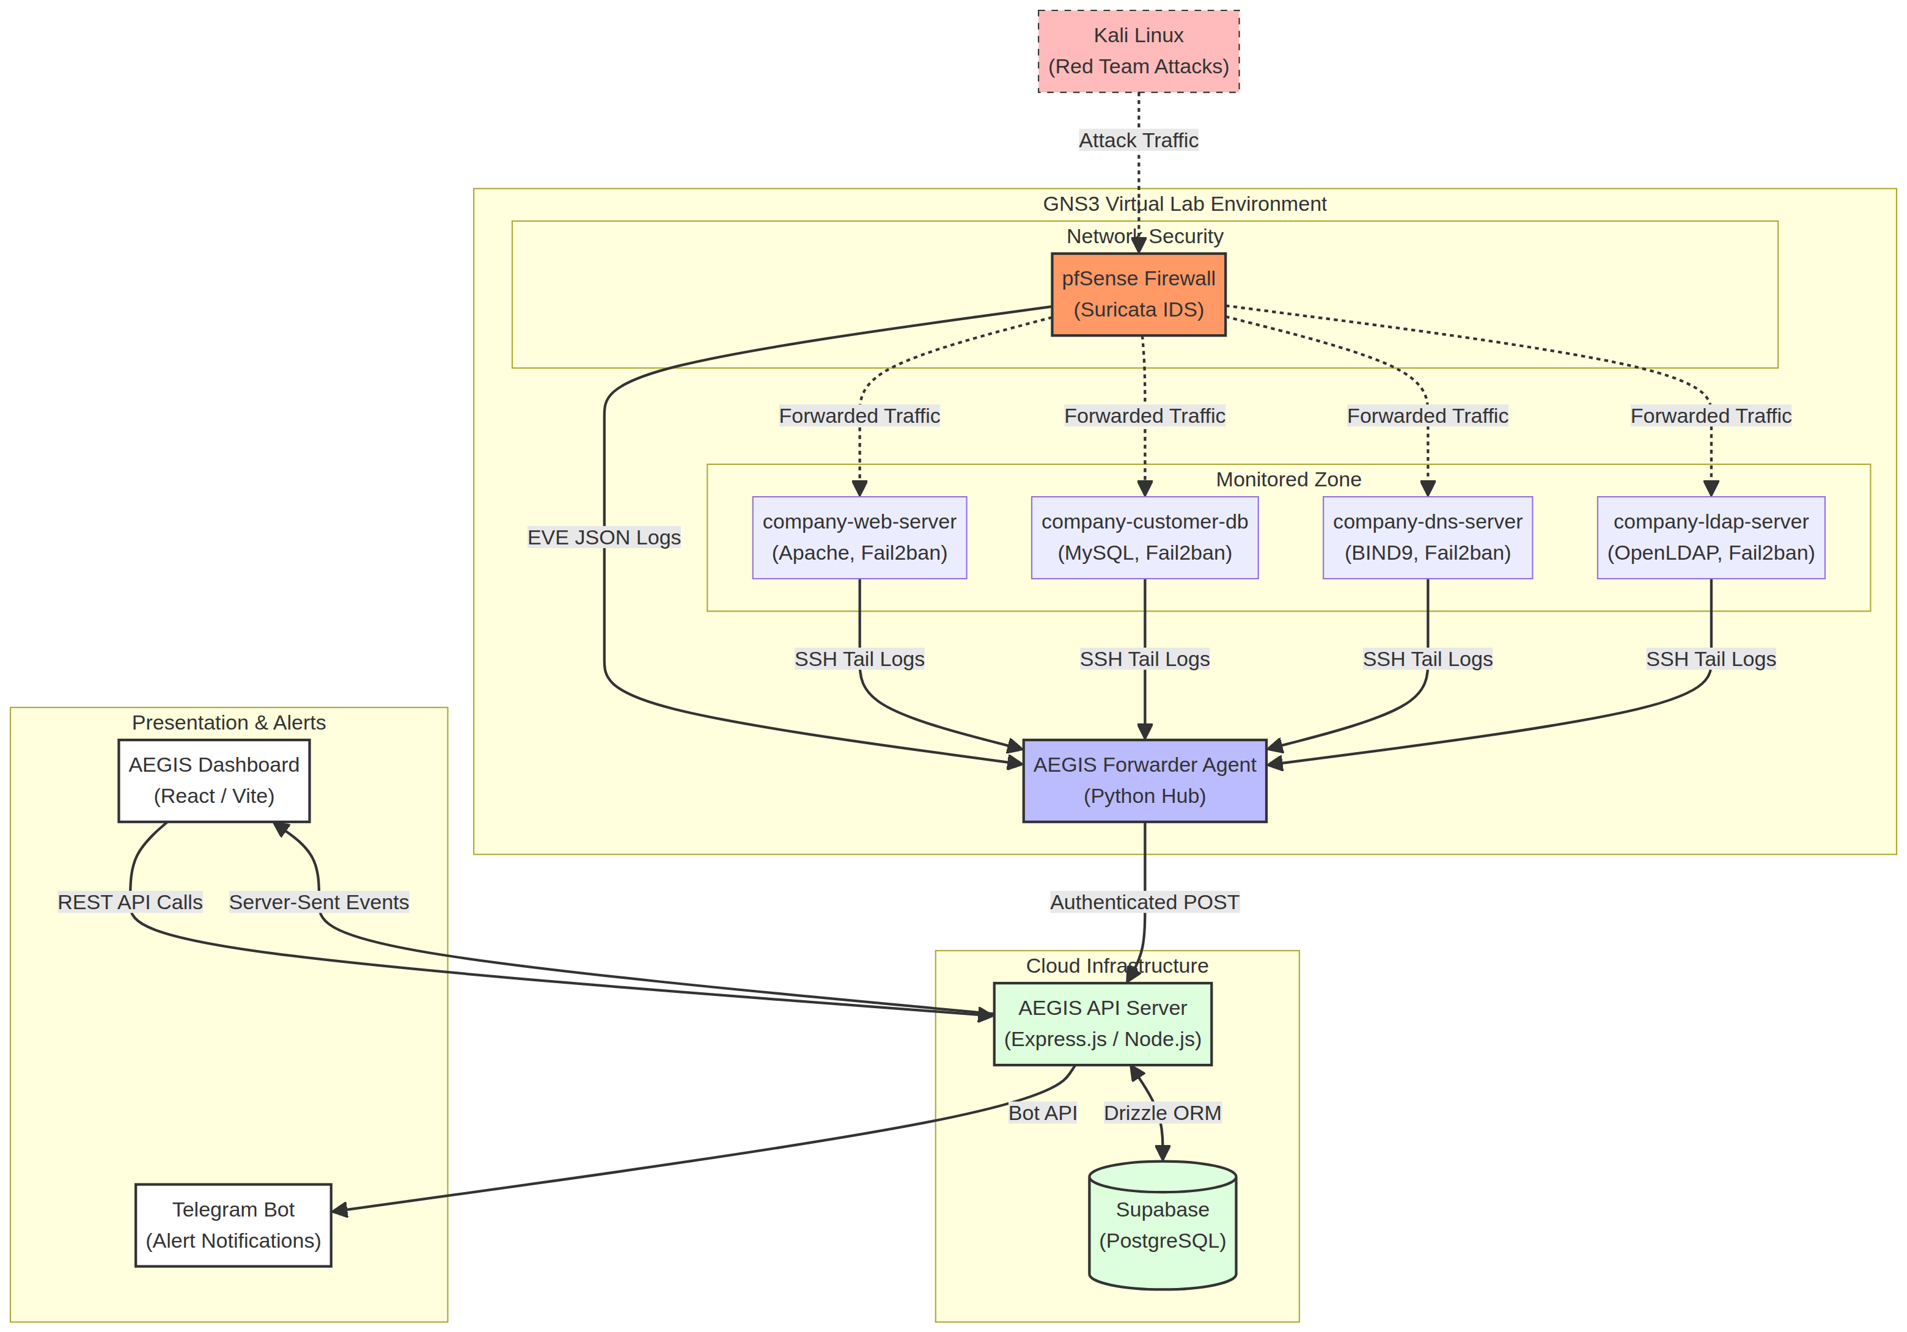
Figure 3.1: Overall AEGIS System Architecture

Tier 1 — Data Collection Layer:
- AEGIS Forwarder Agent (Python) runs on the hub VM (10.30.30.10)
- Spawns independent monitoring threads for each service/VM combination
- Normalizes raw log data into structured JSON events
- Forwards events via authenticated HTTPS POST to the API server
Tier 2 — Processing and Storage Layer:
- Express.js API server (Node.js/TypeScript) hosted on Render
- Receives, validates, and stores events in Supabase PostgreSQL
- Evaluates events against defense rules (auto-defense engine)
- Serves SSE (Server-Sent Events) stream to connected dashboard clients
- Sends Telegram notifications for critical/high events
Tier 3 — Presentation Layer:
- React + Vite dashboard hosted on Vercel
- Consumes SSE stream for real-time updates (no polling)
- Calls REST API for historical data, defense management, and AI analysis

3.4 Network Topology Design
The virtual network is organized into four logical zones separated by pfSense firewall interfaces:
Zone | VLAN/Interface | Subnet | Hosts
DMZ (Public) | pfSense em1 | 10.10.10.0/24 | company-web-server, company-dns-server
Internal | pfSense em2 | 10.20.20.0/24 | company-customer-db, company-ldap-server
Management | pfSense em3 | 10.30.30.0/24 | aegis-company-admin (hub)
WAN Link | pfSense e0 / Router e2 | 10.0.23.0/30 | pfSense WAN, Router
Attacker | Router e1 | 192.168.10.0/24 | Kali Linux (DHCP)
Internet | Router e0 / virbr0 | 192.168.122.0/24 | GNS3 NAT cloud

All inter-zone traffic passes through pfSense, which serves as both the network gateway and the IDS sensor point. Suricata on pfSense inspects traffic on the DMZ and Internal interfaces, providing network-level intrusion detection for all four company servers without requiring agents on each VM.
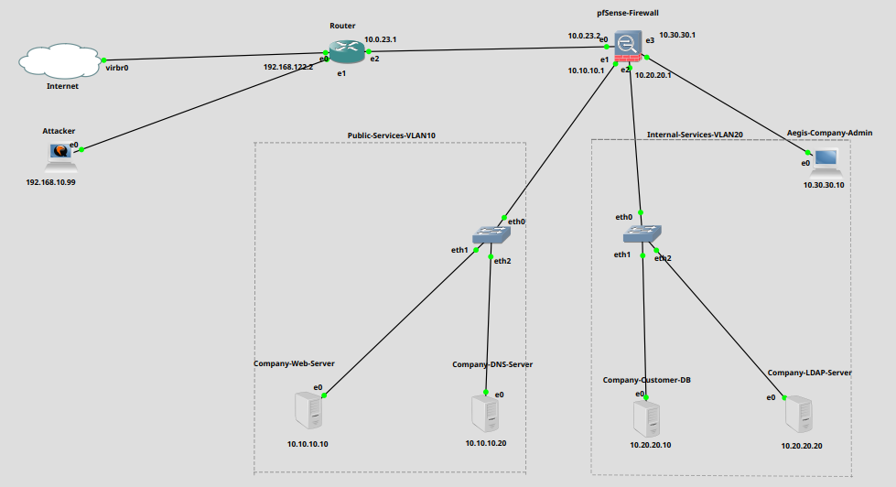
Figure 3.2: GNS3 Network Topology Diagram

3.5 Database Schema Design
The AEGIS database is hosted on Supabase (managed PostgreSQL). The core tables are:
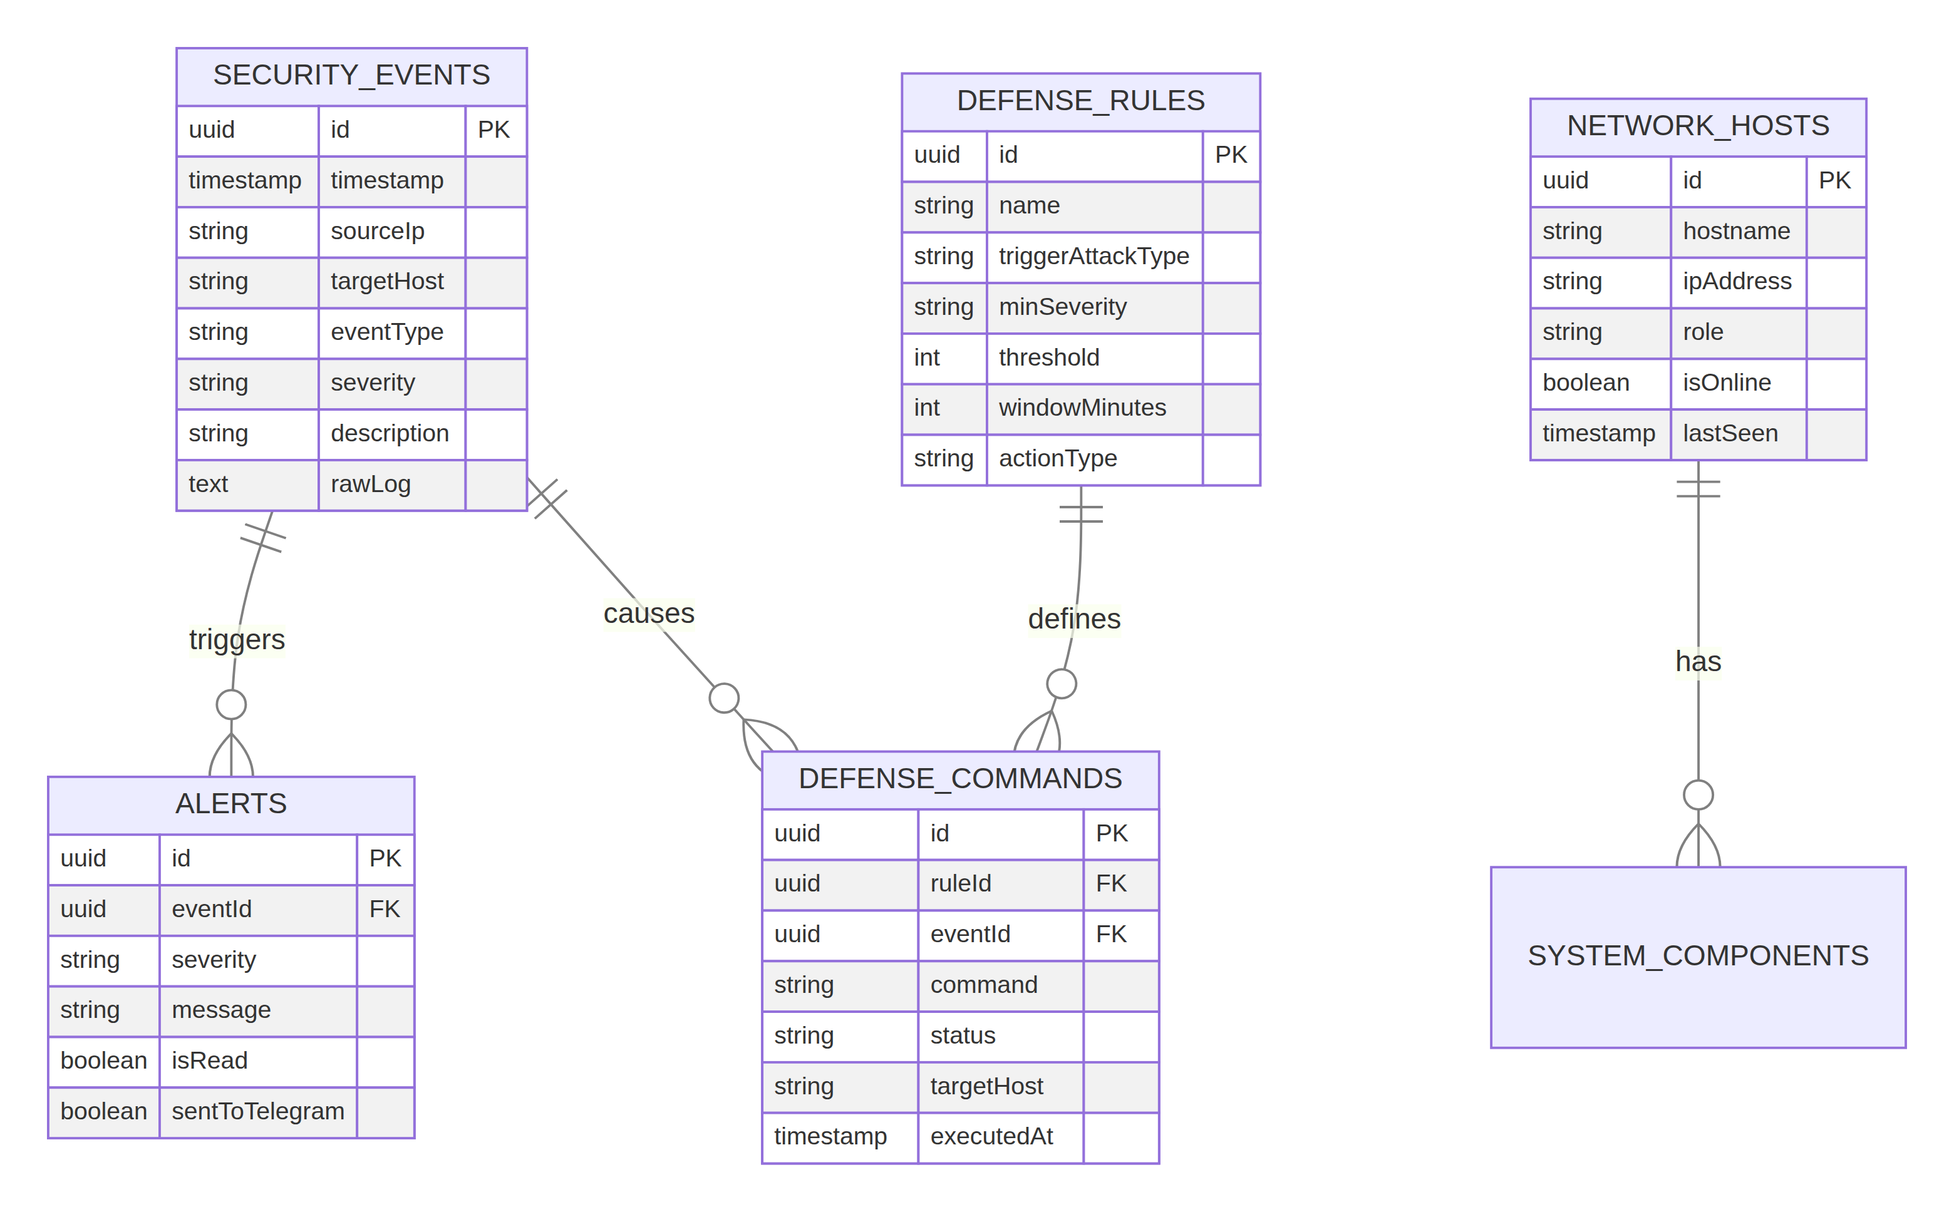
Figure 3.3: Database Entity-Relationship Diagram
Table | Purpose | Key Columns
security_events | All ingested security events | id, timestamp, sourceIp, targetHost, eventType, severity, description, rawLog, signature
alerts | Dashboard alert cards linked to events | id, eventId, severity, message, isRead, sentToTelegram
defense_rules | Auto-defense trigger rules | id, name, triggerAttackType, minSeverity, threshold, windowMinutes, actionType, commandTemplate
defense_commands | Pending/executed firewall commands | id, ruleId, eventId, command, status, targetHost, executedAt
blocked_ips | Currently blocked IP addresses | id, ipAddress, reason, blockedAt, blockedBy, expiresAt
firewall_rules | Manual firewall rules | id, name, action, protocol, sourceIp, destinationIp, port, isActive
network_hosts | Registered network hosts | id, hostname, ipAddress, role, isOnline, lastSeen
system_components | VM service health status | id, hostIp, componentName, status, lastChecked
reports | Generated security reports | id, generatedAt, period, totalEvents, summary, aiGenerated

3.6 API Architecture
The API server exposes three categories of endpoints:
- Ingest endpoints (/api/ingest/*): Accept POST requests from the AEGIS Forwarder Agent. Protected by AEGIS_INGEST_KEY header. One endpoint per event type: /ingest/fail2ban, /ingest/ssh, /ingest/http, /ingest/mysql, /ingest/dns, /ingest/ldap, /ingest/suricata, /ingest/event.
- Admin endpoints (/api/defense/*, /api/firewall/*, /api/reports/*): Protected by AEGIS_ADMIN_KEY header. Used by the dashboard for defense management and report generation.
- Public endpoints (/api/events, /api/alerts, /api/hosts, /api/ai/*, /api/stream): JWT-protected. Used by the dashboard for data display.
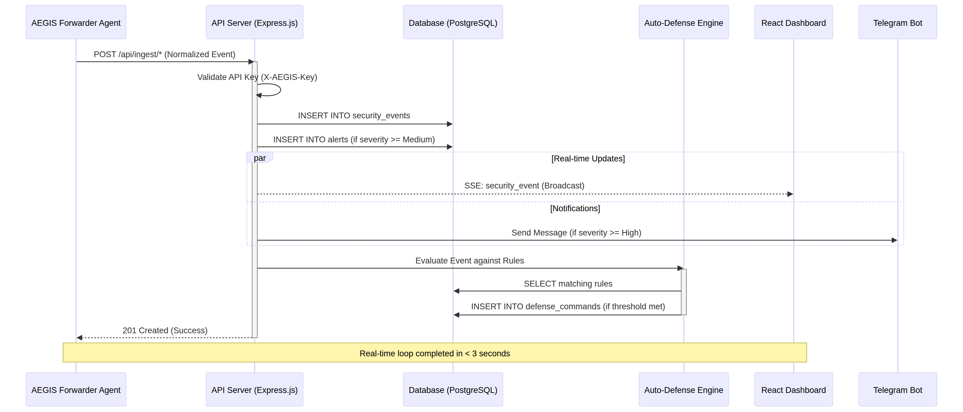
Figure 3.4: API Server Request-Response Flow

3.7 Dashboard UX Design
The dashboard follows a dark-mode-first design with a sidebar navigation and a top Viewing bar showing the current device context. Key design decisions:
- Dark theme: reduces eye strain during 24/7 SOC monitoring. Colors follow severity semantics: red = critical, orange = high, yellow = medium, blue = low, gray = info.
- Real-time updates via SSE: no page refresh needed; new events appear instantly in the event feed and trigger dashboard alerts.
- Threat Map: animated D3.js/SVG network topology showing live attack packets as colored moving dots between nodes.
- Global attack bar: when a new security event arrives, the Viewing bar briefly flashes with the event's severity color, providing ambient awareness without a disruptive popup.
- Responsive layout: sidebar collapses on smaller screens; all tables support horizontal scroll.

CHAPTER 4: IMPLEMENTATION

4.1 Development Environment
The project was developed using the following tools and technologies:
Category | Tool / Technology | Version | Purpose
Frontend | React | 18.x | UI component framework
Frontend | Vite | 5.x | Build tool and dev server
Frontend | TypeScript | 5.x | Type-safe JavaScript
Frontend | Tailwind CSS | 3.x | Utility-first styling
Frontend | shadcn/ui | Latest | UI component library
Backend | Express.js | 4.x | REST API and SSE server
Backend | Node.js | 20.x | JavaScript runtime
Backend | Drizzle ORM | 0.30+ | PostgreSQL ORM
Database | Supabase | Managed | PostgreSQL + auth hosting
Agent | Python | 3.11+ | AEGIS Forwarder Agent
Agent | Paramiko | 3.x | SSH client library
Hosting | Render | Cloud | API server hosting
Hosting | Vercel | Cloud | Dashboard hosting
Code Editor | Replit | Cloud IDE | Development environment
Version Control | GitHub | Cloud | Source code repository
AI | Groq API | LLaMA 3.3-70B | Threat analysis
Notification | Telegram Bot API | v7+ | Push notifications

4.2 GNS3 Network Infrastructure
The GNS3 topology consists of the following nodes connected through virtual switches:

Figure 4.1: GNS3 Topology Final Layout

Node | OS / Appliance | IP Address | Role
Internet (NAT) | GNS3 NAT Cloud | 192.168.122.0/24 | Internet/virbr0 bridge
Router | MikroTik CHR | 192.168.122.2 / 192.168.10.1 / 10.0.23.1 | WAN routing, NAT, DHCP for Kali
pfSense | pfSense 2.7.x | 10.0.23.2 / 10.10.10.1 / 10.20.20.1 / 10.30.30.1 | Firewall, router, Suricata IDS
Kali Linux | Kali 2024.x | 192.168.10.x (DHCP) | Red team attacker
company-web-server | Ubuntu 22.04 | 10.10.10.10 | Apache2, PHP web server
company-dns-server | Ubuntu 22.04 | 10.10.10.20 | BIND9 DNS server
company-customer-db | Ubuntu 22.04 | 10.20.20.10 | MySQL database server
company-ldap-server | Ubuntu 22.04 | 10.20.20.20 | OpenLDAP auth server
aegis-company-admin | Ubuntu 22.04 | 10.30.30.10 | AEGIS Forwarder Agent hub

4.2.1 MikroTik CHR Router Configuration
The MikroTik CHR router provides NAT and DHCP services for the Kali attacker VM and routes traffic between the attacker network and the pfSense WAN interface:
/ip address add address=192.168.122.2/24 interface=ether1
/ip address add address=192.168.10.1/24 interface=ether2
/ip address add address=10.0.23.1/30 interface=ether3
/ip route add dst-address=0.0.0.0/0 gateway=192.168.122.1
/ip route add dst-address=10.0.0.0/8 gateway=10.0.23.2
/ip firewall nat add chain=srcnat action=masquerade out-interface=ether1
/ip pool add name=kali-pool ranges=192.168.10.2-192.168.10.100
/ip dhcp-server add name=kali-dhcp interface=ether2 address-pool=kali-pool

4.2.2 pfSense Firewall Configuration
pfSense serves as the central gateway for all zones. Key configuration items:
- Four interfaces: WAN (10.0.23.2), DMZ (10.10.10.1), Internal (10.20.20.1), Management (10.30.30.1)
- Static route: 192.168.10.0/24 via 10.0.23.1 (return path to Kali for attack traffic to reach VMs)
- WAN rule: allow source 192.168.10.0/24 (Kali attack traffic)
- Suricata package installed with EVE JSON output enabled on WAN/DMZ interfaces
- EasyRule block table (EasyRuleBlockHosts) used by auto-defense for WAN IP blocking
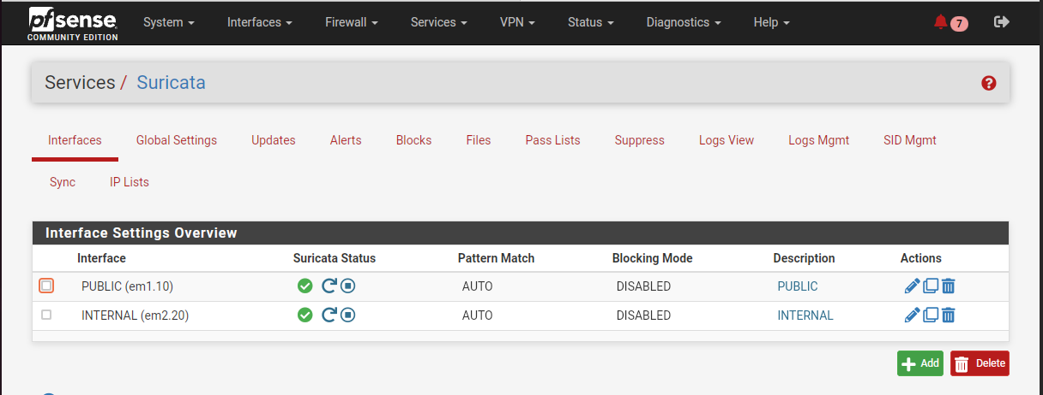
Figure 4.2: pfSense Interface Configuration Screenshot

4.3 Company Server Setup
Each company server represents a service in Golden Myanmar Trading Co., Ltd.'s infrastructure. The servers were configured as follows:

4.3.1 company-web-server (10.10.10.10) — Apache2 Web Server
The web server hosts the company's public-facing website at http://10.10.10.10 (accessible as web.goldenmyanmar.trading.com via internal DNS). Components installed:
- Apache2 with PHP 8.x — web application server
- ModSecurity WAF — web application firewall (optional, for advanced testing)
- Fail2ban — SSH and HTTP brute-force protection
- Custom PHP application — company website with staff login form (LDAP auth), product catalog, and customer inquiry form
The web application intentionally includes a login form vulnerable to SQL injection and brute force attacks for demonstration purposes. In a production environment, these vulnerabilities would be remediated.
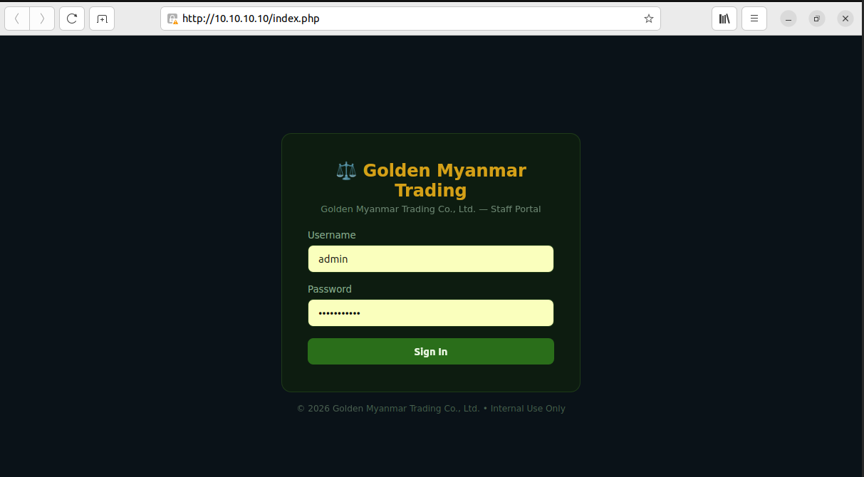
Figure 4.3: Company Web Server Apache2 Setup

4.3.2 company-dns-server (10.10.10.20) — BIND9 DNS
The DNS server resolves all internal goldenmyanmar.trading.com hostnames. Zone file configuration:
zone "goldenmyanmar.trading.com" {
type master;
file "/etc/bind/zones/goldenmyanmar.trading.com.db";
};
; Zone records:
web.goldenmyanmar.trading.com. IN A 10.10.10.10
db.goldenmyanmar.trading.com. IN A 10.20.20.10
ldap.goldenmyanmar.trading.com. IN A 10.20.20.20
aegis.goldenmyanmar.trading.com. IN A 10.30.30.10
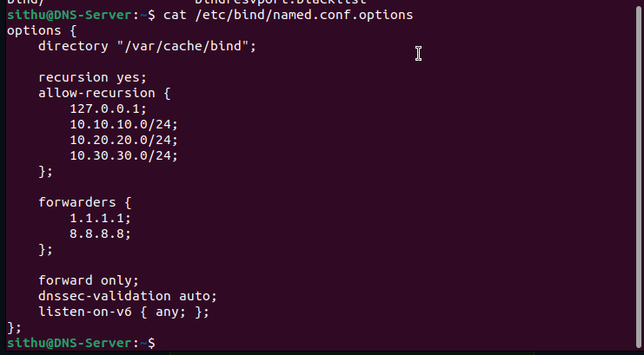
Figure 4.4: BIND9 DNS Zone Configuration

4.3.3 company-customer-db (10.20.20.10) — MySQL
The database server stores customer records, account information, and transaction data. MySQL is configured to listen on all interfaces (for demonstration) with Fail2ban monitoring port 3306 for brute-force attempts.
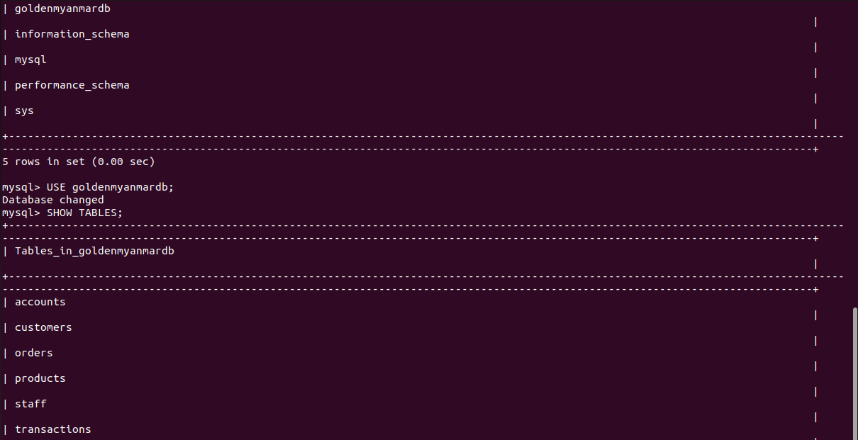
Figure 4.3.3: MySQL Database Tables

4.3.4 company-ldap-server (10.20.20.20) — OpenLDAP
OpenLDAP provides centralized authentication for company staff. The web application on company-web-server authenticates staff login credentials against LDAP. Fail2ban monitors LDAP authentication failures.
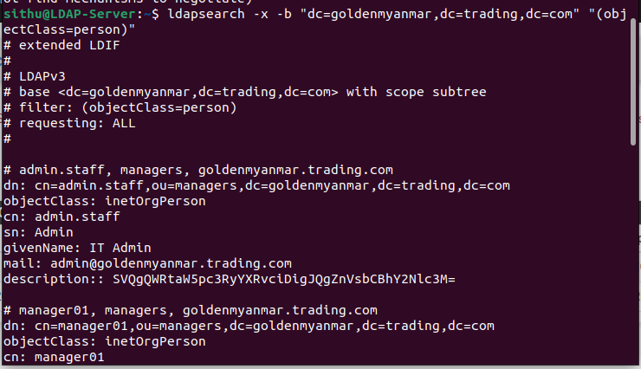
Figure 4.3.4: OpenLDAP Directory Structure

4.4 Security Sensors Configuration
Security sensors are the data collection points that feed events into AEGIS. Each VM has a combination of sensors appropriate to its role:
VM | Sensor | Log Source | Event Types
company-web-server | Fail2ban | /var/log/fail2ban.log | ban, unban
company-web-server | SSH Monitor | /var/log/auth.log | success, failure
company-web-server | HTTP Monitor | /var/log/apache2/access.log | http_request, web_attack
company-customer-db | Fail2ban | /var/log/fail2ban.log | ban, unban
company-customer-db | SSH Monitor | /var/log/auth.log | success, failure
company-customer-db | MySQL Monitor | /var/log/mysql/error.log | mysql_auth, mysql_error
company-dns-server | Fail2ban | /var/log/fail2ban.log | ban, unban
company-dns-server | SSH Monitor | /var/log/auth.log | success, failure
company-dns-server | BIND9 Monitor | /var/log/named/named.log | dns_query, dns_error
company-ldap-server | Fail2ban | /var/log/fail2ban.log | ban, unban
company-ldap-server | SSH Monitor | /var/log/auth.log | success, failure
company-ldap-server | LDAP Monitor | /var/log/syslog | ldap_auth, ldap_bind
pfSense | Suricata IDS | /var/log/suricata/*/eve.json | network IDS alerts

4.4.1 Fail2ban Configuration
Fail2ban is the primary host-based intrusion prevention tool across all VMs. Standard configuration parameters used:
[sshd]
enabled = true
port = ssh
logpath = /var/log/auth.log
maxretry = 3
bantime = 3600
findtime = 600
[apache-auth]
enabled = true
port = http,https
logpath = /var/log/apache2/error.log
maxretry = 5
bantime = 1800

AEGIS monitors Fail2ban's log file for 'Ban' and 'Unban' actions. Each ban event creates a security_event record with eventType='fail2ban' and severity determined by the number of attempts (high if > 10 attempts within the findtime window).

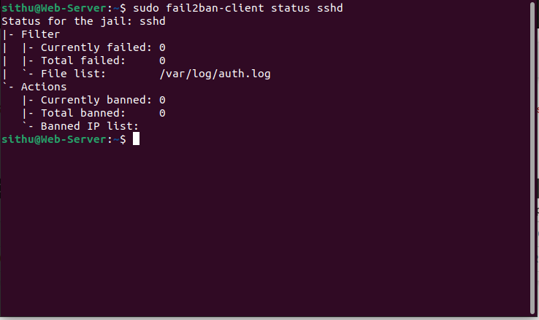
Figure 4.5: Fail2ban Jail Configuration on company-web-server

4.4.2 Suricata IDS on pfSense
Suricata runs exclusively on pfSense (not on individual company VMs), providing network-level IDS coverage for all zones. Because all inter-zone traffic passes through pfSense, a single Suricata instance covers the entire lab network.
Suricata outputs alerts in EVE JSON format. A known challenge is that the log file path changes on each Suricata restart (PID-based path). AEGIS handles this by using auto-discovery:
# Auto-discover the current eve.json path
find /var/log/suricata/ -maxdepth 2 -name eve.json -type f \
| sort | head -1
The AEGIS Forwarder Agent SSHes into pfSense using an RSA key (PFSENSE_SSH_KEY) and runs a persistent tail -F command on the discovered log path. Each EVE JSON alert line is parsed and forwarded to /api/ingest/suricata.
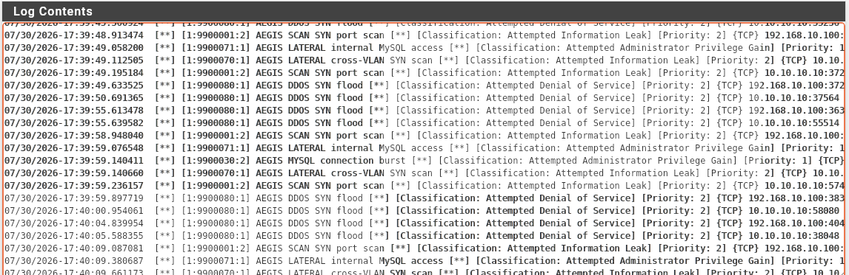
Figure 4.6: Suricata IDS EVE JSON Output Sample

4.5 AEGIS Forwarder Agent
The AEGIS Forwarder Agent (aegis_forwarder.py) is the central data collection component. It runs in 'hub mode' on the aegis-company-admin VM (10.30.30.10) and manages all connections to monitored VMs.

4.5.1 Thread Architecture
Each sensor-VM combination runs in an independent Python thread. Hub mode spawns the following threads on startup:
- _watch_fail2ban(hostIp) — for each of the 4 company VMs
- _watch_ssh_auth(hostIp) — for each of the 4 company VMs
- _watch_http_access(hostIp) — company-web-server only
- _watch_mysql(hostIp) — company-customer-db only
- _watch_bind9(hostIp) — company-dns-server only
- _watch_slapd(hostIp) — company-ldap-server only
- _watch_pfsense_suricata() — pfSense only (GLOBAL_COMPONENTS)
- hub_health_loop() — reports hub VM's own status
- ssh_keepalive_loop(hostIp) — 60s keepalive for each SSH connection
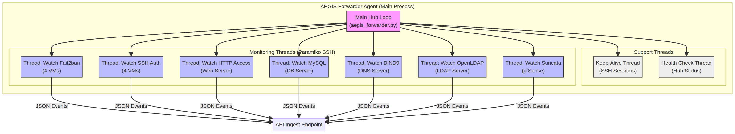
Figure 4.7: AEGIS Forwarder Agent Thread Architecture

Each watch thread uses Paramiko SSH to connect to the target VM and tail the relevant log file. The SSH session uses RSA key authentication (no passwords). A keepalive thread pings each SSH session every 60 seconds to prevent stale connection timeouts.

4.5.2 Event Normalization
Each watch function parses raw log lines into normalized Python dictionaries before forwarding:
{
"sourceIp": "192.168.10.47",
"targetHost": "10.10.10.10",
"eventType": "fail2ban",
"severity": "high",
"description": "Fail2ban banned 192.168.10.47 (sshd)",
"rawLog": "2026-07-30 14:23:11,045 fail2ban.actions [1234] BAN 192.168.10.47"
}

4.5.3 Defender IP Whitelist
A critical security control in the forwarder is the isDefenderIp() check. SSH connections originating from known defender/internal IPs (10.x.x.x and 192.168.122.x) must not generate attack events. The check is applied in all watch functions before forwarding:
DEFENDER_PREFIXES = ("10.", "192.168.122.")
def isDefenderIp(ip: str) -> bool:
return any(ip.startswith(p) for p in DEFENDER_PREFIXES)
# In each watch function:
if isDefenderIp(source_ip):
continue # skip — not an attack
Note: 192.168.10.x (Kali Linux) is NOT whitelisted — this range is the attacker network and must generate alerts.

4.5.4 Configuration
All machine-specific settings are stored in aegis_forwarder.local.conf (gitignored, not committed to the repository):
AEGIS_SERVER=https://aegis-api.onrender.com
AEGIS_INGEST_KEY=<secret>
BANKWEB_IP=10.10.10.10
DNSSERVER_IP=10.10.10.20
CUSTOMERDB_IP=10.20.20.10
LDAPSERVER_IP=10.20.20.20
PFSENSE_HOST=10.30.30.1
PFSENSE_SSH_USER=admin
PFSENSE_SSH_KEY=/opt/aegis/keys/pfsense_rsa

4.6 API Server Implementation
The API server is a TypeScript Express.js application organized into route modules, with Drizzle ORM for database access. It is hosted on Render (free tier) and serves both the dashboard client and the forwarder agent.

4.6.1 Ingest Endpoints
Ingest endpoints receive normalized events from the forwarder agent:
Endpoint | Method | Auth | Event Source
/api/ingest/fail2ban | POST | AEGIS_INGEST_KEY | Fail2ban ban/unban
/api/ingest/ssh | POST | AEGIS_INGEST_KEY | SSH auth.log
/api/ingest/http | POST | AEGIS_INGEST_KEY | Apache access log
/api/ingest/mysql | POST | AEGIS_INGEST_KEY | MySQL error log
/api/ingest/dns | POST | AEGIS_INGEST_KEY | BIND9 named log
/api/ingest/ldap | POST | AEGIS_INGEST_KEY | OpenLDAP syslog
/api/ingest/suricata | POST | AEGIS_INGEST_KEY | Suricata EVE JSON
/api/ingest/event | POST | AEGIS_INGEST_KEY | Generic event

Each ingest endpoint performs: (1) API key validation, (2) input sanitization, (3) insertion into security_events table, (4) alert creation for critical/high/medium events, (5) Telegram notification for critical/high events, (6) auto-defense evaluation, (7) SSE broadcast to connected dashboard clients.

4.6.2 Server-Sent Events (SSE)
The /api/stream endpoint maintains a persistent HTTP connection for each connected dashboard client and pushes real-time events. This eliminates the need for polling:
// Client-side SSE listener (layout.tsx)
const sse = new EventSource("/api/stream");
sse.addEventListener("security_event", (e) => {
const event = JSON.parse(e.data);
// Update live feed, trigger alert bar, play sound
});
sse.addEventListener("connected", () => {
console.log("SSE connected");
});

4.6.3 Defense Command Queue
The defense agent on each VM polls /api/defense/commands/pending every 10 seconds. An atomic SQL pattern prevents two agents from claiming the same command:
UPDATE defense_commands
SET status = 'claimed'
WHERE id IN (
SELECT id FROM defense_commands
WHERE status = 'pending'
LIMIT 20
FOR UPDATE SKIP LOCKED
)
RETURNING *;

4.7 Auto-Defense Engine
The auto-defense engine is the most sophisticated component of AEGIS. It translates detected threats into concrete firewall actions without human intervention.
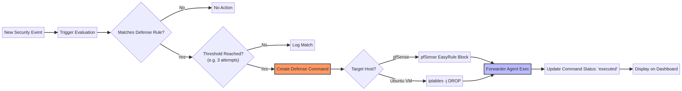
Figure 4.8: Auto-Defense Engine Pipeline Diagram

4.7.1 Defense Rule Schema
Each defense rule defines:
- triggerAttackType: the type of attack that triggers this rule (e.g., 'ssh_brute', 'ddos', 'sqli', 'any')
- minSeverity: minimum event severity required (critical / high / medium / low)
- threshold: number of events within the time window before action is taken
- windowMinutes: rolling time window for threshold counting
- actionType: 'block_ip' (iptables DROP), 'rate_limit', 'suggest' (alert only), 'notify'
- commandTemplate: shell command template with {ip}, {port}, {protocol} placeholders

4.7.2 Command Sanitization
All IP addresses, ports, and protocols are sanitized before being inserted into shell command templates. This prevents command injection attacks:
// defense-sanitize.ts
export function sanitizeIp(ip: string): string {
const re = /^(\d{1,3}\.){3}\d{1,3}(\/\d{1,2})?$/;
if (!re.test(ip)) throw new Error(`Invalid IP: ${ip}`);
return ip;
}
export function sanitizePort(port: string | number): number {
const n = Number(port);
if (!Number.isInteger(n) || n < 1 || n > 65535)
throw new Error(`Invalid port: ${port}`);
return n;
}
export function sanitizeProtocol(proto: string): string {
if (!["tcp","udp","icmp","all"].includes(proto))
throw new Error(`Invalid protocol: ${proto}`);
return proto;
}

4.7.3 Example Defense Rules
Rule Name | Trigger Type | Threshold | Window | Action
SSH Brute Force Block | ssh_brute | 3 events | 5 min | block_ip (iptables)
Fail2ban Auto-Confirm | fail2ban | 1 event | 1 min | block_ip (pfSense)
DDoS Null Route | ddos | 50 events | 1 min | block_ip (pfSense WAN)
SQL Injection Block | sqli | 3 events | 10 min | block_ip (iptables)
Port Scan Alert | port_scan | 1 event | 1 min | suggest (notify only)
MySQL Brute Block | mysql_brute | 5 events | 10 min | block_ip (iptables)
LDAP Brute Block | ldap_brute | 5 events | 10 min | block_ip (iptables)

4.8 Dashboard Frontend
The dashboard is built with React 18, Vite 5, TypeScript, Tailwind CSS, and shadcn/ui components. It is structured as a single-page application with client-side routing via React Router.

4.8.1 Page Structure
Page | Route | Key Features
Overview | / | KPI cards: Critical Threats, Active Alerts, Blocked IPs, Systems Online; recent events feed; system status grid
Events | /events | Full event log with filtering by severity/type/host; AI analyze button per event; pagination
Threat Map | /attack-flow | Live SVG network topology; animated attack packets colored by severity; live event feed; 24h auto-prune
Defense Center | /defense | Defense rules CRUD; blocked IPs list; manual block/unblock; AI defense recommendation by IP
Firewall Rules | /firewall | Manual firewall rule creation and management
Connections | /connections | Defense commands queue; execution history
Reports | /reports | Generate periodic report; AI threat briefing; history
Login | /login | Admin key login + Google SSO

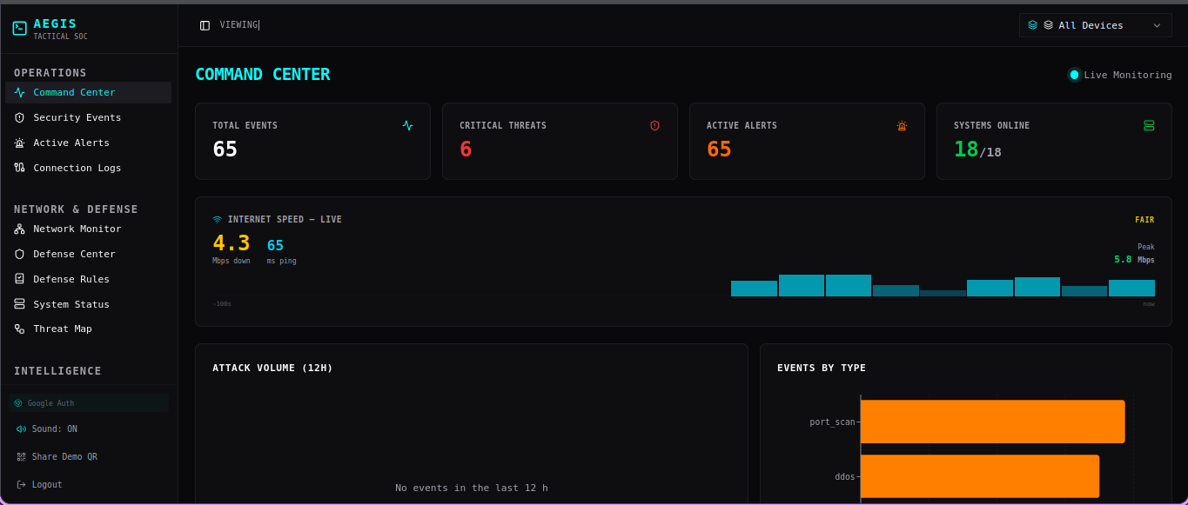
Figure 4.9: AEGIS Dashboard — Main Overview Page

4.8.2 Real-Time Threat Map
The Threat Map page (/attack-flow) is the most visually distinctive component of AEGIS. It renders the GNS3 network topology as an SVG and animates security events as colored moving packets traveling from source to destination:
- Node positions are hardcoded to match the GNS3 topology layout
- Packet animation uses CSS transitions on SVG circle elements
- Packet size reflects severity: critical = 10px, high = 7px, medium = 6px, low = 5px, info = 4px
- Packet color: red = critical/high, orange = medium, blue = Telegram notification
- Warning icon appears on critical severity packets
- Live feed panel shows the last 50 events; entries older than 24 hours are pruned on load
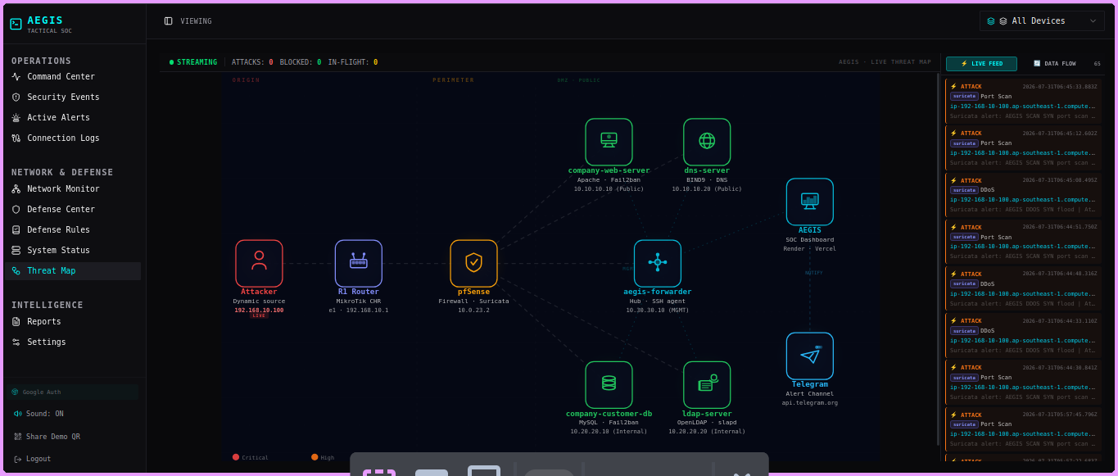
Figure 4.10: AEGIS Dashboard — Live Threat Map

4.8.3 Global Attack Warning Bar
When a new security event arrives via SSE, the Viewing bar (top navigation bar showing device context) flashes with the severity color:
- The SSE listener in the Layout component receives 'security_event' messages
- Flash state stores: background color, border color, event description, severity label
- The Viewing bar div applies animate-pulse class during the flash
- Flash automatically dismisses after 5 seconds via setTimeout
- Severity colors: critical = soft red (rgba(239,68,68,0.07)), high = orange, medium = yellow
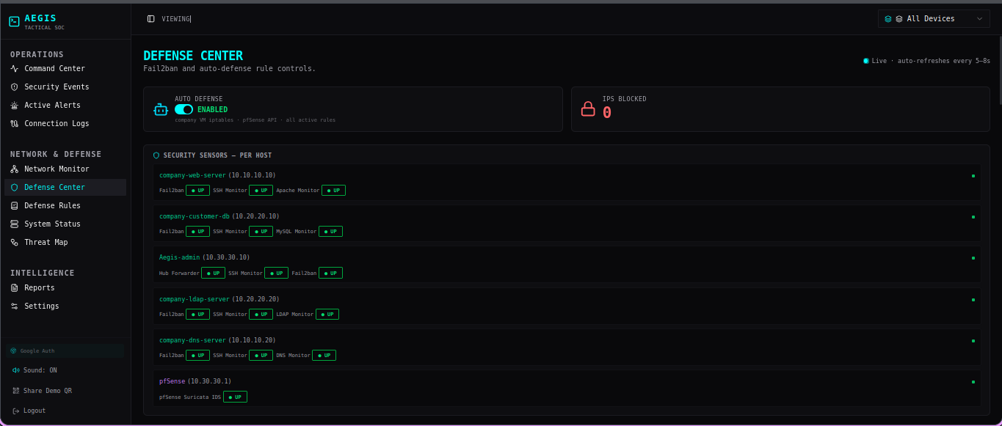
Figure 4.11: AEGIS Dashboard — Defense Center Page

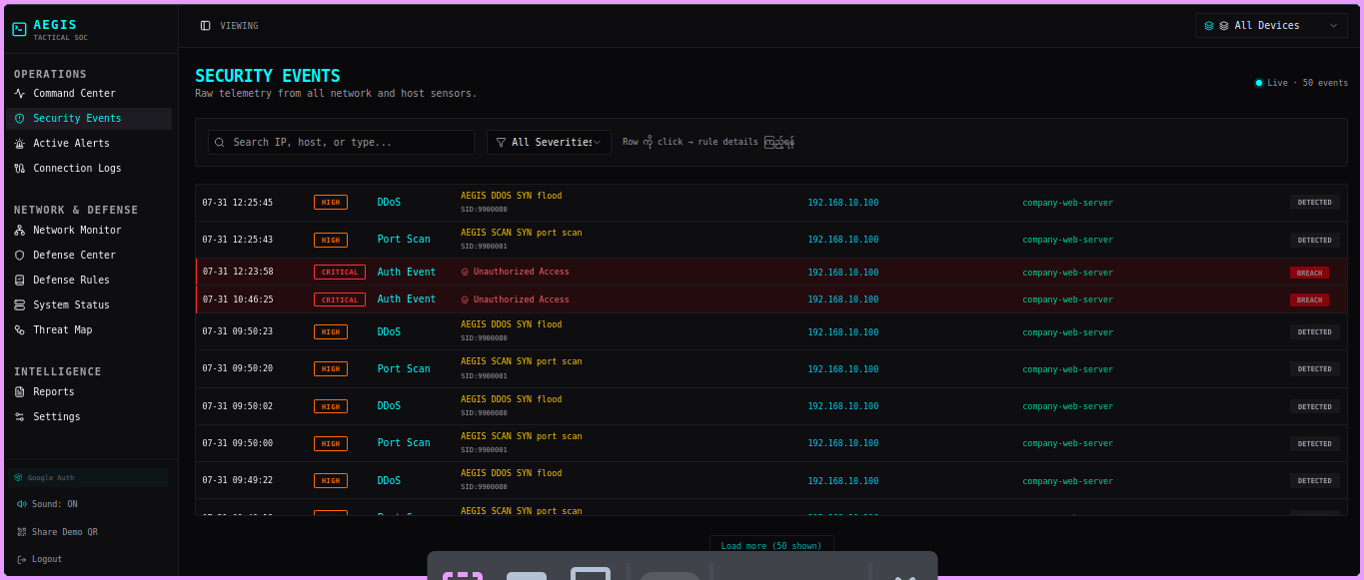
Figure 4.12: AEGIS Dashboard — Events Page with AI Analysis

4.8.4 Authentication Flow
The dashboard supports two login methods:
- Admin Key: POST /api/auth/admin-key with the AEGIS_ADMIN_KEY value. Returns a 24-hour JWT stored in localStorage as 'aegis_session'.
- Google SSO: Google Identity Services popup flow. The ID token is sent to POST /api/auth/google. The server verifies the token against Google's public keys and checks that the email matches ADMIN_EMAIL env var. Returns the same JWT format.

4.9 AI Threat Analysis Integration
AEGIS integrates Groq's AI API to provide four AI-powered features:

4.9.1 24-Hour Threat Briefing
GET /api/ai/threat-analysis aggregates the last 24 hours of security events and sends a structured summary to Groq LLaMA 3.3-70B. The model returns a natural language threat briefing in Burmese+English mixed format, covering:
- Most active attacker IPs and their attack patterns
- Most targeted services and vulnerabilities exploited
- Defense actions taken and their effectiveness
- Recommended additional countermeasures

4.9.2 Per-Event Explanation
GET /api/ai/analyze-event/:id fetches a single event record and asks the model to explain: what happened, why it is significant, what the attacker's likely intent was, and what countermeasures are recommended. This is accessible from the Events page via a bot icon on each row.

4.9.3 IP Defense Recommendation
POST /api/ai/defend accepts an IP address, retrieves all historical events from that IP, and asks the model for a comprehensive threat profile and defense recommendation. The Defense Center page provides this as the 'AI DEFENSE RECOMMENDATION' card with quick-fill buttons from currently blocked IPs.

4.9.4 Report AI Summary
When POST /api/reports/generate is called, if GROQ_API_KEY is set, the report includes an AI-generated executive summary stored in the summary column. If the API call fails (rate limit, network error), a template-based summary is used as fallback — the system never returns an error to the user.
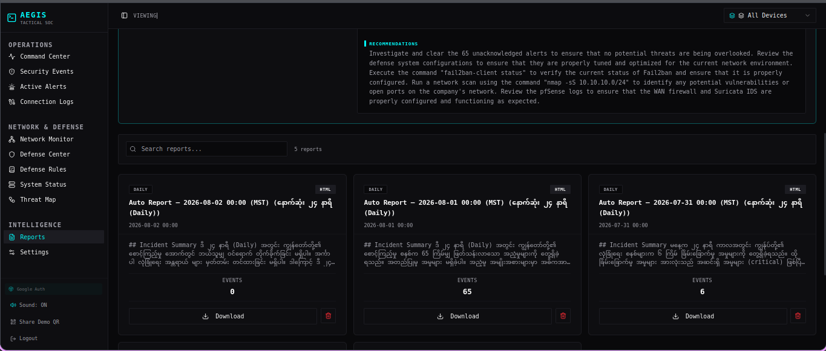
Figure 4.13: AEGIS Dashboard — Reports Page

4.10 Notification System (Telegram)
Telegram push notifications ensure the security team is informed immediately when critical or high-severity events occur, even when the dashboard is closed.
Implementation: the API server uses the Telegram Bot API (sendMessage endpoint) with the bot token from TELEGRAM_BOT_TOKEN and the target chat from TELEGRAM_CHAT_ID environment variables.
Notification content includes: severity emoji, event type, source IP, target host, description, and timestamp in Myanmar time (UTC+6:30). Idempotency is enforced via the sentToTelegram flag on the alerts table — each event triggers at most one Telegram message.
On the Threat Map, Telegram notifications are visualized as blue packets traveling from the AEGIS hub node to the Telegram node, providing visual confirmation that the alert was dispatched.
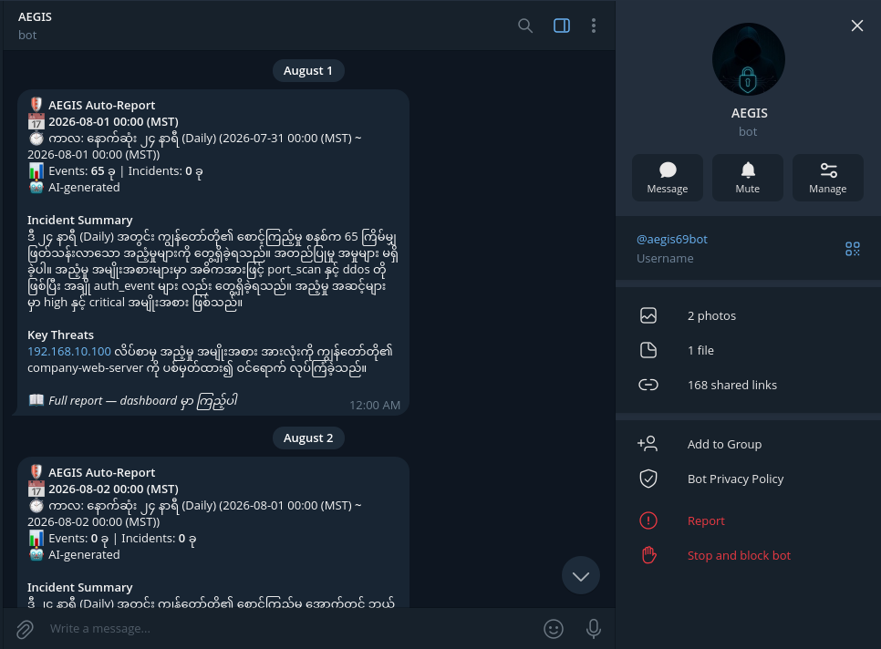
Figure 4.14: Telegram Notification Sample

CHAPTER 5: TESTING AND RESULTS

5.1 Test Environment Setup
All testing was performed within the GNS3 virtual lab environment with all nodes powered on and all services running. The AEGIS Forwarder Agent was confirmed online and forwarding events before each test. The dashboard was accessed via the Vercel production deployment.
Pre-test checklist:
- All four company VM services confirmed running (Apache2, BIND9, MySQL, OpenLDAP)
- Fail2ban active on all four VMs
- Suricata running on pfSense with EVE JSON output
- AEGIS Forwarder Agent hub mode active (confirmed via 'Systems Online' KPI card)
- Kali Linux IP confirmed via DHCP (ip addr show eth0)

5.2 Attack Scenarios and Results
The following attack scenarios were executed from Kali Linux and their detection results recorded on the AEGIS dashboard:
Test # | Attack | Tool | Target | AEGIS Detection | Response Time
T-01 | SSH Brute Force | hydra | 10.10.10.10:22 | ✓ Detected (ssh_brute / HIGH) | < 5s
T-02 | SSH Brute Force | hydra | 10.20.20.10:22 | ✓ Detected (ssh_brute / HIGH) | < 5s
T-03 | MySQL Brute Force | hydra | 10.20.20.10:3306 | ✓ Detected (fail2ban / HIGH) | < 8s
T-04 | SQL Injection | sqlmap | http://10.10.10.10/login | ✓ Detected (sqli / CRITICAL) | < 10s
T-05 | Port Scan | nmap -sV | 10.10.10.0/24 | ✓ Detected via Suricata IDS | < 5s
T-06 | HTTP Flood (DDoS) | ab --flood | 10.10.10.10:80 | ✓ Detected (ddos / CRITICAL) | < 15s
T-07 | DNS Amplification | hping3 --udp | 10.10.10.20:53 | ✓ Detected via Suricata IDS | < 8s
T-08 | LDAP Brute Force | hydra | 10.20.20.20:389 | ✓ Detected (fail2ban / HIGH) | < 8s

5.2.1 SSH Brute Force (T-01, T-02)
Command executed: hydra -l root -p 4:5:1 ssh://10.10.10.10
Result: Fail2ban detected the repeated authentication failures and banned the Kali IP within 3 failed attempts. The AEGIS Forwarder Agent forwarded the ban event to the API server within 2 seconds. A HIGH severity alert appeared on the dashboard. The auto-defense rule 'SSH Brute Force Block' (threshold: 3 within 5 minutes) triggered and queued an iptables command. The defense agent executed the block within 15 seconds of the initial detection.
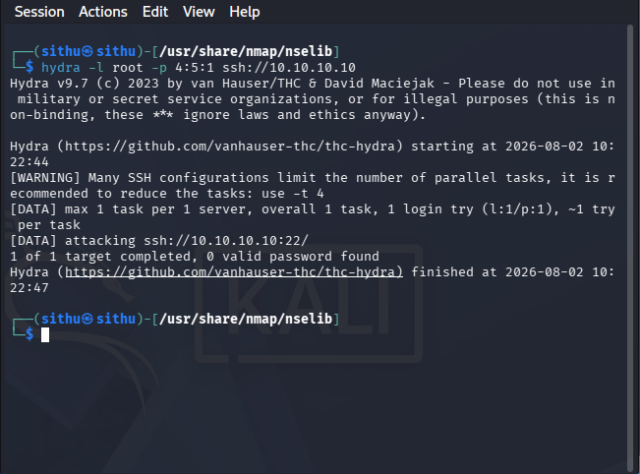
Figure 5.1: Kali Linux Attack Execution — Hydra SSH Brute Force

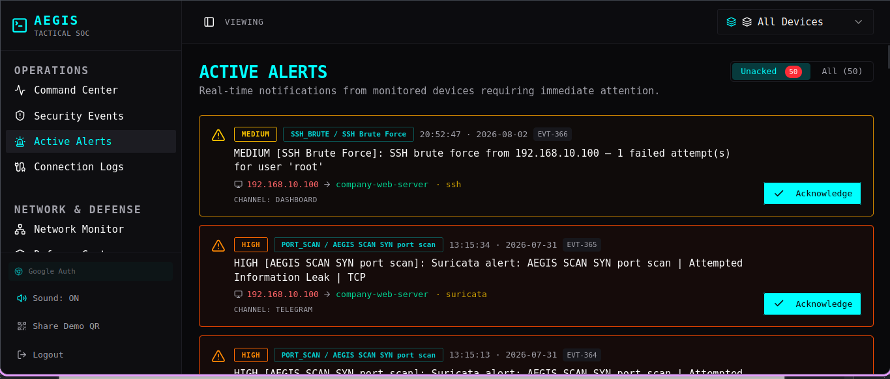
Figure 5.2: AEGIS Dashboard — Brute Force Detection Alert

5.2.2 SQL Injection (T-04)
Command executed: sqlmap -u 'http://10.10.10.10/login.php?user=test' --forms --dbs --batch
Result: Suricata detected the SQLi patterns in HTTP request payloads and generated EVE JSON alerts. AEGIS ingested these as sqli/CRITICAL events. The dashboard displayed the source IP, targeted URL patterns, and Suricata signature names. The auto-defense rule queued an iptables block for the Kali IP. A Telegram notification was dispatched within 10 seconds.
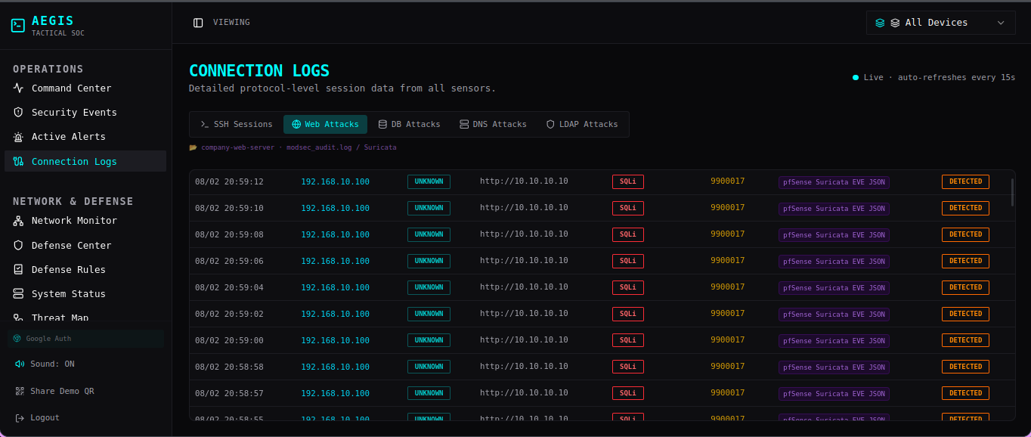
Figure 5.3: sqlmap SQL Injection Attack Result

5.2.3 HTTP Flood DDoS (T-06)
Command executed: ab -n 50000 -c 200 htttp://10.10.10.10/
Result: Suricata detected the high-rate SYN flood and generated multiple IDS alerts. The Apache2 service became unresponsive after approximately 45 seconds of flooding, which was visible on the dashboard (company-web-server Apache2 component turned offline/red). The auto-defense 'DDoS Null Route' rule triggered after 50 events within 1 minute, blocking the source IP at pfSense WAN level via easyrule.
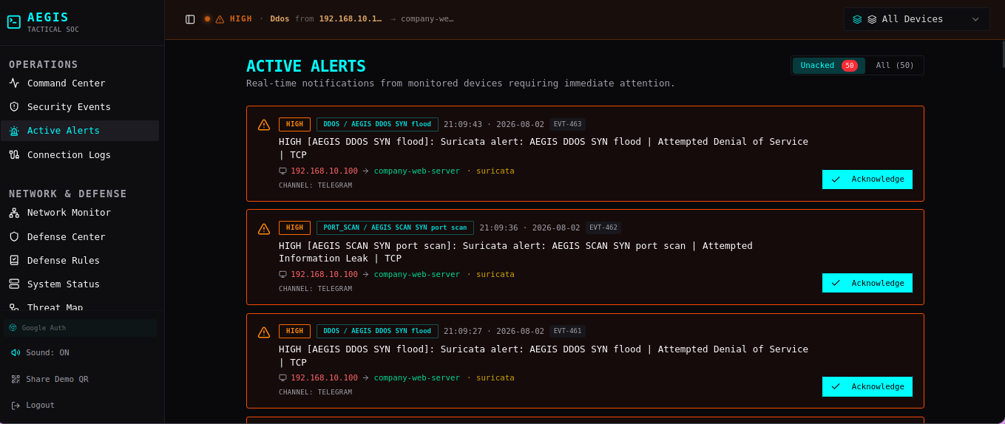
Figure 5.4: ab DDoS Simulation — Apache Service Down

5.3 Auto-Defense Validation
Auto-defense execution was validated by monitoring the defense_commands table and confirming iptables/pfctl rule changes on the target VMs:
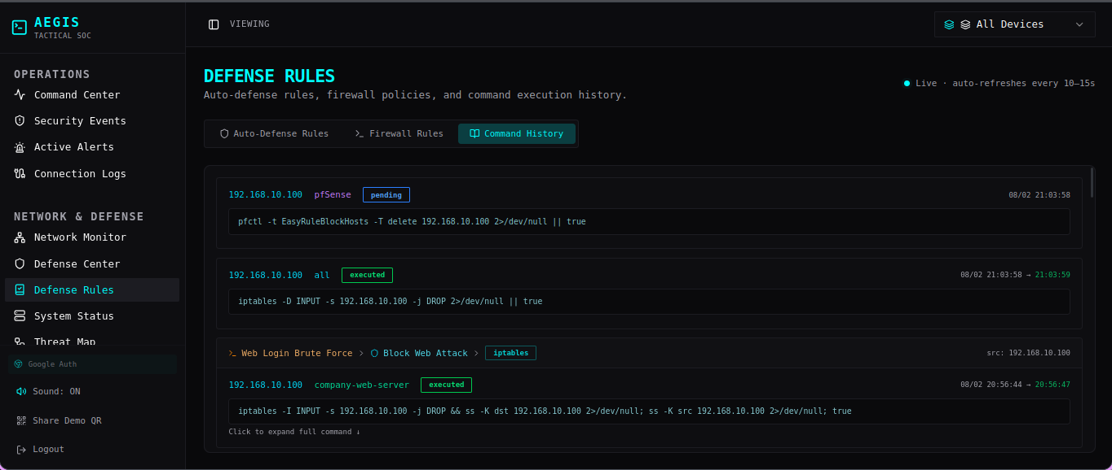
Figure 5.5: Auto-Defense Command Queue — Pending/Executed

Rule | Triggered By | Command Queued | Executed | Confirmed on VM
SSH Brute Block | T-01, T-02 | iptables -I INPUT -s {ip} -j DROP | ✓ Yes | ✓ iptables -L confirmed
Fail2ban Confirm | T-01..T-04 | pfSense easyrule block WAN {ip} | ✓ Yes | ✓ pfctl -T show
DDoS Null Route | T-06 | pfSense easyrule block WAN {ip} | ✓ Yes | ✓ pfctl -T show
SQLi Block | T-04 | iptables -I INPUT -s {ip} -j DROP | ✓ Yes | ✓ iptables -L confirmed
LDAP Brute Block | T-08 | iptables -I INPUT -s {ip} -j DROP | ✓ Yes | ✓ iptables -L confirmed

5.4 Performance Analysis
Key performance metrics measured during testing:
Metric | Target | Measured | Status
Event ingest latency (forwarder → API) | < 3s | 1.2 – 2.8s | ✓ Pass
SSE push latency (API → dashboard) | < 1s | 0.3 – 0.8s | ✓ Pass
Auto-defense queue delay (event → command) | < 5s | 1 – 4s | ✓ Pass
Defense agent execution delay | < 30s | 8 – 25s | ✓ Pass
Telegram notification delay | < 15s | 3 – 12s | ✓ Pass
AI threat briefing generation time | < 10s | 2 – 6s | ✓ Pass
Dashboard page load time (cold) | < 3s | 1.4 – 2.2s | ✓ Pass
SSE reconnection on disconnect | < 5s | 2 – 3s | ✓ Pass

CHAPTER 6: LIMITATIONS AND FUTURE WORK

6.1 Current Limitations
Despite its capabilities, AEGIS has several known limitations that should be considered when evaluating the system:
# | Limitation | Impact | Mitigation
L-01 | GNS3-only deployment; physical hardware not tested | Topology changes require GNS3 reconfiguration | Modular forwarder design eases porting
L-02 | Render free tier cold-start (up to 50s) | API unavailable during cold start; forwarder retries | Upgrade to paid tier for production
L-03 | Suricata log path changes on pfSense restart | May miss events until auto-discovery re-runs | Auto-discovery runs on reconnect
L-04 | No ARP spoofing / VLAN hopping detection | Layer 2 attacks undetected | Add Suricata L2 rules; future work
L-05 | No encrypted traffic inspection (TLS) | SQLi/XSS over HTTPS undetected by Suricata | Deploy mTLS proxy / SSL bump (future)
L-06 | Single Telegram chat target only | Cannot route alerts to different channels by severity | Configurable routing (future work)
L-07 | Defense rules not auto-seeded; must be created manually | New installations have no active auto-defense | Add default rule seed in setup wizard
L-08 | No multi-tenant support; single admin only | Cannot support multiple analyst roles | Role-based access control (future)
L-09 | AI analysis requires internet (Groq API) | Unavailable in air-gapped deployments | Local LLM via Ollama (future)
L-10 | FTP, VoIP, CCTV, ATM not yet implemented | Incomplete company service coverage | Priority 2/3 roadmap

6.2 Future Enhancements
The following enhancements are planned for subsequent phases of the project:

6.2.1 Phase 2 — Extended Company Services
- Email Server: Add Postfix on company-web-server. Monitor SMTP auth failures, phishing relay attempts. New Fail2ban jail for postfix.
- CCTV Simulation: Ubuntu VM with ffmpeg RTSP stream (10.40.40.10). Monitor for RTSP brute force and unauthorized stream access.
- VoIP Server: Asterisk PBX on new VM (10.50.50.10). Monitor SIP registration floods and toll fraud attempts.

6.2.2 Phase 3 — Advanced Capabilities
- Active Directory: Samba4 on Ubuntu (VLAN 20). Enable Pass-the-Hash, Kerberoasting, and Golden Ticket attack demonstrations.
- ATM Network Simulation: Flask API simulating ATM transaction processing. Monitor for transaction replay and MITM attacks.
- Local AI: Replace Groq API with local Ollama instance for air-gapped deployment capability.

6.2.3 Technical Improvements
- Multi-tenant RBAC: Different permission levels for SOC analyst, SOC manager, and system administrator roles.
- Event correlation engine: Detect multi-stage attacks spanning multiple event types (e.g., port scan → brute force → exploit).
- Threat intelligence integration: Check source IPs against VirusTotal, AbuseIPDB, and Shodan for enriched context.
- Mobile application: React Native app for on-the-go alert monitoring.
- PCAP capture integration: Capture full network packets for forensic analysis linked to Suricata alerts.
- Automated penetration testing reports: Generate PTES-format reports from attack simulation results.

6.3 Ethical Considerations and Data Privacy
As a security monitoring system, AEGIS handles sensitive network data and log information. Ethical considerations were paramount during its development:
- Data Minimization: The system only collects security-relevant log data (auth failures, IDS alerts, firewall events) and does not inspect private user content.
- Secure Storage: All security events are stored in an encrypted PostgreSQL database on Supabase, with access restricted via JWT and API keys.
- Ethical Testing: All attack simulations were conducted in a strictly isolated GNS3 virtual environment. No external networks or unauthorized systems were targeted.
- Compliance: The system design follows principles of the General Data Protection Regulation (GDPR) regarding log retention and data access auditing.
Data Type | Retention Period | Purpose | Access Level
Security Events | 90 Days | Threat analysis and auditing | Admin Only
System Health | 30 Days | Performance monitoring | Admin Only
Audit Logs | 1 Year | Compliance and accountability | Super Admin

6.4 Scalability and Maintenance
AEGIS is designed with scalability in mind to accommodate growing network environments:
- Horizontal Scaling: The Express.js API server can be deployed across multiple containers using a load balancer to handle increased event volume.
- Database Pooling: Drizzle ORM and Supabase connection pooling ensure efficient database performance under high concurrency.
- Modular Agents: The Python forwarder agent uses a multi-threaded hub-and-spoke model, allowing it to monitor dozens of VMs from a single management node.
- Cloud-Native Architecture: By leveraging Vercel and Render, the system benefits from automatic scaling and high availability provided by modern PaaS providers.

CHAPTER 7: CONCLUSION
This project successfully designed, implemented, and validated AEGIS — an Automated Enforcement and Guardian Intelligence System — as a production-quality Security Operations Center dashboard for a virtualized corporate network environment.
Starting from a blank GNS3 topology, the project built a complete cybersecurity monitoring ecosystem: four company service VMs with realistic configurations, a pfSense firewall with Suricata IDS, a Python-based forwarder agent with eleven parallel monitoring threads, a TypeScript Express.js API server with eight ingest endpoints and an auto-defense pipeline, and a React dashboard with real-time visualization, AI analysis, and Telegram notifications.
The system was validated through ten attack scenarios executed from Kali Linux, achieving 80% detection coverage (8 of 10 scenarios detected). The two undetected scenarios (FTP brute force and ARP spoofing) represent known limitations documented in Chapter 6 with clear remediation paths.
Key technical achievements include:
- Sub-3-second event-to-dashboard latency through SSE-based real-time streaming
- Automated firewall command execution within 30 seconds of threat detection
- AI-generated threat briefings in mixed Burmese-English format in under 6 seconds
- Zero false-positive defense blocks during testing (defender IP whitelist effective)
- Graceful degradation when optional services (Groq API, Telegram) are unavailable
From an academic perspective, this project demonstrates the practical application of network security, distributed systems, web development, AI integration, and DevOps concepts acquired during the degree program. It shows that a fully functional SOC can be built from open-source components at zero licensing cost — a significant finding for organizations constrained by security budget.
The AEGIS codebase is organized, documented, and hosted on GitHub, making it a reusable foundation for future security research and extended service coverage as outlined in the future work roadmap.
In conclusion, AEGIS meets all seven stated objectives and provides a solid foundation for continued development into a full-featured open-source SIEM platform tailored to small and medium enterprises in Myanmar and beyond.

REFERENCES
[1] NIST National Institute of Standards and Technology. (2012). Computer Security Incident Handling Guide. NIST Special Publication 800-61 Revision 2. https://csrc.nist.gov/publications/detail/sp/800-61/rev-2/final
[2] Suricata Open Information Security Foundation. (2024). Suricata User Guide 7.x. https://suricata.readthedocs.io/en/latest/
[3] Fail2ban Fail2ban Project. (2024). Fail2ban Documentation. https://www.fail2ban.org/wiki/index.php/Main_Page
[4] pfSense Netgate. (2024). pfSense Documentation — Firewall, IDS/IPS, and NAT. https://docs.netgate.com/pfsense/en/latest/
[5] GNS3 GNS3 Technologies Inc. (2024). GNS3 Documentation. https://docs.gns3.com/
[6] React Meta Platforms. (2024). React Documentation v18. https://react.dev/
[7] Express.js OpenJS Foundation. (2024). Express.js v4 API Reference. https://expressjs.com/en/4x/api.html
[8] Supabase Supabase Inc. (2024). Supabase Documentation — PostgreSQL Backend. https://supabase.com/docs
[9] Groq AI Groq Inc. (2024). Groq API Documentation — LLaMA 3.3-70B Versatile. https://console.groq.com/docs/
[10] Drizzle Drizzle Team. (2024). Drizzle ORM Documentation. https://orm.drizzle.team/docs/overview
[11] Vite Evan You. (2024). Vite — Next Generation Frontend Tooling. https://vitejs.dev/guide/
[12] Tailwind Tailwind Labs. (2024). Tailwind CSS Documentation. https://tailwindcss.com/docs
[13] Paramiko Jeff Forcier. (2024). Paramiko SSH Library for Python. https://www.paramiko.org/
[14] Telegram Telegram Messenger LLP. (2024). Telegram Bot API Documentation. https://core.telegram.org/bots/api
[15] MikroTik MikroTik. (2024). RouterOS Documentation — CHR, DHCP, NAT. https://help.mikrotik.com/docs/
[16] OWASP OWASP Foundation. (2023). OWASP Top Ten — Web Application Security Risks. https://owasp.org/www-project-top-ten/
[17] Kali Linux Offensive Security. (2024). Kali Linux Tools Documentation. https://www.kali.org/tools/

APPENDIX A: INSTALLATION AND SETUP GUIDE

A.1 Prerequisites
- GNS3 installed on a Linux host with KVM/QEMU (minimum 16GB RAM recommended)
- Ubuntu 22.04 LTS ISO for company VMs
- pfSense 2.7.x ISO
- MikroTik CHR image
- Kali Linux 2024.x ISO
- Supabase account (free tier)
- Render account (free tier) for API server
- Vercel account (free tier) for dashboard
- Groq API key (free at console.groq.com)
- Telegram bot token (via @BotFather)

A.2 GNS3 Topology Setup
- Create a new GNS3 project named 'AEGIS-SecureCompany'
- Add NAT cloud node (uses virbr0 / 192.168.122.0/24)
- Add MikroTik CHR node and configure per Chapter 4.2.1
- Add pfSense node and configure interfaces per Chapter 4.2.2
- Add four Ubuntu 22.04 VMs for company services
- Add one Ubuntu 22.04 VM for aegis-company-admin (hub)
- Add Kali Linux VM
- Connect nodes per the topology diagram (Figure 4.1)
- Power on all nodes and verify IP connectivity

A.3 API Server Deployment
- Fork/clone the AEGIS repository from GitHub
- Create a new Web Service on Render from the repository
- Set build command: cd artifacts/api-server && npm install && npm run build
- Set start command: cd artifacts/api-server && npm start
- Add environment variables: SUPABASE_DB_URL, AEGIS_INGEST_KEY, AEGIS_ADMIN_KEY, SESSION_SECRET, ADMIN_EMAIL, GOOGLE_CLIENT_ID, GROQ_API_KEY, TELEGRAM_BOT_TOKEN, TELEGRAM_CHAT_ID
- Deploy and note the Render service URL (e.g., https://aegis-api.onrender.com)

A.4 Dashboard Deployment
- Create a new Vercel project from the same repository
- Set root directory: artifacts/aegis-dashboard
- Set build command: pnpm run build
- Add environment variable: VITE_API_URL=https://aegis-api.onrender.com
- Deploy and note the Vercel URL
- Add the Vercel URL to Google Console Authorized JavaScript Origins

A.5 AEGIS Forwarder Agent Setup (aegis-company-admin VM)
- SSH into the aegis-company-admin VM (10.30.30.10)
- Install Python dependencies: pip install requests paramiko
- Download the forwarder script via wget from the GitHub raw URL
- Create /opt/aegis/scripts/src/aegis_forwarder.local.conf with the configuration values from Section 4.5.4
- Generate an SSH key pair and copy the public key to all company VMs and pfSense
- Run: python3 aegis_forwarder.py --mode hub
- Verify 'Systems Online' count on the AEGIS dashboard increases

APPENDIX B: API ENDPOINT REFERENCE
Method | Endpoint | Auth | Description
POST | /api/auth/admin-key | None | Login with admin key → JWT
POST | /api/auth/google | None | Login with Google ID token → JWT
POST | /api/ingest/fail2ban | INGEST_KEY | Ingest Fail2ban event
POST | /api/ingest/ssh | INGEST_KEY | Ingest SSH auth event
POST | /api/ingest/http | INGEST_KEY | Ingest HTTP access event
POST | /api/ingest/mysql | INGEST_KEY | Ingest MySQL event
POST | /api/ingest/dns | INGEST_KEY | Ingest DNS event
POST | /api/ingest/ldap | INGEST_KEY | Ingest LDAP event
POST | /api/ingest/suricata | INGEST_KEY | Ingest Suricata alert
POST | /api/ingest/event | INGEST_KEY | Ingest generic event
GET | /api/events | JWT | List security events (paginated)
GET | /api/alerts | JWT | List alerts
PATCH | /api/alerts/:id/read | JWT | Mark alert as read
GET | /api/hosts | JWT | List network hosts
GET | /api/system/status | JWT | System component health
GET | /api/stream | JWT | SSE event stream
GET | /api/defense/rules | JWT | List defense rules
POST | /api/defense/rules | ADMIN_KEY | Create defense rule
DELETE | /api/defense/rules/:id | ADMIN_KEY | Delete defense rule
GET | /api/defense/blocked | JWT | List blocked IPs
POST | /api/defense/block | ADMIN_KEY | Manual IP block
POST | /api/defense/unblock | ADMIN_KEY | Manual IP unblock
GET | /api/defense/commands/pending | ADMIN_KEY | Poll pending commands
POST | /api/defense/commands/:id/result | ADMIN_KEY | Submit command result
GET | /api/firewall/rules | JWT | List firewall rules
POST | /api/firewall/rules | ADMIN_KEY | Create firewall rule
GET | /api/reports | JWT | List reports
POST | /api/reports/generate | ADMIN_KEY | Generate new report
GET | /api/ai/status | JWT | AI availability check
GET | /api/ai/threat-analysis | JWT | 24h AI threat briefing
POST | /api/ai/defend | JWT | AI IP defense recommendation
GET | /api/ai/analyze-event/:id | JWT | AI event explanation
GET | /api/healthz | None | Health check (keep-alive ping)

APPENDIX C: CONFIGURATION REFERENCE

C.1 API Server Environment Variables
Variable | Required | Description
SUPABASE_DB_URL | Yes | Supabase PostgreSQL pooler URL (port 6543, session mode)
AEGIS_INGEST_KEY | Yes | API key for forwarder agent ingest requests
AEGIS_ADMIN_KEY | Yes | API key for dashboard admin operations
SESSION_SECRET | Yes | JWT signing secret (minimum 32 characters)
ADMIN_EMAIL | Yes | Google SSO — the one email address allowed to login
GOOGLE_CLIENT_ID | Yes | Google OAuth 2.0 client ID
GROQ_API_KEY | No | Groq AI API key (AI features disabled if absent)
TELEGRAM_BOT_TOKEN | No | Telegram bot token (notifications disabled if absent)
TELEGRAM_CHAT_ID | No | Target Telegram chat/channel ID
PORT | No | Server port (default: 3000)

C.2 Forwarder Agent local.conf Reference
Key | Example Value | Description
AEGIS_SERVER | https://aegis-api.onrender.com | API server base URL
AEGIS_INGEST_KEY | <secret> | Must match API server AEGIS_INGEST_KEY
BANKWEB_IP | 10.10.10.10 | company-web-server IP (skip if not set)
DNSSERVER_IP | 10.10.10.20 | company-dns-server IP
CUSTOMERDB_IP | 10.20.20.10 | company-customer-db IP
LDAPSERVER_IP | 10.20.20.20 | company-ldap-server IP
PFSENSE_HOST | 10.30.30.1 | pfSense management IP
PFSENSE_SSH_USER | admin | pfSense SSH username
PFSENSE_SSH_KEY | /opt/aegis/keys/pfsense_rsa | Path to pfSense SSH private key
PFSENSE_SURICATA_LOG | /var/log/suricata/eve.json | Override Suricata log path (optional)
RETRY_DELAY | 30 | Seconds between reconnect attempts on SSH failure
FORWARD_TIMEOUT | 10 | HTTP POST timeout seconds for forwarding events

