**Redesign**

There is one website that every high schooler knows and hates: the CollegeBoard website. From signing up for SAT tests and AP tests to finding information about colleges across the country, the CollegeBoard website is necessary for some of the most important tasks that upperclassmen in high school need to complete. However, every high schooler quickly realizes that there is one flaw with this omnipotent CollegeBoard website**: it’s badly designed. I** decided to take this into my own hands and tried to redesign it, utilizing wireframes, a visual redesign, and a responsive website.

**PART ONE | Usability Redesign**

**My interface choice:** The CollegeBoard website allows you to sign up for SAT and AP tests, view scores for previous tests, and search for colleges and scholarships. It also offers practice tests and help pages for parents, teachers, and students. Their main pages revolve around the SAT, AP, and College Planning. The home page of the website is accessible at: <https://www.collegeboard.org/>.

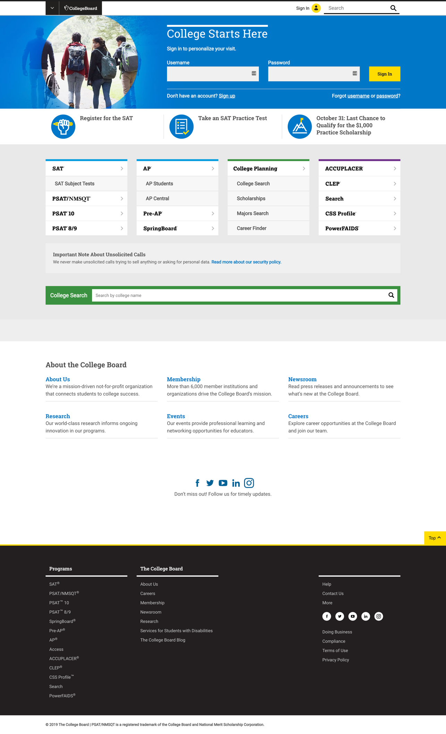**The Current Interface:**

**My Wireframes:**

In my quest to fix the CollegeBoard website, I started by creating wireframes for some of the main pages, to see how the website could be made more usable. I decided to wireframe the Home Page, SAT Page, SAT Signup Page, and Login Page.

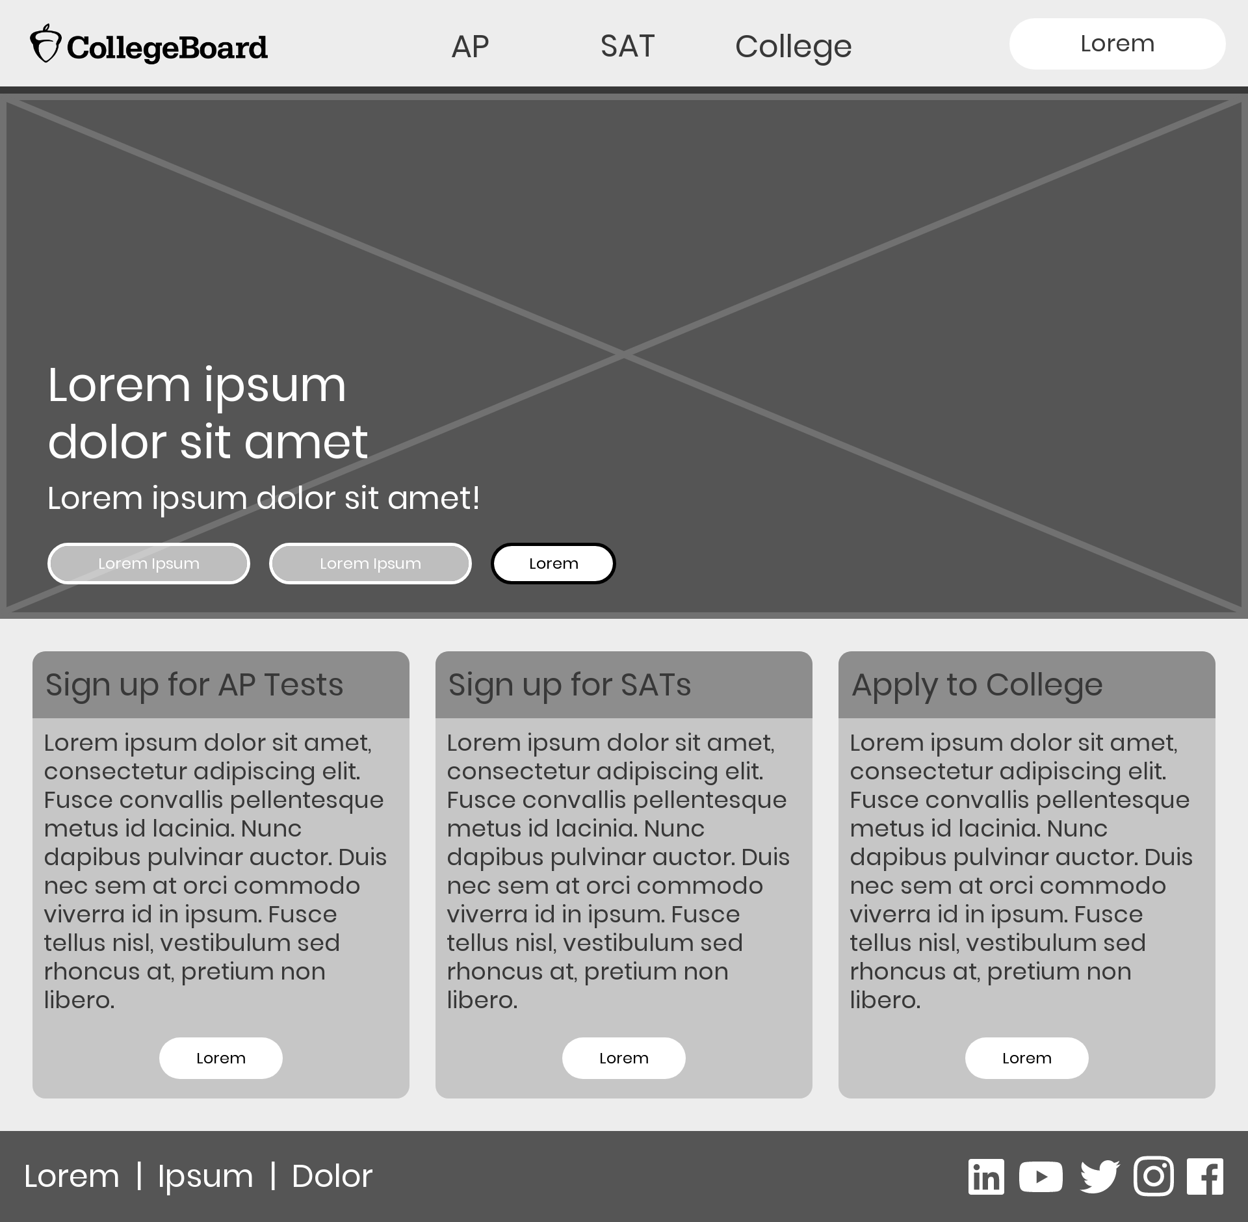**Home Page:**

**SAT Page:**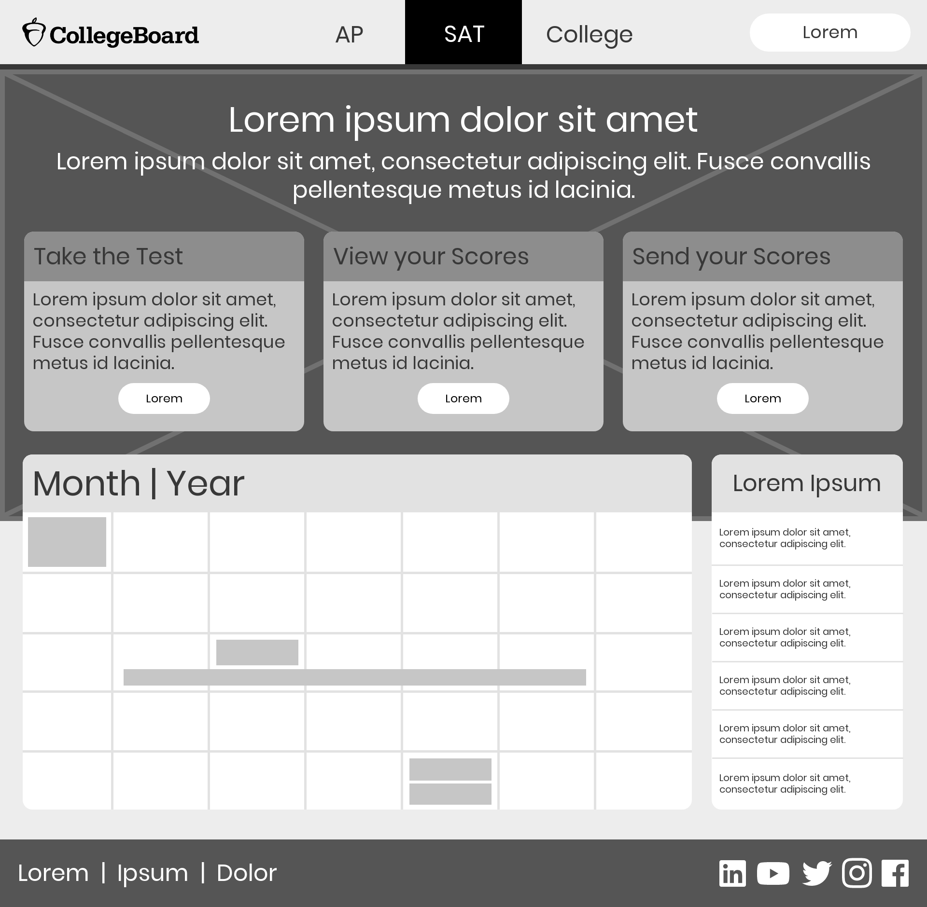

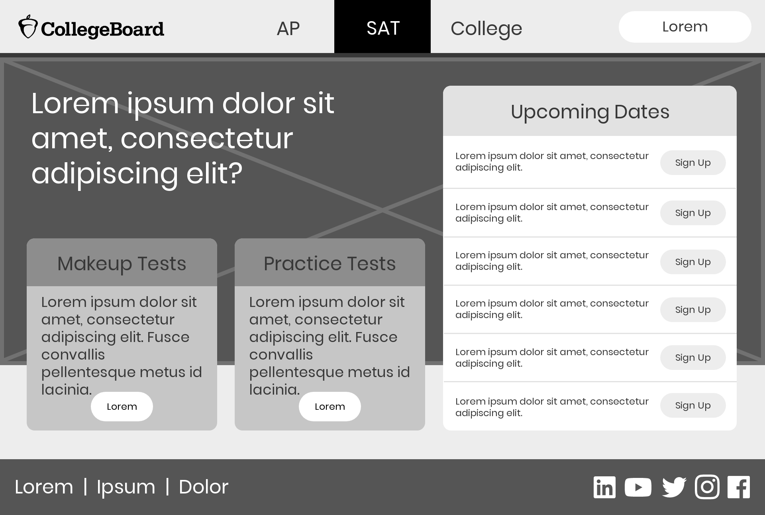**SAT Signup Page:**

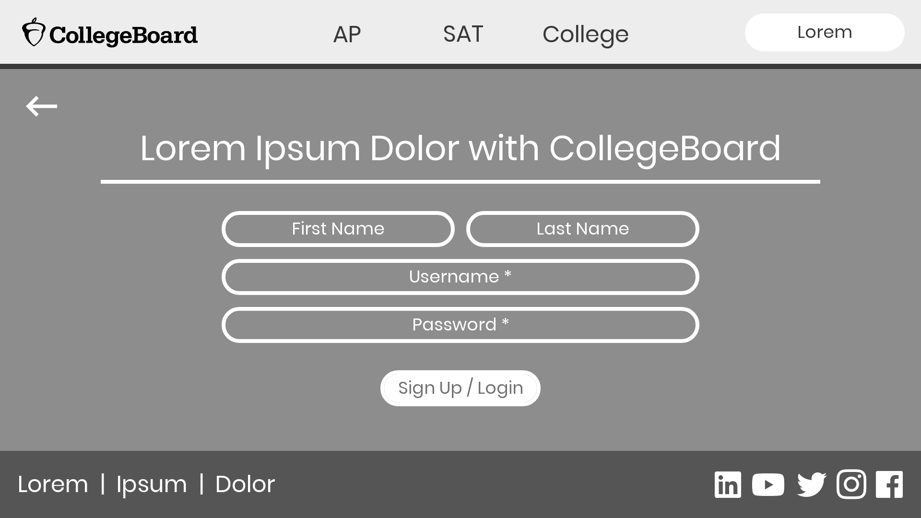**Login Page:**

**My Navigation Flow Chart:**

Then, I moved on to creating a flow chart detailing how the pages would be linked and started to create the overall structure of the entire website.

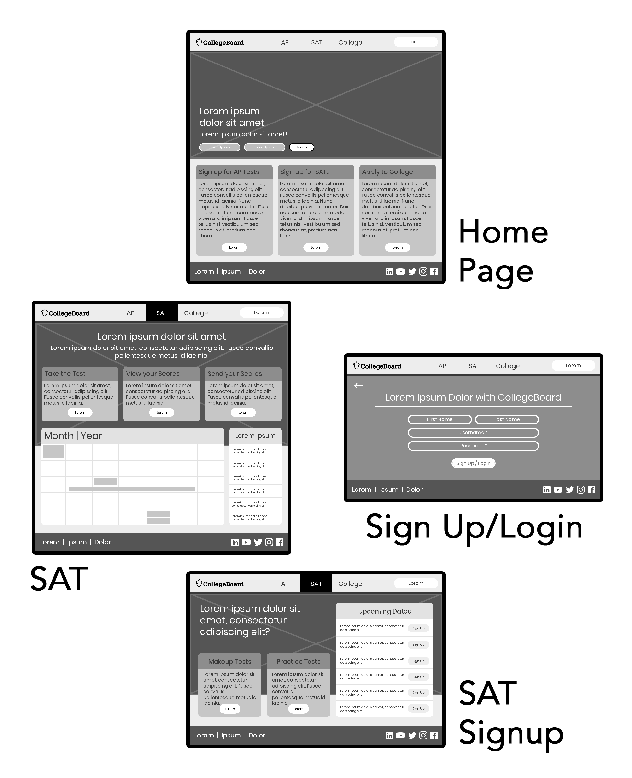

**Usability Criteria Comparison:**

In order to compare my redesign to the original interface, I qualitatively described how the original interface and my redesign addressed several usability principles.

|  |  |  |
| --- | --- | --- |
|  | Original Interface | Redesigned Interface |
| Intuitive Design | The original interface requires you to click on the CollegeBoard logo to see the dropdown menu, and it has lots of extraneous information, while not drawing the viewer’s eyes to the most important information. | My redesign aims to put the most important information at the forefront of the interface, and also reduces the navbar to its most essential elements and puts the three links to the main pages at the top of the page. |
| Ease of Learning | Because it is not clear where exactly you should go to find certain information, it takes a while to learn how to navigate the interface efficiency, even to do the most popular tasks. | My redesign makes it easier to understand the layout of the site, since navigation is very clear throughout and it is very clear what is or is not a link or button (i.e. it is clear what is clickable). |
| Efficiency of Use | Even after learning the layout of the website, it is not very efficient to use the website, since it takes a lot of clicks to navigate to even the most popular tasks, such as signing up for an SAT. Also, the amount of clutter on the webpages makes it hard to quickly see important tasks. | The layout of the website makes it easy to quickly navigate to different tasks, and every main task is no more than two or three clicks away from the main page, due to the redesigned navbar. Because the website is less cluttered, the users can quickly determine what they need to click. |
| Memorability | The website is not very memorable, as you would need to memorize extremely specific and long patterns of clicks to be able to use the website effectively after the first visit, and the various changing sections of the site (like the articles sections) make it so the site cannot be memorized. | The redesign is much more memorable, since much fewer clicks are necessary at any point, and because the sections of the website are very general, the layout of the website will rarely, if ever, have to change, making navigating the website easily memorable. |

**. . .**

**PART THREE | Visual Redesign**

I then decided to make a visual overhaul of the website, creating a mockup of what a finished product of the SAT Signup page could look like:

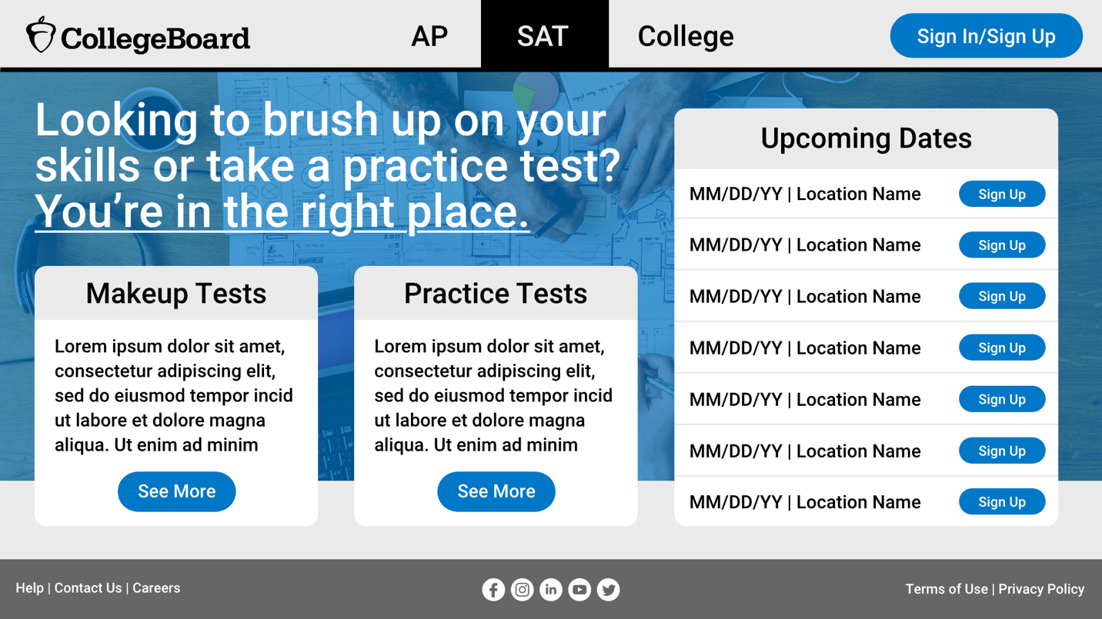

In my visual redesign, the biggest thing I tried to do was to create a visual hierarchy to inform users of the most important parts of the page. To do this, I used a blue accent color – the same blue that the website currently uses – to highlight the actionable tasks on the page (i.e. sign in, sign up for SATs, and see more buttons), and tried to use contrasting type sizes to make it clear what the purpose of different sections was. I also made the font size bigger than it originally was and tried to increase contrast between text and background elements in order to improve readability.

**. . .**

**PART FOUR | Responsive Redesign**

Then, I decided that, before trying to code the website, I should understand how I wanted the different elements of the page to respond to different screen sizes, in order to make the website responsive and easily navigable in any device. To do this, I made an annotated mockup of how my SAT Signup page would change for different screen sizes and orientations.

**Annotated Mockup:**

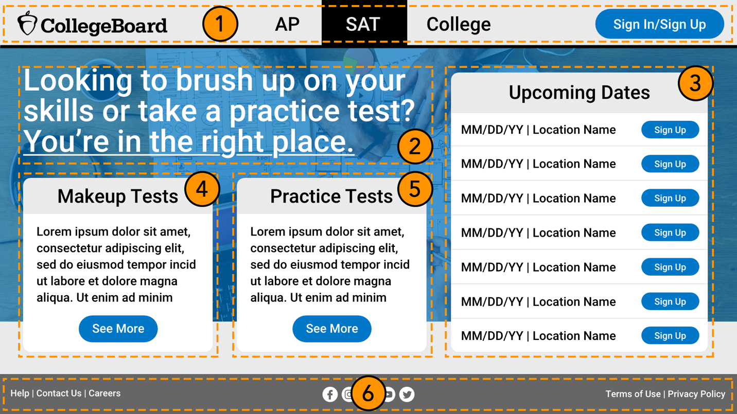

1. The header will always remain full-width and will always be at the top of the page. In landscape mode, the logo, sign in button, and AP/SAT/College page links will scale to fit the width of the screen (with the logo and sign in button remaining at a fixed distance from the sides and the page links remaining in the middle). In portrait mode, the sign in button and page links will be replaced by a hamburger menu icon, which, when clicked, will reveal the links and the button.
2. In landscape mode, this text will scale to fit the same part of the grid as it currently does (which is the left 4 of 7 columns and the top 2 of 5 rows). In portrait mode, it will scale to fit the width of the screen and be right under the header.
3. In landscape mode, this card will scale to fit the same parts of the grid as it currently does (which is the right 3 of 7 columns and all 5 of 5 rows). In portrait mode, it will scale to fit the width of the screen and be right under the makeup tests card.
4. In landscape mode, this card will scale to fit the same parts of the grid as it currently does (which is the left 2 of 7 columns and bottom 3 of 5 rows). In portrait mode, it will scale to fit the width of the screen and be right under the practice tests card.
5. In landscape mode, this card will scale to fit the same parts of the grid as it currently does (which is the left 2 of 7 columns and bottom 3 of 5 rows). In portrait mode, it will scale to fit the width of the screen and be right under the header.
6. The footer will always remain full-width and will always be at the bottom of the page. In landscape mode, the left/right text and the social network links will scale to fit the width of the screen (with the text remaining at a fixed distance from the sides and the social network links remaining in the middle). In portrait mode, the left and right text will be on its own line, and the social network links will be right below them, still centered in the middle.

**Responsive Website:**

Finally, I used HTML and CSS to create a responsive website design for the SAT signup page (the same page I did the visual redesign for), which is located in the index.html file in the /website directory. A screenshot of the website is below:

