WEB PROGRAMMING LABORATORY
Mini Project Report-A
Project Title: Bloodline - Online Blood Bank Management System
________________________________________
Submitted By:
Soham Kanase - 16010124128
Risha Kanthe - 16010124129
Course In-Charge - Bharathi Narayan
K. J. Somaiya School of Engineering
Department of Computer Engineering

Declaration

This is to certify that the mini project titled 'Bloodline - Online Blood Bank Management System’ is a bonafide work carried out by the undersigned students under the guidance of the course instructors as part of the Web Programming Laboratory during the academic year 2025–2026.
Student Signature(s): ____________________
Date: 30th March 2026

Acknowledgement
We express our sincere gratitude to the Department of Computer Engineering, K. J. Somaiya School of Engineering, Somaiya Vidyavihar University for providing the opportunity to work on this mini project. We would like to thank our course incharge Prof. Bharathi Narayan for their guidance and support.

Table of Contents
Right click here in MS Word → Update Field → Update entire table.

1. Introduction
Bloodline is an online blood bank management system developed as a full-stack web application for the Web Programming Laboratory mini project. The system enables donor registration with complete medical history, real-time blood inventory tracking across all eight blood types, hospital blood request management, and donor authentication with a personal dashboard.
The application is built using HTML, CSS, and JavaScript for the frontend, PHP for server-side scripting, and MySQL for the relational database. XAMPP is used as the local development server providing Apache and MySQL. GSAP 3 with ScrollTrigger is used for animations on the frontend.
The project is aligned with SDG 3: Good Health and Well-Being, specifically addressing the challenge of efficient blood bank management in India.

2. Problem Statement
Blood banks in India largely operate through manual record-keeping systems that are slow, error-prone, and difficult to coordinate across multiple locations. In emergency situations, hospitals struggle to locate available blood of the required type quickly, often resulting in critical delays. There is no centralised platform that allows donors to register, hospitals to raise requests, and blood banks to track inventory in real time.
Bloodline addresses this by providing a fully web-based solution where donors can register with their complete medical history, hospitals can submit urgent blood requests, and the blood bank can monitor live inventory across all eight blood types.
This project is directly aligned with SDG 3: Good Health and Well-Being, specifically target 3.8 which focuses on achieving universal health coverage and access to safe medical care for all.

3. Objectives
• To design a responsive, multi-page web interface using HTML, CSS, and JavaScript for donor registration, blood requests, inventory viewing, contact, and donor login.
• To implement server-side scripting using PHP for form handling, data validation, session management, and JSON-based API responses.
• To integrate a normalised MySQL database with 17 tables derived from a complete EER diagram covering donors, blood banks, hospitals, donations, and requests.
• To implement secure user authentication using password hashing with BCrypt and PHP sessions with protected route access for the donor dashboard.
• To provide a live inventory system that fetches and displays real-time blood unit data from the database without page reload using JavaScript fetch() and setInterval().

4. System Architecture / Web Graph
The system follows a three-tier architecture: the Presentation Layer (HTML/CSS/JS frontend), the Application Layer (PHP backend scripts), and the Data Layer (MySQL database via phpMyAdmin).
Navigation Flow:
Home → Register Donor → Login → Donor Dashboard
Home → Make Blood Request
Home → Live Inventory
Home → Contact Us
Donor Dashboard → Make Request / Inventory / Contact / Logout → Login

Data Flow:
Registration Form → POST → register.php → INSERT into Donor, Donor_Contact, Registers_At, Regular_Donor or First_Time_Donor → Redirect with success or error
Blood Request Form → fetch() JSON → submit_request.php → INSERT into Blood_Request → JSON response
Inventory Page → fetch() every 60s → get_inventory.php → SELECT from Blood_Inventory → JSON → update bubbles
Login Form → POST → login_handler.php → password_verify() → session_start() → dashboard.php

5. Web Pages Developed
The following table lists all web pages and PHP scripts developed as part of the Bloodline application:

Page / File | Description
index.html | Landing page with live inventory bubble section, blood type slider, team section, and footer navigation
registration.php | Full donor registration form with medical history, Aadhaar, blood group, password hashing, and DB integration
login.php | Donor sign-in page with email and BCrypt password verification
login_handler.php | Processes login POST, validates credentials, starts PHP session
dashboard.php | Protected donor dashboard showing personal details, donation stats, blood group, and recent requests
make-request.html | Blood type selection grid with slide-up AJAX request form, submits to submit_request.php
inventory.html | Animated bubble view of all 8 blood types with live unit counts from Blood_Inventory table
contact.php | Contact form saving name, email, message to Contact_Messages table
register.php | PHP handler for registration POST - validates, hashes password, inserts into 4 tables
submit_request.php | PHP handler for blood request JSON - inserts into Blood_Request, returns JSON response
get_inventory.php | PHP API endpoint - queries Blood_Inventory, returns JSON for live bubble updates
contact_handler.php | PHP handler for contact POST - validates and inserts into Contact_Messages
logout.php | Destroys PHP session and redirects to login.php
db.php | Singleton database connection file - required by all PHP backend scripts

6. Database Design

We store detailed profiles for every Donor (First/Regular) capturing essential details like their name, age, and contact information.
A Donor Registers at a specific Blood Bank, allowing us to track which local facility manages their registration and donor history.
Whenever a person gives blood, the Donor Donates into a centralized Blood Donations record, logging the exact date, quantity, and blood group of that session.
The Blood Bank (Government/Private) collects these Blood Donations to build up and monitor its available physical inventory.
We also maintain comprehensive records for each Hospital, storing their address and phone numbers so we know exactly where the blood might need to be delivered.
When a patient is in need, the Hospital Raises a Blood Request that explicitly states the required blood group, the date needed, and the exact number of units.
To meet this critical need, a Blood Bank steps in and Fulfills the pending Blood Request raised by the hospital.
On a physical level, specific units from our collected Blood Donations inventory directly Supplies that Blood Request, ensuring every single drop is securely accounted for.
This interconnected data allows us to instantly match a hospital's urgent Blood Request with the nearest Blood Bank that has the right Blood Donations in stock.
To close the supply chain loop, a Blood Bank Fulfills a Blood Request (one-to-many), while the actual physical inventory is mapped via a many-to-many relationship where specific Blood Donations records Supplies the Blood Request.

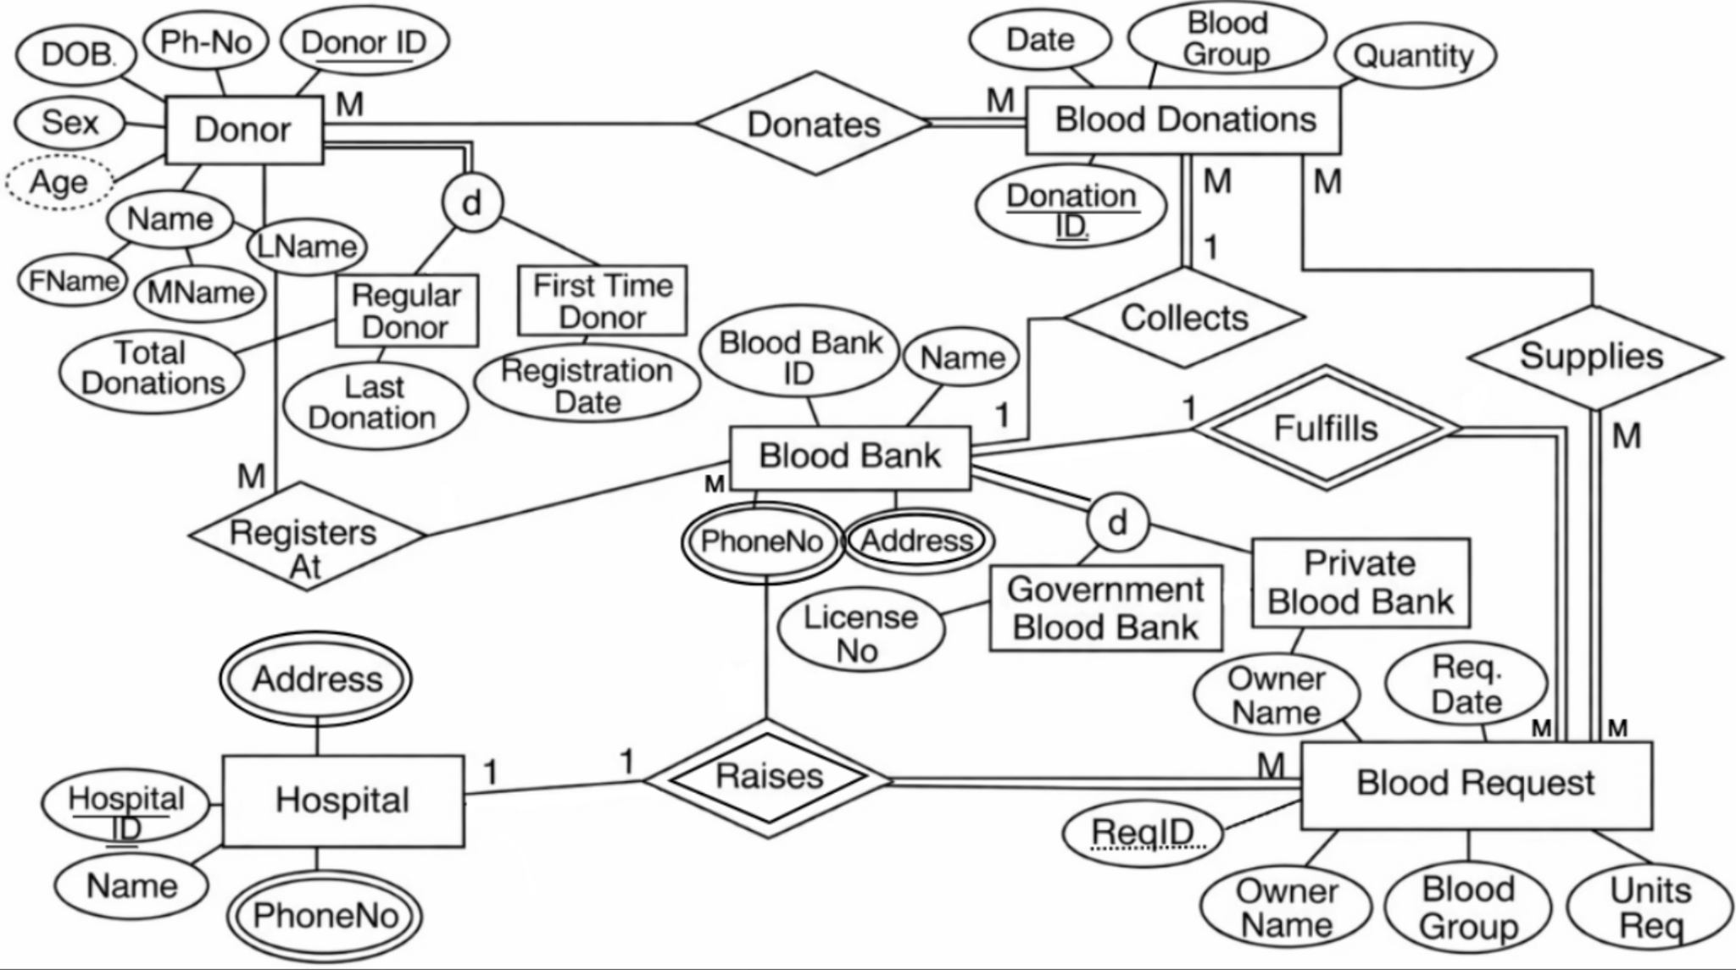

Relational Model Schema
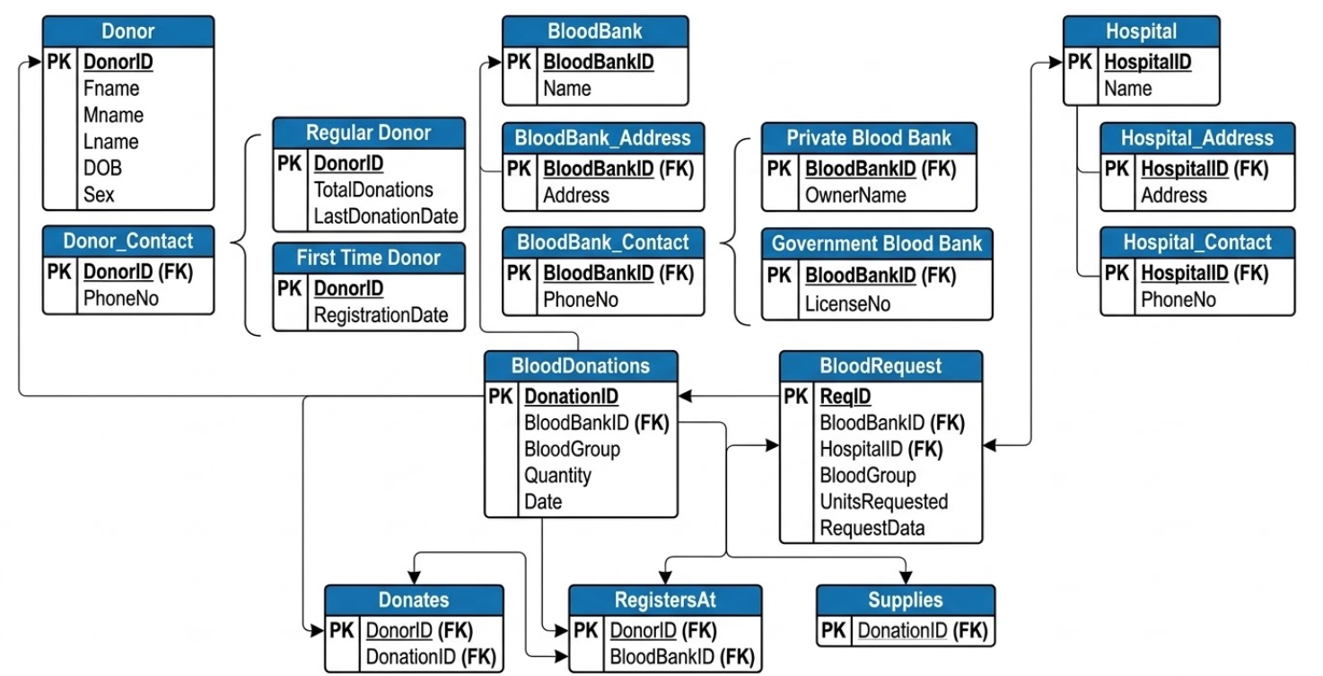

Blood Bank & Hospital Entities
blood_bank
Field | Type | Description
BloodBankID | INT (PK) | Unique identifier for the blood bank
Name | VARCHAR | Full name of the blood bank

government_bloodbank
Field | Type | Description
BloodBankID | INT (PK, FK) | Reference to the core blood bank record
LicenseNo | VARCHAR(50) | Government-issued license number

private_bloodbank
Field | Type | Description
BloodBankID | INT (PK, FK) | Reference to the core blood bank record
OwnerName | VARCHAR(120) | Name of the private owner or organization

bloodbank_address
Field | Type | Description
BloodBankID | INT (PK, FK) | Reference to the blood bank
Address | VARCHAR(255) | Physical address of the blood bank

bloodbank_contact
Field | Type | Description
BloodBankID | INT (PK, FK) | Reference to the blood bank
PhoneNo | VARCHAR (PK) | Contact phone number

hospital
Field | Type | Description
HospitalID | INT (PK) | Unique identifier for the hospital (Auto Increment)
Name | VARCHAR(120) | Full name of the hospital

hospital_contact
Field | Type | Description
HospitalID | INT (PK, FK) | Reference to the hospital
PhoneNo | VARCHAR(15) (PK) | Contact phone number for the hospital

Donor Entities
donor
Field | Type | Description
DonorID | INT (PK) | Unique identifier for the donor (Auto Increment)
FName | VARCHAR(60) | Donor's first name
MName | VARCHAR(60) | Donor's middle name
LName | VARCHAR(60) | Donor's last name
DOB | DATE | Donor's date of birth
Sex | ENUM | Donor's gender ('M', 'F', 'Other')
Marital | VARCHAR(30) | Marital status
Occupation | VARCHAR(100) | Donor's occupation
Email | VARCHAR(120) UNIQUE | Donor's email address
AadharNo | CHAR(12) UNIQUE | 12-digit Aadhaar card number
BloodGroup | ENUM | Donor's blood group
PasswordHash | VARCHAR(255) | Encrypted account password (BCrypt)
City | VARCHAR(80) | Donor's city of residence
Pincode | CHAR(6) | 6-digit postal code
EmergencyContact | VARCHAR(15) | Emergency contact phone number
LastDonationDate | DATE | Date of the donor's most recent donation
UnitsLastDonated | TINYINT | Number of units given in the last donation
MedicalNotes | TEXT | Medical history stored as JSON (questionnaire, allergies, conditions)
RegisteredAt | DATETIME | Timestamp of when the donor registered

first_time_donor
Field | Type | Description
DonorID | INT (PK, FK) | Reference to the donor record
RegistrationDate | DATE | Date the first-time donor registered

regular_donor
Field | Type | Description
DonorID | INT (PK, FK) | Reference to the donor record
TotalDonations | INT | Total number of times the donor has donated
LastDonationDate | DATE | Date of their most recent donation

donor_contact
Field | Type | Description
DonorID | INT (PK, FK) | Reference to the donor
PhoneNo | VARCHAR(15) (PK) | Donor's contact phone number

Transactions, Inventory & Relationships
blood_donations
Field | Type | Description
DonationID | INT (PK) | Unique identifier for the donation
BloodBankID | INT (FK) | Reference to the receiving blood bank
BloodGroup | ENUM | The blood group donated
Quantity | TINYINT UNSIGNED | Number of units donated
DonationDate | DATE | The date the donation took place

blood_inventory
Field | Type | Description
InventoryID | INT (PK) | Unique identifier for the inventory record
BloodBankID | INT (FK) | Reference to the blood bank holding the inventory
BloodGroup | ENUM | The blood group being tracked
UnitsAvailable | INT UNSIGNED | Total number of units currently available
LastUpdated | TIMESTAMP | Timestamp of the last inventory status change

blood_request
Field | Type | Description
ReqID | INT (PK) | Unique identifier for the request
BloodBankID | INT (FK) | Reference to the blood bank receiving the request
HospitalID | INT (FK) | Reference to the hospital making the request
BloodGroup | ENUM | The specific blood group requested
UnitsRequested | TINYINT UNSIGNED | Number of units requested
RequestDate | DATETIME | Date and time the request was made
Urgency | ENUM | Priority level: 'Emergency', 'Urgent', 'Scheduled'
RequesterName | VARCHAR(120) | Name of the individual making the request
RequesterPhone | VARCHAR(15) | Contact number for the requester
PatientName | VARCHAR(120) | Name of the patient needing the blood
Status | ENUM | Current status: 'Pending', 'Fulfilled', 'Cancelled'

donates (Junction Table)
Field | Type | Description
DonorID | INT (PK, FK) | Reference to the donor
DonationID | INT (PK, FK) | Reference to the specific donation

registers_at (Junction Table)
Field | Type | Description
DonorID | INT (PK, FK) | Reference to the registering donor
BloodBankID | INT (PK, FK) | Reference to the blood bank where registered
RegDate | DATE | The date the registration occurred

supplies (Junction Table)
Field | Type | Description
DonationID | INT (PK, FK) | Reference to the donated blood supply
ReqID | INT (PK, FK) | Reference to the fulfilled blood request

Miscellaneous
contact_messages
Field | Type | Description
MessageID | INT (PK) | Unique identifier for the message
FullName | VARCHAR(120) | Name of the sender
Email | VARCHAR(120) | Email address of the sender
Message | TEXT | The content of the contact message
SubmittedAt | DATETIME | Timestamp of when the message was sent

7. GitHub Repository
The complete source code for the Bloodline project is maintained in a public GitHub repository with regular commits tracking the development progress.
Github Repository: https://github.com/sohxmm/Online-Blood-Bank-Management-System
https://github.com/risha2211/Online-Blood-Bank-Management-System

Repository Contents:
• HTML pages: index.html, make-request.html, inventory.html
• PHP pages and handlers: registration.php, login.php, dashboard.php, contact.php, register.php, login_handler.php, submit_request.php, get_inventory.php, contact_handler.php, logout.php, db.php
• Database script: bloodline.sql (creates all 17 tables and inserts seed data)
• JavaScript libraries: gsap.min.js, ScrollTrigger.min.js
• Assets folder: logo images, hero image, team photos, feature images
• README.md: project description, setup instructions, tech stack, and contributor information

References
[1] PHP Manual - php.net/manual/en/
[2] MySQL Documentation - dev.mysql.com/doc/
[3] GSAP Animation Library - greensock.com/docs/
[4] MDN Web Docs - developer.mozilla.org
[5] W3Schools HTML/CSS/PHP Reference - w3schools.com
[6] Somaiya Vidyavihar University Web Programming Lab Manual, 2025-26

12. Appendix (Source Code / Screenshots)
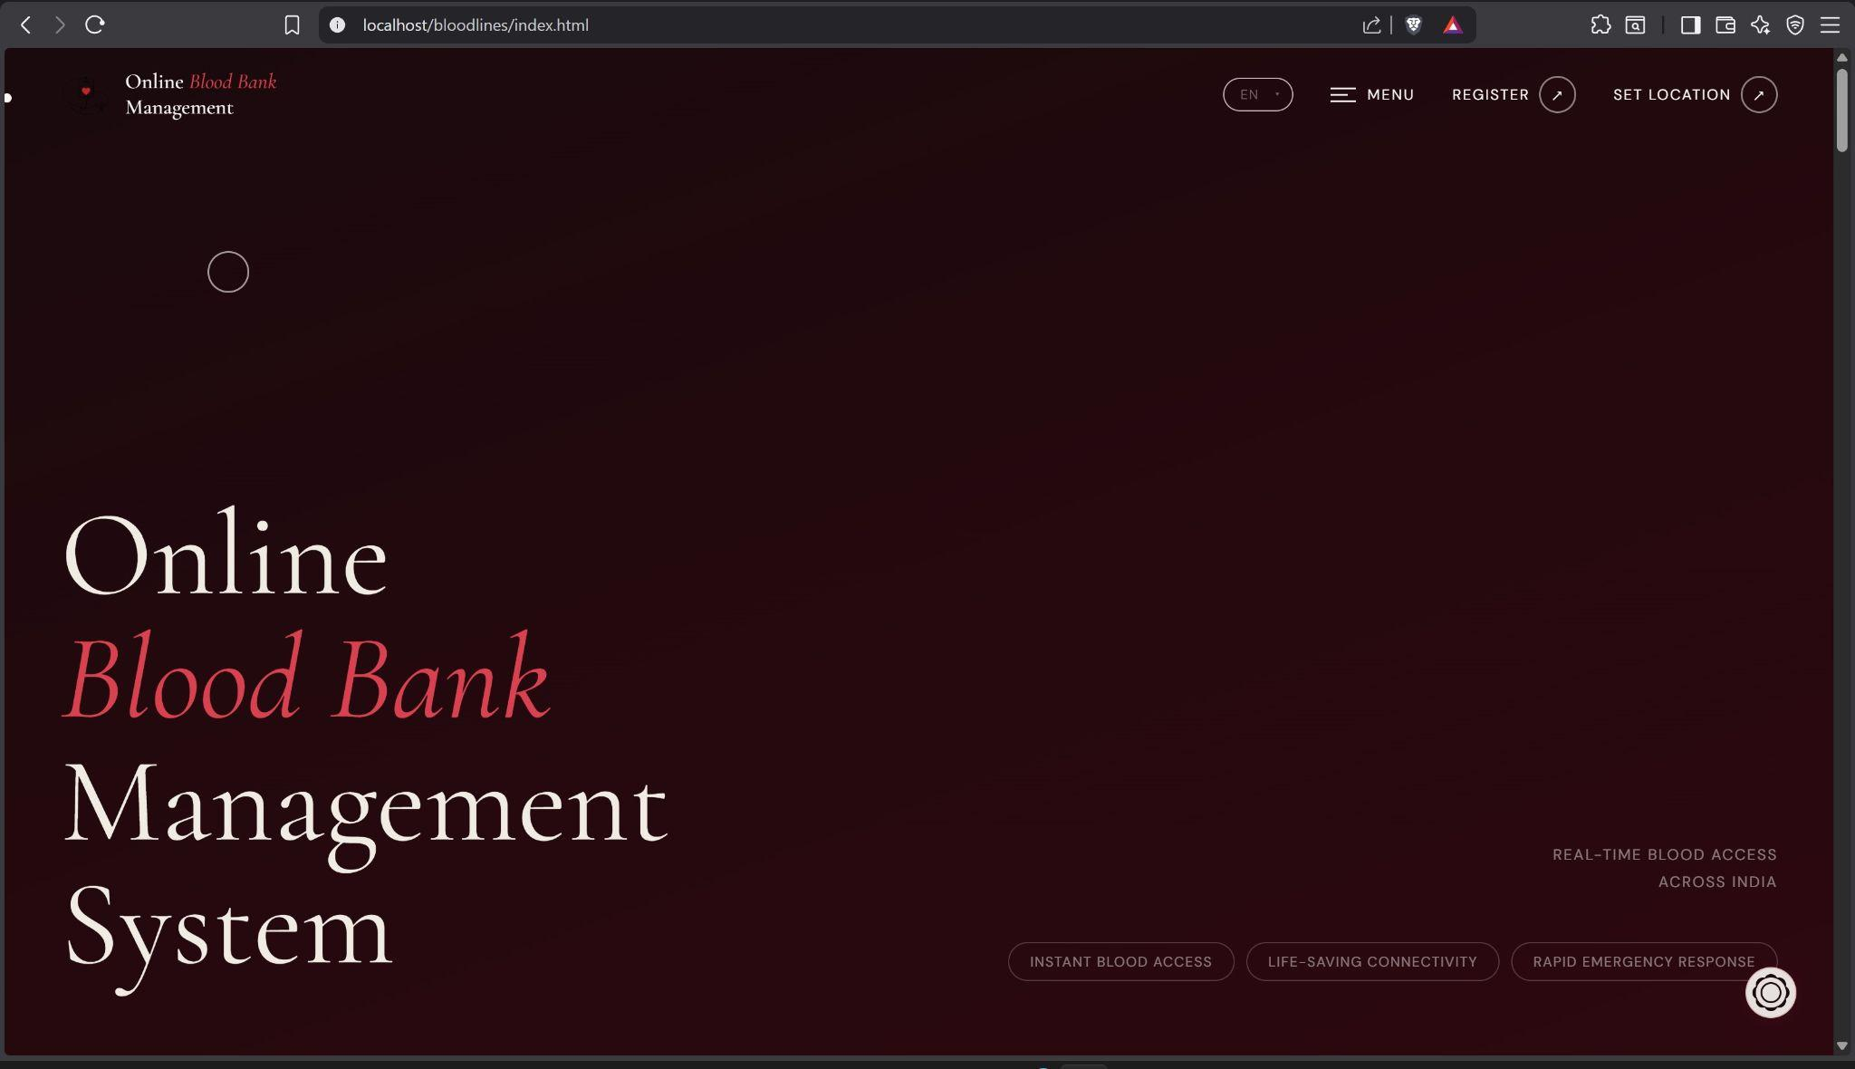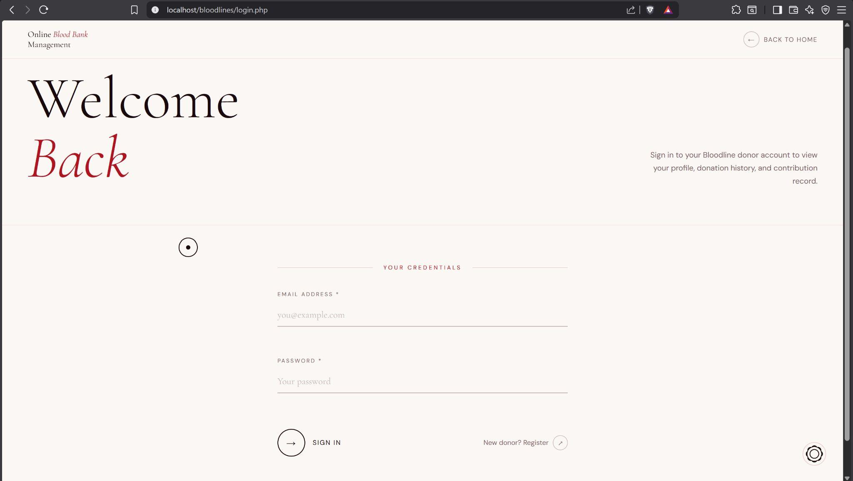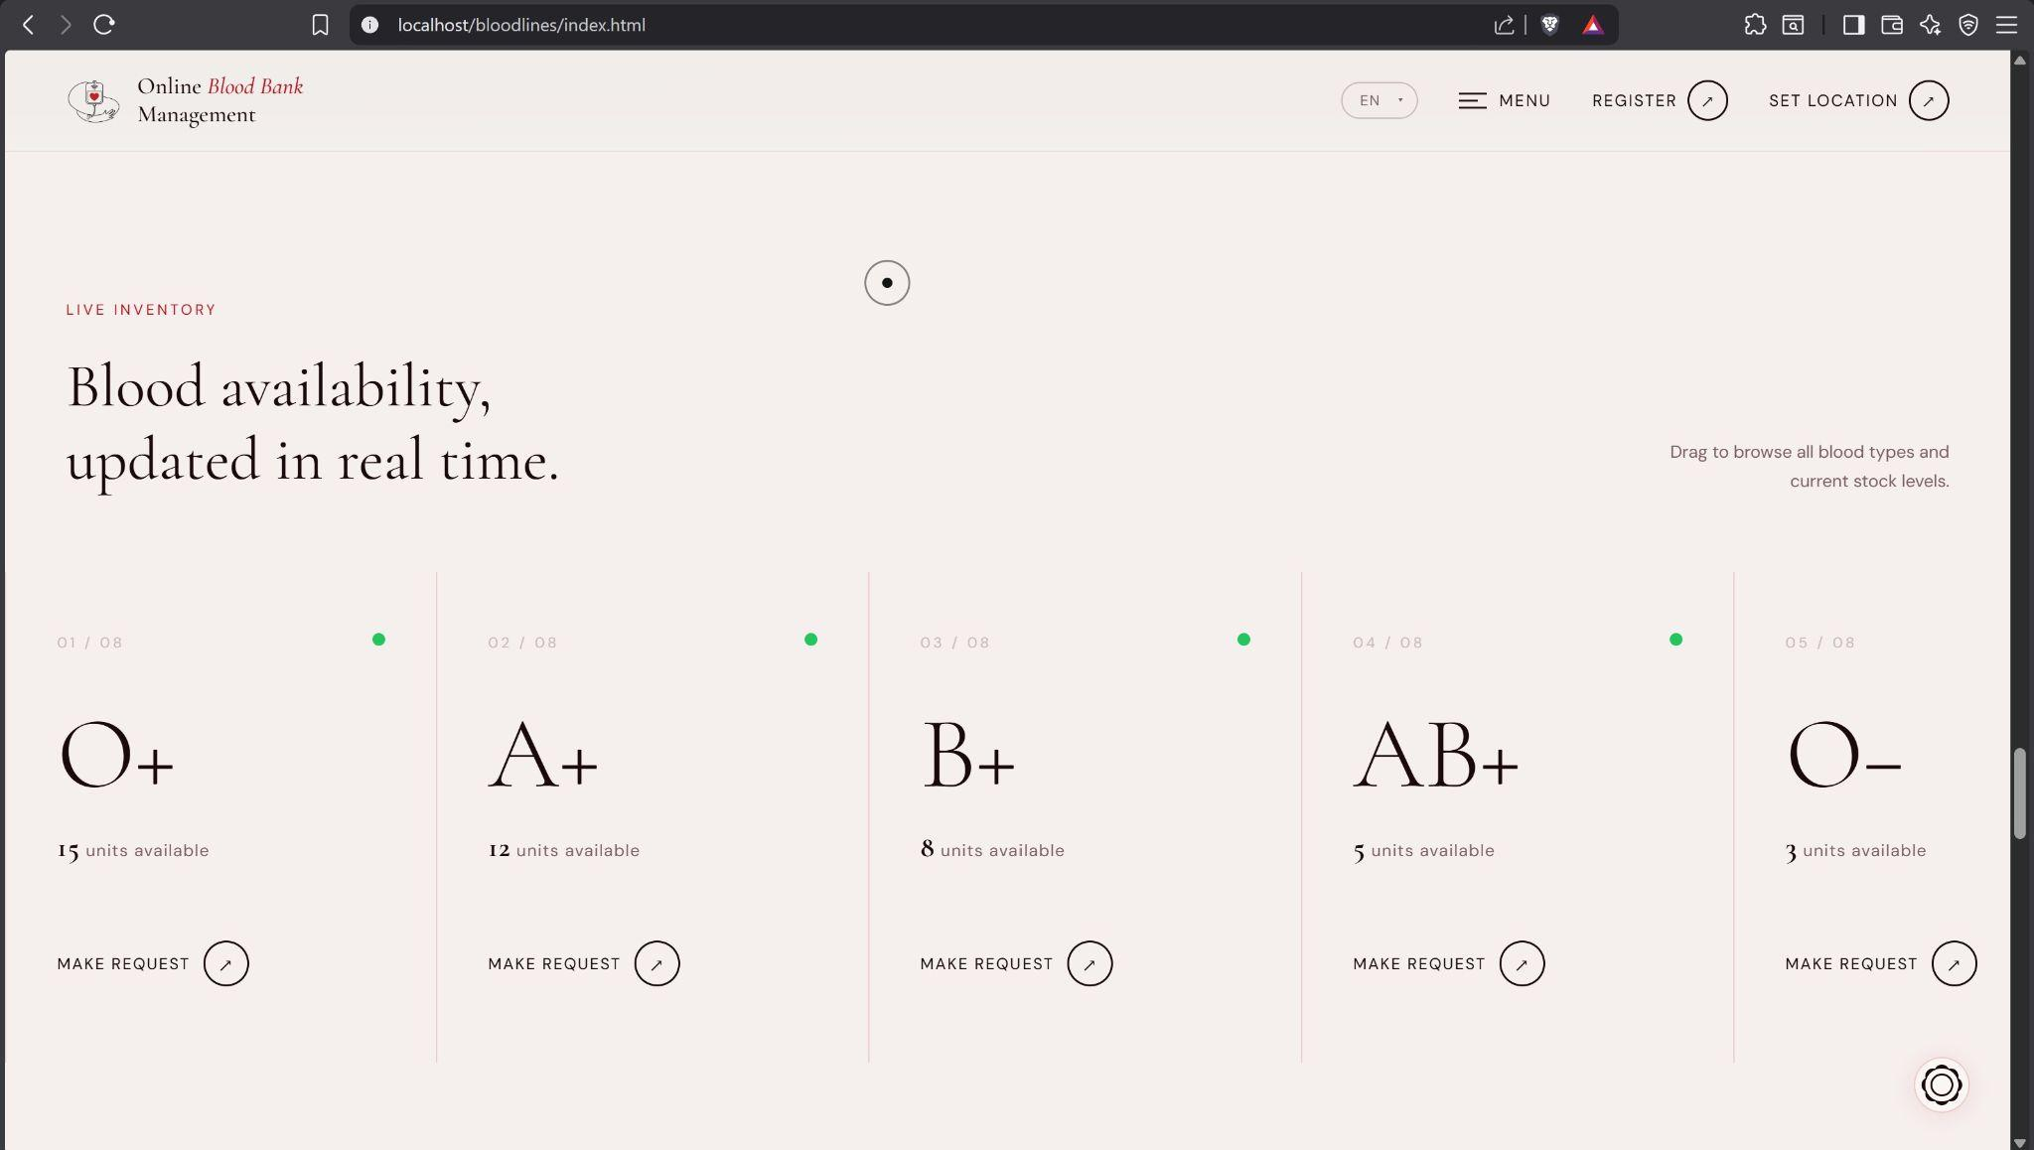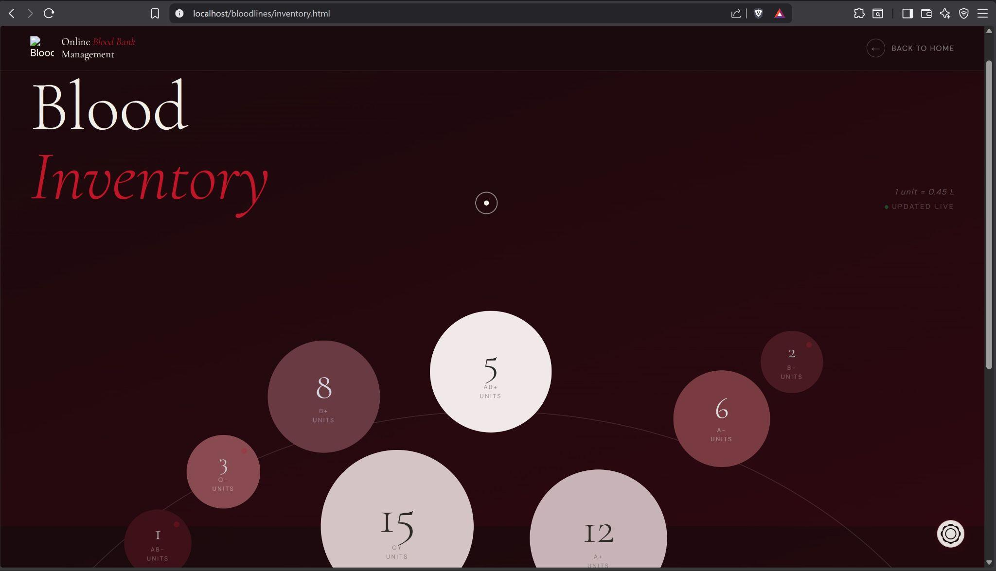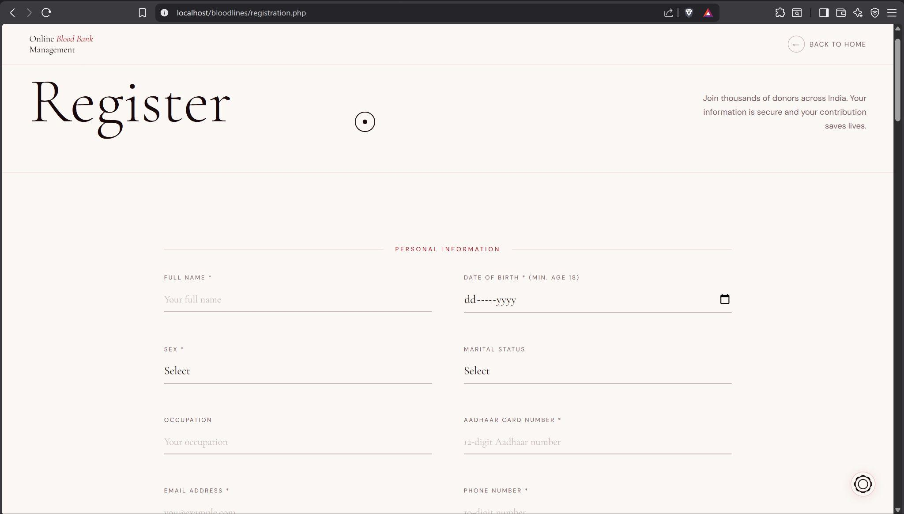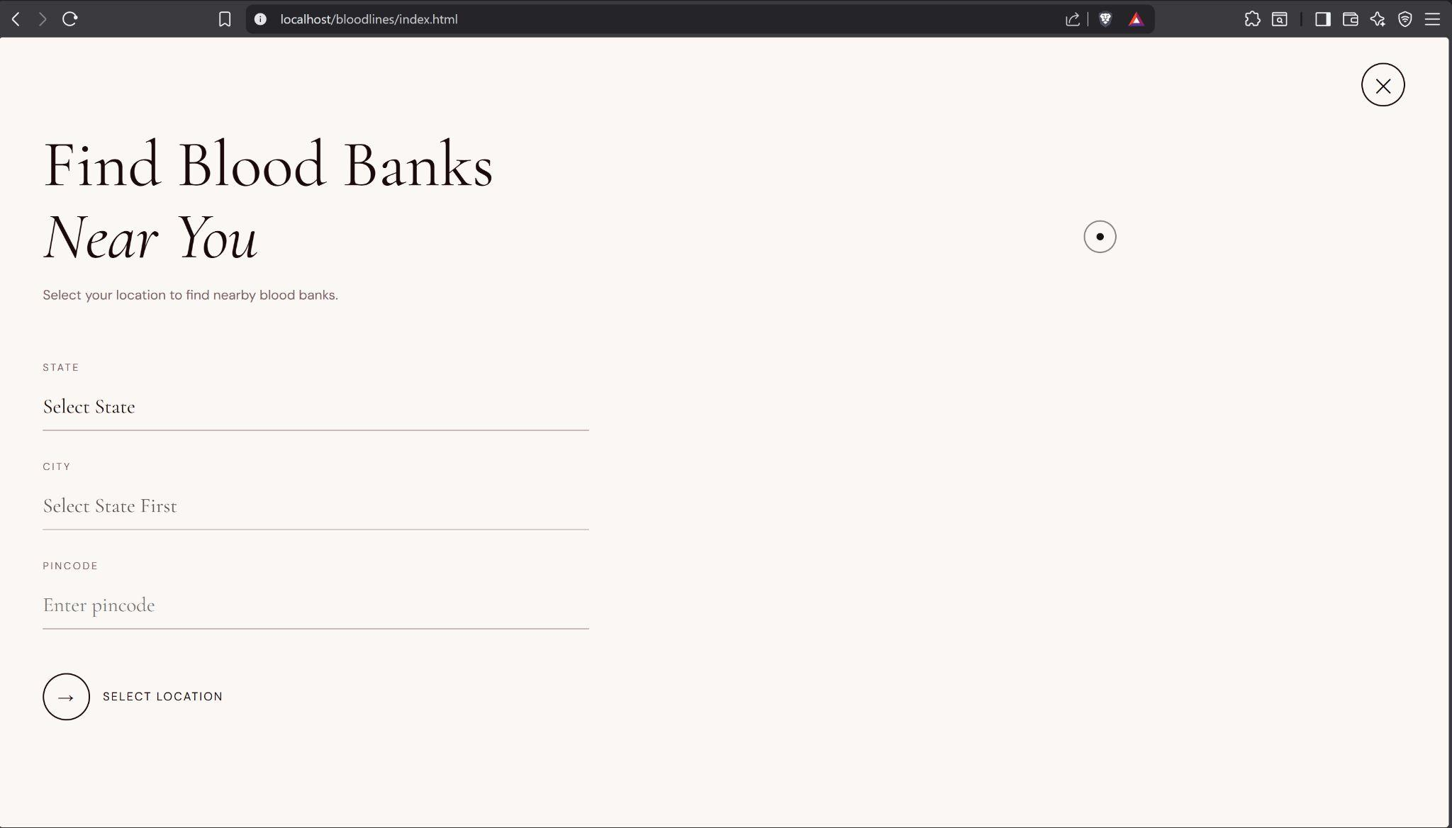
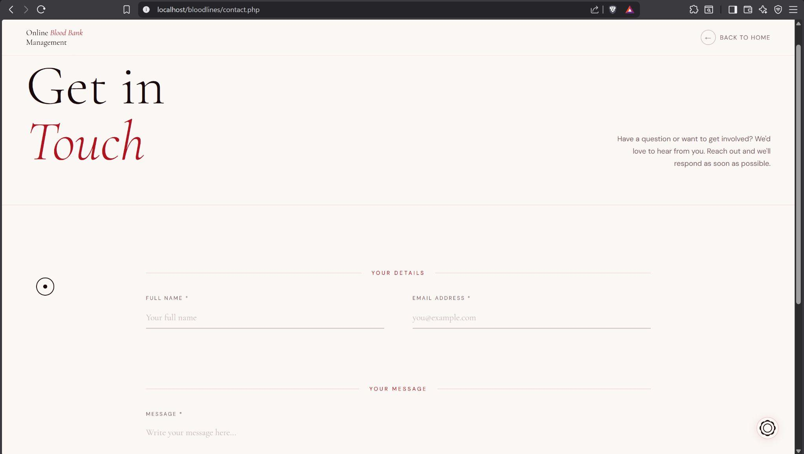
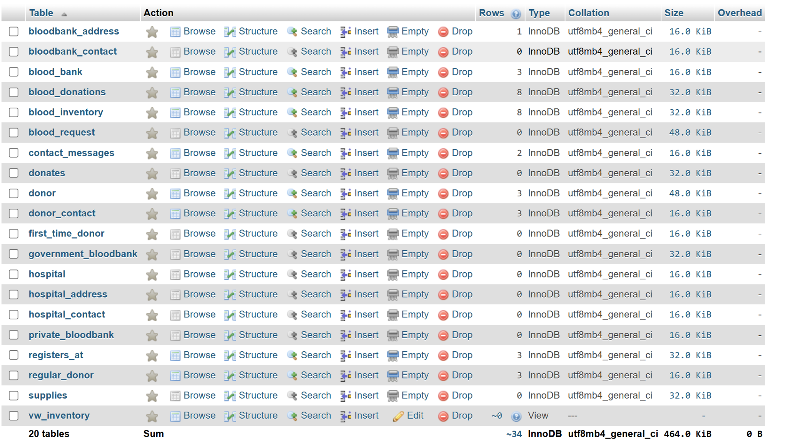
• phpMyAdmin - Donor table showing submitted rows
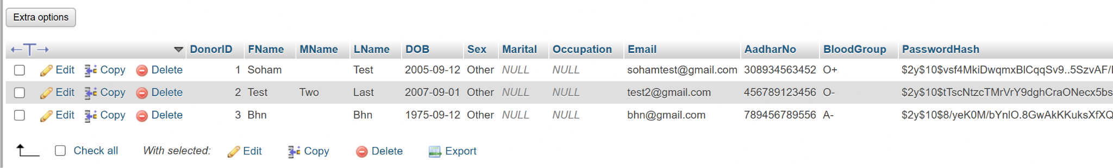
• phpMyAdmin - Blood_Inventory table
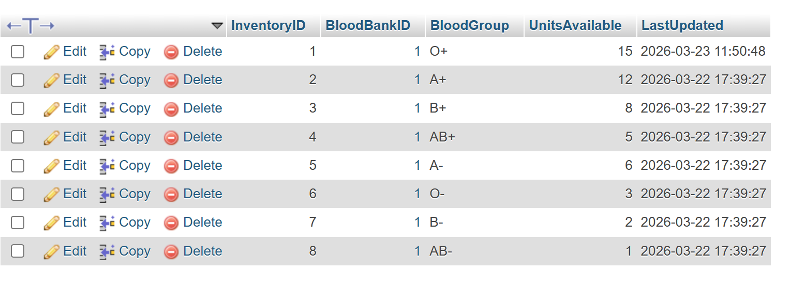

Table: List of Web Pages

Page / File | Description
index.html | Landing page with live inventory bubble section, blood type slider, team section, and footer navigation
registration.php | Full donor registration form with medical history, Aadhaar, blood group, password hashing, and DB integration
login.php | Donor sign-in page with email and BCrypt password verification
login_handler.php | Processes login POST, validates credentials, starts PHP session
dashboard.php | Protected donor dashboard showing personal details, donation stats, blood group, and recent requests
make-request.html | Blood type selection grid with slide-up AJAX request form, submits to submit_request.php
inventory.html | Animated bubble view of all 8 blood types with live unit counts from Blood_Inventory table
contact.php | Contact form saving name, email, message to Contact_Messages table
register.php | PHP handler for registration POST - validates, hashes password, inserts into 4 tables
submit_request.php | PHP handler for blood request JSON - inserts into Blood_Request, returns JSON response
get_inventory.php | PHP API endpoint - queries Blood_Inventory, returns JSON for live bubble updates
contact_handler.php | PHP handler for contact POST - validates and inserts into Contact_Messages
logout.php | Destroys PHP session and redirects to login.php
db.php | Singleton database connection file - required by all PHP backend scripts

Relational Model Schema
Field | Type | Description

