**Term Project Report**



|  |
| --- |
| **제출일 2017, 06. 25 전공 소프트웨어학과** |
| **과목 그래픽스 이름 안소현, 윤지영** |

**1. Introduction**

1.1 Subject

Dress up game. User can dress up a character by clicking items.

1.2 Theme

This is a kind of pixel graphic game.

1.3 Purpose

To dress up or decorate a character.

1.4 Motivation

We often played dress up game in our childhood and we wanted to feel the memories of childhood again.

**2. Technical explanation of implemented contents**

2.1 Used tools

- OpenGL, MFC

2.2 Drawing character

Character which is dressed up by user is consist of small cubes. The number of cubes in character’s head is 9X9X9. And body is 9X12X5, arm is 3X12X5 and leg is 3X12X5. The character is drawn by for loop.

2.3 Getting and Saving item properties

Getting clothes properties is implemented by getting r,g,b values from text files and saving in array. Array variables are consists of default character and four customized items. Each of them has head, body, left/right arm and left/right leg array.

2.4 Setting character properties

When user click specific item which is clicked or not is judged by coordinate value of each items. And selected item’s integer value will allow to draw the item to character.

2.5 Setting action and pose of character

There are some values which are distance or degree to move about body, arm, leg. If user clicks action(동작), arm is rotated 180 degree by x-axis and body is translated left or right by x-axis using timer. The timer helps to repeat the specified action at a certain time. And user clicks pose(포즈), arm, leg and body are rotated by certain value mentioned above.

**3. How to control**

1. Click start button

2. When dress up dialog appears, user can select 4 heads, tops, and pants.

3. When user click item(heads, tops, pants), the default character’s(located at left) appearance will be changed.

4. User can reset appearance by clicking “옷 리셋” in the left top menu(움직이기).

5. In menu, user can also set or reset action and pose of character.

6. By pressing keyboard ‘a’, ’d’, ‘s’, ‘w’, user can rotate the character. ‘a’ and ‘d’ are rotating by y-axis. And ‘s’ and ‘w’ are rotating by x-axis.

**4. Screen shots**

**Default screen:**

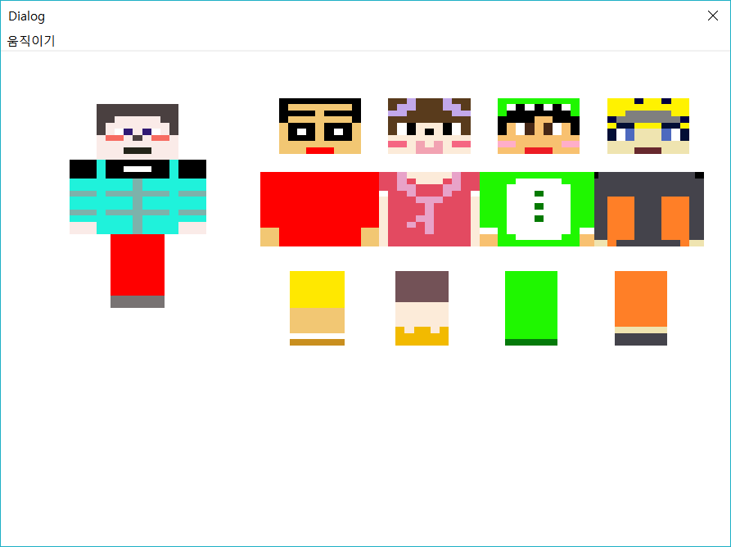

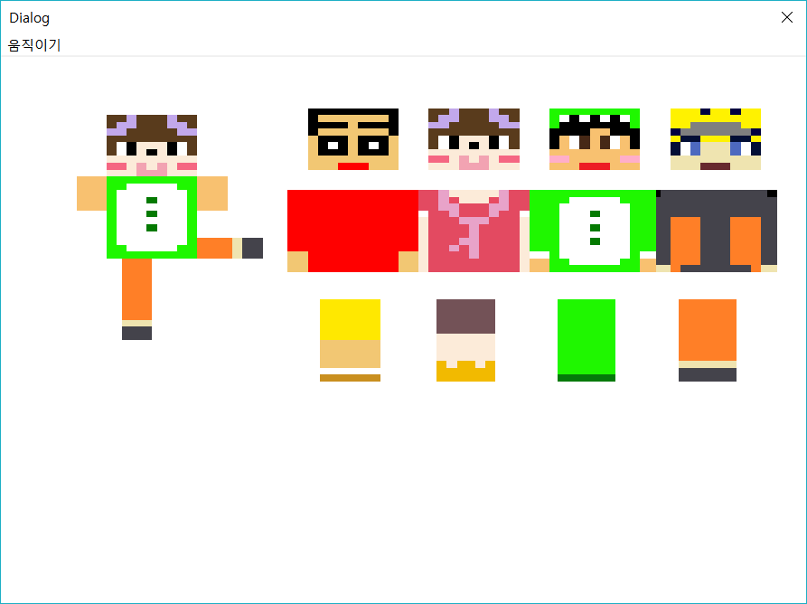

: clicked item

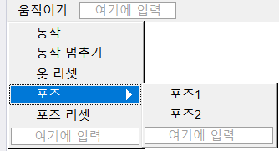

**Pose1:**

**Pose2:**

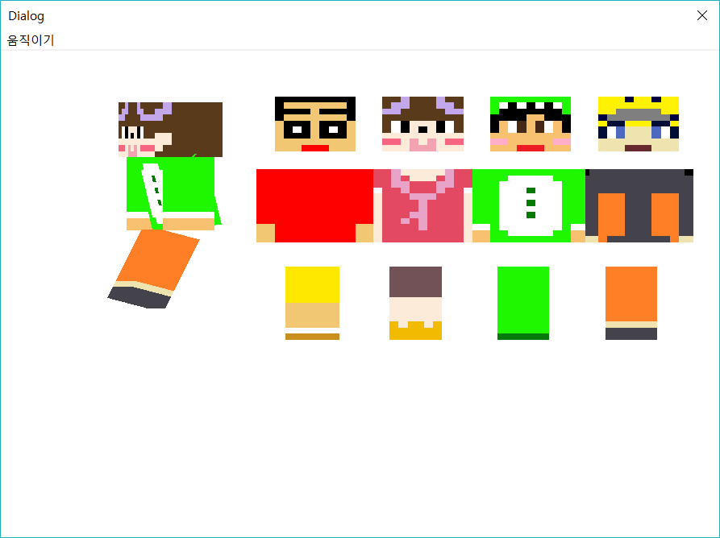

**5. Conclusion**

We thought it would be easy, but it was difficult. Because it is a first time to combine MFC and OpenGL and we painted the character’s clothes and face every pixel. We thought about putting on texture but, it seemed to be done so easily. We made it more harder, so the result is more valuable.

We could know the functions of OpenGL more obviously, so we used the functions in fully understood condition. Also we became more interested in OpenGL and MFC.

**References**

MFC-OpenGL 연동 –

<http://cinema4dr12.tistory.com/entry/OpenGL-MFCOpenGL-%EC%97%B0%EB%8F%99%ED%95%98%EA%B8%B0>

화면 깜박임 방지 – <http://lazineer.tistory.com/45>

다이얼로그 닫기 - <http://grass84.tistory.com/171>

스킨 참고

- http://m.blog.naver.com/bongsun_0309/110161853519

- http://blog.naver.com/PostView.nhn?blogId=wldk6830&logNo=220362216472

- https://www.koreaminecraft.net/skin/502732