Quarto Document

Sohyun Park

2024-10-04

Table of contents

[Quarto Document](https://quarto.org/docs/get-started/authoring/vscode.html)

# 1. Sections

## 1.1 Colors

* Red
* Green
* Blue

## 1.2 Shapes

* Square
* Circle
* Triangle

## 1.3 Textures

* Smooth
* Bumpy
* Fuzzy

## 1.4 Equations

Einstein’s theory of special relatively that expresses the equivalence of mass and energy:

# 2. Citations

Mary says *Hydrophobicity is ubiquitous. Many aquatic and semi-aquatic plants, such as the lotus, utilise hydrophobicity in their self-cleaning mechanisms which reduce their chances of infection from harmful pathogens present in the bodies of water in which they grow [2]. Butterflies have been found to utilise hydrophobicity to ensure that rain droplets which fall on their wings roll off away from their bodies [3]. Proteins have been found to utilise localised hydrophobicity to evacuate surrounding water and enable ligand binding [4]. Detergents utilise the hydrophobicity driven self assembly of amphiphilic molecules into micelle structures to remove grease from clothes [5]. The influence of hydrophobicity is felt in every aspect of our lives.* (Coe, n.d.).

# 3. Cross References

See Figure 3.1 in Section 3.1 for a demonstration of a simple plot.

See Equation 3.1 to better understand standard deviation.

## 3.1 Plot

import matplotlib.pyplot as plt  
plt.plot([1,23,2,4])  
plt.show()

|  |
| --- |
| Figure 3.1: Simple Plot |

## 3.2 Equation

# 4. Callouts

|  |
| --- |
| Note |
| Note that there are five types of callouts, including: note, tip, warning, caution, and important. |

# 5. Placing Colorbars

Colorbars indicate the quantitative extent of image data. Placing in a figure is non-trivial because room needs to be made for them. The simplest case is just attaching a colorbar to each axes:[1].

# #| column: screen-inset  
import matplotlib.pyplot as plt  
import numpy as np  
  
fig, axs = plt.subplots(2, 2)  
fig.set_size_inches(20, 8)  
cmaps = ['RdBu_r', 'viridis']  
for col in range(2):  
 for row in range(2):  
 ax = axs[row, col]  
 pcm = ax.pcolormesh(  
 np.random.random((20, 20)) * (col + 1),  
 cmap=cmaps[col]  
 )  
 fig.colorbar(pcm, ax=ax)  
plt.show()

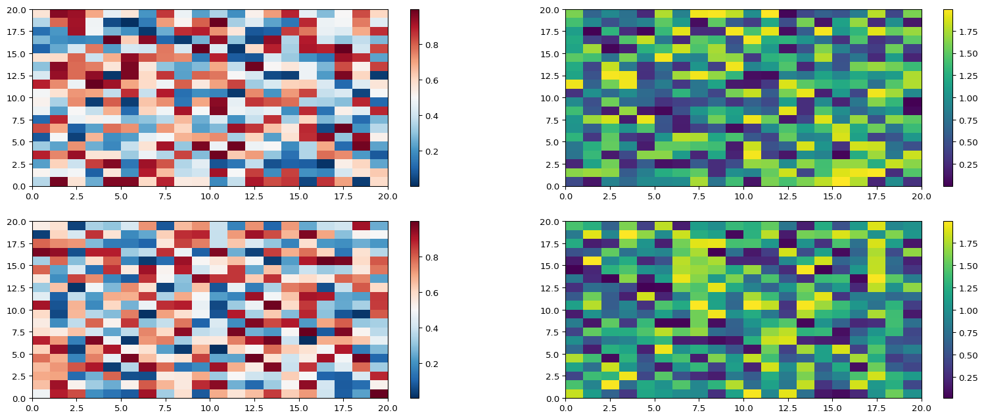

Coe, Mary Kathryn. n.d. “Hydrophobicity Across Length Scales: The Role of Surface Criticality.”

1. See the [Matplotlib Gallery](https://matplotlib.org/stable/gallery/subplots_axes_and_figures/colorbar_placement.html) to explore colorbars further