Frequently Asked Questions (FAQ) for contest coaches
IUSS International Soil Judging Contest, Nanjing, China 2026

Who is organizing this contest?
The contest is being organized jointly by the Soil Science Society of China and the IUSS International Soil Judging Working Group.
Where do I find information and resources?
There are two primary sources for information about this contest:
- The 2026 World Congress of Soil Science Soil Judging website
  - https://www.23wcss.org.cn/fe/index.html
- The IUSS Working Group website
  - https://soiljudgingiuss.github.io/
  - See the section on Resources & Downloads
Who should I contact with questions?
For questions related to registration, visas, and all activities that will occur in China, please email the Soil Science Society of China Organizing Committee:
- soiljudging@issas.ac.cn
For questions related to coaching and contest rules, please email Dr. Brian Needelman (the chair of the IUSS International Soil Judging Working Group) at:
- bneed@umd.edu
For questions related to social media and international soil judging in general, please email the International Soil Judging Working Group:
- soiljudgingiuss@gmail.com
Can I replace, add, or remove participants?
- Yes, you may replace, add, or remove participants up to the limits of four students per team and two coaches per team. If you have changes to make to your participants list that you submitted with your registration, please send them to soiljudging@issas.ac.cn.
How will accommodations be managed during the contest?
- Accommodations will be provided according to the official registration list you provided and booked by the organizer. Each coach will be provided with a single room, while participants will be accommodated in standard twin rooms.
How do I pay for the contest registration?
- Please complete the registration fee of USD 500 per person via bank transfer to the account details provided below. Teams unable to arrange a bank transfer may pay on-site upon arrival, either in cash or card.
- Bank Details:
- Account Name: Soil Science Society of China
- Account Number: 4301 0108 0900 1064 640
- SWIFT Code: ICBKCNBJNJG
- Bank Name: Chengxian Street Sub-branch, Nanjing Branch, Industrial and Commercial Bank of China
- Bank Address: No. 90, Chengxian Street, Xuanwu District, Nanjing City, Jiangsu Province, China
- *Note: We recommend that payments be made by the national soil science society of your respective country/region. If this is not possible, we also accept transfers from personal accounts.
What if I have fewer than four students?
- Teams may compete with three students. If you have fewer than three students, your students can still compete in the individual contest but will not have enough students to be scored as a team. If it is agreeable to the nations involved, the organizers may combine small teams to make a joint team of three or four students.
Are students and coaches required to attend the World Congress?
- Participants at the soil judging contest are not required to go to the World Congress.
Will there be housing available for soil judging contest participants at the World Congress?
- The organizers plan to make a group booking for contest attendees at one of the accommodation options at the World Congress. We hope that this will create a community of individuals that can continue to interact during the World Congress after the shared experience of the soil judging contest. Individuals will need to pay for these accommodations on their own. This is optional. If you are interested in this option, please send the list of individuals seeking accommodations and their departure dates to soiljudging@issas.ac.cn by May 6, 2026.
How should I communicate the travel schedule of my team?
- For travel schedules (arrival and departure dates), participants can send them directly to us via email at soiljudging@issas.ac.cn.
What is the latest time that I should plan to arrive?
- The first event will be a Welcome Ceremony in the evening on June 2 (we have not set a time for the Welcome Ceremony yet). Please let us know if you will be late by emailing us at soiljudging@issas.ac.cn.
What if I arrive earlier than June 2nd?
- Early arrivals in Nanjing will be able to stay at the soil judging contest accommodation with an additional charge by emailing us at soiljudging@issas.ac.cn before May 6, 2026.
Will there be transportation from the Nanjing airport, Nanjing train station, or other arrival locations to the contest site?
- Due to the large number of participants and varying arrival times, the organizing committee may not be able to arrange transportation or pick-up services. The organizing committee will communicate whether you will need to use private transportation or whether you will be providing transportation. Please see below for additional information about arrival information and addresses in Chinese that may be shown to taxi drivers.
What should we bring?
- Please see the contest handbook for soil judging-related equipment that you should bring.
- Please bring long-sleeved and short-sleeved clothes, a sun hat, sunscreen, etc. It is recommended to bring waterproof clothes and shoes, although disposable ones will also be provided on site.
- For the welcome reception, we encourage that each participant bring a gift to share that represents their country or hometown, along with a card that includes background information about the gift and your signature.
Do you have advice on how to make purchases and use technology while in China?
- The World Congress website has related information for congress attendees that also applies to soil judging contest attendees.
  - https://www.23wcss.org.cn/4283/index.html
  - See four files under “Guide in Nanjing, China”
- We are planning to provide additional information related to this topic.
- We recommend that you install WeChat on your mobile phone to facilitate payments and communication with others while in China.
When does the soil judging contest end?
- Activities on June 6 are expected to conclude late in the afternoon, followed by an evening celebration. On June 7, participants will be free. For those attending the World Congress, we will provide dedicated transportation to the venue.
Does the IUSS Working Group have a social media account covering the event?
- Yes, our communications committee is organizing our social media (particularly Jaclyn Fiola).
  - Instagram: soiljudgingiuss
- We are requesting teams to contribute information to help us publicize the event. Here are some suggestions for submissions:
  - Introduce your team members:
    - Photos of each member & coach (preferably with a soil!)
    - Their university/location
    - Fun fact/what they are looking forward to
  - General team introduction:
    - Photos of soils from your country
    - Names of team members & coach
  - What you are most excited about
  - Any language!
- Please submit you content and any questions to either the working group (soiljudgingiuss@gmail.com) or Jaclyn (Jaclyn.fiola@delval.edu).

Arrival Information and Addresses for 5th International Soil Judging Contest
The Institute of Soil Science, Chinese Academy of Sciences (ISSCAS) moved to its new campus in 2024. The location marked on the map on the SJC website (and below) is the correct location—it reflects the new campus in the northern part of Nanjing.
For the first day (June 2), accommodation will be arranged at a hotel approximately 1 km from the new ISSCAS campus. The travel distances are as follows:
From Nanjing Lukou International Airport to the hotel: about 50 km (approx. 40 minutes by car).
From Nanjing South Railway Station to the hotel: about 20 km (approx. 25 minutes by car).
Participants may arrive at the hotel at any time on June 2. Taking a taxi is convenient, but if someone encounters difficulties, they could let us (soiljudging@issas.ac.cn) know in advance, and we can arrange a pickup.
Hotel and Registration: Nanjing Jinfan Wanyuan Hotel (Zhongshan Scenic Area Branch)
Address: Building 10, Artificial Intelligence Industrial Park, No. 266 Chuangyan Road, Qilin Street, Jiangning District, Nanjing
入住酒店：南京金帆万源酒店(钟山风景区店)
酒店地址：南京市江宁区麒麟街道创研路266号人工智能产业园10号楼

Indoor Activity Location: Institute of Soil Science, Chinese Academy of Sciences (ISSCAS)
Address: No. 298, Chuangyou Road, Qilin Street, Jiangning District, Nanjing
室内活动位置：中国科学院南京土壤研究所
地址：南京市江宁区麒麟街道创优路298号

Emergency Contact:
Dr Fei Yang, Mobile:19863331102 (Wechat), fyang@issas.ac.cn;
Dr Jinlong Dong, Mobile: 13605161626 (Wechat), jldong@issas.ac.cn

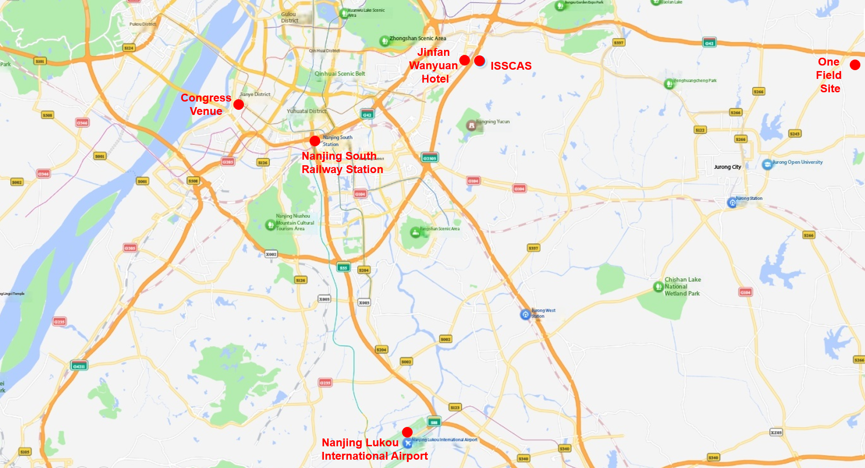
Map for 5th International Soil Judging Contest:

