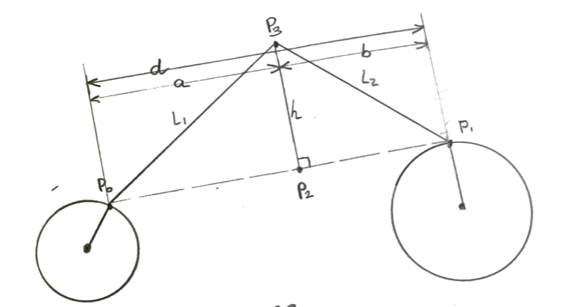

Known: $P_{0},L_{1},L_{2},P_{1}$

Find: $P_{3}$

$$L_{1}^{2}= h^{2}+a^{2} :\left(1\right) pythagorean thereom$$

$$L_{2}^{2}=h^{2}+b^{2} : \left(2\right)$$

Find **a**

$$d=a+b :by diagram definition$$

$$b=d-a :reorder$$

$$b^{2}={\left(d-a\right)}^{2}=d^{2}-2ad+a^{2} :\left(3\right) by algebra$$

$$L_{2}^{2}=h^{2}+d^{2}-2ad+a^{2} :\left(3\right)\&\left(2\right)$$

$$L_{2}^{2}=\left(h^{2}+a^{2}\right)+d^{2}-2ad :reorder$$

$$L_{2}^{2}=\left(L_{1}^{2}\right)+d^{2}-2ad :substitute \left(1\right)$$

$$L_{2}^{2}-L_{1}^{2}-d^{2}=-2ad : reorder$$

$$-L_{2}^{2}+L_{1}^{2}+d^{2}=2ad : reorder$$

$$\frac{L_{1}^{2}+d^{2}-L_{2}^{2}}{2d}=a :\left(4\right)$$

Find **d**

$$d=\sqrt{{\left(x_{1}-x_{0}\right)}^{2}+{\left(y_{1}-y_{0}\right)}^{2}} :Magnitude of \overset{⃑}{P_{0}P_{1}}$$

Find **h**

$$L_{1}^{2}= h^{2}+a^{2} :\left(1\right)$$

$$h^{2}=L_{1}^{2}-a^{2}$$

$$h=\sqrt{L_{1}^{2}-a^{2}}$$

Find **b** (for completeness)

Find **P2**

P2 = P0 + scaled by

P2 = (x2,y2)

Find **P3**

is normal to $\overset{⃑}{P_{0}P_{1}}$ with magnitude **h**, originating at **P2**

Unit Vector of $\overset{⃑}{P_{0}P_{1}}$ is $\overset{⃑}{\frac{P_{0}P_{1}}{d}}$ is $\left(\left(x_{1}-x_{0}\right)/d,\left(y_{1}-y_{0}\right)/d\right)$

Normal Vectors of the Unit Vector of of $\overset{⃑}{P_{0}P_{1}}$ are:



$\left(-\left(y_{1}-y_{0}\right)/d,\left(x_{1}-x_{0}\right)/d)\right)$

$\left(\left(y_{1}-y_{0}\right)/d,-\left(x_{1}-x_{0}\right)/d\right)$

h-Scaled Normal Vectors of the Unit Vector of $\overset{⃑}{P_{0}P_{1}}$ are

*(5a)*

*(5b)*

P3 = P2 + *(5a)*

P3 = (x3, y3) = (x2,y2) +

P3 = P2 + *(5b)*

P3 = (x3, y3) = (x2,y2) +

