- In the context of main memory, why might a 64-bit word not necessarily be referred to as an 8-byte word in some computer architectures?

A. Some architectures use variable-sized words, making the byte-word conversion inconsistent.

B. A 64-bit word is always called an 8-byte word in every system.

C. The term "byte" is only used for 8-bit words, and larger words do not follow this convention.

D. Addresses in memory do not follow a binary representation, affecting the terminology.

Correct Answer: A. Some architectures use variable-sized words, making the byte-word conversion inconsistent.

Explanation: page 94 in book
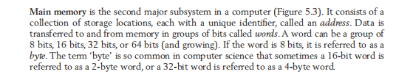
While the passage states that a 16-bit word can be referred to as a 2-byte word and a 32-bit word as a 4-byte word, this convention assumes a fixed word size. However, in some architectures, a "word" does not have a universally fixed size and can vary depending on system design. Thus, a 64-bit word might not always be referred to as an 8-byte word if the architecture has a different way of handling word sizes.

2. What is the main reason why the decimal system does not clearly represent the data stored in a computer?

A. The decimal system is longer than binary notation.

B. The decimal system does not directly reflect binary storage.

C. The decimal system is not used in computing.

D. The decimal system is the same as the hexadecimal system.

Correct Answer: B. The decimal system does not directly reflect binary storage.

Explanation: page 20 in book
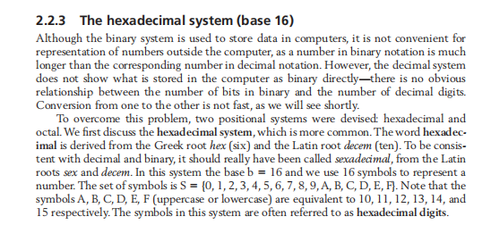
The passage states that the decimal system does not show what is stored in a computer as binary. There is no direct relationship between the number of decimal digits and the number of bits in binary. Hence, converting between them is not straightforward.

- A computer system uses a 32-bit floating-point representation with 1 bit for the sign, 8 bits for the exponent (with bias 127), and 23 bits for the mantissa. What is the stored representation of the decimal number -5.75 in binary?
A) 1 10000001 01110000000000000000000
B) 1 10000000 01110000000000000000000
C) 0 10000001 01110000000000000000000
D) 1 10000001 10111000000000000000000
ANSWER: A
Giải thích:
- Step 1: Chuyển -5.75 sang nhị phân → -101.11
- Step 2: Biểu diễn dưới dạng normalized scientific notation: -1.0111 × 2²
- Step 3: Mã hóa từng phần:
  - Sign bit: 1 (do số âm)
  - Exponent: 2 + 127 = 129 → 10000001
  - Mantissa: 01110000000000000000000
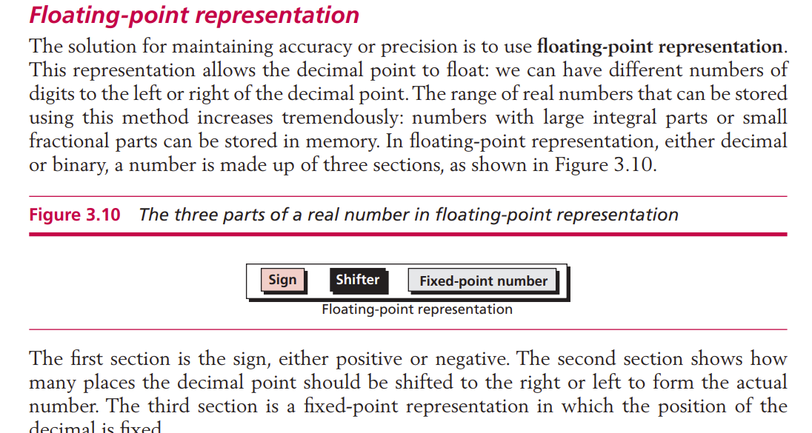

- Which of the following statements about IPv6 vs. IPv4 is false?
A) IPv6 uses 128-bit addresses, while IPv4 uses 32-bit addresses.
B) IPv6 removes the need for NAT (Network Address Translation).
C) IPv6 packets are always smaller than IPv4 packets.
D) IPv6 includes built-in support for IPsec security.
ANSWER: C
📖 Giải thích:
- IPv6 hỗ trợ kích thước gói lớn hơn IPv4, không phải luôn nhỏ hơn.
- A) Đúng: IPv6 dùng 128-bit địa chỉ, IPv4 dùng 32-bit.
- B) Đúng: IPv6 có nhiều địa chỉ hơn nên không cần NAT.
- D) Đúng: IPv6 tích hợp sẵn IPsec để bảo mật.
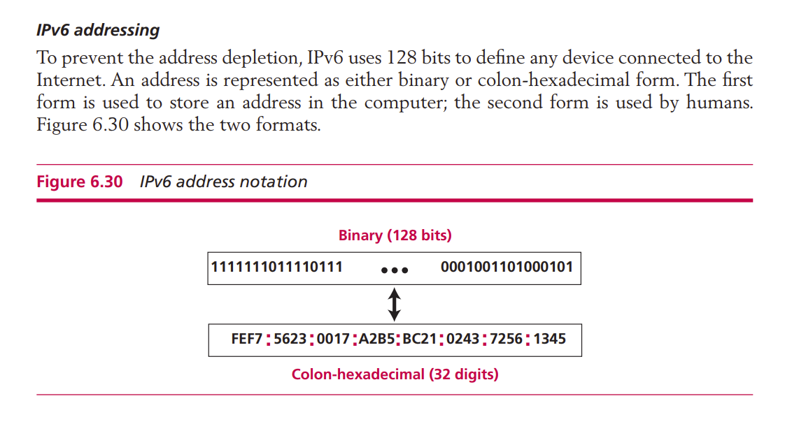

- you have a Time-sharing system that is upgraded by adding multiple CPUs. Would that system become a Parallel system?
- Yes, because both involve multiple tasks running together.
B. No, because Time-sharing still relies on rapid switching between processes.
C. No, because Parallel systems also use a single CPU.
D. Yes, because adding more CPUs to Time-sharing automatically makes it Parallel.
Answer: B No, because Time-sharing still relies on rapid switching between processes.
Explain: page 190 in book
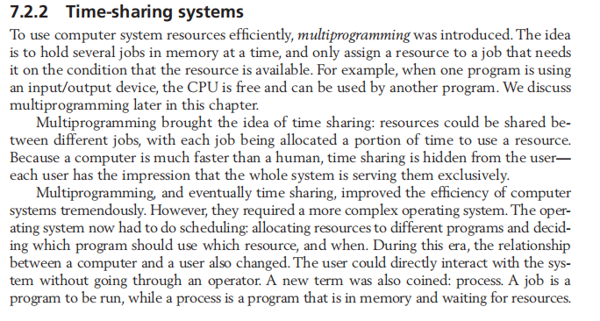
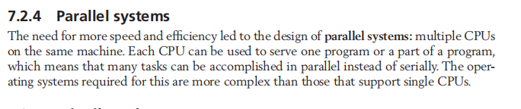
· The Time-sharing system only shares the CPU by allocating usage time in a rotating manner; it does not actually run concurrently.
- Even if there are multiple CPUs, if the operating system still uses the Time-sharing method, the system is not a Parallel system.
- A Parallel system requires the operating system to support true parallel processing, not just time-sharing.
Why the Other Answers Are Incorrect?
- A is incorrect because the correct answer is "No".
- C is incorrect because a Parallel system does not use only one CPU.
- D is incorrect because the correct answer is "No".
- Suppose we have a list of n elements to be sorted using Bubble Sort, but instead of "bubbling up" the smallest element, we apply the original approach of the algorithm, which "bubbles down" the largest element. If the initial list is [78, 56, 45, 32, 23, 8], what will the list look like after 3 passes?
A. [8, 23, 32, 45, 56, 78]
B. [56, 45, 32, 23, 8, 78]
C. [45, 32, 23, 8, 56, 78]
D. [32, 23, 8, 45, 56, 78]
Answer: D. [32, 23, 8, 45, 56, 78]
Explain: page 228 in book
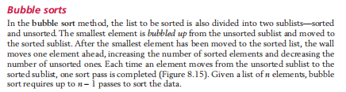
According to the "bubble down" approach, each iteration moves the largest element to the end of the list, rather than bringing the smallest element to the front.
Pass 1: 78 is moved to the end of the list. The list becomes [56, 45, 32, 23, 8, 78].
Pass 2: 56 is moved just before 78. The list becomes [45, 32, 23, 8, 56, 78].
Pass 3: 45 is moved just before 56. The list becomes [32, 23, 8, 45, 56, 78].

- In the object-oriented paradigm (OOP), how does it differ from procedural programming in terms of method execution?
A. Methods in OOP are independent and can be called from anywhere in the program.
B. In OOP, an object executes actions when it receives a stimulus, unlike procedural programming.
C. Objects in OOP do not share methods; each object must define its own methods separately.
D. The object-oriented paradigm does not use classes; it only relies on functions.

Explanation: page 252 in book
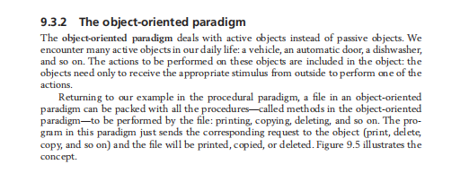
Correct answer: B
→ According to the image, in OOP, an object responds to a stimulus (such as print, copy, or delete), meaning the object itself is responsible for executing the action. This contrasts with procedural programming, where actions are performed by independent procedures.

Why the other answers are incorrect?
A is incorrect:
→ In OOP, methods belong to objects and cannot be called independently from anywhere in the program. They must be accessed through an instance of a class.
C is incorrect:
→ Objects of the same type (e.g., files) share common methods like print(), copy(), and delete(), rather than each object needing to define them separately.
D is incorrect:
→ The object-oriented paradigm is based on classes, which define objects and their behaviors. The image explicitly mentions that object-oriented languages like C++, Java, and C# use class as a unit of definition.
- Why does the software lifecycle include a modification phase instead of immediately replacing outdated software?
A. Modification allows software to adapt to errors and changes before it becomes obsolete.
B. Replacing software immediately is costly and inefficient, so modification is always preferred.
C. Software never truly becomes obsolete as long as it is modified regularly.
D. Modification is only needed when users report issues, not for adapting to new requirements.
Correct Answer: A. Modification allows software to adapt to errors and changes before it becomes obsolete.

Explanation: page 274 in book
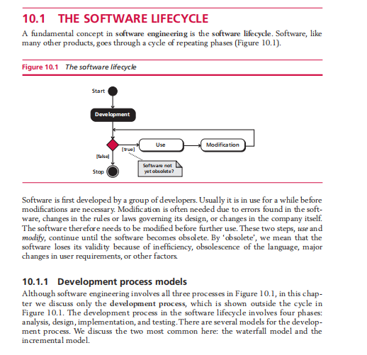
- A is correct because modification helps extend software usability by fixing errors and adapting to new requirements. However, once the software becomes too inefficient or outdated, modification stops, and replacement may be necessary.
- B is incorrect because while replacement is costly, modification is not always preferred—sometimes, full replacement is required.
- C is incorrect because software can still become obsolete despite regular modifications due to evolving technology and user needs.
- D is incorrect because modification is also done proactively to adapt to new technological and regulatory changes, not just in response to user complaints.
- In a row-major storage system, what would be the memory address of the element students[8][2] if the base address is 2000 and each element occupies one memory location? Assume the array has 10 rows and 5 columns.
A) 2042
B) 2040 (Correct Answer)
C) 2038
D) 2050

Explain; page 295 in book
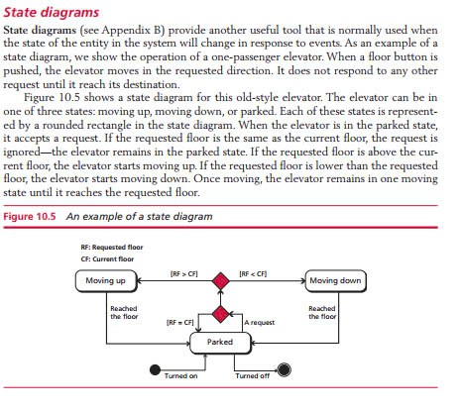
Solution:
Using the formula:
y=x+Cols×(i−1)+(j−1)
Where:
x = 2000 (base address)
Cols = 5
i = 8 (row index)
j = 2 (column index)
y=2000+5×(8−1)+(2−1)
y=2000+5×7+1=2000+35+1=2040
Correct answer: B) 2040.

- In the Modulo division hashing method, why is the list size (list size) often chosen as a prime number?
A) Because a prime number helps reduce the number of collisions in the hashing process.
B) Because a prime number speeds up the computation of the division operation.
C) Because a prime number ensures that all key values are evenly distributed.
D) Because a prime number helps reduce the overall file size.
Correct answer: A)
Explain:
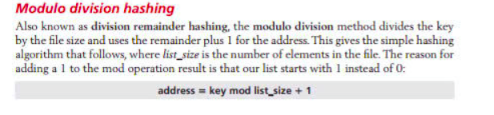

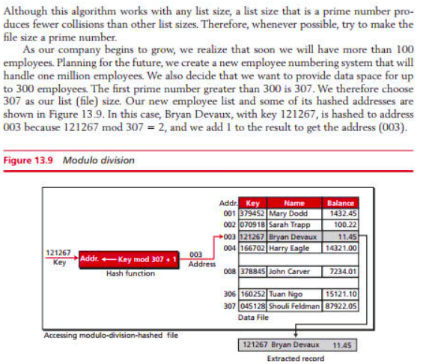
Correct answer : A In the Modulo division hashing method, choosing a prime number as the list size helps distribute the keys more effectively and reduces the number of collisions, meaning fewer cases where two different keys are mapped to the same address.

- B) Incorrect because using a prime number does not make division operations faster.
- C) Incorrect because a prime number reduces collisions but does not guarantee perfectly even distribution of keys.
- D) Incorrect because the overall file size is not affected by the use of a prime number in hashing.
- chapter 13: File Structure slide 356-357 Hashed Files
+ First image: The paragraph right below the heading "Modulo division hashing", starting with "Also known as division remainder hashing...". slide 356
+ Second image: The section explaining the choice of a prime number as the list size, stating that "a prime number produces fewer collisions than other list sizes." slide 357

- You are developing a document management system where each document can contain multiple chapters, and each chapter can contain multiple pages. You need a data structure that can efficiently represent this hierarchical relationship. Which of the following structures is the most suitable?
A. Array
B. Linked List
C. Tree
D. Queue
Correct Answer: C. Tree
Giải thích:
Hệ thống quản lý danh mục sản phẩm trong một cửa hàng trực tuyến có dạng phân cấp, nghĩa là mỗi danh mục có thể chứa danh mục con và các sản phẩm. Đây là tổ chức dữ liệu theo một mối quan hệ cha-con, giúp việc tìm kiếm, thêm, hoặc xóa danh mục trở nên dễ dàng.
Các đáp án sai:
- Array không phù hợp cho biểu diễn cha con
- Linked List dùng để lưu danh sách tuyến tính, không thể biểu diễn cấu trúc phân cấp phức tạp
- Queue không phù hợp vì chỉ hỗ trợ truy xuất theo thứ tự FIFO (First in, First out)
Figure 12.20 in Chap 12.5
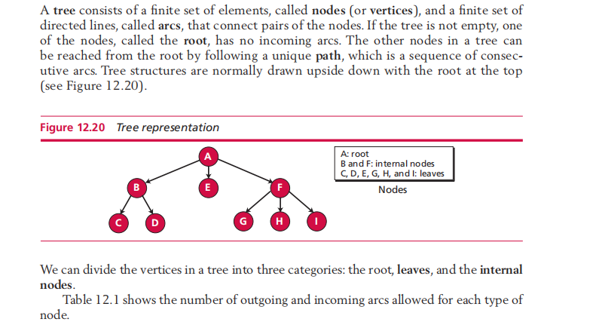

- You are designing a text editor that supports Undo and Redo functionality. Which of the following data structures is the best choice for efficiently managing the edit history?
- Queue
B. Two Stacks
C. Doubly Linked List
D. Binary Search Tree
Correct answer: B. two stacks
Giải thích: Bạn cần thiết kế một trình soạn thảo văn bản hỗ trợ chức năng hoàn tác ( UNDO) và làm lại (REDO)
Các đáp án sai:
- Queue: không phù hợp vì tuân theo quy tắc FIFO (First in, First out) không thể truy xuất nhanh hành động gần nhất
- Doubly Linked List: Có thể hỗ trợ UNDO và REDO, nhưng truy xuất chậm hơn so với sử dụng ngăn xếp
- Binary Search tree: không phù hợp vì không hỗ trợ quản lý thao tác theo thứ tự thời gian
Figure 12.2 chap 12.2
