# GPBR Exercise 5

Name: Soi Zhi Wen

Matriculation Number: 22-132-245

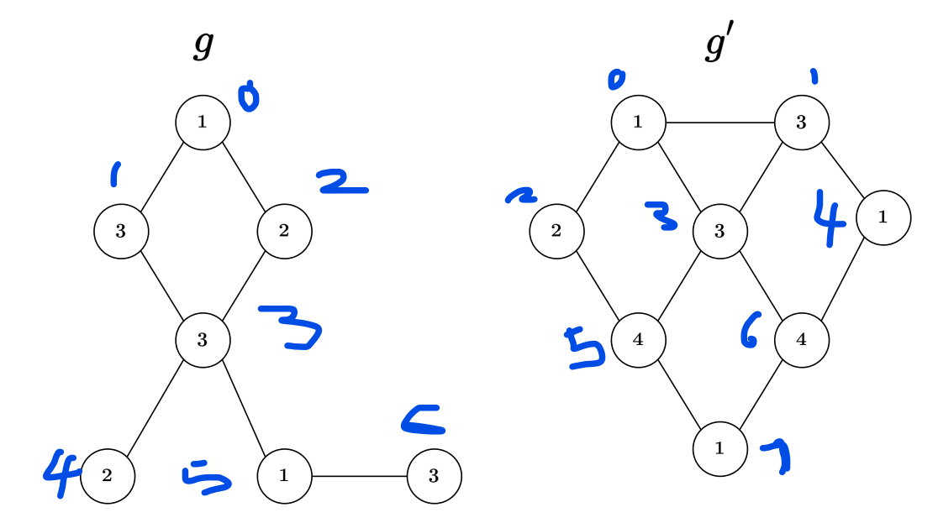

$$g_{features}=\{1,2,3\}$$

$$\left[\begin{matrix}\begin{matrix}1 \\ 0 \\ 0\end{matrix} & \begin{matrix}\begin{matrix}0 \\ 0 \\ 1\end{matrix} & \begin{matrix}0 \\ 1 \\ 0\end{matrix}\end{matrix} \\ \begin{matrix}0 \\ 0 \\ \begin{matrix}1 \\ 0\end{matrix}\end{matrix} & \begin{matrix}\begin{matrix}0 \\ 1 \\ \begin{matrix}0 \\ 0\end{matrix}\end{matrix} & \begin{matrix}1 \\ 0 \\ \begin{matrix}0 \\ 1\end{matrix}\end{matrix}\end{matrix}\end{matrix}\right]$$

$$ϕ\left(g\right)=\left[\begin{matrix}2 & 2 & 3\end{matrix}\right]$$

$${g'}_{features}=\{1,2,3,4\}$$

$$\left[\begin{matrix}\begin{matrix}\begin{matrix}1 \\ 0 \\ 0\end{matrix} & \begin{matrix}0 \\ 0 \\ 1\end{matrix} \\ \begin{matrix}0 \\ 1 \\ \begin{matrix}0 \\ 0 \\ 1\end{matrix}\end{matrix} & \begin{matrix}0 \\ 0 \\ \begin{matrix}0 \\ 0 \\ 0\end{matrix}\end{matrix}\end{matrix} & \begin{matrix}\begin{matrix}0 \\ 1 \\ 0\end{matrix} & \begin{matrix}0 \\ 0 \\ 0\end{matrix} \\ \begin{matrix}1 \\ 0 \\ \begin{matrix}0 \\ 0 \\ 0\end{matrix}\end{matrix} & \begin{matrix}0 \\ 0 \\ \begin{matrix}1 \\ 1 \\ 0\end{matrix}\end{matrix}\end{matrix}\end{matrix}\right]$$

$$ϕ\left(g'\right)=\left[\begin{matrix}3 & 1 & \begin{matrix}2 & 2\end{matrix}\end{matrix}\right]$$

The shape of $ϕ\left(g\right)$ and $ϕ\left(g'\right)$ are not the same, therefore the inner product between $ϕ\left(g\right)$ and $ϕ\left(g'\right)$ is undefined

1. Kernel methods offer non-linear feature extraction and efficient computation as major benefits.

Non-linear feature extraction means that kernel functions can be used to compute similarity between graphs that cannot be easily compared using standard graph metrics. This allows for a more accurate representation of the data.

Efficient computation is possible due to the definition of kernel functions in terms of inner products between feature vectors, which can be computed quickly using matrix operations. For example, graphlet kernels can be computed efficiently using pre-defined reference graphlets and the subgraph isomorphism algorithm.

1. $M_{t}$:

[[0.02799761, 0.05831135, 0.05334757, 0.0525805, 0.05804274]

[0.05256354, 0.03415536, 0.06296225, 0.05549198, 0.05571845]

[0.04711917, 0.06169241, 0.03543291, 0.06138504, 0.0577396]

[0.04551993, 0.05329368, 0.06016674, 0.03733917, 0.06937286]

[0.04995095, 0.05319409, 0.05625831, 0.06896179, 0.03748364]]

$t$: 12

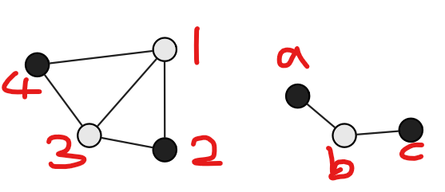

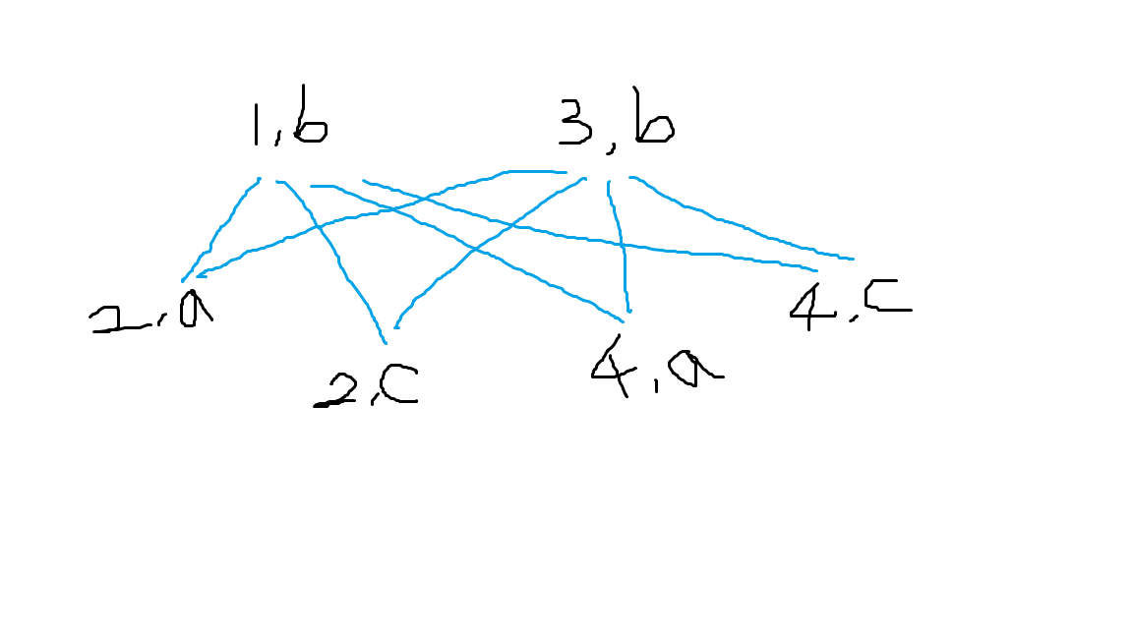

$$A_{×}^{1}=\left[\begin{matrix}\begin{matrix}0 & 1 & 1 \\ 1 & 0 & 0 \\ 1 & 0 & 0\end{matrix} & \begin{matrix}0 & 1 & 1 \\ 1 & 0 & 0 \\ 1 & 0 & 0\end{matrix} \\ \begin{matrix}0 & 1 & 1 \\ 1 & 0 & 0 \\ 1 & 0 & 0\end{matrix} & \begin{matrix}0 & 1 & 1 \\ 1 & 0 & 0 \\ 1 & 0 & 0\end{matrix}\end{matrix}\right]$$

$$A_{×}^{2}=\left[\begin{matrix}\begin{matrix}4 & 0 & 0 \\ 0 & 2 & 2 \\ 0 & 2 & 2\end{matrix} & \begin{matrix}4 & 0 & 0 \\ 0 & 2 & 2 \\ 0 & 2 & 2\end{matrix} \\ \begin{matrix}4 & 0 & 0 \\ 0 & 2 & 2 \\ 0 & 2 & 2\end{matrix} & \begin{matrix}4 & 0 & 0 \\ 0 & 2 & 2 \\ 0 & 2 & 2\end{matrix}\end{matrix}\right]$$

$$A_{×}^{3}=\left[\begin{matrix}\begin{matrix}0 & 8 & 8 \\ 8 & 0 & 0 \\ 8 & 0 & 0\end{matrix} & \begin{matrix}0 & 8 & 8 \\ 8 & 0 & 0 \\ 8 & 0 & 0\end{matrix} \\ \begin{matrix}0 & 8 & 8 \\ 8 & 0 & 0 \\ 8 & 0 & 0\end{matrix} & \begin{matrix}0 & 8 & 8 \\ 8 & 0 & 0 \\ 8 & 0 & 0\end{matrix}\end{matrix}\right]$$

An entry $a_{ij}=4$ in $A_{×}^{2}$ means that there are four paths of length $2$ from node $i$ to node $j$ in the direct product graph.

An entry $a_{ij}=8$ in $A_{×}^{3}$ means that there are eight paths of length $3$ from node $i$ to node $j$ in the direct product graph.

$$d=\left[\begin{matrix}\begin{matrix}0 & 5 & 1 \\ 5 & 0 & 2 \\ 1 & 2 & 0\end{matrix} & \begin{matrix}1 & ∞ & ∞ \\ ∞ & ∞ & 1 \\ 5 & 8 & 3\end{matrix} \\ \begin{matrix}1 & ∞ & 5 \\ ∞ & ∞ & 8 \\ ∞ & 1 & 3\end{matrix} & \begin{matrix}0 & 2 & ∞ \\ 2 & 0 & 3 \\ ∞ & 3 & 0\end{matrix}\end{matrix}\right]$$

$$d_{final}=\left[\begin{matrix}\begin{matrix}0 & 3 & 1 \\ 3 & 0 & 2 \\ 1 & 2 & 0\end{matrix} & \begin{matrix}1 & 3 & 4 \\ 4 & 4 & 1 \\ 2 & 4 & 3\end{matrix} \\ \begin{matrix}1 & 4 & 2 \\ 3 & 4 & 4 \\ 4 & 1 & 3\end{matrix} & \begin{matrix}0 & 2 & 5 \\ 2 & 0 & 3 \\ 5 & 3 & 0\end{matrix}\end{matrix}\right]$$