**Stock Management system**

Stock Management system is one of the fabulous project for managing its back end and front end simultaneously. This project will as same as traditional software’s used for trading purpose. Admin will have the authority to set working criteria of this software as used for trading by professionals such as trading market open for trading at 9 AM and sends at 4 PM, so admin can set the working criteria. Apart from these admin will also have the facility to close the trading facility on particular day and time, such as on special holidays and on Saturday and Sunday.

There will be three type of users who can use this system: – admin, stock holder and the investor. Admin will have the authority to look after the overall work of the system, stock holder can launch their stock under this stock exchange market and the investors are the person who can buy and sell the stocks of a particular company. Investors are the person who will spend their money on stocks and can set the price for selling their purchased stocks. Stock holder can increase or decrease the value of their stocks as per the current market condition. To use this system each users will have their unique login id and password. During registration process users have to select the appropriate type of users they want to be.

**Existing System**

Existing Stock Management system do not have the facility to set opening and closing criteria of the stock market. This system do not used any special plugins which will directly show the current stock status of Delhi stock exchange and Bombay stock exchange. No proper identification method has been used to make validation process easier both from the client side and from the server side. Investors do not able to check their current balance of their account and current fluctuations of the market stock value. Under the existing system, stocks values are not arranged in alphabetical manner and users do not able to identify stocks of various companies based on their business type such as list of petrochemical companies and their current stock value.

**Proposed System**

In this new stock Management system, a special plugin has been used that will provide the current stock market value of a particular company stock. Users will have their account by which they can able to check their current balance and previous transactions. If business criteria will be set the by the admin, its users will not make trading operations on that particular day such as selling and purchasing of stocks, however they can check their account and stock values. Admin will have the authority to block any type of users at any time

**Software Specifications**

Operating System : Windows 10 .

Front - End : Python Django

Back - End : Sqlite3

Browser : Microsoft Edge

**Table Design**

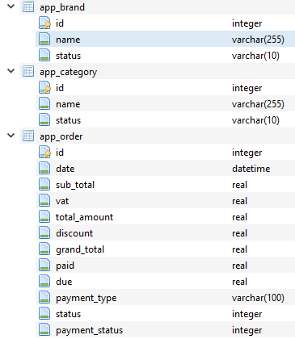

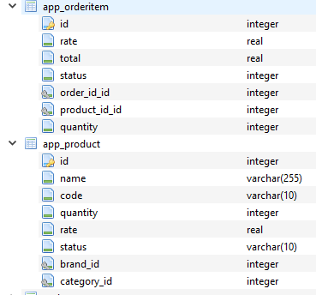

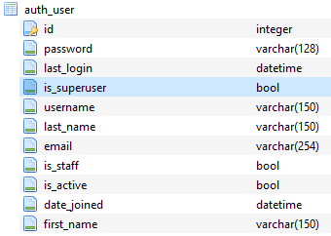



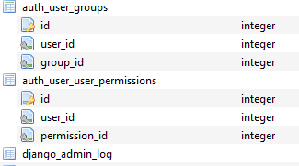

**Data Flow diagram**

**0th Level**

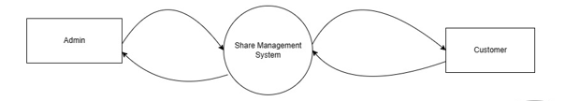

**First Level**

