1. <https://www.tutorialspoint.com/opencv_python/opencv_python_capture_video_camera.htm>

references

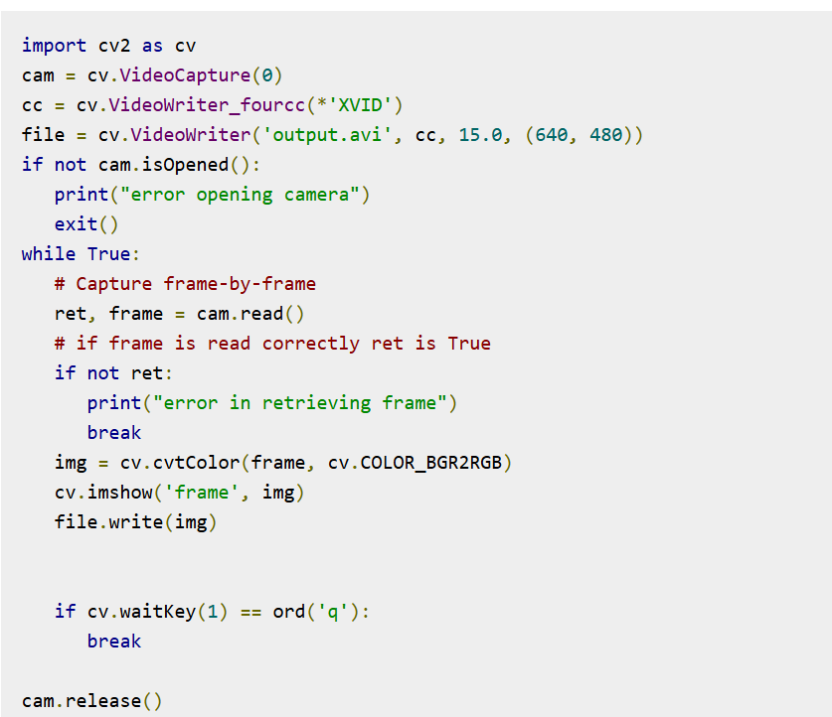

1. json2html.convert

<https://stackoverflow.com/questions/31011179/converting-json-to-html-table-in-python>

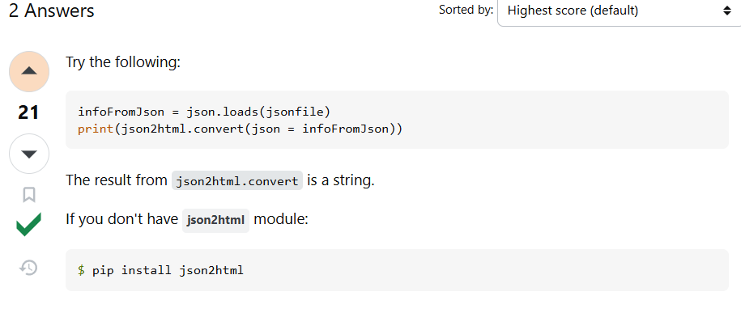

1. https://stackoverflow.com/questions/20199126/reading-json-from-a-file

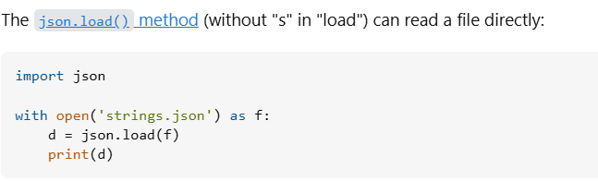

1. <https://stackoverflow.com/questions/12309269/how-do-i-write-json-data-to-a-file>

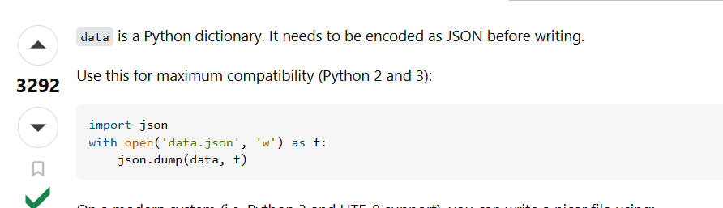

1. <https://stackoverflow.com/questions/32490629/getting-todays-date-in-yyyy-mm-dd-in-python>

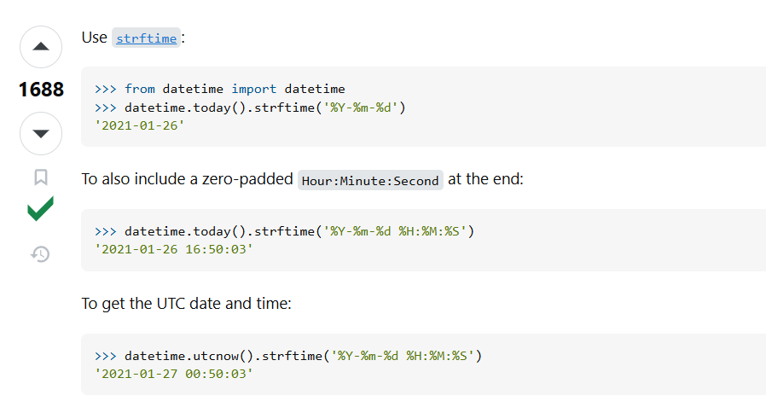

1. Python by using the __file__ ChatGPT

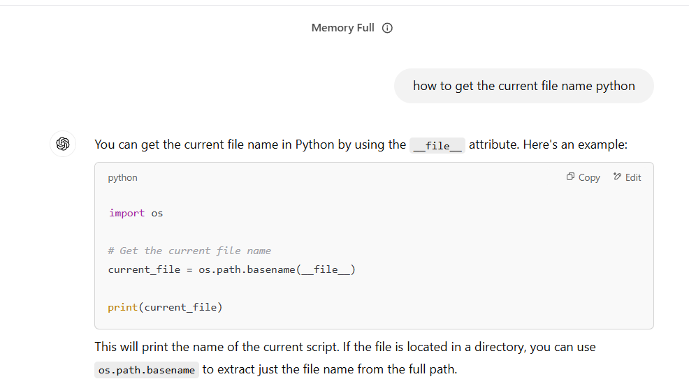

1. <https://stackoverflow.com/questions/6333916/python-logging-ensure-a-handler-is-added-only-once>

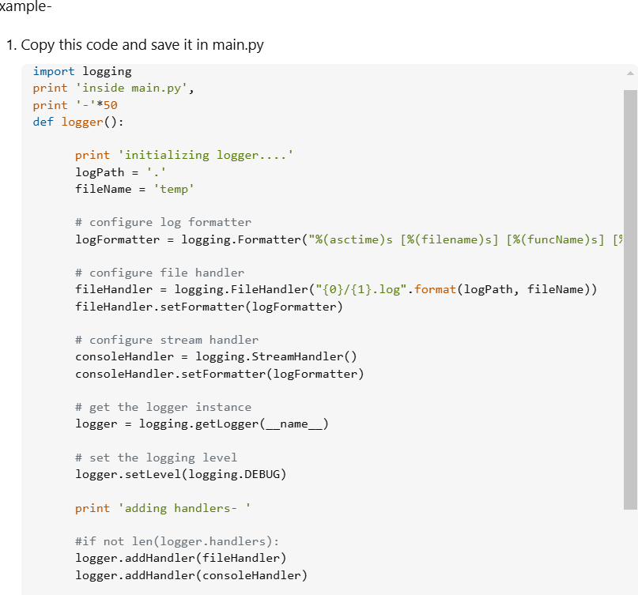

1. Refactoring code

