**LINUX/UNIX**

**mkdir**

**mkdir directory_name** : It creates a directory of name directory_name

**ls .** :lists all the directories in the current folder

Eg:

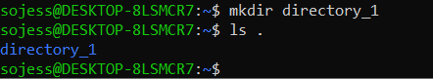

**mkdir -p directory_name1/directory_**name2 : creates nested directory

Eg:

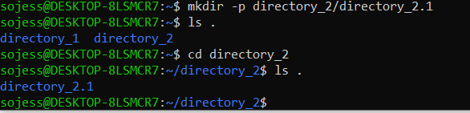

**cd**

**cd directory_name** :takes you to the directory directory_name

cd .. : takes you one directory before

cd - : takes you to previous directory

eg:

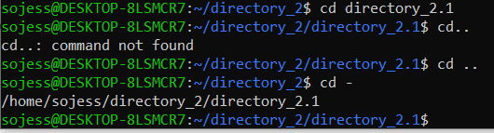

**touch**

touch file_name: touch is used to create a file of file name file_name

eg:



**rm**

**rm –r file_name** : deletes file file_name

**rm -i file_name**: ask user permission before deletion

**rm -I file_name** : doesn’t ask user permission before deletion

eg:

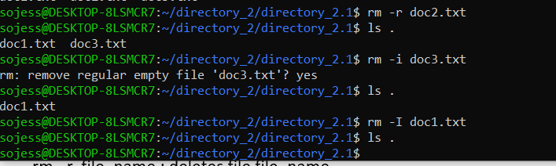

**cat**

**cat > file_name** : This command creates a new file file1 (in write mode) if it doesn’t exist in the present working directory. If any file with file name file1 exists in the current directory then it is overwritten. After writing the text into the file, press ctrl+d to save and exit from the writing mode.

**cat file_name** : this reads the file file_name

eg:

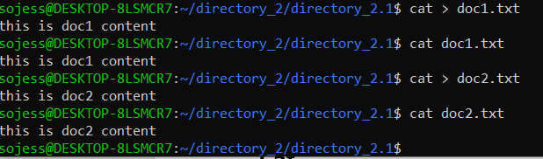

**cp &mv**

**cp parent_file child_file**: copy content of parent_file to child_file. The existing content in child_file is overwritten

eg:

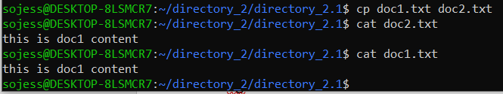

**mv parent_file child_file**: move content of parent_file to child_file And the parent file is removed

eg:

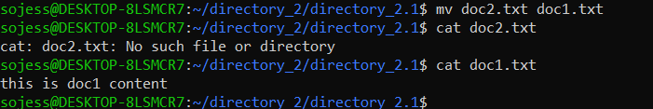

**echo**

echo “text” : prints text on screen

eg:



**Shell scripting**

**nano**

**nano file_name.sh :** creates a shell script , enter the script and press ctrl+x to save and exit

eg:



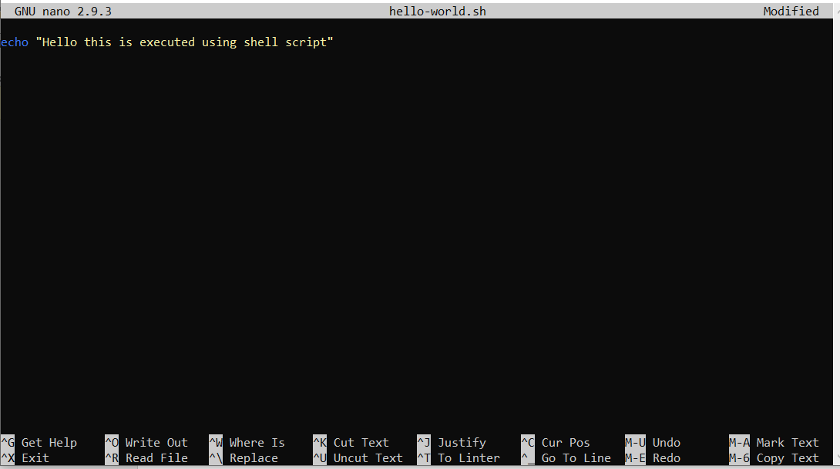

**chmod +124 file_name.sh** or **chmod a+x file_name.sh**:Change the file permission to executable



**./file_name.sh** or **bash file_name.sh** :this executes the file file_name.sh

Eg:



**Echo script**

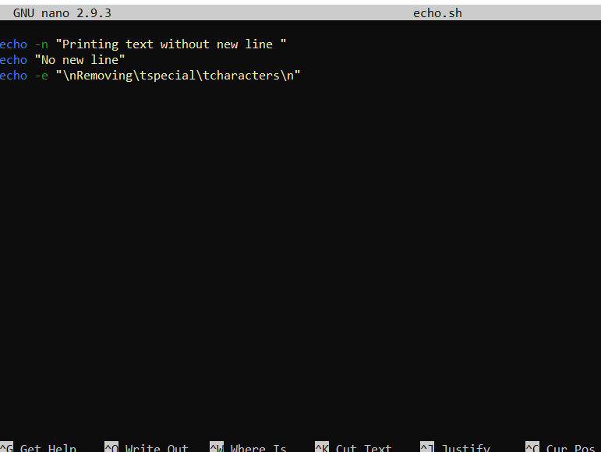

echo -n : print without new line

echo -e: e tells echo that the string passed to it contains special characters

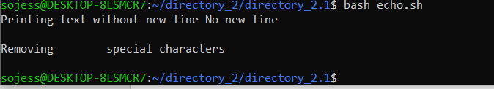

**Comments**

**Single line:**

Comments are useful for documentation and are a requirement for high-quality codebases. It’s a common practice to put comments inside codes that deal with critical logic. To comment out a line, just use the **#**(hash) character before it

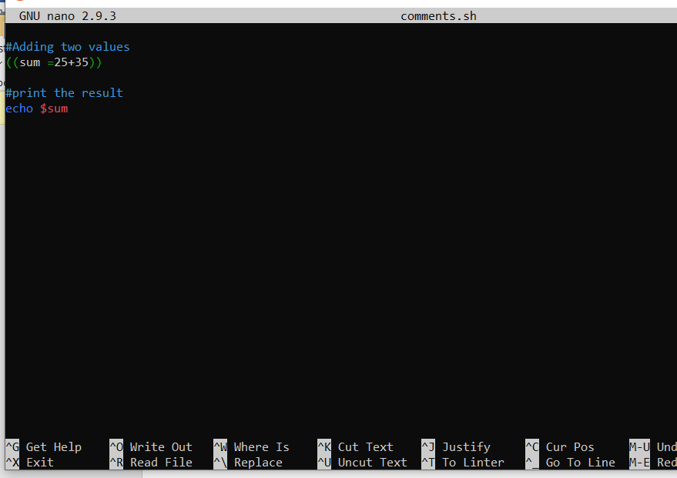

Output:

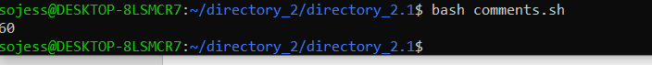

**While loop**

Syntax:

while [ condition ]

do

commands 1

commands n

done

eg:

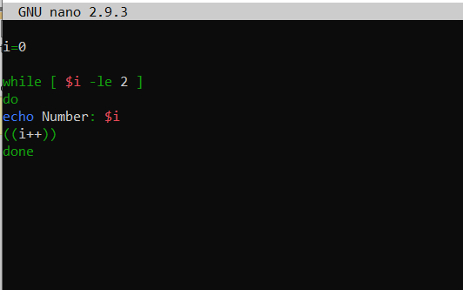

Output:

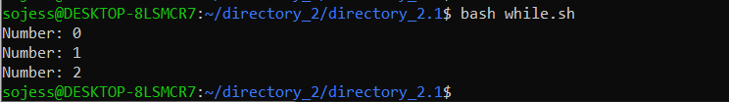

**For loop**

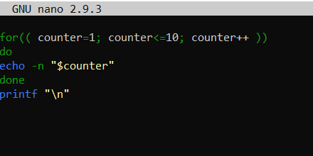

Output:



**Read Input**

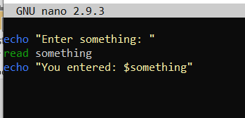

Output:

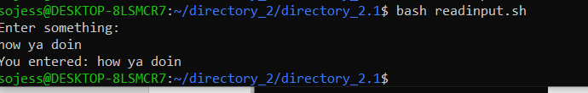

**If condition**

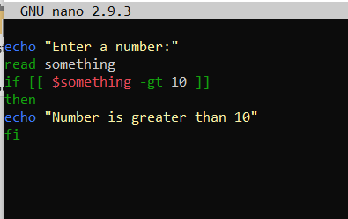

Output:

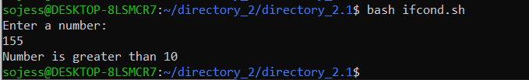

**If else**

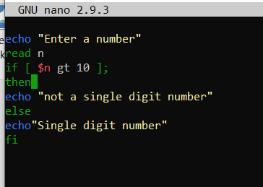

Output:

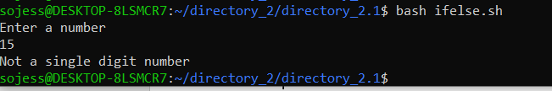

**AND operator**

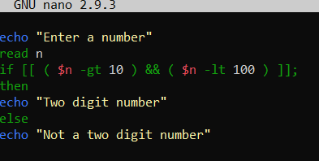

Output:

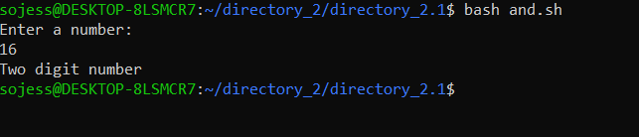

**OR operator**

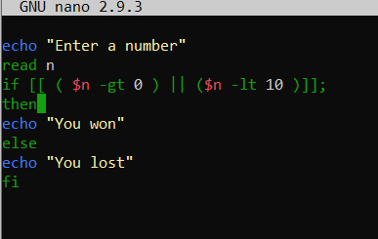

Output:

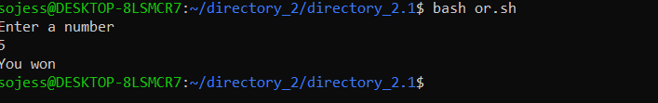

**Elif**

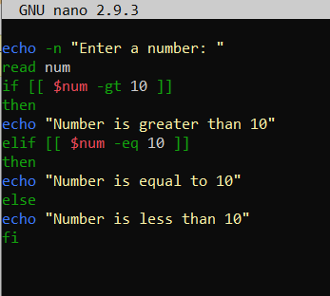

Output:

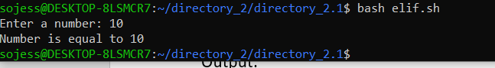

**Switch**

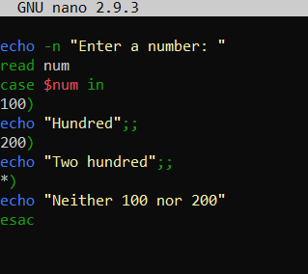

Output:

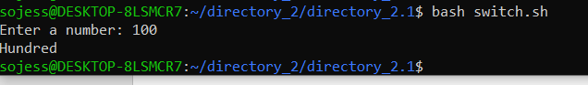

**String concatenation**

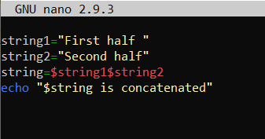

Output:



**String slicing**

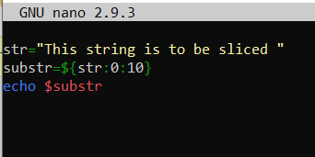

Output:



**Sum of n numbers**

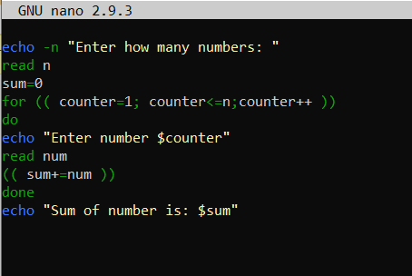

Output:

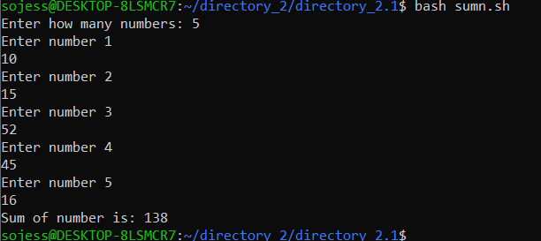

**Functions**

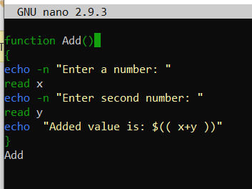

Output:

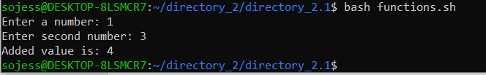

**Functions with Return Values**

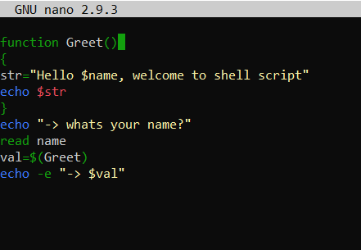

Output:

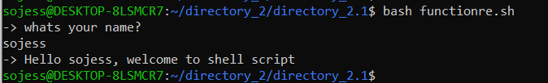

#### ****Creating Directories from Bash Scripts****

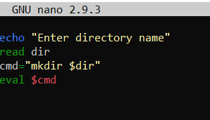

Output:

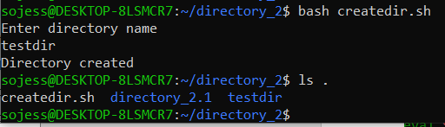

#### ****Create a Directory after Confirming Existence****

#### 

#### Output:

#### 

#### ****Reading Files****

#### 

Output:

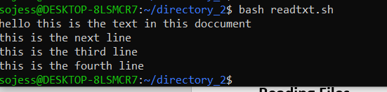

#### ****Appending to Files****

#### 

#### Output:

#### 

#### ****Parsing Date and Time****

#### 

#### Output: