**GROUP-5**

To build using Jenkins the storage module of urban ladder.

StepDefinitions

package Stepsurbanladder;

import java.sql.Driver;

import java.util.ArrayList;

import java.util.List;

import java.util.concurrent.TimeUnit;

import org.junit.Assert;

import org.openqa.selenium.By;

import org.openqa.selenium.JavascriptExecutor;

import org.openqa.selenium.WebDriver;

import org.openqa.selenium.WebElement;

import org.openqa.selenium.chrome.ChromeDriver;

import org.openqa.selenium.interactions.Actions;

import org.openqa.selenium.support.ui.Select;

import io.cucumber.java.After;

import io.cucumber.java.Before;

import io.cucumber.java.en.Given;

import io.cucumber.java.en.Then;

import io.cucumber.java.en.When;

public class Steps {

WebDriver driver ;

public static String url= "https://www.urbanladder.com/";

@Before

public void doBefore() {

System.setProperty("webdriver.chrome.driver", "C:\\Users\\Neethu K Chandran\\Downloads\\chromedriver_win32 (1)\\chromedriver.exe");

driver = new ChromeDriver();

}

@After

public void doAfter() {

driver.close();

}

@Given("The user navigates to {string}")

public void the_user_navigates_to(String string) {

driver.get(url);

}

@Then("Check if the links in storage are working")

public void check_if_the_links_in_storage_are_working() throws InterruptedException {

Actions actions = new Actions(driver);

int end =9;

for(int i=1;i<5;i++) {

if(i==2) {

end=5;

}else if(i==3) {

end=3;

}else if(i==4){

end=11;

}

for(int j=1;j<=end;j++) {

String xpath= "//*[@id=\"topnav_wrapper\"]/ul/li[5]/div/div/ul/li["+i+"]/ul/li["+j+"]/a";

actions.moveToElement(driver.findElement(By.xpath("//*[@id=\"topnav_wrapper\"]/ul/li[5]/span"))).perform();

System.out.println("Mouse hovered over Storage");

TimeUnit.SECONDS.sleep(1);

WebElement link = driver.findElement(By.xpath(xpath));

String linktext=link.getText();

System.out.println(linktext);

link.click();

System.out.println(linktext+" Opened");

TimeUnit.SECONDS.sleep(3);

if(i==1 && j==1) {

TimeUnit.SECONDS.sleep(3);

driver.findElement(By.linkText("Close")).click();

System.out.println("Closed pop-up");

}

}

}

}

@Given("user opens the browser")

public void user_opens_the_browser()throws InterruptedException{

driver.get("https://www.urbanladder.com/crockery-unit?src=g_topnav_storage_dining-storage_crockery-units");

TimeUnit.SECONDS.sleep(5);

driver.findElement(By.linkText("Close")).click();

System.out.println("Closed pop-up");

driver.manage().timeouts().implicitlyWait(5, TimeUnit.SECONDS);

}

@When("checking if checkbox is working")

public void checking_if_checkbox_is_working()throws InterruptedException {

TimeUnit.SECONDS.sleep(2);

WebElement checkbox = driver

.findElement(By.xpath("/html/body/div[2]/div[2]/div[3]/div[2]/div[1]/div/form/div[2]/div/input"));

checkbox.click();

driver.manage().timeouts().implicitlyWait(10, TimeUnit.SECONDS);

System.out.println(checkbox.isSelected());

TimeUnit.SECONDS.sleep(3);

driver.findElement(By.xpath("//*[@id=\"filters-form\"]/div[1]/div/div/ul/li[1]")).click();

List<WebElement> q = driver.findElements(By.name("price_limit"));

for (WebElement webElement1 : q) {

driver.findElement(By.xpath("//*[@id=\"filters-form\"]/div[1]/div/div/ul/li[1]")).click();

TimeUnit.SECONDS.sleep(5);

webElement1.click();

if (webElement1.isSelected()) {

System.out.println("radio button -->" + "-" + webElement1.getAttribute("value") + " is selected");

}

TimeUnit.SECONDS.sleep(2);

}

TimeUnit.SECONDS.sleep(2);

}

@When("checking dropdown")

public void checking_dropdown()throws InterruptedException {

WebElement rrr=driver.findElement(By.className("sort-box"));

WebElement dropdown =rrr.findElement(By.className("gname"));

JavascriptExecutor js = (JavascriptExecutor)driver;

WebElement element = driver.findElement(By.tagName("header"));

List<WebElement> dropdownEl = driver.findElements(

By.xpath("//*[@id=\"content\"]/div[2]/div[1]/div/div/div/div/div[2]/div[2]/div/div/ul/li"));

Actions actions = new Actions(driver);

actions.moveToElement(dropdown).perform();

System.out.println(driver.manage().window().getSize());

for (int i=0;i<dropdownEl.size()-1;i++) {

//TimeUnit.SECONDS.sleep(2);

dropdownEl.get(i).click();

TimeUnit.SECONDS.sleep(3);

System.out.println("==>");

js.executeScript("arguments[0].scrollIntoView();", element);

TimeUnit.SECONDS.sleep(2);

actions.moveToElement(dropdown).perform();

System.out.println("Cursor hovered over to " + dropdown.getText());

}

TimeUnit.SECONDS.sleep(1);

}

@Then("checking searchbox")

public void checking_searchbox() throws InterruptedException {

System.out.println("==>");

WebElement search = driver.findElement(By.id("search"));

search.sendKeys("Astrid TV Unit");

driver.findElement(By.id("search_button")).click();

System.out.println("Searched Astrid TV Unit");

TimeUnit.SECONDS.sleep(20);

}

@When("I open Home Page")

public void i_open_Home_Page() {

String title = "Furniture Online: @Upto 40% Off on Wooden Furniture Online in India at Best Price - Urban Ladder";

driver.get("https://www.urbanladder.com/");

String tt = driver.getTitle();

Assert.assertEquals(tt, title);

}

@Then("Checking the Storage Module in {string}")

public void checking_the_Storage_Module_in(String string) throws InterruptedException {

String[] l = { "Shoe Racks", "Prayer Units", "Entryway & Foyer", "Corner Storage","Living Room Sets","Cupboards"

};

WebElement a = driver.findElement(By.xpath("/html/body/div[1]/header/div[2]/div/nav/div/ul/li[5]/span"));

Actions action = new Actions(driver);

action.moveToElement(a).perform();

for (int i = 0; i <= l.length - 1; i++) {

TimeUnit.SECONDS.sleep(2);

driver.findElement(By.linkText(l[i])).click();

TimeUnit.SECONDS.sleep(3);

pop_up_blocker();

if(driver.findElements(By.className("results-count")).size() != 0) {

TimeUnit.SECONDS.sleep(2);

System.out.println("========>"+driver.findElement(By.className("results-count")).getText());

TimeUnit.SECONDS.sleep(2);

}

System.out.println(i + ":" + driver.getTitle());

TimeUnit.SECONDS.sleep(3);

driver.findElement(By.xpath("//*[@id=\"topnav_wrapper\"]/ul/li[5]/span")).click();

}

}

@When("I open the {string} page in the Storage Module")

public void i_open_the_page_in_the_Storage_Module(String string) {

String url = "https://www.urbanladder.com/shoe-rack?src=g_topnav_storage_living-storage_shoe-racks";

driver.navigate().to(url);

String tt = driver.getCurrentUrl();

Assert.assertEquals(tt, url);

}

@Then("Checking The Radio Buttons")

public void checking_The_Radio_Buttons() throws InterruptedException {

TimeUnit.SECONDS.sleep(2);

pop_up_blocker();

TimeUnit.SECONDS.sleep(3);

driver.findElement(By.xpath("//*[@id=\"filters-form\"]/div[1]/div/div/ul/li[1]")).click();

List<WebElement> q = driver.findElements(By.name("price_limit"));

for (WebElement webElement1 : q) {

driver.findElement(By.xpath("//*[@id=\"filters-form\"]/div[1]/div/div/ul/li[1]")).click();

webElement1.click();

if (webElement1.isSelected()) {

System.out.println("radio button -->" + "-" + webElement1.getAttribute("value") + " is selected");

}

TimeUnit.SECONDS.sleep(2);

}

TimeUnit.SECONDS.sleep(2);

}

@When("I add product to the cart")

public void i_add_product_to_the_cart() throws InterruptedException {

driver.navigate()

.to("https://www.urbanladder.com/cupboards?src=g_topnav_storage_bedroom-storage_cupboards");

TimeUnit.SECONDS.sleep(5);

pop_up_blocker();

driver.findElement(By.xpath("//*[@id=\"content\"]/div[4]/div/ul/li[1]/div")).click();

ArrayList<String> tabs = new ArrayList<String>(driver.getWindowHandles());

driver.close();

driver.switchTo().window(tabs.get(1));

driver.findElement(By.cssSelector("#add-to-cart-button")).click();

Assert.assertEquals(driver.getTitle(),"Shopping Cart - Urban Ladder");

System.out.println("[old]Quantity--:"+driver.findElement(By.className("line_item_quantity")).getAttribute("value"));

Select quantity = new Select(driver.findElement(By.id("select_0_quantity")));

quantity.selectByValue("5");

TimeUnit.SECONDS.sleep(2);

System.out.println("[new]Quantity--:"+driver.findElement(By.className("line_item_quantity")).getAttribute("value"));

String a = driver.findElement(By.xpath("//*[@id=\"line_items\"]/div/div[4]/div/div[1]/div/div/div")).getText().substring(1);

Assert.assertEquals(a, "214,990");

}

public void pop_up_blocker() throws InterruptedException {

TimeUnit.SECONDS.sleep(2);

if (driver.findElements(By.className("reveal-modal-bg")).size() != 0) {

System.out.println("======= pop-up opened =======");

driver.findElement(By.linkText("Close")).click();

System.out.println("======= pop-up closed =======");

TimeUnit.SECONDS.sleep(4);

}

}

}

TestRunner

package Runnerurbanladder;

import org.junit.runner.RunWith;

import io.cucumber.junit.Cucumber;

import io.cucumber.junit.CucumberOptions;

@CucumberOptions(features = "src/test/resources/Feature",strict = true,glue={"Stepsurbanladder"})

@RunWith(Cucumber.class)

public class testRunner{

}

Pom File

<project xmlns=*"http://maven.apache.org/POM/4.0.0"*

xmlns:xsi=*"http://www.w3.org/2001/XMLSchema-instance"*

xsi:schemaLocation=*"http://maven.apache.org/POM/4.0.0 https://maven.apache.org/xsd/maven-4.0.0.xsd"*>

<modelVersion>4.0.0</modelVersion>

<groupId>capstone_cucumber_junit</groupId>

<artifactId>capstone_cucumber_junit</artifactId>

<version>0.0.1-SNAPSHOT</version>

<dependencies>

<dependency>

<groupId>io.cucumber</groupId>

<artifactId>cucumber-java</artifactId>

<version>5.7.0</version>

</dependency>

<dependency>

<groupId>io.cucumber</groupId>

<artifactId>cucumber-junit</artifactId>

<version>5.7.0</version>

</dependency>

<dependency>

<groupId>org.seleniumhq.selenium</groupId>

<artifactId>selenium-java</artifactId>

<version>3.7.0</version>

</dependency>

<!-- https://mvnrepository.com/artifact/junit/junit -->

<dependency>

<groupId>junit</groupId>

<artifactId>junit</artifactId>

<version>4.13.2</version>

<scope>test</scope>

</dependency>

</dependencies>

<build>

<plugins>

<plugin>

<artifactId>maven-compiler-plugin</artifactId>

<version>3.3</version>

<configuration>

<source>1.8</source>

<target>1.8</target>

</configuration>

</plugin>

<plugin>

<groupId>org.apache.maven.plugins</groupId>

<artifactId>maven-surefire-plugin</artifactId>

<version>2.19.1</version>

<configuration>

<includes>

<exclude>

**/*testRunner.java

</exclude>

</includes>

</configuration>

</plugin>

</plugins>

</build>

</project>

Steps:

* Take the project Right capstone in the Jenkins.
* Click on configure and paste the root of pom file in the build environment.

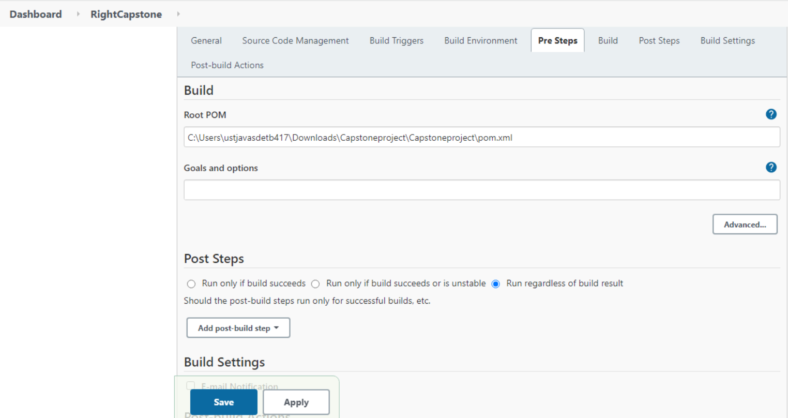

* Click on manage Jenkins🡪Global tool Configuration🡪Give the JDK Path🡪then, give the path of apache maven 3.3.1🡪Save and Apply.

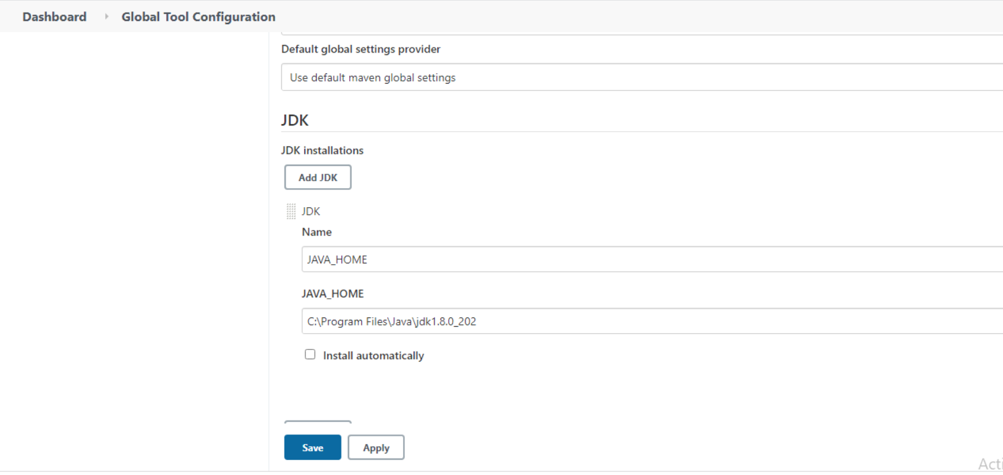

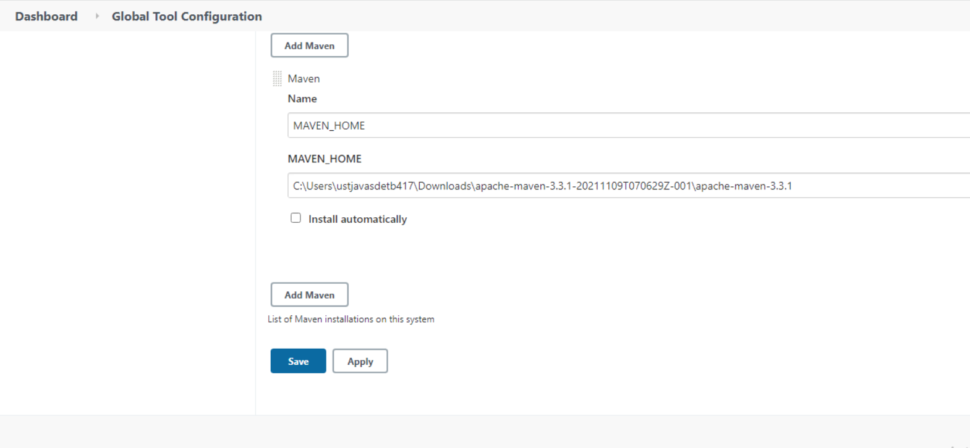

* Select the project🡪Buildnow🡪Click on the console output.

