

Project Report
RL project 2025: Exercise Problems

Soji John
0626734

May 15, 2025

Exercise 1 - Bandit Problem
The goal of this experiment was to implement an epsilon-greedy strategy to solve a multi-armed bandit problem and identify the optimal arm (the arm with the highest mean reward). The multi-armed bandit problem is a classic reinforcement learning problem that models decision-making under uncertainty. The multi armed bandit problem simplifies Reinforcement learning to demonstrate the exploration and exploitation dilemma. Agent chooses actions to maximize rewards which are sampled from distribution
Concepts multi-armed bandit problem
The goal is to learn which arm is the best or which has the highest expect reward
Arms: actions
Rewards: The outcome received when pulling an arm.
Exploration vs. Exploitation: Exploration involves trying new arms to gather information about their rewards, while exploitation focuses on using the arm that currently seems optimal.
Regret: The difference between the reward of the optimal arm and the reward obtained by your chosen arm over time.
Epsilon-Greedy Strategy:
The epsilon-greedy algorithm is one of the simplest strategies for solving the bandit problem.
Exploration is trying different arms to figure out their true reward. And Exploitation picks the best arm as per Q-values.
It works as follows:
With probability epsilon, explore by choosing a random arm.
With probability 1 - epsilon, exploit by choosing the best arm with the highest Q-value
This approach ensures a balance between exploration and exploitation.
Implementation Steps:
Bandit Class:
Defined a Bandit class that simulates multiple arms with predefined reward distributions.
Calculated the true mean rewards for each arm (_means) and identified the optimal arm (_opt_index).
Epsilon-Greedy Algorithm:
Used an exploration probability (epsilon = 0.2) to randomly select an arm 20% of the time.
Exploited by selecting the arm with the highest estimated Q-value 80% of the time.
Updated Q-values using incremental updates based on observed rewards.
Performance Metrics:
Tracked cumulative regret (difference between optimal reward and observed reward).
Counted how many times the optimal arm was selected.
Visualization:
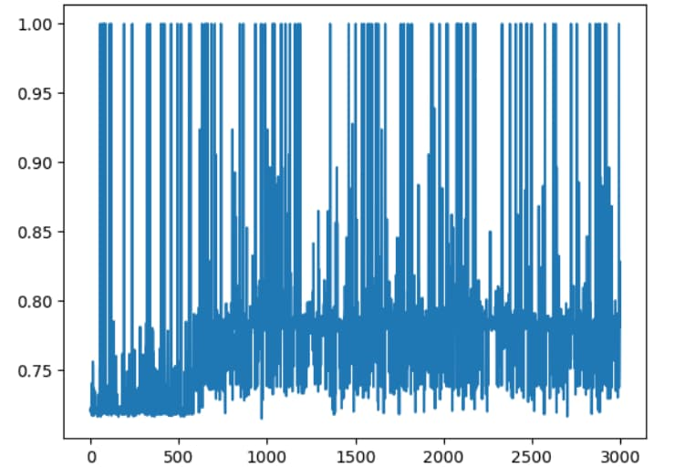
Rewards obtained at each timestep.

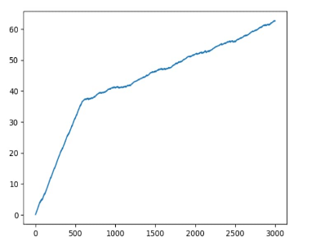

Cumulative regret over time.
Observations:
Rewards Plot: It shows fluctuating rewards over 3000 timesteps as exploration and exploitation occur and rewards stabilize over time as the algorithm learns which arms are better.
Regret Plot: cumulative regret increases initially but grows more slowly as the algorithm learns to select better arms. It indicates that the algorithm gradually reduces its mistakes and approaches optimal performance.
Optimal Arm Selection: The optimal arm was pulled 1925 times out of 3000 timesteps, demonstrating effective learning.
Q-Values vs Actual Means: The estimated Q-values closely match the true mean rewards of each arm, indicating that learning converged successfully.
Number of pulls of the optimal arm: 1925
Estimated Q-values: [0.719, 0.730, 0.740, ..., 0.806]
True mean rewards: [0.726, 0.736, 0.746, ..., 0.795]
Conclusion
This experiment successfully demonstrated how an epsilon-greedy strategy can solve a multi-armed bandit problem by balancing exploration and exploitation:
The algorithm learned to identify and favour the optimal arm over time. Cumulative regret decreased as learning improved. The estimated Q-values converged closely to actual mean rewards, validating the effectiveness of incremental updates.

Exercise-2 MDP- Reinforcement Learning for Fridge Temperature Control

A Markov Decision Process (MDP) provides a mathematical framework for modelling decision-making in situations where outcomes are partly random and partly under the control of a decision-maker. It is the interaction between an agent and its environment.
The Markov property ensures that the next state depends only on the current state and action, not the full history. MDP used extensively in reinforcement learning to formalize environments in which agents learn to achieve a goal through trial and error.
The objective of this experiment was to train an agent to control the cooling system of a fridge in a grocery store to minimize electrical consumption while maintaining a stable temperature. The fridge's environment was modelled as an MDP, and the agent was trained using the PPO algorithm.
Key Components of an MDP:
States (S): A set of all possible situations the agent can be in. The current state should contain enough information to make optimal decisions. In this exercise two continuous variables: time of day and fridge
Actions (A): A set of all possible actions the agent can take. In this excercise the action is the one continuous variable cooling strength. One continuous variable: cooling strength
Transition Model (P): The transition model defines the probability of transitioning states after taking action. In simpler terms, it describes how the environment changes in response to the agent's actions.
Reward Function (R): The reward function defines the reward the agent receives after transitioning states by taking action. The agent's goal is to maximize the cumulative reward over time.
Discount Factor (γ): A discount factor between 0 and 1 determines the importance of future rewards. A value close to 0 makes the agent focus on immediate rewards, while a value close to 1 makes it consider long-term rewards.
How MDPs Work:
At each timestep, the agent observes the current state selects an action according to its policy, and receives a reward. The environment transitions to a new state according to the transition model. This process repeats until the agent reaches a terminal state or a specified number of timesteps.
Implementation
Environment:
State Space: two continuous variables: time of day and fridge
Action Space: One continuous variable: cooling strength
Dynamics: The fridge temperature changes based on heat entering from the environment and cooling applied by the agent's action.
Reward: Reward = 1 - (electrical consumption) / 1000. It encourages the agent to minimize electricity usage while maintaining proper cooling.
Termination: Episode terminates if the temperature goes outside -20C, -15C or after 24 hours.
Algorithm PPO from the stable-baselines3 library.
Policy: Multi-Layer Perceptron (MLP) policy network.
Training: Trained for 20,000 timesteps.
Results of learning curve
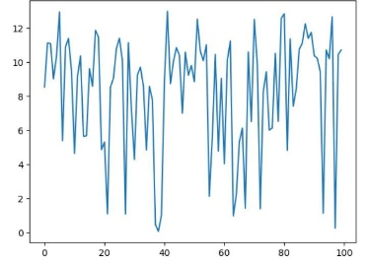
The plot shows the episode returns cumulative rewards over time. The rewards fluctuate significantly at the beginning, indicating that the agent is exploring the environment. The rewards tend to increase, showing that the agent learns to take actions that result in higher cumulative rewards and shows the variations in rewards, which means that the agent's performance varies across different episodes due to the stochastic nature of the environment.
Conclusion:
This experiment demonstrated the successful application of reinforcement learning by using PPO to control a fridge's cooling system. The agent learned to balance cooling and energy consumption to achieve a reasonable reward. The learning curve shows an increase in cumulative rewards over time, indicating effective learning.

