The Birds by Daphne du Maurier

Georgescu Mara
Măgureanu Alesia
Stanciu Briana
Coordonating Teacher-Roxana Neațu
Students at Matei Basarab National College
Class 12 B - Mathematics-Informatics Intensive English
School Year-2025-2026

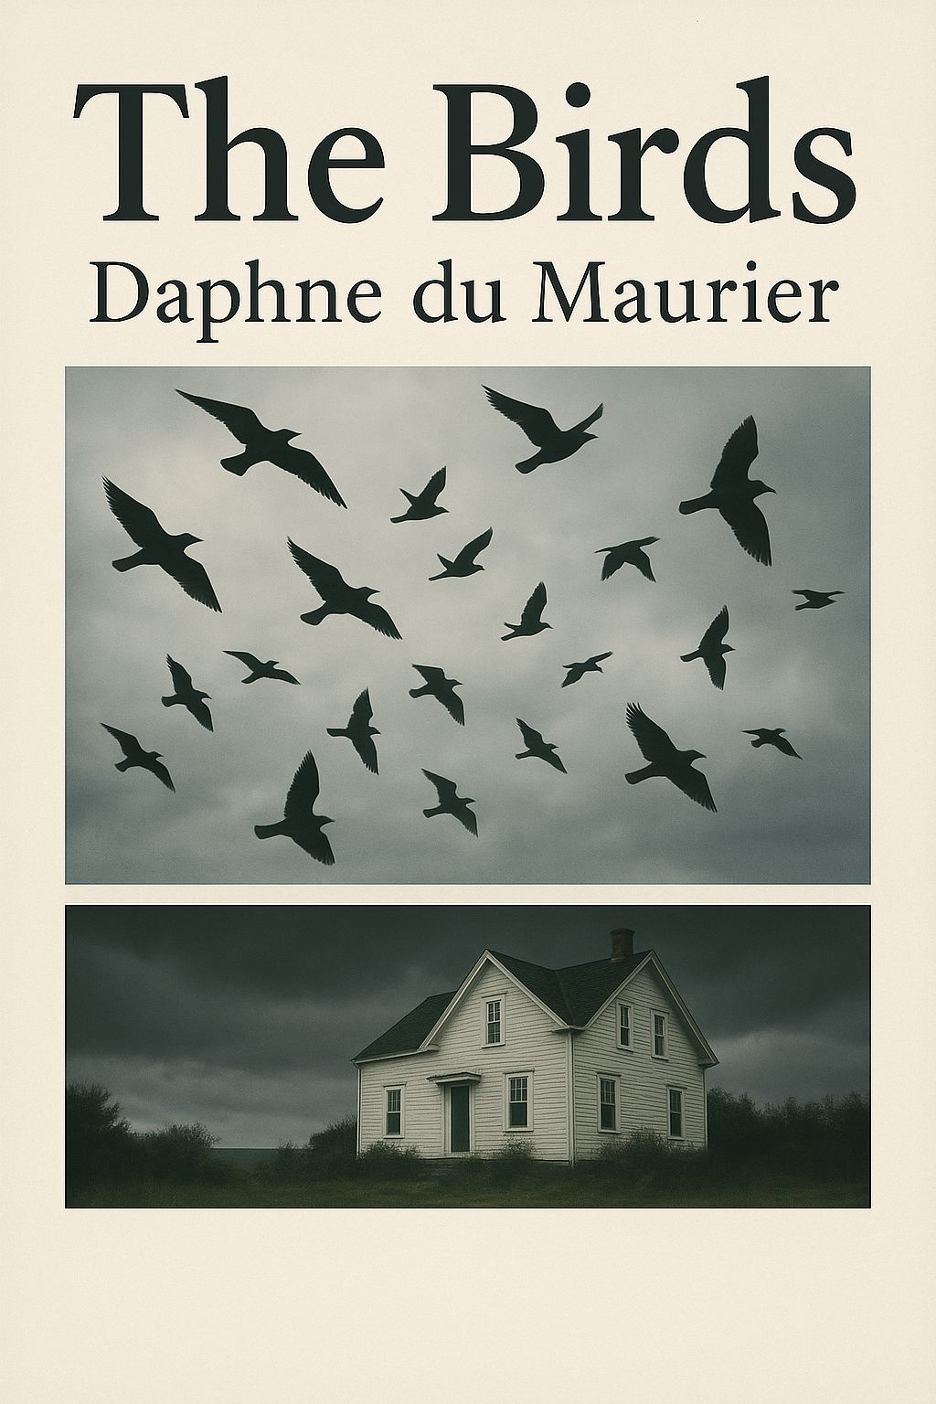

PREFACE
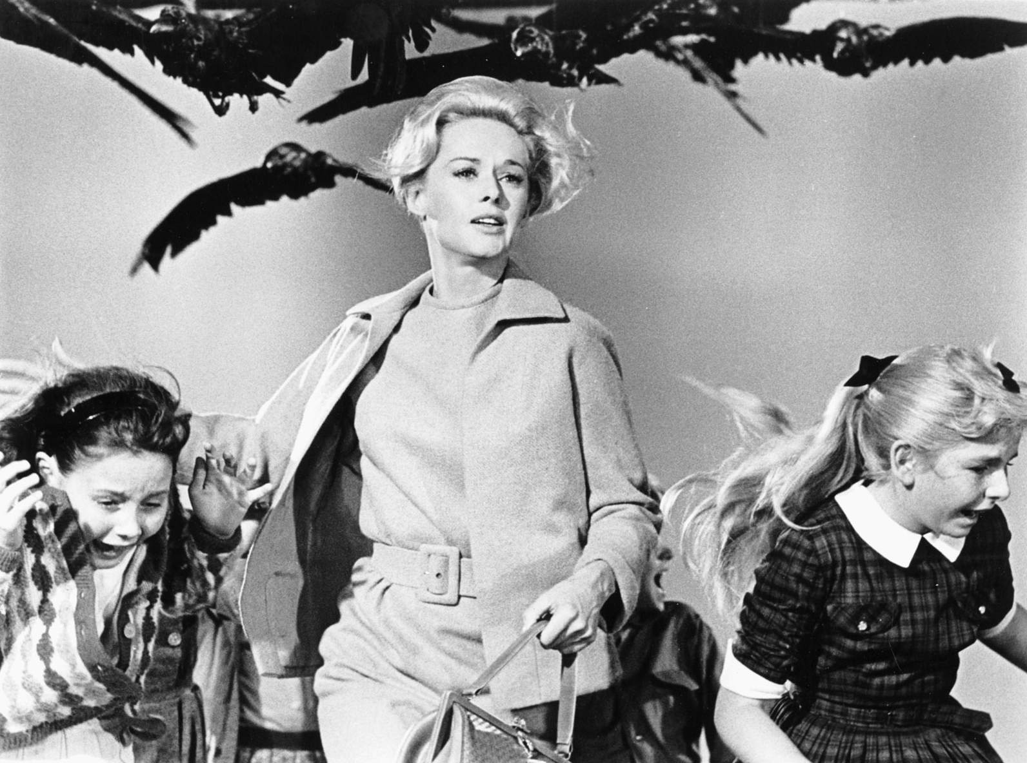
We chose The Birds because it’s a chilling and thought-provoking story that blends psychological horror with suspense. What makes this novella particularly interesting is how it taps into deep fears of nature's unpredictability and humanity's vulnerability. It also explores themes of survival, fear, and the breakdown of normalcy in the face of a catastrophic event, which makes it both timeless and relevant. The slow escalation of terror in the story is masterfully done, creating a constant sense of unease.
What’s special about The Birds is how it transcends a typical "nature attack" story. Instead of focusing on a clear antagonist or cause for the birds' behavior, it leaves the mystery unresolved, which amplifies the horror. The sense of helplessness and the raw human reactions to the attacks are what make it truly captivating. It’s a story that doesn’t just frighten, but makes you question how fragile the boundary is between everyday life and disaster.

Characters

1. Nat Hocken
A disabled war veteran working on a farm, Nat is the story’s protagonist. He's resourceful, protective, and the first to notice the birds’ strange behavior. As the attacks intensify, Nat becomes a determined survivor, trying to protect his family despite the growing threat.

2. Mrs. Hocken
Nat’s wife, who is mostly reactive and fearful during the bird attacks. She trusts her husband’s judgment and helps protect their children. Her character represents domestic stability in the face of chaos.

3. The Children (John and Jill)
Nat and Mrs. Hocken’s children, innocent and vulnerable to the bird attacks. They don’t take an active role in the defense but their terror highlights the threat the family faces.

4. Mr. Trigg
Nat’s employer, a farmer who dismisses the bird attacks as unimportant. He is killed along with his family for underestimating the danger posed by the birds.

5. Jim (The Farm Hand)
Mr. Trigg’s farm hand, who also dies in the bird attacks. His death reinforces the story's theme of nature’s unstoppable force.

6. The Birds
The central antagonist. The birds' coordinated, violent attacks are inexplicable, symbolizing nature’s power and humanity’s helplessness in the face of it.
- Plot
Nat Hocken, a disabled war veteran, works part-time for Mr. Trigg on his farm on the Cornish coast. One cold December evening, Nat notices unusually large flocks of birds acting restlessly, as if they’ve received a warning that winter is approaching. Later that night, the weather turns bitter, and Nat is startled by aggressive birds attempting to attack him and his family. After killing several of them, he finds fifty dead birds outside in the morning. Despite his warnings, his neighbors dismiss his concerns, but soon, the situation grows far more dire.
By midday, Nat observes that vast numbers of gulls are gathering on the sea, waiting. The BBC reports that birds across Britain are attacking people, but the official response remains blasé. Meanwhile, Mr. Trigg plans to shoot the birds for sport, unaware of the imminent danger. Nat experiences a harrowing attack by the gulls but survives and boards up his house in preparation for the next onslaught.
The national situation worsens as birds begin forcing their way into buildings, and a state of emergency is declared. Nat and his family, holed up in their cottage, hear the constant sounds of birds trying to break in, and the air is filled with the chaos of naval guns, planes being downed, and the continuing assault. Nat realizes that the birds attack in sync with the rising tide.
The next day, with the radio silent and no sign of help, Nat ventures to Mr. Trigg’s farm to gather supplies, only to find the gruesome remains of Trigg and his family. Upon returning home, the birds resume their assault as the tide turns. Nat and his family face an uncertain future, trapped and unable to escape the relentless onslaught. The story ends with Nat smoking his last cigarette, as the sound of splintering wood fills the air—his home, the last refuge, under siege.

- Introduction
The Birds is a short story written by the British author Daphne du Maurier in 1952. It was first published in a collection titled The Apple Tree (later republished as The Birds and Other Stories).
Du Maurier was already known for works like Rebecca (1938), and in this story she combined her gothic style with elements of horror and psychological tension. The narrative transforms everyday birds into a destructive natural force, showing how quickly the balance between humans and nature can collapse.
The book gained worldwide recognition when director Alfred Hitchcock adapted The Birds into his 1963 film, though the movie differs significantly from du Maurier’s original story. Today, the text is considered a classic of modern horror literature and a powerful reflection on fear, survival, and humanity’s vulnerability.
- About the author-Daphne Maurier
- Full Name: Dame Daphne du Maurier
- Born: May 13, 1907, London, England
- Died: April 19, 1989, Cornwall, England
Daphne was born into an artistic family. Her father, Sir Gerald du Maurier, was a famous actor and manager of the Adelphi Theatre, while her mother, Muriel Beaumont, was an actress. Daphne had two siblings, and her family’s prominence in the entertainment world heavily influenced her early life.
Her father’s fame and emotional distance, however, created a strained relationship with him. Daphne’s complex feelings about her family, especially her father, would later surface in much of her writing.

2. Education
- Daphne attended several schools but never excelled academically. She spent time at Homewood School in Hampstead and later Falmouth Grammar School in Cornwall, where her family had a summer residence.

3. Personal Life and Marriage
- Daphne married Frederick Browning, a retired British Army officer, in 1932. They had three children: Tessa, Flora, and Christian.
- Daphne and her husband moved to Cornwall after their marriage, where they bought a house that would become central to Daphne’s life and writing. The dramatic Cornish coastline inspired many of her novels, including Rebecca and Jamaica Inn.

4. Writing Career
- Daphne’s writing career began with The Loving Spirit (1931), but her big breakthrough came in 1938 with Rebecca. The gothic novel, centered around themes of jealousy, obsession, and the haunting presence of the past, became a massive success. It remains one of the most widely read books of the 20th century.
Major Works:
- Rebecca (1938) – The novel tells the story of a young woman overshadowed by the memory of her husband's first wife, Rebecca. It was adapted into an iconic film by Alfred Hitchcock in 1940.
- Jamaica Inn (1936) – A gothic thriller set in Cornwall about a woman who uncovers dark secrets at a remote inn.
- Frenchman’s Creek (1941) – A historical romance about a woman’s affair with a French pirate.
- My Cousin Rachel (1951) – A psychological thriller about a man who suspects his cousin Rachel of murder but becomes romantically involved with her.
- The Birds (1952) – A chilling short story about an unexpected, violent bird attack, which was adapted into a film by Alfred Hitchcock in 1963.
- The House on the Strand (1969) – A time-travel novel that blends historical fiction with supernatural elements.
Themes:
Du Maurier’s works often explored themes such as:
- Psychological suspense
- Obsession and jealousy
- Isolation and loneliness
- The complexities of human relationships
Her ability to create haunting atmospheres and her deft handling of suspense set her apart from many of her contemporaries in the thriller and gothic genres.

5. Later Life and Recognition
- Daphne continued to write throughout her life but became more reclusive in her later years. Her final years were marked by health problems and personal challenges, including struggles with her own identity and relationships.
- In 1969, Daphne was made a Dame Commander of the British Empire (DBE) for her contribution to literature.
- Daphne du Maurier passed away in 1989 at the age of 81. She died of natural causes in her beloved Cornwall home.

- Quotes

- " But luxury has never appealed to me, I like simple things, books, being alone, or with somebody who understands. "
- Daphne du Maurier
The author values simplicity over luxury, finding fulfillment in quiet moments, reading, and genuine connections with others.
- "Happiness is not a possession to be prized, it is a quality of thought, a state of mind."
- Daphne Du Maurier
Happiness is an internal state, not something you can own. It's about mindset and how you choose to think.
- "You understand now... how simple life becomes when things like mirrors are forgotten. "
-Daphne Du Maurier
Letting go of vanity and self-judgment (symbolized by mirrors) makes life simpler and more focused on what truly matters.

The Film by Alfred Hitchcock

Alfred Hitchcock’s The Birds takes inspiration from Du Maurier’s idea but develops it in a very different direction. The movie is set in Bodega Bay, California, and introduces new characters, especially Melanie Daniels, a young socialite who becomes the focus of the story. The plot begins as a light romantic comedy, with Melanie following Mitch Brenner, a lawyer, to his hometown. This playful beginning contrasts strongly with the horror that follows.
Hitchcock uses visual spectacle to create fear. One of the most iconic scenes is when Melanie sits outside the schoolhouse and crows silently gather on the playground equipment behind her. The slow build-up, combined with the children later running and screaming while being attacked, is terrifying. Hitchcock himself explained: “It is not the attack itself that is frightening, but the waiting, the anticipation of when it will happen.” This philosophy is close to Du Maurier’s method, but Hitchcock translates it into cinematic language.
The film also includes shocking large-scale attacks. In one famous sequence, seagulls dive-bomb a gas station, causing explosions and chaos. In another, birds invade a house through the chimney, filling the living room in a scene of pure panic. Unlike Du Maurier’s subtle psychological terror, Hitchcock emphasizes shock and action.
Yet, like the story, the film ends without a solution. The final scene shows Melanie, Mitch, and his family driving slowly away, surrounded by thousands of silent birds. No reason is given, and no victory is achieved. Hitchcock explained that he wanted to “leave the audience with the sense that the nightmare was not over.”

Similarities and Differences

Despite sharing the same basic idea, the story and the film differ in tone and focus.
• Setting and Characters: The short story is set in Cornwall with a humble farmer as protagonist, while the film takes place in California with more glamorous characters and social conflicts.
• Atmosphere: Du Maurier emphasizes silence, isolation, and psychological fear. Hitchcock focuses on visual spectacle and dramatic attack sequences.
• Themes: Both works explore human vulnerability, but Du Maurier’s story is more pessimistic and claustrophobic, while Hitchcock mixes romance and community dynamics into the horror.
• Endings: Both endings are unresolved and bleak, but Du Maurier’s is darker, suggesting complete destruction, while Hitchcock leaves a small possibility of survival.
Themes and Symbolism

Both works explore deep themes that make the story meaningful beyond its surface-level horror.
1. The Power of Nature – Birds, normally harmless, become deadly. Du Maurier suggests that nature has its own will, which humans cannot control. This is emphasized in the line: “It seemed to Nat that a vast concourse of birds was assembling, waiting for the tide to turn.”
2. Human Vulnerability – Nat is an ordinary man with no weapons or power. His helplessness reflects the fragility of human beings. Hitchcock also highlights this when characters realize that even guns or fire cannot stop the birds.
3. Fear of the Unknown – Neither Du Maurier nor Hitchcock explains why the birds attack. This mystery increases the terror. As Hitchcock once said, “The unexplained is what makes it frightening.”
4. Isolation and Survival – In the book, Nat’s family is cut off from the world, with no help coming. In the film, the whole town is isolated by terror, and each character must fight for survival.

Postface

I would recommend The Birds to students and readers who enjoy suspenseful, thought-provoking stories. The short story is powerful because it shows how fragile humans are in the face of forces beyond their control. I chose this story because it demonstrates that true horror does not need supernatural monsters—it can come from ordinary creatures acting in extraordinary ways.
The book especially appeals to those who appreciate psychological tension, while the film is a masterpiece of cinematic suspense. Together, they prove that the same idea can inspire different forms of art, both unforgettable in their own way.
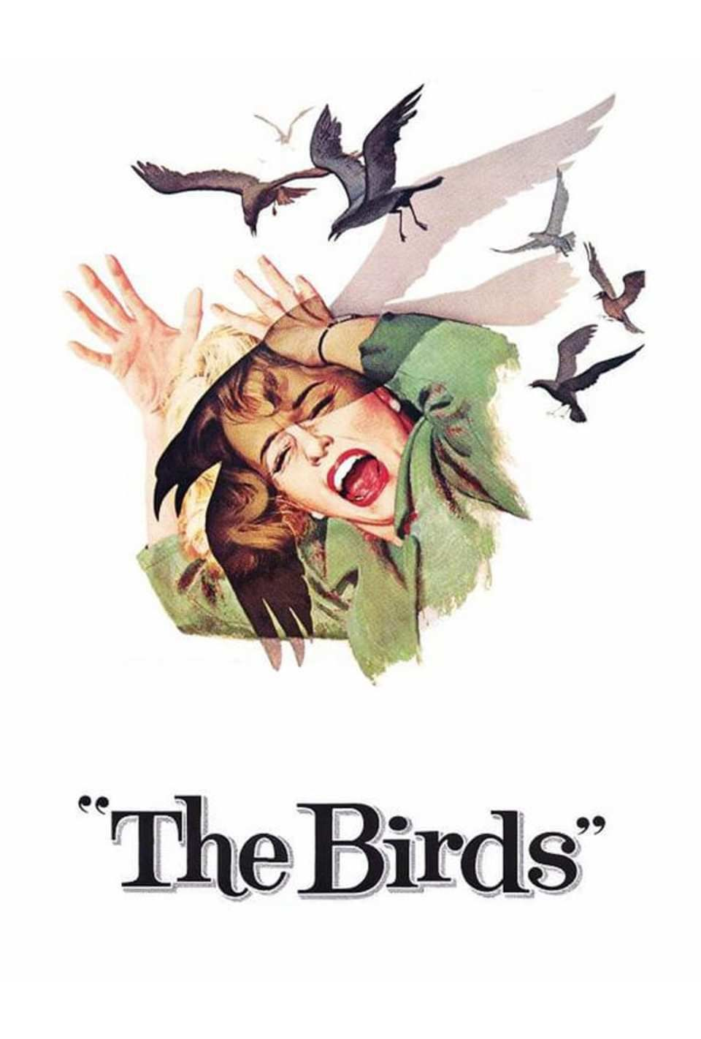
Conclusion
In conclusion, Daphne du Maurier’s The Birds and Alfred Hitchcock’s adaptation are two remarkable works that approach the same terrifying idea from different perspectives. The short story is subtle, atmospheric, and pessimistic, focusing on the claustrophobic fear of isolation. The film is dramatic, visual, and shocking, focusing on community panic and spectacular attacks. Both, however, leave audiences with the same haunting message: human beings are vulnerable, and nature, when it turns against us, is unstoppable. This is why The Birds remains a timeless masterpiece of both literature and cinema.

Bibliography
• Du Maurier, Daphne. The Birds and Other Stories. London: Victor Gollancz Ltd, 1952.
• Hitchcock, Alfred, director. The Birds. Universal Pictures, 1963.
• SparkNotes Editors. “The Birds by Daphne du Maurier – Summary and Analysis.” SparkNotes, www.sparknotes.com.
• IMDb Editors. “The Birds (1963) – Film Analysis.” IMDb, www.imdb.com.
• Reilly, Patrick. Daphne du Maurier: Haunted Heiress. London: Virago Press, 1991.
• Spoto, Donald. The Dark Side of Genius: The Life of Alfred Hitchcock. Boston: Little, Brown and Company, 1983.

