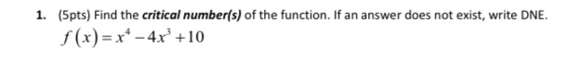

**Solution**

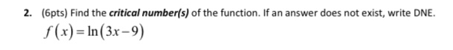

**Solution**

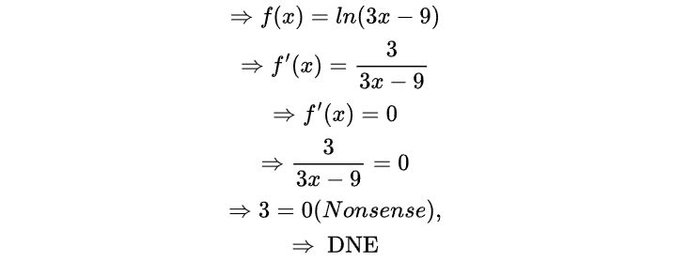

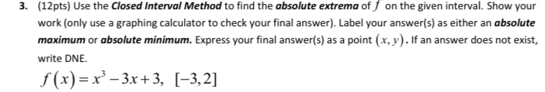

**Solution**

**Solution**

**Solution**

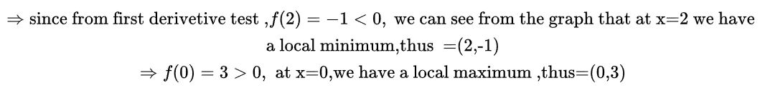



**Solution**

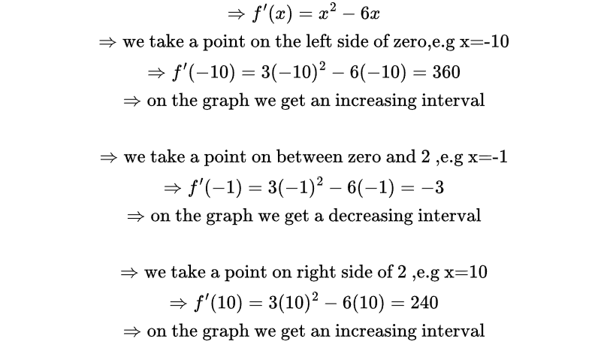

**Solution**

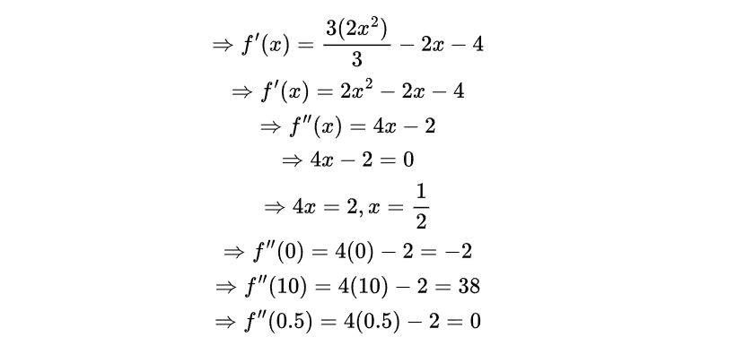



**Solution**

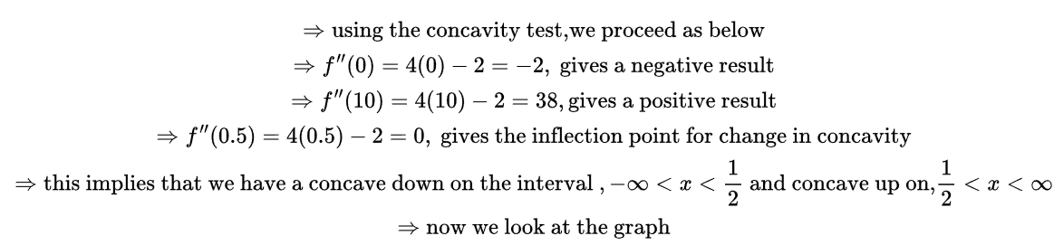

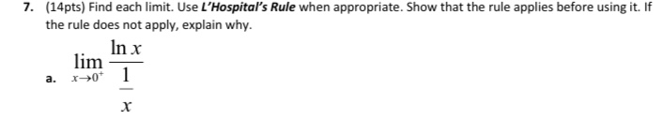

**Solution**

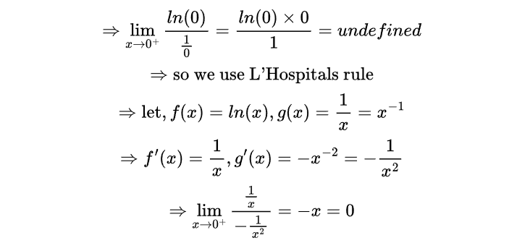



**Solution**

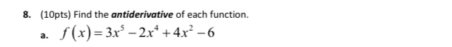

**Solution**



**Solution**

**Solution**



**Solution**





**Solution**



**Solution**





**Solution**



**THANK YOU!!!**

**THE END**