Solution

With replacement

- (R)=11/20 P(G) =9/20

11/20

9/20

R

G

11/20


9/20

11/20

9/20

R
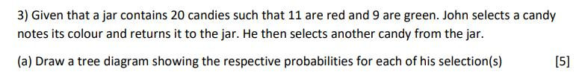

G

R

G

Solution

(i)

(ii)

Solution

Without replacement

- (R)=11/20 P(G) =9/20

11/20

9/20

R

G

10/19

9/19

11/19

8/19

R

G

R

G
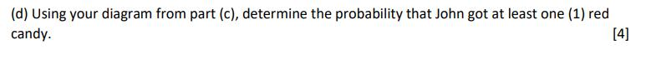

Solution
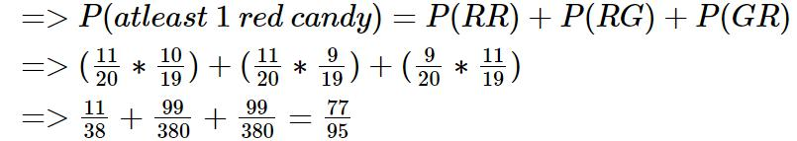

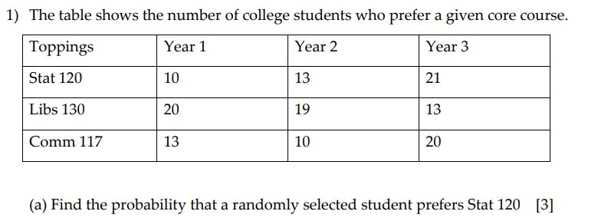

Solution

Toppings | Year 1 | Year 2 | Year 3 | Total
Stat 120 | 10 | 13 | 21 | 44
Libs 130 | 20 | 19 | 13 | 52
Comm 117 | 13 | 10 | 20 | 43
Total | 43 | 42 | 54 | 139
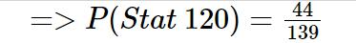

Solution
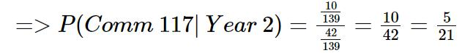
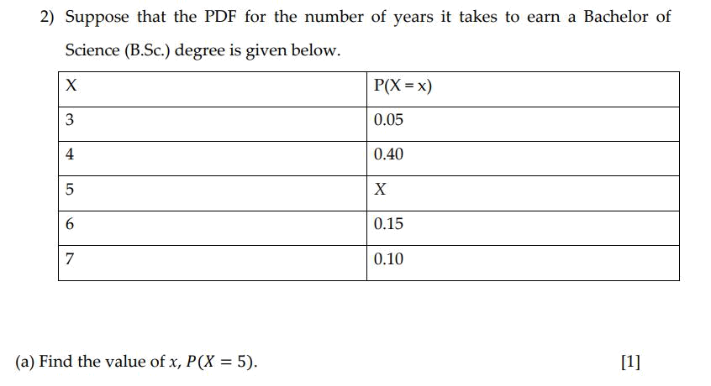

Solution
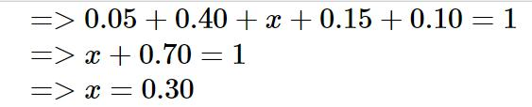
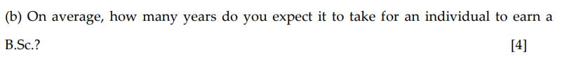

Solution

Solution
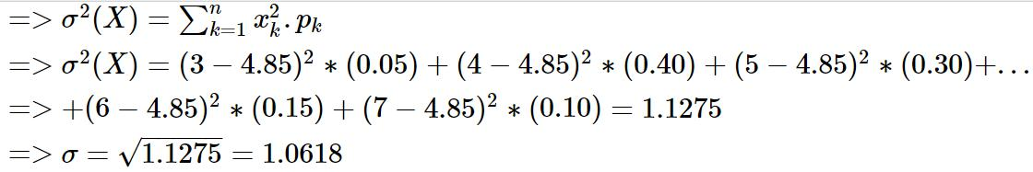
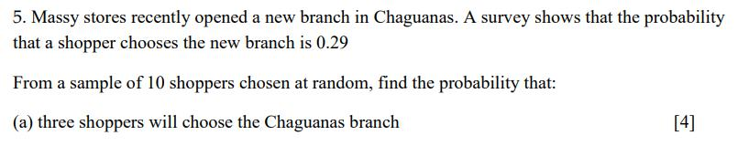

Solution

This is a binomial distribution with parameters, p=0.29 and n=10
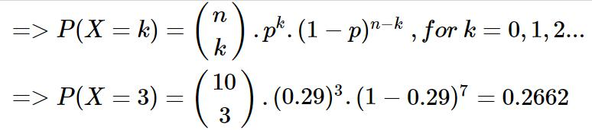

Solution
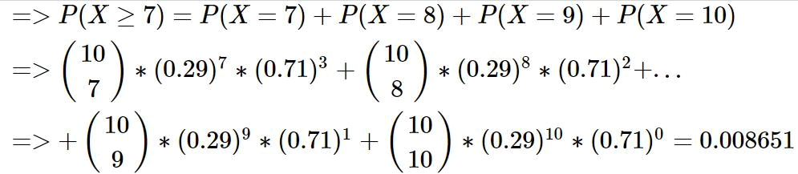

THE END

