**NAME:**

**Solution**

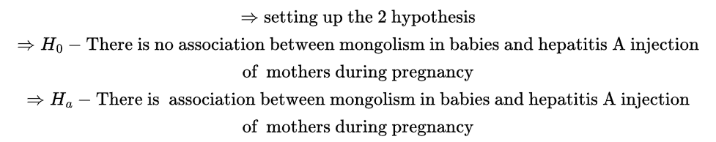

|  |  |  |  |
| --- | --- | --- | --- |
| **Hepatitis** | **Baby** |  |  |
| **A** | **Mongoloid** | **Non-**  **Mongoloid** | **Total** |
| **+** | **26,**  **EX1=0.9** | **34,**  **EX2=59.1** | **60** |
| **-** | **4,**  **EX3=29.1** | **1936,**  **EX4=1910.9** | **1940** |
| **Total** | **30** | **1970** | **2000** |

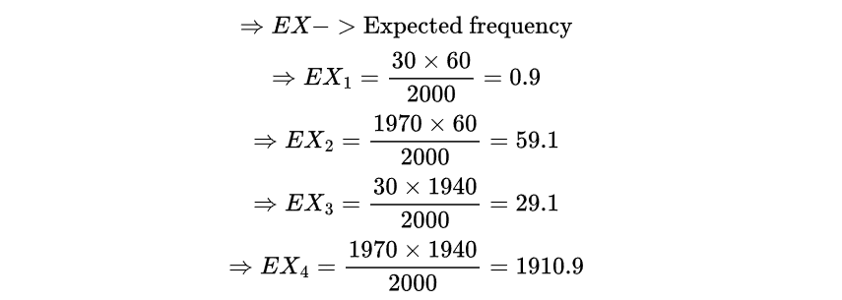

**Solution**

|  |  |  |  |  |
| --- | --- | --- | --- | --- |
| **Age(X)** | **Price(Y)** | **X^2** | **XY** | **Y^2** |
| **6** | **290** | **36** | **1740** | **84100** |
| **2** | **384** | **4** | **768** | **147456** |
| **5** | **315** | **25** | **1575** | **99225** |
| **4** | **355** | **16** | **1420** | **126025** |
| **5** | **328** | **25** | **1640** | **107584** |
| **1** | **425** | **1** | **425** | **180625** |
| **Totals/ 23** | **2097** | **107** | **7568** | **745015** |



**Solution**



**Solution**



**Solution**

**THE END**