**NAME:**

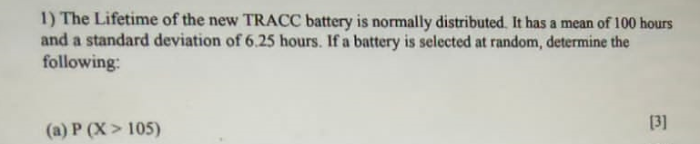

**Solution**



**Solution**





**Solution**



**Solution**



**Solution**



**Solution**

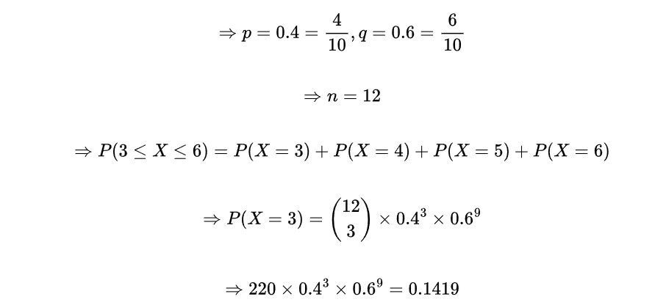

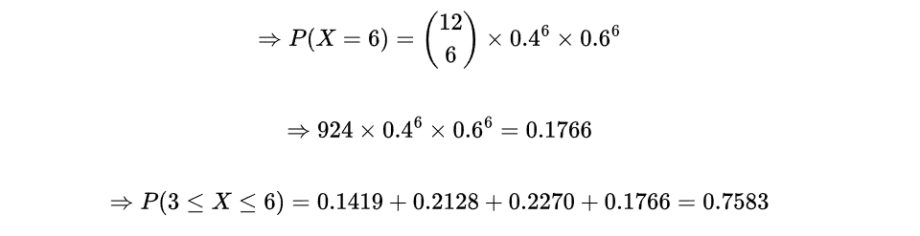

**Solution**

**THE END**