**Solution**

**With replacement**

P (R)=11/20

P(G) =9/20

9/20

11/200

9/20

11/20

9/20

11/20

G

R

G

R

R

G



**Solution**

**(i)**



**(ii)**





**Solution**

**Without replacement**

P (R)=11/20

P(G) =9/20

8/19

11/190

9/19

10/19

9/20

11/20

G

R

G

R

R

G

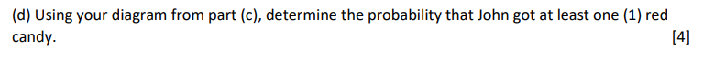

**Solution**

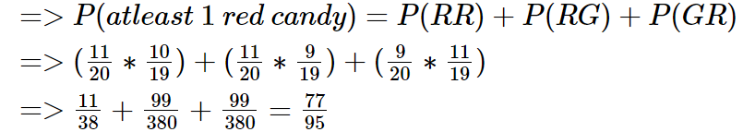

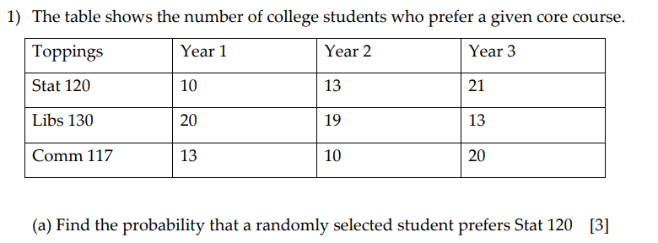

**Solution**

|  |  |  |  |  |
| --- | --- | --- | --- | --- |
| Toppings | Year 1 | Year 2 | Year 3 | **Total** |
| Stat 120 | 10 | 13 | 21 | **44** |
| Libs 130 | 20 | 19 | 13 | **52** |
| Comm 117 | 13 | 10 | 20 | **43** |
| **Total** | **43** | **42** | **54** | **139** |





**Solution**

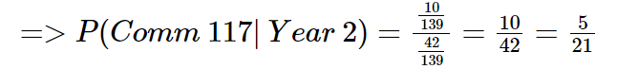

**Solution**

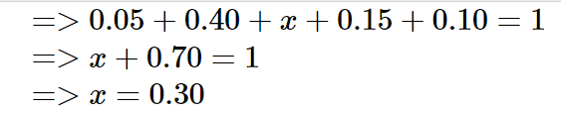

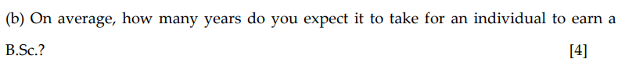

**Solution**





**Solution**

**Solution**

This is a binomial distribution with parameters, p=0.29 and n=10



**Solution**

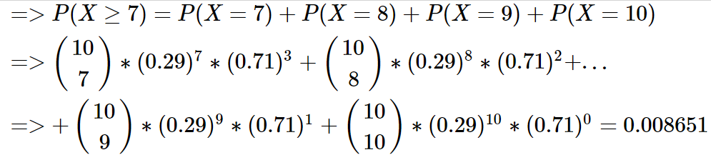

**THE END**