

**Solution**



**Solution**



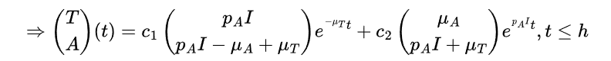





**Solution**



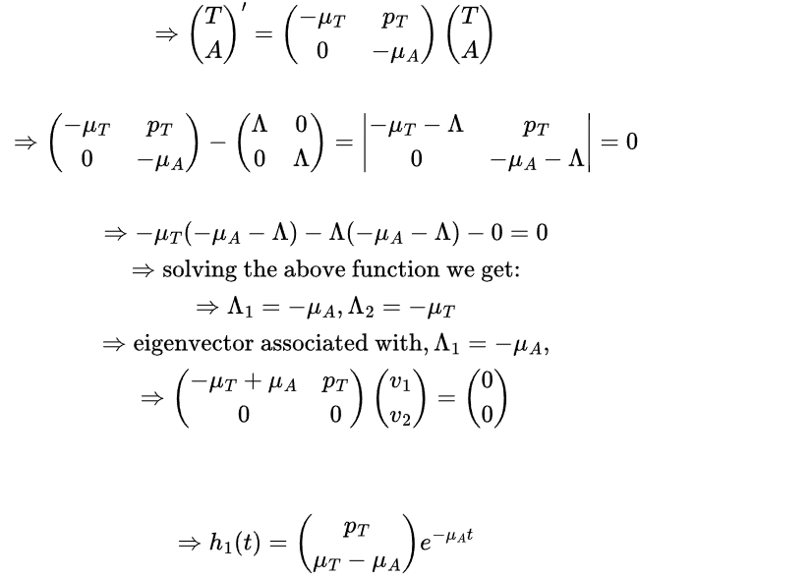

**Solution**



**Solution**



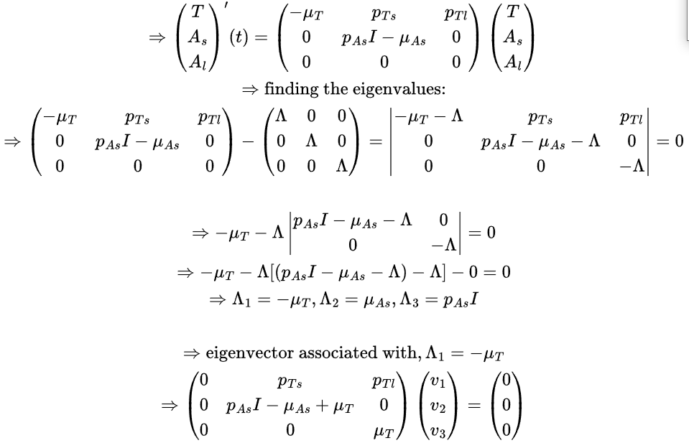



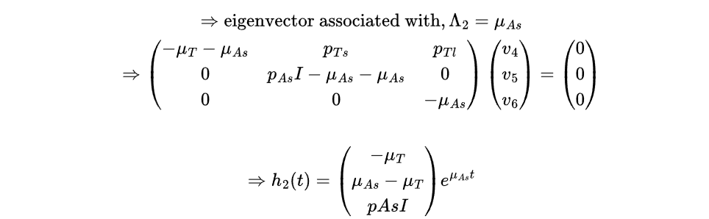

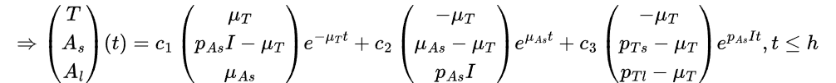

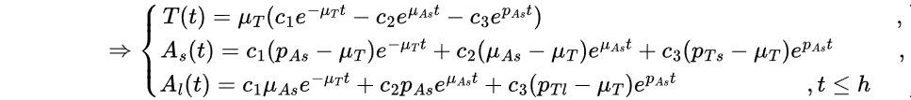



**Solution**



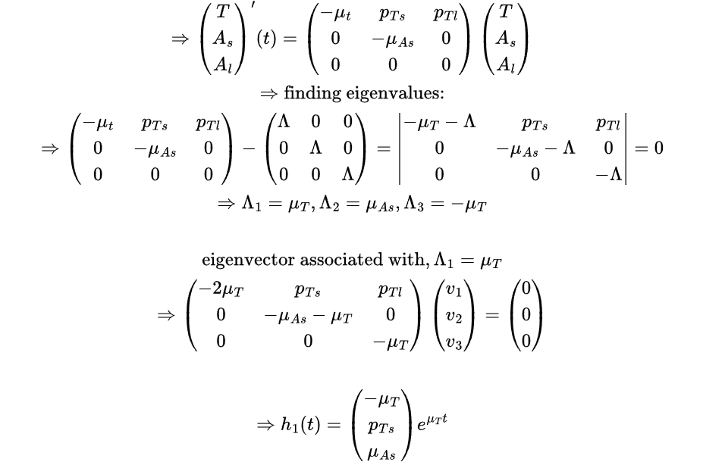

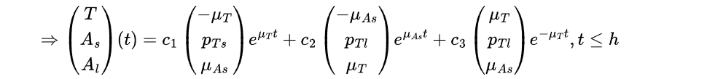

**THE END**