Juliano Nguyen

11/10/17

CSS 430

Program 3 Report

For the algorithm in part 1, SyncQueue creates an array of QueueNode objects, and has the methods enqueueAndSleep and dequeueAndWakeup. The enqueueAndSleep method returns a child ID by calling the sleep method and dequeueAndWakeup notifies a thread by calling the wake method based on a condition number. In QueueNode, it has a vector of child thread IDs, and has the methods sleep and wake. The sleep method makes a thread wait and when it wakes up, the method returns the first thread ID from the vector queue. The wake method adds a thread ID to the vector queue and notifies a thread that is waiting to be woken up. In the kernel for the wait case, it returns the thread ID. For the exit case, it dequeues based on the condition of the parent ID and the scheduler deletes the thread.

For the algorithm in part 2, Test3 takes the first argument that will set the number of pairs of threads. It will get the starting time in milliseconds from the Date class, then execute threads in TestThread3a and TestThread3b for the number of pairs. In TestThread3a, it will do numerical computations, so it simply adds numbers to a sum in a for loop. In TestThread3b, it will read and write blocks across the disk, which is done multiples times in a for loop. After execution is done for both TestThreads, Test3 will call “join” for both TestThreads in a for loop separately. Finally, it will get the ending time in milliseconds and calculate the elapsed time from start to end. In the new kernel, busy waiting is replaced with a block in the RAWREAD, RAWWRITE, and SYNC cases.

The results in the new kernel has a shorter time than in the old kernel. Thus, the new kernel with the blocks executes the threads faster than the old kernel with busy wait. The threads in busy wait keep spinning until the current thread is terminated, which wastes CPU resources. In the blocking case, the threads are blocked and placed into a queue until they are notified by a calling thread. Although the time difference is small between the new and old kernel, the time may mean a lot within the operating system to quickly compute CPU and disk operations.

Part 1:

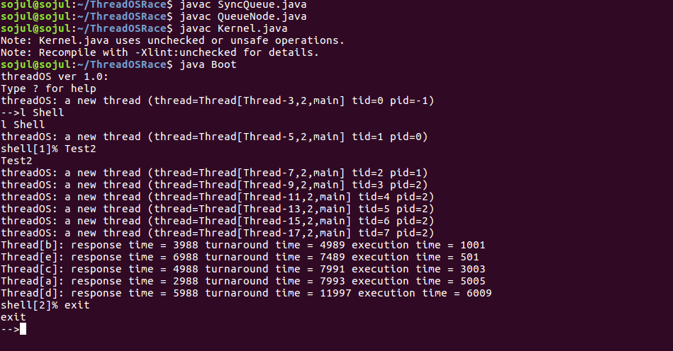

New Kernel Result:



Old Kernel Result: