**Step by step documentation for the WebdriverIO with cucumber framework with Docker**

* Prerequisite (Install the latest version)

1. node
2. npm
3. Visual studio Core
4. Install Docker and login
5. Open the VS Code and install and config Webdriver IO

* Create a folder location
* 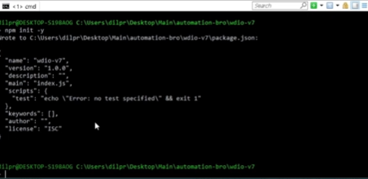Initialize npm

* Install webdriver io cli (npm install @wdio/cli)

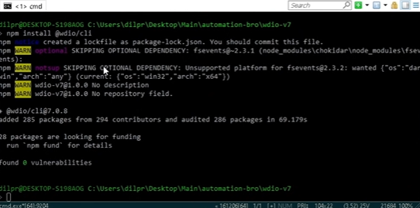

* Config Webdriver io (npx wdio config )

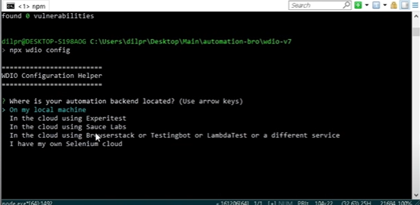

Setup the config as below and install

1. where is your automation backend located - > On my local machine
2. which is the framework do you want to use -> Cucumber
3. Do you want to run WebdriverIo commands sync or asynchronous -> async
4. Are you using a compiler -> default option
5. Type Script -> no
6. Where are your test Specs located -> default option
7. Do you want WebdrierIo to generate some test files -> Yes
8. Do you want to use Project objects -> yes
9. Where are you page object located -> default option
10. Which report do you want to use -> allure
11. Do you want to add a service to your test setup -> chromedriver
12. What is the base url -> default option

* Run the example file and make sure the Webdriver io working (npx wdio run wdio.conf.js)

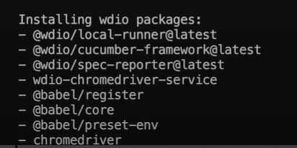

* Create a Jsonfig.json file

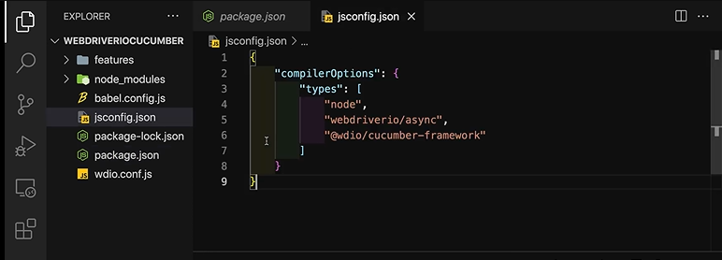

* Install cucumber plugin in Vs code

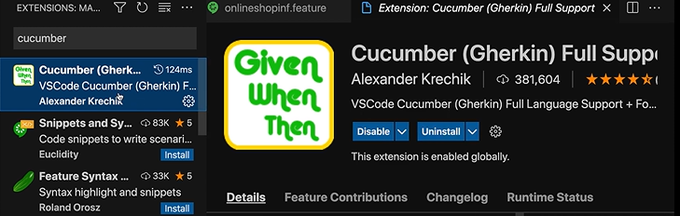

* Create feature file and stepdefinition file

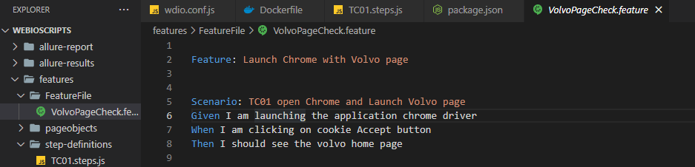

(Right click and select new file-> rename and save with. feature extension)

* Install code formatter plugin in Vs code

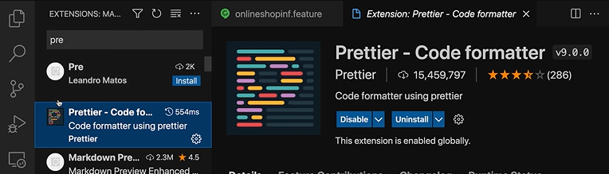

* Create step definition class

(Right click and select new file-> rename and save with. js extension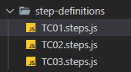)

1. Setup allure report

* Install the allure reporter (npm install @wdio/allure-reporter --save-dev)

Run the above cmd in the vs terminal

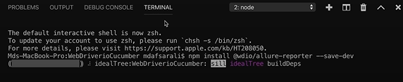

* Configure the report (<https://webdriver.io/docs/allure-reporter>)

Copy the config code and paste in wido file

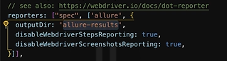

* Add the allure report generate code in package .json file (https://webdriver.io/docs/allure-reporter)

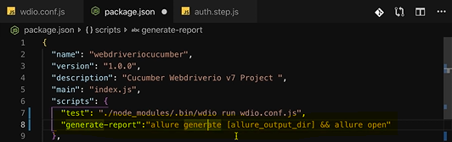

(cmd for generate report : npm run generate-report)

1. Setup Docker

* Create a Docker file and copy the base image setup

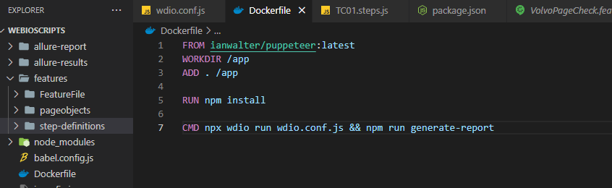

Copy the base image from the Webdrier io webpage (<https://webdriver.io/docs/docker/>)

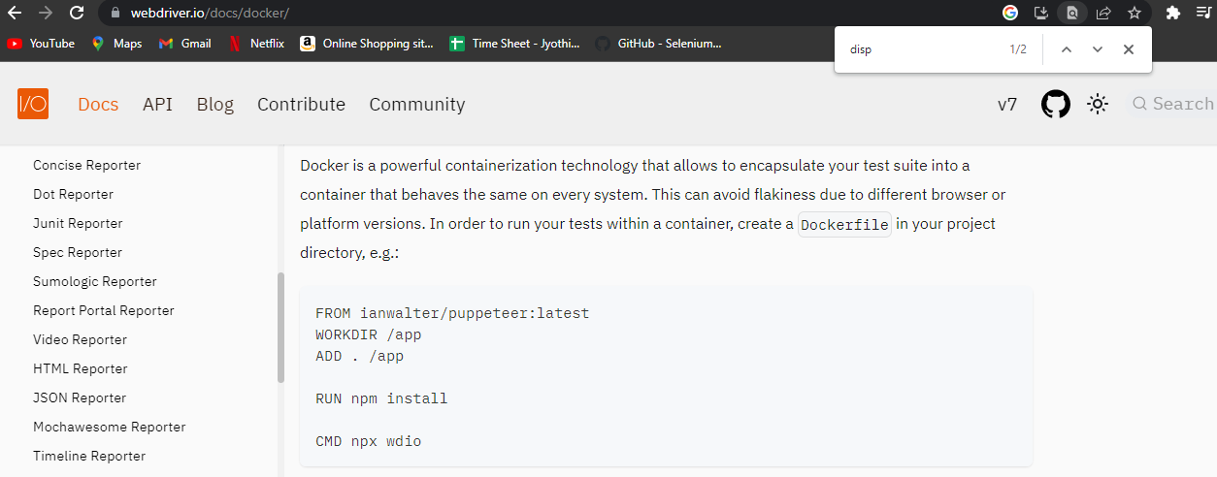

* Install the Docker desktop application and login (<https://docs.docker.com/desktop/install/windows-install/>)

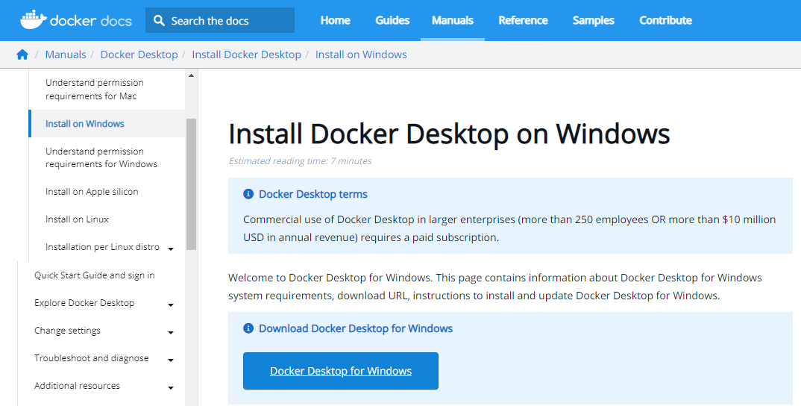

* Create the image

Cmd for creating image : docker build -t < name >-image .

It will take some time to create the image 1st time , once create the image verify the image.

Cmd for verify image : docker images



* Run the docker image

Cmd : docker run <image name> -image

