ENTITY RELATIONSHIP DIAGRAM (ERD)
RaceDay System
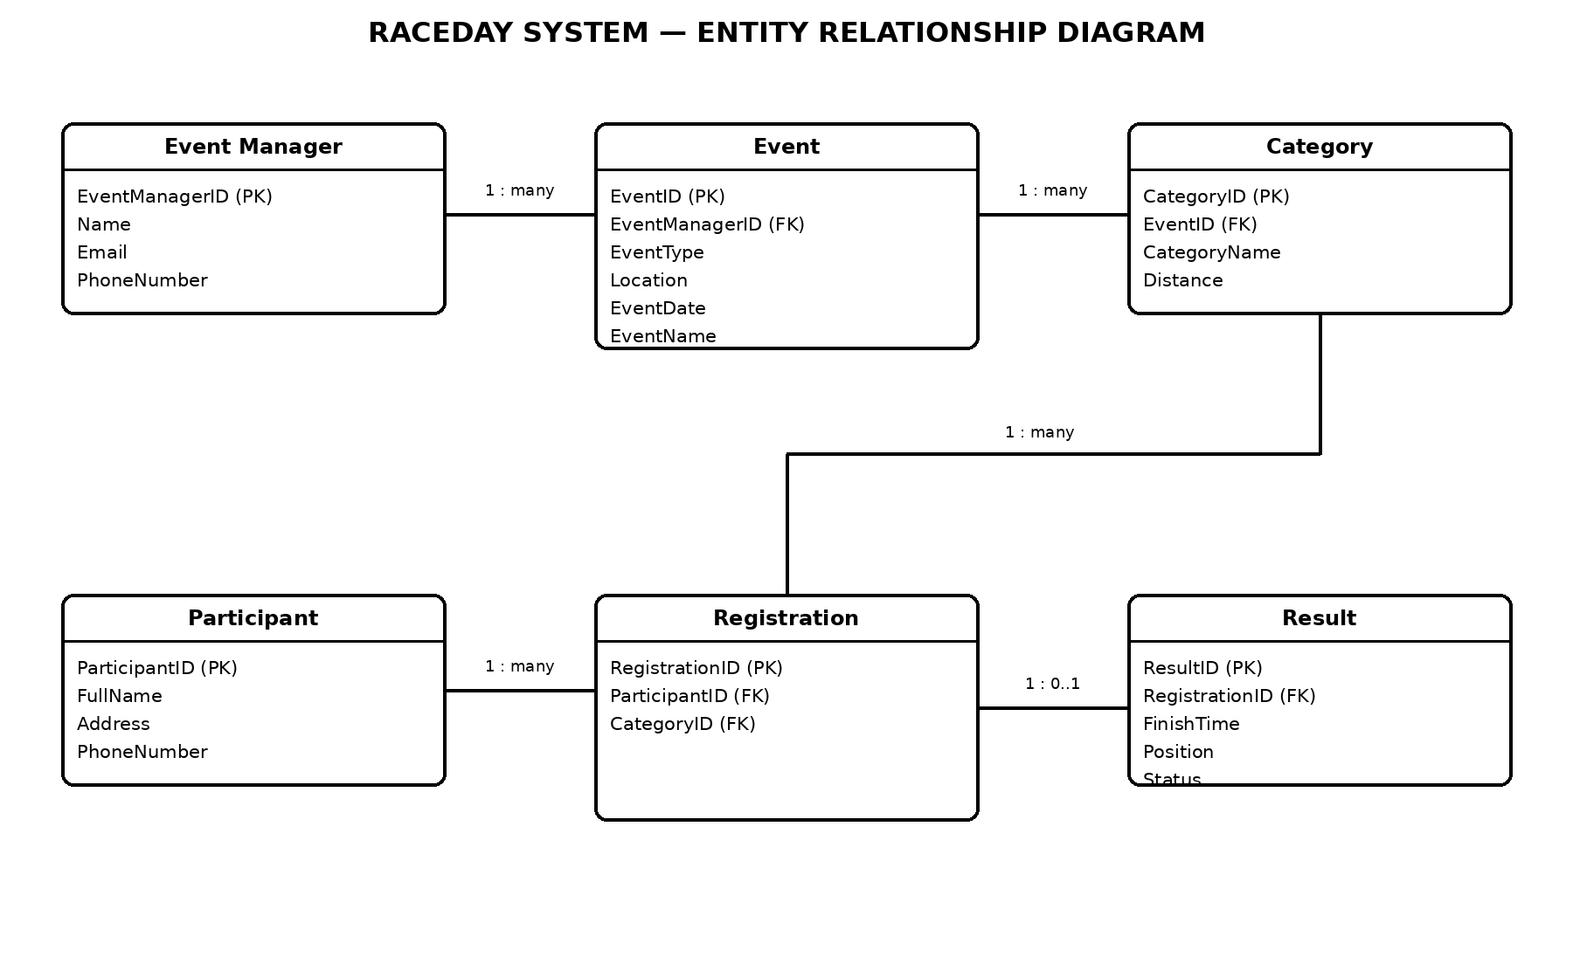
Notes on corrections
- The Result entity is linked to Registration because Result contains RegistrationID (FK).
- The EventID foreign key was removed from Registration because Category already identifies the event in this model; this avoids storing the same event relationship twice.
- Relationship cardinalities are labelled clearly: one event manager manages many events; one event has many categories; one participant can have many registrations; one category can have many registrations; and a registration can have zero or one result.

