COMP422 Mini-Project
Group Project

Group Member:
CHENG Wai Hung (02703340t)
TAM Koon Wing (02706110t)

Q1) Explain the user-defined data types in Oracle Spatial, and give examples how these data types and their associated operations are used to support.
- Storage
- Indexing
- Retrieval
of spatial data.

Oracle Spatial manages spatial data by providing an object data type (SDO_GEOMETRY), indexing capability, and functions/operators on SDO_GEOMETRY. It enables spatial data to be stored, accessed, and analyzed quickly and efficiently in an Oracle database.

Oracle Spatial supports three geometric primitive types and geometries composed of collections of these types. The three primitive types are: Point, Line String, and N-point polygon where all these primitive types are in 2-Dimensions. A 2-D point is an element composed of two ordinates, X and Y. Line strings are composed of an ordered sequence of two or more points that define line segments. Line strings can be composed of straight line segments, arc segments or a mixture of both. Polygons are composed of connected line strings that form a closed ring and the interior of the polygon is implied. Because polygons are composed of line strings, this implies that a polygon can have some edges as straight lines and some edges as circular arcs.

i) Storage

The user-defined data type MDSYS.SDO_GEOMETRY is a container for storing points, lines, polygons, or homogeneous or heterogeneous collections of these elements.

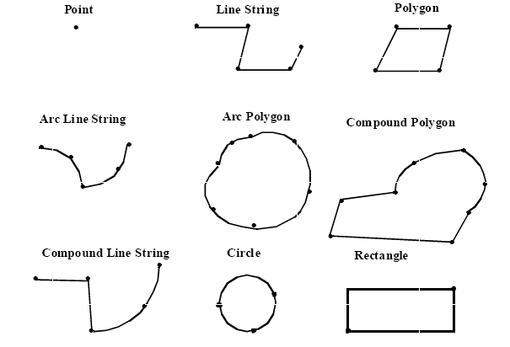
A column in a table can be declared as being of type MDSYS.SDO_GEOMETRY. For example, you can create a table named ROADS as follows:

CREATE TABLE ROADS (
Name Varchar2(64),
Classification Varchar2(64),
Geometry MDSYS.SDO_GEOMETRY);

INSERT operation should be done before creating any spatial index or using any spatial functions or operators.

Rows are inserted using the standard SQL INSERT statement as follows (Line example):

INSERT INTO ROADS VALUES('Short Street', 'Bylane',
MDSYS.SDO_GEOMETRY(2002, 8307, null,
MDSYS.SDO_ELEM_INFO_ARRAY(1, 2, 1),
MDSYS.SDO_ORDINATE_ARRAY(10, 10, 10, 15, 15, 15)));

The first value, 2002, is a geometry type identifier that indicates this is a 2D linear geometry. The second value is 8307, specifying that this geometry has the spatial reference system identified by 8307 (in this case 8307 corresponds to WGS 84). The third value is set to null, but it can be used as a label point location. The fourth value is the element descriptor array and specifies that the element’s ordinates start at offset 1 in the SDO_ORDINATES array, that the element is a line string (indicated by typecode 2), and that its vertices are connected by straight line segments. The fifth value is the ordered sequence of ordinate values, which in this instance specifies the vertices {(10, 10), (10, 15),
(15, 15)}.

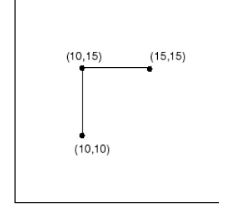

Figure 1. The line representing Short Street.

ii) Indexing

The syntax for index creation and maintenance are simply domain specific extensions to the CREATE, ALTER, and DROP statements. Creating a spatial index on a table (ROADS) with a column (GEOMETRY) of type MDSYS.SDO_GEOMETRY can be done as follows:

CREATE INDEX ROADS_GEOMIDX ON ROADS(GEOMETRY)
INDEXTYPE IS MDSYS.SPATIAL_INDEX;

The index can be altered:

ALTER INDEX ROADS_GEOMIDX REBUILD
PARAMETERS ('tablespace=DOM_IDX');
or deleted:

DROP INDEX ROADS_GEOMIDX;

iii) Retrieval

Queries and data manipulation statements can involve application-specific operators, like the Relate operator in the spatial domain. In general, user-defined operators are bound to functions. This is called the functional implementation of an operator. For example, consider the following query

SELECT a.feature FROM ROADS a,windows b WHERE
MDSYS.SDO_RELATE(a.geometry, b.geometry,
'mask=OVERLAPBDYINTERSECT');

This example finds all the features in the ROADS table that overlap with the window query objects in the windows table. In the case of the functional implementation of the operator, each geometric object in the ROADS table is tested against each window object to find out whether or not they overlap. This
could be very costly if the number of objects in the ROADS table is high.

With indexing, the application defines the structure of the domain (specific) index. The application stores the index data either inside the Oracle database (in tables) or outside the Oracle database (in the
form of files). It manages, retrieves and uses the index data to evaluate user queries. In effect, the application controls the structure and semantic content of the domain index. The database system interacts with the application to build, maintain, and employ the domain index.

Indextypes can be used to bind user-defined operators to an index. This results in any SQL query containing those operators being efficiently evaluated using the corresponding index. Oracle Spatial defines an INDEXTYPE (SPATIAL_INDEX) and associated OPERATORS (SDO_RELATE, SDO_FILTER, SDO_WITHIN_DISTANCE, and SDO_NN). Consider a query such as the following:

SELECT Parks.Name FROM Parks, Roads WHERE
MDSYS.SDO_RELATE(Parks.Geometry, Roads.Geometry,
'MASK=ANYINTERACT') = 'TRUE'
AND Roads.Name = 'I-93';

The optimizer can determine that it is less expensive to first evaluate the second predicate (Roads.Name = 'I-93') followed by SDO_RELATE(...) = 'TRUE' rather than the other way around.

Q2) Based on the 2-D Polyu map given (PolyU Map 011.jpg), perform the following activities. Each of the grids in the PolyU map is having a size of (10x10) meters.

- R-Tree for the locations of academic buildings.

AG -> (18,215, 54,251)
BC -> (0,177, 20,219)
CD -> (7,127, 20,169)
DE -> (18,115, 55,132)
EF -> (52,128, 66,169)
FJ -> (62,165, 100,181)
HJ -> (97,178, 110,219)
GH -> (60,215, 99,232)
PQ -> (162,55, 200,71)
QR -> (196,67, 210,107)
QT -> (206,56, 243,72)
ST -> (240,67, 252,108)
TU -> (248,56, 289,72)

G1 G2
G3 G4
G5 G6 G7
AG BC
FJ HJ GH
CD DE EF FJ
PQ QR QT ST
ST TU

- Let the following capital letter to the amenity establishment.
A -> Shaw Sports Complex (123,222) (158,262)
B -> Swimming Pool (175,240) (218,260)
C -> Keith Legg Pavilion (222,232) (236,258)
D -> Football field (216,158) (272,215)
E -> Outdoor basketball field (242,208) (264,228)
F -> Tennis Courts (270,145) (295,172)
G -> Communal Building (215,125) (248,160)
H -> Jockey Club Auditorium (228, 71) (240,104)
I -> Li Ka Shing Tower (132,123) (164,158)
J -> Fong Shu Chuen Hall (124,194) (154, 205)
K -> Jogging Track (122,230) (383,282)
L -> Industrial Centre (284,30) (324,70)
M -> Pao Yue Kong Library (60,76) (100,122)

R-Tree for locations of amenity establishments.

G1 G2
G3 G4
G5 G6 G7
A J K
I M
B C K
D E F G
H L

- Let the following capital letter to the roads, Covered Walkway and bus stop.

A -> Chatham Road (52,128) (380,300)
B -> Yuk Choi Road (210,90) (350,159)
C -> Hong Chong Road (0,0) (380,60)
D -> Bus Stop (0,40) (120,85)
E -> Covered Walkway (108,152) (215,176)

R-Tree for Roads, Covered Walkway and bus stop.

G1 G2
A B E
C D
Q3) Based on the 3 R-trees developed in part 2, design and execute the appropriate SQL queries to answer the following question.

Before run the following sql file, you must run this sql file one by one first.
- create1.sql
- create2.sql
- create3.sql
- insert_data1.sql
- insert_data2.sql
- insert_data3.sql
- metadata1.sql
- metadata2.sql
- metadata3.sql
- index1.sql
- index2.sql
- index3.sql

- Find all the buildings/ establishments (both academic and amenity) that are having overlaps with the roads, or walkway or the bus stop.

Ans: Run the sql file miniq3i .sql.

- Locate all the disjoint objects.

Ans: Run the sql file miniq3ii.sql to find all disjoint objects between both academic and amenity. It was because the MBR of Chatham Road is very large, so that it almost overlap all the buildings and establishments. Finally we are also intersect the result with table roads or covered walkway in the sql file miniq3iia.sql, but it cannot find any disjoint objects in the three R-tree.

- Find all the objects that are within 20 meters distance from each other.

Ans: Run the sql file miniq3iii.sql.

- Find the nearest academic building from Li Ka Shing Tower.

Ans: Run the sql file miniq3iv.sql.

