Date: 2014-09-13

Database Modeling Excel

Version: 7.0

Table of Contents

1 Document Usage 3

2 Features 3

2.1 Support Databases 3

2.2 Function List 3

3 Before running 3

3.1 How to enable macros in Excel 3

4 How to 4

4.1 What meaning of every sheet? 4

4.2 How to adjust page number in index sheet 4

4.3 How to edit database schema? 4

4.4 Where is the menu-bar? 4

4.5 How to generate script 5

4.6 How to import 5

4.7 What meaning of Tools🡪Add Hyperlinks in The Index Sheet 5

4.8 What meaning of Tools🡪Set sheet name 5

4.9 What meaning of Tools🡪Sort sheets by sheet name 5

4.10 How to ignore a worksheet when generating script 5

4.11 How to let it work in my build process 5

5 Tools 5

5.1 What is Tools\DBME_CopyToFile.vbs 5

6 Our websites 6

7 Support the project 6

8 Author 6

9 License 6

# Document Usage

It’s a help document for the project.

# Features

## Support Databases

* SQL Server
* My SQL
* Oracle
* SQLite

## Function List

* Design and maintenance database schema
* Generate script of database schema using workbook’s content.
* Create Tables SQL
* Drop Tables SQL
* Drop and Create Tables SQL
* Create Tables IF Not Exists SQL
* Support ignore some worksheets when generating SQL scripts
* Import database schema from database into the workbook
* Support automatic build process
* Fine print (A4 paper)

# Before running

The utility is implemented by VBA, so need the Excel application enables macros.

## How to enable macros in Excel

* In Excel 2007 or later versions

Click the options…

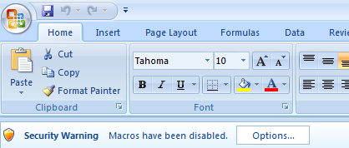

Select “Enable this content” and Click OK

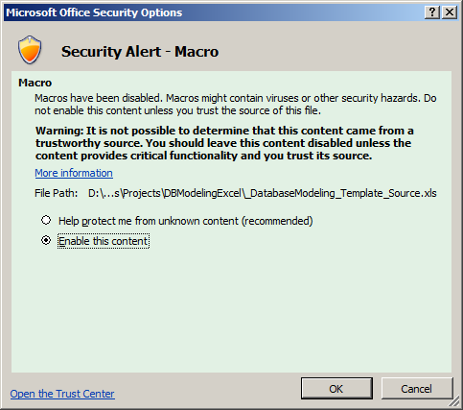

# How to

## What meaning of every sheet?

* Index sheet:
* Update history: like sheet name, you can fill you update history here
* Rules: you can write your define schema rules here
* Others: after 4th sheet, there are table worksheets, you can edit you table schema in these sheets and every sheet only contain one table schema definition.

## How to adjust page number in index sheet

If you know some sheet will be printed more than one page, ex: 2 pages, you can fill corresponding row’s ‘F’ column with value “2”, you will see the page number changed as you except.

## How to edit database schema?

Look “rules” sheet for details.

## Where is the menu-bar?

When the workbook running, you can see:

* In Excel 2007 or later

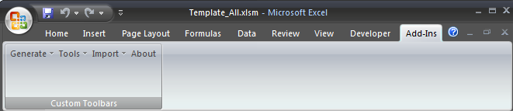

## How to generate script

Click Menu-bar “Generate” item.

## How to import

Click Menu-bar “Import” item.

## What meaning of Tools🡪Add Hyperlinks in The Index Sheet

The function will add hyperlinks to each table sheets in the index sheet.

## What meaning of Tools🡪Set sheet name

The function is set all table worksheets’ sheet name to contained table name.

## What meaning of Tools🡪Sort sheets by sheet name

The function is arranging all table worksheets’ in sheet name alphabet order.

## How to ignore a worksheet when generating script

When you develop a new version of your application, database schema will be changed; you may add some new tables into your database.

So what you wanted is just generating script for these new tables.

You can do it! Just add "ignore" text to K3 Cell in the worksheet which you want to skip when generating scripts.

For the situation: some old tables’ schema changed, there is no good solution to meet it.

## How to let it work in my build process

Please have a look section: What is Tools\DBME_CopyToFile.vbs

# Tools

## What is Tools\DBME_CopyToFile.vbs

Usage of the script is helping your automatic build process.

In our excel file, there are some macros which are located at basSQLCommand. These macros can generate SQL script you wanted and copy it to clipboard.

They are:

CopyAllCreateTableSQL

CopyAllCreateTableWithDescriptionSQL

CopyAllDropTableSQL

CopyAllDropAndCreateTableSQL

CopyAllCreateTableIfNotExistsSQL

CopyAllDropAndCreateTableWithDescriptionSQL

And the file DBME_CopyToFile.vbs can help you run the macro and copy clipboard content to a file you indicated.

For more detail:

'------------------------------------------------------------------------------------------------

'

' Usage: DBME_CopyToFile <--filename|-f ExcelFilename>

' <--macroname|-m macroName >

' [--arguments|-a arg1[,arg2,arg3...]]

' <--targetfilename|-t TargetFilename>

' [--verbose|-v]

' [--help|-?]

'

' Example 1: DBME_CopyToFile -f "D:\DBModelExcel\DatabaseModeling_Template.xls" -m "CopyAllCreateTableIfNotExistsSQL" -t "D:\DBModelExcel\CreateTables.sql"

'------------------------------------------------------------------------------------------------

# Our websites

* CodePlex

<http://www.codeplex.com/dbmodelexcel/Release/ProjectReleases.aspx>

<http://www.codeplex.com/dbmodelexcel>

* SourceForge

<http://sourceforge.net/projects/db-model-excel>

# Support the project

There are some ways to support the project.

* Feedback your information

If you find any bug or want some new features, please notice me. Let us make the project better.

* Write comment in our website

It will encourage project developer.

* Denote the project

<http://sourceforge.net/donate/index.php?group_id=171489>

# Author

Yang Ning (Steven) Email: [steven.n.yang@gmail.com](mailto:steven.n.yang@gmail.com)

# License

New BSD License