# This is hard word document

This document contains *different* styles and **languages**.

«Хочется узнать, как программа отработает в разных случаях»

Docx can contain:

* Lists
* Styled text
* Images with text
* Tables

|  |  |  |
| --- | --- | --- |
| Table | also | can |
| contain | Text or numbers | 12345 |

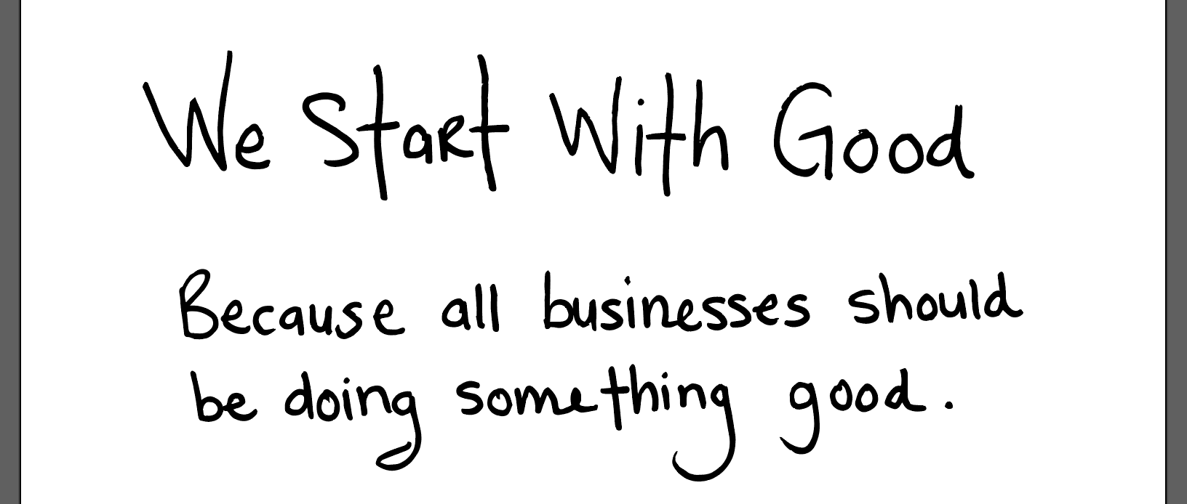

**WORD ART TEXT**

Second page to check!