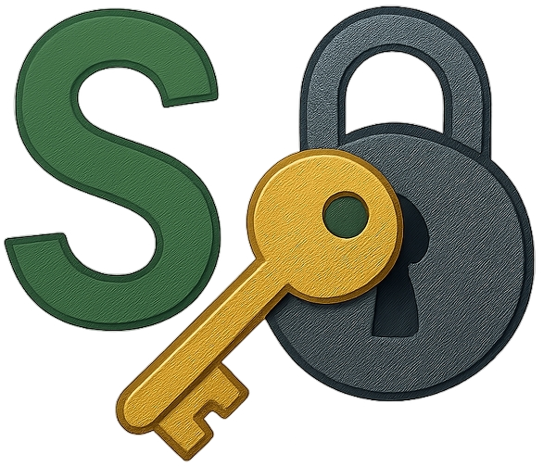

sokonalysis
The Cipher Toolkit Built For All Skill Levels

User Guide

Table of Contents
Introduction 3
Requirements 3
Linux 3
Windows 3
Features 4
Memory/Cashe 4
Header 4
File 4
Exit 4
View 5
Switch Theme 5
Layout 5
Default 6
Compact 6
Wide 6
Tools 6
Config 7
Wordlist Settings 7
John Settings 11
Quadgram Settings 11

Introduction
Welcome to sokonalysis v4.0.0 a cryptographic desktop application meant for all skill levels that can be accessed in both Windows and Linux. This application was developed by Soko James and Rosaria Phiri from Kapasa Makasa University featuring a Command Line Interface (CLI) as their Cybersecurity final year project.

Requirements

Linux
The current version works well on all distros including Kali, Parrot and Ubuntu. Ensure to have the following tools installed externally –
- John The Ripper
- Aircrack-ng Suite
- Steghide
- Stegseek
- OpenSSL

Windows
The current version works well in Windows 10 and 11. For cracking hashes, John The Ripper as been integrated in sokonalysis and can be used without any errors. For other options requiring external tools can not be utilized in Windows for now. We recommend, you use Linux or wait for coming updates that will integrate those external tools.

Features

Memory/Cashe

All your preferences such as theme, layout, header position, wordlist and quadgrams paths will be cashed. Your settings will restart where you ended even if you close the app.

Header

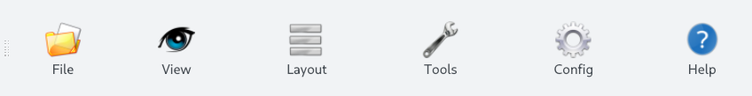
The header is customizable from top to left or right depending on your preference. To achieve this, drag from the left side of the header to any position of your choice, e.g., left, right or top again.

File

Exit
This enables the user to close the application.

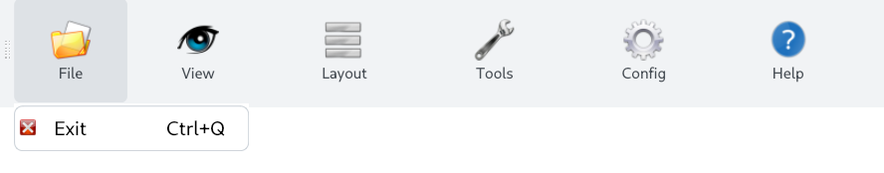

View

Switch Theme
By default the applications theme is light mode when the applicaion is installed, but will depend on your preference later.

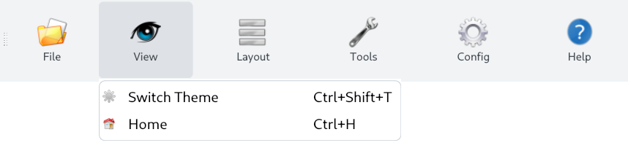

To switch into dark mode, you can click on Switch Theme under View or use the shortcut, Ctrl + Shift + T on the keyboard or tell the Assistance to help you achieve this.

Layout
When you maximize the window, it will trigger Wide mode, while when minimized it will trigger compact mode.
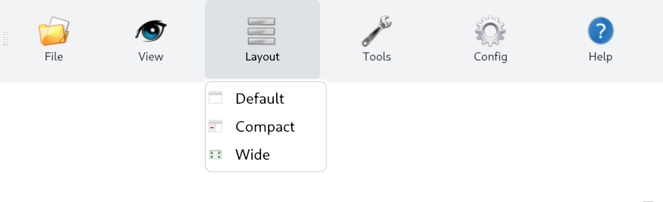

Default
By default the application opens in the Default layout when you just install the app, then later depends on your preference. This opens the application in a minimized screen window mode.

Compact

This layout opens the application in a smaller minimized screen window mode than the Default layout.

Wide
This layout opens the application in full screen.

Tools
These are just shortcuts of the main menu, and can be used when a user is in a category and wants to switch into another category without navigating back multiple times.

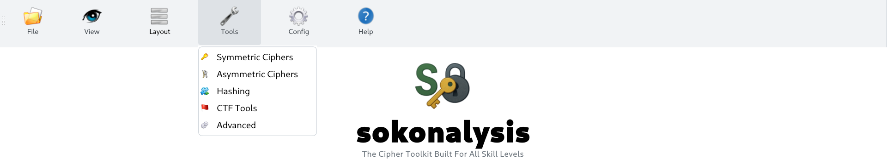

Config
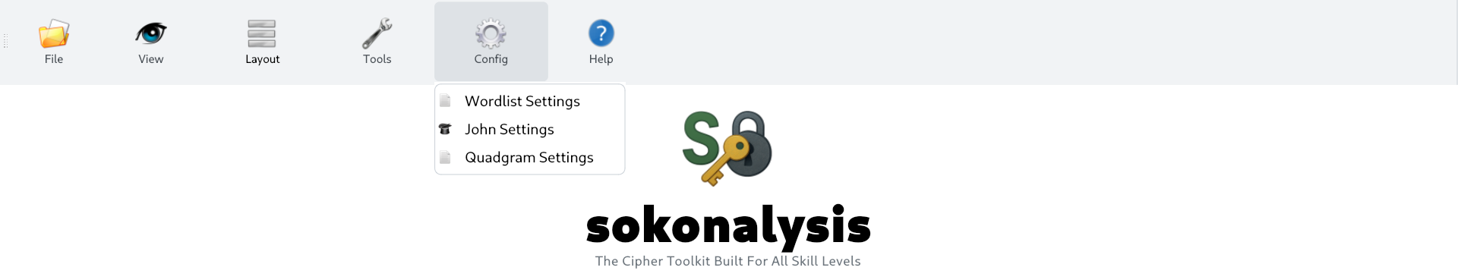

Wordlist Settings
Based on the wordlist used, the system will slipt it into multiple parts based on the system cores or threads, users can also set up the number of parts to be slipted. This helps speed up cracking process.
For example, you want to crack a protected documents password, in this case for a CTF challenge on Cyber Talents called Boss Message.

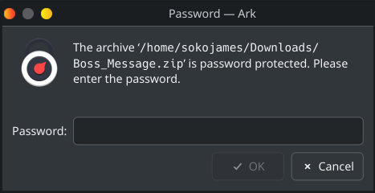

If you are just getting started in CTFs, you can just darg and drop the file onto the Assistant, to get some info.

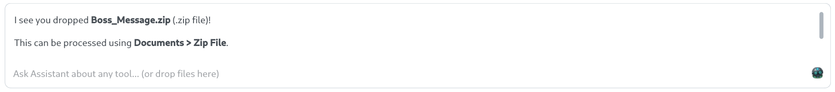
Now we know that we need to use a wordlist and the path for the Zip File cracking as been provided.

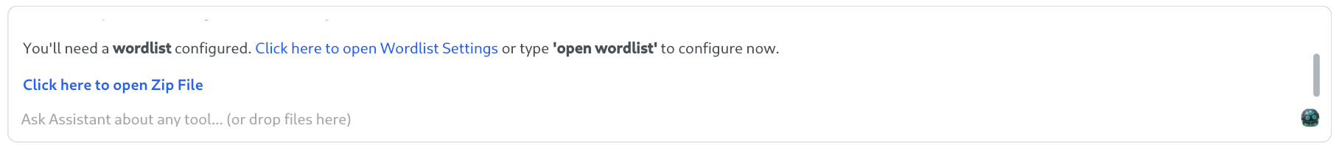

Notice we need to configure the wordlist first
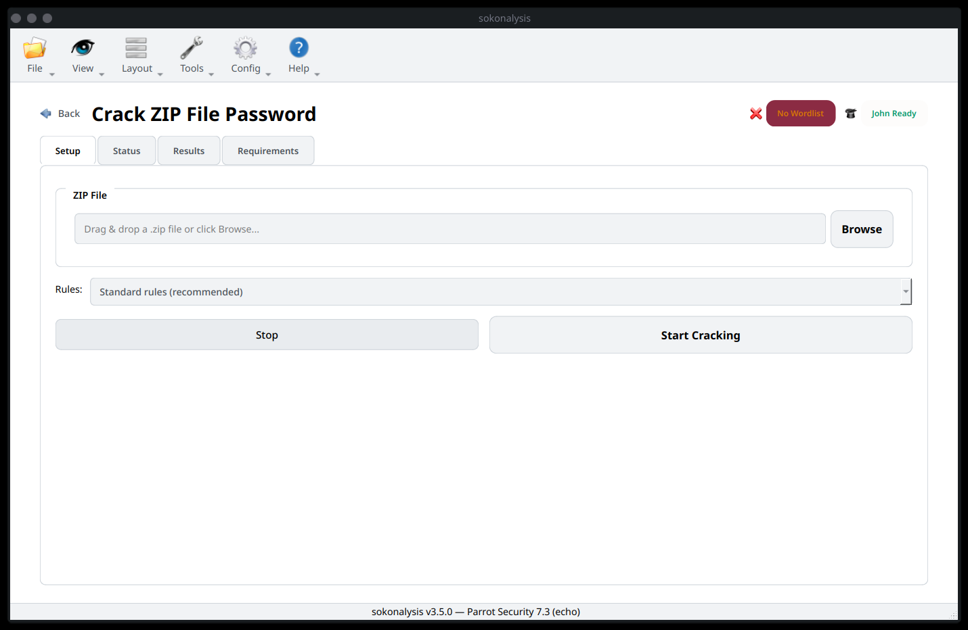

Using the Config tab then Wordlist Settings can help us achieve this. In most cases, the mostly commonly used wordlist is rockyou.txt which can be found via /usr/share/wordlists/ in a Linux system file structure.

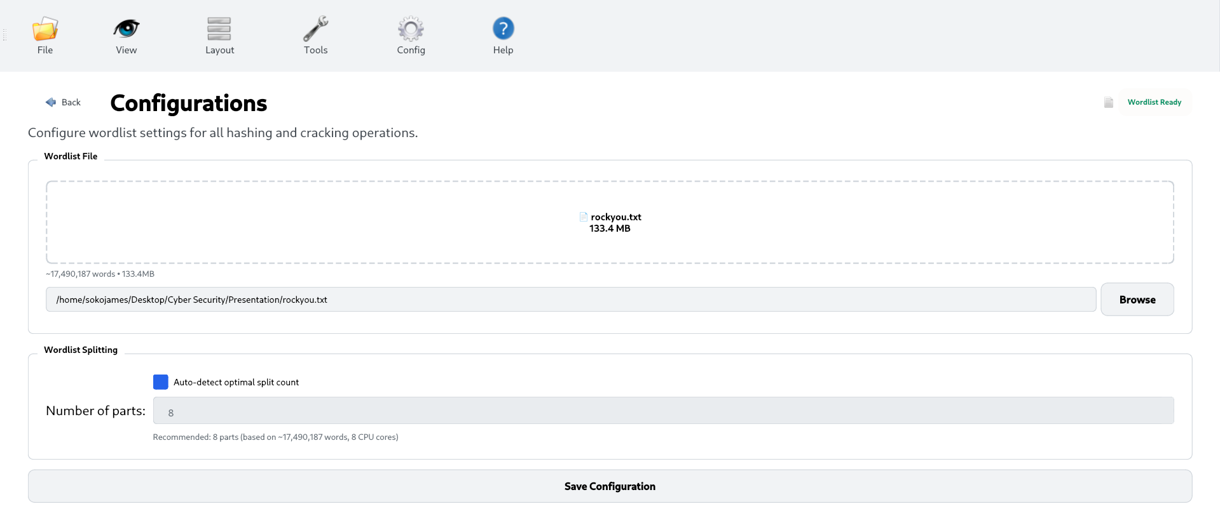

Save the configurations, then drag and drop your zip file then press Start Cracking.

Notice the wordlist splitting taking place and the password was found in less than a minute.
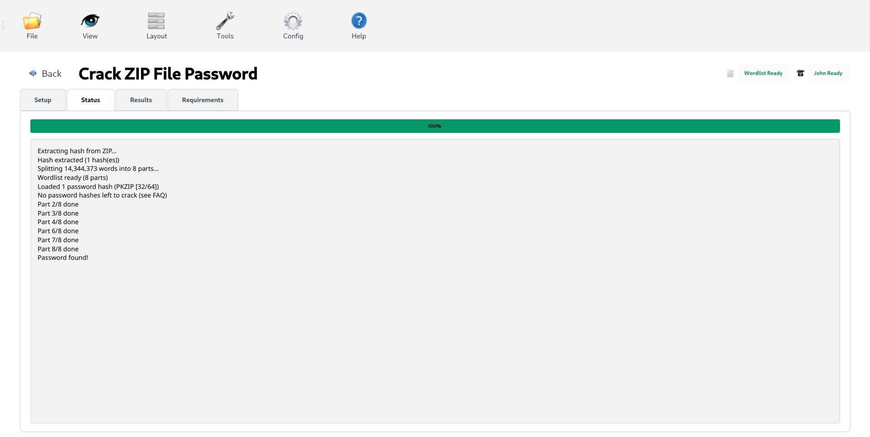
We can use use the found password to unzip the Ziped File.

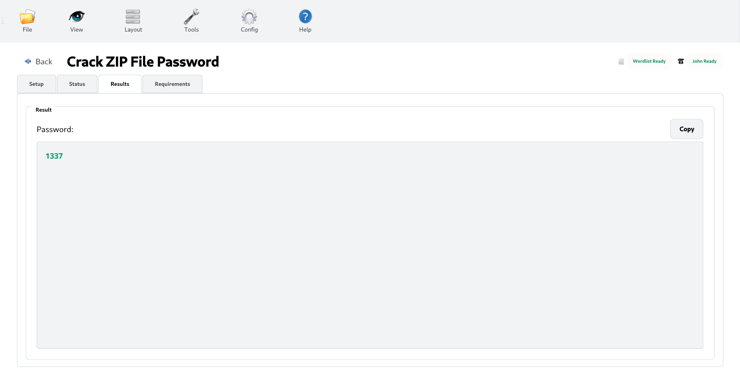

John Settings
Most of the Document password cracking passwords such as Zip File use John The Ripper, sometimes john crashes its pot files where the cracked passwords are saved. So in cases where the john fails to crack a password using a wordlist but the password is in the wordlist, clear the session logs via Config the John Settings.

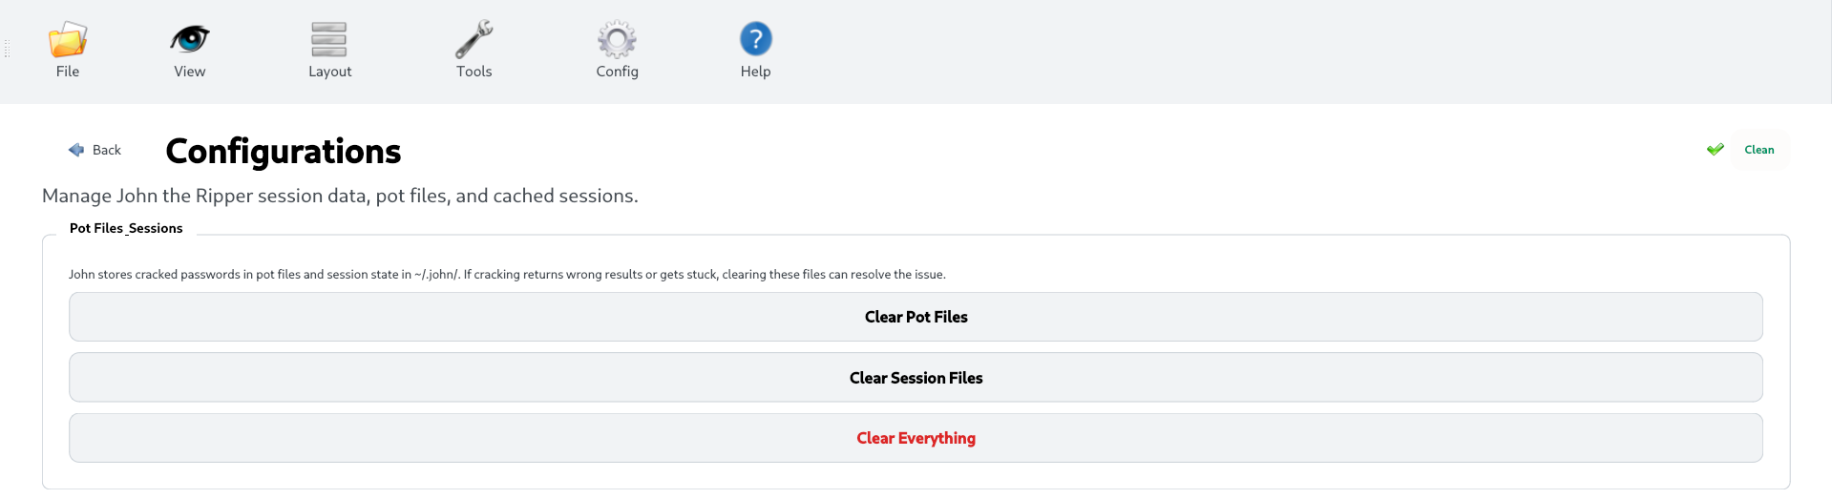

Quadgram Settings
This is useful in a Substitution Cipher brute-force cracking using Frequence Analysis. The AI assistant can provide us with more info about it.

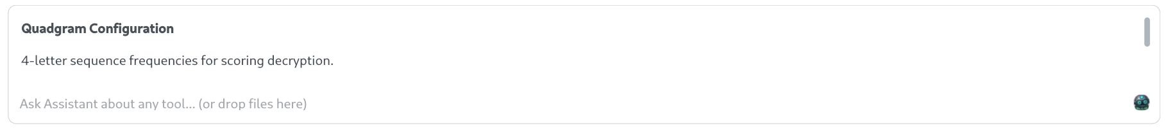

Let’s take an example, on CyLab Security Academy famously known as PicoCTF, they are multiple substitution cipher challenges we can work with.

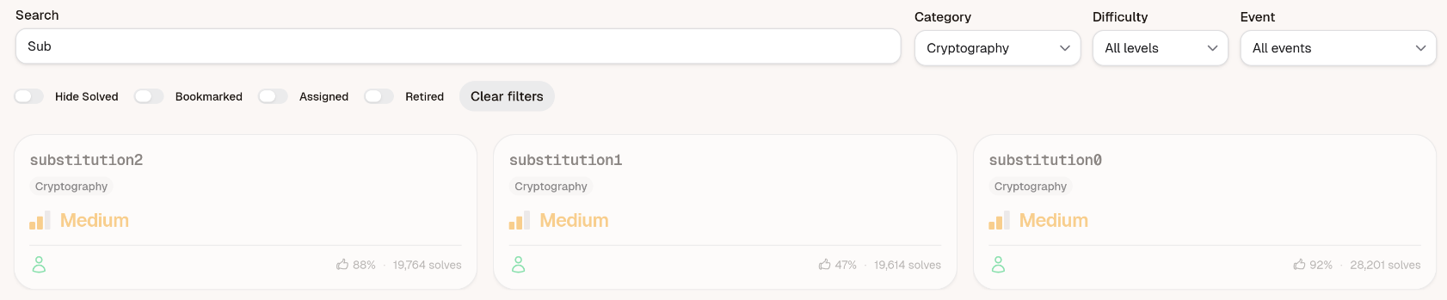
In this demo, will use substitution2 challenge. Download the message.txt file to view the cipher text. Using the Search option, type sub and Filter by the CTF category.

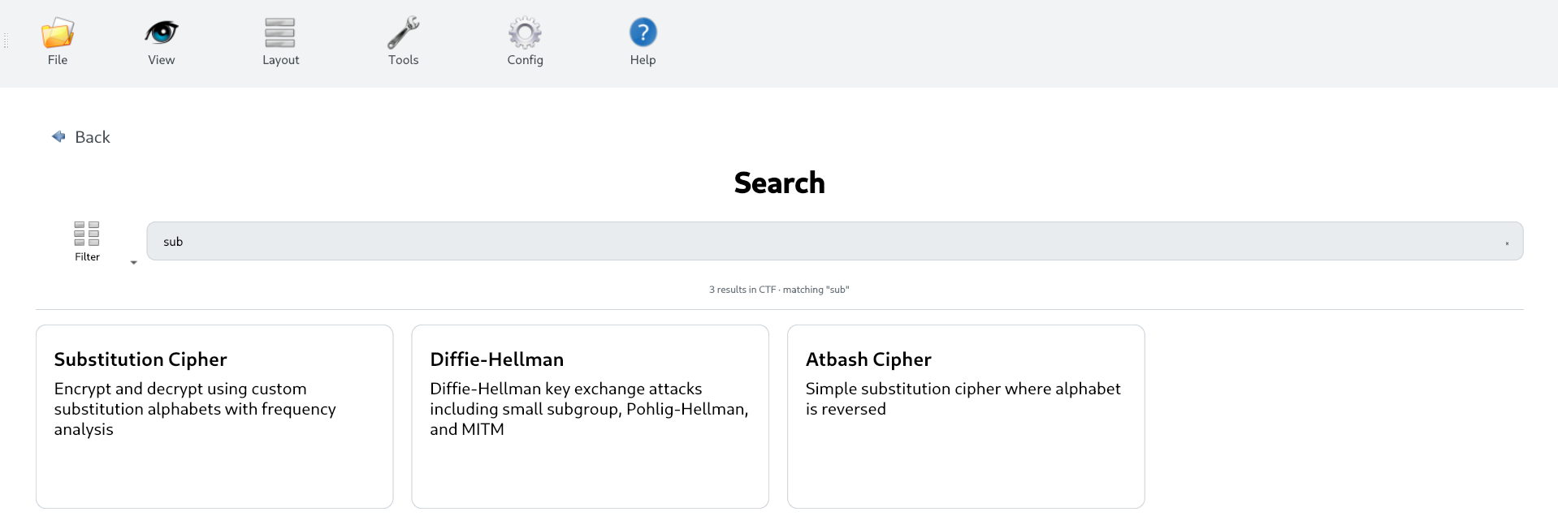

Select Substitution Cipher and then Frequency Analysis. Unlike the wordlist option, quadgrams are not common, use we provide a default json file that you can use. Paste the cipher text and press Break Cipher.

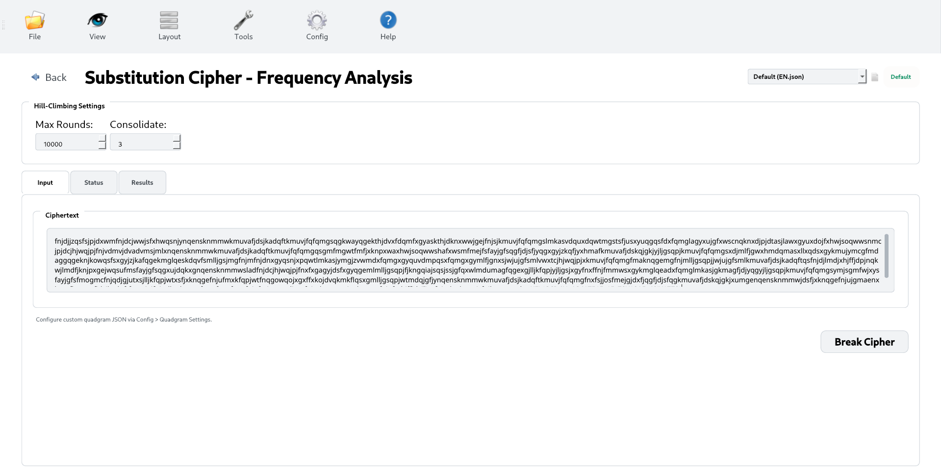

There we go, we have our flag

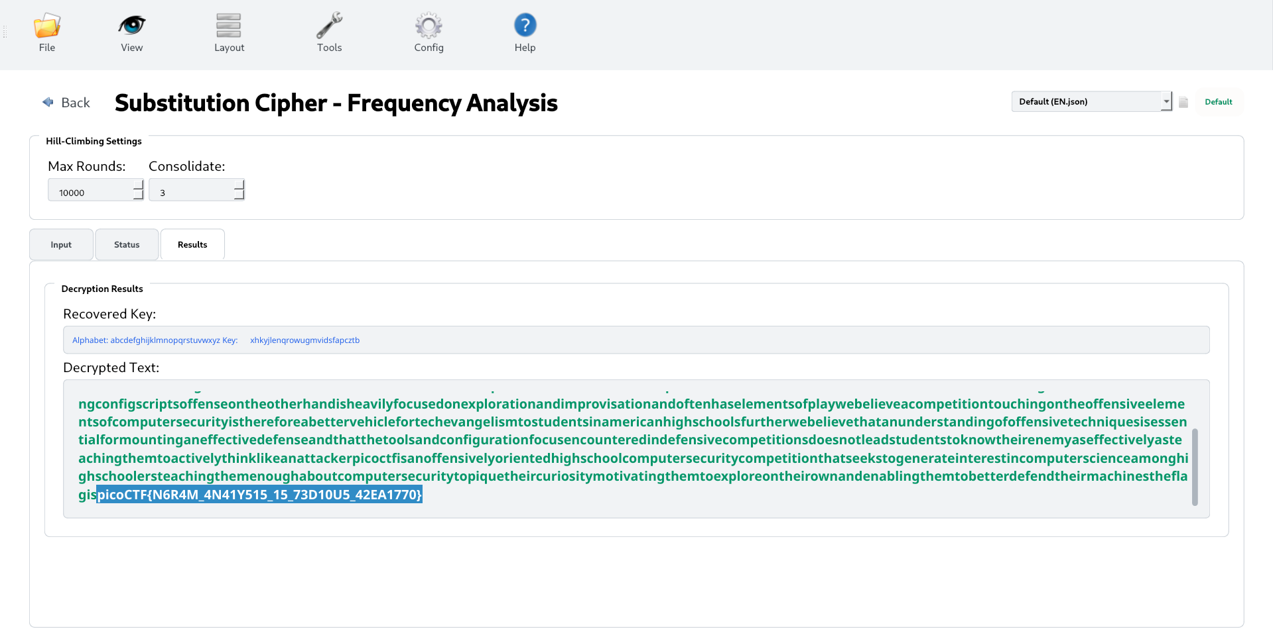

Similary to the Wordlist Settings, we can also configure a custom quadgram json file. First, switch from Default (EN.json) to Custom Json.

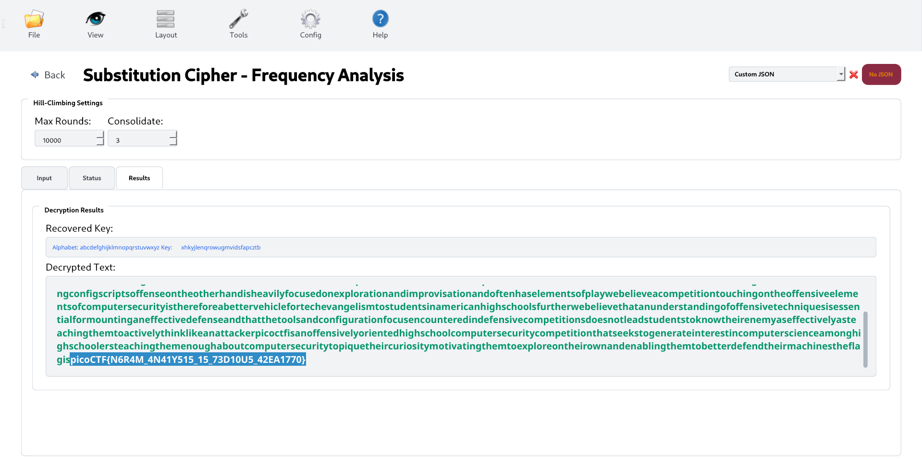

Under Config select Quadgram Settings then drag and drop your custom json file.

