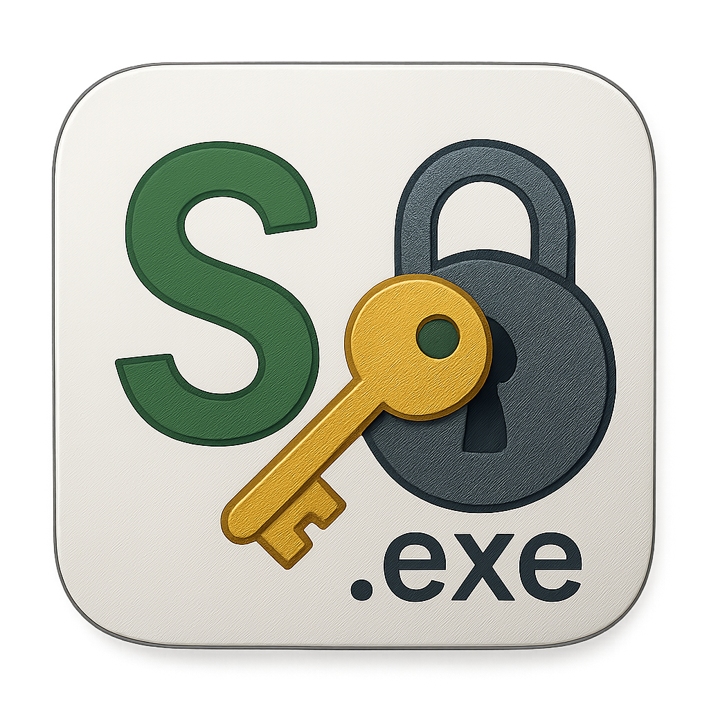

sokonalysis
The Cipher Toolkit Built For All Skill Levels

User Guide

Table of Contents
HEARDER 3
File 3
Exit 3
View 4
Switch Theme 4
Layout 5
Default 6
Compact 6
Wide 7
Tools 8
Config 9
Wordlist 9
SYMMETRIC 10
Caesar Cipher 10
Basic Shift 10
Brute Force Decrypt 13
Polyalphabetic 16
Keybord-based 16
Vigenere 18
Kasiski Examination 18
Friedmans Test 20
Hybrid Approach 23
Squence-based 24

HEARDER

File

Exit
This enables the user to close the application.

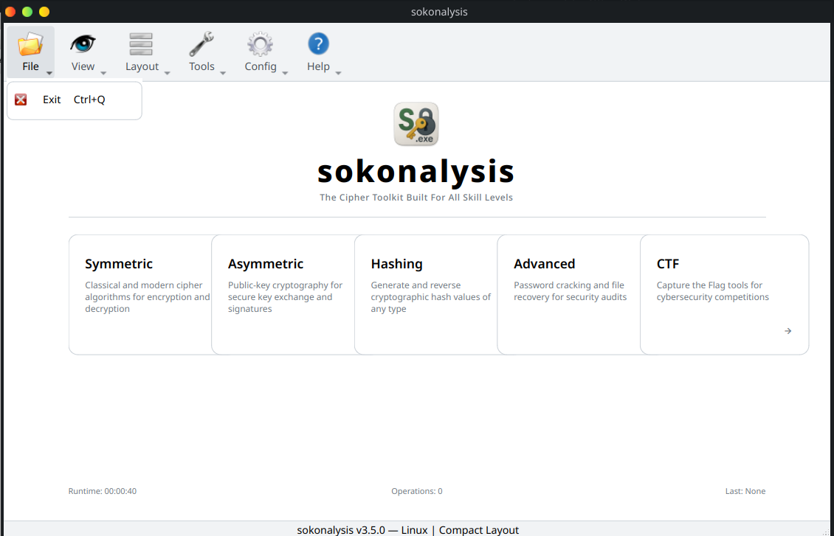

View

Switch Theme
By default the applications theme is light mode.

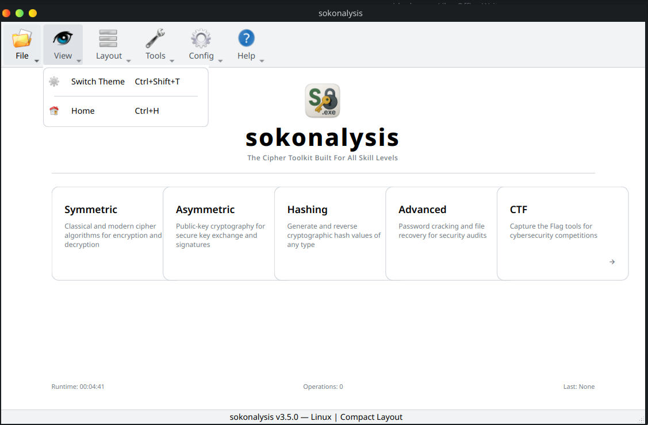

To switch into dark mode, you can click on Switch Theme under View or use the shortcut, Ctrl + Shift + T on the keyboard.

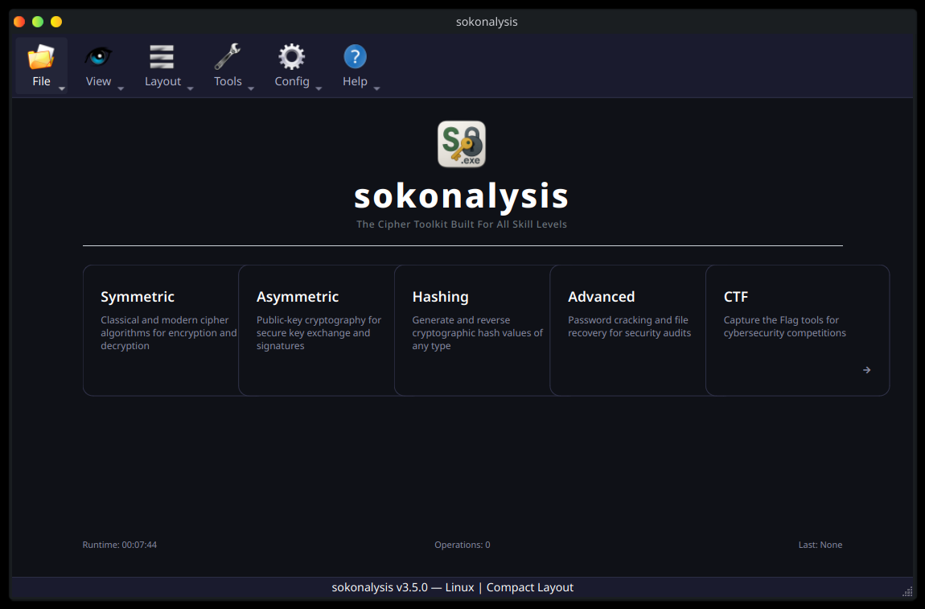

Layout

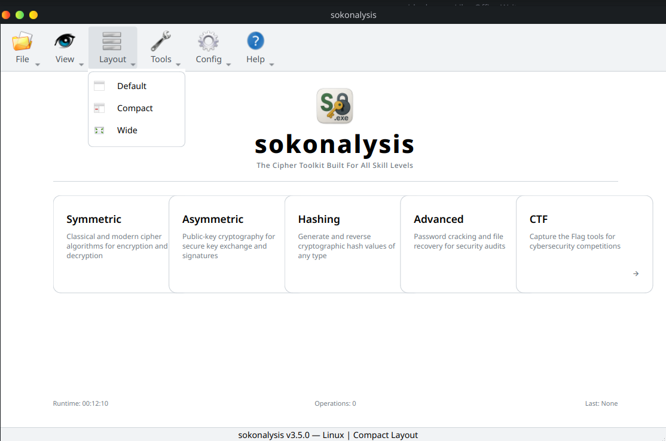

Default
By default the application opens in the Default layout

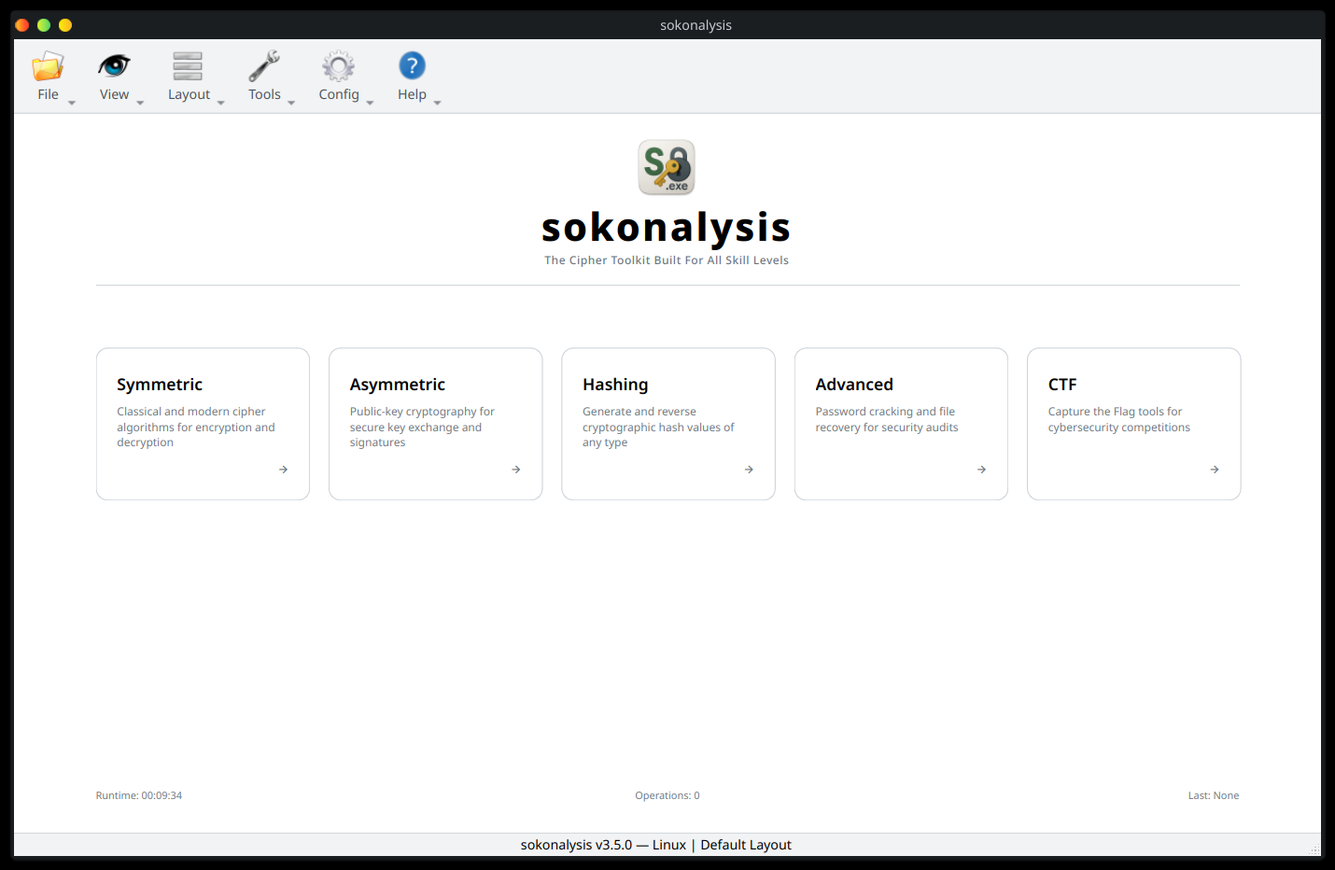

Compact

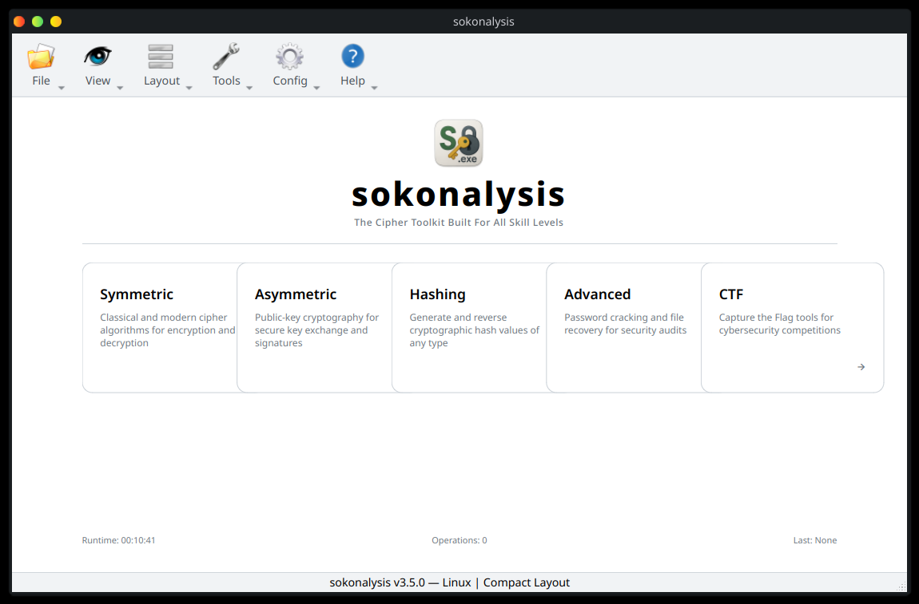

Wide

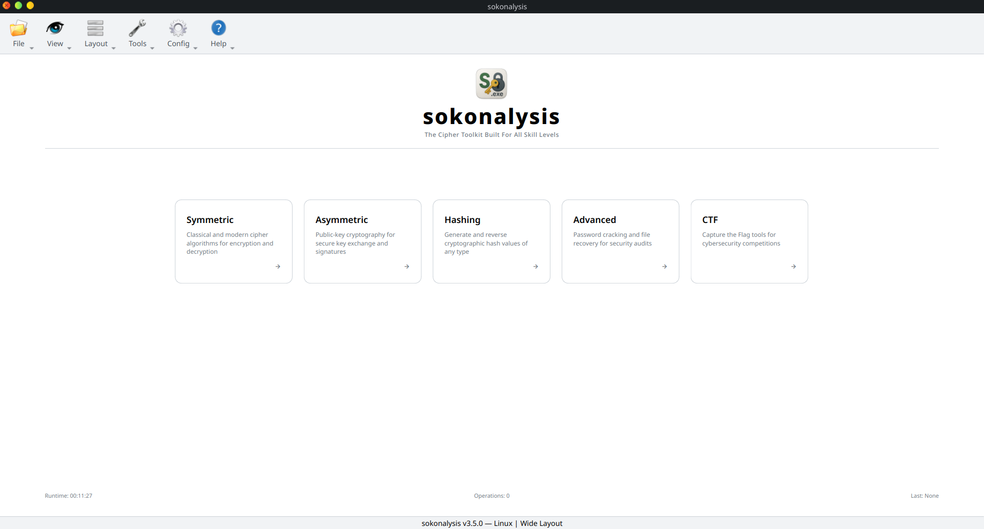

Tools
These are just shortcuts of the main menu, and can be used when a user is in a category and wants to switch into another category without navigating back multiple times.
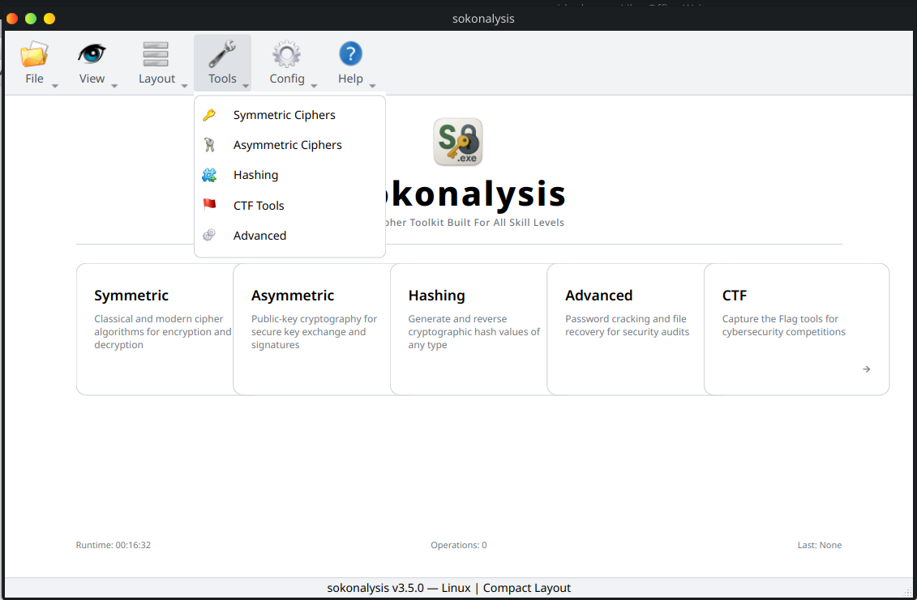

Config

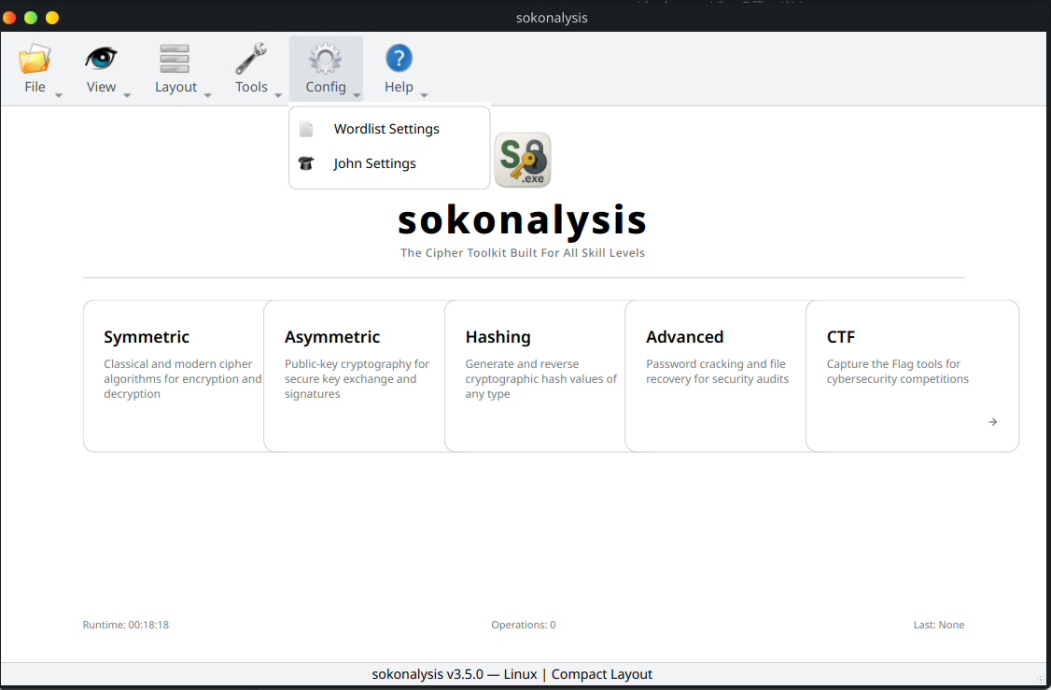

Wordlist
Based on the wordlist used, the system will slipt the wordlist based on the system cores or threads, users can also set up the number of parts to be slipted. This helps speed up cracking process.

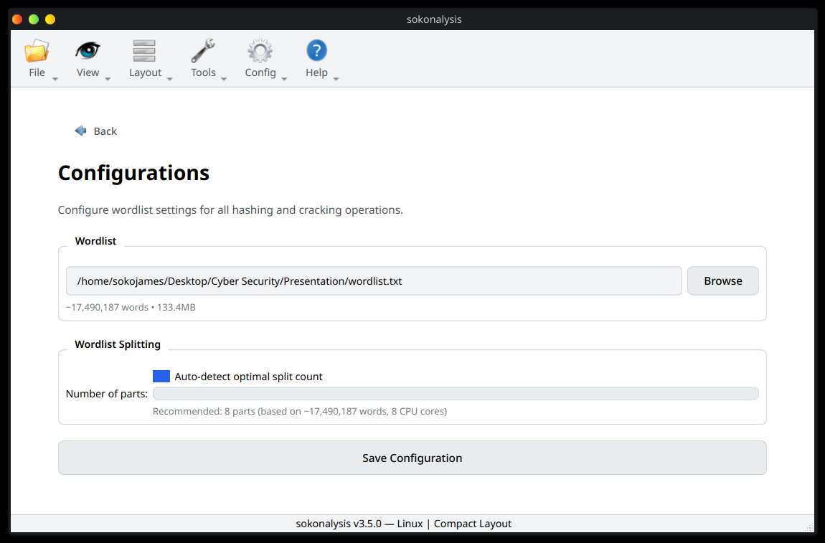

SYMMETRIC

Caesar Cipher

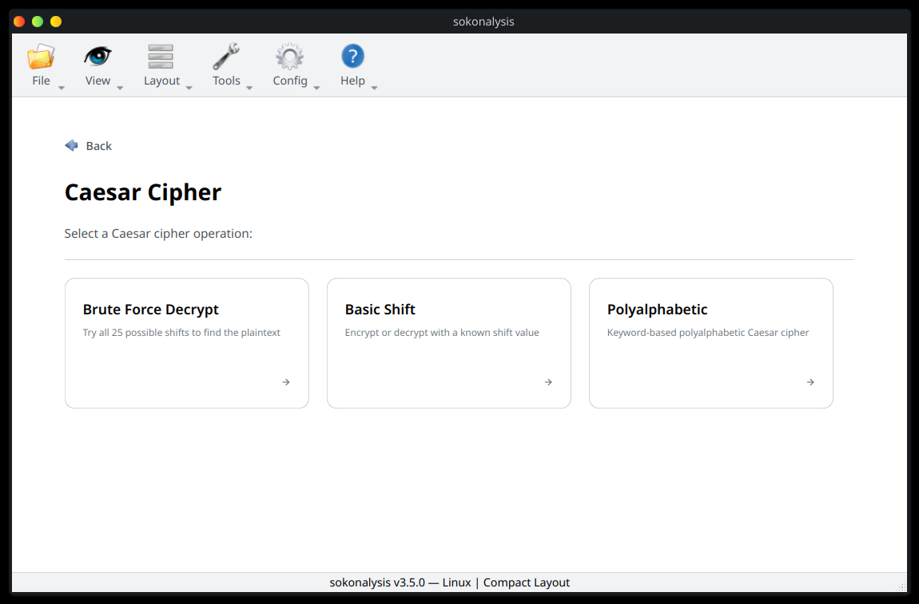

Basic Shift
Select the mapping style, mostly in Universities, the common used style is A1 – Z16.

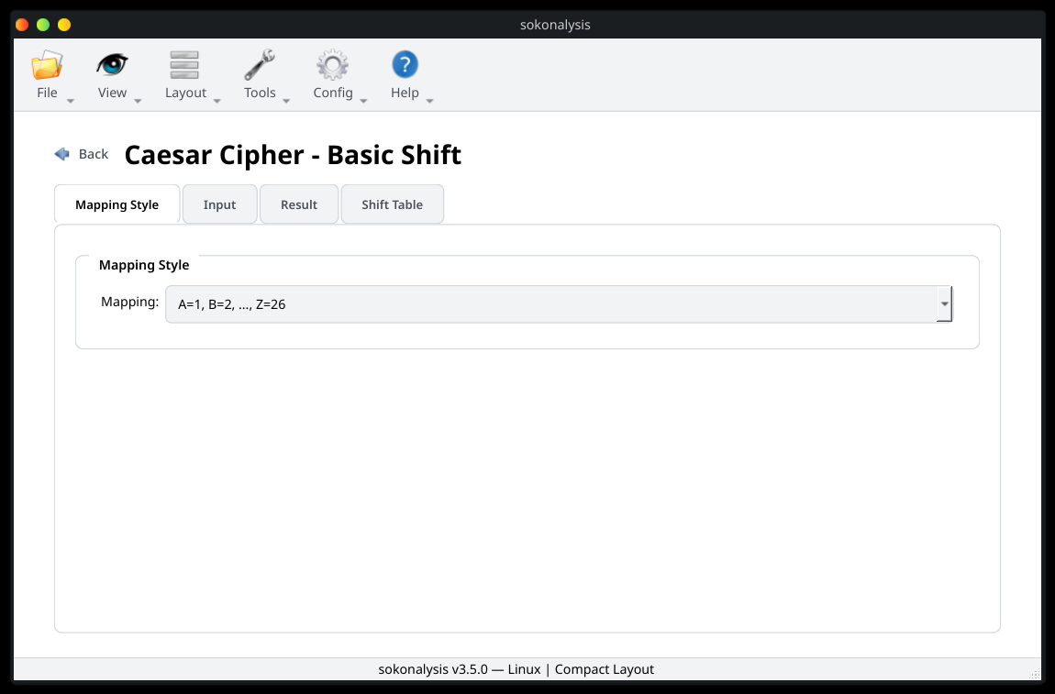

Question:
Using a Caesar cipher of S = 5 encode the message being sent THIS TEST IS INTERESTING.

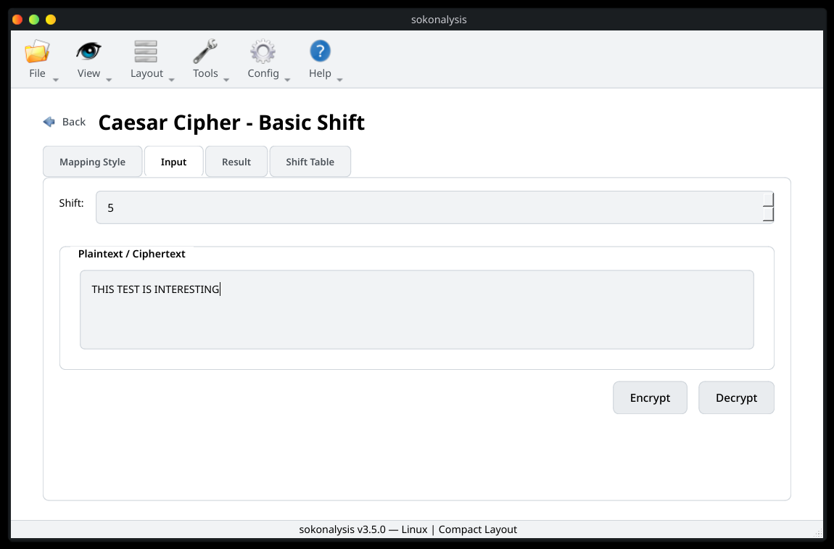

Press the Encrypt button and check the results

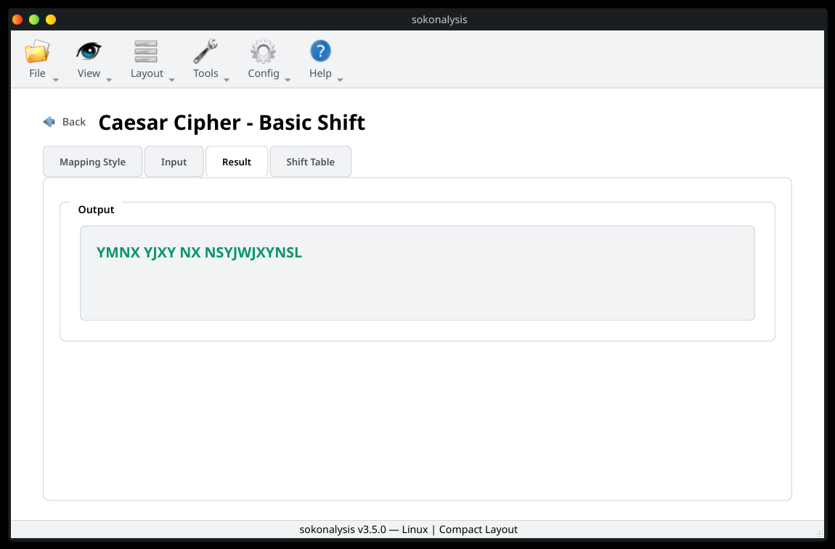

A user can also view the Shift Table to view how this encryption has been done.

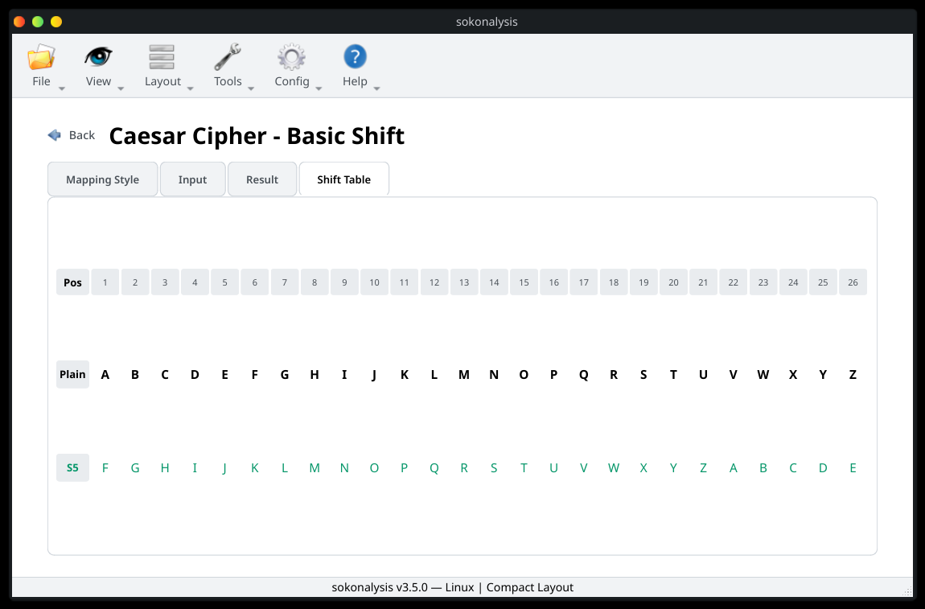

By copying the Result, you can decrypt the cipher text by pasting the cipher on the input and press Decrypt.

Brute Force Decrypt
This option requires you to configure a wordlist to get more accurate results if the word is contained in the wordlist. This is reccommeded for known english words are not statements.

Question
Decrypt the cipher text DAEQ using a caesar brute force attack.

First, configure the Mapping Style just like we did if the basic shift if required.

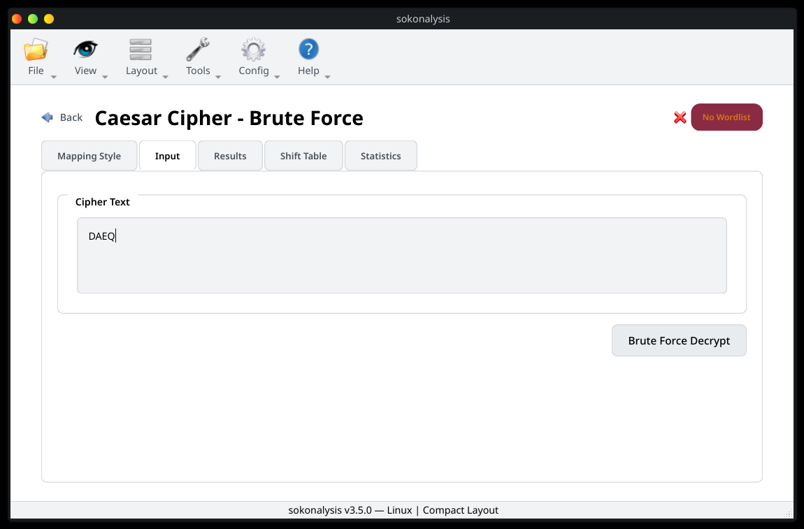
With no wordlist, this will provide a list of shifts, and a user is required to look at a word or statement which is readable.

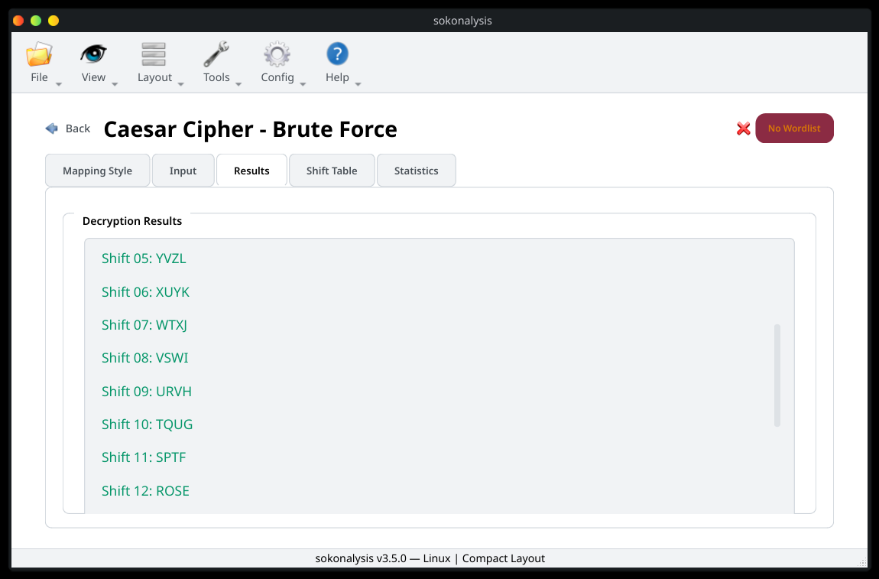

To get a more acurate result, a user is reccommened to configure a wordlist.

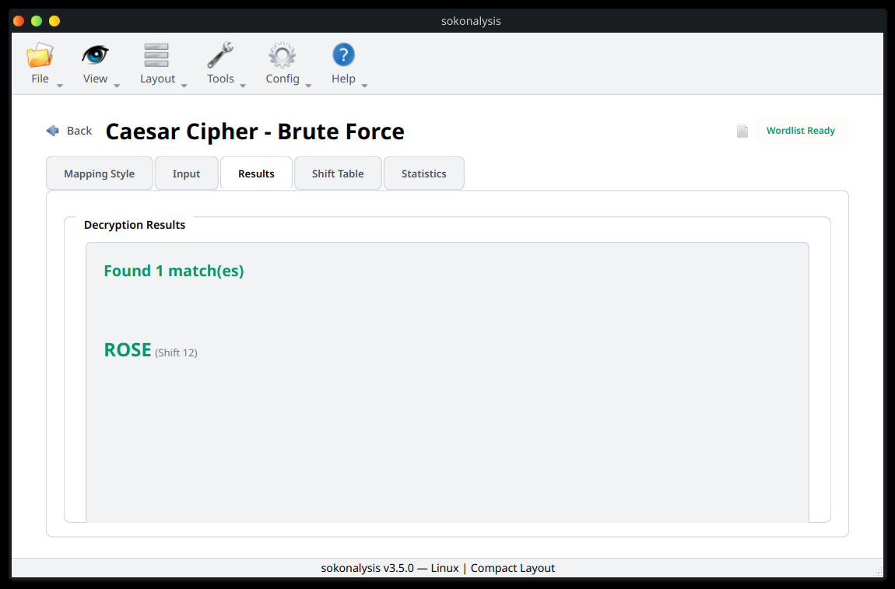

The Shift Table shows the brute force table
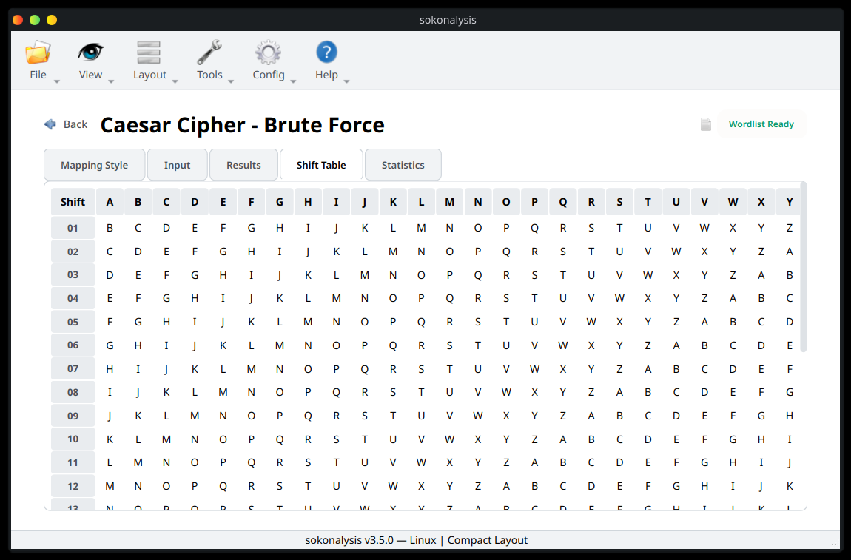

The Statistics show how often the cipher text letters apppear per letter on the alphabet.

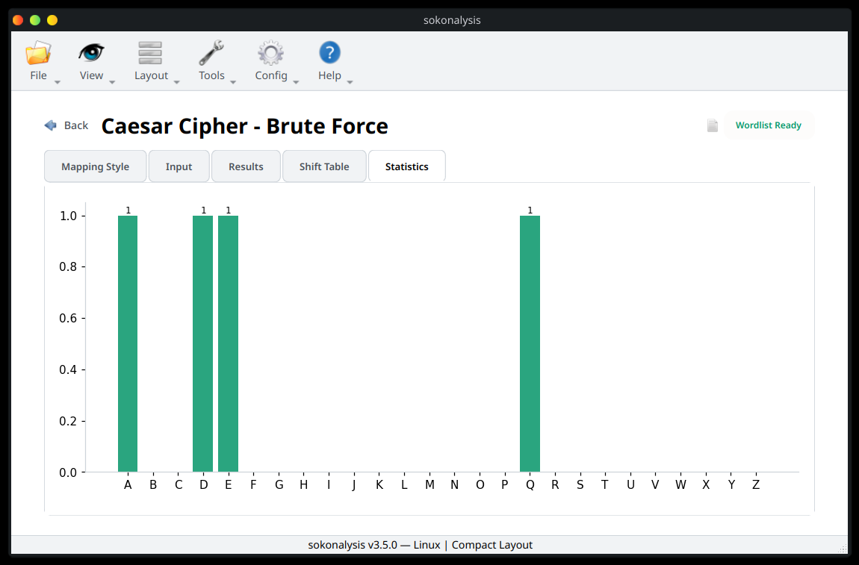

Polyalphabetic

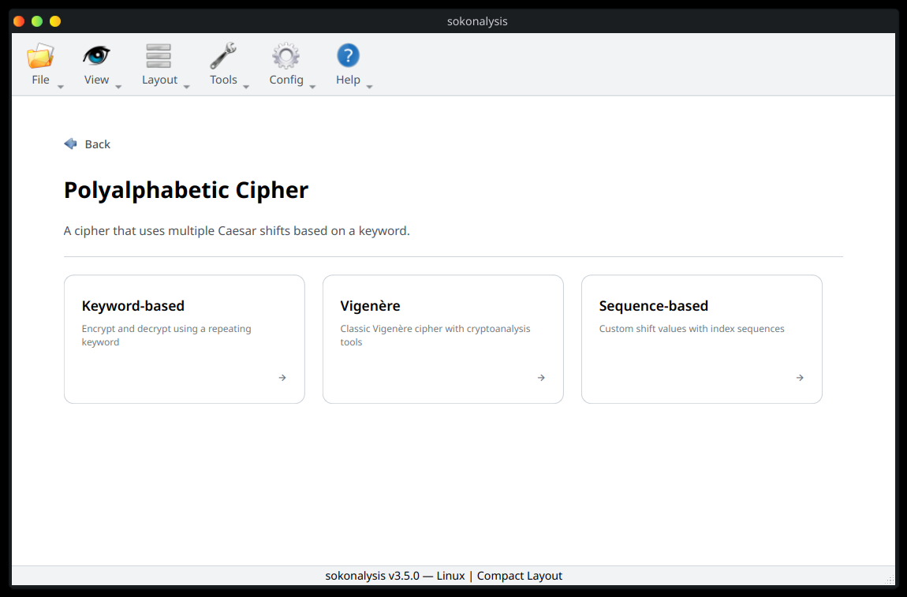

Keybord-based
Select the mapping style, in this case will use A1 – Z26. In this case, let’s encrypt THE CIPHER TOOLKIT BUILT FOR ALL SKILL LEVELS
using the key SOKO.

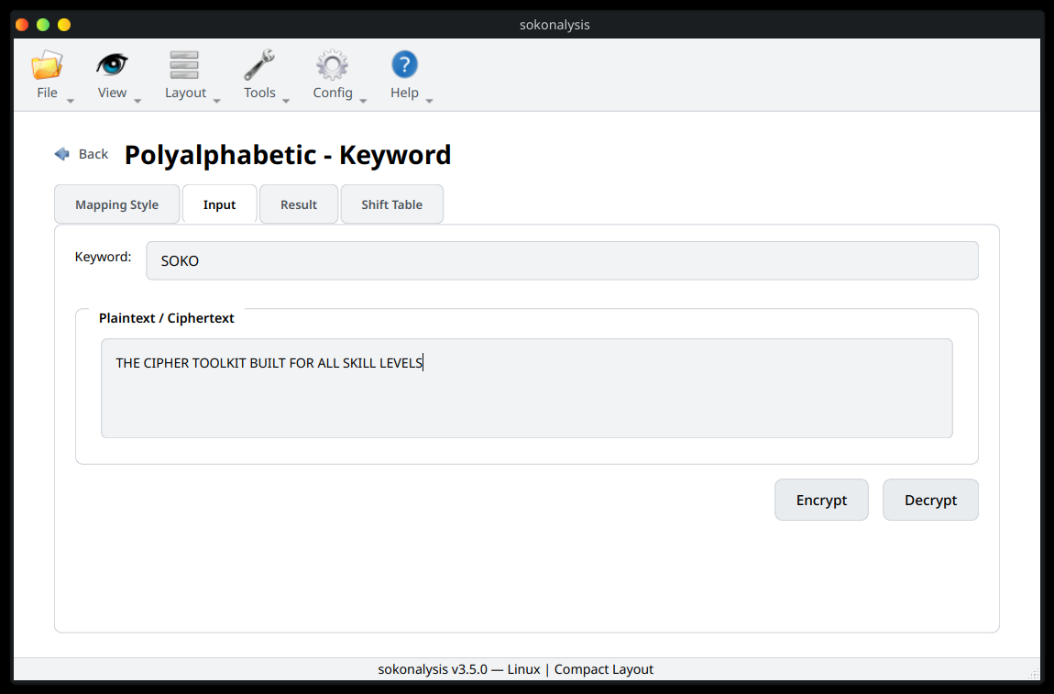

Press the Encrypt button to encrypt and see the results

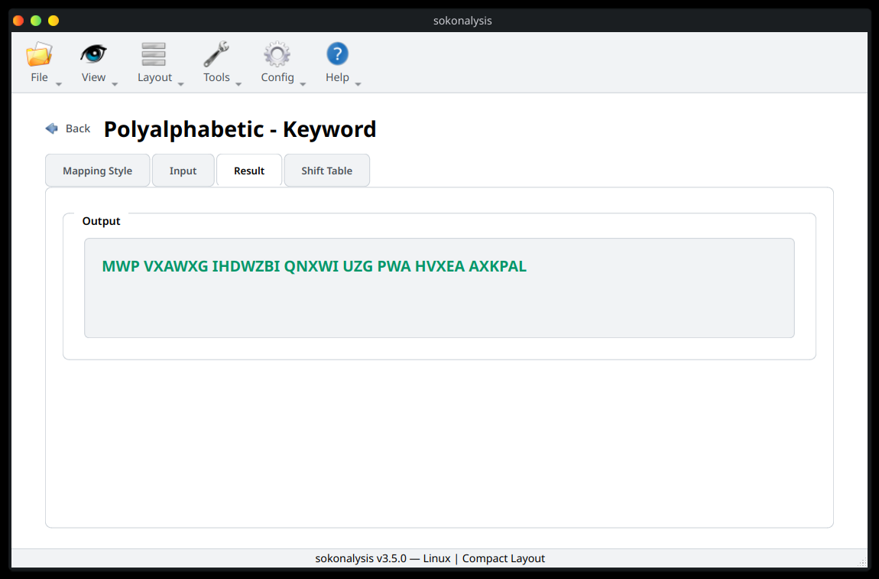

To understand the encryption logic, check the Shift Table tab

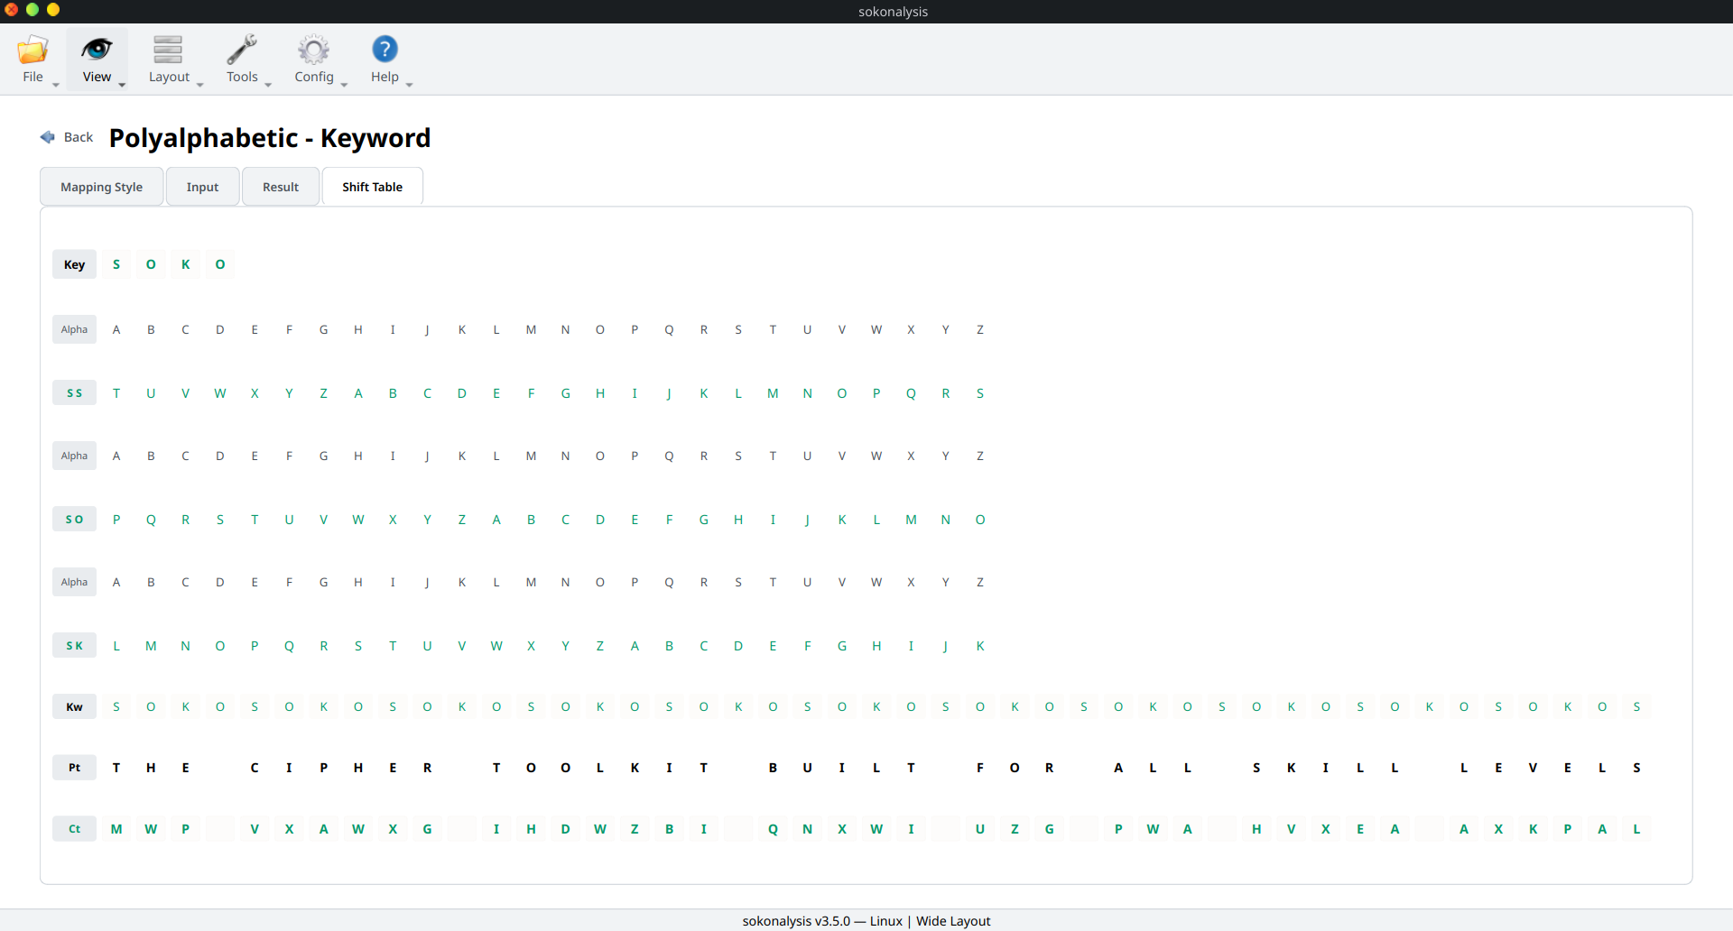

Vigenere
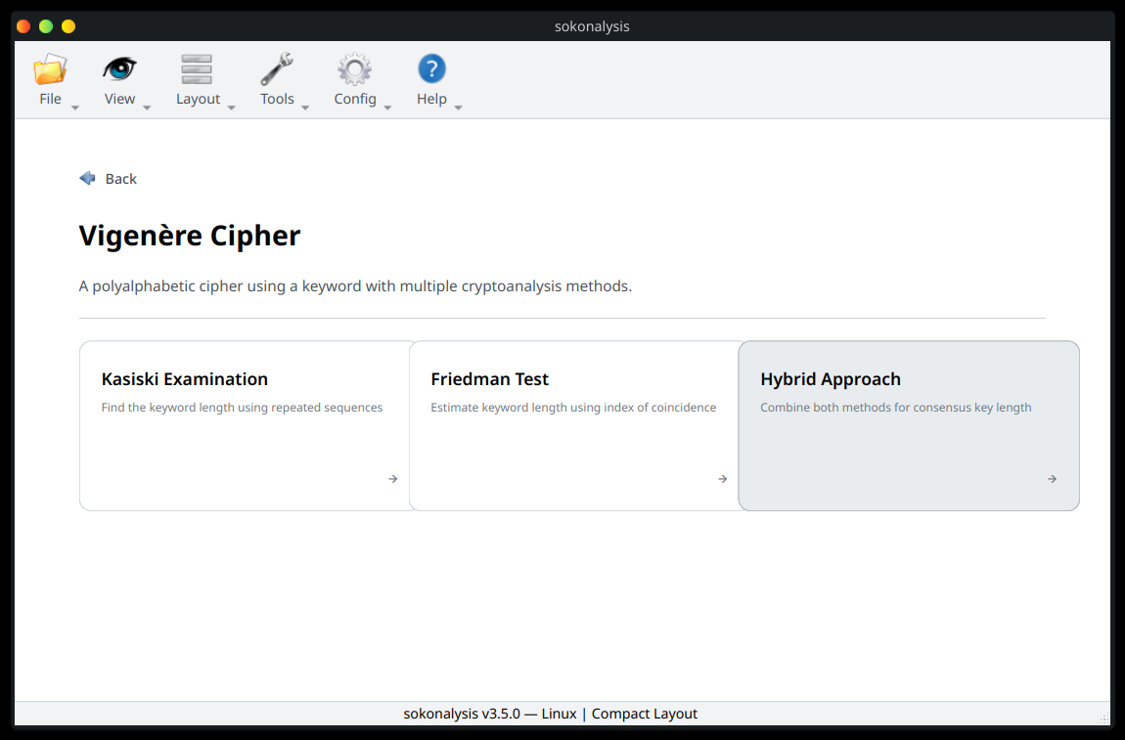

Kasiski Examination
Question:
Find a set of keys for the cipher CSASTPKVSIQUTGQUCSASTPIUAQJB.

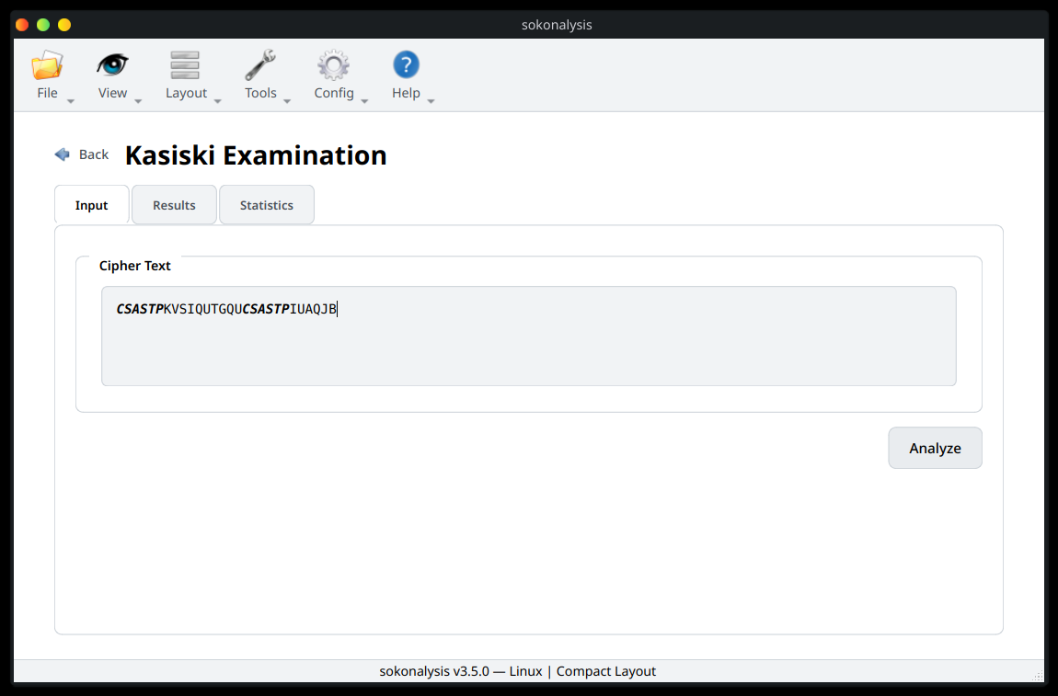

Use the Analyze button to start the analysis

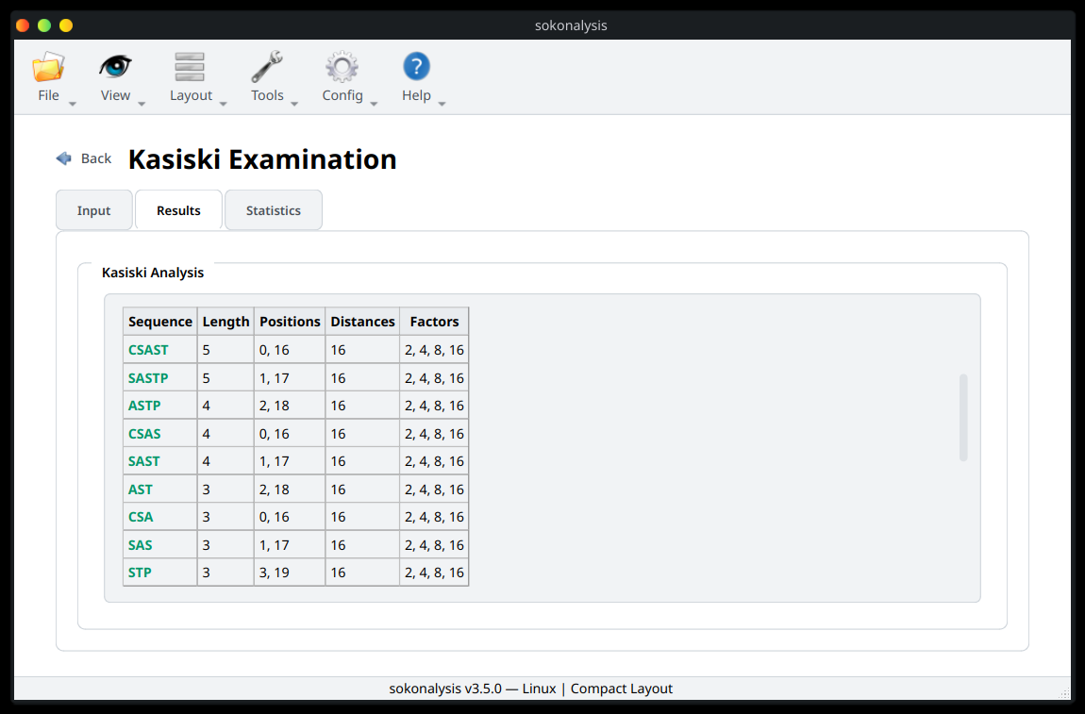

Based on the cipher text length, the estimated key length is

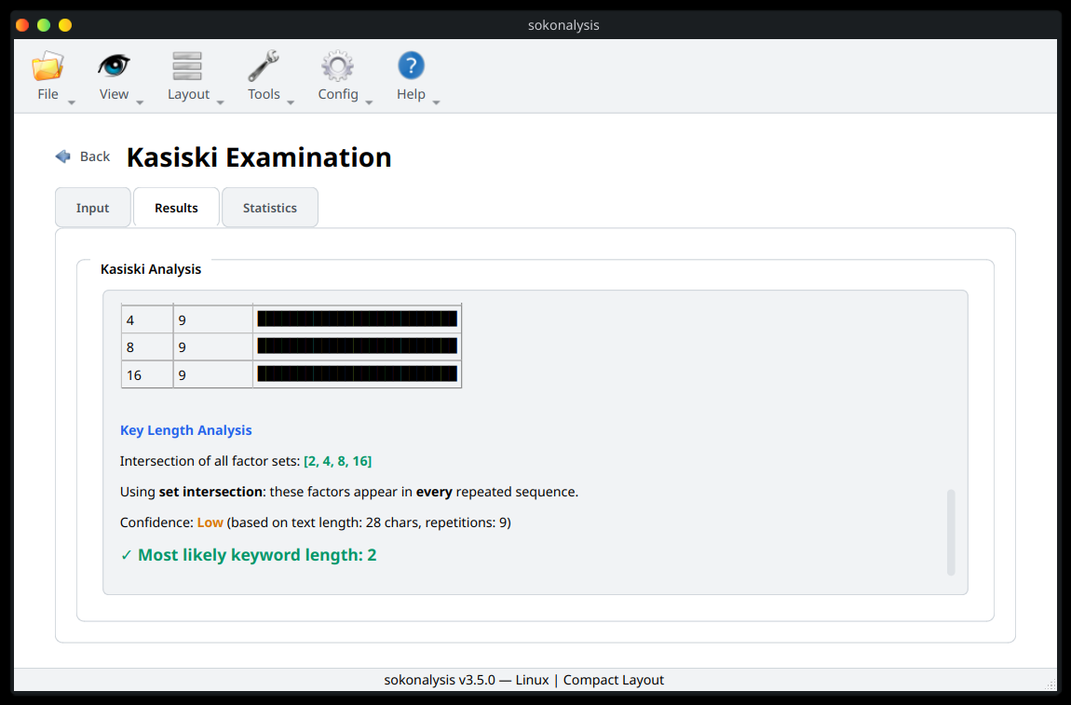

The Statistics shows the frequence of each factors (possible keys)

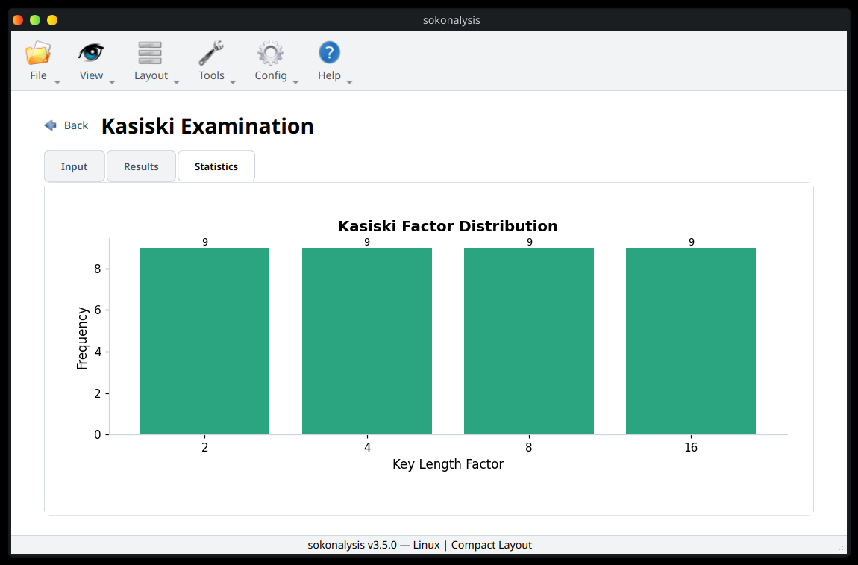

Friedmans Test
Question:
Find the estimated key length for OZGRFQZXOPOWZEJWVOKJBVDI
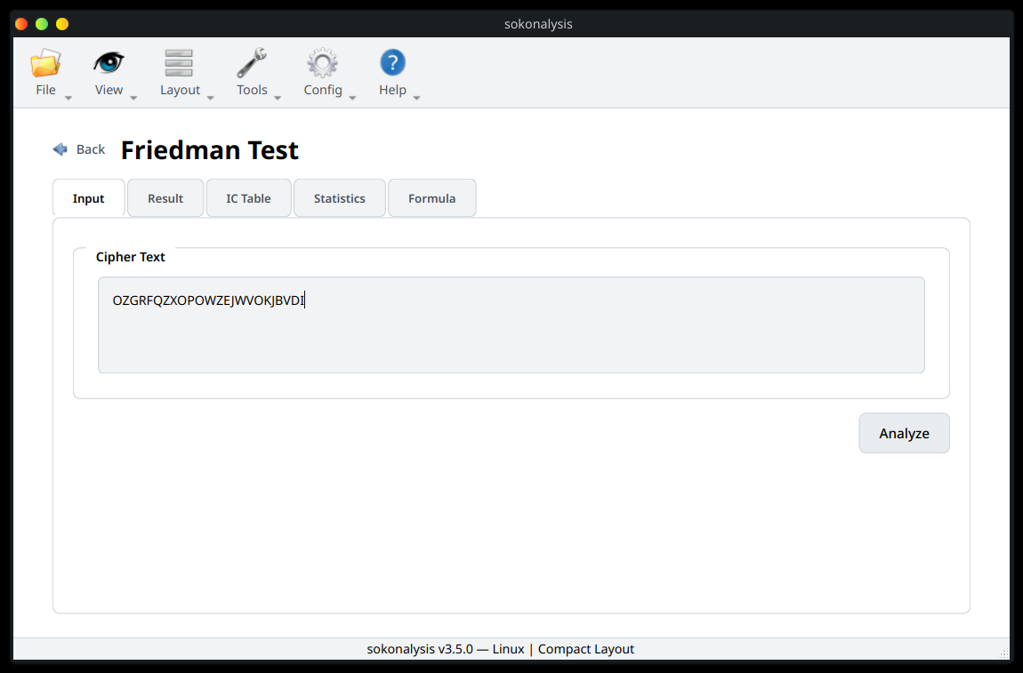

Press the Analyze button to find the estimated key
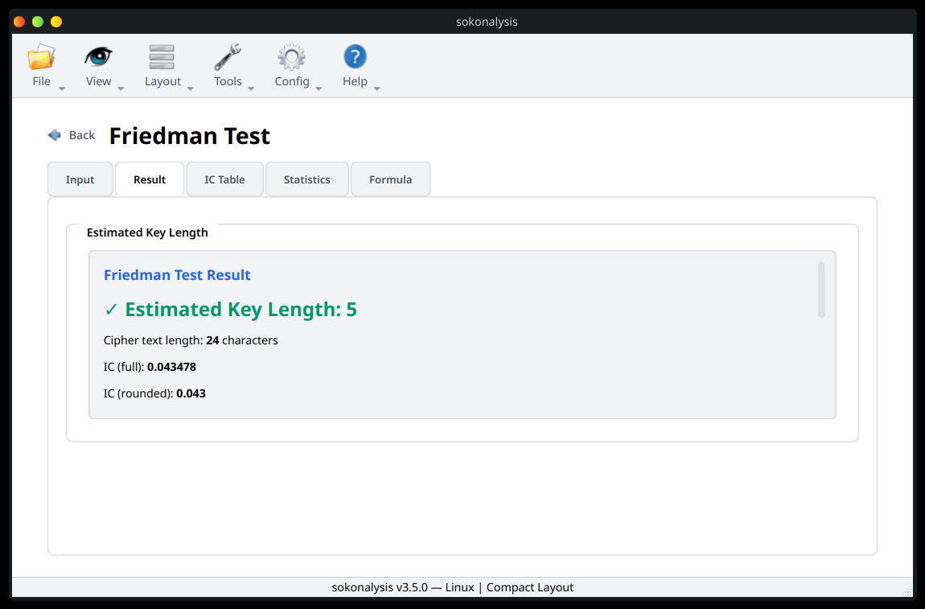

You can view the IC Table to see why the estimated key is 5
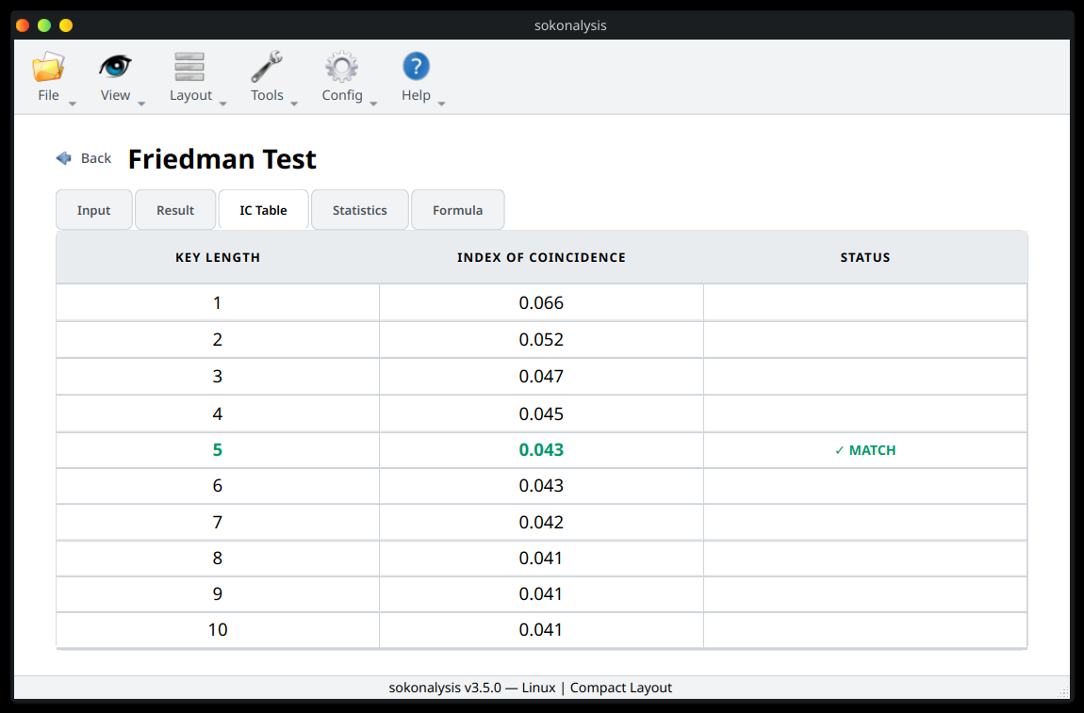

The Statistics tab shows how frequently each letter appears from the cipher text
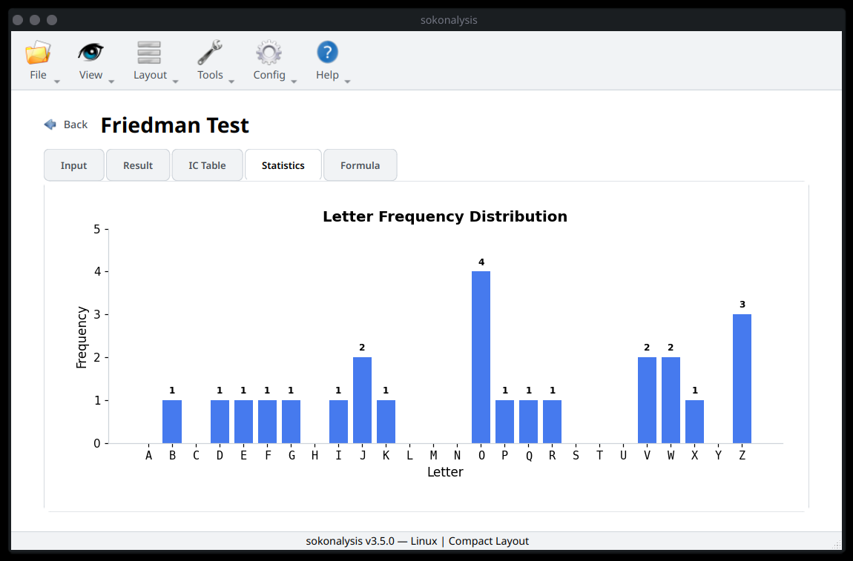

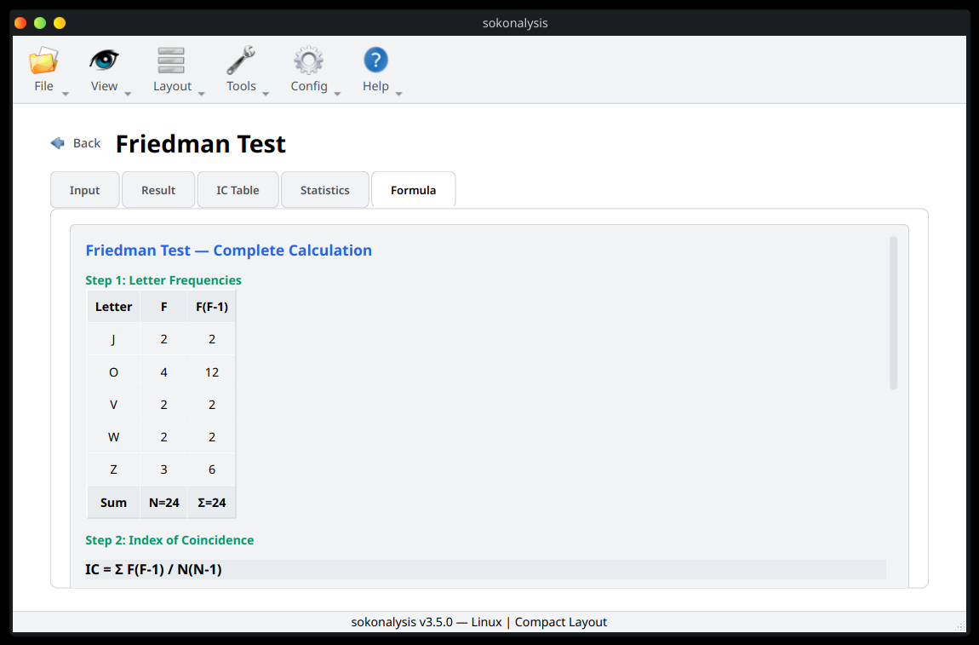
The Formular tab shows the detailed information on how to find the estimated key length.

Hybrid Approach
The hybrid approach combines both the Kasiski and Friedmans Test. Refering to the cipher text used in the previous example
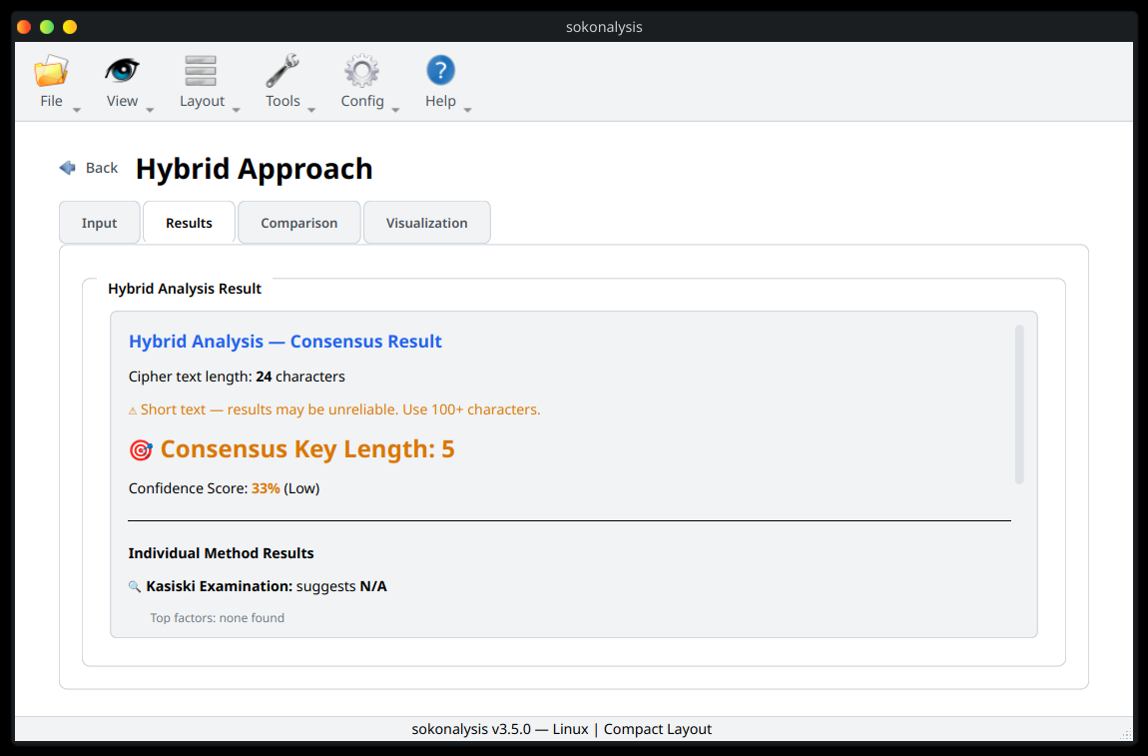

The Comparison tab shows how the two methods have been used for decision making.
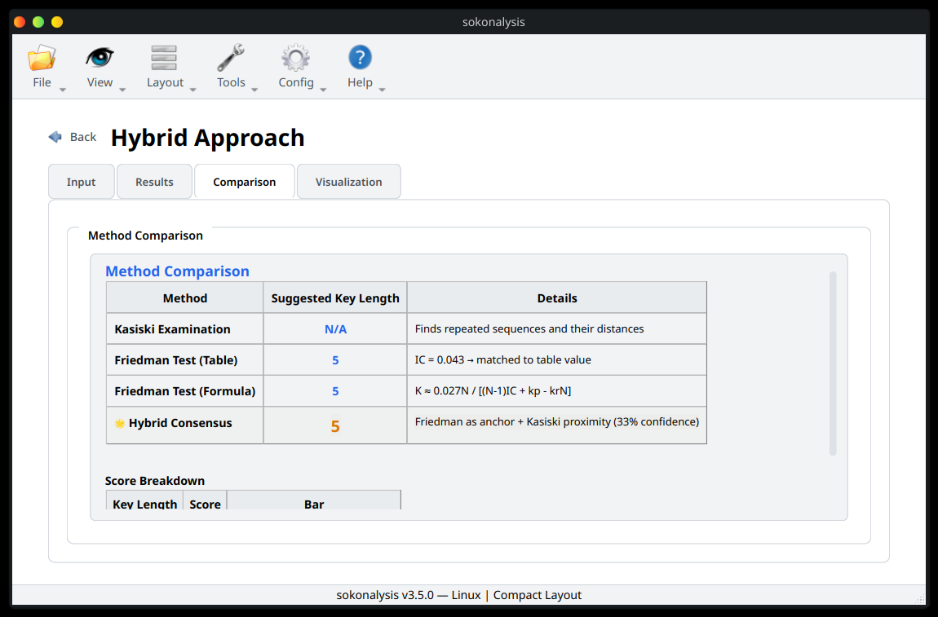

Squence-based
Question:
Using a Caesar cipher with S = 3 and S = 7. Encrypt the message WELCOME TO CRYPTOGRAPHY using a C1C2C2C1C2 sequence.

Key Setup
- Number of keys, enter 2 then press Generate
- Enter the shift value for the two keys, in this case 3 and 7 respectively
- Enter the Sequence length value, in this case 5

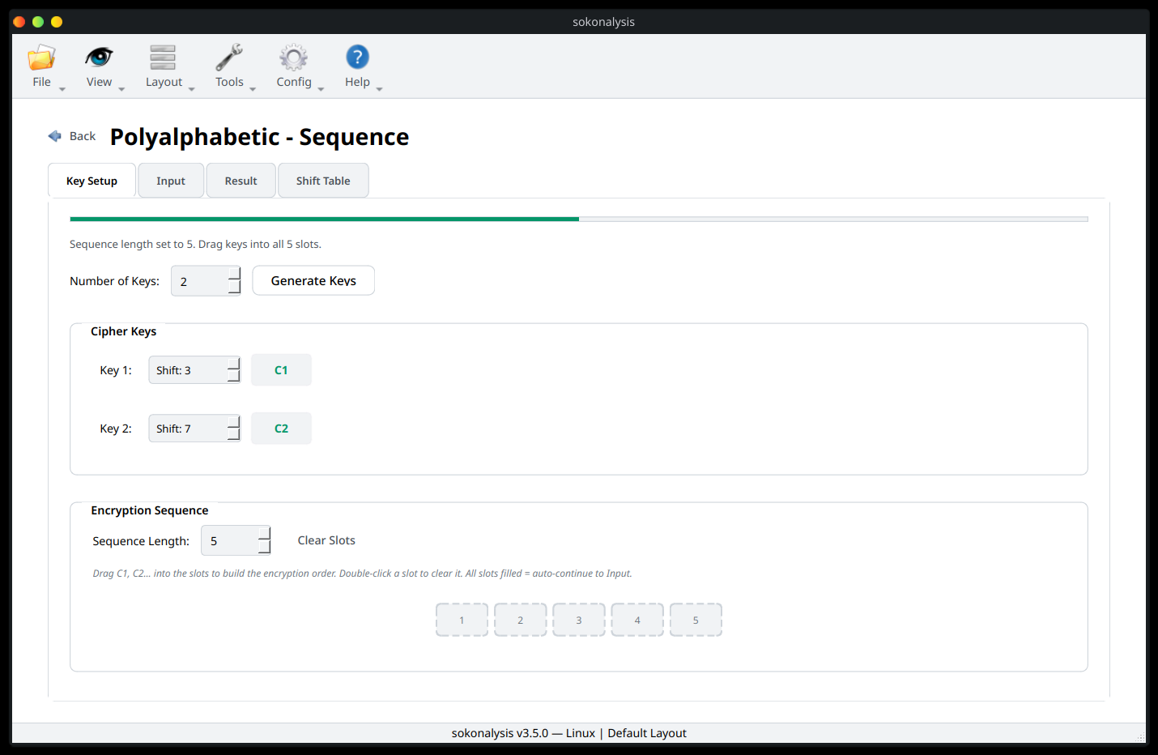
Now drag and drop the sequence in the empty slots, and it will automatically take you to the Input field.

Now enter the text you want to encrypt
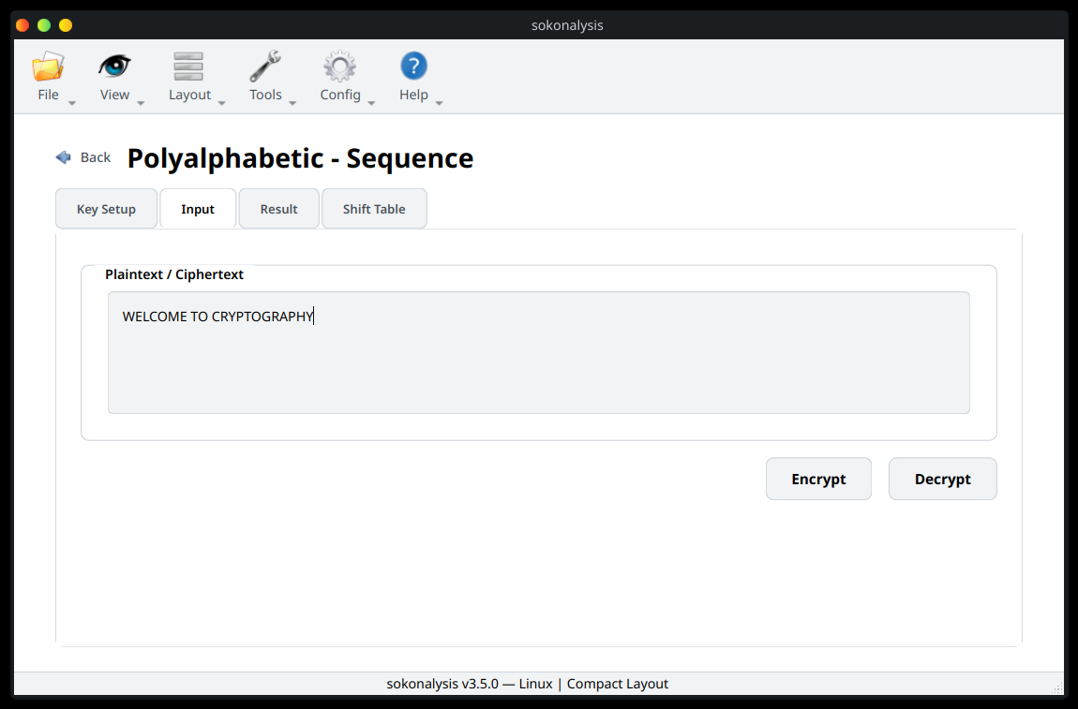

Press the Encrypt button and check the Results
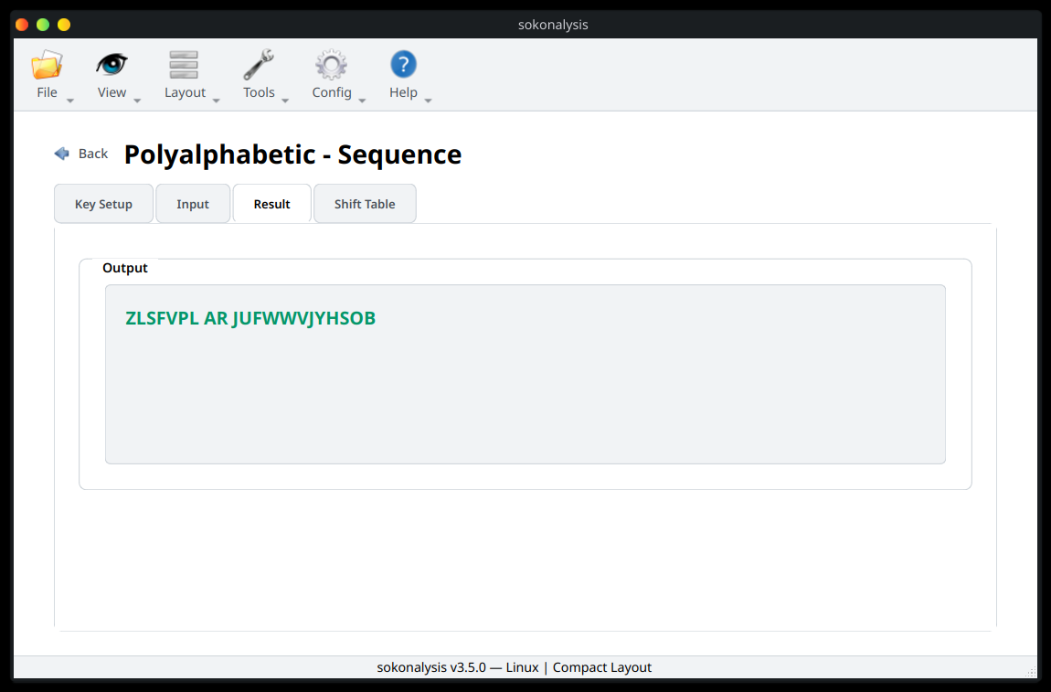

The Shift Table demonstrates exactly how the plain text has been encrypted
