Prediction of Settlement of Embankment in Soft Soil Using Conventional and Elastoplastic Method

B.Sc. Engineering THESIS
BY

Khondoker Istiak Ahmad Ayon
Masnun Abrar
Tanjib Islam Nasif
Istiaq Ahmed

ISLAMIC UNIVERSITY OF TECHNOLOGY (IUT)
2018

Prediction of Settlement of Embankment in Soft Soil Using Conventional and Elastoplastic Method

Khondoker Istiak Ahmad Ayon (145405)
Masnun Abrar (145406)
MD. Tanjib Islam (145415)
Istiaq Ahmed (145438)

A THESIS SUBMITTED
FOR THE DEGREE OF BACHELOR OF SCIENCE IN
CIVIL ENGINEERING

DEPARTMENT OF CIVIL AND ENVIRONMENTAL ENGINEERING
ISLAMIC UNIVERSITY OF TECHNOLOGY (IUT)
2018
PROJECT REPORT APPROVAL
The thesis titled “Prediction of Settlement of Embankment in Soft Soil
-Using Conventional and Elastoplastic Method” submitted by
Khondoker Istiak Ahmad Ayon, Masnun Abrar, MD.Tanjib Islam, Istiaq Ahmed, Std. No. 145405,145406,145415,145438 has been found as satisfactory and accepted as partial fulfillment of the requirement for the Degree Bachelor of Science in Civil Engineering.

SUPERVISOR
Dr. Hossain MD. Shahin
Professor
Department of Civil and Environment Engineering (CEE)
Islamic University of Technology (IUT)
Board Bazar, Gazipur, Bangladesh
DECLARATION OF CANDIDATE
We hereby declare that the undergraduate research work reported in this thesis has been performed by us under the supervision of Professor Dr. Hossain MD. Shahin and this work has not been submitted elsewhere for any purpose (except for publication).

Khondoker Istiak Ahmad Ayon
Student No: 145405
Year: 2017-2018
Department of Civil and Environment Engineering (CEE)
Islamic University of Technology (IUT), OIC
Board Bazar, Gazipur, Bangladesh
Masnun Abrar
Student No: 145406
Year: 2017-2018
Department of Civil and Environment Engineering (CEE)
Islamic University of Technology (IUT), OIC
Board Bazar, Gazipur, Bangladesh
MD.Tanjib Islam
Student No: 145415
Year: 2017-2018
Department of Civil and Environment Engineering (CEE)
Islamic University of Technology (IUT), OIC
Board Bazar, Gazipur, Bangladesh
Istiaq Ahmed
Student No: 145438
Year: 2017-2018
Department of Civil and Environment Engineering (CEE)
Islamic University of Technology (IUT), OIC
Board Bazar, Gazipur, Bangladesh

DEDICATION
We dedicate our thesis work to our family. A special feeling of gratitude to our loving parents.
We also dedicate this thesis to our many friends who have supported us throughout the process. We will always appreciate all they have done.
ACKNOWLEDGEMENTS
ACKNOWLEDGEMENTS
"In the name of Allah, Most Gracious, Most Merciful"
All the praises to Allah (SWT) for giving us the opportunity to complete this book.
We wish to express our sincere gratitude to Professor Dr. Hossain MD. Shahin for providing us with all the necessary facilities, giving undivided attention and fostering us all the way through the research. His useful comments, remarks and engagement helped us with the learning process throughout the thesis. We are also grateful to Wasif Jitu, lecturer, Presidency University and Sultan Al Shafian , Junior Engineer, Karnafuli Tunel project (1st Bangladeshi engineer to recruit).
We want to wish our heartiest gratitude and thanks to ‘MR. Saeed and ‘KDA’ for their helping hand to us for performing field level soil investigation and collection soil sample from different depths in soil layers from selected places. We would like express gratitude to all of the departmental faculty members for their help and support. We are also grateful to our parents for their encouragement, support and attention and for being ravished patrons.
We also place on record, our sense of gratitude to one and all, who directly or indirectly, have contributed to this venture.
TABLE OF CONTENTS

ACKNOWLEDGEMENT ...……………………………………………………..…...……….V
TABLE OF CONTENTS …………………………………………………………........…….VI
ABSTRACT ……………………………………………………………………………...…VIII
LIST OF SYMBOLS …….………………………………………………………………..….IX
LIST OF FIGURES ……….………………………………………………………………..…X
LIST OF TABLES ………….……………………………………………………………..…XI
CHAPTER 1 INTRODUCTION ……………………………………………….1
1.1 General ……………………………………………………………………………………………......1
1.2 Objectives of the Study ………………………………..……………………………………………...2
1.3 Scope of the Study …………………………………..………………………………………………..2
CHAPTER 2 LITERATURE REVIEW ……………………………………….3
2.1 General ………………………………………………………………………………………3
2.2 Summary …………………………………………………………………………………….4
CHAPTER 3 METHODOLOGY ………………………………………………5
3.1 General ………………………………………………………………………………………5
3.2 Study area …………………………………………………………………………………....5
3.3 Material collection …………………………………………………………………………...6
3.4 Laboratory experiments ……………………………………………………………………...8
3.4.1 Specific Gravity of Soil ……………………………………………………………………8
3.4.2 Grain Size Analysis ………………………………………………………………………10
3.4.3 Atterberg limit of soil ……………………………………………………………………………...13
3.4.3.1 Determination of liquid limit (LL) ……………………………………………………...14
3.4.3.2 Determination of plastic limit (PL) ……………………………………………………..15
3.4.3.3 Determination of plasticity Index (PI) …………………………………………………..15
3.4.4 Consolidation test of soil ………………………………………………………………….17
3.4.5 Hydrometer Test …………………………………………………………………………..26
3.5 Conclusion …………………………………………………………………………………..32
CHAPTER 4 Soil Characteristics at the Study Locations ……………………33
CHAPTER 5 Results and Discussions …………………………………………34
5.1 General ………………………………………………………………………………………34
5.2 Subloading t_{ij} Model (Finite Element Method) ……………………………………………..34
5.3 Conventional Method ……………………………………………………………………….51
5.4 Results ………………………………………………………………………………………52

CHAPTER 6 CONCLUSION ………………………………………………….53
6.1 Reviews on Completed Research Work …………………………………………………….53
6.2 Future Research ……………………………………………………………………………..53
REFERENCES ………………………………………………………………….54

ABSTRACT

Keywords: Embankment, Settlement, Soft Soil, Elastoplastic method, Finite Element method, Sub-loading tij model, Soil parameters

Settlement Analysis and calculation is a paramount concern for any geotechnical engineer. The prediction of embankment settlement is a critically important issue for the serviceability of subgrade projects. To ensure the design grade of embankment, we have to calculate settlement specially differential settlement. Our thesis research is about the prediction of embankment settlement in soft type of soil and comparison between subloading tij model and conventional method.
For this reason, we have selected the southern part of Bangladesh, Particularly, Khulna region. We have collected our soil sample from just one site – Sheikh Abu Naser Specialized Hospital area. We have collected soil sample from 3 different depths(6’,12’,18’) .From FEM t_{ij} model , we have calculated the settlement value=0.62 m and from conventional method the settlement value= 0.86 m. These two values are quite identical. So, our research is quite satisfying in this manner.
For proper modeling of any soil. In this research, subsoil characteristics of study locations are presented based on field and laboratory test results. Elasto-plastic constitutive model parameters of study locations soil has been determined for extended sub-loading tij model. Using these parameters, settlement of embankment in soft soil has been estimated. Considering the effect of settlement in 1D Finite Element analysis has been conducted. It is found that settlement determined by the conventional methods match well with the results of the numerical simulations.

LIST OF SYMBOLS
Cc – (Compression index)
Cs – (Swelling index)
eo – (Initial void ratio)
LL - (Liquid limit)
PL – (Plastic limit)
PI – (Plasticity index)
Wn – (Natural water content)
Gs – (Specific gravity)
GT – (Specific gravity at T₀ ⁰C)
∆℮ - (Variation of void ratio)
∆logσ’ - (Variation of effective stress)
Ws – (Weight of dry soil)
V – (Volume of soil sample)
Pc – (Preconsolidation pressure
σ – (Stress)
€ - (Strain)
λ – (Compression index for FEM tij simulation)
Ќ - (Swelling index for FEM tij simulation)
av – (Co-efficient of compressibility)
Mv – (Co-efficient of volume compressibility)
Cv – (Co-efficient of consolidation)

LIST OF FIGURES
Figure 3.1 Study area near Sheikh Abu Naser Specialized Hospital ……………………………..5 Figure 3.2 Shelby Tubes ………………………………………………………………………….6 Figure 3.3 Soil sample collection from site and collected undisturbed sample in Shelby tube ….7 Figure 3.4 Laboratory test of determination of Specific gravity of soil ………………………….8 Figure 3.5 Determination of Atterberg Limit of Soil ……………………………………………13 Figure 3.6 Consolidation Test …………………………………………………………………...19 Figure 3.7 Hydrometer Analysis ………………………………………………………………...29 Figure 3.8 Bore log chart collected from KDA …………………………………………………33
LIST OF TABLES
Table 3.1 Specific gravity value of soil sample …………………………………………………..9
Table 3.2.1 Sieve analysis data (6’ soil sample) ………………………………………………...11
Table 3.2.2 Sieve analysis data (12’ soil sample) ……………………………………………….12
Table 3.3.1 Atterberg limit test (6’ Soil Sample) ………………………………………………..16
Table 3.3.2 Atterberg limit test (18’ Soil Sample) ………………………………………………16
Table 3.4.1 Consolidation Test (6’ sample) ……………………………………………………..20
Table 3.4.2 Consolidation Test (12’ sample) ……………………………………………………22
Table 3.4.3 Consolidation Test (18’ sample) ……………………………………………………24
Table 3.5.1 Hydrometer Analysis (6’ Soil Sample) ……………………………………………..30
Table 3.5.2 Hydrometer Analysis (12’ Soil Sample) ……………………………………………31
Table 3.6 Soil parameters from laboratory tests ………………………………………………...32

Chapter 1: Introduction
1.1 General
In geotechnical engineering, settlement is defined as the vertical movement of the ground, generally caused by changes in stresses within the earth. Settlements most likely to occur when increased vertical stresses are applied to the ground on or above soft or loose soil strata.
Differential settlement occurs when the soil beneath the structure expands, contracts or shifts away. This can be caused by drought conditions, the root systems of maturing trees, flooding, poor drainage, frost, broken water lines, vibrations from nearby construction or poorly compacted fill soil. The prediction of embankment settlement is a critically important issue for the serviceability of subgrade projects, especially the post-construction settlement. A number of methods have been proposed to predict embankment settlement; however, all of these methods are based on a parameter, i.e. the initial time point. The difference of the initial time point determined by different designers can definitely induce errors in prediction of embankment settlement.
The purpose of laboratory test in geotechnical engineering is to find out the soil parameters which will be used to performing analyses of settlement calculation of embankment. The laboratory tests included soil classification, unit weight, and most importantly consolidation. Sometimes it is not possible to determine all the parameters of soil due to different problems. But there are empirical equations established. From these equations if we know the value of one parameter, we can determine others.
Our thesis research is about the prediction of the embankment settlement in soft type of soil and comparison between Subloading t_{ij} model and Conventional method. For this reason we have selected the southern part of Bangladesh, particularly Khulna region. We have collected our soil sample from just one site- Sheikh Abu Naser Specialized Hospital area. We have collected soil sample from 3 different depths (6’, 12’ and 18’). After collecting the soil sample, we performed the laboratory tests to obtain the soil parameters data. By using these data in both our conventional method calculation and software based analysis, we found that the predicted value of embankment settlement almost nearly matches. In that sense, we can say that our analysis through the FEM analysis can be declared to accurate as it matched with conventional method calculation value.
The phenomenon of predicting settlement is related to many civil engineering structures as it is becoming more common and frequent to construct structures on soft soils. However, accurate prediction of embankment’s settlement is particularly difficult concerning complicated consolidation process and water-soil interaction. Finally, we can depend more on the settlement value obtained from the software based analysis because it is more accurate as it takes into consideration of the terms like soil-water interaction, coupling etc.

  - Objectives of the study
1. Predicting embankment settlement for soft clay by FEM analysis (Subloading t_{ij} model)
2. Analyzing settlement using conventional method
3. Comparison between the results from FEM analysis (Subloading t_{ij} model) and conventional method.

1.3 Scope of the study
1. The calculated/predicted value of settlement can help us in designing the appropriate foundation type for soft type of soil.
2. The subgrade structures like embankment’s design and construction can be highly affected in economic aspects if we can predict the accurate value of settlement.
3. In this study we calculate the settlement rate, for reducing the settlement time, we can also consider which technology should be adopted for this region like PVD, geo-textile, geo-fiber and other modern technologies.
4. We can also incorporate salinity effect which can affect our result.

Chapter 2: Literature Review
2.1 General
Literature review has been done to identify the so far studies related to this field.

Different types of analysis for settlement of embankment have been conducted-
Balasubramaniam et al. conducted some analysis on embankment settlement, basically giving priority on highway embankment. The fundamentals of preloading techniques with and without PVD (Pre-fabricated Vertical Drains) as ground improvement measures are also included.
Chunlin Li et al. conducted some analysis for prediction of embankment settlement in clays. This paper proposed a concept named “Potential Settlement” and a simplified method based on in-situ data. Finally, an example was used to demonstrate the advantage of proposed method by comparing with other methods.
Jia Xie et al. conducted some analysis about long-term performance prediction of road embankment on estuarine deposits. In this paper, a case study was carried out to back analyze the long term settlement of road embankment. Following the back calculation of the key consolidation parameters by curve fitting method, the post construction settlement were re-assessed by numerical analysis.
Ir.Tan Yean Chin et al. conducted some analysis on embankment over soft clay. Basically, in this paper presents a set of guidelines for the design and selection of construction methods for embankment taking into considerations of safety, direct/indirect cost, settlement and other benefits.
Surachat Sambhandharaksa et. al conducted their research based on Terzaghi and Peck(1948) and POULOS and Davis(1980)’s method. The Poulos method is not very successful for cases where pile tips are in clays.The Terzaghi estimation should include sand settlement yielding conservative result.
N. Loganathan et. al conducted their research by using a new methodology termed ‘Field Deformation Analysis(FDA)’ which is based on simple concept dealing with lateral and vertical deformation characteristics of soft foundation under embankment stage loading.

2.2 Summary
From different research paper review we have come to know that the settlement calculation for embankment have been conducted in different countries, but for Bangladesh in soft type of soil no such research has been conducted yet, also software based calculation/ prediction has been rarely found in this particular field. And in embankment’s settlement estimation sub-loading t_{ij} model for FEM analysis is very much convenient and gives more accurate result than conventional method calculation.

Chapter 3: Methodology
3.1 General
As the study has a wide insight on a variety of aspects, different methods were adopted in order to achieve the objective of this study properly. And by implementing these methods, a direct approach has been set out to fulfill the scope of the study. In this chapter, the methods adopted and implemented are discussed thoroughly.
3.2 Study Area
Our research is about the prediction of settlement of embankment in soft soil. For this purpose, we have selected Khulna region which is situated at the southern part of Bangladesh. We have collected our soil sample from just one site- Sheikh Abu Naser Specialized Hospital area (figure 3.1). We have collected soil sample from 3 different depths (6’, 12’ and 18’). All these locations are shown in figure 3.1. In this study, the physical and geotechnical properties are carried out with the help of field observations and different laboratory tests.

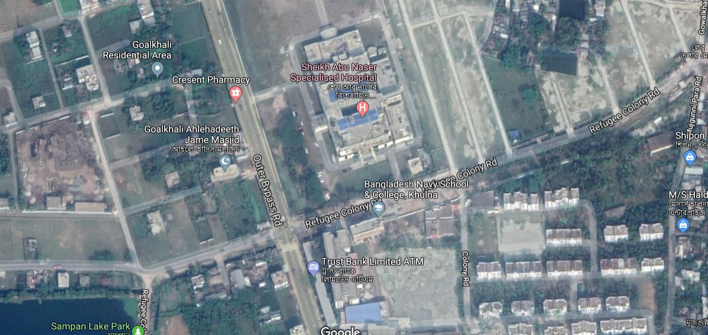

Figure 3.1 Study area near Sheikh Abu Naser Specialized Hospital
3.3 Material Collection
Soil samples are collected as boring sample using Shelby tubes. It is thin-walled open-tube samplers are designed for taking samples in soft and firm cohesive soils. These samplers have a much lower area ratio (approximately 10%) than U100 samplers and therefore give less disturbed samples. However, some disturbance is caused due to friction of the sample on the inside of the sample tube. Each tube has one end that is chamfered to form a cutting edge and the upper end includes holes for securing the tube to a drive head. Shelby tubes are useful for collecting soils that are particularly sensitive to sampling disturbance, including fine cohesive soils and clays.
The tubes can also be used to transport samples back to the lab as well.

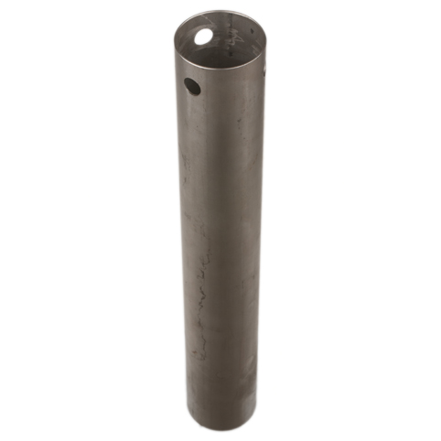

Figure 3.2. Shelby Tubes

So, the samples were undisturbed. The length of the each tube was 450 mm. We have collected samples from different depths of earth i.e. 6ft, 12ft, 18ft below from the earth surface. These samples are then tested in laboratory by different experimental procedures.

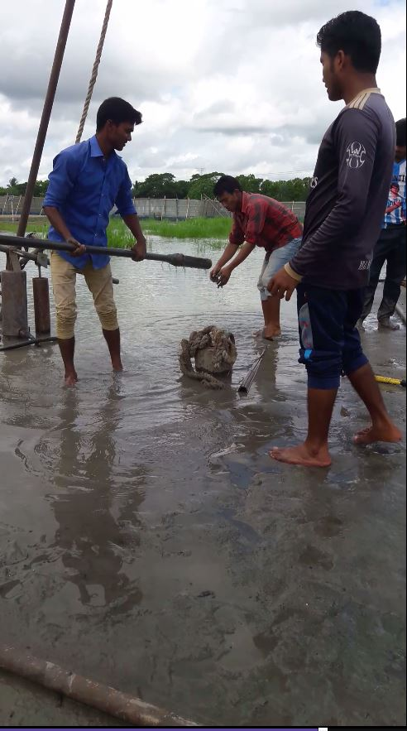

Figure 3.3 Soil sample collection from site and collected undisturbed sample in Shelby tube

3.4 Laboratory Experiments
We have performed several laboratory tests in the laboratory to determine various soil parameters. The tests we have performed are described briefly here.

3.4.1 Specific Gravity of Soil
Specific gravity (Gs) is defined as the ratio of the weight of an equal volume of distilled water at that temperature both weights taken in air. We have determined specific gravity of soil. We have followed procedure described below:
- First we had cleaned and dried pycnometer. Then we had taken water into the pycnometer up to the mark and taken weight W₁.
- Then we had put the water out and taken 50 gm of oven dried soil in the pycnometer and took some water into it.
- Then we took the pycnometer and submerged it into boiling water and stirred it for 10 minutes. After 10 minutes we pulled the pycnometer out of water and kept it in rest to get cool down.
- After that we filled the pycnometer up to mark with water and taken weight W₂. We have determined the water temperature and from chart we got specific gravity of water at that temperature.
- Then from these value we calculated specific gravity three times and taken the average value.
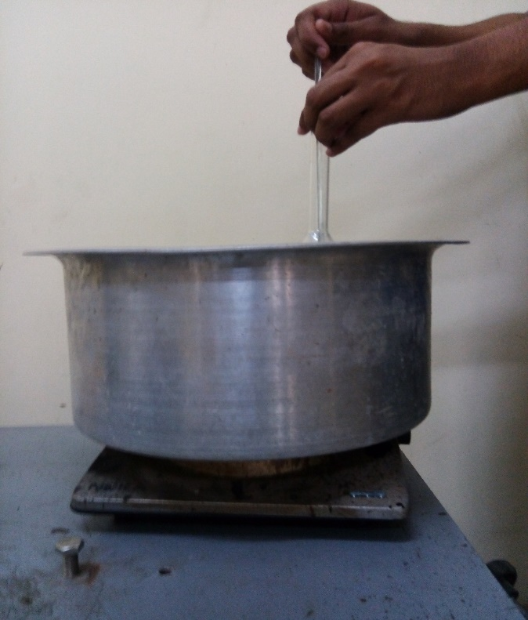
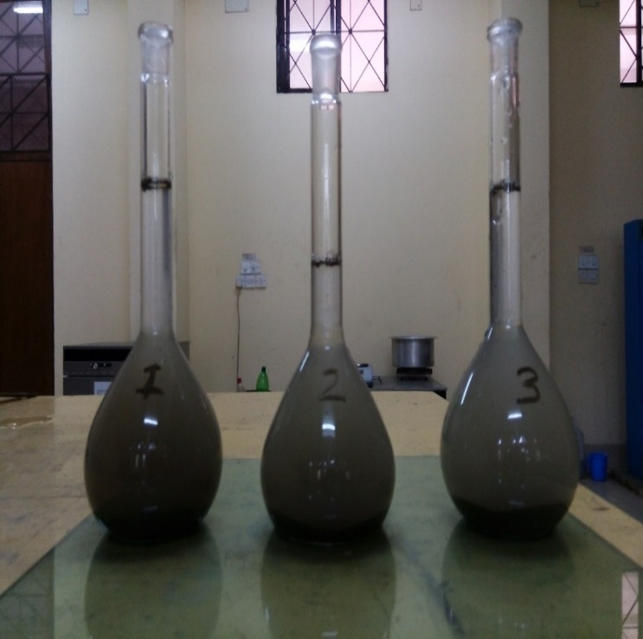

Figure 3.4 Laboratory test of determination of Specific gravity of soil.
We have measured specific gravity (Gs) of soil samples (Table 3.2), to calculate the soil properties like Void Ratio (e₀), Degree of Saturation etc. Data we collected during the test:

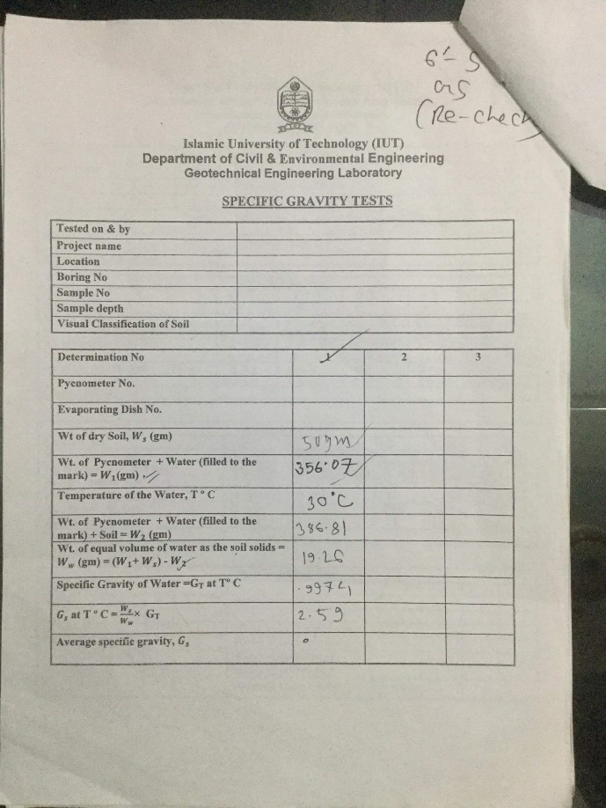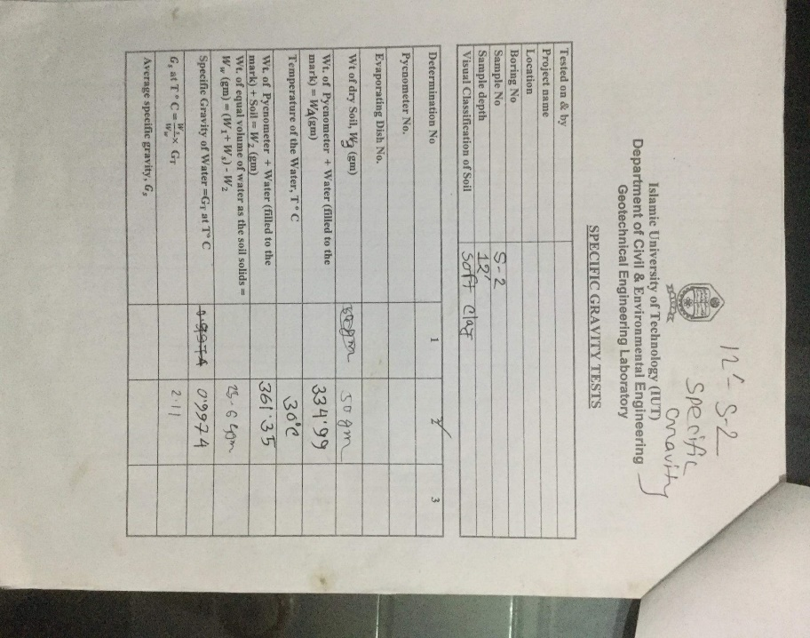

Table 3.1 Specific gravity value of soil sample

3.4.2 Grain Size Analysis
In order to classify a soil for engineering purposes, one needs to know the distribution of the size of grains in a given soil mass. Sieve analysis is a method used to deter mine the grain size distribution of soils. The method of sieve analysis described here is applicable for soils that are mostly granular with some or no fines. Sieve analysis does not provide information as to shape of particles.

We have followed procedure described below:
- Collect a representative oven dry soil sample. Samples having largest particles of the size of No. 4 sieve openings (4.75 mm) should be about 500 grams. For soils having largest particles of size greater than 4.75 mm, larger weights are needed.

- Break the soil sample into individual particles using a mortar and a rubber-tipped pestle. (Note: The idea is to break up the soil into individual particles, not to break the particles themselves.)

- Determine the mass of the sample accurately to 0.1 g CW).

- Prepare a stack of sieves. A sieve with larger openings is placed above a sieve with smaller openings. The sieve at the bottom should be No. 200. A bottom pan should be placed under sieve No. 200. As mentioned before, the sieves that are generally used in a stack are Nos.4, 10, 20, 40, 60, 140, and 200; however, more sieves can be placed in between.

- Pour the soil prepared in Step 2 into the stack of sieves from the top.

- Place the cover on the top of the stack of sieves.

- Run the stack of sieves through a sieve shaker for about 10 to 15 minutes.

- Stop the sieve shaker and remove the stack of sieves.

- Weigh the amount of soil retained on each sieve and the bottom pan.

- If a considerable amount of soil with silty and clayey fractions is retained on the No. 200 sieve, it has to be washed. Washing is done by taking the No. 200 sieve with the soil retained on it and pouring water through the sieve from a tap in the laboratory

Table 3.2.1 Sieve analysis data ( 6’ soil sample )

Table 3.2.2 Sieve analysis data ( 12’ soil sample )
3.4.3 Atterberg Limit of Soil
Liquid Limit is the minimum water content at which the soil is still in the liquid state, but has a small shearing strength against flow. The water content at which a soil will just begin to crumble when rolled into a thread approximately 1/8" (3 mm) in diameter. Plasticity index is the difference in moisture content of soils between the liquid and plastic limits expressed in percentage.
We have done Atterberg limit test to calculate Liquid Limit (LL) and Plastic Limit (PL) and Plasticity Index (PI) of the soil samples.

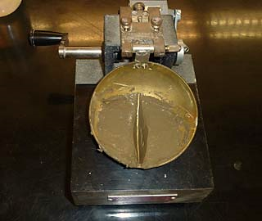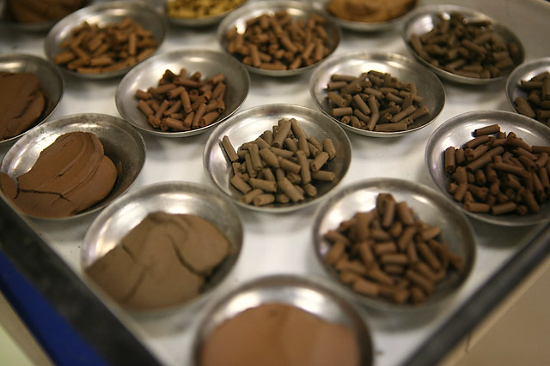

Figure 3.5 Determination of Atterberg Limit of Soil

3.4.3.1 Determination of Liquid limit (LL)
The procedure of determining liquid limit of soil:
- Place a portion of the paste in the cup of the liquid limit device.

- Level the mix so as to have a maximum depth of 1cm.

- Draw the grooving tool through the sample along the symmetrical axis of the cup, holding the tool perpendicular to the cup.

- For normal fine grained soil: The Casagrande tool is used to cut a groove 2mm wide at the bottom, 11mm wide at the top and 8mm deep.

- For sandy soil: The ASTM tool is used to cut a groove 2mm wide at the bottom, 13.6mm wide at the top and 10mm deep.

- After the soil pat has been cut by a proper grooving tool, the handle is rotated at the rate of about 2 revolutions per second and the no. of blows counted, till the two parts of the soil sample come into contact for about 10mm length.

- Take about 10g of soil near the closed groove and determine its water content.

- The soil of the cup is transferred to the dish containing the soil paste and mixed thoroughly after adding a little more water. Repeat the test.

- By altering the water content of the soil and repeating the foregoing operations, obtain at least 5 readings in the range of 15 to 35 blows. Don’t mix dry soil to change its consistency.

- Liquid limit is determined by plotting a ‘flow curve’ on a semi-log graph, with no. of blows as abscissa (log scale) and the water content as ordinate. Then after plotting we have determined the water content at 25 blow. That is the liquid limit (LL).

3.4.3.2 Determination of Plastic limit (PL)
The procedure of determination of plastic limit of soil:
- Take about 8g of the soil and roll it with fingers on a glass plate. The rate of rolling should be between 80 to 90 strokes per minute to form a 3mm dia.

- If the dia. of the threads can be reduced to less than 3mm, without any cracks appearing, it means that the water content is more than its plastic limit. Knead the soil to reduce the water content and roll it into a thread again.

- Repeat the process of alternate rolling and kneading until the thread crumbles.

- Collect and keep the pieces of crumbled soil thread in the container used to determine the moisture content.

- Repeat the process at least twice more with fresh samples of plastic soil each time.

3.4.3.3 Determination of Plasticity Index (PI)

Plasticity index is the difference in moisture content of soils between the liquid and plastic limits expressed in percentage.
Plasticity index PI = LL-PL

Table 3.3.1 Atterberg limit test (6’ Soil Sample)

Table 3.3.2 Atterberg limit test (18’ Soil Sample)

3.4.4 Consolidation Test of Soil
A test in which an undisturbed sample of clay measuring 6 cm in diameter and 2 cm thick is confined laterally in a metal ring and compressed between two porous plates that are kept saturated with water. A load is applied and the clay consolidates, the excess pore water escaping through the porous stones. After each increment of load is applied, it is allowed to remain on the sample until equilibrium is established, and a consolidation curve showing the deformation with time is obtained for each increment.
For performing consolidation test of soil we have done Oedometer test (Figure 3.11) of soil sample which measures soil’s consolidation properties i.e. Compression Index (Cc) and Void Ratio (e₀). Oedometer tests are performed by applying different loads to a soil sample and measuring the deformation response. The results from these tests are used to predict how a soil in the field will deform in response to a change in effective stress.
Oedometer Test Procedure:
- Clean and dry the metal ring. Measure its diameter and height. Take the mass of the empty ring.
- Press the ring into the soil sample contained in a large container at the desired density and water content. The ring is to be pressed with hands.
- Remove the soil around the ring. The soil specimen should project about 10mm on either side of the ring. Any voids in the specimen due to the removal of large size particles should be filled back by pressing the soil lightly.

- Trim the specimen flush with the top and bottom of the ring.

- Remove any soil particles sticking to the outside of the ring. Weigh the ring with the specimen.
- Take a small quantity of the soil removed during trimming for the water content determination.

- Saturate the porous stones by boiling them in distilled water for about 15min.
- Assemble the Consolidometer. Place the bottom porous stone, bottom filter paper, specimen, top filter paper and the top porous stone, one by one.
- Position the loading block centrally on the top porous stone. Mount the assembly on the loading frame. Centre it such that the load applied is axial. In the case of the lever loading system, counterbalance the system.
- Set the dial gauge in position. Allow sufficient margin for the swelling of the soil.

- Connect the mold assembly to the water reservoir having the water level at about the same as the soil specimen. Allow the water to flow into the specimen till it is fully saturated.

- Take the initial reading of the dial gauge.

- Apply an initial setting load to give a pressure of 2kg to the assembly so that there is no swelling. Allow the setting load to stand till there is no change in the dial gauge reading or for 24 hours.

- Take the final gauge reading under the initial setting load.

- Apply the first load increment to apply a pressure of 4kg, and start the stop watch.

- Record the dial gauge readings at 0.05, 0.1, 0.25, 0.5, 1, 2, 4, 8, 15, 30, 60minutes.

- Increase the load to apply a pressure of 8kg and repeat the step (15). Likewise increase the load to apply a pressure of 16, 32 or upto the desired pressure.

- After the last load increment had been applied and the readings taken, decrease the load to 1/4 of the last load and allow it to stand for 24 hours. Take the dial gauge reading after 24 hours. Further reduce the load to 1/4 of the previous load and repeat the above procedure. Likewise, further reduce the load to 1/4 previous and repeat the procedure.

- Finally reduce the load to the initial setting load and keep it for 24 hours and take the final dial gauge reading.

- Dismantle the assembly. Take out the ring with the specimen. Wipe out the excess surface water using a blotting paper.

- Take the mass of the ring with the specimen.

- Dry the specimen in the oven for 24 hours and determine the dry mass of specimen.

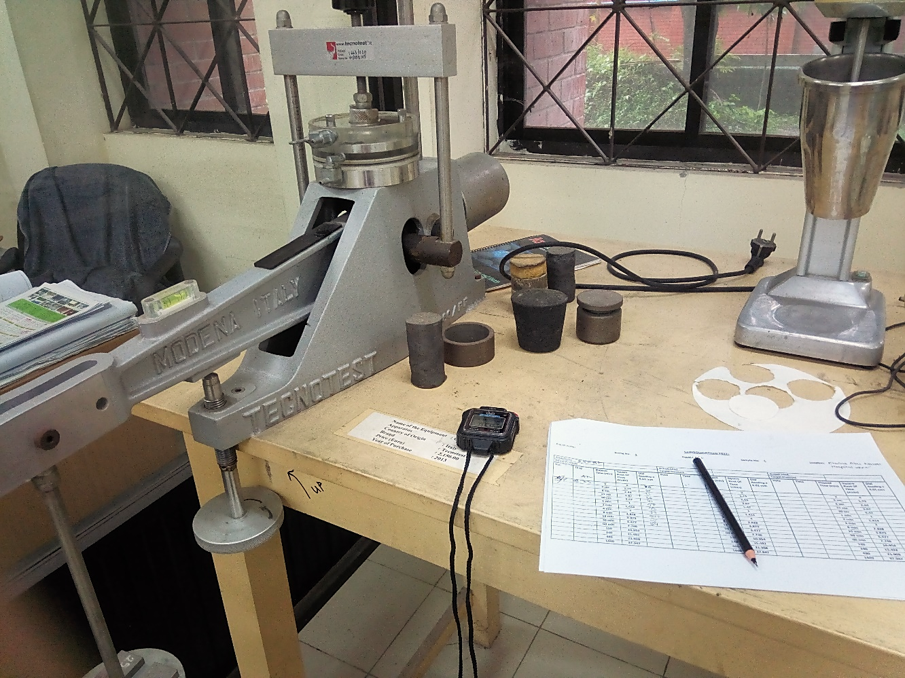

Figure 3.6 Consolidation Test

Table 3.4.1 Consolidation Test (6’ sample)

Table 3.4.2 Consolidation Test (12’ sample)

Table 3.4.3 Consolidation Test (18’ sample)

3.4.5 Hydrometer Test
In geotechnical engineering, hydrometer test is primarily used to know the grain size distribution of a fine grained soil. In case of fine grained soil, sieve analysis test does not give reliable test result. This because a fine grained soil consist of different sizes of particles starting from 0.075 mm to 0.0002 mm. and it is not practicable to design sieve having so smaller screen size. Also there is a chance of loss of sample during sieving. Therefore hydrometer analysis is done for grain size analysis of fine grained soils.

Procedure of Hydrometer Test

Part – 1: Calibration of Hydrometer

- Take about 800ml of water in one measuring cylinder. Place the cylinder on a table and observe the initial reading.
- Immerse the hydrometer in the cylinder. Take the reading after the immersion.
- Determine the volume of the hydrometer (V_{H}) which is equal to the difference between the final and initial readings. Alternatively weigh the hydrometer to the nearest 0.1g. The volume of the hydrometer in ml is approximately equal to its mass in grams.
- Determine the area of cross section (A) of the cylinder. It is equal to the volume indicated between any two graduations divided by the distance between them. The distance is measured with an accurate scale.
- Measure the distance (H) between the neck and the bottom of the bulb. Record it as the height of the bulb (h).
- Measure the distance (H) between the necks to each marks on the hydrometer (R_{h}).
- Determine the effective depth (H_{e}), corresponding to each of the mark (R_{h}) as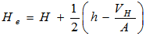
[Note: The factor V_{H}/A should not be considered when the hydrometer is not taken out when taking readings after the start of the sedimentation at ½, 1, 2, and 4 minutes.]
8. Draw a calibration curve between H_{e} and R_{h}. Alternatively, prepare a table between H_{e} and R_{h}. The curve may be used for finding the effective depth H_{e} corresponding to reading R_{h}.

Part – 2: Meniscus Correction

- Insert the hydrometer in the measuring cylinder containing about 700ml of water.
- Take the readings of the hydrometer at the top and at the bottom of the meniscus.
- Determine the meniscus correction, which is equal to the difference between the two readings.
- The meniscus correction C_{m} is positive and is constant for the hydrometer.
- The observed hydrometer reading R_{h}’ is corrected to obtain the corrected hydrometer reading R_{h} as

Part – 3: Pretreatment and Dispersion

- Weigh accurately, to the nearest 0.01g about 50g air-dried soil sample passing 2mm IS sieve, obtained by riffling from the air-dried sample passing 4.75mm IS sieve. Place the sample in a wide mouthed conical flask.
- Add about 150ml of hydrogen peroxide to the soil sample in the flask. Stir it gently with a glass rod for a few minutes.
- Cover the flask with a glass plate and leave it to stand overnight.
- Heat the mixture in the conical flask gently after keeping it in an evaporating dish. Stir the contents periodically. When vigorous frothing subsides, the reaction is complete. Reduce the volume to 50ml by boiling. Stop heating and cool the contents.
- If the soil contains insoluble calcium compounds, add about 50ml of hydrochloric acid to the cooled mixture. Stir the solution with a glass rod for a few minutes. Allow it to stand for one hour or so. The solution would have an acid reaction to litmus when the treatment is complete.
- Filter the mixture and wash it with warm water until the filtrate shows no acid reaction.
- Transfer the damp soil on the filter and funnel to an evaporating dish using a jet of distilled water. Use the minimum quantity of distilled water.
- Place the evaporating dish and its contents in an oven and dry it at 105 to 110 degree C. Transfer the dish to a desiccator and allow it to cool.
- Take the mass of the oven dried soil after pretreatment and find the loss of mass due to pretreatment.
- Add 100ml of sodium hexa-metaphosphate solution to the oven – dried soil in the evaporating dish after pretreatment.
- Warm the mixture gently for about 10minutes.
- Transfer the mixture to the cup of a mechanical mixture. Use a jet of distilled water to wash all traces of the soil out of the evaporating dish. Use about 150ml of water. Stir the mixture for about 15minutes.
- Transfer the soil suspension to a 75 µ IS sieve placed on a receiver (pan). Wash the soil on this sieve using a jet of distilled water. Use about 500ml of water.
- Transfer the soil suspension passing 75 µ sieve to a 1000ml measuring cylinder. Add more water to make the volume exactly equal to 1000ml.
- Collect the material retained on 75 µ sieve. Dry it in an oven. Determine its mass. If required, do the sieve analysis of this fraction.

Part – 4: Sedimentation Test

- Place the rubber bung on the open end of the measuring cylinder containing the soil suspension. Shake it vigorously end-over-end to mix the suspension thoroughly.
- Remove the bung after the shaking is complete. Place the measuring cylinder on the table and start the stop watch.
- Immerse the hydrometer gently to a depth slightly below the floating depth, and then allow it to float freely.
- Take hydrometer reading (R_{h}’) after 1/2, 1, 2 and 4 minutes without removing the hydrometer from the cylinder.
- Take out the hydrometer from the cylinder, rinse it with distilled water.
- Float the hydrometer in another cylinder containing only distilled water at the same temperature as that of the test cylinder.
- Take out the hydrometer from the distilled water cylinder and clean its stem. Insert it in the cylinder containing suspension to take the reading at the total elapsed time interval of 8minutes. About 10 seconds should be taken while taking the reading. Remove the hydrometer, rinse it and place it in the distilled water after reading.
- Repeat the step (7) to take readings at 15, 30, 60, 120 and 240minutes elapsed time interval.
- After 240 minutes (4 hours) reading, take readings twice within 24 hours. Exact time of reading should be noted.
- Record the temperature of the suspension once during the first 15minutes and thereafter at the time of every subsequent reading.
- After the final reading, pour the suspension in an evaporating dish, dry it in an oven and find its dry mass.
- Determine the composite correction before the start of the test and also at 30min, 1, 2 and 4 hours. Thereafter just after each reading, composite correction is determined.
- For the determination of composite correction (C), insert the hydrometer in the comparison cylinder containing 100ml of dispersing agent solution in 1000 ml of distilled water at the same temperature. Take the reading corresponding to the top of meniscus. The negative of the reading is the composite correction.

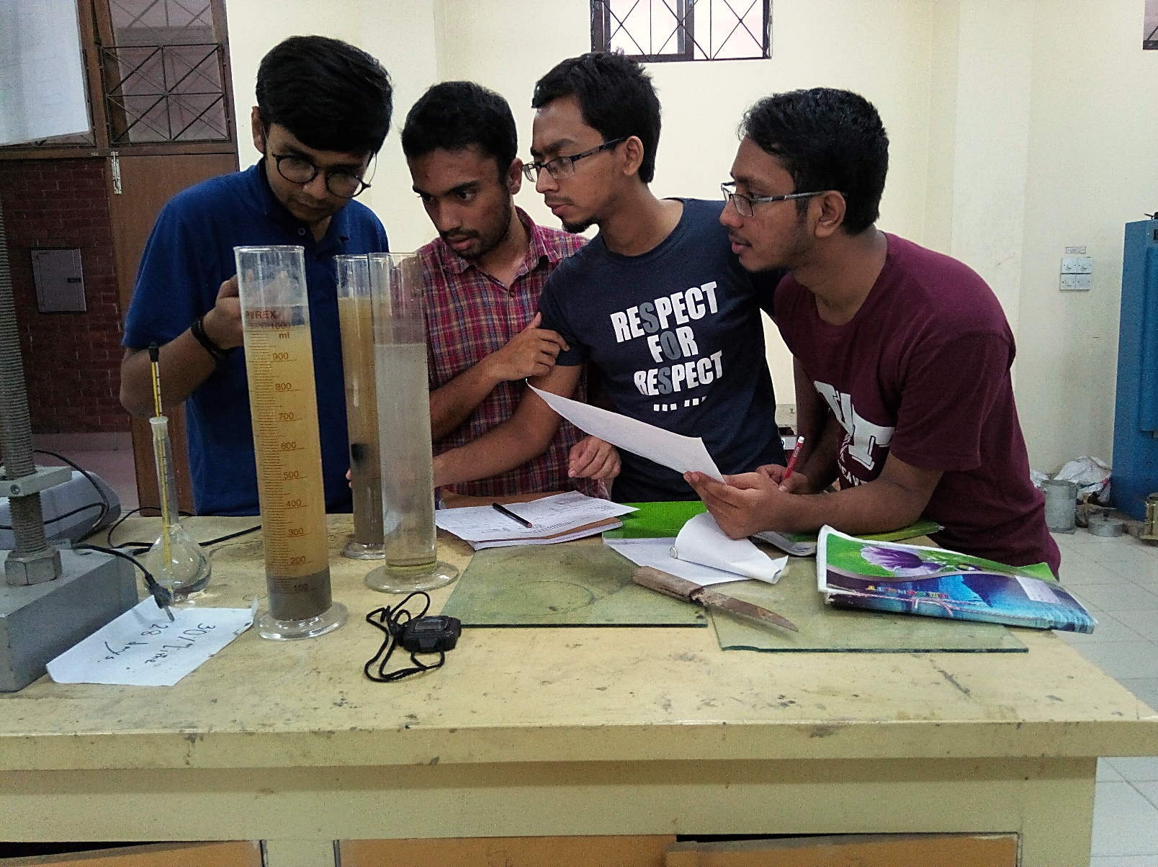

Figure 3.7 Hydrometer Analysis

The hydrometer tests were done in our varsity geotech lab.
The test were done according to the standard. The test results are shared in the next page.

Table 3.5.1 Hydrometer Analysis (6’ Soil Sample)

Table 3.5.2 Hydrometer Analysis (12’ Soil Sample)

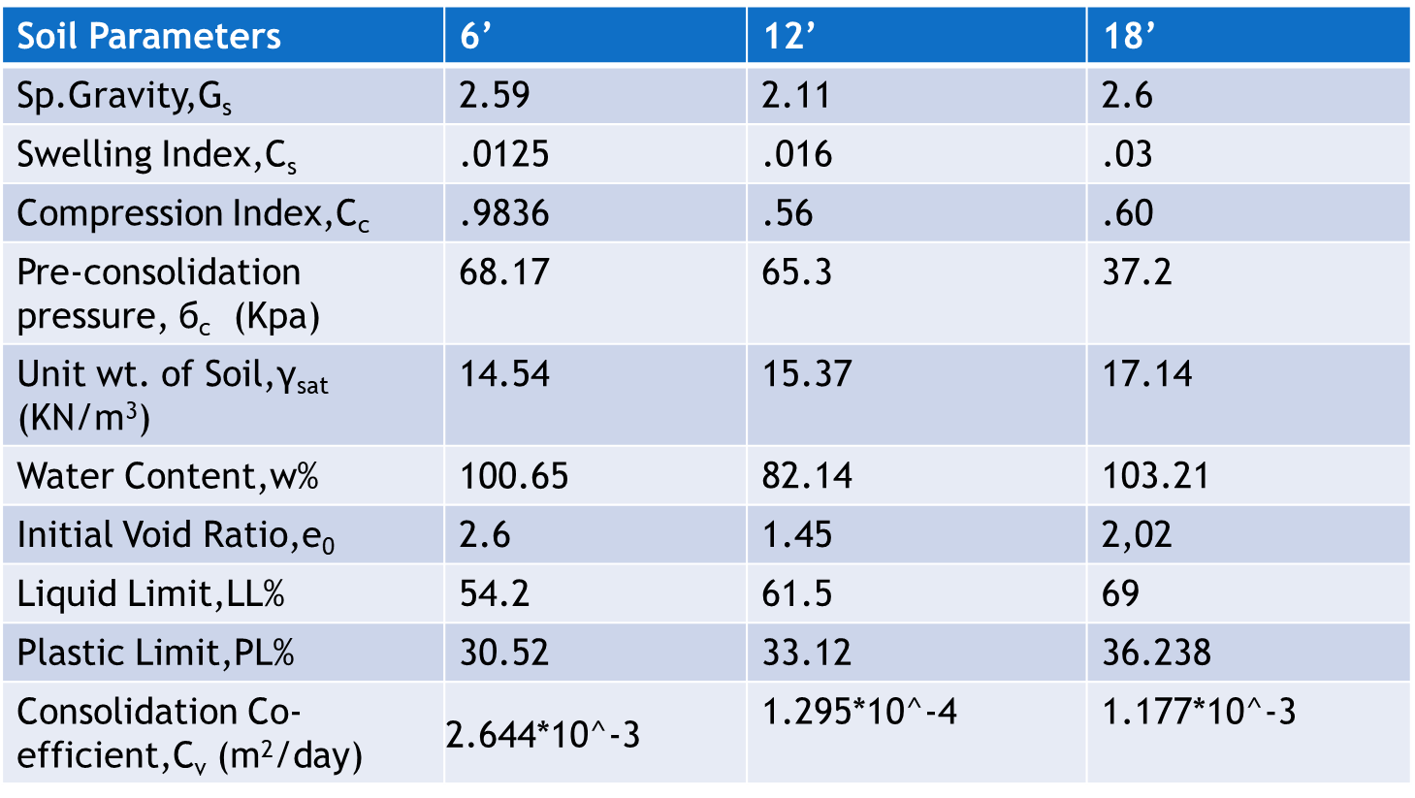

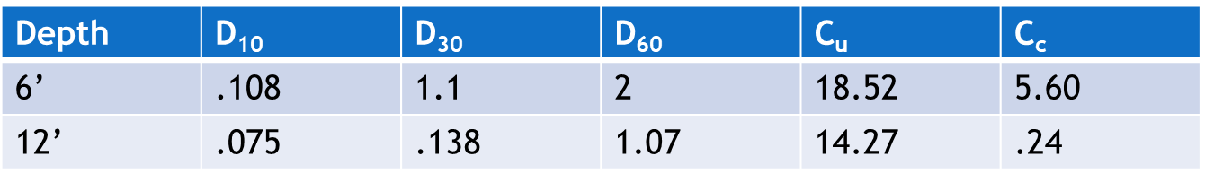

Table 3.6 Soil parameters from laboratory tests

3.5 Conclusion
In this chapter, different methods adopted to achieve the objectives of the study are thoroughly discussed. Different parameters of soil are explained in order to relate it to the study result. Experimental method is important in order to set out the scope of the study. So, the methodology is followed by the result and discussion in the next chapter.
Chapter 4: Soil Characteristics at the Study Locations
Physically Khulna district is characterized by alluvial formations
caused by several rivers such .Khulna district is mainly formed of olive grey silty
loam and dark grey silty loam soil. The percentage of water content is very high , in most cases, it was found to be more than 100%. Again, as it is situated adjacent to coastal belt, the high level salinity is found in the soil. Moreover,in our test sample, we found that , the soil is black in visibility which suggests it to be organic soil.
By observing and testing we have found similarity
among the soils of study locations in different depths which are shown in Figure

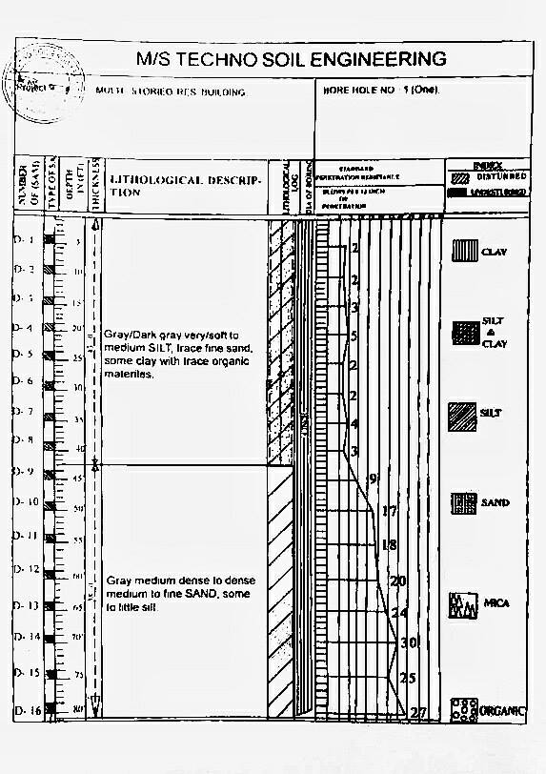
Figure 3.8 Bore log chart collected from KDA
Chapter 5: Results and Discussions
5.1 General
This chapter deals with the presentation of results obtained from various tests and simulation conducted on soil. The main objective of the research program was to determine and Predicting embankment settlement for soft clay by FEM analysis (Subloading t_{ij} model) and also by analyzing settlement using conventional method. Another objective was to make comparison between the results from FEM analysis (Subloading t_{ij} model) and conventional method.

5.2 Subloading t_{ij} Model (Finite Element Method)
In this study we are calculating settlement of soft soil by elastoplastic method .This analysis is based on Finite Element Method. Here are the interface of our used software.

Here the total depth of the soil is divided into some elements. The depth of the soil is 6m and the soil was collected from three depths. So every layer of soil is 2m deep. And the total depth is divided into 24 elements.

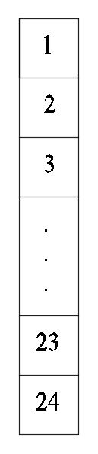

The next picture shows the software input interface, where the real life data were put to analyze using FEM.
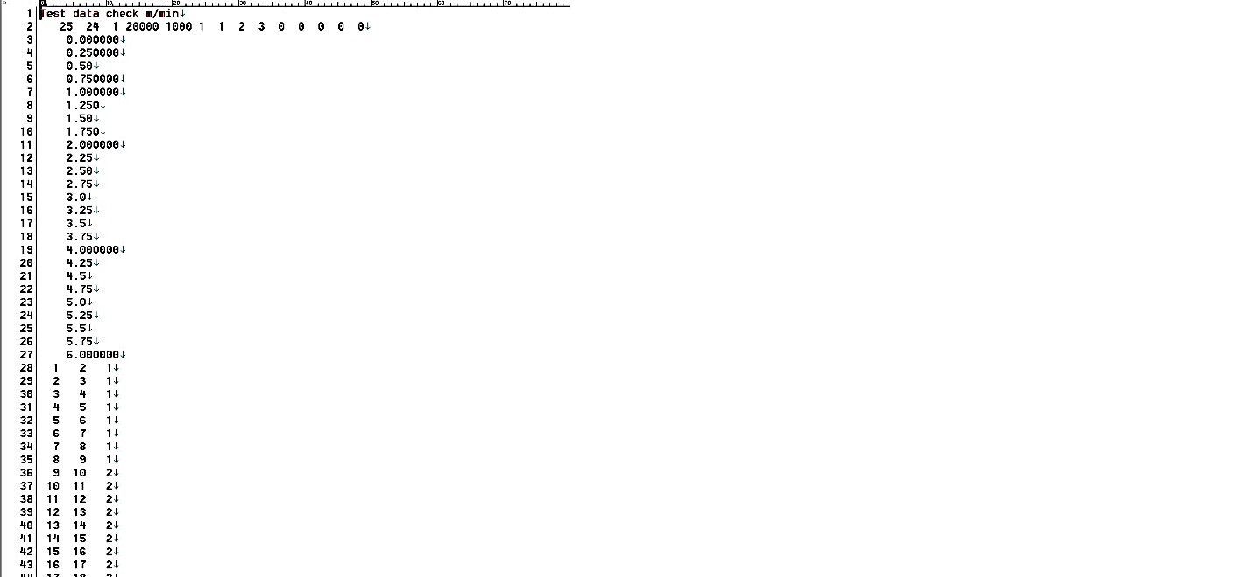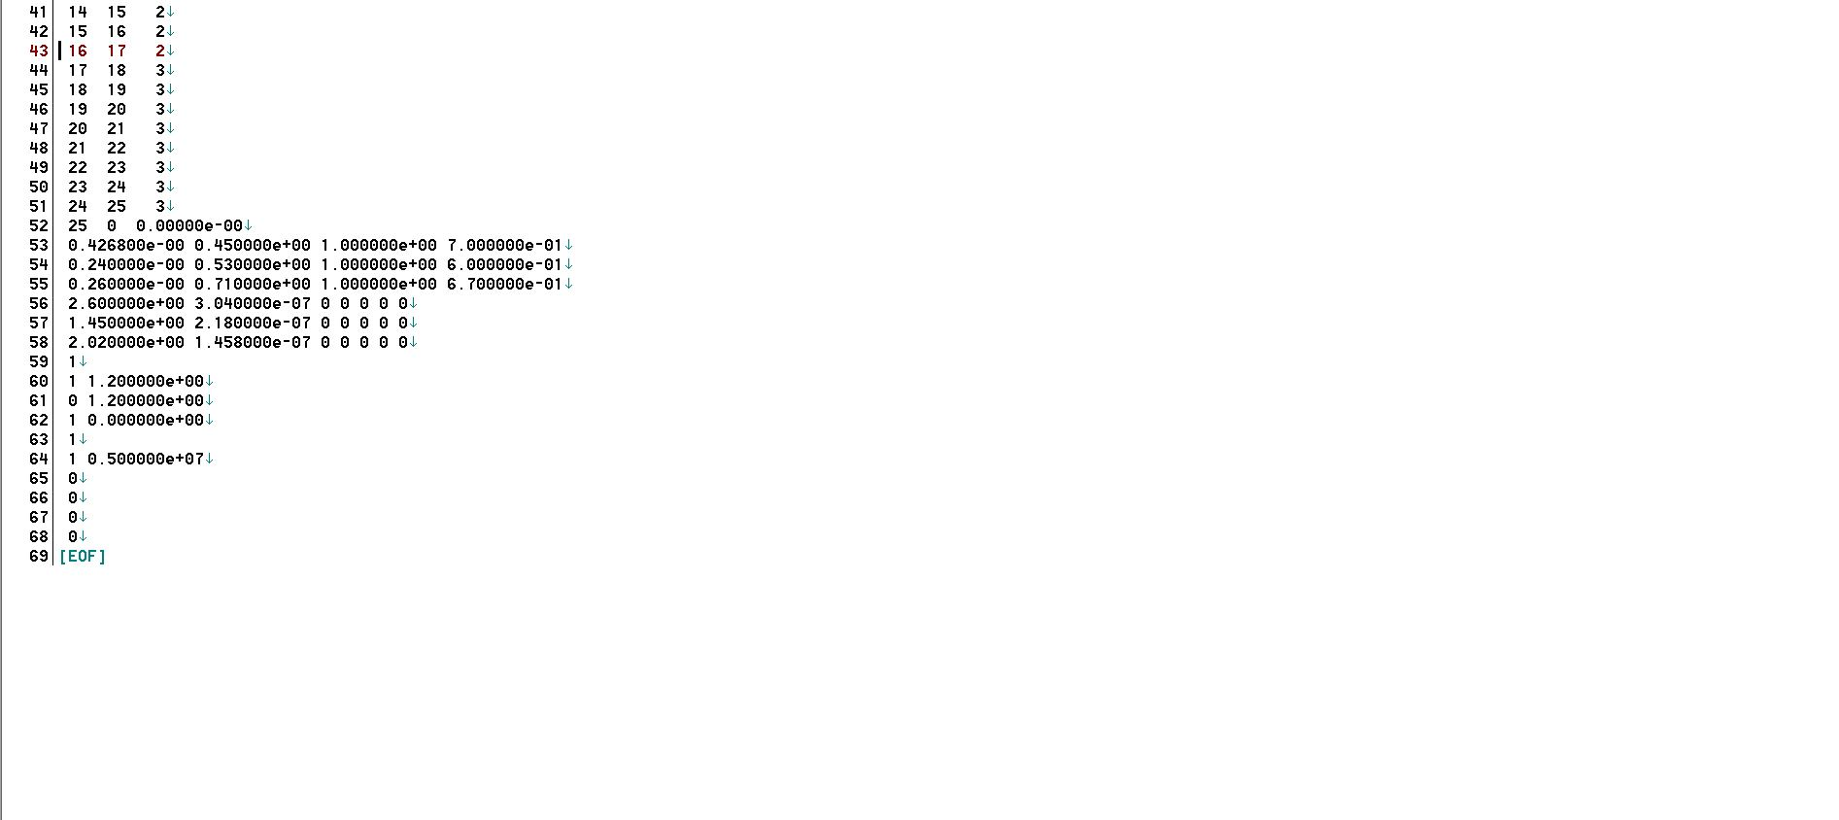
Then our calculation file has been attached here. This calculation file shows some of the parts of our result(1and24element) .From our analysis(Total stress, Effective stress, Void ratio, pore water pressure, displacement)of all the elements have been calculated.
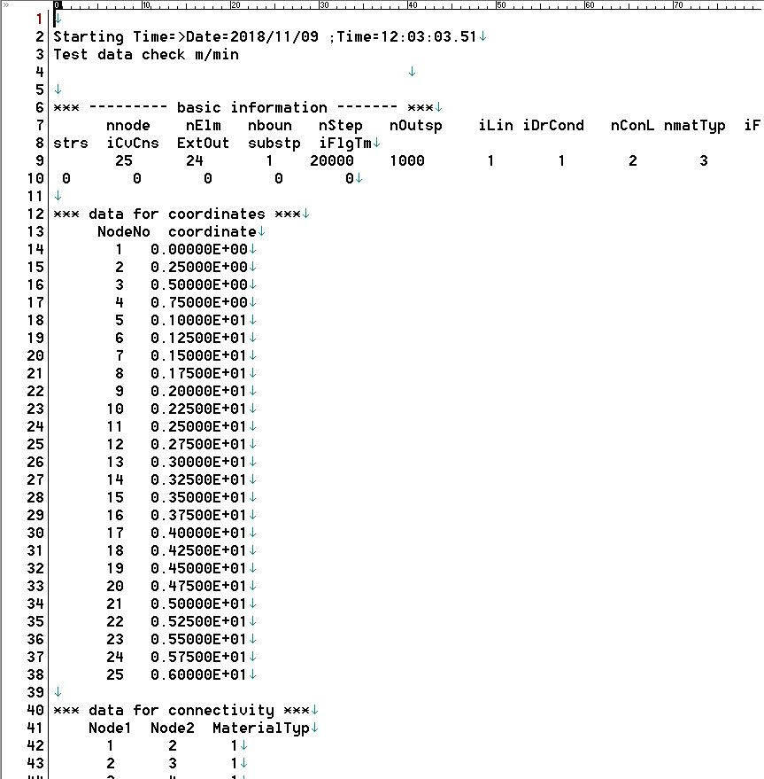
Fig: First Page of the Cal file
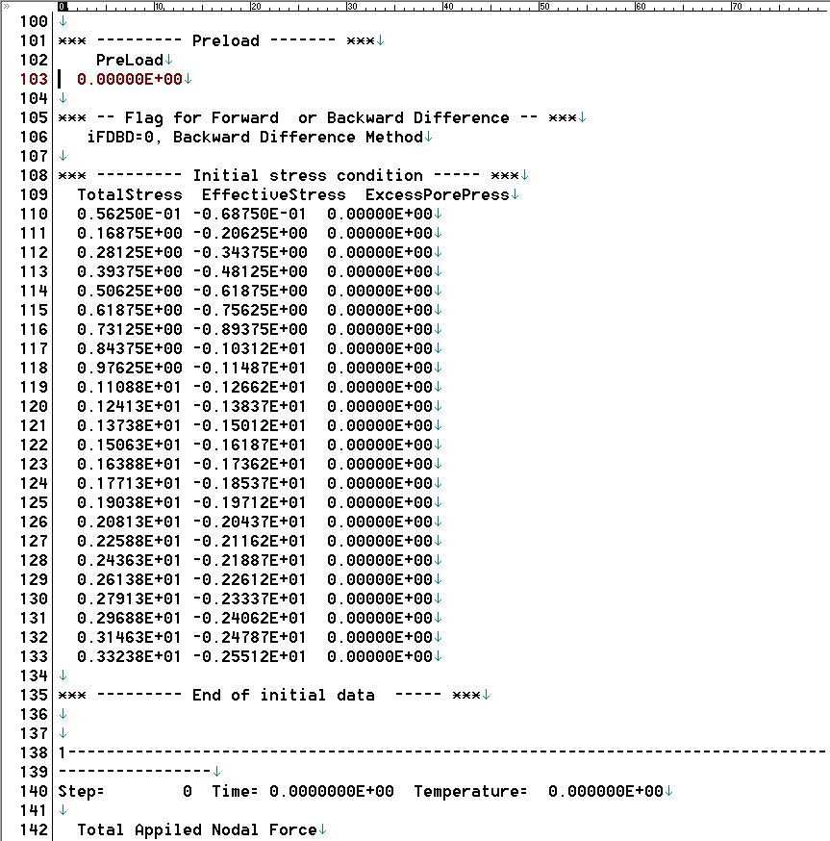
Fig: Initial stress condition of the Cal file
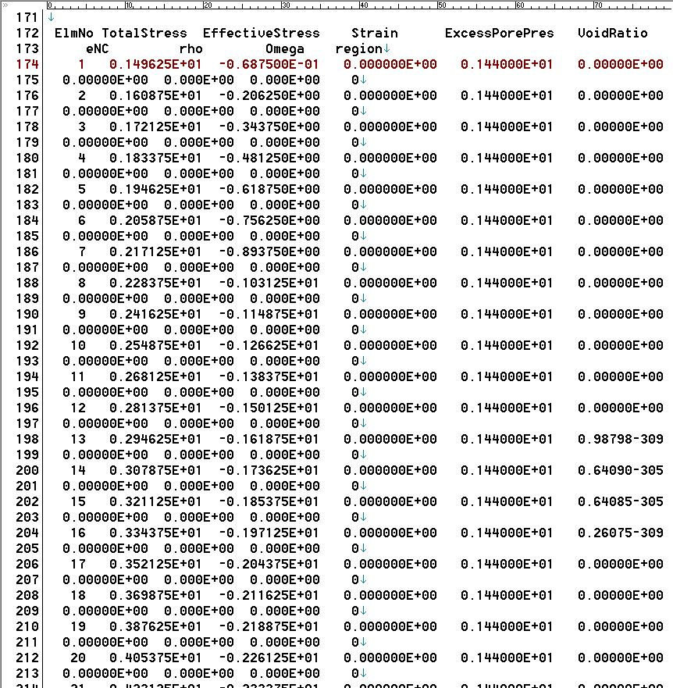
Fig: Step 1000 of the Cal file
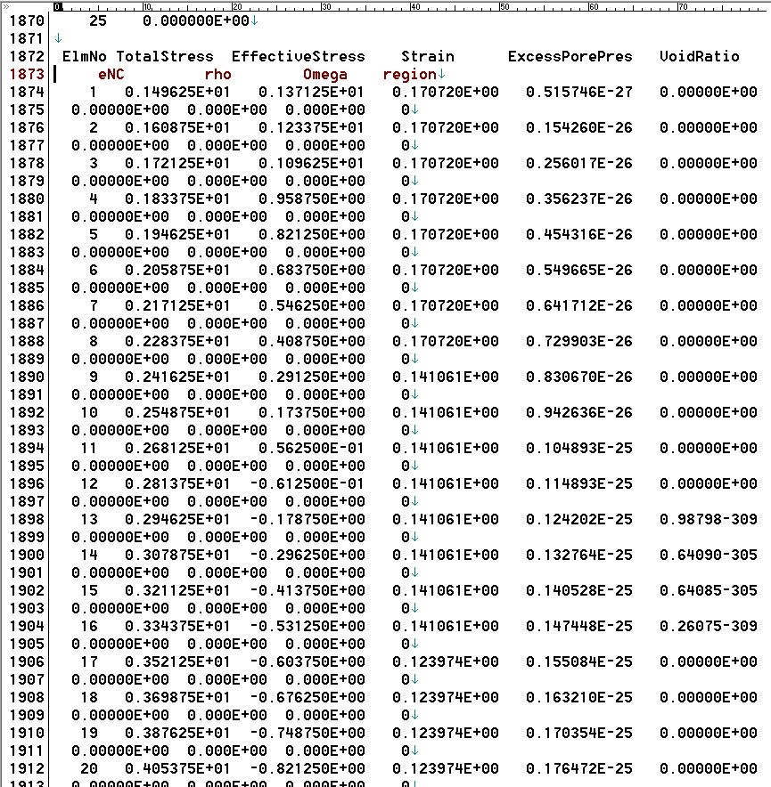
Fig: Step 20000 of the Cal file

Now there is a graphical representation(depth vs excess pore water pressure)which has been shown.From this analysis we can see that in step 0 there is a constant excess pore water pressure.In step 1000 there is a change of excess pore water pressure along with the depth.It’s shape is semiparabolic because the drainage system is one way. The value of excess pore water pressure is decreasing and the change is gradual.After 7000 steps the value of excess pore water pressure is turnrd into nearly“zero’.In 20000 steps the value is almost nill.This phase is almost consolidated and well settled.
Step 0
Step 1000
Step 2000
Step 3000

Step 4000

Step 5000
Step 6000
Step 7000
Step 20000

Depth vs. Initial effective stress

This is a graphical representation of depth vs. initial effective stress. We can see that the difference between the initial and final step is constant. This difference shows the load increment due to surcharge.
Settlement vs. time

This is a graphical representation of settlement vs. time. This is a hyperbolic which clearly shows that this is a time dependent settlement. And at last the settlement becomes constant.
This graph is derived from element 1. So this represents the total settlement of the embankment.
And from graph, the total settlement is 8.6 meters.
5.3 Conventional Method
This is the real life problem set based on our lab data tests. The water level was at top of the soil.

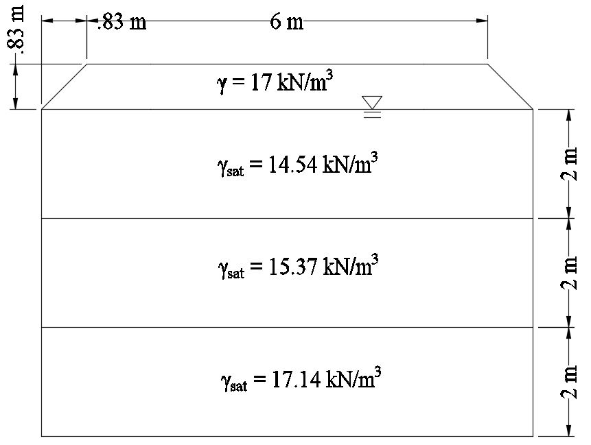

Now we are going to calculate the total settlement using the conventional method.

γH= 17*.83= 14.11 kN/m²
Δσ+σ₀₁’= 18.673 kN/m²
Δσ+σ₀₂’= 28.25 kN/m²
Δσ+σ₀₃’= 40.6 kN/m²

For first layer:
σ_{o1}’= (14.54-9.81)*1=4.41kN/m²

For second layer:
σ_{o2}’= (14.54-9.81)*2+(15.37-9.81)x1=14.2kN/m²

For third layer:
σ_{o3}’= (14.54-9.81)*2+(15.37-9.81)x2+(17.14-9.81)x1=28.2kN/m²

For first layer:
S_{c1}=$\frac{1*2}{1+2.55}\log{\frac{18.6}{4.41} }$= 0.35m

For second layer:
S_{c2}=$\frac{0.6*2}{1+1.39}\log{\frac{28.25}{14.2}}$= 0.15 m

For third layer:
S_{c2}= $\frac{0.7*2}{1+2}\log{\frac{40.6}{26.5} }$ = 0.1 m

S_{c} =S_{c1} +S_{c2} +S_{c3}= 0.62 m

T_{v}=$\frac{C_{v}t}{H_{{dr}^{2}}}$
C_{v}=$\frac{2.644*{10}^{-3}+1.295*{10}^{-4}+1.177*{10}^{-3}}{3}$=1.32*10⁻³m²/day

For 90% consolidation
T_{v90}=0.848
C_{v}t=T_{v}*H_{dr}²
t=$\frac{T_{v90}*H_{{dr}^{2}}}{C_{v}}$=23127.27day
From this conventional analysis we can see that for the real data set the total settlement is 0.62 m.

5.4 Results
From Elastoplastic analysis (Subloading t_{ij} model),
Settlement = 0.86 m
From conventional calculation,
Settlement = 0.62 m
Difference = 0.85-0.62 =0.24 m

Chapter 6: Conclusion
6.1 Reviews on Completed Research Work
From the analysis results, we can say that there is a difference between the results of two methods of analysis.
The reasons behind it can be-
- Soil water interaction (coupling effects) is more accurately represented in the FEM analysis than conventional analysis.

- 2D analysis shows more accurate result than 1D analysis because 2D analysis is more realistic.

6.2 Future Research
- For reducing the settlement time, the most suitable technology which should be adopted for this region like PVD, geo-textile, geo-fiber and other modern technologies.
- Type of foundation for best economic and structural sustainability should be provided in this region.
- For time scarcity, we could not consider the saline effect in study area. In future, we want to incorporate the salinity for better result.
- We will use FEM and Limit Equilibrium based different softwares (OptumCE, PLAXIS etc.) to compare settlement for reliability check.

References

- Surachat Sambhandharaksa, Thanin Pongrujidqrn, Phatom Chaloeywares .Settlements of Structures and their prediction in Bangkok subsoils.” 9TH Southeast Asian Geotechnical Conference,Bangkok,Thailand.

- Balasubramaniam, Bala, Cai, Hao, Surarak, Chanaton, Oh, Erwin “Settlements of Embankments in Soft Soils.” (2010) Geotechnical Engineering Journal

- By N. Loganathan, A.S. Balasubramaniam, D.T Bergado. “Deformation Analysis of Embankments” (1992) Journal of Geotechnical Engineering.

- Vasantha Wijeyakuasuriya, G. Hobbs, A. Brandon. “Some Experience with Performance Monitoring of Embankments on Soft Soil.” 8th Australia New Zealand Conference on Geomechanics, Hobart.

- Liu Chun-hong1.2, Xiao Zhao-yun1, Wang Jian-hua1, Chen Jin-jian1” Finite element analysis of road embankment on soft soil reinforced with geotextiles” (2004) Rock and soil Mechanics

- Ir. Tan Yean Chin “Design and Construction of Road Embankment on Soft Ground” (2016) Sabah Road Conference

- Chunlin Li “A simplified method for prediction of embankment settlement in clays” (2014) Journal of Rock Mechanics and Geotechnical Engineering

- Dr. Md. Monjur Hossain and M.A. Razzaque, “Structural Advantage of Floating Foundation Over Traditional Mat Foundation for Soft Clay: A Case Study” (1999) Civil and Environmental Engineering Conference

- Muhammad Alamgir and Khaled Hassan Choudhury, “Ground Improvement Methods Recently Practiced to Solve the geotechnical Engineering Problems in Bangladesh” (2004) International Conference on Case Histories in Geotechnical Engineering

