**One-Axis-Balancing-Stick Project**

1. **Motor Selection**

|  |  |
| --- | --- |
| Name | Nidec 24H |
| Rated Voltage | 12V – 24V DC |
| Type | BLDC, 3 Phase Wye, Slot 9, Poles 12, Sinusoidal |
| Speed control | PWM (15 to 25kHz) |
| Current Limit | 3 Amps |
| Encoder Output | 2 Channels – 100PPR |

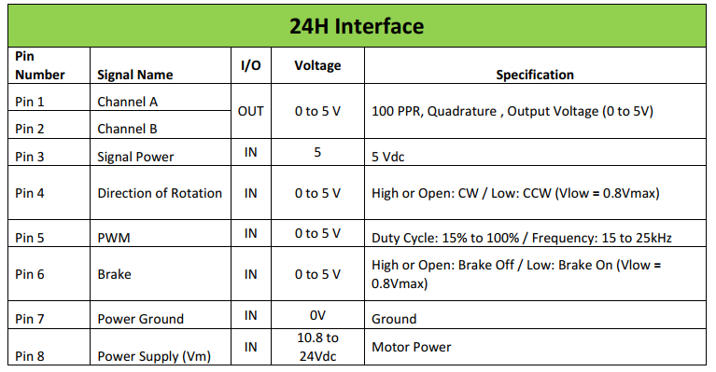

3

2

1

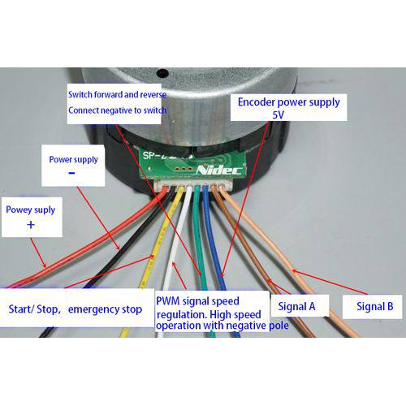

1. **IMU (MPU6050)**

|  |  |
| --- | --- |
| Name | MPU6050 |
| Integrated | 6-axis (3-axis gyroscope + 3-axis accelerometer) |
| Features | 16-bit ADCs for both gyro and accelero |
| User-program gyro | Full-scale range of ±250, ±500, ±1000, and ±2000°/sec (dps) |
| User-program accelero | Full-scale range of ±2g, ±4g, ±8g, and ±16g |
| Communication | I2C at 400kHz |

Noted:

* 16-bit ADC is equal to 2^16 = 65536 refers to resolution smallest changes in measure quantity that the sensor can detect
* User-programmable gyroscope full-scale-range ±250, ±500, ±1000, and ±2000°/sec (dps) mean that gyro can accurately measure between that range. For example, ±500 dps gyro can accurately measure between -500 dps to 500 dps.
* User-programmable accelerometer Full-scale range of ±2g, ±4g, ±8g, and ±16g. For example, ±2g meaning that accelerometer can accurately measure acceleration ranging from -2g to +2g twice of gravitation.
* Higher full-scale range provide greater sensitivity to large acceleration but may scarify precision for smaller acceleration.
* It’s essential to select a range that covers the expected level while ensuring that the sensors resolution and accuracy meet the application.
* Accuracy refers to how close the measured value is to the true value of quantity being measured. It’s indicated that sensor’ ability to provide result that are consistent with the actual physic quantity being measured
* Accuracy can be affected by various factors
  + Sensor calibration
  + Environment conditions (temperature, humidity)
  + Manufacturing tolerance
* Resolution refers to smallest change in measure quantity that the sensor can detected. Resolution determine by the sensor’s internal architecture such as digital or analog to digital conversion ADC.