Prototype 1: Chat Application
PBT205 Assessment 1 · Soksereyvathna Uk (A00152091)

1. Introduction
We built a RabbitMQ chat system: a command-line client, a GUI client with rooms, and automated tests. Persistent room history for late joiners goes beyond the brief (Torrens University Australia, 2024). Code: https://github.com/soksereyvathna-uk/pbt205

2. Requirements and constraints
RabbitMQ runs in Docker. Following the group contract, chat uses topic exchange chat, routing key room.<roomname> and JSON fields user, room, text, timestamp (Bray, 2017; RabbitMQ, n.d.-a). The clients use the group’s mq_common helpers to declare the exchange and publish. Boundary cases: empty messages, invalid port, broker down, room names with spaces, idle connections and late joiners. Streams require acknowledgements (RabbitMQ, n.d.-b).

3. Design
Each room has a stream history.ROOM bound to the exchange with key room.ROOM (Figures 1 and 2). Clients read it from the oldest message, so late joiners see history, then live messages. Each client uses two connections: one consuming in a thread, one publishing. Streams replaced per-user temporary queues, which cannot replay messages.
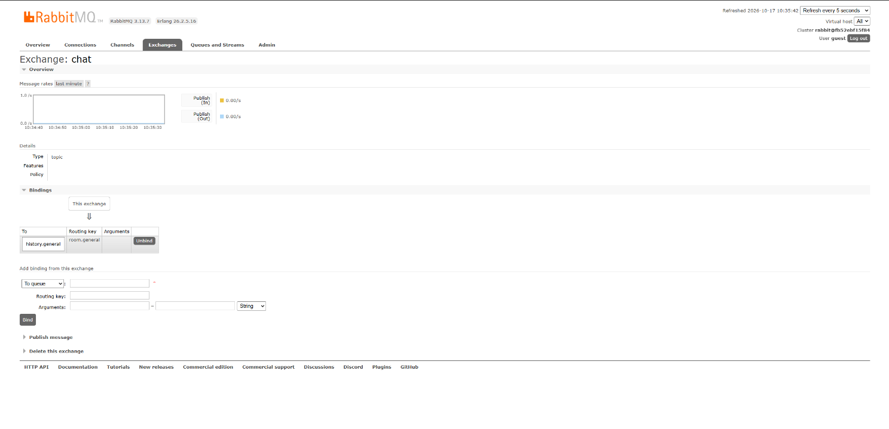Figure 1: Topic exchange bindings
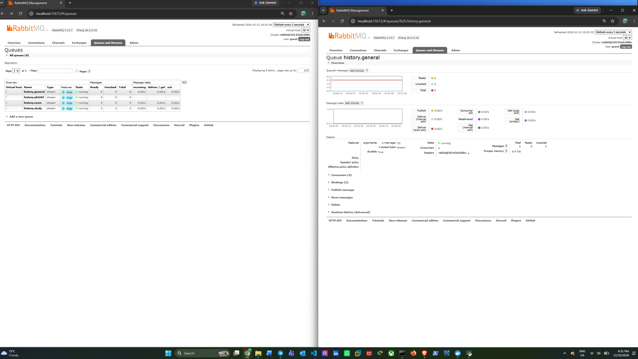
Figure 2: Per-room history streams

4. Testing
All tests passed: users sharing a room (Figure 3), a late joiner receiving history (Figure 4), separate rooms (Figure 5), a 12-minute idle gap (Figure 6), connection errors (Figure 7) and nine automated tests (Figure 8).
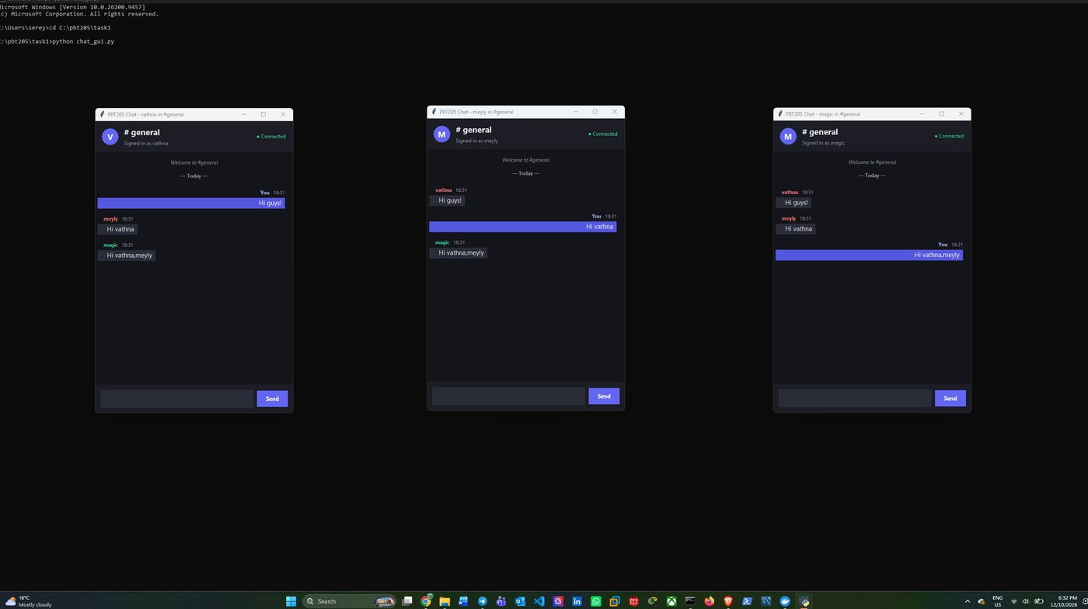
Figure 3: GUI users in one room
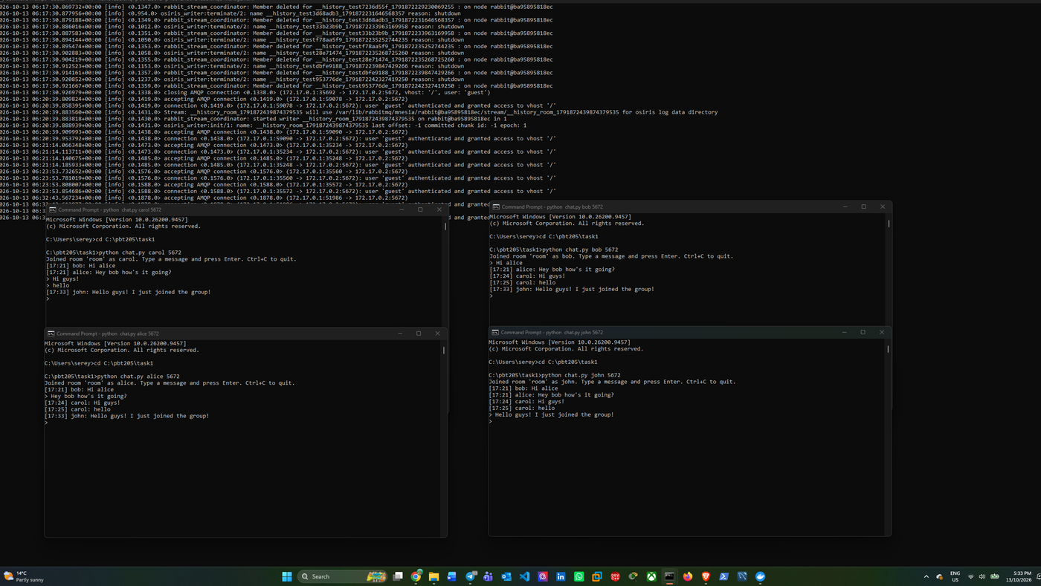
Figure 4: Late joiner receives history
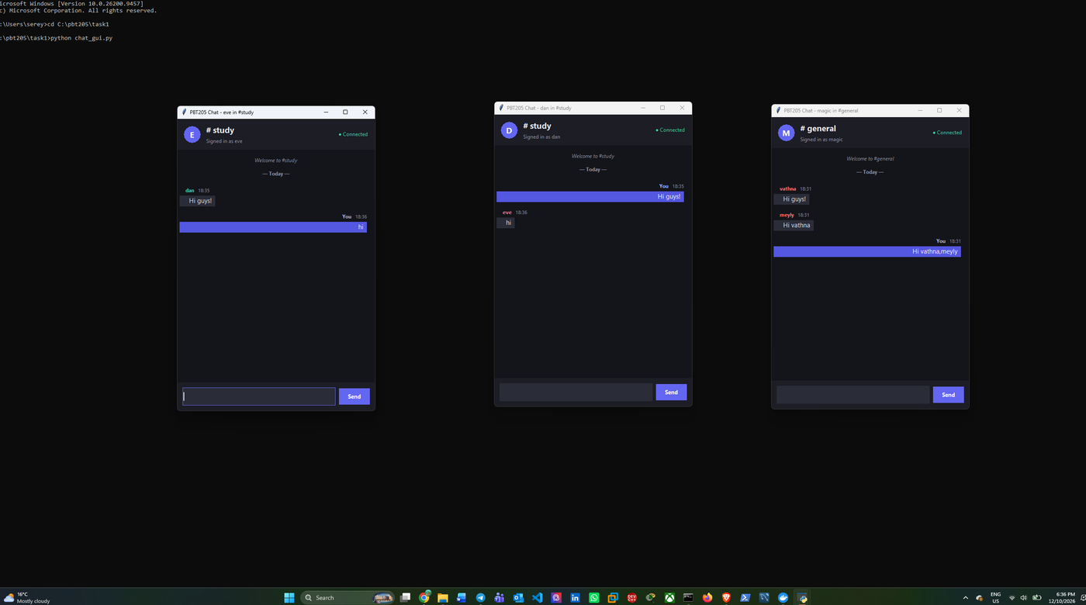
Figure 5: Rooms stay separate
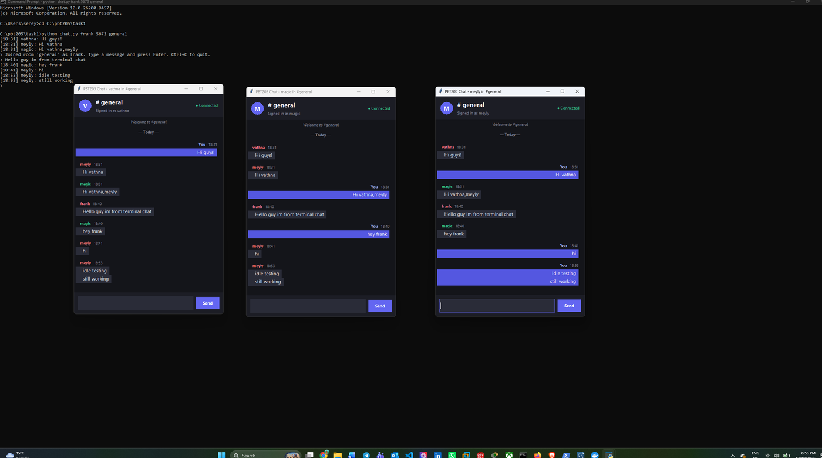
Figure 6: Idle test, 12-minute gap
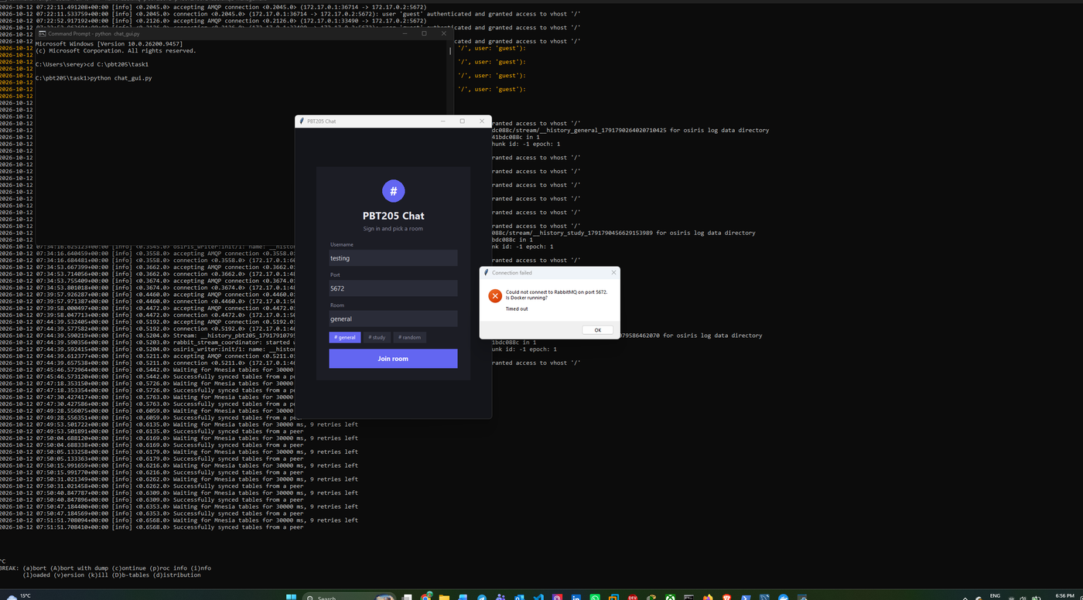
Figure 7: Connection error
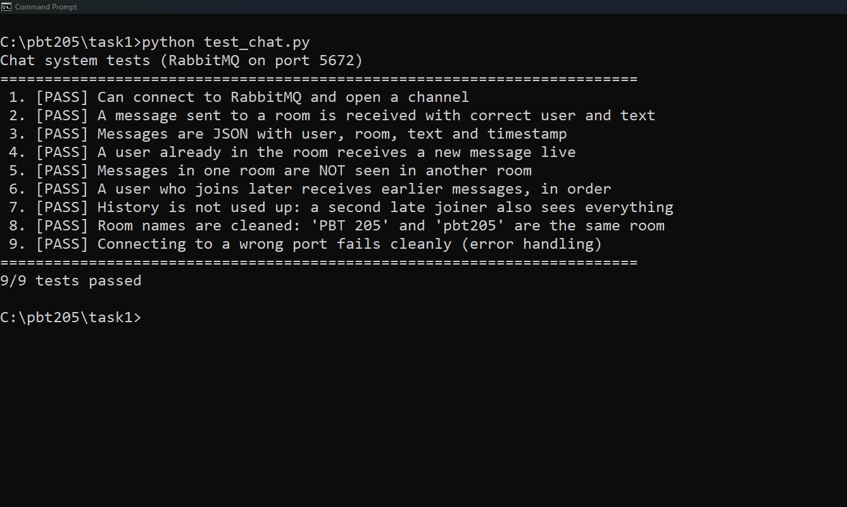Figure 8: Automated tests, 9 of 9 passed

5. Problems found and fixed
- Idle publisher connections dropped, missing heartbeats (RabbitMQ, n.d.-c). Fix: heartbeat=0.
- The GUI listener timed out. Fix: heartbeat=0 and a visible notice.
- Room names with spaces created separate rooms. Fix: names are cleaned.
- Late joiners saw nothing. Fix: one stream per room.
- The shared connect() uses default heartbeats, so our clients open their own connections.

6. Limitations
No authentication or encryption; history is lost when the container is removed; each join replays all messages; usernames are not unique.

Use of generative AI
I acknowledge that I used Claude (Sonnet 5.5, Anthropic, 2026) as a supporting tool during the development and documentation of this project. I used Claude to help me understand unfamiliar programming concepts, generate and suggest code improvements, troubleshoot errors, and explore design solutions for chat.py, chat_gui.py, and test_chat.py. I reviewed and adapted relevant code suggestions, installed and ran the application, conducted tests, captured screenshots, identified errors, and verified the results. I also used Claude to assist with drafting and refining parts of the report, which I reviewed and paraphrased where appropriate. I take responsibility for reviewing the final implementation and ensuring that the submitted work accurately reflects the testing process and project outcomes.

References
Anthropic. (2026). Claude (Sonnet 5.5) [Large language model]. https://claude.ai
Bray, T. (Ed.). (2017). The JavaScript Object Notation (JSON) data interchange format (RFC 8259). IETF. https://www.rfc-editor.org/rfc/rfc8259
RabbitMQ. (n.d.-a). AMQP 0-9-1 model explained. https://www.rabbitmq.com/tutorials/amqp-concepts
RabbitMQ. (n.d.-b). Streams and super streams. https://www.rabbitmq.com/docs/streams
RabbitMQ. (n.d.-c). Heartbeats and TCP keepalives. https://www.rabbitmq.com/docs/heartbeats
Torrens University Australia. (2024). PBT205 Assessment 1 brief.

