Proceedings of the CREATE Symposium
Cultivating Resources for Employment with Assistive Technologies Symposium
CREATE2025
April 9th, 2025, Albany, NY, USA

create: Garden Shears
Saira Billah, Taaseen Jahan, Jade Lombardo, Sonam Okuda
The Cooper Union, NYC
ME393 Senior Capstone Project
Spring 2025

Abstract
This project focuses on the redesign of common garden shears to improve comfort and reduce fatigue for users with disabilities. The team participated in the Cultivating Resources for Employment with Assistive Technologies (CREATE) Competition that is hosted by the New York State Industries for the Disabled (NYSID). For the CREATE competition, the partner organization was the CP Unlimited collaboration with Smile Farms, a non-profit greenhouse that provides produce to local restaurants. At Smile Farms, volunteers with disabilities maintain and harvest vegetables from the garden for the sale of produce and ingredients. The primary issues highlighted by the participants in the Smile Farms project include fatigue from repeated clenching of the garden shears, pain and discomfort from needing to rotate their wrist to harvest, and a safety mechanism that is difficult to operate unless the pair of shears are consistently maintained. The newly designed shears improve ergonomics by altering the cutting motion to shift the load away from sensitive hand muscles, resulting in a 19% increase in maximum actuation. A novel linkage system increases mechanical advantage to improve the comfort of harvesting vegetables.

Keywords: Assistive Technology, Garden Shears, Hand Fatigue Test, Ergonomic Shears

- INTRODUCTION

  - CREATE Competition
The CREATE Competition is hosted by NYSID and gives engineering students an opportunity to work on a product to help people with disabilities in the workforce. Students work on establishing a problem and designing in the first semester, while the second semester focuses on prototyping and manufacturing. The product is then presented during the CREATE Symposium, where they are scored and ranked. The Cooper Union has chosen to partner with CP Unlimited, a program that employs people with cerebral palsy and similar disabilities.

  - User and Client
Smile Farms is a local nonprofit that employs people with disabilities in agriculture. Through CP Unlimited, an organization that connects people with disabilities to jobs across New York, employees maintain greenhouses and harvest serrano peppers, tomatoes and other vegetables. These volunteers have limited hand mobility and are the primary users of our redesigned garden shears. During a team visit to Smile Farms, volunteers expressed that they experienced fatigue when clipping vegetables over time. They also mentioned discomfort in clipping vegetables in hard-to-reach places.
The team found the safety lock mechanism difficult to open and close, even for people with full hand dexterity. This can be largely attributed to the rust and accumulation of dirt on the shears. A worker at Smile Farms also pointed out that on top of fatigue from clenching his fist to operate the shears, rotating his wrist to angle himself to snip vegetables was difficult. His range of motion was limited, and extending beyond it caused pain. To improve the working environment for the employees, Smile Farms is interested in implementing an ergonomic solution that reduces the fatigue of the user and enables them to work for longer with less discomfort.

  - Problem Statement
Harvesting garden vegetables with the use of garden tools, such as clippers and shears, can be difficult for people who suffer from disabilities that impact hand mobility and dexterity. Clippers, especially when covered with rust or dirt, are difficult to close with sufficient force to sever a plant stem, as they require three pounds for typical garden shears as shown in Appendix B. Moreover, the repeated motion of shearing, as well as any adjustment movements users have to make to snip vegetables (such as angling their wrists), can cause fatigue for users in their hands, wrists and forearms.

  - Goal
To address the problems highlighted by Smile Farm employees, a device that reduces the fatigue of the user, improves the ergonomics of existing shears, and has an easy, user-friendly safety lock will be implemented.

- BACKGROUND RESEARCH

For gardening tasks such as digging, weeding and harvesting, a variety of tools have been designed and created to assist gardeners. Garden shears are the most common tool used for harvesting produce as they are versatile and intuitive to use. However, gardeners with mobility issues due to age or physical conditions tend to struggle to maintain their gardens as having weaker grip strength and being more prone to joint and muscle pain affects their ability to perform garden-related tasks. Emphasis should be put on balance, construction, adaptability, and weight for improved shears designs that have been adapted to the address the needs of gardeners with disabilities.
Gardening shears have remained relatively the same since the 1800s. [1] A design similar to scissors, called bypass pruners, is the typical design. This mechanism consists of two sharpened blades passing each other, which cuts the stem or branch between them. In the 1920s, anvil pruners were created, which consists of one sharpened blade cutting onto a block that acts as the cutting board. Currently, these two designs are still in production, but have been adapted for slightly different uses. While the bypass pruners are used to cut thinner stems, the anvil pruners are used to cut plants that are slightly thicker; large loads on bypass pruners cause the blades to deflect, so the “cutting board” actuation is found to be more effective when dealing with larger plants. [2] Another type of shear also in production is called ratcheting shears. These cut thicker stems and branches using ratchets or “steps”, which reduces the amount of force the user has to input by increasing the distance the user has to “travel”. This design and its ability to reduce maximum load could also address fatigue as each squeeze doesn’t require as much force as bypass or anvil pruners but also poses a disadvantage as the user has to make more shearing movements.
Shears like the bypass pruner can make clean cuts that don’t bruise the stem while also making the tool easy to operate using the thumb. [3] Other shears like anvil shears operate by having the blade close in onto the pivoting anvil. The heavy-duty pruner is useful for thicker blades but is said to be difficult to operate, likely because of the amount of force needed to cut the stems and for the tool weight. Some shears are small and easy to use but only cut small stems while the heavier and larger shears such as the two-handed shears, are suitable for thicker stems. However, they require more effort and are more difficult to operate for those without the physical strength to hold heavy two-handed items. These shears are also impractical for the greenhouse operated by Smile Farms, as all of their produce is harvested from small plants, and the facility has limited space.
The main issues that the redesigned garden shears need to tackle are reducing the fatigue experienced by the user as they cut stems and rotate their wrist. The tool should also allow vegetable stems of varying thicknesses to be snipped and prevent problems that arise from rust (such as difficulty locking).
  - Prior Art
There are various types of garden shears that exist on the market which attempt to address some of these problems. These include ratcheting garden shears, motorized garden shears, and shock-absorbing garden shears.
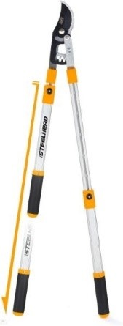
Figure 1: Telescoping Garden Shears
The shears in Figure 1 have extendable handles and are ratcheting and shock absorbing. The telescoping mechanism allows the user to harvest produce from farther distances. The ratchet mechanism claims to achieve three times the cutting force and reduces cutting effort required, which is desirable for users that struggle with putting enough force into the shears. However, the repeated motion of the ratchet leads to added fatigue experienced by the hands, and the tool requires use of both hands and some arm movement to operate. Moreover, this tool is often used to cut high tree branches; the greenhouse at Smile Farms does not require cutting plants at such distances. These garden shears weigh approximately one pound.
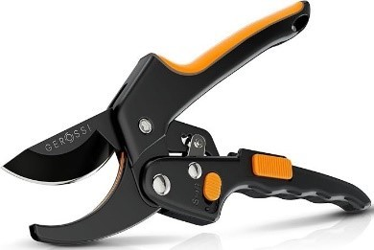
Figure 2: Ratcheting Garden Shears
Figure 2 displays ratcheting garden shears, where the goal is to reduce the cutting force by making the cut in multiple steps. However, the main disadvantage of this design is that the user experiences fatigue due to the repeated motion of the ratchet. Because Smile Farm deals with relatively thin vegetables, this design is not suitable as there is little need for repeated ratcheting motion.
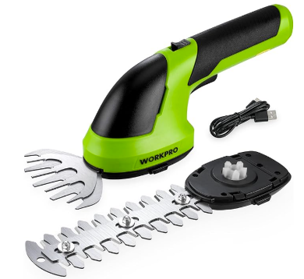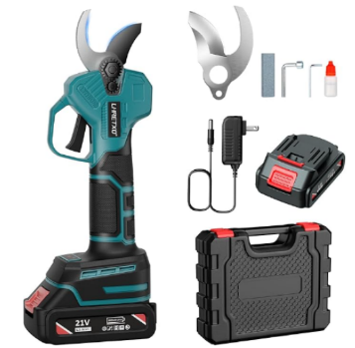
Figure 3: Motorized Garden Shears
Motorized shears, as seen in Figure 3, are useful for cutting thin stems and small weeds. The shears on the left are lower voltage shears that make them light and easier to carry. However, these shears struggle to cut produce with thicker stems. Additionally, there is nothing guarding the blades during use, so it can also be dangerous for people with disabilities to use. The figure on the right is another pair of motorized shears with a higher voltage. This makes it easier to cut stems of various thicknesses, but the weight of the shears ranges anywhere from 2 to 6 pounds. To reduce the weight, using a mains power source such as an outlet could be introduced instead of designing a battery-operated tool, but the lack of electricity supply in the greenhouse and the tripping hazard posed by extension makes this solution less than ideal.
  - Regulations and Codes
A 2019 study [7] investigates various types of garden shears in terms of how much force is required to cut abelia branches of varying diameters. A tensile machine is used to conduct tests to quantify the forces required. They reference the EN-1005-3 standard which states that the force applied by a hand should not exceed 300N and ideally should stay between 150-200N. In this study, low-cost shears were compared to find optimal designs for the best hand health. For the experiment, a speed of 300 mm/min was used. They found the angle of the blade directly affects the cutting energy required. Ultimately, all the garden shears performed well below the recommended cutting forces, so they were all ergonomic.

- Design Process

  - Design Criteria

    - Requirements
There are several requirements that our product must meet. First, the product must be able to remove a vegetable from its stem to harvest. The product should also be able to cut peppers, tomatoes, and eggplant stems, as those are typically harvested at the Smile Farms greenhouse in CP Unlimited. These stems are around 0.1 inch in diameter, as measured from tomato plants (Appendix B). Additionally, the product should be able to cut at least 50 vegetables continuously as a benchmark for the amount of produce an employee is estimated to harvest at one time. Lastly, the product must operate for two hours minimum, which is the estimated length of time an employee harvests for.

    - Criteria
Because CP Unlimited and CREATE aim to provide job opportunities to people with disabilities, introducing a fully automated system or tool would be counterproductive to the goals of the program. Having sensors that could detect stem location or using a motorized tool would take away agency from the user, thus those design choices should be avoided. Moreover, workers at Smile Farms should be able to engage with their work without the need for intense supervision, so safety and maneuverability of the tool are important to consider.

To ensure user safety while promoting independence, the safety lock must be improved upon. It should also be easily maintainable to prevent rust from forming as well as dirt clogging the lock. The rusting of shears blades can be addressed by implementing cheap, replaceable blades that can be removed and switched out. The emphasis on replaceability also allows the redesigned shears to be more cost effective in the long term.

To address the limited wrist rotation and joint movement of the users, a design centered around user comfort should be implemented. Completely reducing the need for wrist adjustments is not possible, as introducing new mechanisms will add width and weight, while not being able to fully account for the randomness of plant shapes and orientations. Instead, the design should prioritize aligning the wrist with the arm to execute the cutting motion, rather than having the user bend their wrist at an awkward angle.

The redesign should emphasize user independence by implementing a one-handed, fully mechanical design, allowing human input to provide actuation and maintain control of the tool. The ergonomics of the new shears should also be improved to provide a more comfortable experience for users with disabilities.

    - Constraints
Various constraints were chosen for the product to introduce limitations for the design. The benchmark values for the redesign are based off single-handed, generic bypass pruners of similar design observed at Smile Farms, as seen in Figure 4.

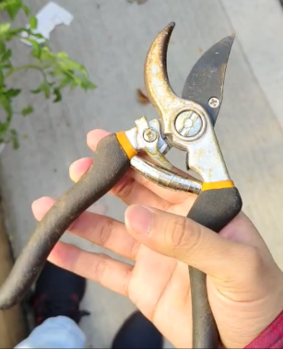
Figure 4: The pair of shears that Smile Farm uses for their greenhouse.

The product should require less than or, at worst, equal to the load required to actuate the generic shears, which was measured to be three pounds of force, as determined by preliminary testing. The weight of the product should be either lighter than or equal to the average weight of the generic shears (8.0 oz). These constraints were determined for a user with a healthy body and full hand and arm dexterity, so tighter constraints may be needed for future prototypes.

The material for the redesigned shears should be suitable for greenhouse environments; it should be able to withstand heat, sunlight, and moisture. The inner mechanisms should be made of materials that are strong, lightweight, and resistant to rust.

  - Iterations
Following the design criteria, numerous prototypes were developed to convert the rotational wrist motion of traditional shears to a linear, pulling motion that utilizes more of the user’s hand. Moreover, the idea of pulling towards the body and making use of the natural wrist alignment to improve ergonomics and reduce wrist pain was explored.

Figures 5a and 5b show the first prototype that introduces the pulling mechanism. In this iteration, a blade attached to a handle slides down the case to chop a vegetable stem against a lower blade fixed to the body of the tool, similar to the actuation method of an anvil pruner. When testing the feel of this actuation, members of the research group concluded that the basic pulling motion was less stressful on the wrist and overall more comfortable to use than regular garden shears. To further improve the function and comfort of the tool, this prototype demonstrated that the next iteration requires some form of mechanical advantage to easily cut vegetable stems. In addition, the user would also benefit from a more ergonomic grip for the handle and springs that reset the device after each cut.

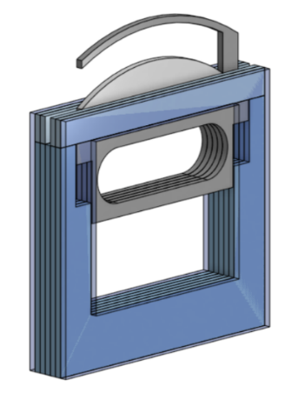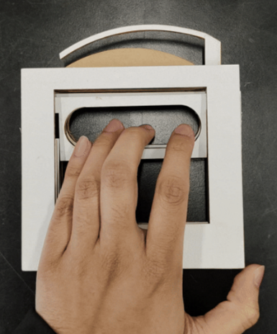
Figure 5a and 5b: The first prototype which includes a pulling mechanism with springs.

The second prototype employs a slot design and pivot point along with springs and a more defined handle grip. Figures 6a and 6b demonstrate how this version of the tool draws inspiration from traditional shears via the pivoting blades to include mechanical advantage. The slot designs are intended to guide the arms of the blade along a circular path as the user pulls the handle down. Unfortunately, the dowels that move along the slots produce a significant amount of friction and the precise geometry of the slots is too complex to implement without restricting the mechanical advantage or size of the tool.
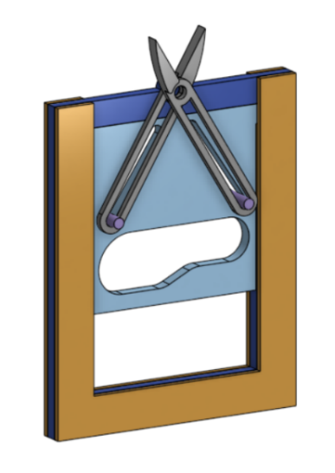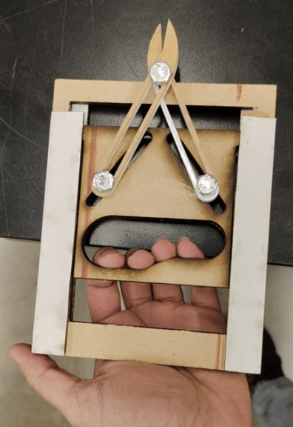
Figure 6a and 6b: The second prototype employs a slot design to move the shears’ blades.

Instead of implementing slots, the next prototype was simplified to use pins to constrain and actuate the blades, as shown in Figures 7a and 7b. As the center actuator plate moves down, the pins push against the arms of the blade to bring them closer together. An additional inner spring between the arms ensures that the tool arms could push back to the starting position after each cut, while also providing additional force to reset the device. Along with a simpler design, this iteration also focuses on easy assembly and a larger profile to fit a wider variety of hands. The goals of the next iteration were to implement a more streamlined design, a locking mechanism, and added adjustability for different hand sizes.

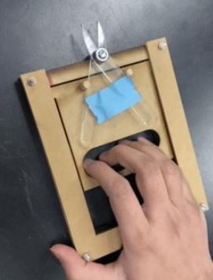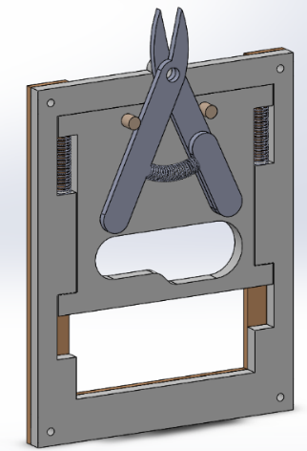
Figure 7a and 7b: The third prototype uses dowls to guide the shears’ handles and springs to push the actuator back up.

Figure 8 shows the final design of the inner mechanisms of the tool. This iteration builds upon its predecessor by adding bearings to the pins to reduce friction against the arms of the blades. Furthermore, garden shears blades from a generic pair were bolted onto linkage arms so that users could easily replace them if they wear down or rust. The handle was modified with a grip that supports the fingers, and a curved base was added to rest the palm against. The shell of the shears was designed to have two slots for the base, allowing the user to adjust the height of the palm rest. By using the screwable knobs on either side of the base, the user can adjust the length by moving the base up or down a slot.
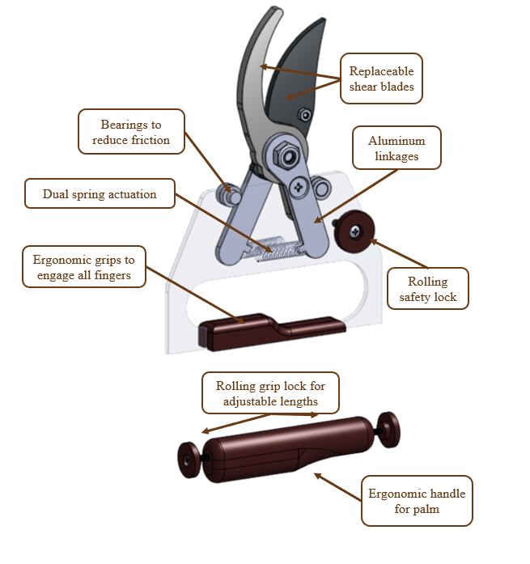
Figure 8: The inner mechanisms of the final prototype.

Springs on either side of the case are used to push up the middle actuator plate. To limit the physical size of the shears for maneuverability, the plate is sandwiched between the actuator arms. To ensure both arms reset to the correct position, two springs on either side of the actuator plate were added.

Figures 9a and 9b demonstrate how the case and handle were chamfered at the top to reduce the overall profile of the tool. As a safety measure, a lock is implemented in the form of a knob that prevents the actuator plate from moving up, effectively keeping the blades closed. Lastly, the casing of the tool is now a shell rather than flat layers, protecting the inner mechanisms of the tool while also providing a sturdy frame to hold onto.
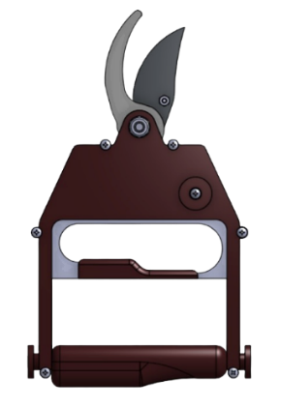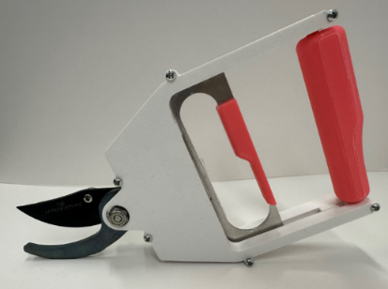
Figure 9a and 9b: The final prototype implements a sleek chamfered design and ergonomic handles.

  - Other Designs
There were a few other configurations and designs that were explored. As shown in Figure 4, the market variety of shears has a telescopic spring that folds into itself when compressed. This spring, while available for purchase under “shears spring” or “telescoping spring”, was expensive and too large to fit within the shell of the shears.

Alternative springs, such as torsion and leaf springs were also considered, but were omitted from the final design for several reasons. Leaf springs were expensive and hard to purchase, and torsion springs were difficult to install into the shell during assembly. The coil of the torsion spring also inhibited the alignment and closing of blade arms.

  - Manufacturing
There are multiple parts of the shears that need to be manufactured, including the case, middle actuator, dowels, linkages, and handle. The case and handle were 3D printed with acrylonitrile butadiene styrene (ABS) due to its durability and resistance to heat, as the shears would likely sit in the sun when in use. The handle is adjustable via screws, which were attached to knobs for easy turning. The middle actuator and the linkages were made using a water jet cutter. This was chosen due to its precise nature and the smooth finish it leaves. Lastly, the dowels were turned down and cut with the lathe, with a press fit tolerance in reference to the middle actuator.

In addition, a bushing was machined so that the shears blades would fit onto the pivot point without shifting around. The blades were bolted onto a threaded rod that extends through the top of the case.

  - Cost Analysis

Table 1: Item Breakdown
Amount ($) | Item Name
17.99 | Compression Springs NEWST Spring Assortment Kit
35.47 | Clear Colorless Acrylic Sheet 18" x 24" and 1/8" thick
5.89 | Metal Bearings
48.53 | Sheet Metal
12.00 | Torsion Springs
11.96 | Aluminum Extended Rod
8.99 | Socket Head Screws
16.79 | ABS Filament
7.49 | 10pc Deep Groove Bearings
27.78 | Sheet Metal

The total amount spent on materials for this project is $192.89 as seen in Table 1. However, because most of the materials ordered were bulk orders, such as bearings, and not all the sheet metal was used for the cut pieces, the cost of the final prototype is much less. Using unit prices and estimates for surface area and 3D printing material, the total cost to manufacture a single pair of shears is less than fifteen dollars. When manufactured on a larger scale, it is possible to reduce the price further. While the retail price is difficult to estimate, the manufacturing of the shears cost less than the generic market shears, which were priced at around $18 dollars, making the cost of the new shear design a competitive price.

- Results
  - Feedback
The team wanted feedback from the employees at Smile Farms to see if they found the product comfortable and easy to use. To conduct human testing, Institutional Review Board (IRB) approval is required. This allows the group to test their product with the employees at Smile Farms with an approved procedure that respects participant rights and confidentiality, ensuring that any form of testing is done safely and without harm. The blades of the shears were replaced with a dull, 3D printed version to ensure the safety of the participants. The employees were asked to hold the shears and mimic the motion of cutting a stem, and were then asked questions on the comfort, user-friendliness, and practicality of the design. The workers found the product to be a lot more comfortable to hold than typical shears and they could see themselves using the product for an extended period of time.

  - Comparison with Regular Shears
The redesigned shears outperform typical shears in a few ways. First, they are approximately 0.6 oz lighter than typical shears that are 8.0 oz. This is because of the lightweight materials used such as aluminum for the inner mechanism and ABS for the exterior. The new design also keeps the wrist position parallel to the arm, as can be seen in Figure 10.

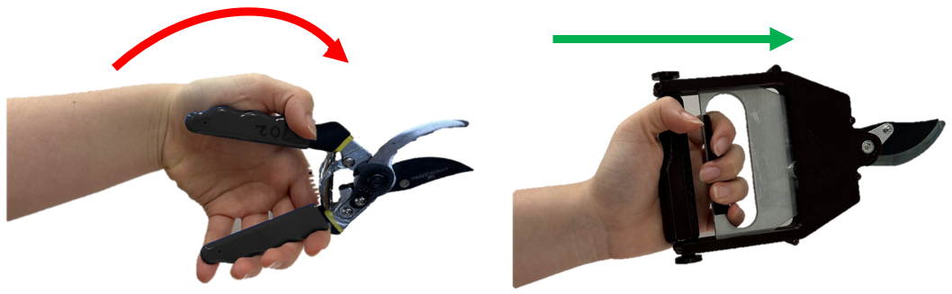
Figure 10: Wrist orientation of typical shears (left) and newly designed shears (right)

The new design also applies stress away from the most sensitive parts of the hand, as can be seen in Figure 11. This figure is adopted from a paper that studies the various parts of the hand and provides information on how much pressure the hand can withstand before experiencing damage. The generic shears design directly utilizes area 2 to hold the shears and apply load, while the new design shifts the pressure onto the middle of the hand, applying the load more horizontally.
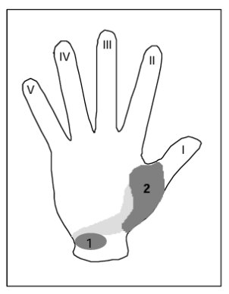
Figure 11: Most sensitive parts of the hand [9]

This design also utilizes the strongest parts of the hand by engaging all four fingers due to the raised finger bed. It also solves previous issues of developing rust on typical shears as this design has replaceable blades that can be easily swapped out and an internal locking mechanism that will not rust.

  - Hand Fatigue Test
The team conducted a hand fatigue test on typical shears and the newly designed shears to see if the motion of pulling is more comfortable and easier than a squeezing motion. Various users executed a cutting motion using both shears with their arms extended to mimic harvesting vegetables. The users were asked to do this motion until they experienced fatigue in their wrist, and the number of cutting motions they could do was recorded. Using the results seen in Figure 12, the team found an average 19% increase in actuation using the new shears as compared to typical shears, proving that their design is more comfortable on the hand.

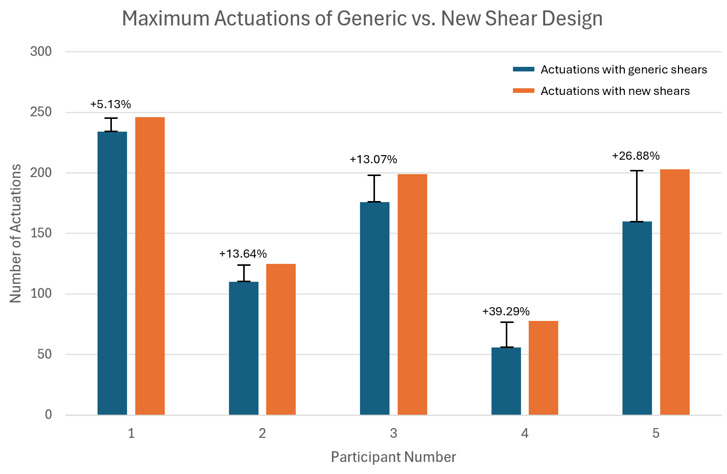
Figure 12: Comparison of max actuations between generic design and new design

  - Issues
The biggest issue with the current prototype is jamming caused by the middle actuator falling out of line with the blade arms. If the actuator is pulled too far back, the plate slips and catches on one of the arms, preventing the plate from moving back up. To combat this, a guard was implemented to prevent the middle plate from being pulled too far, eliminating the jamming issue.

Another issue that affected the performance of the prototypes was friction between the case and the inner plate. Because the inner mechanism was spring-loaded using compression springs, it was difficult to prevent buckling. The springs that were applying loads on the arms of the blades would often buckle and push against the plate, forcing the actuator against the plastic shell. Further chamfering the inner plate actuator edges manually with a file reduced the friction and allowed the plate to slide, but if the plate rotated in plane with the shell, it would get stuck. To prevent buckling, a telescopic spring, such as the one found in generic shears, could be used, but a redesign to account for the spring size would be needed.

Preventing rotation and keeping the mechanisms in line with each other was a challenge. Due to the size constraint and tolerancing in relation to the middle plate, the springs were not loaded with a perfectly axial force, which contributed to the buckling. In a later design that was later discarded, the middle plate was moved to the side to prevent jamming, but because the shears were no longer symmetrical, the plate would rotate and increase friction between the shell walls. Because the blades were lifted from existing market bypass shears, the new design also had to adopt the bypass blade actuation method. Stopping the blades from deflecting while still allowing them to slide past each other was another design challenge that had to be addressed.

- Conclusion
The purpose of this project was to help workers with disabilities at Smile Farms harvest vegetables over an extended period of time. The new and improved garden shears incorporate a more comfortable pulling motion, as opposed to a squeezing motion, to utilize the strength of all four fingers. This allows the workers at Smile Farms to use these shears comfortably for long hours. The employees at Smile Farms were very confident in the design and thought it was much more comfortable and intuitive to use than typical shears. After speaking with judges at the CREATE 2025 Symposium, the team received a lot of positive feedback from judges, suggesting that their product can help a much larger demographic. The team believes their product could help not only the employees at Smile Farms, but also the elderly who enjoy gardening but struggle to garden as they age, or even other individuals who enjoy gardening but have health issues like arthritis, carpal tunnel, etc.

  - Future Work
Although the shears work to cut smaller stems for tomatoes and herbs, there is currently not enough mechanical advantage to cut anything larger. Calculations could be made to optimize the length and starting angle of the internal shears arm. This would make it more similar to a standard pair of shears. However, the problem lies in the size constraints of the case and how far the user has to pull down to cut.

To make the shears more comfortable, a rubber handle could be added. Silicone could be an alternative material to plastic, as it would coat the outside like regular shears handles.

When holding the shears, most of the weight is placed at the blades, making it heavier at the front. This is due to the plastic case being much lighter than the steel shears blades. To combat this, an additional weight could be placed at the handle to reduce the moment. Alternatively, a wrist strap could be added to the shears so that the wrist wouldn’t feel fatigue due to the uneven weight distribution.

ACKNOWLEDGEMENTS
We would like to thank our advisor, Professor David Wootton, and the shop staff for our design consultations. We would also like to thank NYSID for sponsoring this project, and CP Unlimited, Jessica Ann Francese, and the Smile Farms employees for their support and feedback.
REFERENCES
[1] Mahachandramuki, E., P. Kathirvelan, and S. Selvakumar. "Home Tools For Gardening." Farming at Home (2024): 136.
[2] Relf, D. (2000) ‘Gardening Equipment’.
[3] Walden, F. R. J., Baxendale, K. M., Kelsall, A. D., and Cochrane, G. M., 1997, “Gardening: an Equipment Guide (Equipment for Disabled People),” Disability Information Trust, Oxford.
[4] Sugiyama T, Whitney DG, Schmidt M, Haapala H, Bowman A, Peterson MD, Hurvitz EA. Measuring grip strength in adolescents and adults with cerebral palsy in a clinic setting: Feasibility, reliability, and clinical associations. Dev Med Child Neurol. 2024 Jan;66(1):87-94. doi: 10.1111/dmcn.15662. Epub 2023 Jun 5. PMID: 37277918.
[5] Giampaoli, S., Ferrucci L., Cecchi F., Lo Noce C., Poce A., Dima F., Santaquilani A., Vescio MF, Menotti A., 1999, “Hand-grip strength predicts incident disability in non-disabled older men,” Age and Ageing, 28(3), pp. 283–288.
[6] R. L. Parish, 1998, “Operating force requirements for manual pruning shears,” Applied Engineering in Agriculture, 14(4), pp. 349–352.
[7] SELVİ, K., KABAŞ, Ö. and KARATAŞ, M. (2019) FORCE REQUIREMENTS OF DIFFERENT MANUAL PRUNING SHEARS WHEN CUTTING ABELIA (ABELIA GRANDIFLORA) BRANCHES. Available at: https://2019.tae-conference.cz/proceeding/TAE2019-085-Kemal-Ca%C4%9Fatay-Selvi.pdf
[8] Office for Human Research Protections (OHRP) (2024) The Belmont Report, HHS.gov. Available at: https://www.hhs.gov/ohrp/regulations-and-policy/belmont-report/index.html (Accessed: 16 December 2024).
[9] Paivinen, M. (2002). The assessment of ergonomics and usability of consumer products – Four case studies on hand tools [PhD thesis]. Tampere 2002.

APPENDIX A: Hand Fatigue Testing
Table 2: Max reps for generic vs. new shear design before experiencing fatigue
 | Regular Shears Max Reps | New Shears Design Max Reps | % Change
Contestant 1 | 234 | 246 | 5.13%
Contestant 2 | 125 | 125 | 13.36%
Contestant 3 | 199 | 199 | 13.07%
Contestant 4 | 78 | 78 | 39.29%
Contestant 5 | 203 | 203 | 26.88%

APPENDIX B: Force Testing of Shears
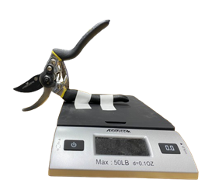
Figure 13: Test set up for measuring the force to cut tomato stems

Table 3: Diameter of tomato stem and force required to cut
Diameter (in) | Force (lb)
0.120 | 4.08
0.123 | 3.81
0.091 | 2.01
0.131 | 2.67
0.115 | 2.17
0.155 | 5.57

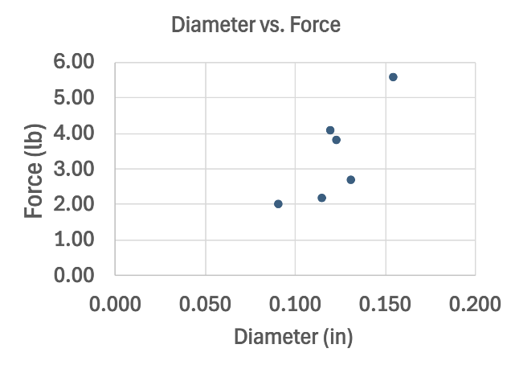
Figure 14: Diameter of tomato stem vs force to cut tomato stem

