November 4, 2015

The Amir Sahib

Ahmadiyya Muslim Jama’at Nigeria

KM 23 Lagos Abeokuta Exp. Way

Ojokoro, Lagos

Dear Sir

Assalam Alaikum Warahmatullah Wabarakatuhu

**HUMAN RESOURCE MANAGEMENT SOFTWARE**

The staff strength of our Jama’at which has risen to 339 calls for a robust software to effectively manage the staff record. A software that will provide management with first-hand information about staff across various demographic strata. It is against this backdrop that I wish to honourably offer the Jama’at a robust tailor-made Human Resource software that is tagged:

* *AHMADIYYA HUMAN RESOURCE MANAGER*

The software has the following features:

* It captures all the necessary bio-data and employment details of the staff
* It favourably inter-face with the existing Payroll software. The management can have an overview of the payroll for collective and individual management
* The software is tightly coupled with our Accounting Software in such a way that one can view the staff financial commitment with the Jama'at
* It provides a good platform for hiring and firing of staff
* It is designed with a range of reports as follows:
  + Staff List A-Z
  + Staff List By Age
  + Staff List By Auxiliary Body
  + Staff List By Length of Service
  + Staff List By No. of Children
  + Staff List By State of Residence
  + Staff List By Grade
  + Staff List By Department
  + Staff List By Academic Discipline
  + Staff List By Ghost Worker

The following are few snapshot overview of the software

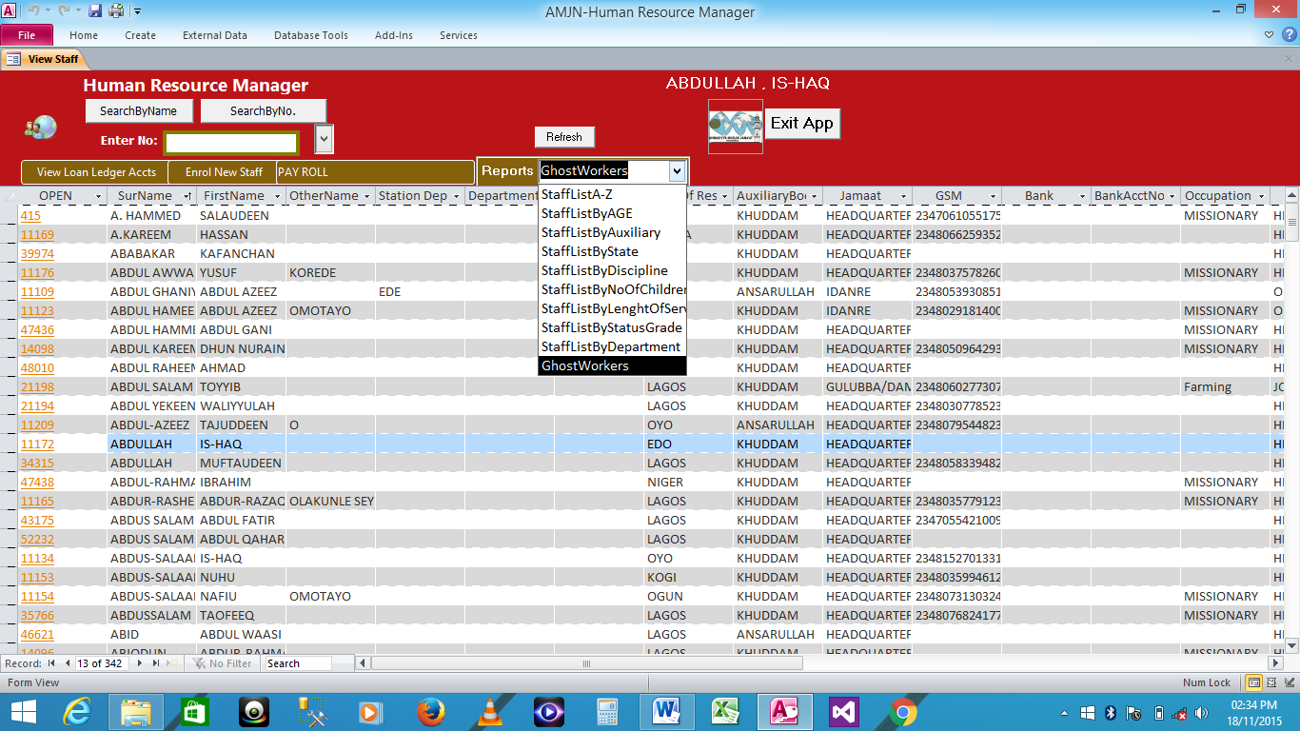

The Home page of the software, showing list of staff in Jama'at employment

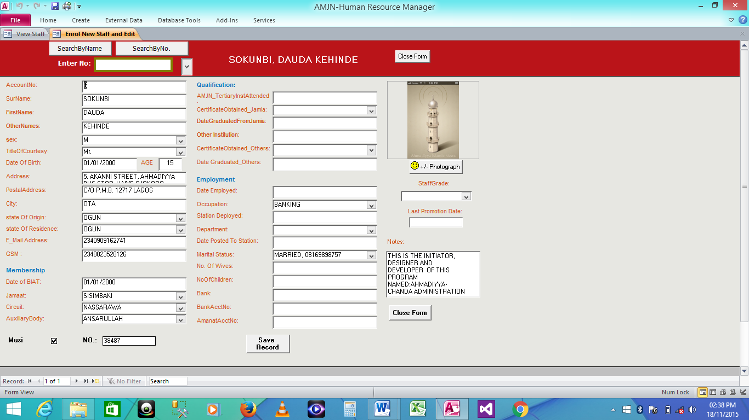

A snapshot showing detail of a staff record

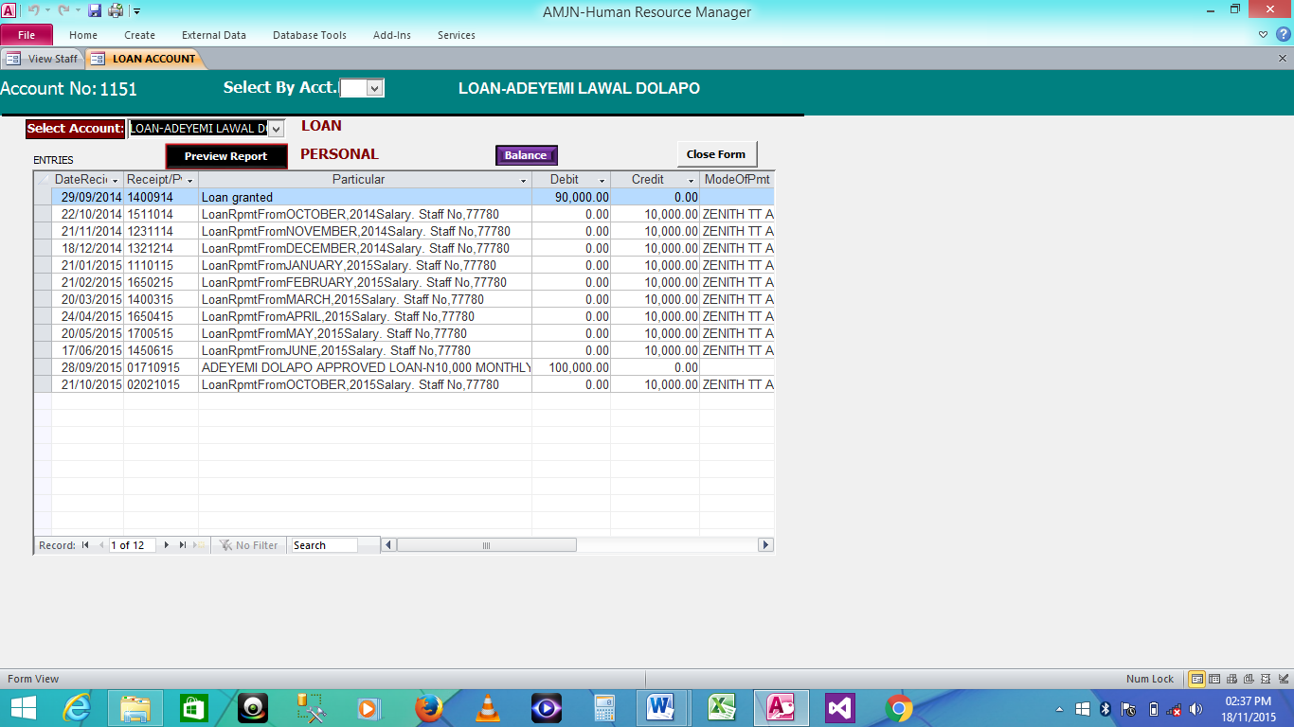

A window showing detail of a staff financial commitment to the Jamaat

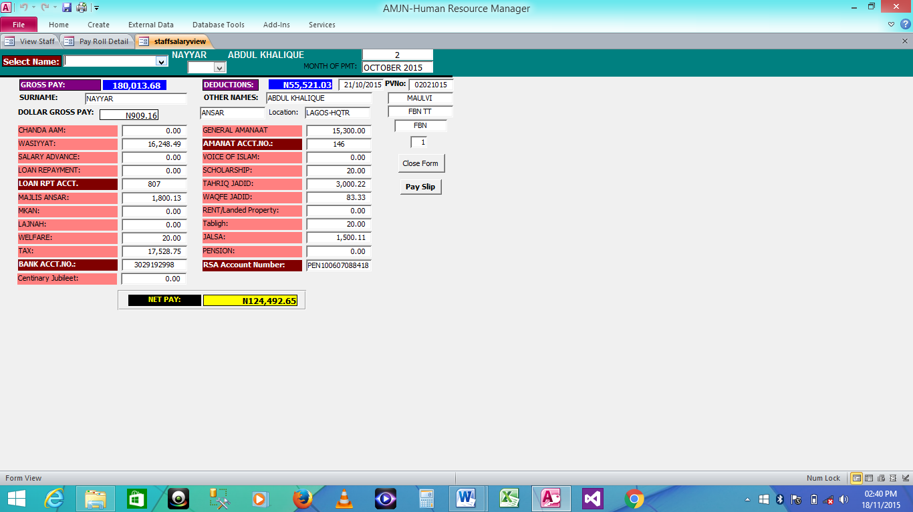

An interface with Payroll showing a staff payroll details

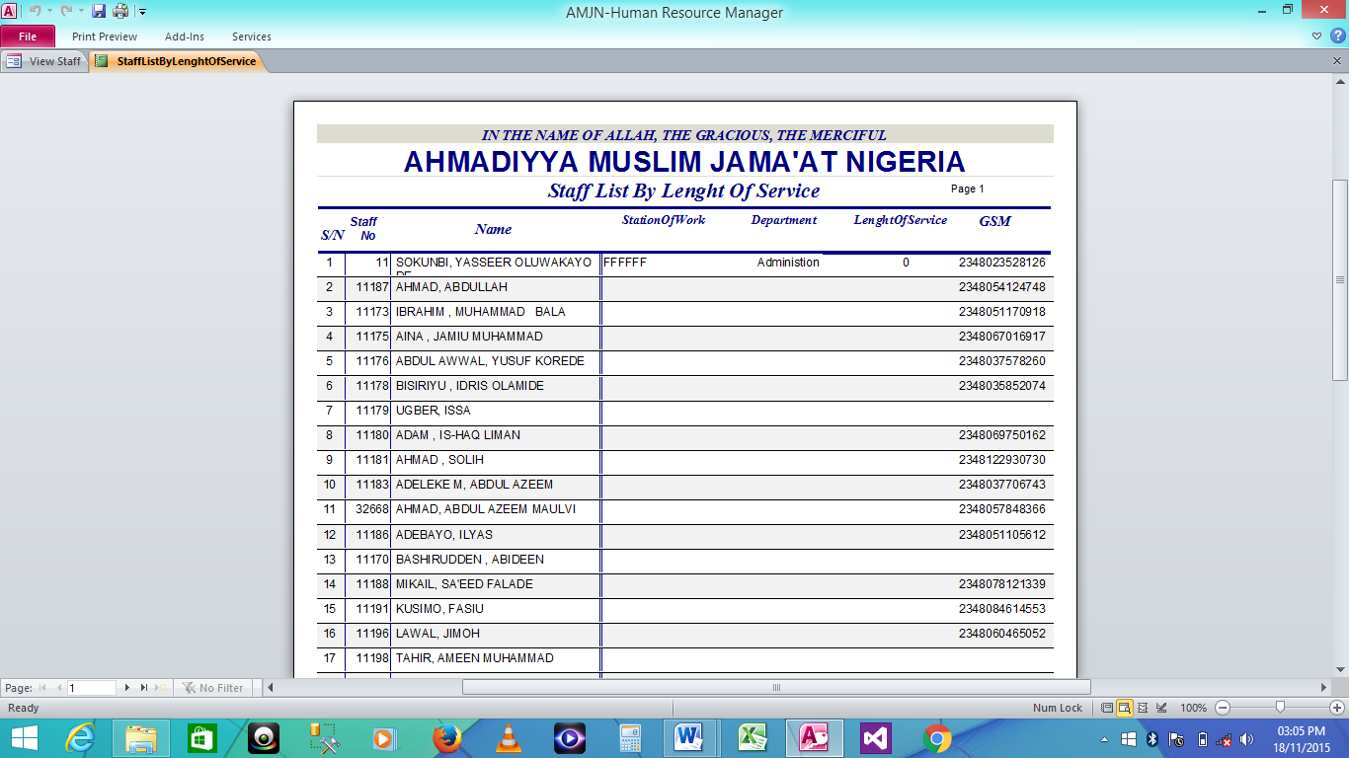

A section of the report showing staff and Length of Service

I have developed several other software free-of-charge for the Jama'at which includes:

1. Chanda Administration Systems
2. Ahmadiyya Account Management Systems
3. Ahmadiyya Payroll Managers
4. Scholarship Chronicles
5. Rishtanata Administration Software
6. Chanda Administration Systems(Circuit Version)

* Hospital Management Software Under proposal
* Hospital Accounting Software

**PRICE**

The market price for this software is N1,500,000. However, I can give it to the Jama'at almost free of charge at the cost of N300,000

Jazakallahu Khairan

Yours faithfully,

SOKUNBI D.K

Programmer