**Student Management System (SMS)**

**Documentation**

1. The definition of topic.

School Management System is a is a complete school management software designed to automate a school's diverse operations from classes, exams to school events calendar, classes in the class and subject for the students to study.

This school software has a powerful online community to bring parents, teachers and students on a common interactive platform. It is a paperless office automation solution for today's modern schools. The School Management System provides the facility to carry out all day to day activities of the school, making them fast, easy, efficient and accurate.

1. The purpose of topic.

* The system helps a school manage data
* The system help to communications between students and teachers.
* A school system generates and uses a large amount of data. This data must be communicated appropriately to students, faculty, and parents.
* It easy for the students to access to all the resource in school.
* This system easy for the school to manage all students, teachers and everything in the school.

1. The process of building.

The first day we our team have a meeting to discuss about the topic that we will develop to help our country or to help the customer that easy to manage their business.

After we select the topic to develop, we are discussed in our team to choose the language PHP, Editor, Database. We start analysis the process of system and design the mockup template for the system. We start coding static template system by us HTML and CSS language. We design user interface. When we finished the design user interface we started implement with backend by using PHP language.

The end of implement the process of system. We testing the functionality the system working.

1. The module of system

* Login module
* School information
* Class module
* Subject module
* Student module
* Change password module

1. Task Response

* Sith Phor : Function login, school in formation and class module.
* Sokvebol Kol: Function Register to the system, subject module, change password and student management.

1. Function overview

* Login Module:

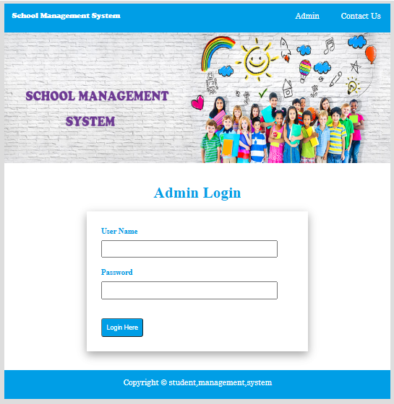

* Class Module

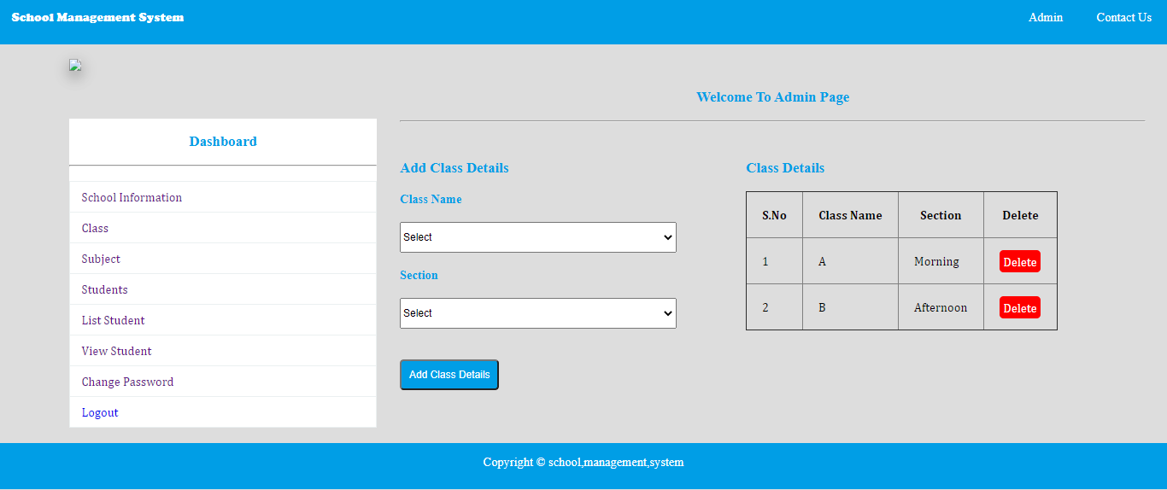

* Subject module

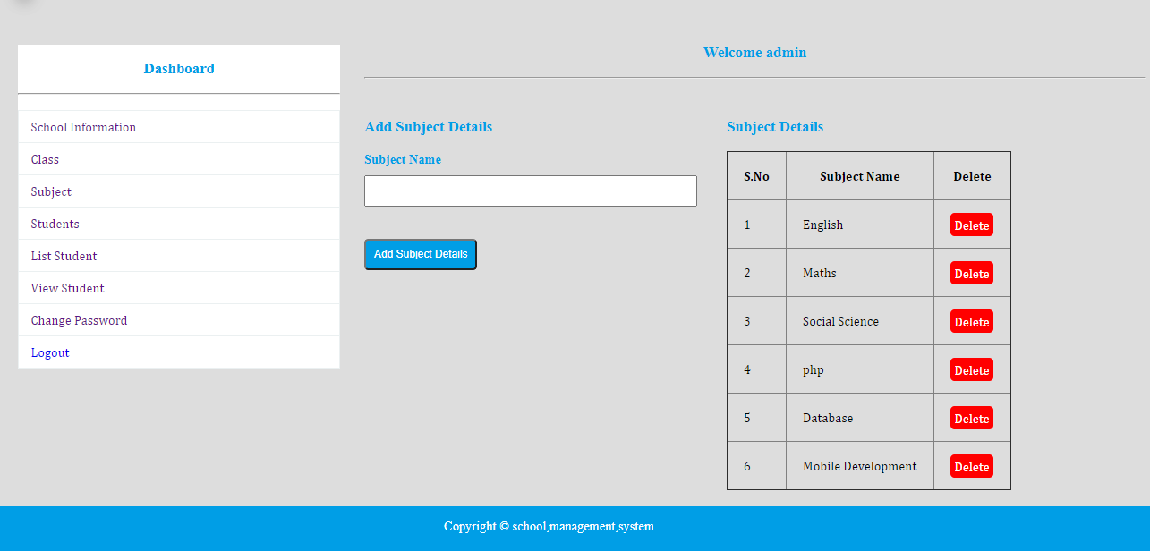

* Student module
* 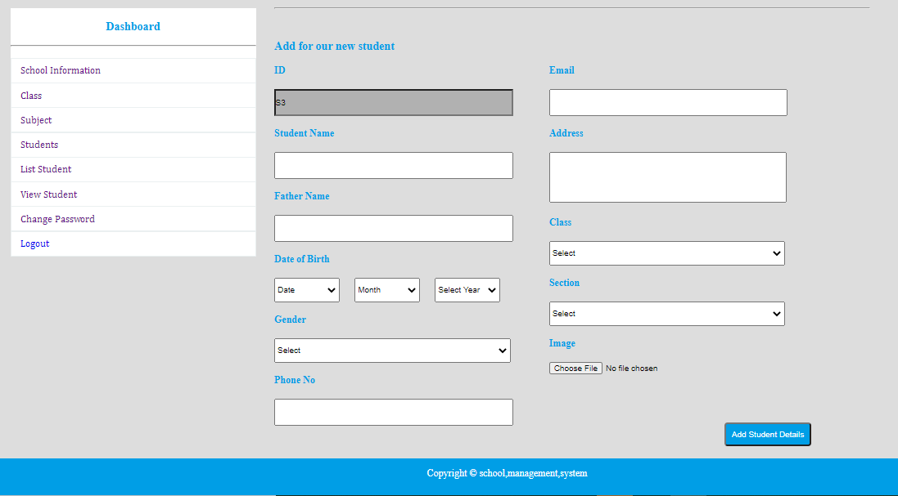 Add student

* List student

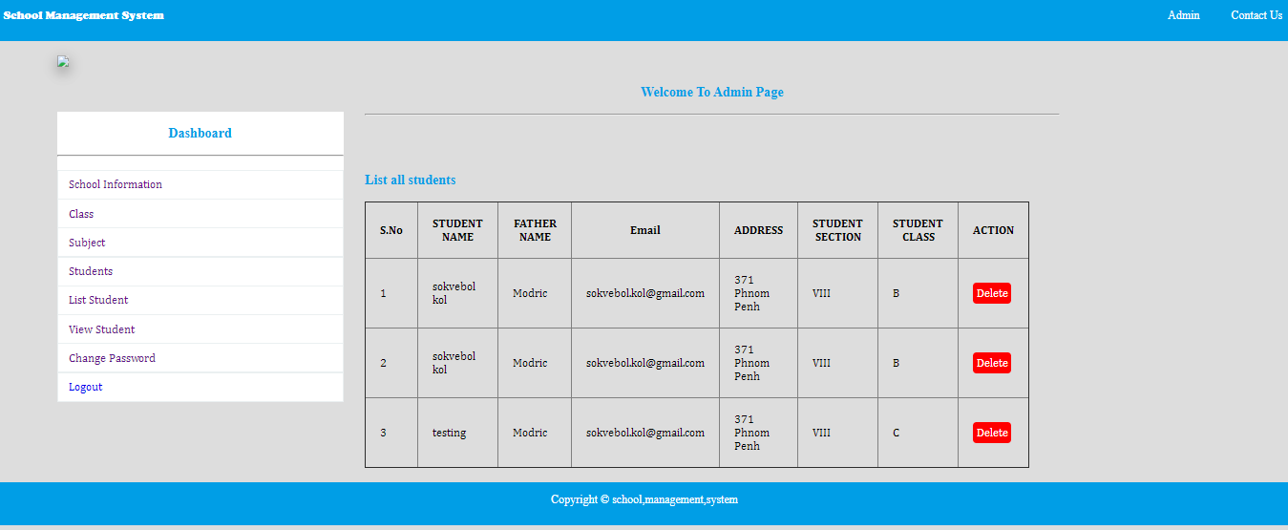

* Search and View Student

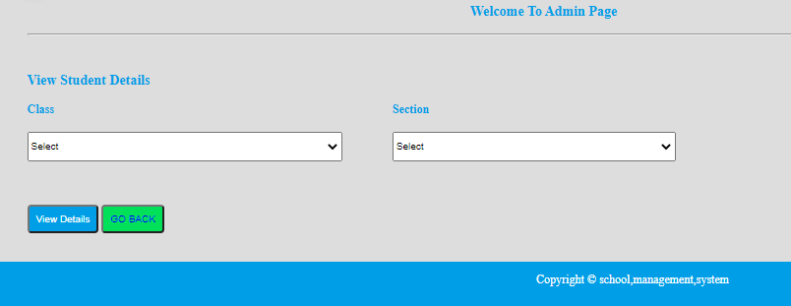

* Change password

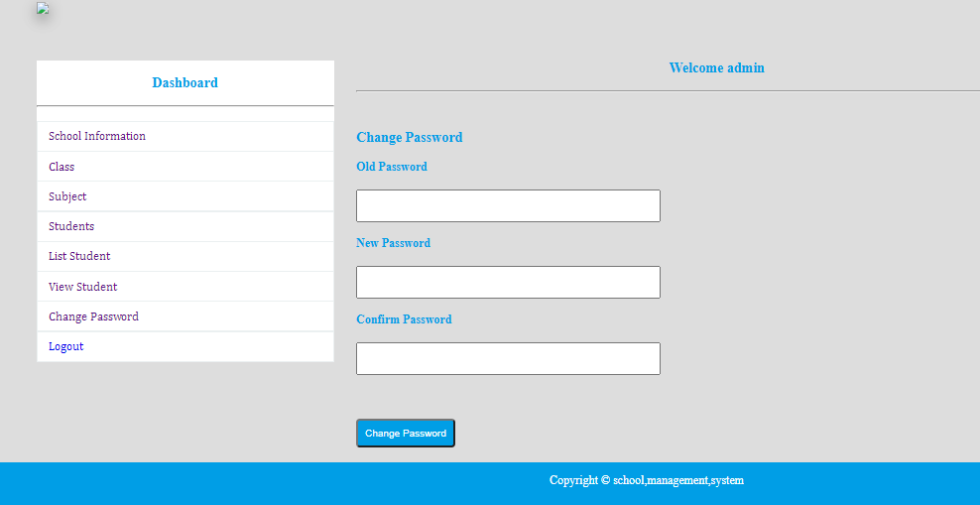

The End!!