**Team Report**

**Project Name: Tech Store**

**Team Members:**

* Kol sokvebol
* Phor Seth
* Soeun Sreykhuoch

**Introductions:** Project Tech Store we create for list product

technology by category we can order the product and

pay service of the product by system.

**Project Feature:**

* Login page
* Homepage
* Navigation bar
* Banner
* Promotion new product
* List of products
* Advertisement
* Contact us page

**Responsibility:**

* **Kol Sokvebol**
* 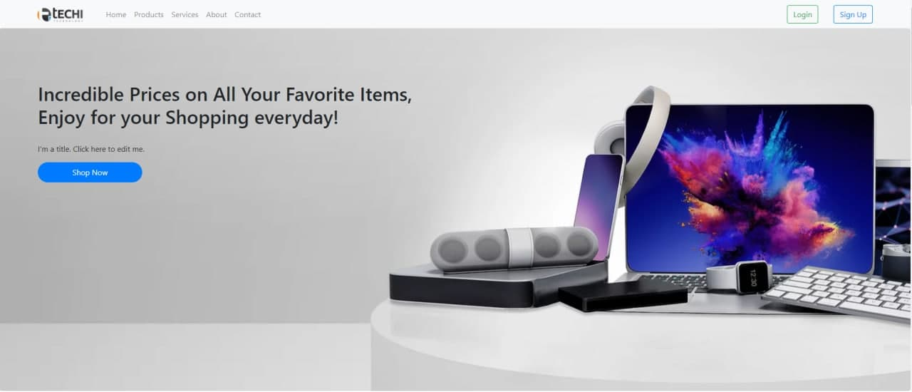 homepage-header and banner
* homepage-new promotion



* homepage-section advertisement and footer

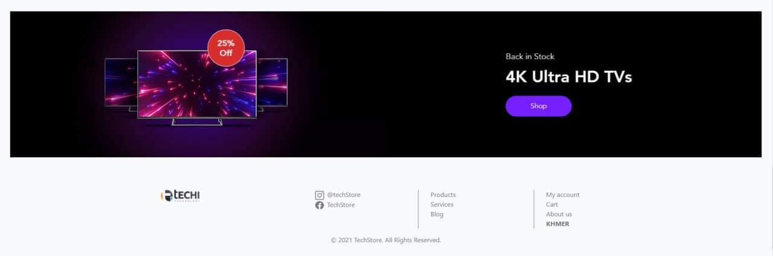

* list of product best seller

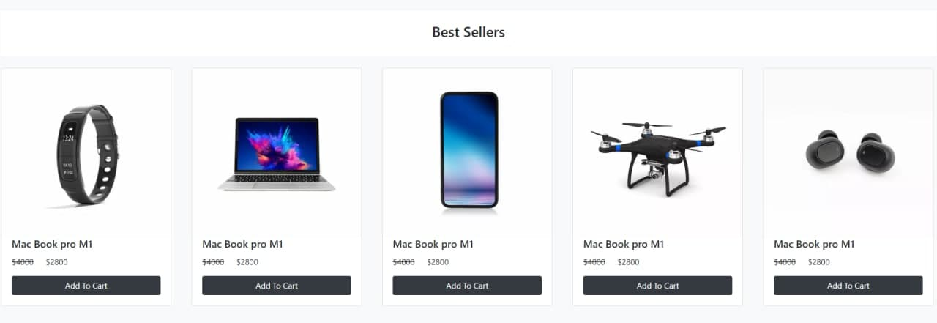

* Shop by category

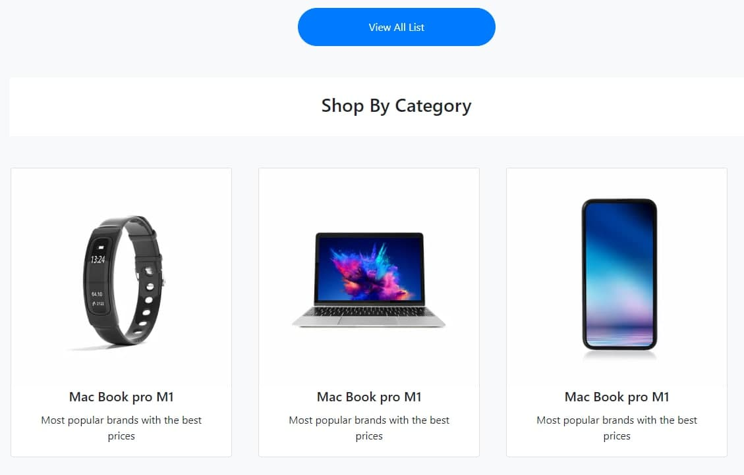

* Contact us page
* Phor Seth

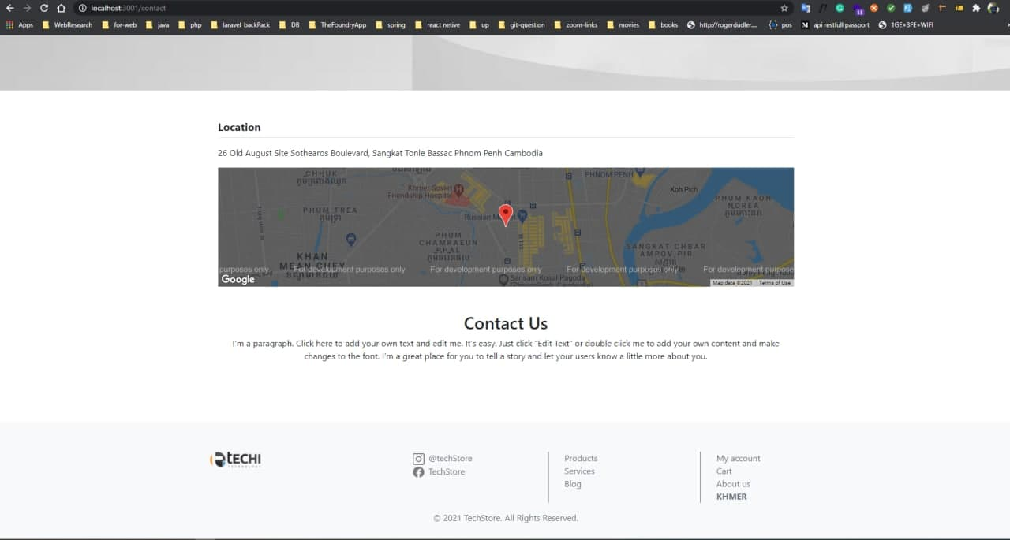

* Login page

Soeun Sreykhouch

