Hair Salon Scheduling and Product Inventory System Design Document

Project Members:
Date:
Client:
Project Manager: Randolph B. Kaltenbach

Table of Contents
Section 1: Preface 6
1.1 Purpose of this Document 6
1.2 Documentation Standards 7
Section 2: User Requirements 8
2.1 Business Overview and Objectives 8
2.2 Project Overview 8
2.2A Statement of the Problem 8
2.2B Project Scope 8
2.2C System Environment 9
2.2D Current System 9
Section 3: Requirements Models 10
3.1 Use Case Diagram 10
3.2 Use Case Descriptions and Scenarios 11
3.3 Business Rules 25
3.4 Problem Domain Class Diagram 45
3.5 State Machine Diagram 46
3.5A shopSchedule 46
3.6 Activity Diagram 47
3.6A Generate Shop Schedule 47
Section 4: System Design 48
4.1 Layered Architecture 48
4.1A Package Diagram 48
4.1B Component Diagram 49
4.2 Hardware Architecture 50
4.2A Textual Description 50
4.2B Deployment Diagram 51
4.2C Communication Mechanisms 51
4.3 Hardware Platform 52
4.3A Development System 52
4.3B Production System 52
4.4 Software Platform 53
4.4A Development system 53
4.4B Production system 53
4.5 Interaction Model 54
4.5A Textual Description 54
4.5B Main Screens 56
4.5C Data Entry / Detail Forms 60
4.5D Search Forms 62
4.5E Error and Confirmation Message Boxes 63
4.6 Persistence Model 65
4.6A Conceptual ERD 65
4.6B Implementation ERD 65
4.6C Table Definitions 66
4.6D Expected Data Size 68
4.6E Persistence Class Diagram 69
4.7 Class Diagram 70
4.7A User Interface Class Diagram 70
4.7B Problem Domain Class Diagram 71
4.7C Persistence Class Diagram 72
4.8 Interaction Sequence Diagrams 73
4.8A Adjust Product Inventory 73
4.8B Confirm an Appointment 74
4.8C Log In 75
4.8D Log Out 76
4.8E Maintain Availability 77
4.8F Maintain Client 78
4.8G Maintain Order 79
4.8H Maintain Product 80
4.8I Maintain Service 81
4.8J Maintain Stylist 82
4.8K Maintain Supplier 83
4.8L Report Order List 84
4.8M Report Orders 85
4.8N Report Product Usage 86
4.8O Report Service Usage 87
4.8P Request Appointment 88
4.8Q Schedule Appointment 89
4.8R Update Appointment 90
4.8S View Shop Schedule 91
4.9 Data Dictionary 92
Section 5: System Administration 115
5.1 Security 115
5.2 Operation 115
5.3 Backup and Restore 115
Section 6: Project Management 116
6.1 Schedule 116
6.2 Design Document Gantt Chart 117
6.3 Team Configuration 118
6.4 Project Standards and Procedures 118
6.4A Team Purpose 118
6.4B Team Standards 119
6.4C Roles 119

Table of Figures
Figure A - Use Case Diagram 10
Figure B - Problem Domain Class Diagram 45
Figure C - State Machine Diagram - shopSchedule 46
Figure D - Activity Diagram - Generate Shop Schedule 47
Figure E - Package Diagram 48
Figure F - Component Diagram 49
Figure G - Deployment Diagram 51
Figure H - Main Screen 56
Figure I - Main Schedule Screen 57
Figure J - Main Customer Screen 58
Figure K - Main Inventory Screen 59
Figure L - Book Appointment 60
Figure M - Appointment Details 61
Figure N - Search Appointment 62
Figure O - Search Available Time 62
Figure P - Appointment Conflict Error 63
Figure Q - Cancel Appointment 63
Figure R - Confirm Appointment 63
Figure S - Invalid Entry Error 64
Figure T - No Matches Found 64
Figure U - No Selection Error 64
Figure V - Conceptual ERD 65
Figure W - Implementation ERD 65
Figure X - Persistence Class Diagram 69
Figure Y - User Interface Class Diagram 70
Figure Z - Problem Domain Class Diagram 71
Figure AA - Persistence Class Diagram 72
Figure BB - Adjust Product Inventory 73
Figure CC - Confirm an Appointment 74
Figure DD - Log In 75
Figure EE - Log Out 76
Figure FF - Maintain Availability 77
Figure GG - Maintain Client 78
Figure HH - Maintain Order 79
Figure II - Maintain Product 80
Figure JJ - Maintain Service 81
Figure KK - Maintain Stylist 82
Figure LL - Maintain Supplier 83
Figure MM - Report Order List 84
Figure NN - Report Orders 85
Figure OO - Report Product Usage 86
Figure PP - Report Service Usage 87
Figure QQ - Request Appointment 88
Figure RR - Schedule Appointment 89
Figure SS - Update Appointment 90
Figure TT - View Shop Schedule 91
Figure UU - Design Document Gantt Chart 117

Section 1: Preface

1.1 Purpose of this Document

This document will provide the audience with a detailed design schematic for the hair salon scheduling and product inventory system. The intended audience will be our project manager, Randolph B. Kaltenbach, as well as our client for the system.

The main design elements discussed within this document will include a step-by-step execution of each use case description including the possible error messages and confirmation boxes that the user will encounter. In addition, a state machine diagram will outline the various screen shots that will be displayed throughout the execution of a selected use case.

Screenshots of the main interface as well as errors, confirmation boxes, data entry forms, and data display forms will be included. Interaction sequence diagrams for each use case will be documented as well as many other design elements that have been required to develop this software platform.

A Class Diagram shows a more in-depth look on the design scheme and how the database classes related with the interface classes. An actually procedures will show how the system work with the hair salon deals with appointment and inventory procedure.

1.2 Documentation Standards

This document contains various standards to aid the reader in viewing all sections easily and consistently. They are outlined below:

1. Section headings are displayed in bold Arial font with a size of 24 point. In addition, there will be a section number assigned to each section heading.
Ex. Section 4: Heading

2. Section sub headings are in bold Arial font with a size of 16 point. Section sub heading numbers will be assigned.
Ex. 1.2 Sub Heading

3. Section sub-sub headings will be in bold, italic Arial font with size 14 point. Capitalized letters will be added to the section number.
Ex. 2.1D Sub-Sub Heading

4. Section sub-sub-sub headings will be in bold, Arial font with size 12 point. Numbers will be added to the end of the section character.
Ex. 2.1D2 Sub-Sub Heading

5. All body text will be in basic 12 point Arial font.

6. All captions will be in italic 10 point Arial font.

7. All pages will have a header displaying the current section and page number.

8. The appendix and index will not contain any section numbers, however all other heading font styles and sizes previously mentioned will be used.

Section 2: User Requirements

2.1 Business Overview and Objectives

Hair Candy is a small salon located within the community of Copperfield. It employs various stylists and estheticians all supervised by the shop manager, Candy. Candy is the main client involved in the design and requirements of this system. Her input is vital to the success of this system.

Hair Candy’s mission is to provide a comfortable, personal environment for their customers to allow for one-on-one attention and service. The goal is to keep this mission as the utmost importance when considering a new system, allowing an increase in structure without sacrificing the service of the customer. Hair Candy spends more time being personal with the client rather than just seeing them out the door. The current structure in place allows for this to happen, therefore they are hesitant to change to a new system.

2.2 Project Overview

2.2A Statement of the Problem

Hair Candy would like a more functional system in place of the current system without sacrificing the flexibility and efficiency that it provides.

2.2B Project Scope

Many of the functions present in the current system must be passed on to the new information system to be put in its place. The main functionality involves booking clients for appointments daily and allowing modification of those appointments.

Hair Candy will require customer information for an appointment such as name, phone number and e-mail address (optional). As new clients are booked, their information will be stored within a database for future appointments. Allowing real-time changes to existing appointments is also required. Many customers may require additional services when they arrive, those additional variables will be added to the original slot. Manual cancellations of scheduled appointments will also be within the project’s capacity.
In addition to the appointment functionality, inventory tracking will also be an added component. When an inventory count is complete for a period, the stylist or manager can adjust the amount of the product in the system to keep it up-to-date. At the same time, the product supplier information is also stored in the system. By combining both type of information and the ability to generate ordering reports, it can help keep organize when doing any product ordering.

Hair Candy has discussed the possibility of a web interface that allows clients to place appointment requests online with the specified information. Final approval will come from Candy or another Hair Candy employee. We will be implementing this web interface however it will be independent of the core system allowing for separate modification or removal.

As a result from the above, the main functionalities of the new system would involve:
- Allow the client book an appointment though the website.
- Allow the stylist and manager to book an appointment for a client.
- Maintain the salon appointment database.
- Maintain the salon inventory (both product and supplier) database.
- Generate various reports for ordering product and forecasting sale.

2.2C System Environment

The environment that this system will operate in will be a basic hair salon business. There will be a high electrical demand from the building so a possible surge protection system may be put in place. In the summer months, there need to be a high heat tolerance with all hair electrical appliances in the facility being used. The main hardware will be placed at the front desk of the salon to allow for the most convenient access.

2.2D Current System

The current system in place is a strictly manual entry procedure. When customers provide information, it is manually entered into an appointment book at the front desk. The flexibility of the current system is the largest contributor to its success in this environment. It allows immediate changes to be entered with no hesitation or difficulty. All of the inputs needed for this current method will be reassigned into the new system.

The only shortcoming of this system is the security of it. The fact that anyone and everyone have access to the information makes it an issue that will be address in the new system by using a security login system to restrict access from the public. In addition, the users of the current system are very comfortable with its use and may be reluctant to change the procedure due to possible complexities and lost time in training with the new system. Simplicity will be a major factor in design of the new interface.

Section 3: Requirements Models

3.1 Use Case Diagram

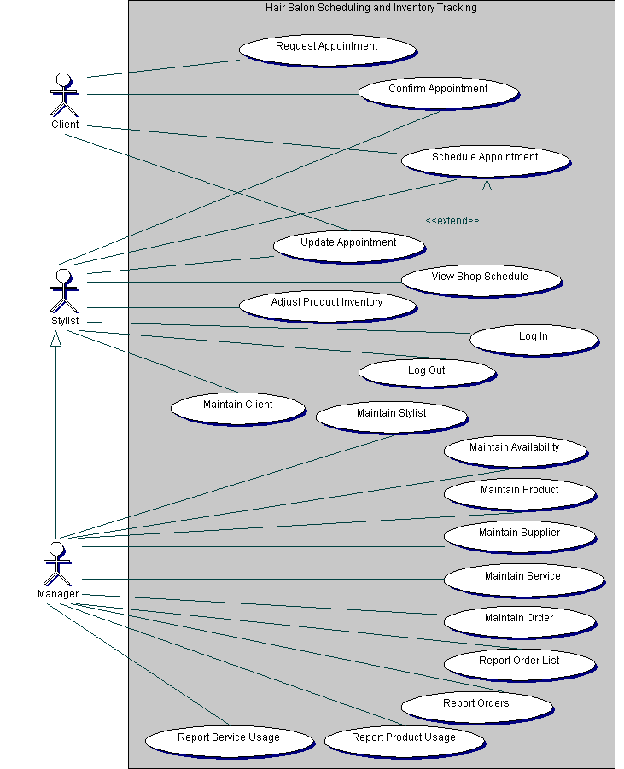
Figure A - Use Case Diagram

3.2 Use Case Descriptions and Scenarios

Use Case: Adjust Product Inventory

Actors: Stylist, Manager

Purpose: This use case begins when an actor wants to change the item quantity in the product inventory.

Prerequisites: The User must be logged in and system is up and running from the main screen.

Normal Flow:
1.1 Stylist clicks “Adjust Product Inventory”.
2.1 System displays list of all products and quantities.
3.1 Stylist clicks on product
OR
Stylist enters criteria and clicks “Search”
(Run Maintain Product Use Case 2.1 -8.1).
(Error E1 3.1.1)
4.1 System displays product information (report).
5.1a Stylist enters a quantity and clicks the
“Add” or “Remove” button.
(Proceed to 6.1)
(Error E2 5.1.1)
OR
Stylist clicks “Cancel” (Proceed to 7.1)
5.1b Stylist enters a quantity and clicks the
“Update Quantity” button.
(Proceed to 6.1)
(Error E2 5.1.1)
OR
Stylist clicks “Cancel” (Proceed to 7.1)
6.1 System displays an updated list of all products and quantities.
7.1 System returns back to the Main Menu.

Errors
(E1)
3.1.1 One or more required fields are empty or invalid.
3.1.2 System displays an error message detailing the invalid fields.
3.1.3 Stylist clicks the “Ok” button.
3.1.4 System displays list of all products and quantities. Continues from step 3.1
(E2)
5.1.1 Can not remove if the resulting quantity is less than zero.
5.1.2 System displays an error message detailing the quantity error.
5.1.3 Stylist clicks the “Ok” button.
5.1.4 System displays product information (report). Continues from step 5.1

Business Rules:
BR1: The quantity of a product can not be less than zero. The system will prevent this from happening.

Use Case: Confirm an Appointment

Actors: Stylist

Purpose: This use case begins after a customer sends a request of an appointment at a time which is not open in the scheduling system through.

Prerequisites: System displays the notification on the main screen.
Normal Flow:
1.1 Stylist clicks “View Requested Appointment” button on the main screen.
2.1 System displays the appointment details as well as a GUI representation of the time slot on the specified date.
3.1 Stylist clicks “Confirm Appointment” button. Proceed to 3.2a
OR
3.1 Stylist clicks “Cancel Appointment” Proceed to 3.2b
3.2a System saves the appointment into the schedule system.
4.1a System sends a confirmation to the web server.
5.1a Web server sends a confirmation e-mail to the customer. Process to step 6.1.
3.2b System deletes the appointment.
4.1b System sends a notification to the web server.
5.1b Web server sends a cancellation e-mail to the customer. Process to step 6.1.
6.1 System loads the main page.

Use Case: Log In

Actors: Stylist, Manager

Purpose: This use case begins when an actor wants to log in to the system.

Prerequisites: The system is up and running from the log in screen.

Normal Flow:
1.1 Stylist starts system.
2.1 System displays log in screen.
3.1 Stylist enters username and password and clicks “OK”.
OR
Stylist clicks on “Cancel” (Terminate System)
4.1 System validates the log in information from the database. (Error E1 4.1.1)
5.1 System displays Main Menu.

Errors
(E1)
4.1.1 Username/password is invalid.
4.1.2 System displays an error message. System continues from 2.1

Use Case: Log Out

Actors: Stylist, Manager

Purpose: This use case begins when an actor wants to log out of the system.

Prerequisites: The User must be logged in and the system is up and running from the main screen.

Normal Flow:
1.1 Stylist clicks on “Log Out”.
2.1 Disable all further access (except log in) to the system.
3.1 System displays log in screen.

Use Case: Maintain Availability (Create, Update, Report, Delete)

Actor: Manager

Purpose: This use case begins when a manager which to create, update, report, or delete a stylist’s availability.

Prerequisite: User must be logged on, system must be displaying main screen

Normal Flow – View Record
1.1 Manager clicks “Maintain Stylist”
2.1 System loads Maintain Stylist GUI
3.1 Manager enters search criteria and clicks “Search”
(Error E1 3.1.1)
OR
Manager clicks “New Availability”. Proceed to 4.1D.
OR
Manager clicks “Cancel”. Proceed to 10.1A
4.1 System runs search and returns all results
5.1A Manager selects Stylist from search results
OR
Manager clicks “Cancel. Proceed to 3.1.
6.1A System Populates Maintain Stylist GUI with information
7.1A Manger clicks “Maintain Availability”
OR
Manager clicks “Cancel”. Proceed to 10.1A.
8.1A System loads and populates Maintain Availability GUI
9.1A Manager clicks “Cancel”
10.1A Returns to Maintain Stylist screen

Extended Flow - Update
9.1B Manager changes all values that need to be changed and clicks “OK”.
(Error E1 3.1.1)
OR
Manager clicks “Cancel”. Proceed to 6.1.
10.1B System persists updated availability to database
11.1B System displays successful operation screen
12.1B Manager clicks “OK”.
13.1B System returns to Maintain Stylist screen

Extended Flow - Delete
9.1C Manager clicks “Delete”
10.1C System deletes availability from database
11.1C System displays successful operation screen
12.1C Manager clicks “OK”
13.1C System returns to Maintain Stylist screen

Alternate Flow – Create
4.1D System loads New Availability Screen
5.1D Manager enters in information and clicks “OK”.
(Error E1 3.1.1)
6.1D System creates and persists new availability
(Error E2 6.1.1)
7.1D System displays successful operation screen
8.1D Manager clicks “OK”.
9.1D System returns to Maintain Stylist screen

Errors
(E1)
3.1.1 One of more required fields are empty or invalid
3.1.2 System displays an error message detailing the invalid fields
3.1.3 Stylist clicks “OK”. Proceed to 5.1A
(E2)
6.1.1 The availability begin created overlaps a currently existing availability
6.1.2 System displays an error message detailing error
6.1.3 Stylist clicks “OK”. Proceed to 5.1D

Business Rules
BR1: User can not delete availability if appointment is scheduled for that day and stylist.
BR2: User can not search for appointments that are in the past.

Use Case: Maintain Client

Actors: Stylist

Purpose: This use case begins when a stylist needs to add, modify, delete or gather a report of a client.

Prerequisite: User logged on and the system is up and running from the main screen.

Normal Flow: View Client Record:
1.1 The stylist clicks the “Maintain Client” button on the main menu.
2.1 System displays the Maintain Client GUI
3.1 The stylist enters the name of the client that they wish to view.
OR
The stylist enters the client’s information. Proceed to 3.1C
4.1 The stylist clicks the “search” button.
5.1 System searches the database for the client name and populates the Maintain Client GUI fields with the client’s information. (Error E1 5.1.1)

Extended Flow: Modifying a client
6.1A The stylist changes the necessary information of the client and clicks on the “save” button
7.1A System takes the information and commits it to the database.

8.1A System displays a confirmation message. To confirm the modification was completed.
9.1A The stylist clicks the “OK” button on the confirmation message.

Extended Flow: Deleting a client
6.1B The stylist clicks on the “Delete” button.
7.1B System displays a confirmation message to make sure the stylist wants to delete the client.
8.1B The stylist clicks the “yes” button.

9.1B System removes the client from the database.
10.1B System displays a confirmation message to confirm the client was deleted.
11.1B The stylist clicks the “OK” button on the confirmation message.

Alternate Flow: Adding a client
3.1C The stylist clicks on the “New Client” Button. (Error E2 3.1.1)
4.1C System takes information and commits It to the database.
5.1C System displays a confirmation message To confirm the client was added.
6.1C The stylist clicks the “OK” button in the confirmation message.

Errors:
(E1)
5.1.1 Client is not found in the database
5.1.2 System displays an error message saying that the client was not found.

5.1.3 Stylist clicks on “ok”
5.1.4 Stylist enters in another client name. Proceed to 4.1
(E2)
3.1.1 Stylist enters in invalid information
3.1.2 System displays an error message saying that the information entered was incorrect.
3.1.3 Stylist clicks on “ok”
3.1.4 Stylist enters the information again. Proceed to 3.1C

Use Case: Maintain Order(Create, Update, Report, Delete)

Actor: Manager

Purpose: This use case begins when a manager which to create, update, report, or delete an order.

Prerequisite: User must be logged on, system must be displaying main screen.

Normal Flow – View Record
1.1 Manager clicks “Maintain Order”
2.1 System loads Maintain Order GUI
3.1 Manager enters search criteria and clicks “Search”
(Error E1 3.1.1)
OR
Manager clicks “New Order”. Proceed to 4.1D.
OR
Manager clicks “Cancel”. Proceed to 10.1A
4.1 System runs search and returns all results
5.1A Manager selects order from search results
OR
Manager clicks “Cancel”. Proceed to 3.1.
6.1A System Populates Maintain Order GUI with information
7.1A Manger clicks “Maintain Order”
OR
Manager clicks “Cancel”. Proceed to 10.1A.
8.1A System loads and populates Maintain Order GUI
9.1A Manager clicks “Cancel”
10.1A Returns to Maintain Order screen

Extended Flow - Update
9.1B Manager changes all values that need to be changed and clicks “OK”.
(Error E1 3.1.1)
OR
Manager clicks “Cancel”. Proceed to 6.1
10.1B System persists updated Order information to database
11.1B System displays successful operation screen
12.1B Manager clicks “OK”.
13.1B System returns to Maintain Order screen

Extended Flow - Delete
9.1C Manager clicks “Delete”
10.1C System deletes order from database
11.1C System displays successful operation screen
12.1C Manager clicks “OK”
13.1C System returns to Maintain Stylist screen

Alternate Flow – Create
4.1D System loads New Order Screen
5.1D Manager enters in information and clicks “OK”.
(Error E1 3.1.1)
6.1D System creates and persists new Order
(Error E2 6.1.1)
7.1D System displays successful operation screen
8.1D Manager clicks “OK”.
9.1D System returns to Maintain Order screen

Errors
(E1)
3.1.1 One of more required fields are empty or invalid
3.1.2 System displays an error message detailing the invalid fields
3.1.3 Stylist clicks “OK”. Proceed to 5.1A
(E2)
6.1.1 The Order begin created already exists in the database
6.1.2 System displays an error message detailing error
6.1.3 Stylist clicks “OK”. Proceed to 5.1D

Use Case: Maintain Product

Actors: Manager

Purpose:
The Maintain Product use case allows the manager to add, view, update, or delete a Product’s record.

Preconditions: User logged on and the system is up and running from the main screen.

Normal Flow: View Product Record
1.1 User clicks the “Maintain Product” button on the main menu.
2.1 System displays the Maintain Product GUI.
3.1 User enters the UPC, brand, type Product name, or any combination of the last three criteria.
4.1 User clicks the “Search button”.
5.1 System searches the Product database.
(Error E1 5.1.1)
6.1 System lists the Product or Products (if more than one) in the list box.
7.1 User selects Product from the list.
8.1 System fills in the Product information into the fields of the Maintain Product GUI.

Extended Flow: Update Product Record
8.1A User modifies the fields in the Product record.
9.1A User clicks the “Save” button.
10.1A System displays continue or cancel message box.
11.1A User clicks the “OK” button.
12.1A System saves the Product changes to the database.
13.1A System displays in the message box a confirmation that the Product was modified.
14.1A User clicks the “OK” button in the confirmation message box.

Extended Flow: Delete Product Record
8.1B User clicks the “Delete” button.
9.1B System displays continue or cancel message box.
10.1B User clicks the “OK” button.
11.1B System deletes the Product record from the database.
12.1B System displays a message box that the Product was deleted.
13.1B User clicks the “OK” button

Alternate Flow: Add Product Record
4.1C User clicks the “Add” button.
5.1C System saves the Product record to the database.
6.1C System displays in the message box a confirmation that the Product was added.
7.1C User clicks the “OK” button in the confirmation message box.

Errors:
(E1)
5.1.1 Product(s) not found in database
5.1.2 System displays error message box with “Product Not Found” message.
5.1.3 User clicks “OK” button.
Return to 2.1

Business Rules

BR1: Each product must have a product record.
BR2: Each product will have a unique number.
BR3: There cannot be duplicate product records.
BR4: Product record can be accessed by UPC, name, brand, or type.

Use Case: Maintain Service

Actors: Manager

Purpose: This use case begins when a manager needs to add, modify, delete or gather a report of a service that the salon would offer.

Prerequisite: User logged on and the system is up and running from the main screen.

Normal Flow: View Service Record
1.1 The manager clicks the “Maintain Service” button on the main menu.
2.1) System displays the Maintain Service GUI
3.1 The manager enters the name of the Service that they wish to view.
OR
The manager enters the Service information. Proceed to 3.1C
4.1 The manager clicks the “search” button.
5.1 System searches the database for the Service and populates the Maintain Service GUI fields with the Service information. (Error E1 5.1.1)

Extended Flow: Modifying a Service
6.1A The manager changes the necessary information of the Service and clicks on the “save” button
7.1A System takes the information and commits it to the database.
8.1A System displays a confirmation message. To confirm the modification was completed.
9.1A The manager clicks the “OK” button on the confirmation message.

Extended Flow: Deleting a Service
6.1B The manager clicks on the “Delete” button.
7.1B System displays a confirmation message to make sure the manager wants to delete the Service.
8.1B The manager clicks the “yes” button.
9.1B System removes the Service from the database.

10.1B System displays a confirmation message to confirm the Service was deleted.
11.1B The manager clicks the “OK” button on the confirmation message.

Alternate Flow: Adding a Service
3.1C The manager clicks on the “New Service” Button. (Error E2 3.1.1)
4.1C System takes information and commits It to the database.
5.1C System displays a confirmation message To confirm the Service was added.
6.1C The manager clicks the “OK” button in the confirmation message.

Errors:
(E1)
5.1.1 Client is not found in the database
5.1.2 System displays an error message saying that the client was not found.

5.1.3 Stylist clicks on “ok”
5.1.4 Stylist enters in another client name. Proceed to 4.1
(E2)
3.1.1 Stylist enters in invalid information
3.1.2 System displays an error message saying that the information entered was incorrect.
3.1.3 Stylist clicks on “ok”
3.1.4 Stylist enters the information again. Proceed to 3.1C

Use Case: Maintain Stylist

Actors: Manager

Purpose:
The Maintain Stylist use case allows the manager to add, view, update, or delete a Stylist’s record.

Preconditions: User logged on and the system is up and running from the main screen.

Normal Flow: View Stylist’s Record
1.1 User clicks the “Maintain Stylist” button on the main menu.
2.1 System displays the Maintain Stylist GUI.
3.1 User enters the name of the Stylist’s to search for.
OR
User enters the Stylist’s information.
Proceed to 4.1C.
4.1 User clicks the “Search button”.
5.1 System searches the Stylist database.
(Error E1 5.1.1)
6.1 System fills in the Stylist’s information into the fields of the Maintain Client GUI.

Extended Flow: Update Stylist’s Record
7.1A User modifies the fields in the record.
8.1A User clicks the “Save” button.
9.1A System displays continue or cancel message box.
10.1A User clicks the “OK” button.
11.1A System saves the changes to the database.
12.1A System displays in the message box a confirmation that the Stylist was modified.
13.1A User clicks the “OK” button in the confirmation message box.

Extended Flow: Delete Stylist Record
7.1B User clicks the “Delete” button.
8.1B System displays continue or cancel message box.
9.1B User clicks the “OK” button.
10.1B System deletes the Stylist’s record from the database as well as any schedules linked to the Stylist.
11.1B System displays a message box that the Stylist was deleted.
12.1B User clicks the “OK” button.

Alternate Flow: Add Stylist Record
4.1C User clicks the “Add” button.
5.1C System saves the Stylist’s record to the database.
6.1C System displays in the message box a confirmation that the Stylist was added.
7.1C User clicks the “OK” button in the confirmation message box.

Errors:
(E1)
5.1.1 Stylist not found in database
5.1.2 System displays error message box with “Stylist Not Found” message.
5.1.3 User clicks “OK” button.
Return to 2.1

Use Case: Maintain Supplier (Create, Update, Report, Delete)

Actor: Manager

Purpose: This use case begins when a manager which to create, update, report, or delete a supplier.

Prerequisite: User must be logged on, system must be displaying main screen.

Normal Flow – View Record
1.1 Manager clicks “Maintain Supplier”
2.1 System loads Maintain Supplier GUI
3.1 Manager enters search criteria and clicks “Search”
(Error E1 3.1.1)
OR
Manager clicks “New Supplier”. Proceed to 4.1D.
OR
Manager clicks “Cancel”. Proceed to 10.1A
4.1 System runs search and returns all results
5.1A Manager selects Supplier from search results
OR
Manager clicks “Cancel”. Proceed to 3.1.
6.1A System Populates Maintain Supplier GUI with information
7.1A Manger clicks “Maintain Supplier”
OR
Manager clicks “Cancel”. Proceed to 10.1A.
8.1A System loads and populates Maintain Supplier GUI
9.1A Manager clicks “Cancel”
10.1A Returns to Maintain Supplier screen

Extended Flow - Update
9.1B Manager changes all values that need to be changed and clicks “OK”.
(Error E1 3.1.1)
OR
Manager clicks “Cancel”. Proceed to 6.1
10.1B System persists updated supplier information to database
11.1B System displays successful operation screen
12.1B Manager clicks “OK”.
13.1B System returns to Maintain Supplier screen

Extended Flow - Delete
9.1C Manager clicks “Delete”
10.1C System deletes supplier from database
11.1C System displays successful operation screen
12.1C Manager clicks “OK”
13.1C System returns to Maintain Stylist screen

Alternate Flow – Create
4.1D System loads New Supplier Screen
5.1D Manager enters in information and clicks “OK”.
(Error E1 3.1.1)
6.1D System creates and persists new supplier
(Error E2 6.1.1)
7.1D System displays successful operation screen
8.1D Manager clicks “OK”.
9.1D System returns to Maintain Supplier screen

Errors
(E1)
3.1.1 One of more required fields are empty or invalid
3.1.2 System displays an error message detailing the invalid fields
3.1.3 Stylist clicks “OK”. Proceed to 5.1A
(E2)
6.1.1 The supplier begin created already exists in the database
6.1.2 System displays an error message detailing error
6.1.3 Stylist clicks “OK”. Proceed to 5.1D

Use Case: Report Order List

Actors: Manager

Purpose: This use case begins when an actor wants view the Order List of products.

Prerequisites: The User must be logged in and the system is up and running from the main screen.

Normal Flow:
1.1 Stylist clicks “View Order List”.
2.1 System displays list of all products that are under the reorder point. (Error E1 2.1.1)
3.1 Stylist clicks on “Print”
OR
Stylist clicks on “Cancel” (Proceed to 5.1)
4.1 System prints the Order List.
5.1 System returns back to Main Menu.

Errors
(E1)
2.1.1 No products are under the reorder point.
2.1.2 System displays an error message detailing that no products need to be ordered. System continues from the Main Menu.

Business Rules:
BR1: Manager can set the reorder date in the config file.

Use Case: Report Order Usage

Actors: Manager

Purpose: This use case begins when a manager needs to find out the usage of a certain order from a supplier.

Prerequisite: User logged on and the system is up and running from the main screen.

Normal Flow:
1.1 The manager clicks on the “Reports” button.
2.1 System loads the Reports GUI
3.1 The manager clicks on the “Orders” button.
4.1 System retrieves a list of all orders from the database and lists them in the Reports GUI. (Error E1 4.1.1)
5.1 The manager selects the service that they want to view.
6.1 The manager clicks the “Generate Report” button.
7.1 System gathers information about the service from the database and formats it into a readable report.
8.1 The manager clicks “Print”
OR
The manager clicks “OK”

Errors:
(E1)
4.1.1 No services are found in the database
4.1.2 System displays an error message saying that there are no services found in the database.

4.1.3 Stylist clicks on “ok”

Use Case: Report Product Usage

Actors: Manager

Purpose: This use case begins when a manager needs to find out the usage of a certain product.

Prerequisite: User logged on and the system is up and running from the main screen.
Normal Flow:
1.1 The manager clicks on the “Reports” button.
2.1 System loads the Reports GUI
3.1 The manager clicks on the “Product Usage” button.
4.1 System retrieves a list of all products from the database and lists them in the Reports GUI. (Error E1 4.1.1)
5.1 The manager selects the product that they want to view.
6.1 The manager clicks the “Generate Report” button.
7.1 System gathers information about the product from the database and formats it into a readable report.
8.1 The manager clicks “Print”
OR
The manager clicks “OK”

Errors:
(E1)
4.1.1 No products are found in the database
4.1.2 System displays an error message saying that there are no products found in the database.

4.1.3 Stylist clicks on “ok”

Use Case: Report Service Usage

Actors: Manager

Purpose: This use case begins when a manager needs to find out the usage of a certain service.

Prerequisite: User logged on and the system is up and running from the main screen.

Normal Flow:
1.1 The manager clicks on the “Reports” button.
2.1 System loads the Reports GUI
3.1 The manager clicks on the “Service Usage” button.
4.1 System retrieves a list of all services from the database and lists them in the Reports GUI. (Error E1 4.1.1)
5.1 The manager selects the service that they want to view.
6.1 The manager clicks the “Generate Report” button.
7.1 System gathers information about the service from the database and formats it into a readable report.
8.1 The manager clicks “Print”
OR
The manager clicks “OK”

Errors:
(E1)
4.1.1 No services are found in the database
4.1.2 System displays an error message saying that there are no services found in the database.

4.1.3 Stylist clicks on “ok”

Use Case: Request Appointment

Actors: Customer

Purpose: This use case begins when the actor wants to request an appointment at a time which is not open in the scheduling system.

Prerequisites: The customer has loaded the salon web page.
Normal Flow:
1.1 Customer clicks the “Request an appointment” button from the main page.
2.1 Web server loads the book appointment data entry form.
3.1 Customer enters appointment details.
4.1 Customer clicks the “Request Appointment” button on the form.
(Error E1 4.1.1)
5.1 Web server saves the appointment details.
6.1 Web server sends a notification to the core system of a new online appointment.
7.1 System displays the notification on the main screen.

Errors:
(E1)
4.1.1 Customer has not entered all the required fields.
4.1.2 System displays an error message detailing missing fields.
4.1.3 Customer clicks the “Ok” button.
4.1.4 System reloads the request appointment data entry form with the modified fields still present. Continues from step 3.1

Use Case: Schedule Appointment

Actors: Customer, Stylist

Purpose: This use case begins when a customer would like to book an appointment through the web server or the Stylist on the phone.

Prerequisites: A) The customer has loaded the salon web page. OR
B) The stylist logged on, system must be displaying main screen.

Normal Flow – Booking Appointment Online:
1.1 Customer clicks the “Book an Online Appointment” button from the main page. Continue at 2.1A
OR
Stylist clicks the “Create an Appointment” button from the main page. Continue at 2.1B
2.1A Web server loads the client contact form.
3.1A Customer enters contact information.
4.1A Customer clicks the “Submit” button on the form. (Error E1 4.1.1)
5.1A Client information is retrieved from the database
OR
Client information is persisted to the database
6.1A Web server loads the calendar window
7.1A Customer clicks on the desired date.
8.1A Customer clicks the “Submit” button on the form. (Error E2 7.1.1)
OR
Customer clicks “Modify Contact” button on the form. Proceed to 2.1
9.1A Web server load the GUI representation of an appointment schedule for the date selected.
10.1A Customer clicks any opened time slot to select the time.
11.1A Web server loads the service window.
12.1A Customer check all the applicable Service(s) needed for the appointment.
13.1A Customer clicks the “Submit” button on the form. (Error E3 12.1.1)
OR
Customer clicks “Modify Date” button on the form. Proceed to 5.1
14.1A Web server load the confirmation window with all the information submitted.
15.1A Customer clicks the “Book Appointment” button on the form. Proceed to 16.1
OR
Customer clicks “Cancel Appointment” Proceed to 20.1
16.1A Web server saves the appointment details.
17.1A Web server sends a notification to the core system of a new online appointment.
18.1A Web server load the process completed window.
19.1A Customer clicks the “Ok” button on the form.
20.1A Web server load the main page

Alternate Flow – Booking Appointment by Phone:
2.1B System loads the client contact form.
3.1B Stylist enters contact information.
4.1B Customer clicks the “Submit” button on the form. (Error E1 4.1.1)
OR
Customer clicks “Return to main menu” Proceed to 18.1B
5.1B Client information is retrieved from the database
OR
Client information is persisted to the database.
6.1B System loads the calendar window
7.1B Stylist clicks on the date when a customer wanted the appointment.
8.1B Stylist clicks the “Submit” button on the form. (Error E2 7.1.1)
OR
Stylist clicks “Modify Contact” button on the form. Proceed to 2.1B
9.1B System load the GUI representation of an appointment schedule for the date selected.
10.1B Stylist clicks any opened time slot to select the time.
11.1B System loads the service window.
12.1B Stylist check all the applicable
Service(s) needed for the appointment.
13.1B Stylist clicks the “Submit” button on the form. (Error E3 12.1.1)
OR
Stylist clicks “Modify Date” button on the form. Proceed to 6.1B
14.1B System load the confirmation window with all the information submitted.
15.1B Stylist clicks the “Book Appointment” button on the form. Proceed to 15.1B
OR
Stylist clicks “Cancel Appointment” Proceed to 18.1B
15.1B System saves the appointment details into database.
16.1B System load the process completed window.
17.1B Stylist clicks the “Ok” button on the form.
18.1B System load the main page

Errors:
(E1)
4.1.1 User has not entered all the required fields.
4.1.2 System displays an error message detailing missing fields.
4.1.3 User clicks the “OK” button.
4.1.4 System reloads the client contact form with the modified fields still present. Continues from step 3.1
(E2)
7.1.1 User selected an invalid date.
7.1.2 System displays an error message.
7.1.3 User clicks the “Ok” button.
7.1.4 System reloads the calendar window. Continues from step 7.1
(E3)
12.1.1 The number of hours required for the service(s) selected is longer then the open time slot.
12.1.2 System displays an error message and given an option to either pick another day or modify service list.
12.1.3 User clicks the “Modify date” button. If so, process to 12.1.4a
OR
12.1.3 User clicks the “Modify service” button. If so, process to 12.1.4b
12.1.4a System reloads the calendar window. Continues from step 11.1
12.1.4b System reloads the service window. Continues from step 11.1

Use Case: Update Appointment

Actor: Stylist

Purpose: This use case begins when a Stylist wishes to update the minutiae of an appointment.

Prerequisite: User must be logged on, system must be displaying main screen. At least one appointment must be in the database.

Normal Flow
1.1 Stylist clicks “View Appointments”
OR
Stylist clicks “Find Appointment”. Proceed to 2.1B
2.1A System loads Appointments for the next two weeks
3.1A Stylist chooses Appointment to be updated
OR
Stylist clicks “Cancel”. Proceed to 9.2A
4.1A System displays selected Appointment’s information in Update Appointment screen
5.1A Stylist changes values that need to be changed
(Error E1 5.1.1)
OR
Stylist Clicks “Cancel”. Proceed to 2.1A
5.2A Stylist clicks “Save Appointment”
6.1A System persists Appointment object to database updating the appropriate record(s)
7.1A System displays successful operation screen
8.2A Stylist clicks “OK”
9.2A System closes screens and returns to main menu

Alternate Flow
2.1B System loads Appointment Search GUI
3.1B Stylist enters criteria to be searched by
(Error E1 5.1.1)
OR
Stylist clicks “Cancel”. Proceed to 8.2A
4.1B System runs search and returns all Appointments found in the search results GUI
Proceed to Normal Flow 3.1A

Errors
(E1)
5.1.1 One of more required fields are empty or invalid
5.1.2 System displays an error message detailing the invalid fields
5.1.3 Stylist clicks “OK”. Proceed to 5.1A

Use Case:View Shop Schedule

Actor: Stylist

Purpose: This use case begins when an actor want to view the schedule for day when all available stylists working on.

Prerequisites: User must be logged on, system must be displaying main screen.

Normal Flow:
1.1 Stylist clicks the “View Shop Schedules” button on the main menu
2.1 System loads the loads the calendar window.
3.1 Stylist clicks on the desired date.
4.1 Stylist clicks the “Submit” button on the form. (Error E2 4.1.1)
5.1 System displays the schedules for the week.

Errors:
(E1)
4.1.1 Stylist selected an invalid date.
4.1.2 System displays an error message.
4.1.3 Stylist clicks the “Ok” button.
4.1.4 System reloads the calendar window. Continues from step 2.1

3.3 Problem Domain Class Diagram

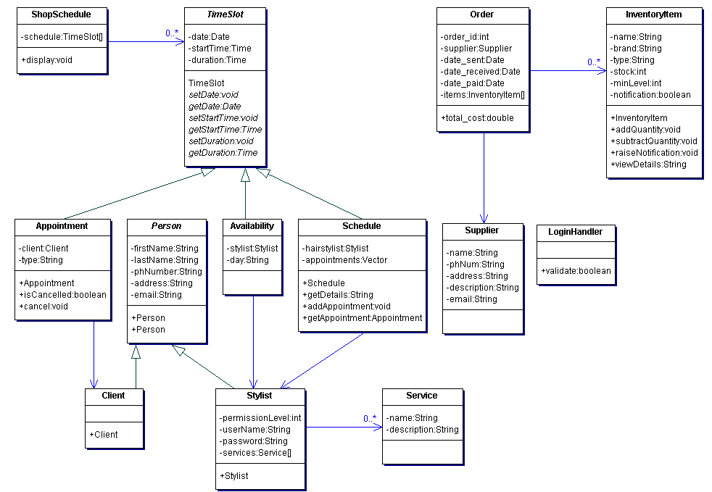
Figure B - Problem Domain Class Diagram

3.4 State Machine Diagram

3.4A shopSchedule

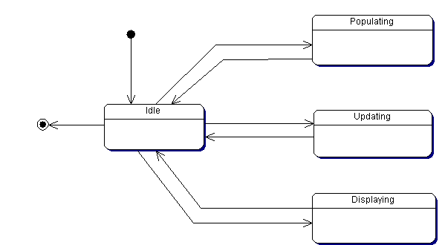
Figure C - State Machine Diagram - shopSchedule

3.5 Activity Diagram

3.5A Generate Shop Schedule
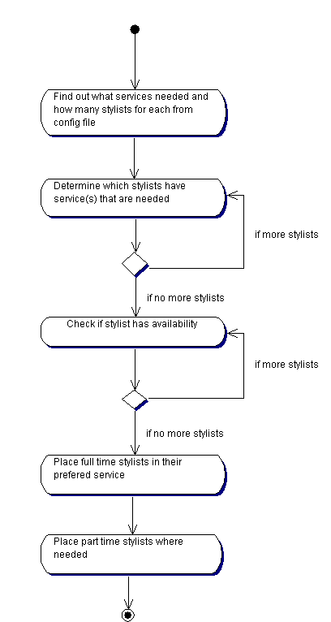
Figure D - Activity Diagram - Generate Shop Schedule

Section 4: System Design

4.1 Layered Architecture

4.1A Package Diagram

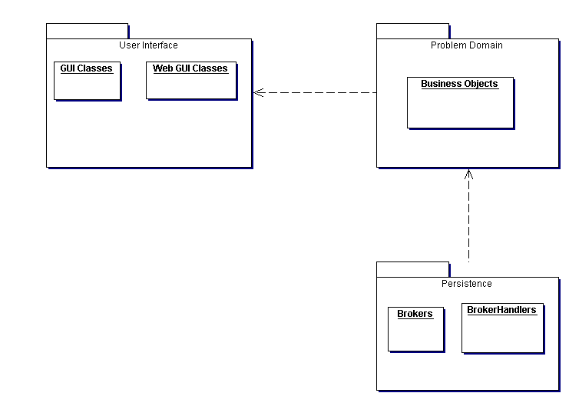
Figure E - Package Diagram

4.1B Component Diagram

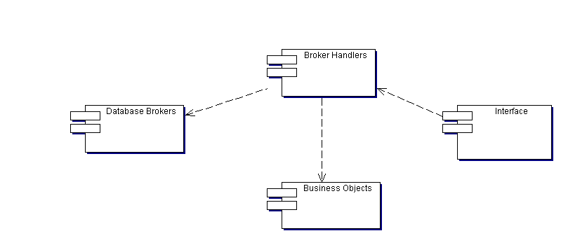
Figure F - Component Diagram

4.2 Hardware Architecture

4.2A Textual Description

The system will consist of a server and a laptop.

The server will run Windows XP with Apache, Tomcat, and MySQL installed and configured. Apache and Tomcat will allow the client, through web access, to make their appointment looking at the salon’s basic schedule. MySQL will handle the persistence of schedules, appointments, stylists, clients, and inventory.
The laptop will also run Windows XP with the JRE and the Salon Scheduling and Product Inventory java application installed and configured. The application will access the MySQL database directly to handle schedules and appointments as well as the product inventory.

4.2B Deployment Diagram

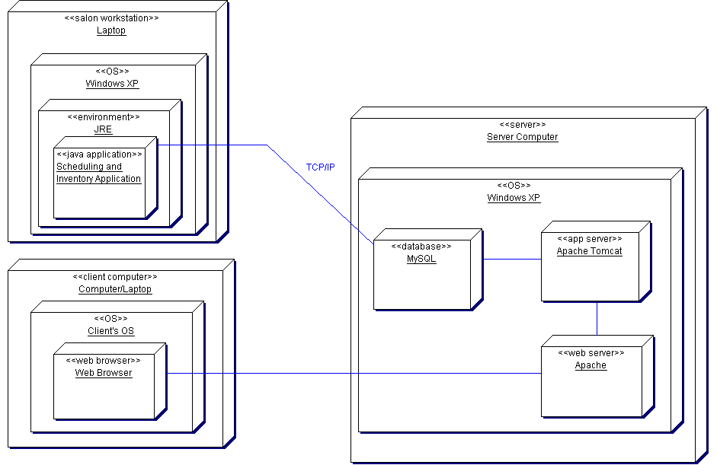
Figure G - Deployment Diagram

4.2C Communication Mechanisms

The communication mechanism will be using the TCP/IP protocol of the network. Using this protocol the access to the database will using JDBC for the Java application and the web access will be using HTTP to communicate with the servlets using JSP to provide the client a way to make their appointment over the Internet.

4.3 Hardware Platform

4.3A Development System

The development system will be on a system with standard requirements of:
1.66 megahertz or higher processor clock speed recommended
1.5 GM of RAM or higher
160 GB hard disk
Super VGA (800 x 6000) or higher-resolution capable video adapter and monitor
Ethernet Card for internet connection
Keyboard and Mouse

4.3B Production System

The main application will reside on a laptop with standard requirements of:
1.0 megahertz or higher processor clock speed recommended
500 megabytes (MB) of RAM or higher recommended
1.0 gigabytes (GB) of available hard disk space
Super VGA (800 x 6000) or higher-resolution capable video adapter and monitor recommended
Ethernet Card for internet connection
Keyboard and Mouse

The web access server system will require a standard server of:
550-MHz processor recommended
500 MB of RAM or higher recommended
160 GB hard disk space
CD-ROM RW or DVD-ROM RW drive
VGA or hardware that supports console redirection required; Super VGA (800 x 6000) or higher-resolution video adapter and monitor recommended
Ethernet Card for internet connection
Keyboard and Mouse

4.4 Software Platform

4.4A Development system

The development system will require Windows XP with Eclipse to develop the main application in Java, Apache web server, Apache Tomcat, MS Visual Studio .NET and the latest .NET framework to develop the web access forms and database.

4.4B Production system

The software requirement for the main application will require any operating system that can run the Java Runtime Environment. Therefore, the application can run on Windows, Mac O/S or Unix/Linux system. As well, to access the database the Java database drivers (JDBC) will need to be installed.
The server will run on Windows Server 2003 with the latest .NET Framework installed. The Windows Server comes with Internet Information Services (IIS) so it will be used to run the web server. MySQL server will be used to handle the database requirement.
The clients can use any standard web browser; Internet Explorer, Netscape, Mozilla Firefox, Opera etc., to access the web server to make appointments online.

4.5 Interaction Model

4.5A Textual Description

4.5A1 Style
- Dialog will be task-based from the user perspective and to the point

4.5A2 Desired user support
- Any invalid or null fields on a data entry screen will have an error message with either an example of correct input
- When updating a record(client, product, etc.) or an appointment, a confirmation message will display
- When scheduling an appointment, a confirmation message will display

4.5A3 System feedback style
- Generating the shop schedule may take 10-15 seconds, so a loading screen may be applicable

4.5A4 Standards
- Arial font
- Font size 12
- The web interface will follow the basic calendar based interface of the schedule appointment screen

4.5A5 List of every screen and sub-screen
- Log in screen
- Main menu screen
  - Configuration screen
- Schedule appointment screen
- Update appointment screen
- Pending appointment screen
- Confirm appointment screen
- Adjust product quantity screen
- Maintain client screen
  - Add client screen
- Maintain product screen
  - Add product screen
- Maintain availability screen
  - Add availability screen
- Maintain stylist screen
  - Add stylist screen
- Maintain supplier screen
  - Add supplier screen
- Maintain service screen
  - Add service screen
- View shop schedule screen
  - View stylist schedule screen
- Report order list screen
  - Order list print preview screen
- Report product usage screen
  - Product usage print preview screen
- Report service usage screen
  - Service print preview screen
- Web interface

4.5B Main Screens

4.5B1 Main Screen
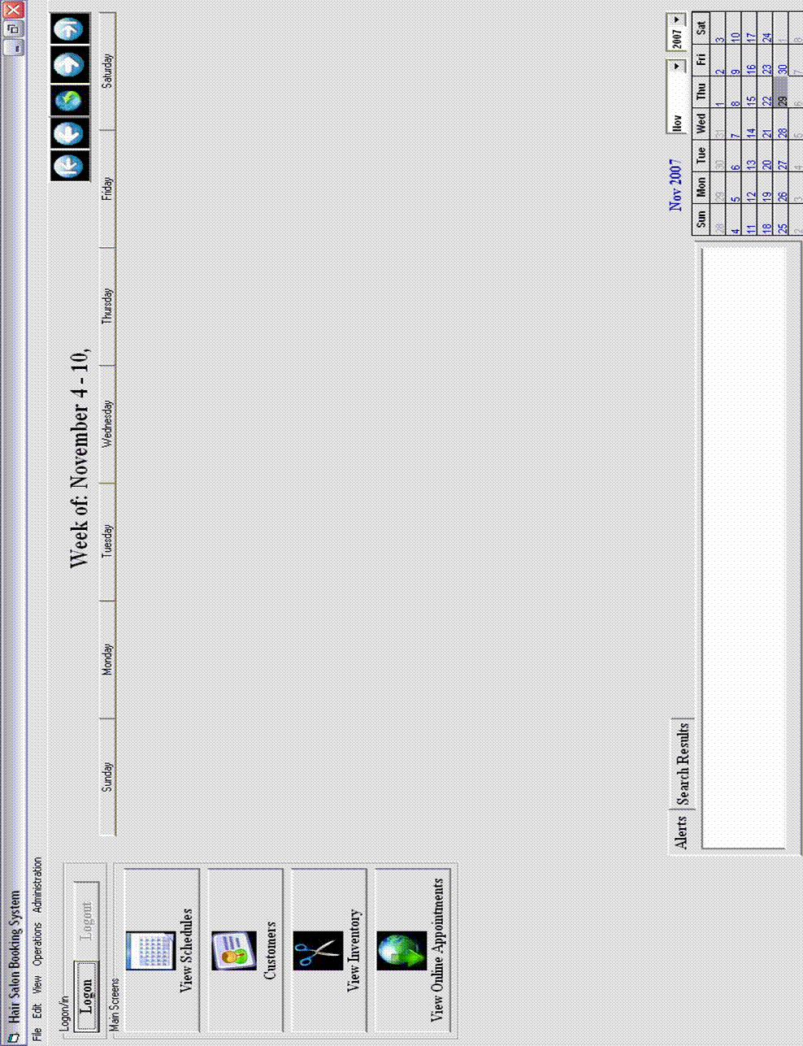
Figure H - Main Screen
4.6B2 Main Schedule Screen
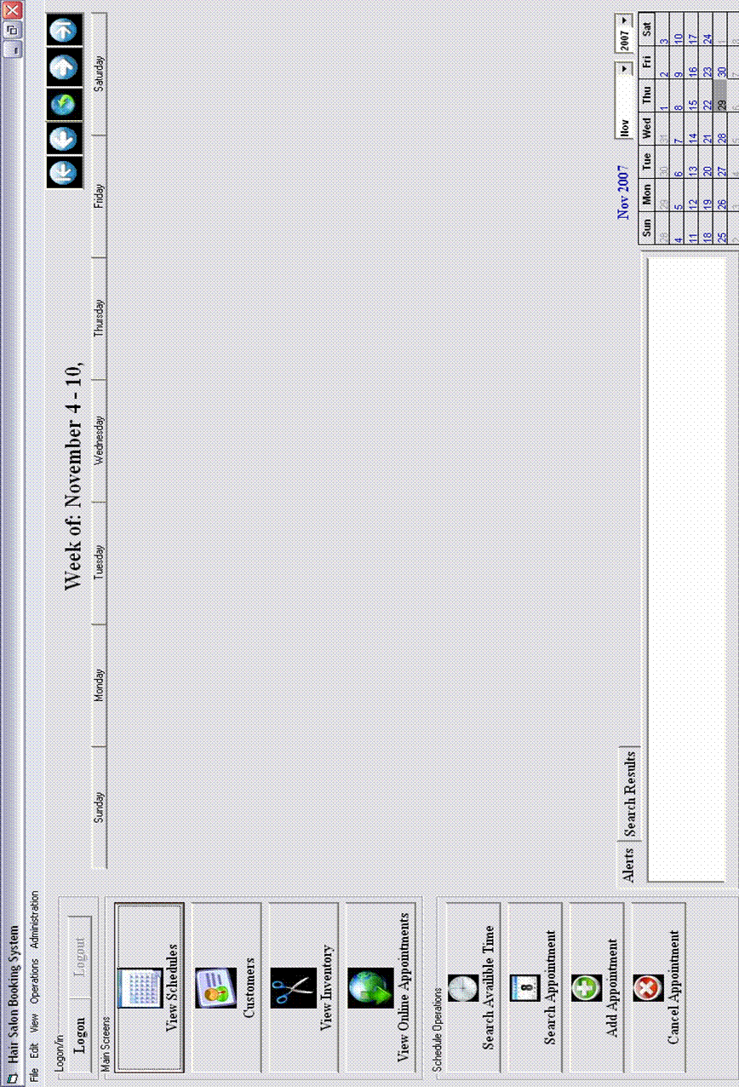
Figure I - Main Schedule Screen
4.5B3 Main Customer Screen
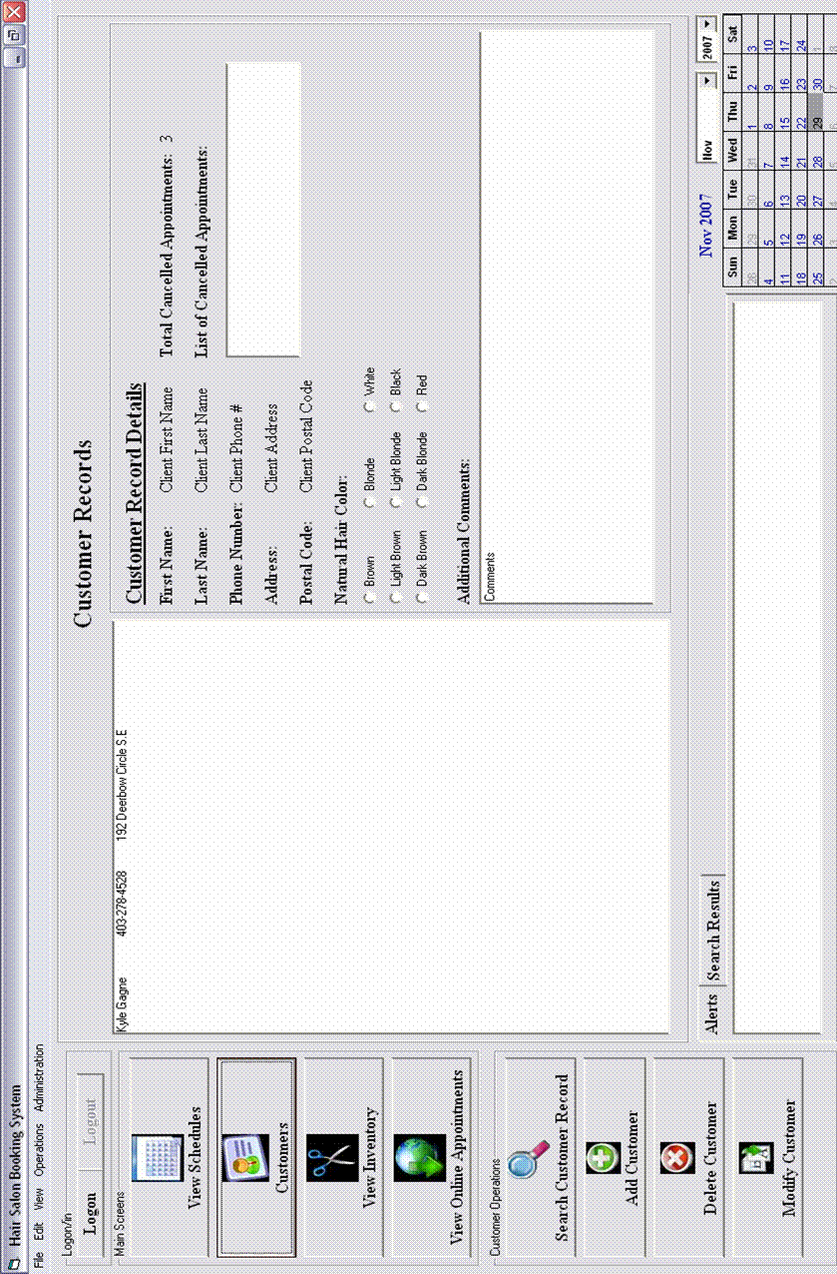
Figure J - Main Customer Screen
4.5B4 Main Inventory Screen
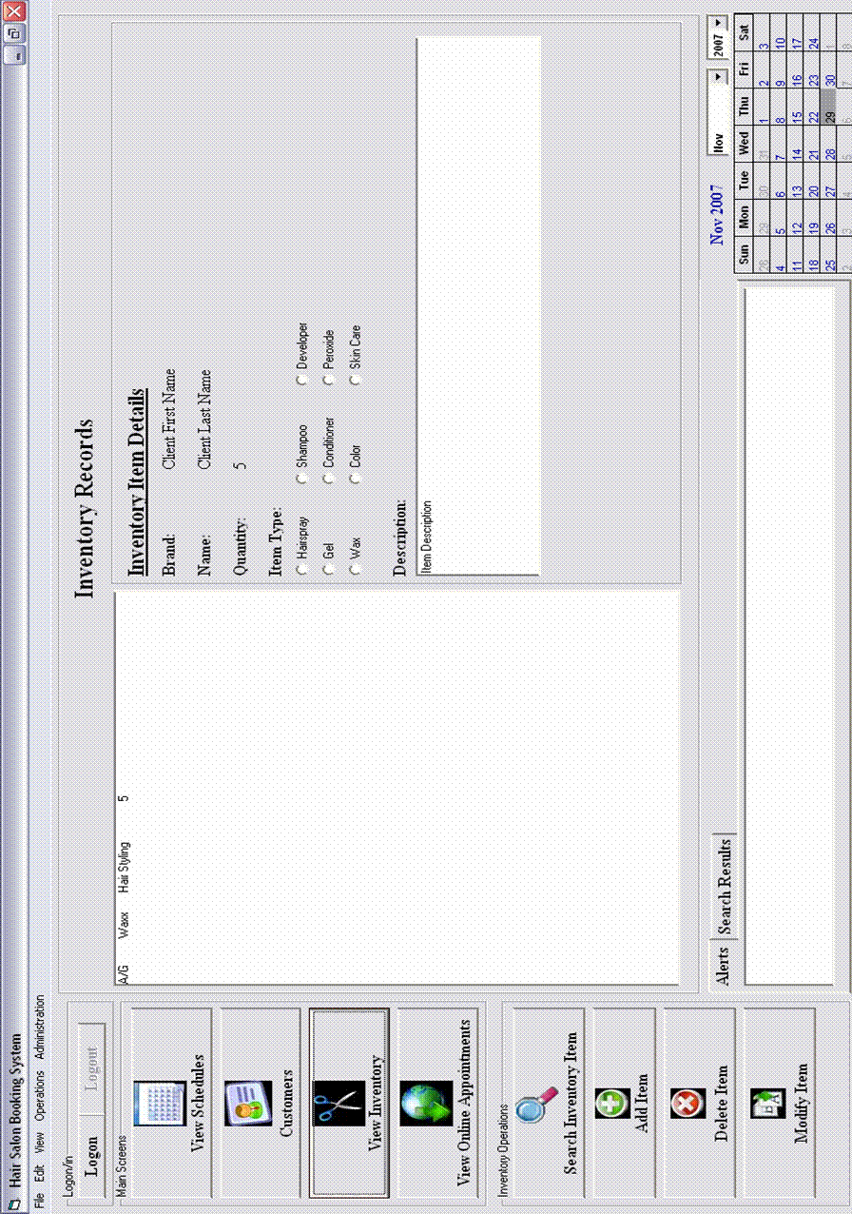
Figure K - Main Inventory Screen

4.5C Data Entry / Detail Forms

4.5C1 Book Appointment

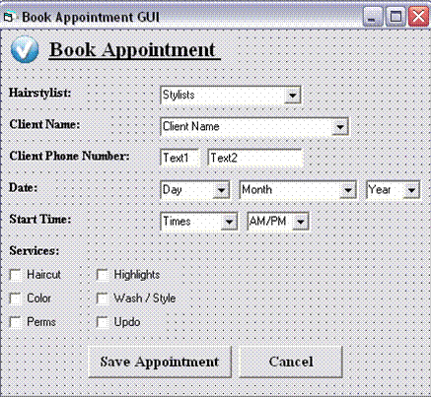
Figure L - Book Appointment

4.5C2 Appointment Details

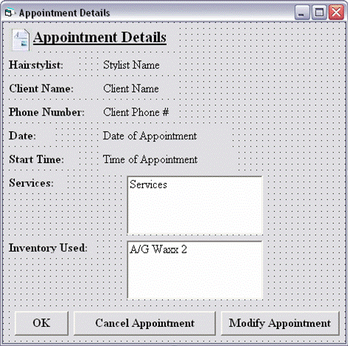
Figure M - Appointment Details

4.5D Search Forms

4.5D1 Search Appointment

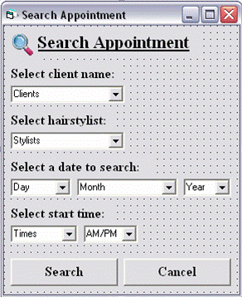
Figure N - Search Appointment

4.5D2 Search Available Time

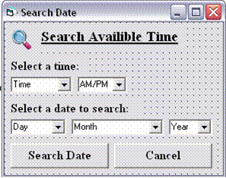
Figure O - Search Available Time

4.5E Error and Confirmation Message Boxes

4.5E1 Appointment Conflict Error

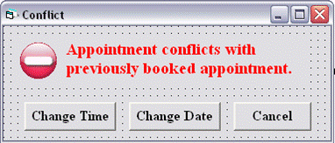
Figure P - Appointment Conflict Error

4.5E2 Cancel Appointment

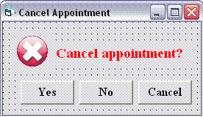
Figure Q - Cancel Appointment

4.5E3 Confirm Appointment

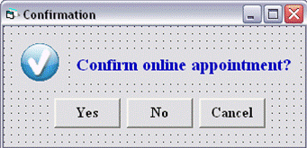
Figure R - Confirm Appointment

4.5E4 Invalid Entry Error

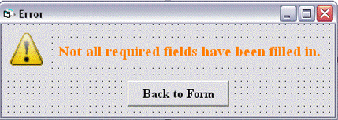
Figure S - Invalid Entry Error

4.5E5 No Matches Error

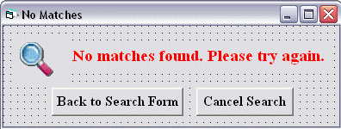
Figure T - No Matches Found

4.5E6 No Selection Error

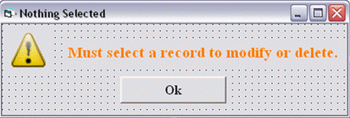
Figure U - No Selection Error

4.6 Persistence Model

4.6A Conceptual ERD
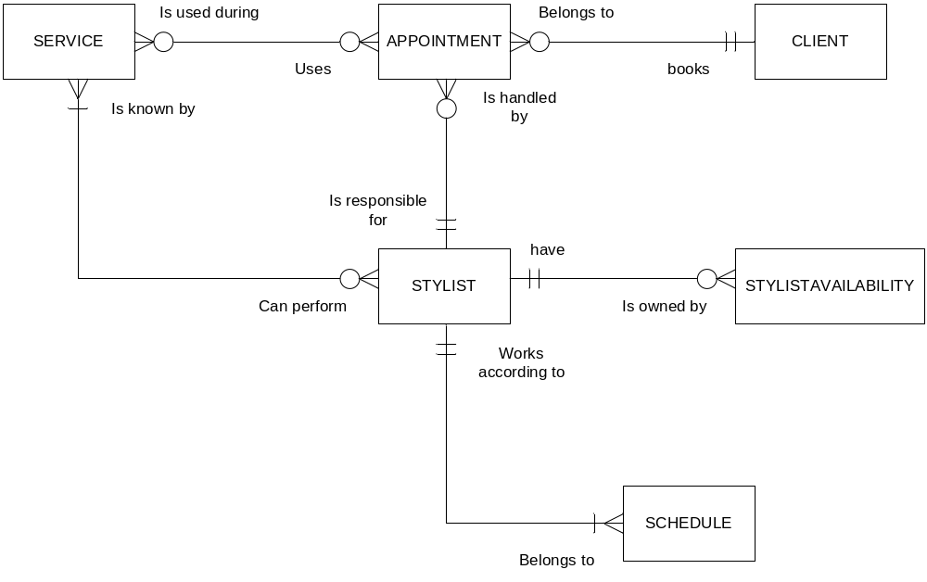
Figure V - Conceptual ERD

4.6B Implementation ERD

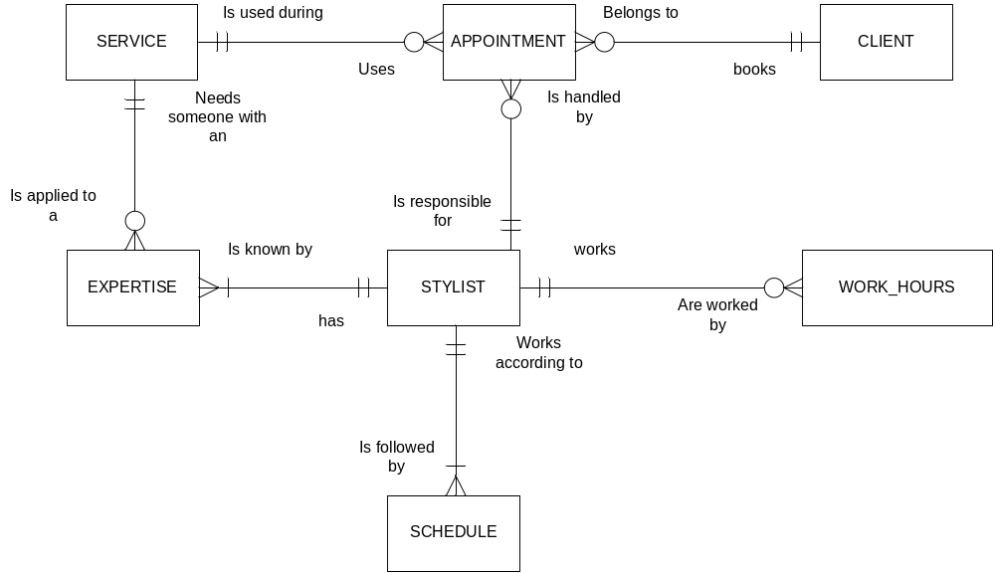
Figure W - Implementation ERD

4.6C Table Definitions

APPOINTMENT – 72 bytes
*(appointment_id) – VARCHAR2(9) – 11 bytes
client_id – VARCHAR2(9) – 11 bytes
start_time – DATETIME – 8 bytes
date – DATETIME - 8 bytes
stylist_id – VARCHAR2(9) – 11 bytes
duration – NUMBER(3) – 4 bytes
service_id - VARCHAR2(9) – 11 bytes
type – VARCHAR2(16) – 18 bytes

CLIENT – 120 bytes
*(client_id) – VARCHAR2(9) – 11 bytes
first_name – VARCHAR2(15) – 17 bytes
last_name – VARCHAR2(20) – 22 bytes
phone_number - VARCHAR2(9) – 11 bytes
-address - VARCHAR2(30) – 32 bytes
-email - VARCHAR2(25) – 27 bytes

STYLIST – 103 bytes
*(stylist_id) - VARCHAR2(9) – 11 bytes
first_name - VARCHAR2(15) – 17 bytes
last_name - VARCHAR2(20) – 22 bytes
username - VARCHAR2(15) – 17 bytes
password - VARCHAR2(15) – 17 bytes
phone_number - VARCHAR2(9) – 11 bytes
expertise - VARCHAR2(5) – 7 bytes
manager – BOOLEAN – 1 byte

SERVICE – 28 bytes
*(service_id) - VARCHAR2(9) – 11 bytes
name - VARCHAR2(15) – 17 bytes

SCHEDULE – 31 bytes
*date – DATETIME - 8 bytes
(stylist_id) - VARCHAR2(9) – 11 bytes
start_time – DATETIME - 8 bytes
duration – NUMBER(3) – 4 bytes

EXPERTISE – 26 bytes
*(service_id) - VARCHAR2(9) – 11 bytes
*(stylist_id) - VARCHAR2(9) – 11 bytes
expertise_level – NUMBER(2) – 4 bytes

STYLISTAVAILABILITY – 53 bytes
*(availability_id) - VARCHAR2(9) – 11 bytes
-date – DATETIME - 8 bytes
day - VARCHAR2(9) – 11 bytes
stylist_id - VARCHAR2(9) – 11 bytes
start_time – DATETIME - 8 bytes
duration – NUMBER(3) – 4 bytes

INVENTORYITEM - 94 bytes
*upc - VARCHAR2(16) – 18 bytes
brand - VARCHAR2(12) – 14 bytes
name - VARCHAR2(20) – 22 bytes
quantity_in_stock – NUMBER – 4 bytes
order_point – NUMBER – 4 bytes
-description - VARCHAR2(30) – 32 bytes

SOURCE – 33 bytes
*upc - VARCHAR2(16) – 18 bytes
*(supplier_id) - VARCHAR2(9) – 11 bytes
price – NUMBER – 4 bytes

SUPPLIER – 39 bytes
*(supplier_id) - VARCHAR2(9) – 11 bytes
name - VARCHAR2(15) – 17 bytes
phone_number - VARCHAR2(9) – 11 bytes

ORDER – 50 bytes
*(order_id) - VARCHAR2(9) – 11 bytes
(supplier_id) - VARCHAR2(9) – 11 bytes
total_cost – NUMBER – 4 bytes
order_sent – DATETIME - 8 bytes
order_paid – DATETIME - 8 bytes
order_received – DATETIME - 8 bytes

ORDER_ITEM – 38 bytes
*(order_id) - VARCHAR2(9) – 11 bytes
*upc - VARCHAR2(16) – 18 bytes
quantity_ordered – NUMBER – 4 bytes
quantity_recieved – NUMBER – 4 bytes
item_received – BOOLEAN – 1 byte

TOTAL ESTIMATION = 4,556,771

4.6D Expected Data Size

Each table will need to approximately store the following amount of information per record:
appointment – 72 bytes
client – 120 bytes
stylist – 103 bytes
service – 28 bytes
schedule – 31 bytes
expertise – 26 bytes
work_hours – 53 bytes
inventory_item – 94 bytes
source – 33 bytes
supplier – 39 bytes
order – 50 bytes
order_item – 38 bytes

It is estimated that over the course of a year (the amount of time between database purges) there will be 54750 appointments in a given year. Approximately 2000 clients serviced by 25 stylists with 50 expertise assuming 12 services are offered. This nets 9100 schedule objects and 190 work_hours. There will be roughly 100 unique inventoryitems supplied by 10 suppliers and 20 sources. There will be approximately 100 orders placed with 1500 order_items.

appointment = 54750 * 72 = 3942000 bytes
client = 2000 * 120 = 240000 bytes
stylist = 25 * 103 = 2575 bytes
service = 12 * 28 = 336 bytes
schedule = 9100 * 31 = 282100 bytes
expertise = 50 * 26 = 1300 bytes
stylistavailability = 190 * 53 = 10070 bytes
inventoryitem = 100 * 94 = 9400 bytes
source = 200 * 33 = 6600 bytes
supplier = 10 * 39 = 390 bytes
order = 100 * 50 = 5000 bytes
order_item = 1500 * 38 = 57000 bytes

For information storage alone, the system will require approximately 4,556,771 bytes, or 4.3 MB. The Oracle software and the system will need 2 GB of space. For overhead purposes, the entire system should have an allocated space of 5 GB.

4.6E Persistence Class Diagram

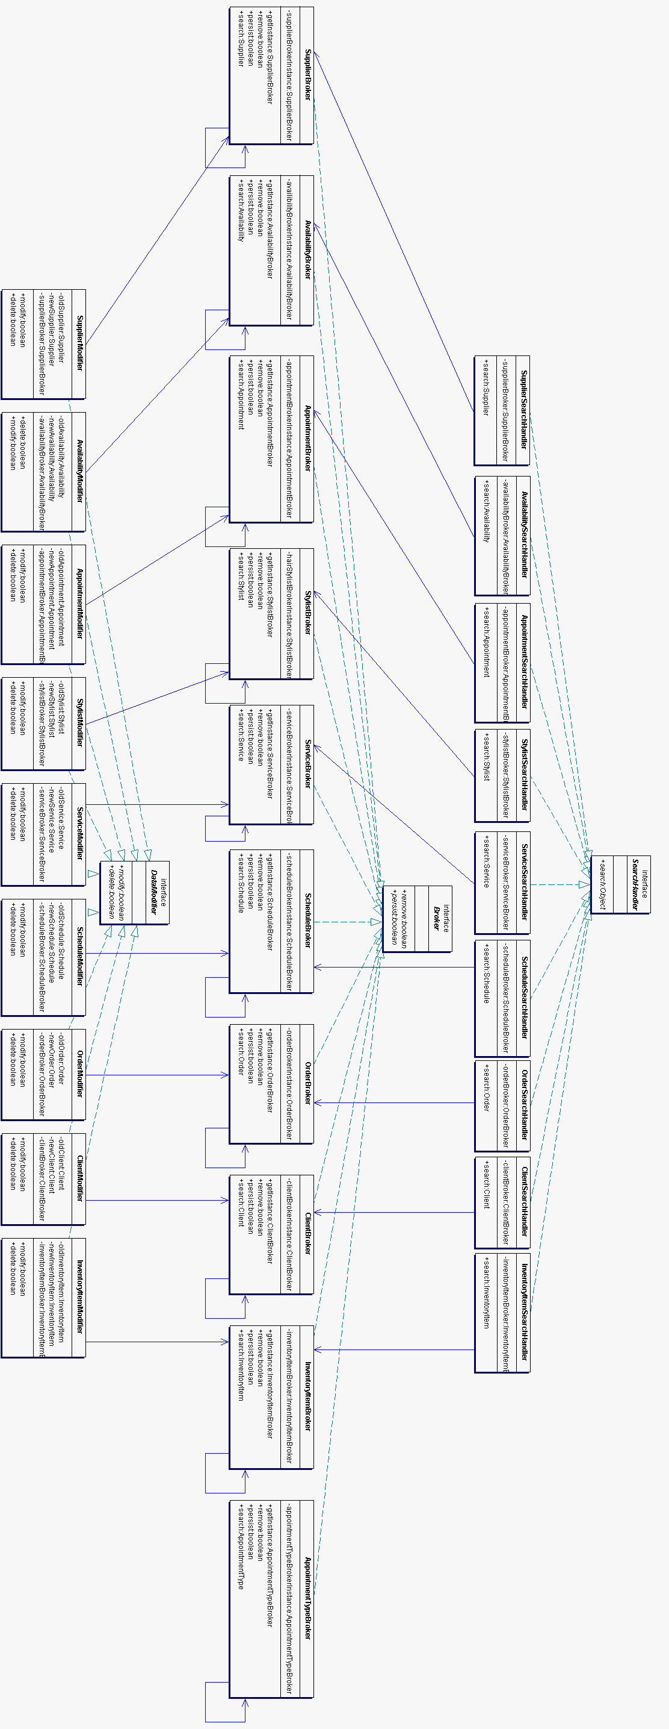
Figure X - Persistence Class Diagram

4.7 Class Diagram

4.7A User Interface Class Diagram

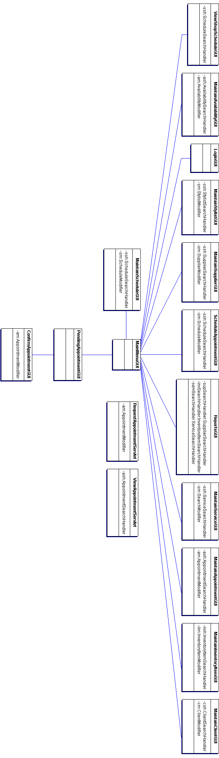
Figure Y - User Interface Class Diagram

4.7B Problem Domain Class Diagram
Figure Z - Problem Domain Class Diagram

4.7C Persistence Class Diagram
Figure AA - Persistence Class Diagram

4.8 Interaction Sequence Diagrams

4.8A Adjust Product Inventory

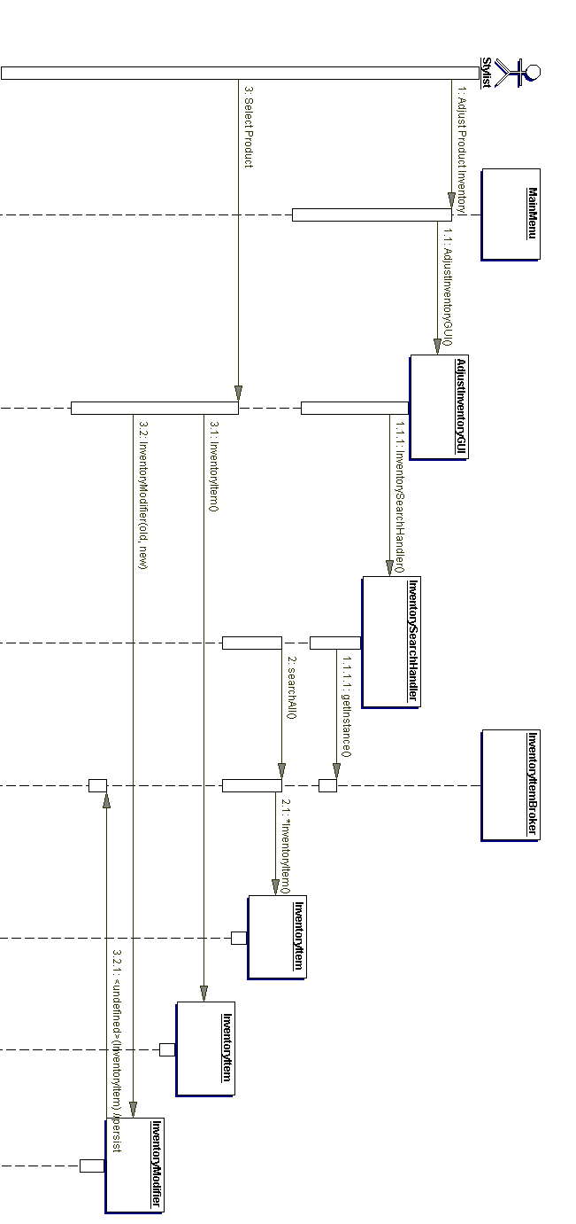
Figure BB - Adjust Product Inventory

4.8B Confirm an Appointment
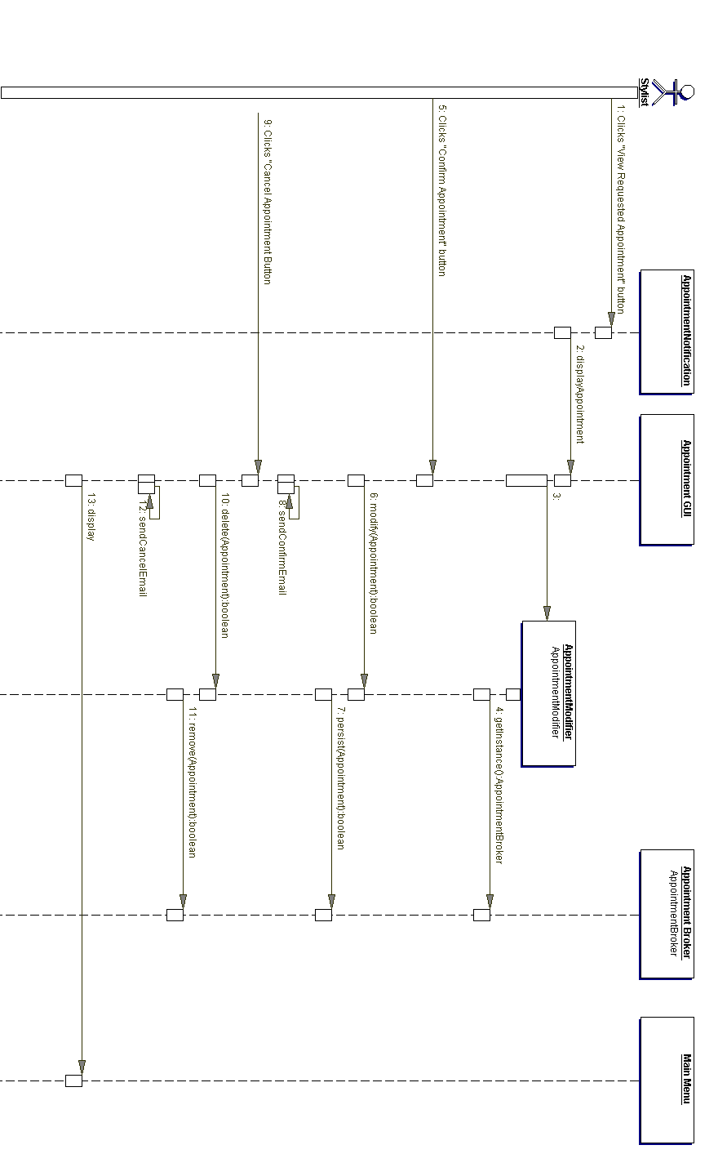
Figure CC - Confirm an Appointment
4.8C Log In
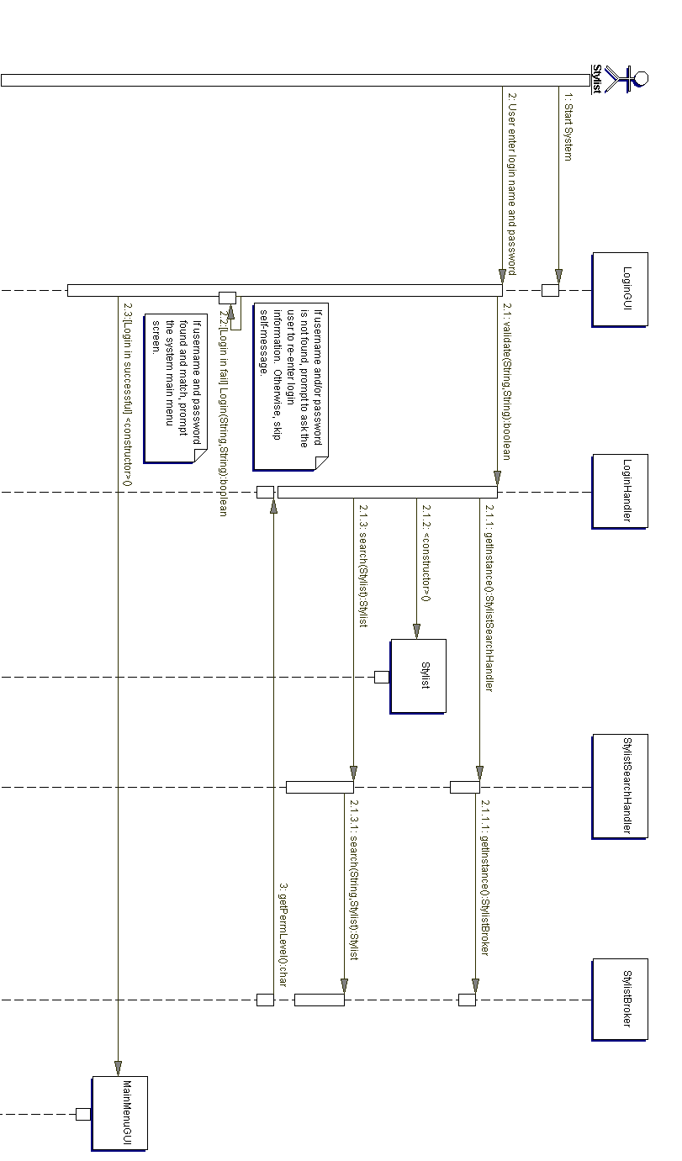
Figure DD - Log In

4.8D Log Out
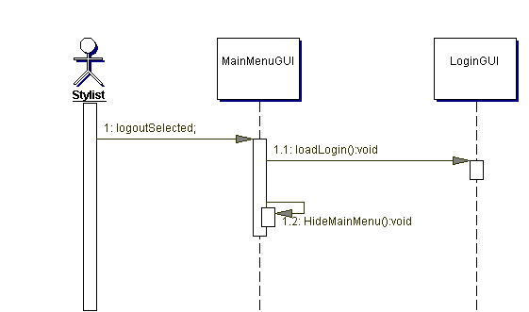
Figure EE - Log Out

4.8E Maintain Availability
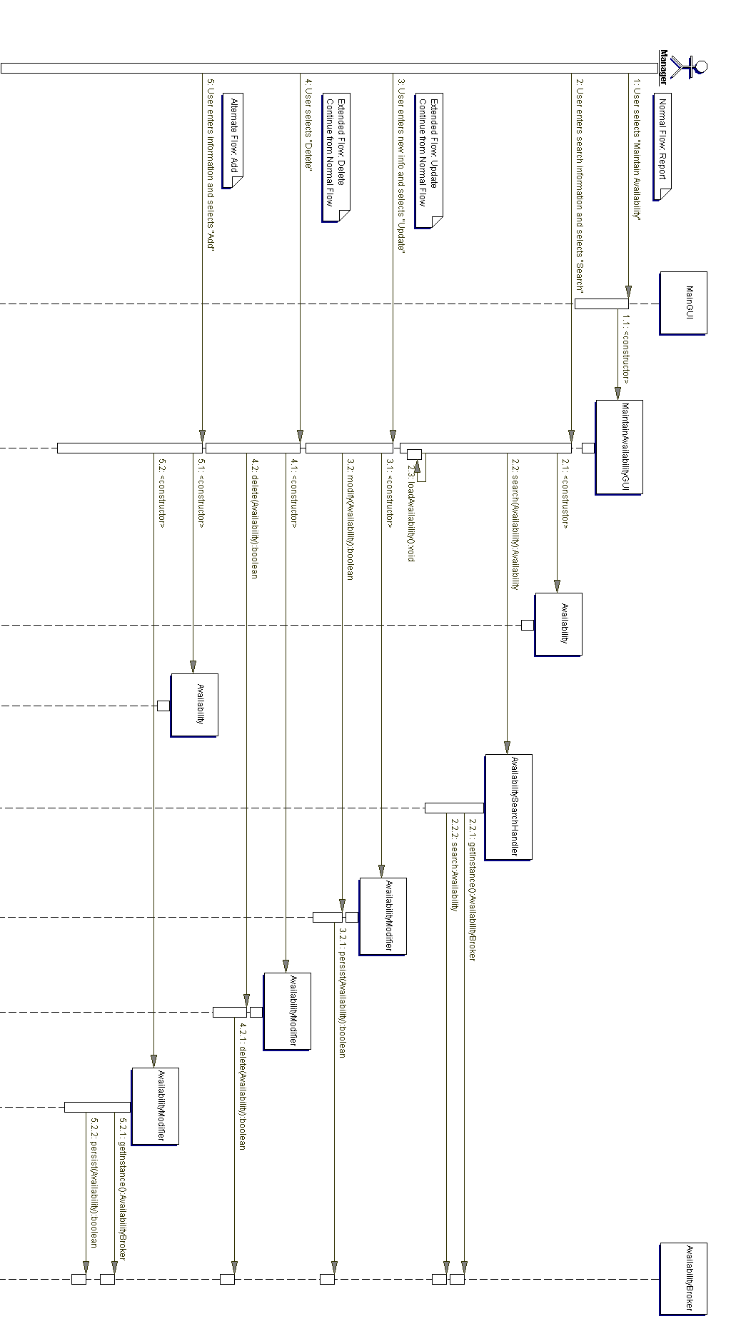
Figure FF - Maintain Availability

4.8F Maintain Client
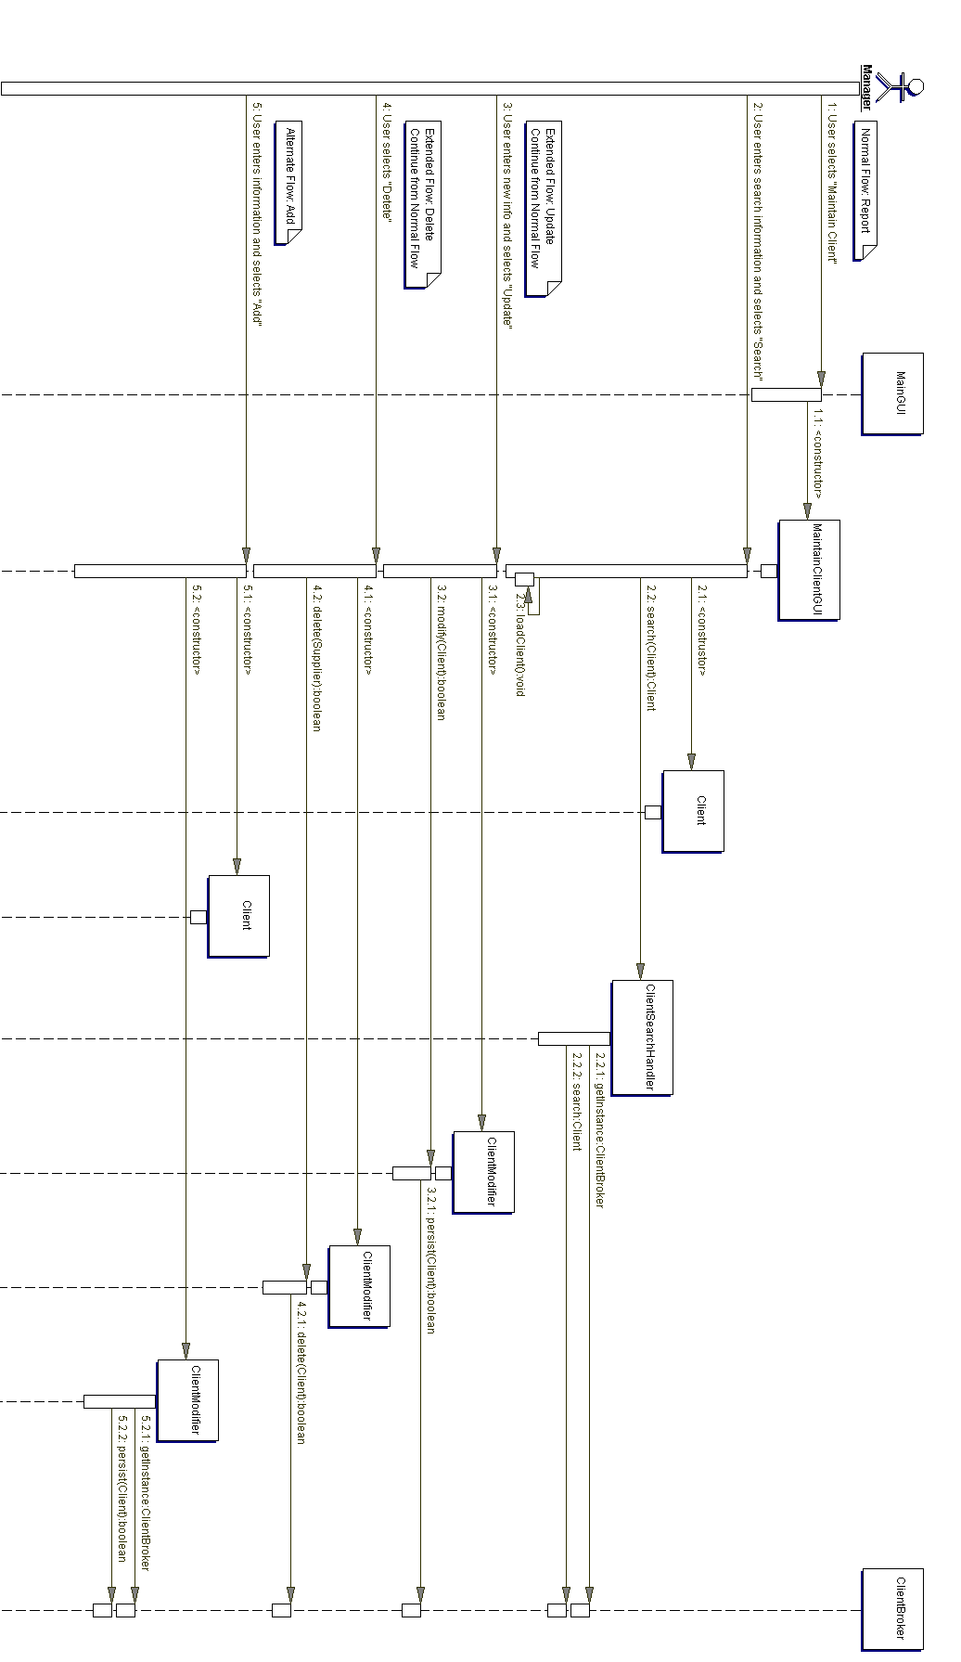
Figure GG - Maintain Client

4.8G Maintain Order
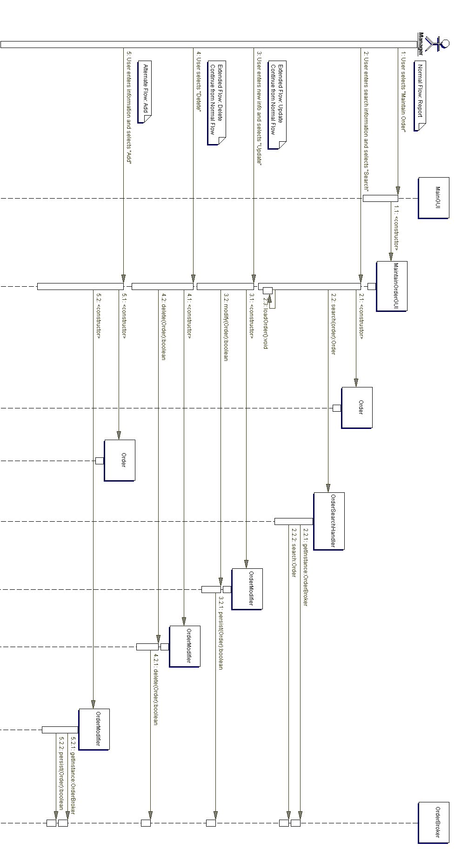
Figure HH - Maintain Order

4.8H Maintain Product
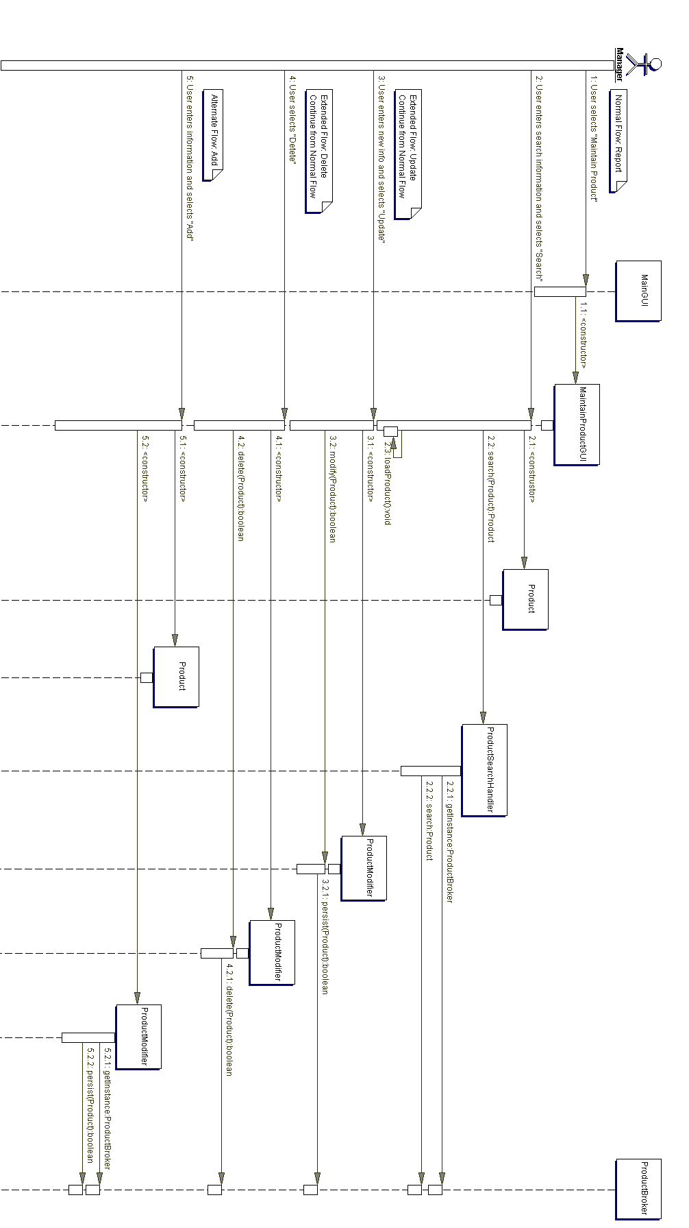
Figure II - Maintain Product

4.8I Maintain Service
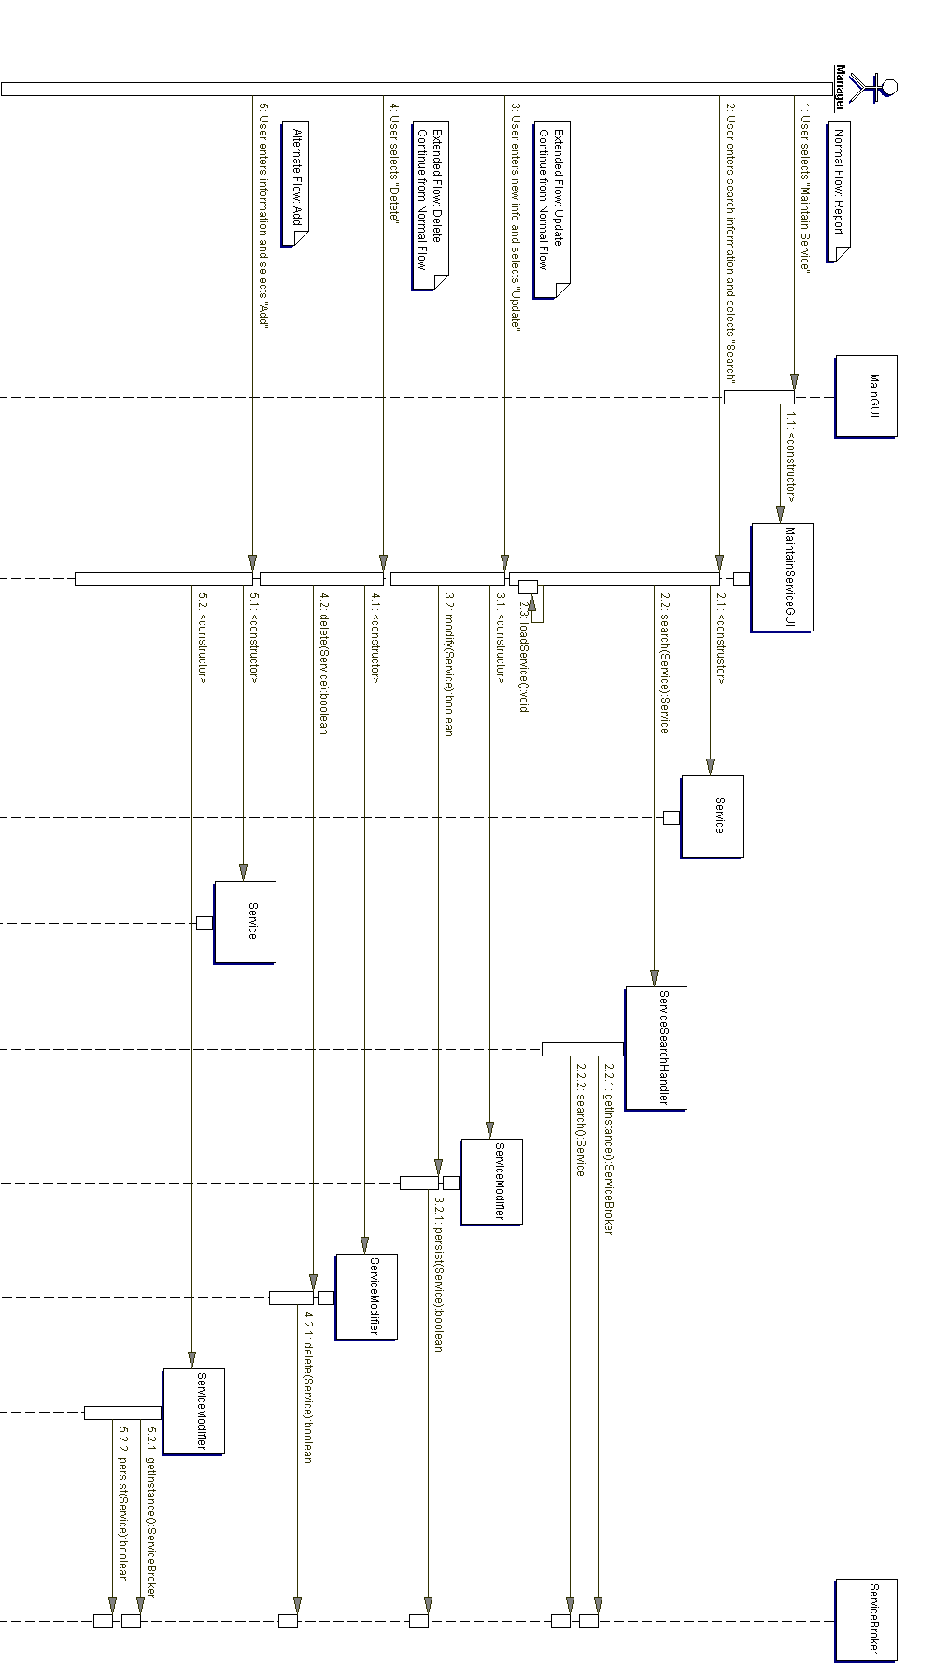
Figure JJ - Maintain Service

4.8J Maintain Stylist
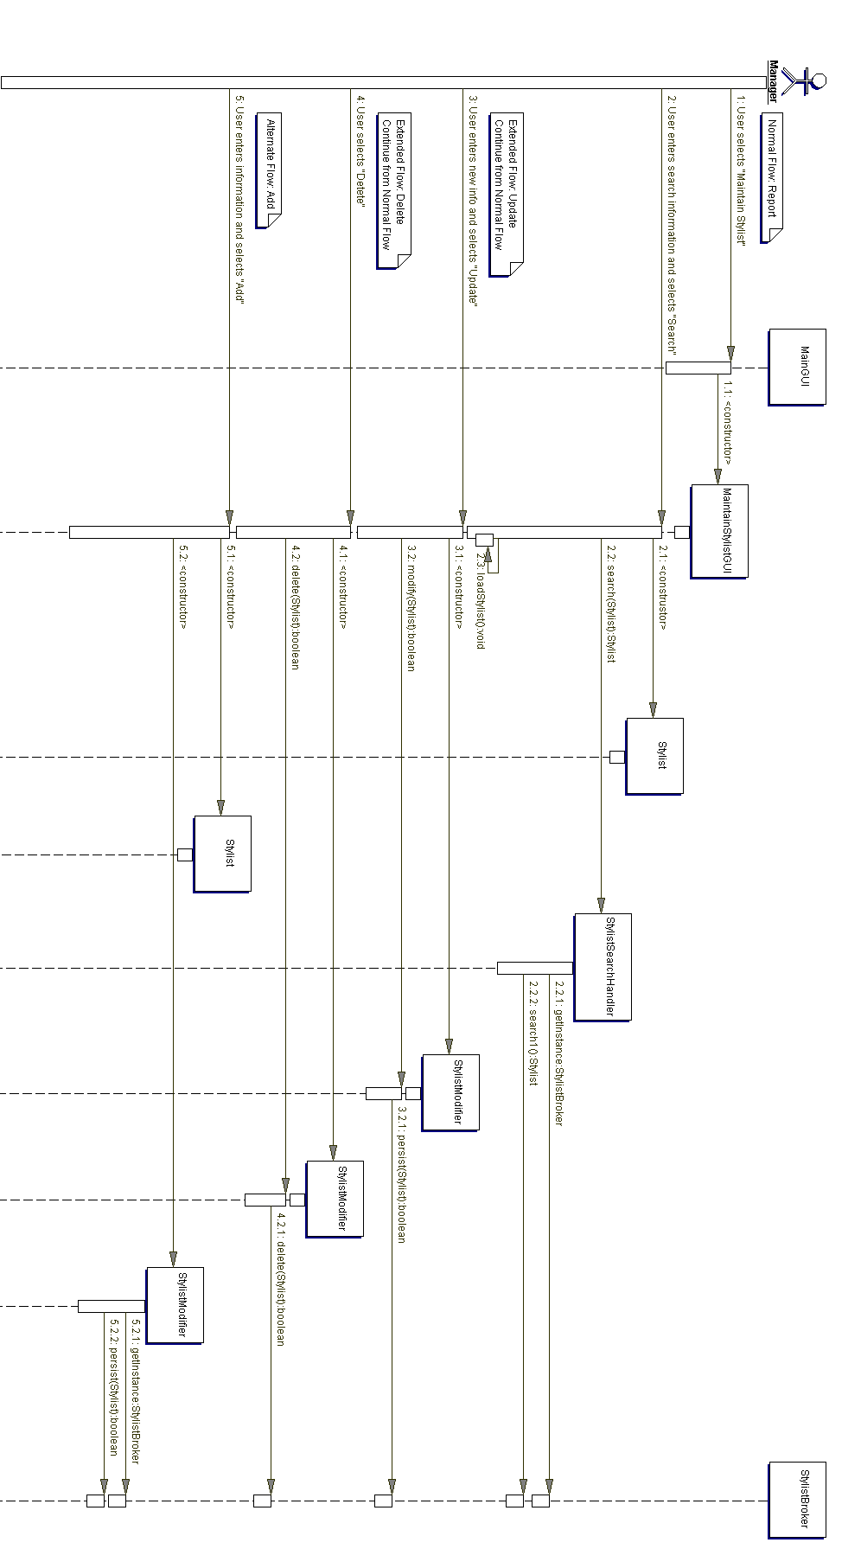
Figure KK - Maintain Stylist

4.8K Maintain Supplier
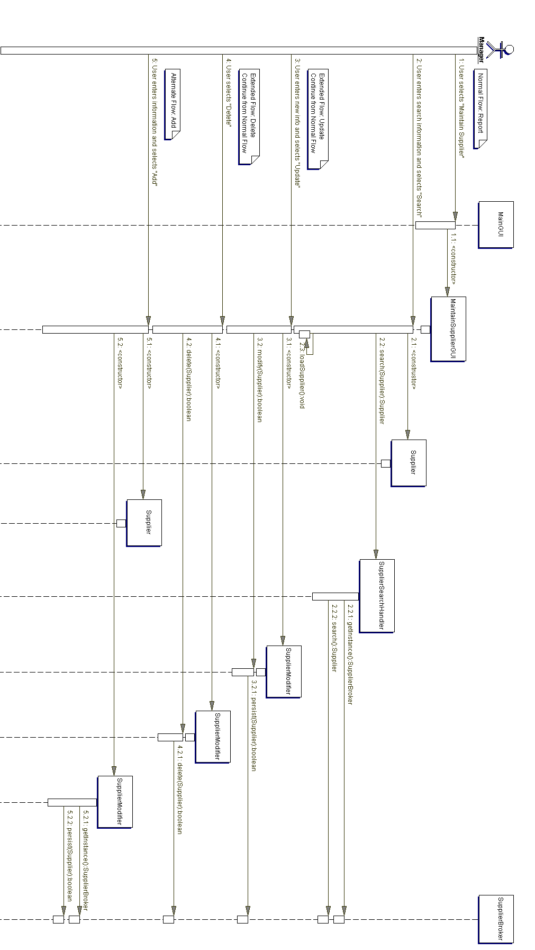
Figure LL - Maintain Supplier

4.8L Report Order List
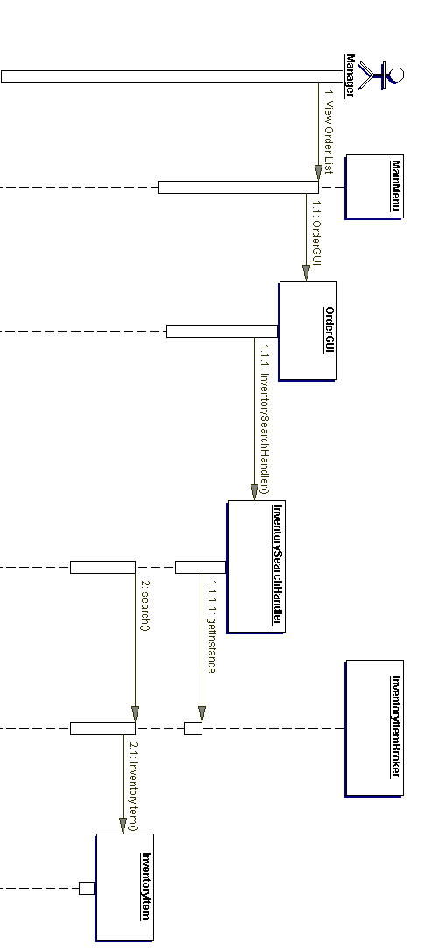
Figure MM - Report Order List

4.8M Report Orders
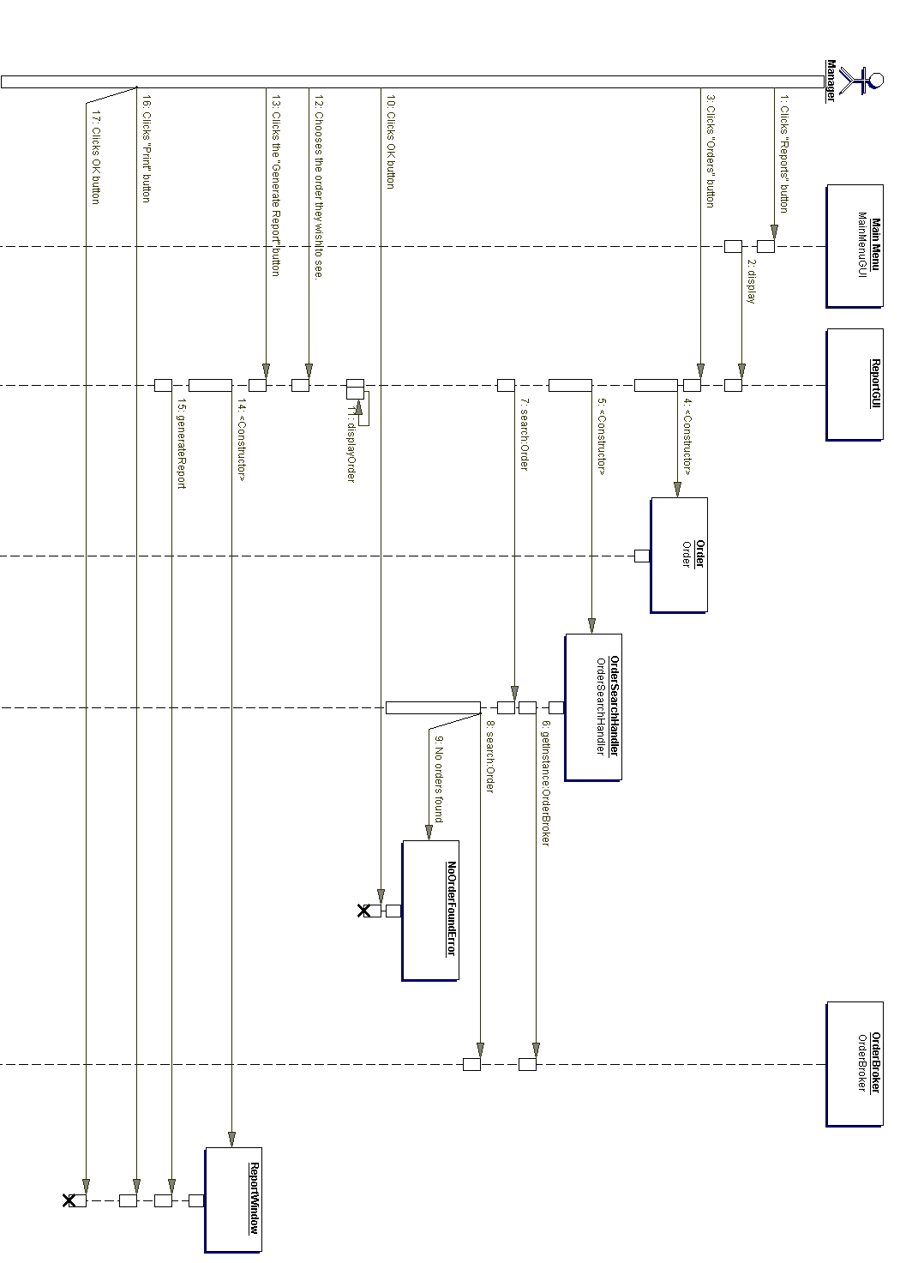
Figure NN - Report Orders

4.8N Report Product Usage
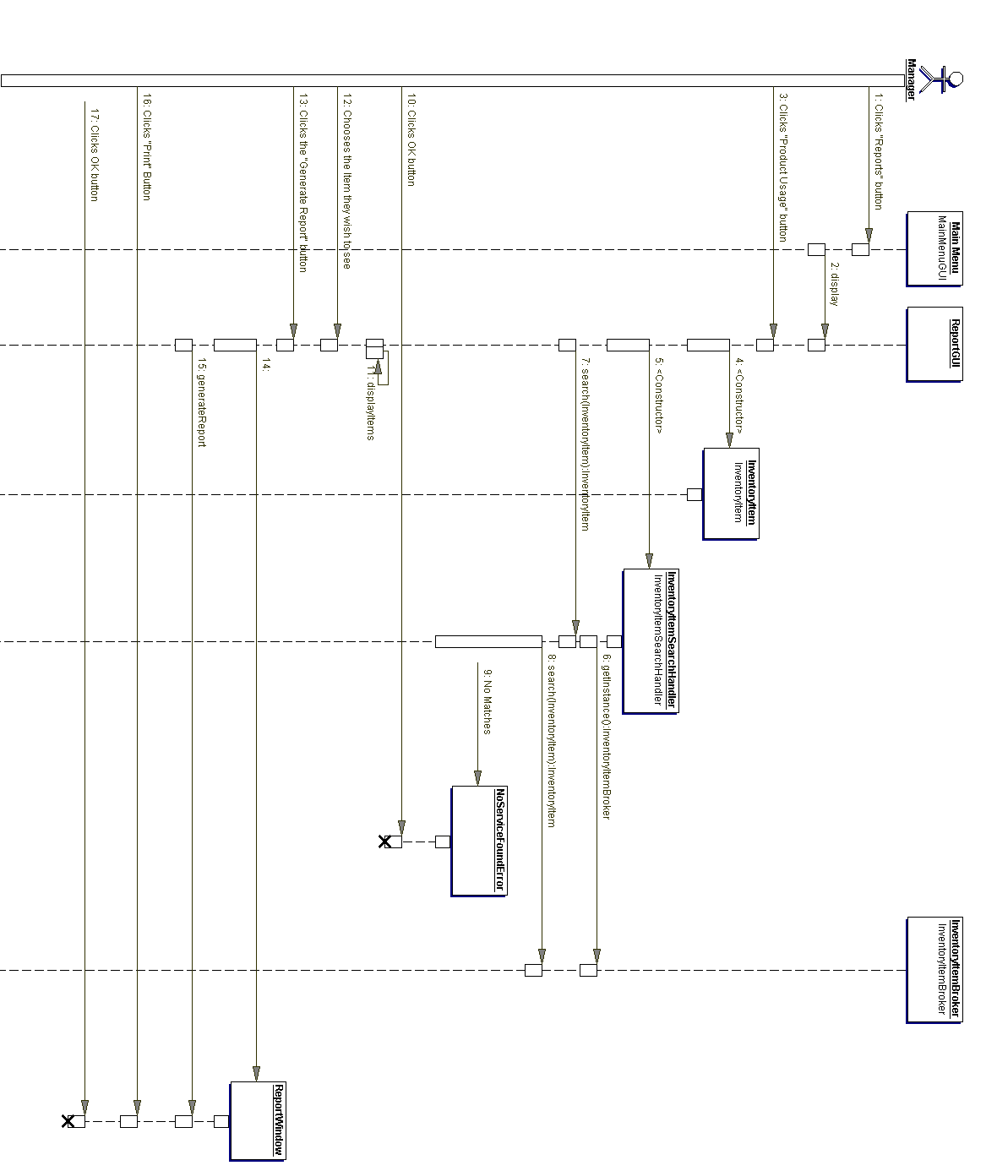
Figure OO - Report Product Usage

4.8O Report Service Usage
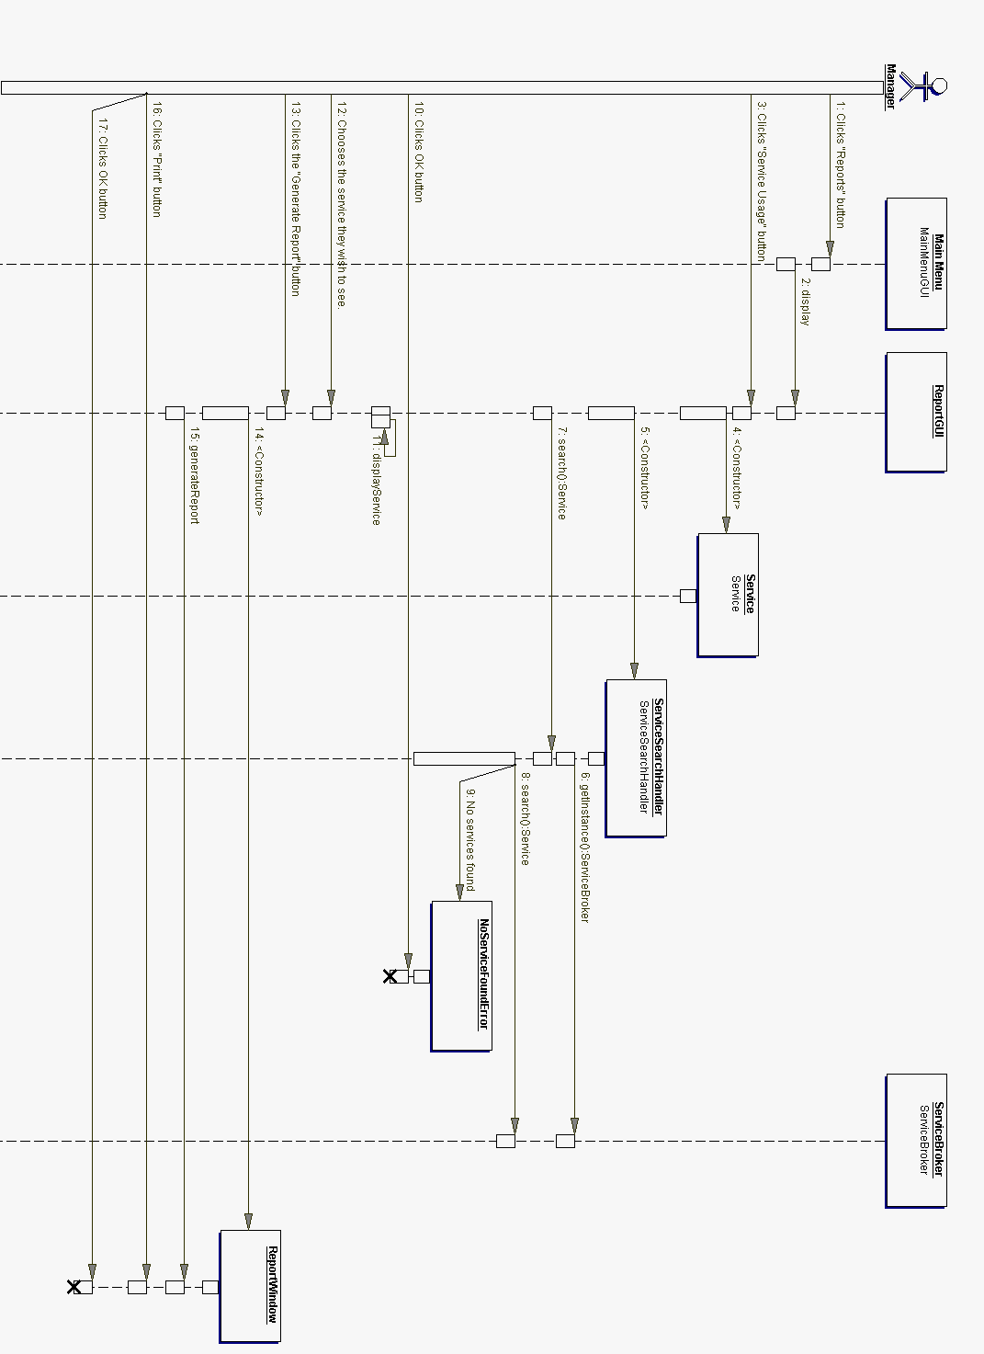
Figure PP - Report Service Usage

4.8P Request Appointment
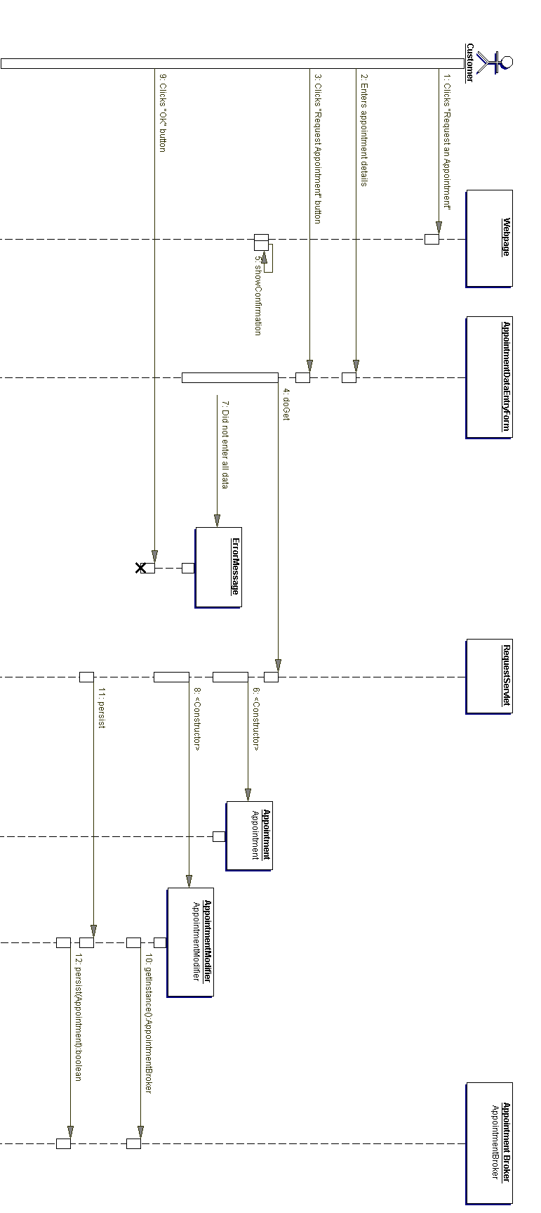
Figure QQ - Request Appointment

4.8Q Schedule Appointment
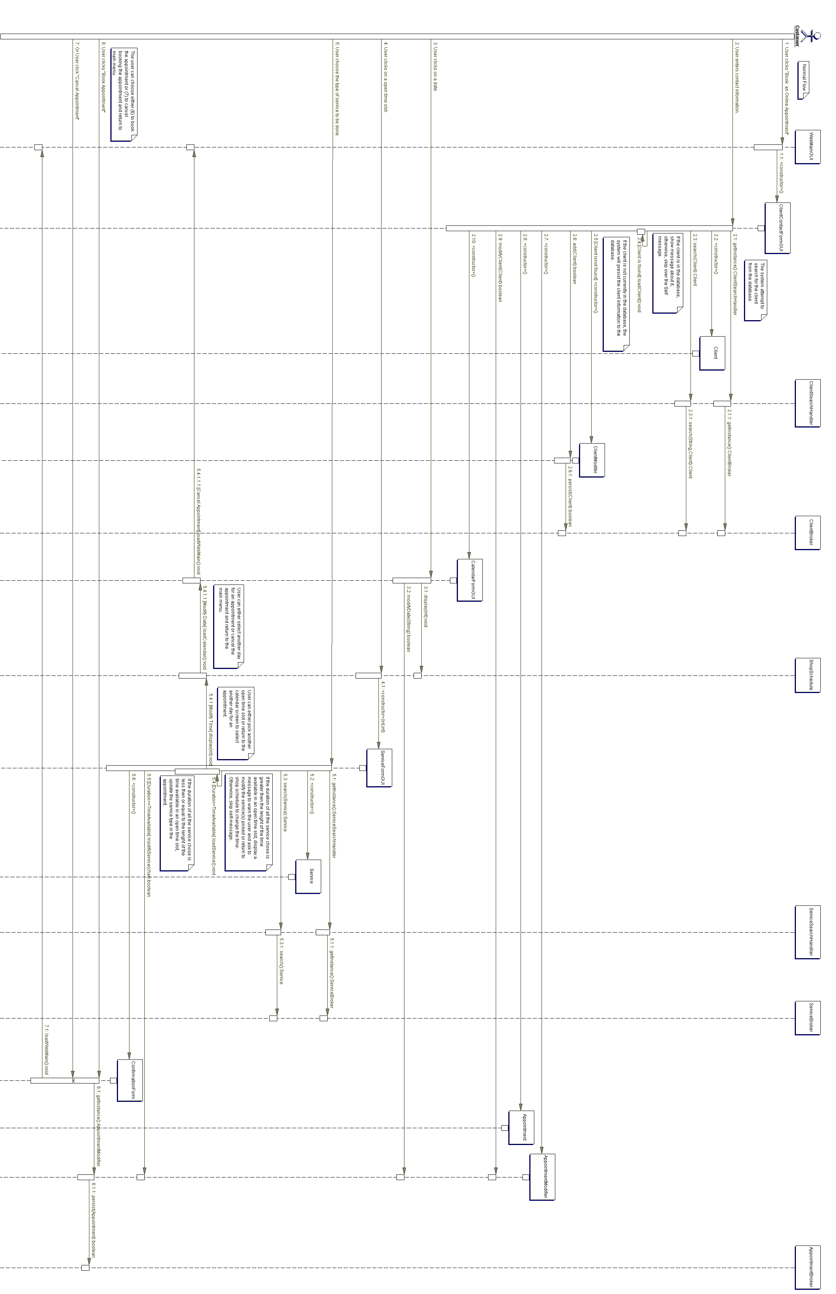
Figure RR - Schedule Appointment

4.8R Update Appointment
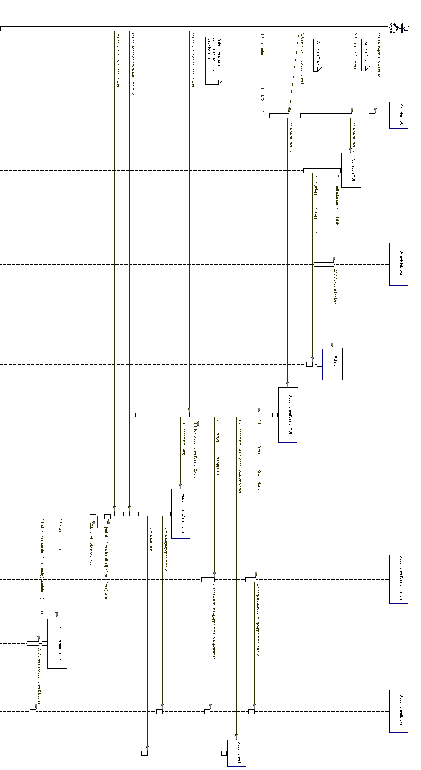
Figure SS - Update Appointment

4.8S View Shop Schedule

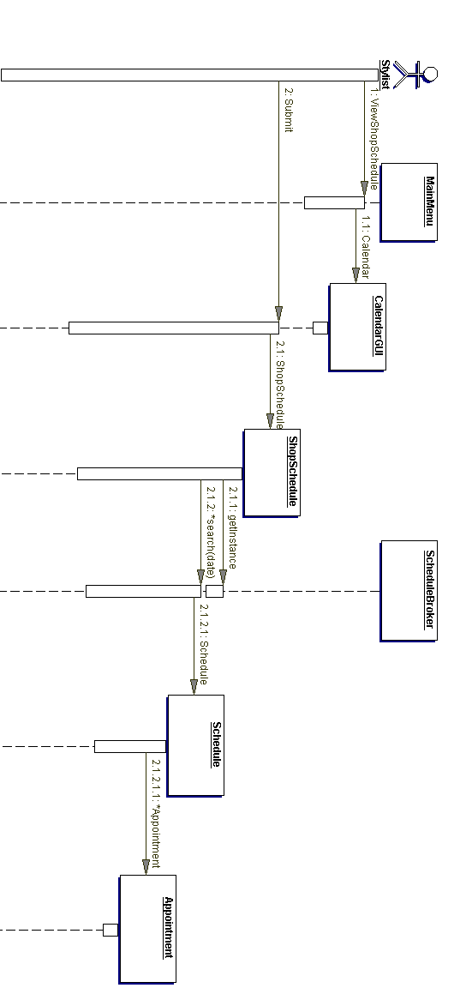
Figure TT - View Shop Schedule

4.9 Data Dictionary

Class name: Appointment
Description: This class represents the appointment.

- Attribute: client
Data type: Client
Description: This is the client associated with the appointment.

+ Method: isCancelled
Return: boolean
Description: This method returns if the appointment is cancelled.

+ Method: cancel
Return: void
Description: This method cancels the appointment.

Class name: AppointmentBroker
Description: This is the broker class of appointment.

- Attribute: appointmentBrokerInstance
Data type: AppointmentBroker
Description: This is the single instance of the AppointmentBroker class based on the singleton pattern.

+ Method: getInstance
Return: AppointmentBroker
Description: This method returns the single instance of AppointmentBroker.

+ Method: search
Return: Appointment
Description: This method returns an appointment matching the search criteria.
Parameter: Date

+ Method: remove
Return: boolean
Description: This method removes the appointment in the database based on the appointment
input object.
Parameter: Appointment

+ Method: persist
Return: boolean
Description: This method updates the appointment in the database based on the appointment input object.
Parameter: Appointment

Class name: AppointmentModifier
Description: This class passes data through to the AppointmentBroker and uses the appropriate methods to handle the data.

-Attribute: oldAppointment
Data Type: Appointment
Description: This is the old appointment to be modified.

-Attribute: newAppointment
Data Type: Appointment
Description: This is the new appointment to replace the old appointment.

-Attribute: appointmentBroker
Data Type: AppointmentBroker
Description: This is the single instance of the AppointmentBroker.

+Method: modify
Return: boolean
Description: This method calls the persist method from the AppointmentBroker to modify an existing appointment or add a new appointment to the database
Parameter: Appointment

+Method: delete
Return: boolean
Description: This method calls the remove method from the AppointmentBroker to delete an existing appointment from the database.
Parameter: Appointment

Class name: AppointmentSearchHandler
Description: This class takes the search criteria of the user and passes it to the AppointmentBroker class.

-Attribute: appointmentBroker
Data Type: AppointmentBroker
Description: This is the single instance of the AppointmentBroker.

+ Method: search
Return: Appointment
Description: This method passes on an Appointment object and returns the Appointment object based on the search criteria.
Parameter: Appointment

Class name: Availability
Description: This class represents the availability of a Stylist.

-Attribute: stylist
Data Type: Stylist
Description: This is the stylist’s availability that is represented.

-Attribute: day
Data Type: String
Description: This is the day the stylist is available.

Class name: AvailabilityBroker
Description: This is the broker class for the Availability class.

- Attribute: availabilityBrokerInstance
Data Type: AvailabilityBroker
Description: This is the single instance of the AvailabilityBroker class based on the singleton pattern.

+ Method: getInstance
Return: AvailabilityBroker
Description: This method returns the single instance of AvailabilityBroker.

+ Method: search
Return: Availability
Description: This method returns an Availability object based on the search criteria.
Parameter: String

+ Method: remove
Return: boolean
Description: This method removes the stylist’s availability from the database based on the input object.
Parameter: Availability

+ Method: persist
Return: boolean
Description: This method updates the stylist’s availability in the database based on the input object.
Parameter: Availability
Class name: AvailabilityModifier
Description: This class passes data through to the AvailabilityBroker and uses the appropriate methods to handle the data.

-Attribute: oldAvailability
Data Type: Availability
Description: This is the old availability to be modified.

-Attribute: newAvailability
Data Type: Availability
Description: This is the new availability to replace the old availability.

-Attribute: availabilityBroker
Data Type: AvailabilityBroker
Description: This is the single instance of the AvailabilityBroker.

+Method: modify
Return: boolean
Description: This method calls the persist method from the AvailabilityBroker to modify an existing availability or add a new availability to the database
Parameter: Availability

+Method: delete
Return: boolean
Description: This method calls the remove method from the AvailabilityBroker to delete an existing availability from the database.
Parameter: Availability

Class name: AvailabilitySearchHandler
Description: This class interacts with the AvailabilityBroker to search for Availabilitys that are requested from the user.

-Attribute: availabilityBroker
Data Type: AvailabilityBroker
Description: This is the single instance of the AvailabilityBroker.

+Method: search
Return: Availability
Description: This method passes on an Availability object and returns the Availability object based on the search criteria.
Parameter: Availability

Interface name: Broker
Description: This interface specifies general information for brokers.

+ Method: remove
Return: boolean
Description: This method removes an object from the database.

+ Method: persist
Return: boolean
Description: This method adds or updates an object in the database.

Class name: Client
Description: This class represents the client.

Class name: ClientBroker
Description: This is the broker class of client.

- Attribute: clientBrokerInstance
Data Type: ClientBroker
Description: This is the single instance of the ClientBroker class based on the singleton pattern.

+ Method: getInstance
Return: ClientBroker
Description: This method returns the single instance of ClientBroker.

+ Method: search
Return: Client
Description: This method returns a Client object based on the search criteria.
Parameter: String

+ Method: remove
Return: boolean
Description: This method removes the client in the database based on the client input object.
Parameter: Client

+ Method: persist
Return: boolean
Description: This method updates the client in the database based on the client input object.
Parameter: Client
Class name: ClientModifier
Description: This class passes data through to the ClientBroker and uses the appropriate methods to handle the data.

-Attribute: oldClient
Data Type: Client
Description: This is the old client to be modified.

-Attribute: newClient
Data Type: Client
Description: This is the new client to replace the old client.

-Attribute: clientBroker
Data Type: ClientBroker
Description: This is the single instance of the ClientBroker.

+Method: modify
Return: boolean
Description: This method calls the persist method from the ClientBroker to modify an existing client or add a new client to the database
Parameter: Client

+Method: delete
Return: boolean
Description: This method calls the remove method from the ClientBroker to delete an existing client from the database.
Parameter: Client

Class name: ClientSearchHandler
Description: This class interacts with the ClientBroker to search for Clients that are requested from the user.

-Attribute: clientBroker
Data Type: ClientBroker
Description: This is the single instance of the ClientBroker.

+Method: search
Return: Client
Description: This method passes on a Client object and returns the Client object based on the search criteria.
Parameter: Client

Class name: ConfirmAppointmentGUI
Description: This class is the user interface where a Stylist or Manager can confirm or cancel an appointment that was booked through the web interface.

Class name: DataModifier
Description: This interface specifies general information about the data modifiers.

+Method: modify
Return: boolean
Description: This method calls the persist method from the appropriate broker.
Parameter: Object

+Method: delete
Return: boolean
Description: This method calls the remove method from the appropriate broker.
Parameter: Object

Class name: InventoryItem
Description: This class represents the inventory item.

- Attribute: name
Data Type: String
Description: This is the name of the inventory item.

- Attribute: brand
Data Type: String
Description: This is the brand of the inventory item.

- Attribute: type
Data Type: String
Description: This is the type of the inventory item.

- Attribute: stock
Data Type: int
Description: This is the quantity of the inventory item.

- Attribute: minLevel
Data Type: int
Description: This is the minimal level of the inventory item.

- Attribute: notification
Data Type: boolean
Description: This indicates if the inventory item needs to be notified.

+ Method: addQuantity
Return: void
Description: This method adds the quantity of the inventory item.
Parameter: Int

+ Method: subtractQuantity
Return: void
Description: This method subtracts the quantity of the inventory item.
Parameter: Int

+ Method: raiseNotification
Return: void
Description: This method raises the notification of the inventory item.

+ Method: viewDetails
Return: String
Description: This method returns the details of the inventory item.

Class name: InventoryItemBroker
Description: This is the broker class of inventory item.

- Attribute: inventoryItemBrokerInstance
Data Type: InventoryItemBroker
Description: This is the single instance of the InventoryItemBroker class based on the singleton pattern.

+ Method: getInstance
Return: InventoryItemBroker
Description: This method returns the single instance of InventoryItemBroker.

+ Method: remove
Return: boolean
Description: This method removes the inventory item in the database based on the inventory item input object.
Parameter: InventoryItem

+ Method: persist
Return: boolean
Description: This method updates the inventory item in the database based on the inventory item input object.
Parameter: InventoryItem

+ Method: search
Return: InventoryItem
Description: This method returns an InventoryItem object based on the search criteria.
Parameter: String
Class name: InventoryItemModifier
Description: This class passes data through to the InventoryItemBroker and uses the appropriate methods to handle the data.

-Attribute: oldInventoryItem
Data Type: InventoryItem
Description: This is the old inventoryItem to be modified.

-Attribute: newInventoryItem
Data Type: InventoryItem
Description: This is the new inventoryItem to replace the old inventoryItem.

-Attribute: inventoryItemBroker
Data Type: InventoryItemBroker
Description: This is the single instance of the InventoryItemBroker.

+Method: modify
Return: boolean
Description: This method calls the persist method from the InventoryItemBroker to modify an existing inventoryItem or add a new inventoryItem to the database
Parameter: InventoryItem

+Method: delete
Return: boolean
Description: This method calls the remove method from the InventoryItemBroker to delete an existing inventoryItem from the database.
Parameter: InventoryItem

Class name: InventoryItemSearchHandler
Description: This class interacts with the InventoryItemBroker to search for InventoryItems that are requested from the user.

-Attribute: inventoryItemBroker
Data Type: InventoryItemBroker
Description: This is the single instance of the InventoryItemBroker.

+Method: search
Return: InventoryItem
Description: This method passes on an InventoryItem object and returns the InventoryItem object based on the search criteria.
Parameter: InventoryItem

Class name: LoginGUI
Description: This class is the user interface where a Stylist or Manager can log in to the system.

Class name: MainMenuGUI
Description: This class is the main menu user interface where the Stylist or Manager can navigate to all other functions.

Class name: MaintainAppointmentGUI
Description: This class is the user interface where a Stylist or Manager can add, remove, modify, or view an Appointment’s details.

Class name: MaintainAvailabilityGUI
Description: This class is the user interface where a Stylist or Manager can add, remove, modify, or view a Stylist’s Availability details.

Class name: MaintainClientGUI
Description: This class is the user interface where a Stylist or Manager can add, remove, modify, or view a Client’s details.

Class name: MaintainInventoryItemGUI
Description: This class is the user interface where a Stylist or Manager can add, remove, modify, or view an Inventory Item’s details.

Class name: MaintainScheduleGUI
Description: This class is the user interface where a Stylist or Manager can add, remove, modify, or view a Stylist’s Schedule details.

Class name: MaintainServiceGUI
Description: This class is the user interface where a Stylist or Manager can add, remove, modify, or view a Service’s details.

Class name: MaintainStylistGUI
Description: This class is the user interface where a Stylist or Manager can add, remove, modify, or view a Stylist’s details.

Class name: MaintainSupplierGUI
Description: This class is the user interface where a Stylist or Manager can add, remove, modify, or view a Supplier’s details.

Class name: Order
Description: This class represents an Order.

- Attribute: order_id
Data Type: int
Description: This attribute uniquely identifies an order.

- Attribute: supplier
Data Type: Supplier
Description: This attribute specifies the supplier that this order came from.

-Attribute: date_sent
Data Type: Date
Description: This attribute specifies the date that this order was sent.

-Attribute: date_received
Data Type: Date
Description: This attribute specifies the date that this order was received.

-Attribute: date_paid
Data Type: Date
Description: This attribute specifies the date that this order was paid for.

-Attribute: items
Data Type: InventoryItem[]
Description: This attribute represents one or many items that this order contains.

+Method: total_cost
Return: double
Description: This method calculates the total cost of items that this order holds.

Class name: OrderBroker
Description: This is the broker class for Order.

- Attribute: orderBrokerInstance
Data Type: OrderBroker
Description: This is the single instance of the OrderBroker class based on the singleton pattern.

+ Method: getInstance
Return: OrderBroker
Description: This method returns the single instance of OrderBroker.

+ Method: remove
Return: boolean
Description: This method removes the order in the database based on the order input object.
Parameter: Order

+ Method: persist
Return: boolean
Description: This method updates the order in the database based on the order input object.
Parameter: Order

+ Method: search
Return: Order
Description: This method returns an Order object based on the search criteria.
Parameter: String

Class name: OrderModifier
Description: This class passes data through to the OrderBroker and uses the appropriate methods to handle the data.

-Attribute: oldOrder
Data Type: Order
Description: This is the old order to be modified.

-Attribute: newOrder
Data Type: Order
Description: This is the new order to replace the old order.

-Attribute: orderBroker
Data Type: OrderBroker
Description: This is the single instance of the OrderBroker.

+Method: modify
Return: boolean
Description: This method calls the persist method from the OrderBroker to modify an existing order or add a new order to the database
Parameter: Order

+Method: delete
Return: boolean
Description: This method calls the remove method from the OrderBroker to delete an existing order from the database.
Parameter: Order

Class name: OrderSearchHandler
Description: This class interacts with the OrderBroker to search for Orders that are requested from the user.

-Attribute: orderBroker
Data Type: OrderBroker
Description: This is the single instance of the OrderBroker.

+Method: search
Return: Order
Description: This method passes on an Order object and returns the Order object based on the search criteria.
Parameter: Order

Class name: PendingAppointmentGUI
Description: This class is a window that appears when there is an appointment that was scheduled through the web interface that is waiting to be confirmed.

Class name: Person
Description: This class holds the information of a person.

-Attribute: address
Data Type: String
Description: This is the person’s address.

-Attribute: email
Data Type: String
Description: This is the person’s email address.

- Attribute: firstName
Data Type: String
Description: This is the person’s first name.

-Attribute: lastName
Data Type: String
Description: This is the person’s last name.

- Attribute: phoneNumber
Data Type: String
Description: This is the person’s phone number.

Class name: ReportsGUI
Description: This class is the user interface where a Stylist or Manager can generate and print specific reports.

Class name: RequestAppointmentServlet
Description: This class handles appointment requests from clients in the web interface.

Class name: Schedule
Description: This class represents the schedule.

- Attribute: hairstylist
Data Type: Stylist
Description: This is the hairstylist that the schedule belongs to.

- Attribute: appointments
Data Type: Vector
Description: This is the vector of appointments belongs to the schedule.

+ Method: getDetails
Return: String
Description: This method gets details of the schedule.

+ Method: addAppointment
Return: void
Description: This method adds an appointment to the schedule.
Parameter: Appointment

+ Method: getAppointments
Return: Appointment
Description: This method gets the vector of appointments belongs to the schedule.

Class name: ScheduleAppointmentGUI
Description: This class is the user interface that allows a Stylist or Manager to schedule an appointment with a client.

Class name: ScheduleBroker
Description: This is the broker class of schedule.

- Attribute: scheduleBrokerInstance
Data Type: ScheduleBroker
Description: This is the single instance of ScheduleBroker class based on singleton pattern.

+ Method: getInstance
Return: ScheduleBroker
Description: This method returns the single instance of ScheduleBroker.

+ Method: search
Return: Schedule
Description: This method returns a schedule object based on the search criteria.
Parameter: Date

+ Method: remove
Return: boolean
Description: This method removes the schedule in the database based on the schedule input object.
Parameter: Schedule

+ Method: persist
Return: boolean
Description: This method updates the schedule in the database based on the schedule input object.
Parameter: Schedule

Class name: ScheduleModifier
Description: This class passes data through to the ScheduleBroker and uses the appropriate methods to handle the data.

-Attribute: oldSchedule
Data Type: Schedule
Description: This is the old schedule to be modified.

-Attribute: newSchedule
Data Type: Schedule
Description: This is the new schedule to replace the old schedule.

-Attribute: scheduleBroker
Data Type: ScheduleBroker
Description: This is the single instance of the ScheduleBroker.

+Method: modify
Return: boolean
Description: This method calls the persist method from the ScheduleBroker to modify an existing schedule or add a new schedule to the database
Parameter: Schedule

+Method: delete
Return: boolean
Description: This method calls the remove method from the ScheduleBroker to delete an existing schedule from the database.
Parameter: Schedule
Class name: SearchHandler
Description: This is an interface class for all search handler classes.

+Method: search
Return: Object
Description: This class searches for an object from the database.
Parameter: Object

Class name: Service
Description: This class represents a service that a stylist can perform.

-Attribute: name
Data Type: String
Description: This is the name of the service.

-Attribute: description
Data Type: String
Description: This is the description of the service.

Class name: ServiceBroker
Description: This is the broker class of service.

-Attribute: serviceBrokerInstance
Attribute: ServiceBroker
Description: This is the single instance of the ServiceBroker class based on the singleton pattern.

+Method: getInstance
Return: ServiceBroker
Description: This method returns the single instance of ServiceBroker.

+Method: search
Return: Service
Description: This method returns a Service object based on the search criteria.
Parameter: String

+Method: remove
Return: boolean
Description: This method removes the service in the database based on the service input object.
Parameter: Service

+Method: persist
Return: boolean
Description: This method updates the service in the database based on the service input object.
Parameter: Service

Class name: ServiceModifier
Description: This class passes data through to the ServiceBroker and uses the appropriate methods to handle the data.

-Attribute: oldService
Data Type: Service
Description: This is the old service to be modified.

-Attribute: newService
Data Type: Service
Description: This is the new service to replace the old service.

-Attribute: serviceBroker
Data Type: ServiceBroker
Description: This is the single instance of the ServiceBroker.

+Method: modify
Return: boolean
Description: This method calls the persist method from the ServiceBroker to modify an existing service or add a new service to the database
Parameter: Service

+Method: delete
Return: boolean
Description: This method calls the remove method from the ServiceBroker to delete an existing service from the database.
Parameter: Service

Class name: ServiceSearchHandler
Description: This class interacts with the ServiceBroker to search for Services that are requested from the user.

-Attribute: serviceBroker
Data Type: ServiceBroker
Description: This is the single instance of the ServiceBroker.

+Method: search
Return: Service
Description: This method passes on a Service object and returns the Service object based on the search criteria.
Parameter: Service

Class name: Stylist
Description: This class represents an employee.

-Attribute: permissionLevel
Data Type: int
Description: This defines the access level of this Stylist.

-Attribute: username
Data Type: String
Description: This is the user name this Stylist will use to log in to the system.

-Attribute: password
Data Type: String
Description: This is the password this Stylist will use to log in to the system.

-Attribute: services
-Data Type: Service[]
Description: This is a list of services this Stylist will perform.

Class name: StylistBroker
Description: This is the broker class of stylist.

- Attribute: stylistBrokerInstance
Attribute: StylistBroker
Description: This is the single instance of the StylistBroker class based on the singleton pattern.

+ Method: getInstance
Return: StylistBroker
Description: This method returns the single instance of StylistBroker.

+ Method: search
Return: Stylist
Description: This method returns a Stylist object based on the search criteria.
Parameter: String

+ Method: remove
Return: boolean
Description: This method removes the stylist in the database based on the stylist input object.
Parameter: Stylist

+ Method: persist
Return: boolean
Description: This method updates the stylist in the database based on the stylist input object.
Parameter: Stylist

Class name: StylistModifier
Description: This class passes data through to the StylistBroker and uses the appropriate methods to handle the data.

-Attribute: oldStylist
Data Type: Stylist
Description: This is the old stylist to be modified.

-Attribute: newStylist
Data Type: Stylist
Description: This is the new stylist to replace the old stylist.

-Attribute: stylistBroker
Data Type: StylistBroker
Description: This is the single instance of the StylistBroker.

+Method: modify
Return: boolean
Description: This method calls the persist method from the StylistBroker to modify an existing stylist or add a new stylist to the database
Parameter: Stylist

+Method: delete
Return: boolean
Description: This method calls the remove method from the StylistBroker to delete an existing stylist from the database.
Parameter: Stylist

Class name: StylistSearchHandler
Description: This class interacts with the StylistBroker to search for Stylists that are requested from the user.

-Attribute: stylistBroker
Data Type: StylistBroker
Description: This is the single instance of the StylistBroker.

+Method: search
Return: Stylist
Description: This method passes on a Stylist object and returns the Stylist object based on the search criteria.
Parameter: Stylist

Class name: Supplier
Description: This class represents an individual supplier, or a company that provides products for this salon.

-Attribute: name
Data Type: String
Description: This is the name of the supplier.

-Attribute: phNum
Data Type: String
Description: This is the phone number of the supplier.

-Attribute: address
Data Type: String
Description: This is the address of the supplier.

-Attribute: description
Data Type: String
Description: This is the description of the supplier.

-Attribute: email
Data Type: String
Description: This is the email address of the supplier.

Class name: SupplierBroker
Description: This is the broker class of supplier.

- Attribute: supplierBrokerInstance
Attribute: SupplierBroker
Description: This is the single instance of the SupplierBroker class based on the singleton pattern.

+ Method: getInstance
Return: SupplierBroker
Description: This method returns the single instance of SupplierBroker.

+ Method: search
Return: Supplier
Description: This method returns a Supplier object based on the search criteria.
Parameter: String

+ Method: remove
Return: boolean
Description: This method removes the supplier in the database based on the supplier input object.
Parameter: Supplier

+ Method: persist
Return: boolean
Description: This method updates the supplier in the database based on the supplier input object.
Parameter: Supplier

Class name: SupplierModifier
Description: This class passes data through to the SupplierBroker and uses the appropriate methods to handle the data.

-Attribute: oldSupplier
Data Type: Supplier
Description: This is the old supplier to be modified.

-Attribute: newSupplier
Data Type: Supplier
Description: This is the new supplier to replace the old supplier.

-Attribute: supplierBroker
Data Type: SupplierBroker
Description: This is the single instance of the SupplierBroker.

+Method: modify
Return: boolean
Description: This method calls the persist method from the SupplierBroker to modify an existing supplier or add a new supplier to the database
Parameter: Supplier

+Method: delete
Return: boolean
Description: This method calls the remove method from the SupplierBroker to delete an existing supplier from the database.
Parameter: Supplier

Class name: SupplierSearchHandler
Description: This class interacts with the SupplierBroker to search for Suppliers that are requested from the user.

-Attribute: supplierBroker
Data Type: SupplierBroker
Description: This is the single instance of the SupplierBroker.

+Method: search
Return: Supplier
Description: This method passes on a Supplier object and returns the Supplier object based on the search criteria.
Parameter: Supplier

Class name: TimeSlot
Description: This class represents the time slot.

- Attribute: date
Data Type: Date
Description: This is the date of the time slot.

- Attribute: startTime
Data Type: Time
Description: This is the start time of the time slot.

- Attribute: endTime
Data Type: Time
Description: This is the end time of the time slot.

+ Method: setDate
Return: void
Description: This method sets the date of the time slot.
Parameter: Date

+ Method: getDate
Return: Date
Description: This method gets the date of the time slot.

+ Method: setStartTime
Return: void
Description: This method sets the start time of the time slot.
Parameter: Time

+ Method: getStartTime
Return: Time
Description: This method gets the start time of the time slot.

+ Method: setDuration
Return: void
Description: This method sets the end time of the time slot.
Parameter: Time

+ Method: getDuration
Return: Time
Description: This method gets the end time of the time slot.

Class name: ViewAppointmentServlet
Description: This class allows clients to view the current schedule of Stylists so that they would be able to book an appointment at a time they want.

Class name: ViewShopScheduleGUI
Description: This class is the user interface where a Stylist or Manager can view the schedule of all the other Stylists or Managers that are working in a day or week view.

Section 5: System Administration

5.1 Security

Online Webpage: There is no login/logout require to book an appointment through the webpage. There were maximum of 3 appointments to be book for one client and is validated when the client enters the name and contact information.

System: User requires pass a security login in order to access the system. All users are assigned with a unique username and changeable password for the login. The passwords must be between 6-30 characters; they are case sensitive and including special characters other then number and alphabet. The password is also encrypted by a simple hashing method in the database.

5.2 Operation

The system is started by the user on the client machines by double-clicking the executable file or shortcut. Alternatively the executable could be placed in the Windows startup folder so that it runs on computer power on. When the system is run it reads a configuration file so that the application is configured as the user wants it to be. The port number to be used to access the database is also read from this configuration file.

The server should have MySQL, Apache, and Tomcat all installed as automatic services so that they will start on computer power on. The server should not be shut down except for necessary maintenance and updates.

5.3 Backup and Restore

The database should be backed up regularly with small incremental backups to provide additional security and speed to the restore process. An example would be to have the database fully backed up once a month with weekly incremental backups taking place at the end of each business week. All backups should be automatic unless the client specifically requests otherwise. A restore process should be run through with the client at least once to provide the necessary knowledge and experience to run the restore and a more critical time.

Section 6: Project Management

6.1 Schedule

Document Title | Description | Date
Synopsis | Description of the system | January 10, 2008
Team Charter | Analysis of team | January 15, 2008
Design Document | Document outlining the design of the new system | January 31, 2008
System Completion | Implemented System | April 11, 2008

6.2 Design Document Gantt Chart
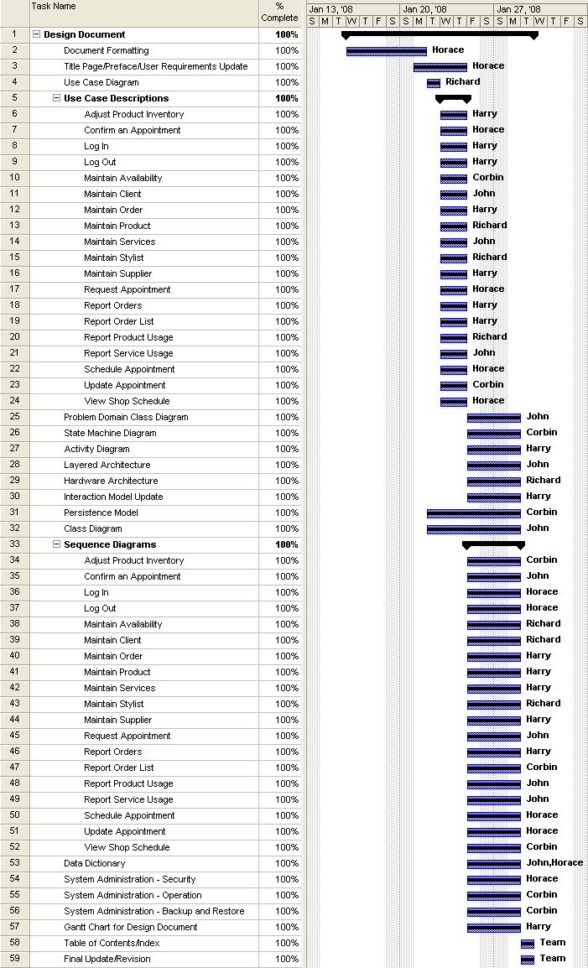
Figure UU - Design Document Gantt Chart

6.3 Team Configuration

Name | Phone | e-mail(other than SAIT) | MSN? (yes/no)
Richard Hayashi | 692-0490 | rhayashi601@shaw.ca | yes
Harry Kilmer | 830-6666 | clint@kilmer.ca tickle_riff@hotmail.com | yes
John Saygnavong | 390-0541 | jo_say@hotmail.com | yes
Corbin Laight | 462-9105 | c_laight@hotmail.com | yes
Horace Wan | 612-9405 | sin916@hotmail.com | yes

6.4 Project Standards and Procedures

Microsoft word will be the text editor. We will use Together to handle the UML diagrams. We will use Microsoft Visio will handle the ERD.

6.4A Team Purpose

To develop high quality software products aimed at meeting the client’s specifications to the best of our abilities.

6.4B Team Standards

Everyone must attend planned meetings, if that is not possible, that person must contact at least one person in the group and explain why.
- When designated a task, that task is expected to be completed in the set time frame.
- The leadership role will be transferred between members based on who has more experience/strength in the stage of the project.
- All roles will be rotated accordingly.
- Everyone will take on each role at least once with guidance from the previous member in that role.
- After meetings, everyone is to get a copy (hard or e-mail) of the minutes.
- Everyone's opinion is valid and respected.
- When changing roles, we will have a set change pattern agreed upon.

6.4C Roles

Leader – Chair for the meetings and keeps meetings on track
Scribe – Creates a hard copy of meetings and decisions and sends copies to all group members
Critical Evaluator – Makes suggestions on other courses of action for each decision debate
Mediator – Any conflicts will be sent through to them for debate and resolution.
Standards Person – Keeps the team standards in check during meetings and assigning tasks to be completed

Glossary

Appointment
An arrangement to meet on a certain date and time to have a stylist (or stylists) o provide service(s) to a customer.

Appointment type
The type of an appointment based on a range of services which a customer chooses.

Blocked off
Time set aside for an appointment.

Brand name
The name of a product line belonging to a manufacturing company.

Calendar
An object that arranges the year into months, weeks, and days. It holds the schedules of stylist and the appointments made with clients.

Client
The term used at the hair salon for a customer.

Customer
The person who will pay to have a service performed.

Color Formula
The formula for hair coloring of a specific customer. It gives the proportions of the chemicals used in preparing the colour.

Discontinued
To no longer have available an item because it will no longer be made.

Double book
Having multiple appointments overlapping the same time slot.

Estheticians
A person skilled in giving facials, manicures, pedicures, and other beauty treatments

Hairstylist
A person who designs and arranges hair styles; can also involve hair coloring.

Hair Salon
A place where one goes to get their hair cut, styled, highlighted, or colored.

Inventory
The list of items and their quantity held in the salon to be used in appointments.

Inventory type
The type of item in the inventory; be it shampoo, conditioner, hair coloring, or chemicals used in hair coloring.

Log on
To access an application by providing the username and password to use it.

Log off
To exit an application so that the next person can use it with their own username and password.

Maintain
This mean

Manager
The person who manages or supervise the hair salon.

Notification
To inform a person or user of an event.

Online booking system
A program accessed through the internet to book appointments at the salon.

Record
Information saved about an appointment.

Service
Any service that available in the salon.

Shop Schedule
A daily calendar shows all the appointments which are booked for each stylist for a date specified.

Stylist schedule
The date and times a stylist will be working during the week.

Stylist
The Stylist can be efficient at any service offered at the salon.

Web interface
The form displayed to access a program’s functions on the internet.

Time Slot
A time period set aside in a schedule for an appointment.

Tracking
To keep a check on items in the inventory being used so that it can be ordered if the quantity is low.

Web interface
The form displayed to access a program’s functions on the internet.

Index
A
Activity Diagram 41
Add Inventory item 38
B
Book Appointment 11
Book Appointment Online 13
Business Overview and Objectives 6
C
confirm 9
conflict 31, 34
conflicting 31, 34
conflicting appointments 32, 34
current system 6
Current System 7
D
data entry form 9, 13, 14
data entry forms 5
Documentation Standards 5
I
Interaction sequence diagrams 5
M
Modify Existing Appointment 31
Modify Hairstylist 28
P
Project Overview 6
Project Scope 6
Purpose of this Document 5
R
Requirements Models 8
S
schedule 11, 22, 30, 31, 34
search appointment 15
Search Appointment 15
software platform 5
State Machine Diagram 40
Statement of the Problem 6
System Environment 7
U
Use Case Descriptions and Scenarios 9
Use Case Diagram 8
Use Case: Add Inventory Item 9
Use Case: Cancel an Appointment 15
Use Case: Delete Inventory Item 16
Use Case: Enter Appointment Details 19
Use Case: Enter Customer Information 20
Use Case: Enter Hairstylist Schedule 21
Use Case: Enter New Hairstylist 24
Use Case: Modify Existing Appointment 26
Use Case: Modify Hairstylist 28
Use Case: Modify Hairstylist Schedule 30
Use Case: Remove Hairstylist 33
Use Case: Search for Customer 36
Use Case: Search for Hairstylist 37
Use Case: Search for Inventory 38
Use Case: View Inventory List 39
User Requirements 6

U
Use Case Descriptions and Scenarios 9
Use Case Diagram 8
Use Case: Add Inventory Item 9
Use Case: Cancel an Appointment 15
Use Case: Delete Inventory Item 16
Use Case: Enter Appointment Details 19
Use Case: Enter Customer Information 20
Use Case: Enter Hairstylist Schedule 21
Use Case: Enter New Hairstylist 24
Use Case: Modify Existing Appointment 26
Use Case: Modify Hairstylist 28
Use Case: Modify Hairstylist Schedule 30
Use Case: Remove Hairstylist 33
Use Case: Search for Customer 36
Use Case: Search for Hairstylist 37
Use Case: Search for Inventory 38
Use Case: View Inventory List 39
User Requirements 6

