GAMA-RCA: A Graph-Augmented Multi-Agent Framework for Root Cause Analysis on RCA100
Achmad Solaeman,, Nur Rohman Rosyid², Ardhi Wicaksono³, Prima Asmara Sejati⁴, Hamzah⁵
¹Department of Electrical Engineering and Informatics, achmad.solaeman@ugm.ac.id
²Department of Electrical Engineering and Informatics, nrohmanr@ugm.ac.id
³Department of Electrical Engineering and Informatics, ardhi.wicaksono.s@mail.ugm.ac.id
⁴Department of Electrical Engineering and Informatics, prima.asmara.s@ugm.ac.id
⁴PT Media Pangan Kreatif Indonesia, hamzah@gmail.com
Abstract

INTRODUCTION: Automated failure diagnosis in microservice systems depends on metrics, logs, and traces (MLT). The RCA100 benchmark from Alibaba extends this telemetry with events, alerts, and service topology. During cascading faults, this multimodal data becomes voluminous and only partly relevant to any single incident. The resulting evidence overload undermines both the accuracy and the explainability of root cause analysis (RCA).

OBJECTIVES: This study examines how well a graph-augmented multi-agent framework can localize root causes, identify fault types, and explain its reasoning on RCA100.

METHODS: We propose GAMA-RCA, a Graph-Augmented Multi-Agent Retrieval-Augmented Generation framework that combines topology-aware graph retrieval with hybrid vector retrieval. The graph module traverses the service dependency graph from the alerted entity to prioritize topologically relevant candidates, and the hybrid stage fuses this structural signal with vector similarity over metrics, logs, traces, and events. Structured evidence tables and an Evidence Summarizer organize the result by modality for specialized Metrics, Logs, Trace, and Topology agents. A Coordinator agent aggregates their findings into a causal chain, the root-cause entity, and the fault type. The language model makes all decisions, and no component is trained or tuned on benchmark ground truth.

RESULTS: We evaluated GAMA-RCA on 30 RCA100 development cases using Qwen2.5-7B-Instruct, scored by the Final Score (0.4·Entity + 0.3·Fault + 0.3·Process, scale 0–100). The best configuration (best of several on the development set) reached 38.2 (Entity Localization 54.4, Fault Identification 20.0, Reasoning Process 34.8). The entity was exactly correct in 43.3% of cases, but the correct fault type was assigned in only 23.1% of those. The Process score is a local approximation of the official scorer.

CONCLUSION: This work examined topology-aware graph retrieval combined with modality-specialized multi-agent reasoning for microservice root cause analysis. GAMA-RCA localized the root-cause entity in a substantial share of cases using a 7B open model, but assigning the correct fault type to a localized entity remained the main limitation. GAMA-RCA offers a retrieval-grounded, auditable foundation for AIOps diagnosis. It has been validated on RCA100 development cases only; held-out and production-scale evaluation remain to be verified.

REPRODUCIBILITY: Code and configuration are available at https://github.com/solaemanachmad/gama-rca.

Keywords: root cause analysis; microservices; AIOps; large language models; retrieval-augmented generation; multi-agent systems; observability
Received on 20 08 2026, accepted on DD MM YYYY, published on DD MM YYYY

Copyright © 2026 Author et al., licensed to EAI. This is an open access article distributed under the terms of the CC BY-NC-SA 4.0, which permits copying, redistributing, remixing, transformation, and building upon the material in any medium so long as the original work is properly cited.

doi: 10.4108/_______________

- Introduction
Microservice architectures decompose an application into many independently deployed services that communicate through dynamic call graphs. This design improves scalability and release velocity, but it also complicates failure diagnosis: a fault in one downstream service can cascade along service dependencies and surface as symptoms in many unrelated components. During an incident, site reliability engineers must therefore examine heterogeneous observability data under strict time constraints, namely metrics, logs, and traces (MLT), together with events, alerts, and service topology snapshots exposed by modern cloud platforms. Automating this diagnosis, known as root cause analysis (RCA), has become a core problem in artificial intelligence for IT operations (AIOps).

Large language models (LLMs) have recently enabled a new class of AIOps agents that reason over multimodal observability data through chain-of-thought prompting and ReAct-style tool use [1]. Most LLM-based RCA systems, however, pass the retrieved evidence to the model with little structural guidance, which gives rise to two limitations. First, they are topology-blind: without explicit knowledge of service dependencies, the model cannot reliably separate causally relevant evidence from evidence that is only temporally correlated, which leads to spurious root-cause attributions. Second, they yield opaque diagnoses: single-pass inference over a large, unstructured evidence set returns an answer with little indication of how it was reached, which weakens operator trust during post-incident review.

Retrieval-augmented generation (RAG) [2] grounds LLM outputs in external evidence instead of parametric memory, and GraphRAG [3] showed that organizing evidence as a graph, rather than as flat text chunks, improves retrieval precision and answer traceability. In parallel, multi-agent LLM systems such as Flow-of-Action [4] and mABC [5] decompose RCA into specialized reasoning roles and report fewer hallucinations than a single ReAct-style agent [1]. These two lines of work, however, have largely developed independently. To the best of our knowledge, GraphRAG has not yet been adapted to the multimodal, topology-rich setting of microservice observability data, and existing multi-agent RCA systems do not use the service dependency graph to constrain retrieval before reasoning starts.

The RCA100 benchmark [6], released by Alibaba, makes this gap measurable. Beyond MLT, it supplies events, alerts, and a service topology graph (UModel) for every case, and it evaluates agentic diagnosis along three pillars, namely Entity Localization, Fault Identification, and Reasoning Process, using a typed causal chain with evidence checkpoints rather than final-answer matching alone. Under this protocol, a system may localize the correct entity and still fail to justify it with the right evidence in the right causal order. Accuracy and explainability must therefore be pursued jointly, and neither follows automatically from using a larger LLM.

Motivated by this gap, this paper presents GAMA-RCA, a Graph-Augmented Multi-Agent framework for root cause analysis that separates what to retrieve from how to reason. The topology graph first narrows the search space around the alerted entity, and this structural signal is combined with vector similarity search over metrics, logs, traces, and events. Deterministic operators then extract structured evidence tables from the retrieved data, and an Evidence Summarizer organizes the result by modality. Four specialized agents (Metrics, Logs, Trace, and Topology) analyze their evidence, and a Coordinator agent writes an explicit causal chain before naming the root-cause entity and the fault type. The language model makes every decision, no component is trained on benchmark ground truth, and the framework runs on an open 7B model, which supports reproducible local deployment.

The contributions of this paper are summarized as follows:
- We propose GAMA-RCA, a graph-augmented multi-agent framework that combines topology-aware graph retrieval, vector retrieval, and deterministic evidence extraction, and that produces an explicit causal chain together with the root-cause entity and the fault type.
- We evaluate the framework on RCA100 development cases with a 7B open model, using the benchmark’s Entity Localization, Fault Identification, and Reasoning Process metrics, and we report ablations of the evidence and fault-typing components.
- We analyze where the diagnosis fails: the entity is localized correctly far more often than the fault type is assigned, and none of the fault-typing variants closes this gap, which identifies the mapping from evidence to fault label as the main bottleneck.

The remainder of this paper is organized as follows. Section 2 reviews related work on LLM-based RCA agents, retrieval-augmented generation, and multi-agent systems for AIOps. Section 3 describes the architecture of GAMA-RCA. Section 4 presents the experimental setup and the results on RCA100. Section 5 concludes the paper and outlines future work.
- Related Work
Before LLMs, RCA relied on single-modality statistical methods: graph-centrality ranking over the service topology [7], [8] causal discovery over metric time series [9], [10], [11], change-point detection [12], and trace-path mining [13], [14]. Later work such as Nezha [15] and MULAN [16] fused multiple modalities, but by collapsing them into a shared embedding or event graph before reasoning. Across this line of work, three limitations recur: single-modality or fused-and-flattened evidence, sensitivity to hyperparameter tuning, and no human-readable justification beyond a ranked list. These limitations are the motivation for LLM-based reasoning, which is the focus of the rest of this section.
2.1. LLM-Based RCA Agents and Benchmarks
LLMs have been applied to RCA primarily as an in-context reasoning problem: Chen et al. [17] show an LLM can recommend a plausible root cause given structured incident context, and this is formalized as a benchmark task by OpenRCA [18] and RCAEval [19], both of which report that a single LLM call over raw telemetry struggles to localize faults reliably without additional structural guidance. This finding motivates architectures that decompose retrieval and reasoning explicitly, which is the direction taken by the multi-agent systems below and by the framework proposed in this paper. A related but distinct line of work—AIOpsLab [20], ITBench [21], SREGym [22]—builds interactive environments for live, tool-using agents rather than offline diagnosis over fixed evidence snapshot and is complementary rather than directly comparable to the setting studied here.
2.2. Multi-Agent LLM Systems for RCA
Closest to the present work are systems that decompose RCA across collaborating agents. Flow-of-Action [4] guides a ReAct-style [1] agent with structured operating procedures distilled from expert playbooks. mABC [5] coordinates seven specialized agents through blockchain-inspired voting. GALA [23] generates an initial ranking from statistical causal discovery and a trace-graph scoring module (TWIST), then iteratively refines it through a re-ranking agent and a deep-dive agent before a remediation agent produces an incident summary; evaluated on RCAEval, it reports substantial top-1 accuracy gains over its statistical baselines.

These systems confirm that specialized agent roles improve on a single LLM call, motivating the multi-agent design adopted here. However, none constructs its evidence set through semantic retrieval—Flow-of-Action and mABC rely on tool-call sequences, and GALA's ranking comes from statistical scoring, not vector similarity. Their agents are also organized by diagnostic stage (ranking, deep-dive, remediation, or voting) rather than by observability modality, which limits how directly a modality-specific signal can be isolated and audited. All three are evaluated by top-k accuracy or NLG quality rather than checkpoint-level verification of whether cited evidence matches the true causal chain—the capability RCA100 [6] is designed to measure.
2.3. LLM Agents and Reasoning Paradigms
RAG [2] grounds generation in evidence retrieved by dense vector similarity, and GraphRAG [3] extends this with graph-traversal retrieval, improving precision and traceability where relationships between evidence carry causal information. None of the RCA-specific work reviewed above uses vector-based semantic retrieval, and none combines graph traversal with vector similarity as a single hybrid retrieval stage—graph structure, where used, functions only as a scoring signal (e.g., GALA's TWIST), never as a retrieval gate on what reaches the LLM. This is the gap the proposed GraphRAG-RCA framework (Section IV) is designed to close: a hybrid graph-and-vector retrieval stage feeding modality-specialized multi-agent reasoning, evaluated against RCA100's checkpoint-level Reasoning Process score rather than top-k accuracy alone.
Table 1. Positioning of GAMA-RCA relative to prior LLM-based RCA work
Approach | Retrieval method | Agent design | Explainability
RCAEval | Raw context | Single LLM | Top-k accuracy
Flow-of-Action | Tool-call sequence | ReAct single agent | Top-k accuracy
mABC | Tool-call sequence | 7-agent voting | Top-k accuracy
GALA | Statistical + trace scoring (TWIST) | 3-agent sequential loop | Top-k accuracy + NLG (SURE-Score)
GAMA-RCA | Hybrid graph + vector retrieval | Parallel modality agents + coordinator | Reasoning Process

- Methodology
  - Architecture Overview
This research proposes Graph-Augmented Multi-Agent RAG (GAMA-RCA), an RCA framework that explicitly separates the retrieval stage from the reasoning stage before information reaches the LLM. This separation matters because feeding raw logs, metrics, and traces directly into an LLM is not only token-inefficient but also degrades reasoning quality due to irrelevant evidence — a problem that has driven retrieval-augmented generation research since it was introduced by Lewis et al. [2] and later extended with graph structures by Edge et al. [3]. Figure 1 shows the resulting pipeline, and Algorithm 1 summarizes it for one incident.
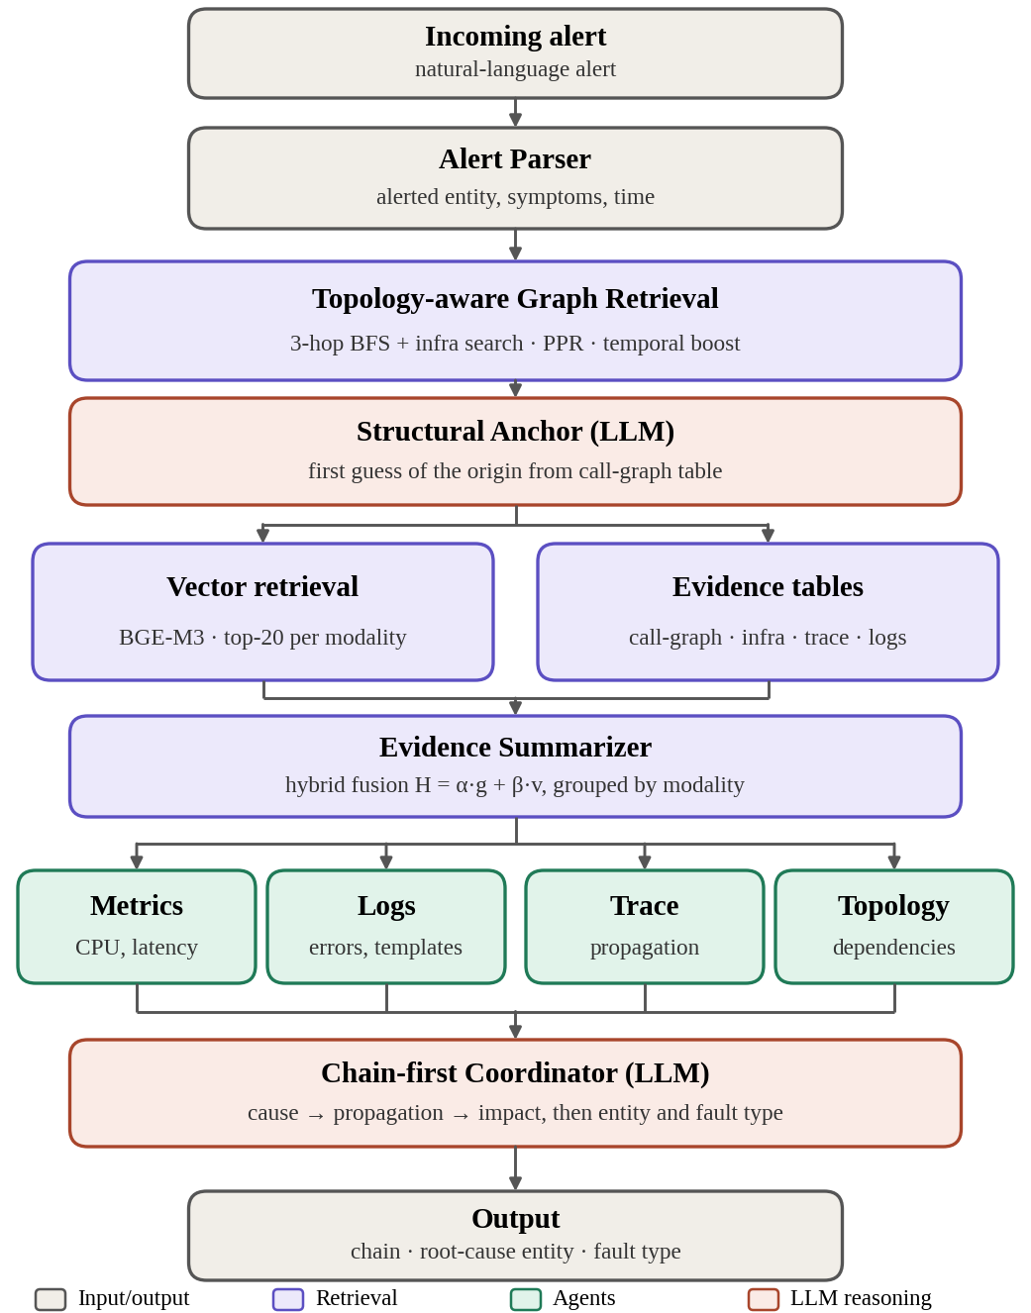
Figure 1. Architecture of Graph-Augmented Multi-Agent
  - Topology-Aware Graph Retrieval
Given the entity s named in the alert, a breadth-first search over the topology graph collects the service neighborhood within three hops, and a bounded search of up to six service hops reaches the nearest instance, pod, and node entities of the infrastructure layer. The entities of the resulting subgraph are ranked by personalized PageRank on the undirected view of the graph, with s as the restart node:
$π = α P^{⊤}π + (1 − α) e_{s}$ (1)
where P is the row-normalized adjacency matrix, e_{s} is the one-hot vector of s, and α = 0.85 is the damping factor. The graph score g(e) of an entity e is its PageRank value. A temporal boost then favors candidate causes over downstream effects:
$g′(e) = \left\{\begin{aligned}λ_b · g(e), if t_e < t_a \\ λ_a · g(e), if all evidence of e is after t_a \\ g(e), otherwise\end{aligned}\right.$ (2)
where t_{e} is the earliest timestamped evidence of e, t_{a} is the alert time, λ_{b} = 1.5, and λ_{a} = 0.8. Entities without timestamped evidence keep their score.
  - Evidence Retrieval and Extraction
Vector retrieval embeds metric, log, trace, and event observations with BGE-M3 and returns the top 20 observations per modality for each query. Each retrieved observation o that belongs to entity e(o) receives a hybrid score that fuses the structural and the semantic signal:
$H(o) = ω_{g} · g′(e(o)) + ω_{v} · v(o)$ (3)
where v(o) is the vector similarity of o to the query and ω_{g} = ω_{v} = 0.5. In parallel, deterministic operators build structured evidence tables: a call-graph propagation table, infrastructure tables for nodes, pods, and Kubernetes events, trace tables, and log templates. Rows are selected by entity name and never by significance, so that the language model, not the extraction code, decides what matters. For traces, every service s additionally receives a composite anomaly score:
$T(s) = \sum_{k=1}^{4}{w_{k}c_{k}(s)}$ (4)
where w_{k} = 1/4 and c₁ to c₄ are the self-anomaly score (share of anomalous spans of s), the trace impact score (share of anomalous traces that contain s), the blast radius score (mean number of immediate downstream services per span, capped at 10), and the delay severity score (delay excess normalized by the maximum over services).
  - Multi-Agent Reasoning
An Evidence Summarizer groups the retrieved evidence by modality. A structural anchor, one LLM call that sees only the topology and the call-graph table, proposes a first guess of the origin. Four specialist agents (Metrics, Logs, Trace, and Topology) then read the summarized evidence of their own modality and report their findings. The Coordinator receives the reports, the anchor, and the evidence, and writes the causal chain first, as cause, propagation, and impact steps that quote signal values from the evidence. Only after the chain does it name the root-cause entity and one of the 28 fault types of the benchmark. All agents use the same 7B model, and no component is trained on benchmark ground truth.
Algorithm 1. GAMA-RCA diagnosis of one incident.
Input | alert a, topology graph G, telemetry O (metrics, logs, traces, events, alerts)
Output | causal chain C, root-cause entity ê, fault type f̂
1 | (s, t_{a}) ← ParseAlert(a)
2 | G_{s} ← BFS(G, s, 3 hops) ∪ InfraSearch(G, s, ≤ 6 hops)
3 | g ← PPR(G_{s}, s, α = 0.85); g′ ← TemporalBoost(g, O, t_{a})
4 | ê₀ ← LLMAnchor(G_{s}, CallGraphTable(G_{s}, O))
5 | tables ← CallGraph, Infra, Trace (with T(s)), LogTemplates
6 | V ← VectorRetrieve(O, query(a), top 20 per modality)
7 | E ← Sort(Fuse(g′, V), by H)
8 | S ← Summarize(E, tables), grouped by modality
9 | for each m in {Metrics, Logs, Trace, Topology}: r_{m} ← LLMSpecialist_{m}(S_{m})
10 | C ← LLMCoordinator(a, ê₀, {r_{m}}, S) # cause → propagation → impact
11 | (ê, f̂) ← entity and fault type named after C
12 | return C, ê, f̂
Algorithm 1 uses the symbols defined above; ê₀ denotes the anchor’s first guess and r_{m} the report of specialist m.
- Experiment and Results
  - Experimental Setup
This section describes the benchmark, the language model, and the configurations compared in the evaluation.
Microservice Application. We evaluate GAMA-RCA on RCA100, a benchmark of 103 expert-labeled failure cases collected from the OpenTelemetry Demo Store, a polyglot e-commerce microservice application (Java, C++, Rust, Python) comprising roughly a dozen services, deployed on an Alibaba Cloud ACK cluster with managed RDS, Redis, and message-bus backends. Each case is injected via a chaos drill and labeled with one of 28 root-cause types aggregated into six semantic groups—application logic, JVM runtime, cloud resource, middleware and database, Kubernetes lifecycle, and resource/performance faults. Every case ships with six observability modalities (metrics, logs, traces, events, alerts, and a per-case topology snapshot), though on average a case touches only 4.02 of the 6 modalities, and 95 of 103 cases (92.2%) require traversing two or more entities in the topology graph to reach the labeled root cause—both of which motivate the topology-aware retrieval design described in Section 3. Ground truth for each case includes the target root-cause entity (pinned to a UModel entity ID), the fault type, a causal chain of typed cause–propagation–impact steps, and, for each step, one or more numerically constrained observability checkpoints. This paper reports results on 30 of the 103 cases, which serve as the development set; the remaining 73 cases are held out and are not used here. Scoring follows the benchmark’s three-pillar protocol, namely Entity Localization, Fault Identification, and Reasoning Process.
LLM settings. To keep the framework reproducible on modest hardware, all agents use the open-weight Qwen2.5-7B-Instruct model, run in Kaggle notebooks. The later configurations in Table 2 use deterministic decoding (temperature 0, fixed seed). The first three configurations were run earlier with sampled decoding and are marked † in Table 2. No component is trained or tuned on benchmark ground truth, and the language model makes every diagnostic decision.

Compared configurations. Because the aim of this paper is to describe the framework and to locate where its diagnosis fails, we compare successive configurations of GAMA-RCA itself instead of external baselines:
- Anchor only, which returns the structural guess made from the topology graph before any language model reasoning;
- + call-graph table, which adds a table of call-graph propagation evidence to the anchor;
- Full pipeline, which adds the chain-first Coordinator, the infrastructure and trace evidence tables, log templates, and the knowledge block; and
- Fault-typing variants, which change only the evidence or the call used to choose the fault type (scoped events, a separate typing call, and a typing call that compares candidate types).
Comparison with external baselines such as a single-call LLM or standard RAG on the same model and cases has not been run and is left for future work.
  - Results
We report results on the 30 RCA100 development cases using Qwen2.5-7B-Instruct. Scores follow the benchmark formula Final = 0.4·EL + 0.3·FI + 0.3·RP on a 0–100 scale, where EL is Entity Localization, FI is Fault Identification, and RP is Reasoning Process. EL and FI follow the benchmark definitions. RP is a local approximation of the official process score, so absolute RP and Final values may differ from official scores. Runs marked † used sampled decoding; all other runs used deterministic decoding (temperature 0, fixed seed). Differences between configurations are paired over the same 30 cases and reported with 95% bootstrap intervals (10,000 resamples). With n = 30, these are development results and not claims about generalization.
Pipeline progression and component ablation
Table 2 and Fig. 2 show how the score developed. The structural anchor alone reached a Final score of 27.6. Adding the call-graph propagation table raised EL from 45.7 to 54.0 and Final to 32.9. The full pipeline, which adds the chain-first Coordinator, the infrastructure and trace evidence tables, log templates, and the knowledge block, kept EL at 54.6 but raised RP from 27.7 to 34.3 and FI from 10.0 to 13.3, reaching a Final score of 36.1. The added structure therefore improved EL first and RP second. These three runs used sampled decoding, so the differences between them are indicative.
Three variants changed only the fault-typing step or its evidence. The first restricted Kubernetes events to objects named after services in the alert neighbourhood and to the nodes hosting them (scoped events). The second added a separate typing call that selects the fault type from the evidence rows mentioning the chosen entity, combined with scoped events. The third extended the typing call to compare up to three candidate types, each with a supporting and a contradicting evidence row. Their Final scores were 37.0, 37.0, and 38.2, against 36.1 for the full pipeline. The paired differences were +0.9 [−0.8, 3.4], +0.9 [−3.4, 5.4], and +2.1 [−2.8, 7.1], and all intervals include zero. The reference run used sampled decoding while the variants used deterministic decoding, so these differences also contain decoding noise. Across the variants, EL ranged from 53.5 to 56.7, FI from 13.3 to 20.0, and RP from 34.6 to 35.3.
Table 2. Scores on the 30 RCA100 development cases (0–100). † Sampled decoding; other runs deterministic. Δ Final is the paired difference from the full pipeline with its 95% bootstrap interval.
Configuration | EL | FI | RP | Final | Δ Final [95% CI]
Anchor only† | 45.7 | 3.3 | 27.8 | 27.6 | –
+ call-graph table† | 54.0 | 10.0 | 27.7 | 32.9 | –
Full pipeline† | 54.6 | 13.3 | 34.3 | 36.1 | reference
+ scoped events | 53.5 | 16.7 | 35.3 | 37.0 | +0.9 [−0.8, 3.4]
+ typing call + events | 56.7 | 13.3 | 34.6 | 37.0 | +0.9 [−3.4, 5.4]
+ typing call + candidates | 54.4 | 20.0 | 34.8 | 38.2 | +2.1 [−2.8, 7.1]

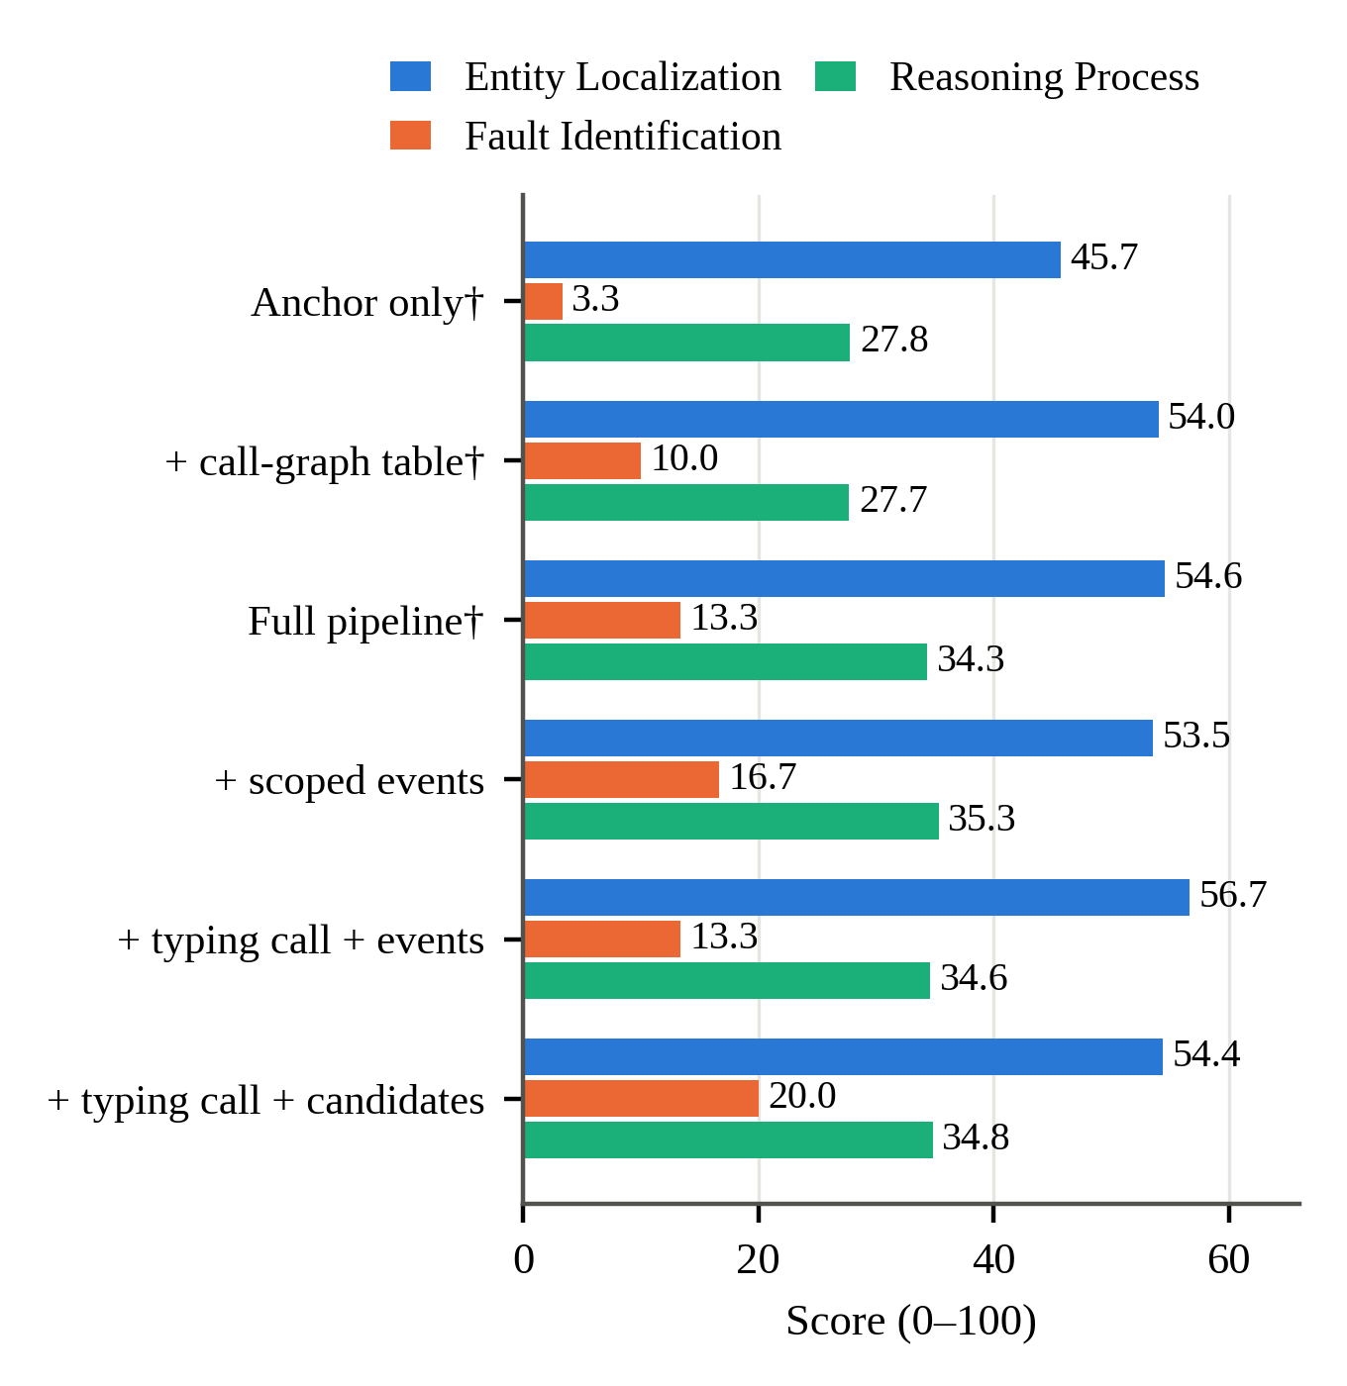
Figure 2. Component scores for each configuration († sampled decoding).
Where the diagnosis fails
Separating the 30 cases by whether the entity and the fault type were each exactly correct shows where the score is lost. In the full pipeline, the entity was exactly correct in 13 cases but the fault type in only 4, and only 2 cases had both correct. In the best variant, the entity was exactly correct in 13 cases (43.3%) and the fault type was correct in 3 of them (23.1%); in the other 17 cases, the fault type was correct in 3 (17.6%). The largest group in every configuration (10 to 12 cases) is therefore a correctly localized entity with a wrong fault type, and the typing variants moved only one or two cases out of it.
Fault-type predictions
Fig. 3 compares the predicted labels with the ground truth for the labels that were most frequently predicted or present. The full pipeline predicted F014 (httpError5xx) in 8 cases and F010 (slowSQL) and F011 (codeDefect) in 7 cases each, although F011 does not occur in these 30 cases. The best variant removed the F010 over-prediction and reduced F011 to 3, but predicted F006 (trafficSurge) in 14 cases, of which 3 were correct, namely all three F006 cases. Its higher FI of 20.0 is therefore partly explained by one frequently predicted label rather than by better discrimination between fault types. Node- and replica-level faults (F026 nodeCpuHigh and F036 replicaScaleDown, 8 of the 30 cases) were never predicted by either configuration.
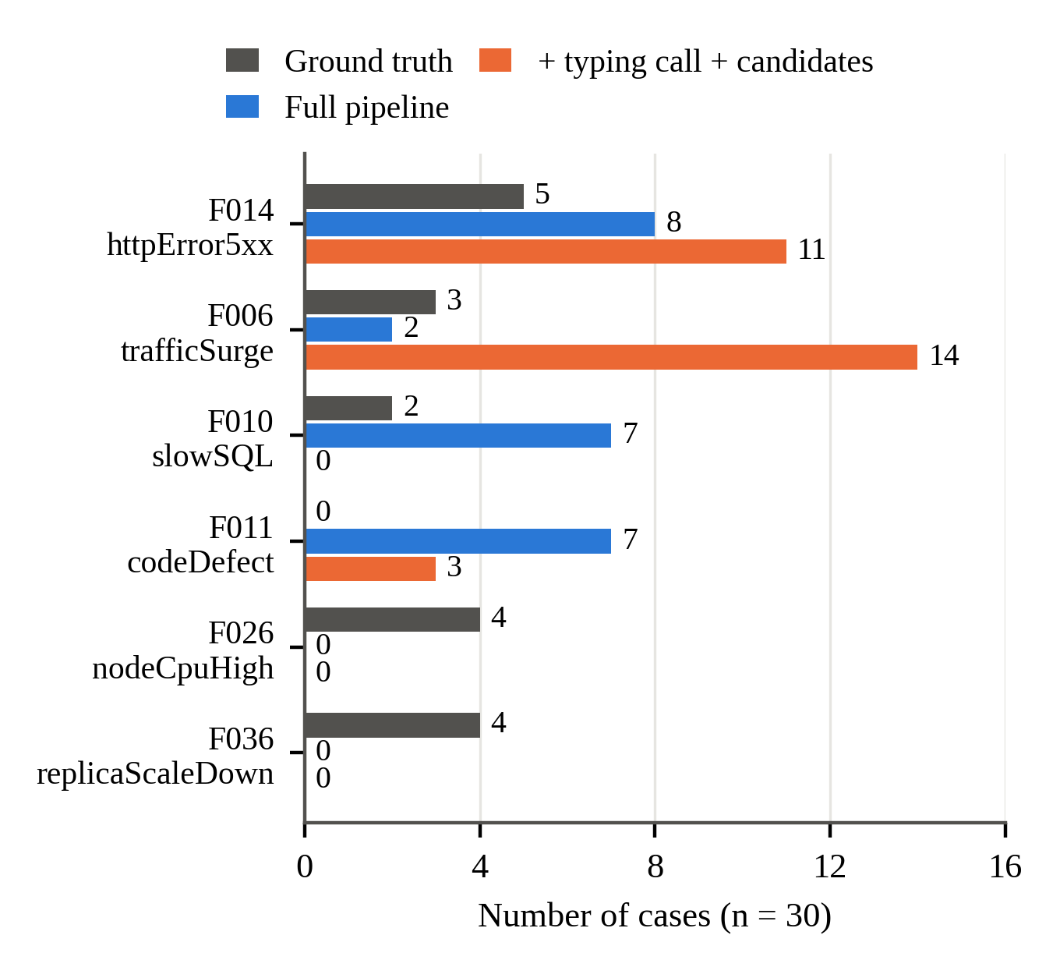
Figure 3. Predicted fault-type labels compared with the ground truth for the labels most frequently predicted or present (n = 30).
Example of a generated reasoning chain
To illustrate what the Coordinator produces, Table 3 shows the output for case t032, which the TYPELEAN+EVSC configuration diagnosed correctly in both entity and fault type. The chain is written before the verdict and orders three steps: the cause, its propagation along the service dependencies, and the resulting impact. Each step cites the signals it relies on. The inventory service returned HTTP 429 responses, which is the signature of rate limiting. The frontend then returned HTTP 500 errors, and the cart service recorded errors as well. The Coordinator named inventory as the root-cause entity and assigned F016 (rateLimiting) with a confidence of 0.9. The chain scored 0.448 on the local Reasoning Process approximation, with 80% of the evidence checkpoints hit, so the diagnosis was right but the justification only partly matched the reference chain.
Table 3. Reasoning chain generated for case t032 (values as emitted by the Coordinator; per-window counts omitted).
Step | Entity | Signal and value
Cause | inventory | HTTP 429, no message; error_count = 518, error_rate = 1
Propagation | frontend | HTTP 500, no message; error_count = 9,017, error_rate = 6.5
Impact | cart | no message; error_count = 1,785, error_rate = 4.1
Verdict | inventory | F016 (rateLimiting), confidence 0.9
This example is not typical. Case t032 is one of the few cases in which both the entity and the fault type were correct, so it illustrates the intended behavior of the chain-first Coordinator rather than the average outcome.
These findings come from the development cases only. Several ablation variants were designed after inspecting errors on these cases, and the best configuration was selected on the same cases, so the variants should be read as exploratory. Held-out evaluation and comparison against other baselines remain to be done.
- Conclusion
This paper presented GAMA-RCA, a graph-augmented multi-agent framework that uses the service dependency graph to narrow retrieval before language-model reasoning, and that requires its Coordinator to write a cause, propagation, and impact chain before naming the root-cause entity and the fault type. On 30 RCA100 development cases with an open 7B model, the framework localized the entity far more often than it identified the fault type, and the generated chains make each diagnosis auditable.
None of the variants that changed only the fault-typing step closed this gap, which points to the mapping from evidence to fault label, and to the choice between service-level and node- or replica-level entities, as the main bottleneck. These results come from development cases and a local approximation of the Reasoning Process score. Future work will evaluate the frozen configuration on the held-out cases, compare it with external baselines, and test whether the chain can constrain the choice of fault type more strongly.
Acknowledgements
The authors gratefully acknowledge the Hibah Damas Penelitian Tahun 2026 from Sekolah Vokasi for supporting this research. Terima kasih.
References
[1] S. Yao et al., “React: Synergizing reasoning and acting in language models,” arXiv preprint arXiv:2210.03629, 2022.
[2] P. Lewis et al., “Retrieval-augmented generation for knowledge-intensive nlp tasks,” Adv. Neural Inf. Process. Syst., vol. 33, pp. 9459–9474, 2020.
[3] D. Edge et al., “From local to global: A graph rag approach to query-focused summarization,” arXiv preprint arXiv:2404.16130, 2024.
[4] C. Pei et al., “Flow-of-action: Sop enhanced llm-based multi-agent system for root cause analysis,” in Companion Proceedings of the ACM on Web Conference 2025, 2025, pp. 422–431.
[5] W. Zhang et al., “mABC: multi-Agent Blockchain-Inspired Collaboration for root cause analysis in micro-services architecture,” in Findings of the Association for Computational Linguistics: EMNLP 2024, 2024, pp. 4017–4033.
[6] Y. Cai et al., “A Multi-Dataset Benchmark for Evaluating LLM Agents in Microservice Failure Diagnosis,” arXiv preprint arXiv:2606.29193, 2026.
[7] L. Wu, J. Tordsson, E. Elmroth, and O. Kao, “Microrca: Root cause localization of performance issues in microservices,” in IEEE/IFIP Network Operations and Management Symposium (NOMS), 2020.
[8] J. Lin, P. Chen, and Z. Zheng, “Microscope: Pinpoint performance issues with causal graphs in micro-service environments,” in International Conference on Service-Oriented Computing, Springer, 2018, pp. 3–20.
[9] A. Ikram, S. Chakraborty, S. Mitra, S. Saini, S. Bagchi, and M. Kocaoglu, “Root cause analysis of failures in microservices through causal discovery,” Adv. Neural Inf. Process. Syst., vol. 35, pp. 31158–31170, 2022.
[10] R. Xin, P. Chen, and Z. Zhao, “Causalrca: Causal inference based precise fine-grained root cause localization for microservice applications,” Journal of Systems and Software, vol. 203, p. 111724, 2023.
[11] M. Li et al., “Causal inference-based root cause analysis for online service systems with intervention recognition,” in Proceedings of the 28th ACM SIGKDD conference on knowledge discovery and data mining, 2022, pp. 3230–3240.
[12] L. Pham, H. Ha, and H. Zhang, “Baro: Robust root cause analysis for microservices via multivariate bayesian online change point detection,” Proceedings of the ACM on Software Engineering, vol. 1, no. FSE, pp. 2214–2237, 2024.
[13] Y. Meng et al., “Localizing failure root causes in a microservice through causality inference,” in 2020 IEEE/ACM 28th International Symposium on Quality of Service (IWQoS), IEEE, 2020, pp. 1–10.
[14] Z. Li et al., “Practical root cause localization for microservice systems via trace analysis,” in 2021 IEEE/ACM 29th International Symposium on Quality of Service (IWQOS), IEEE, 2021, pp. 1–10.
[15] G. Yu, P. Chen, Y. Li, H. Chen, X. Li, and Z. Zheng, “Nezha: Interpretable fine-grained root causes analysis for microservices on multi-modal observability data,” in Proceedings of the 31st ACM joint European software engineering conference and symposium on the foundations of software engineering, 2023, pp. 553–565.
[16] L. Zheng, Z. Chen, J. He, and H. Chen, “Mulan: Multi-modal causal structure learning and root cause analysis for microservice systems,” in Proceedings of the ACM Web Conference 2024, 2024, pp. 4107–4116.
[17] Y. Chen et al., “Automatic root cause analysis via large language models for cloud incidents,” in Proceedings of the Nineteenth European Conference on Computer Systems, 2024, pp. 674–688.
[18] J. Xu et al., “Openrca: Can large language models locate the root cause of software failures?,” in The thirteenth international conference on learning representations, 2025.
[19] L. Pham, H. Zhang, H. Ha, F. Salim, and X. Zhang, “RCAEval: a benchmark for root cause analysis of microservice systems with telemetry data,” in Companion Proceedings of the ACM on Web Conference 2025, 2025, pp. 777–780.
[20] Y. Chen et al., “Aiopslab: A holistic framework to evaluate ai agents for enabling autonomous clouds,” Proceedings of Machine Learning and Systems, vol. 7, 2025.
[21] S. Jha et al., “Itbench: Evaluating ai agents across diverse real-world it automation tasks,” arXiv preprint arXiv:2502.05352, 2025.
[22] J. Clark et al., “SREGym: A Live Benchmark for AI SRE Agents with High-Fidelity Failure Scenarios,” arXiv preprint arXiv:2605.07161, 2026.
[23] Y. Tian, Y. Liu, Z. Chong, Z. Huang, and H.-A. Jacobsen, “GALA: Can Graph-Augmented Large Language Model Agentic Workflows Elevate Root Cause Analysis?” arXiv preprint arXiv:2508.12472, 2025.

Corresponding author. Email: author@emailaddress.com

