Project 2: Data Analysis and Visualization

Objective

The objective of this project is to use Python libraries (NumPy, Pandas, and Matplotlib) to load, process, analyze, and visualize real-world data.

Requirements

1. Dataset Selection

Choose a dataset (CSV or Excel file).

The dataset must contain at least 50 rows.

Each group must use a different dataset.

2. Data Loading (Pandas)

Load the dataset using Pandas (read_csv or read_excel).

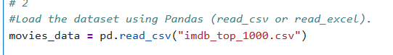

Display the following:

First 5 rows using head()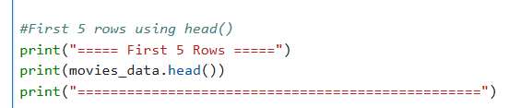

Output:

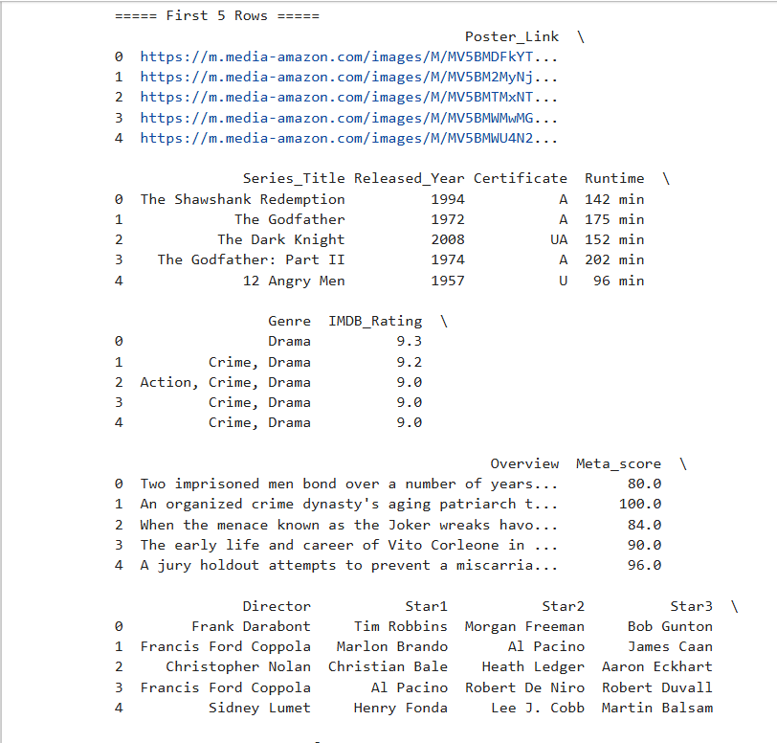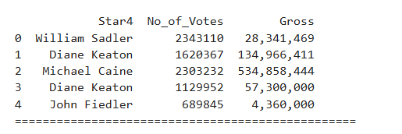

Dataset shape (number of rows and columns)

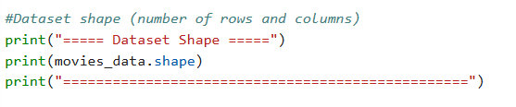

Output:

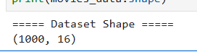

Column names

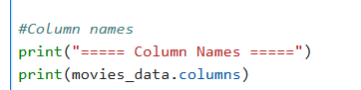

Output:

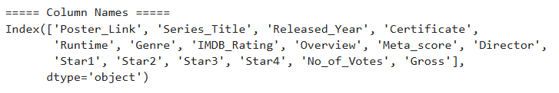

3. Data Processing (Pandas)

Perform all the following operations:

Select specific columns

Output:

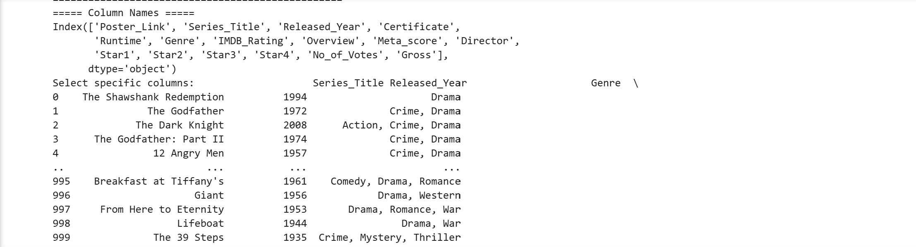

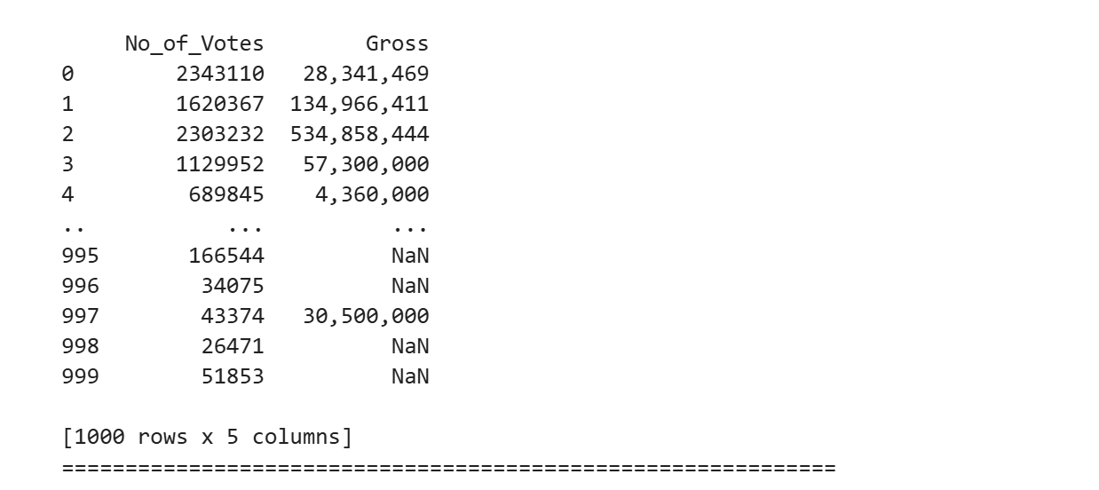Select specific rows

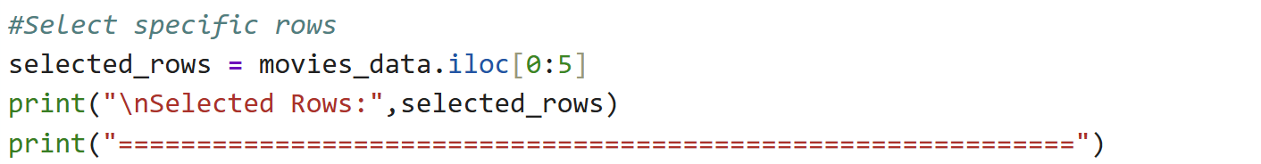

Output:

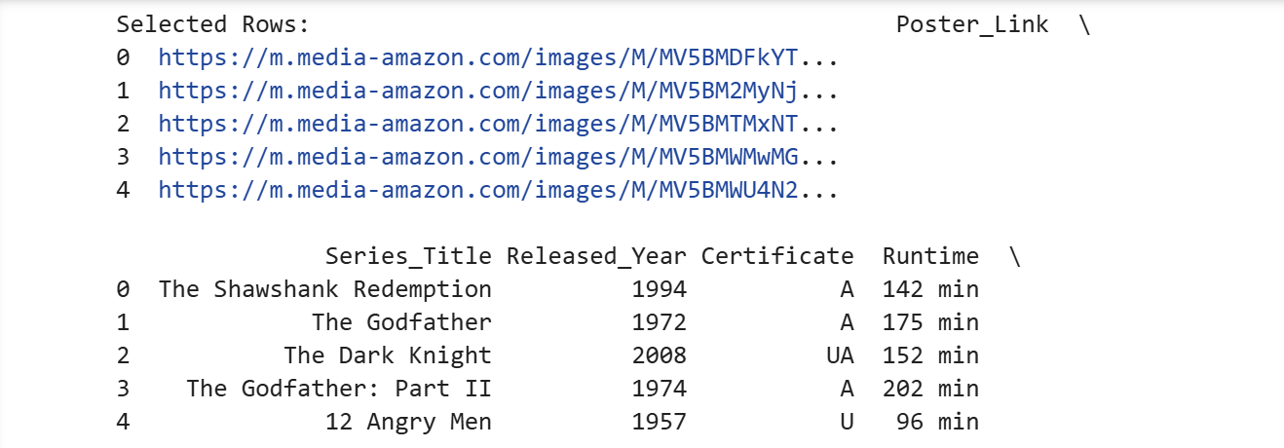

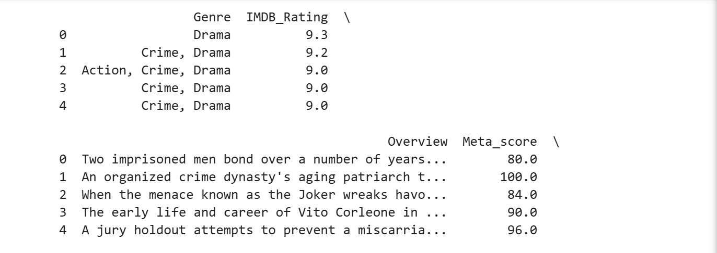

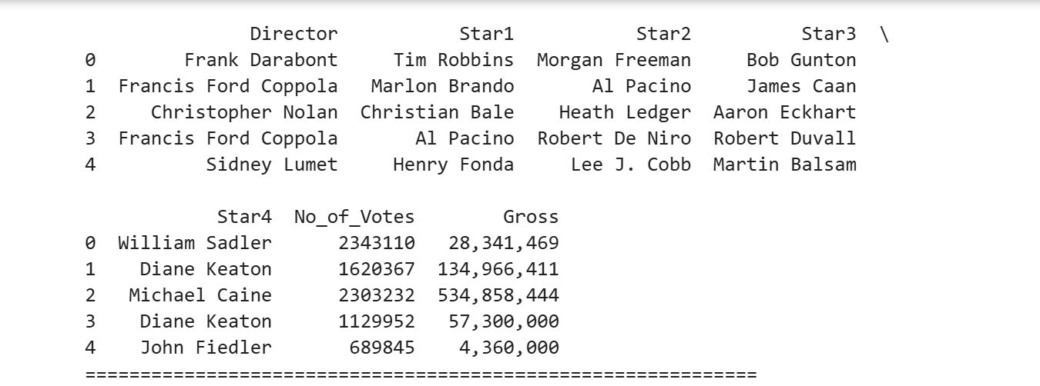

Remove duplicate rows

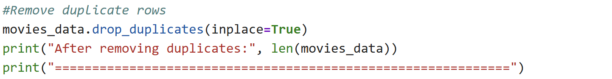

Output:

Change the index using set_index()

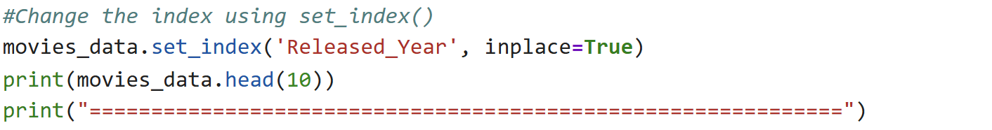

Output:

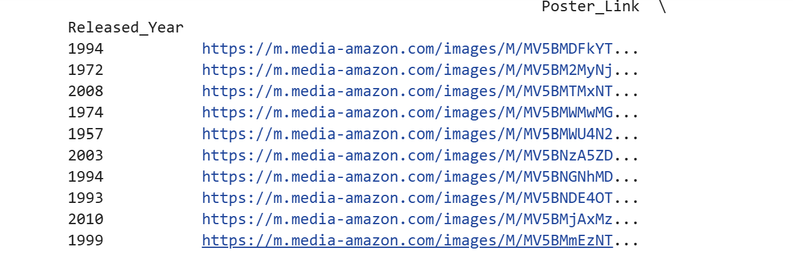

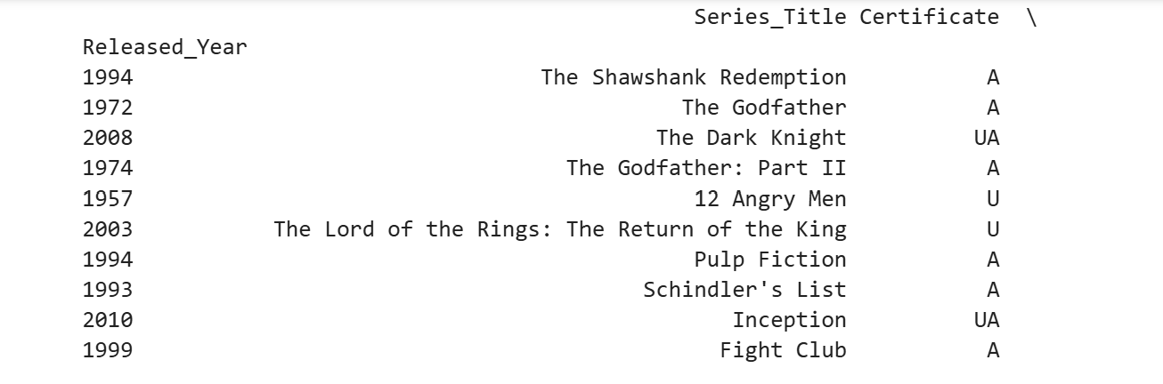

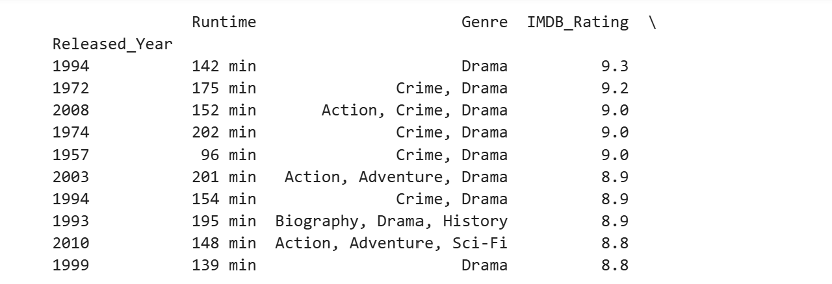

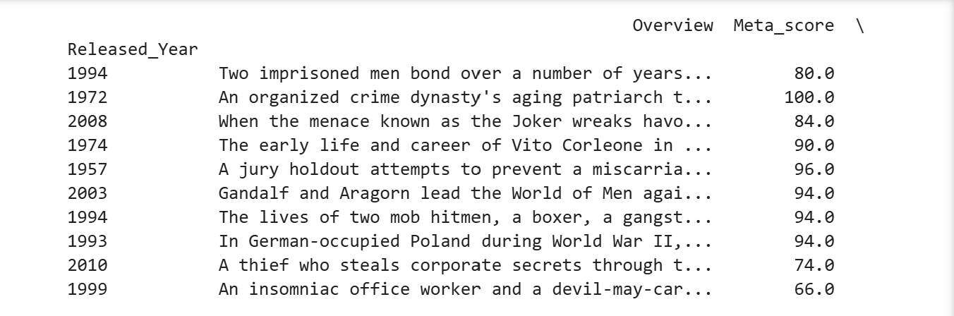

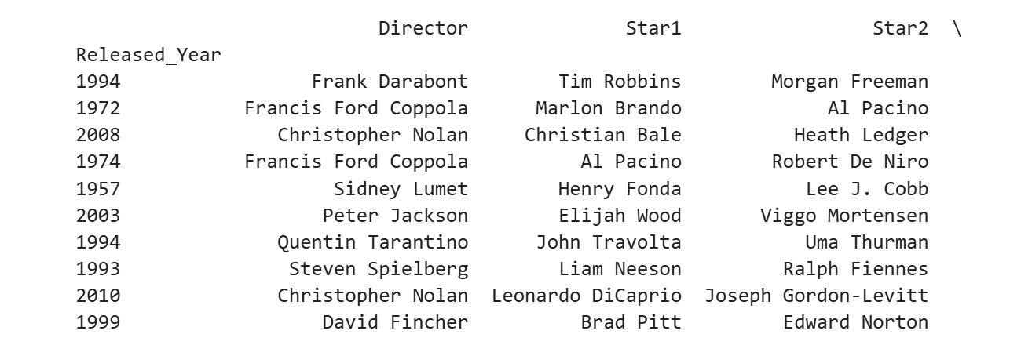

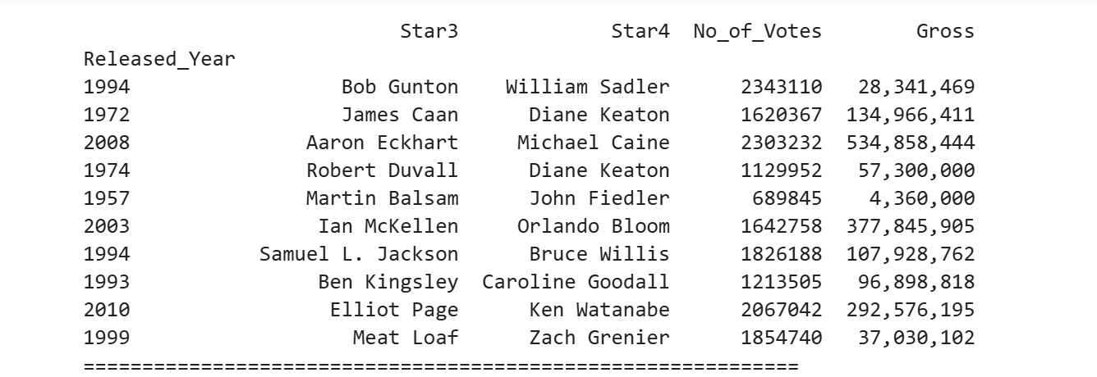

Create a new DataFrame from part of the data

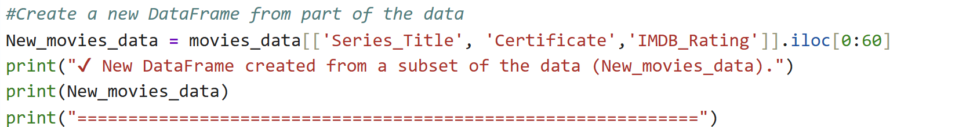Output:

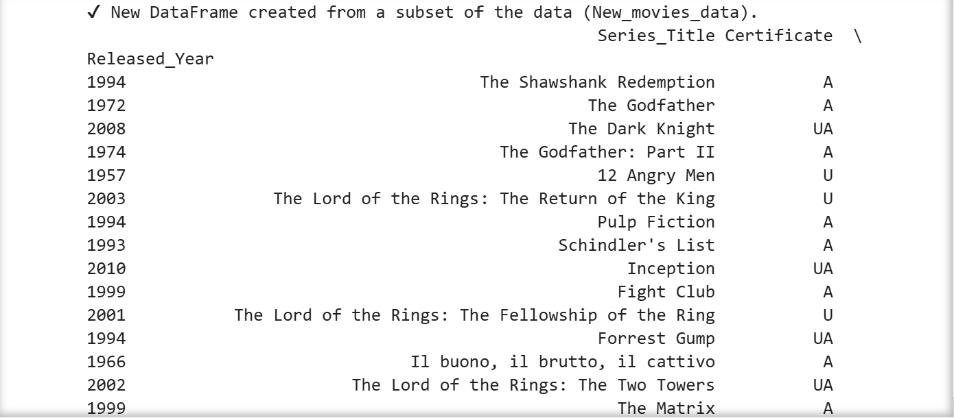

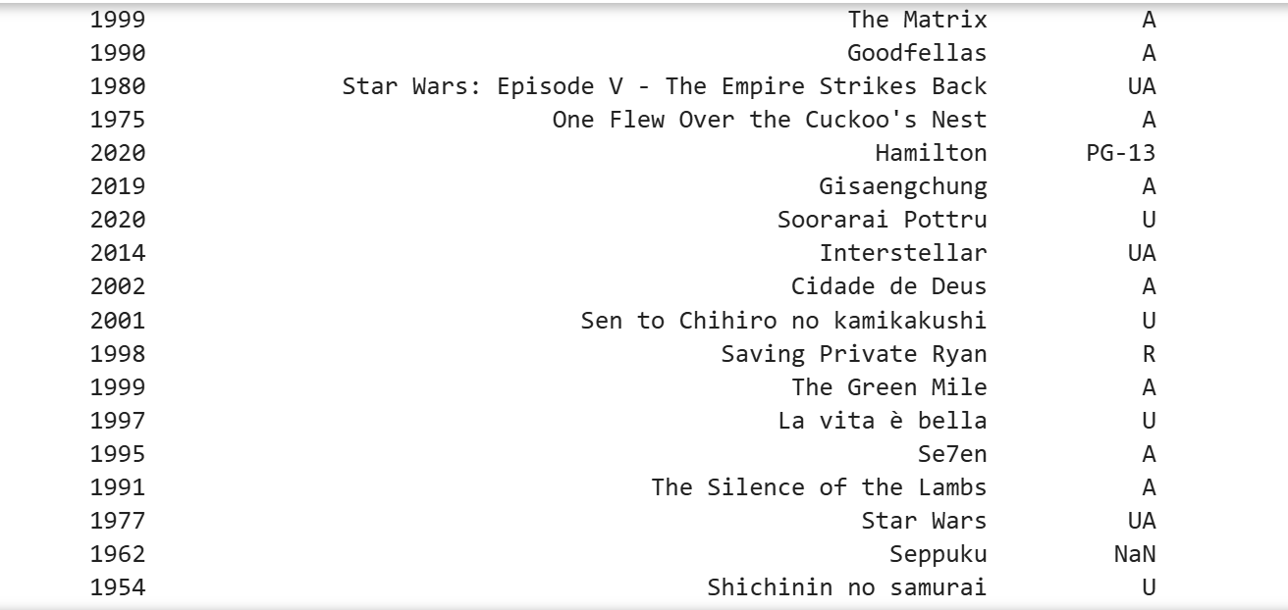

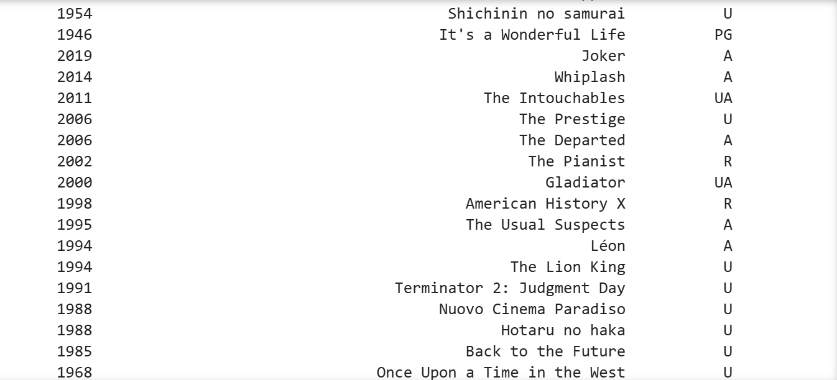

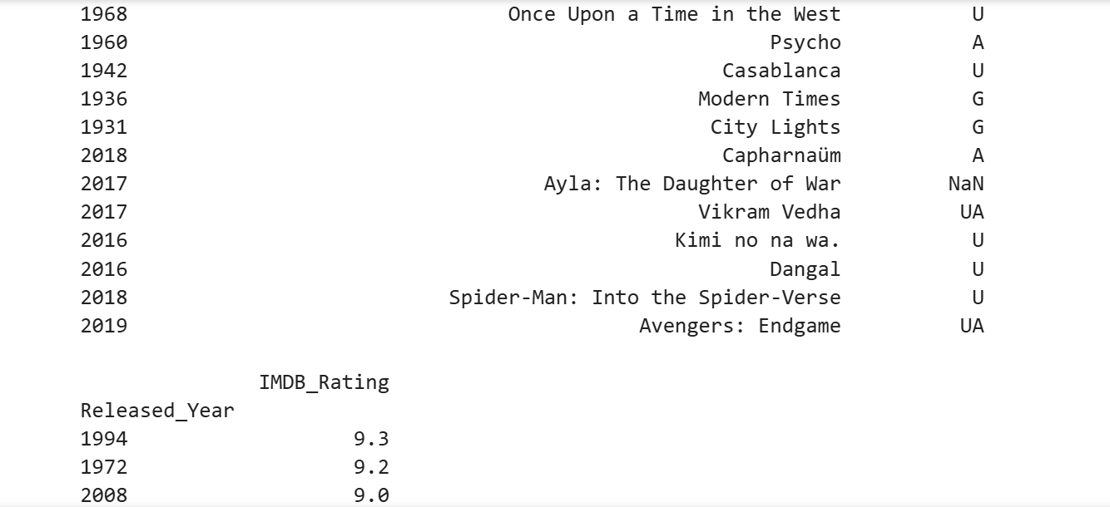

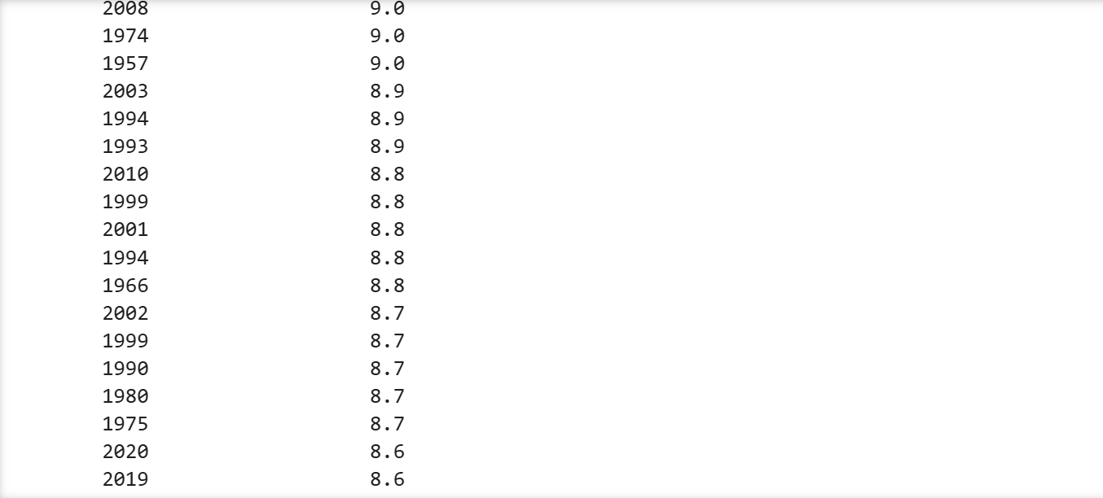

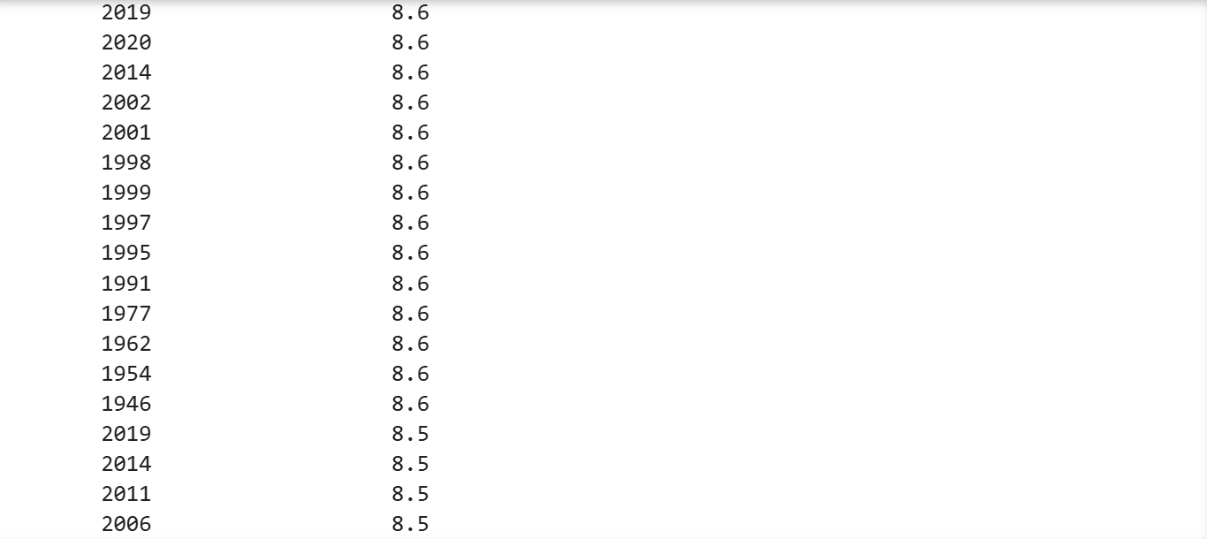

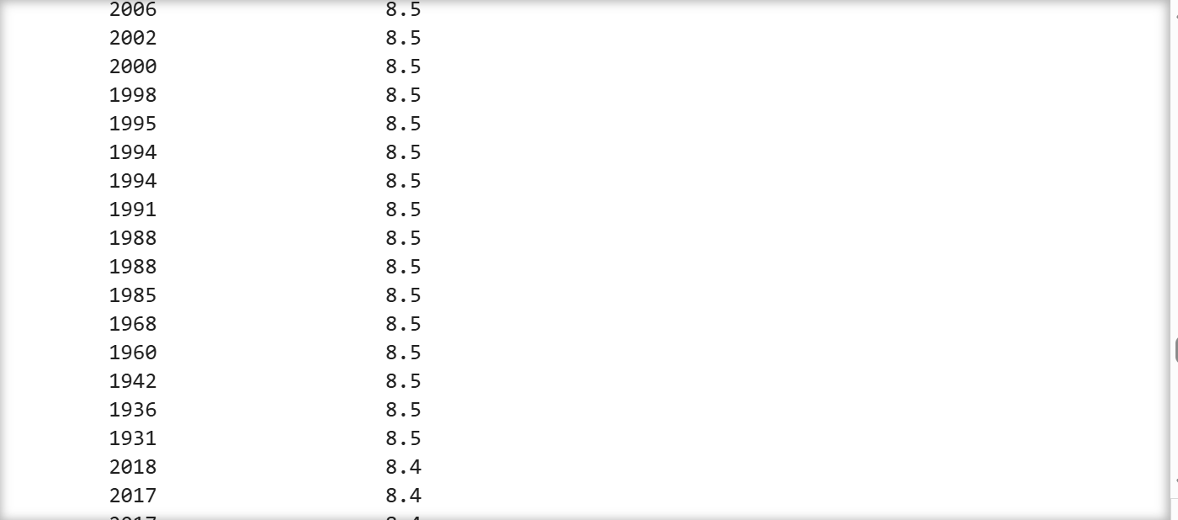

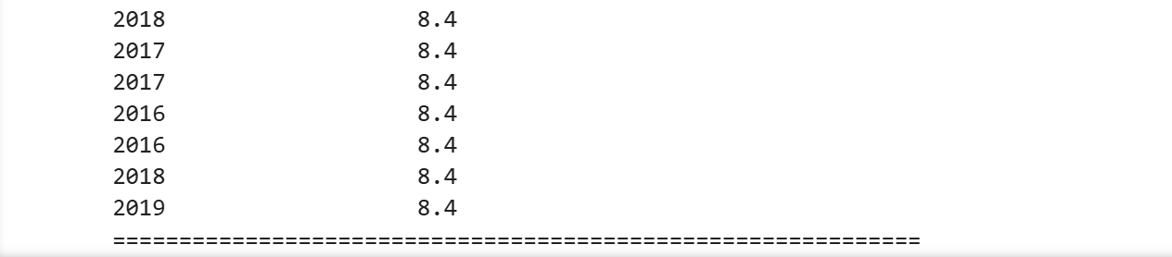

4. Basic Data Analysis

Calculate the following:

Mean

Minimum

Maximum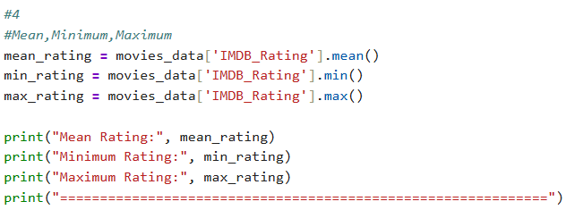

Output:

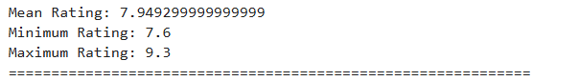

Use describe() to display statistics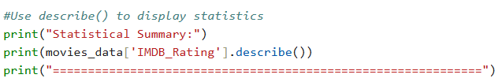

Output:

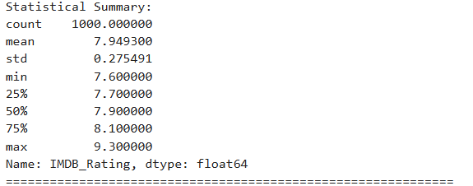

Use NumPy to perform all of the following:

Create a NumPy array from a column in the dataset

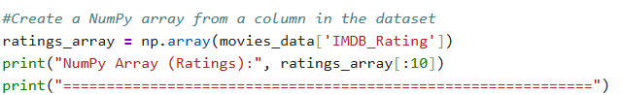

Output:

Perform a mathematical operation on an array (e.g., addition or multiplication)

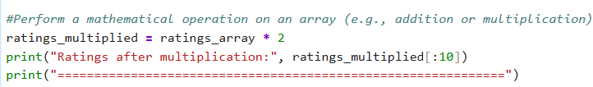output:

Calculate a statistical value using NumPy (e.g., mean or standard deviation)

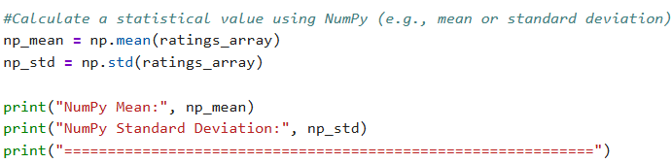

Output:
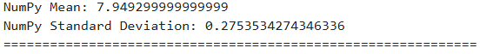

5. Data Saving

Save the processed data into a new file:

CSV or Excel

Output :

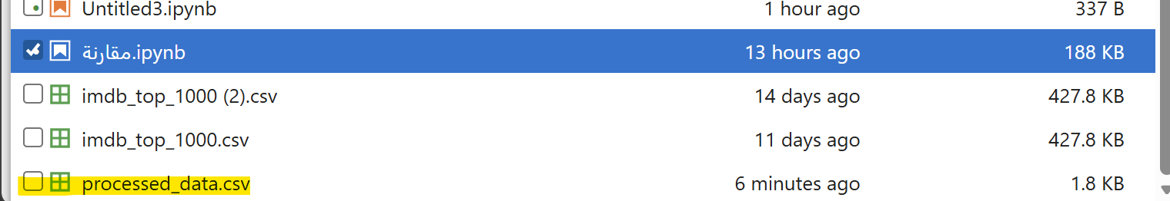

6. Data Visualization (Matplotlib)

A. Create at least two different charts:

One must be a Bar Chart

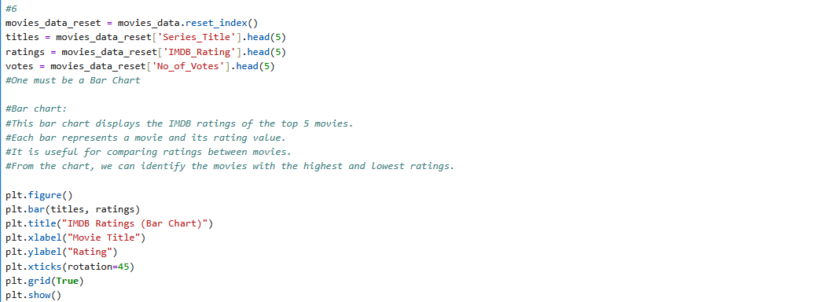

Output:

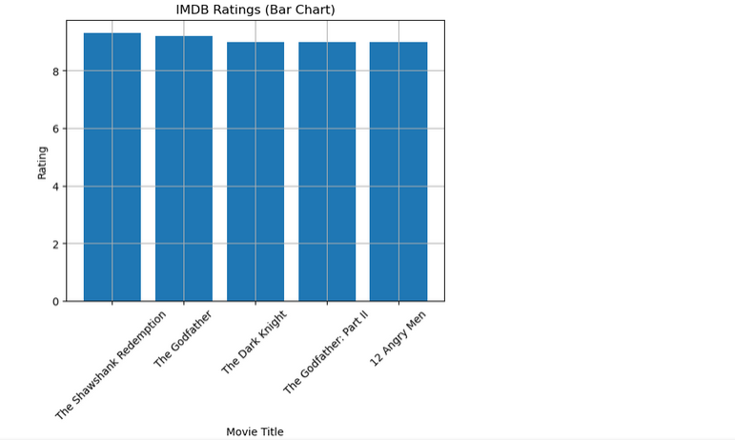

One must be one of the following:

Line chart

Scatter plot

Pie chart

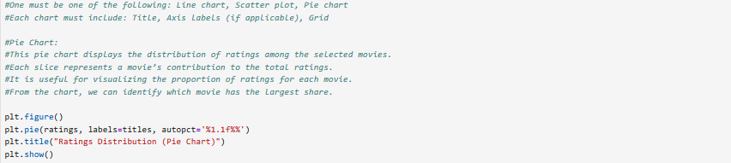

Output:

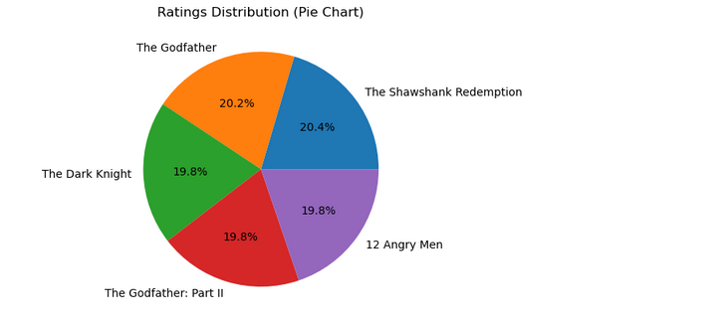

B. Each chart must include:

Title

Axis labels (if applicable)

Grid

C. Subplots Requirement:

Display two charts in one figure using subplots

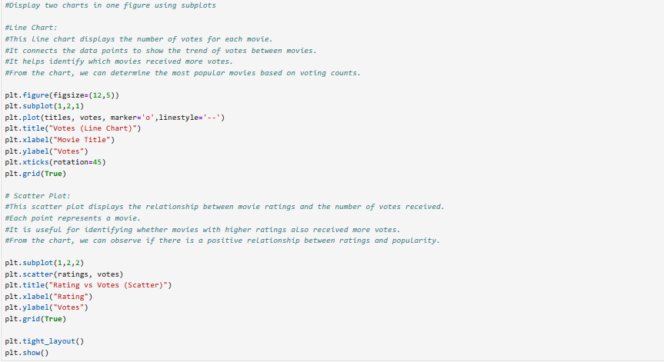

Output:

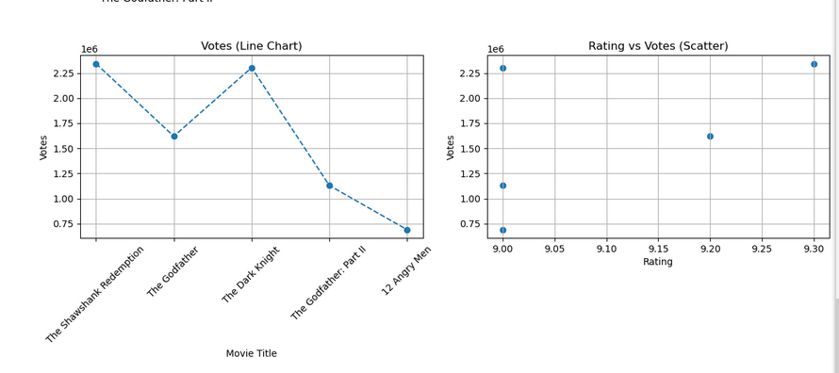

7. Explanation

Write a short explanation (3–5 lines) for each chart:

What does the chart show?

What conclusion can you make?

