**Resume Screening System**

**Code :**

import java.util.*;

class Candidates

{

public String name, suitability;

public int minExperience;

public List<String> skills;

public float score;

public Candidates(String name, int minExp, List<String> skills)

{

this.minExperience = minExp;

this.skills = skills;

this.name = name;

}

public void display()

{

System.out.println("Name : "+this.name);

System.out.println("Skills : "+this.skills);

System.out.println("Score : "+this.score);

System.out.println("Suitability : "+this.suitability);

System.out.println("===========================\n");

}

}

public class ResumeScreeningSystem

{

public static void main(String[] args)

{

Scanner sc = new Scanner(System.in);

String jobRole;

int minExperience;

List<String> skills;

// set up the hiring role information

System.out.print("Enter the Hiring Job Role : ");

jobRole = sc.nextLine();

System.out.print("Enter the Minimum no. of years of Experience: " );

minExperience = sc.nextInt();

sc.nextLine();

System.out.print("Enter the required skills(seperated by commas) : ");

String[] s = sc.nextLine().split(",");

skills = new ArrayList<>();

for(String skill : s)

{

skills.add(skill.trim());

}

System.out.println("---------------------------------------------------");

System.out.print("Enter the number of candidates : ");

int num = sc.nextInt();

sc.nextLine();

// get the user input

Candidates[] users = getInput(num);

// evaluating the scores and suitability score

evaluateCandidates(users,jobRole,minExperience,skills,num);

// displaying the result

System.out.println("-----Evaluation Result-----");

System.out.println("===========================");

for(int i=0;i<num;i++)

users[i].display();

sc.close();

}

// function to get the user input

public static Candidates[] getInput(int num)

{

Scanner sc = new Scanner(System.in);

Candidates[] users = new Candidates[num];

String name;

int userExperience;

List<String> userSkills;

for(int i=0;i<num;i++)

{

System.out.println("For Candidate : "+(i+1));

System.out.println("=======================");

System.out.print("Enter your name : ");

name=sc.nextLine();

System.out.print("Enter your experience : ");

userExperience = sc.nextInt();

sc.nextLine();

System.out.print("Enter your skils(seperated by commas) : ");

String[] s2 = sc.nextLine().split(",");

userSkills = new ArrayList<>();

for(String skill:s2)

userSkills.add(skill);

users[i] = new Candidates(name,userExperience,userSkills);

}

sc.close();

return users;

}

// function to evaluate the candidates

public static void evaluateCandidates(Candidates[] users, String jobRole,int minExperience, List<String> skills, int num)

{

for(int i=0;i<num;i++)

{

// experience score

users[i].score += getExperienceScore(users[i].minExperience,minExperience);

// skill score

users[i].score += geSkillScore(users[i].skills , skills);

// get the suitability score

users[i].suitability = getSuitability(users[i].score);

}

}

public static int getExperienceScore(int exp, int min)

{

if(min<=exp)

{

if(exp>min+5)

return 50;

else if(exp>min+3)

return 40;

else if(exp>min+1)

return 30;

else

return 20;

}

return 10;

}

public static float geSkillScore(List<String> userSkills, List<String> skills)

{

float individualScore = (50.0f/skills.size());

float skillScore=0.0f;

for(String skill:userSkills)

{

if(skills.contains(skill))

{

skillScore+=individualScore;

}

}

return skillScore;

}

public static String getSuitability(float score)

{

if(score>80.0f)

return "Best suitable";

else if(score>50.00f)

return "Moderate suitable";

else

return "Not suitable";

}

}

**Output :**

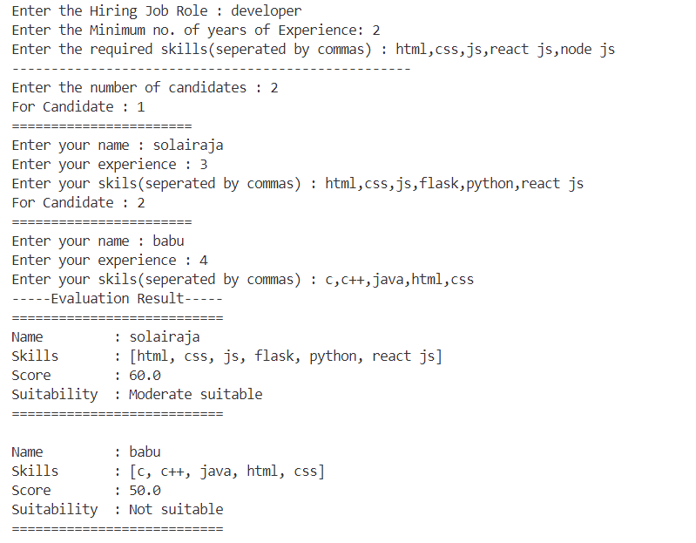

**Job Matching System**

**Code :**

import java.util.*;

class Candidates implements Comparable<Candidates>

{

public String name, suitability;

public int minExperience;

public List<String> skills;

public float score;

public Candidates(String name, int minExp, List<String> skills)

{

this.minExperience = minExp;

this.skills = skills;

this.name = name;

}

public void display()

{

System.out.println("Name : " + this.name);

System.out.println("Skills : " + this.skills);

System.out.println("Score : " + this.score);

System.out.println("Suitability : " + this.suitability);

System.out.println("===========================");

}

@Override

public int compareTo(Candidates other) {

return Float.compare(other.score, this.score); // Sort in descending order

}

}

public class ResumeScreeningSystem

{

public static void main(String[] args)

{

Scanner sc = new Scanner(System.in);

String jobRole;

int minExperience;

List<String> skills;

System.out.print("Enter the Hiring Job Role: ");

jobRole = sc.nextLine();

System.out.print("Enter the Minimum no. of years of Experience: " );

minExperience = sc.nextInt();

sc.nextLine();

System.out.print("Enter the required skills (separated by commas): ");

String[] s = sc.nextLine().split(",");

skills = new ArrayList<>();

for (String skill : s) {

skills.add(skill.trim());

}

System.out.println("---------------------------------------------------");

System.out.print("Enter the number of candidates: ");

int num = sc.nextInt();

sc.nextLine();

Candidates[] users = getInput(num);

evaluateCandidates(users, jobRole, minExperience, skills, num);

Arrays.sort(users); // Sorting candidates based on their scores

System.out.println("----- Ranking List -----");

System.out.println("===========================");

for (int i = 0; i < num; i++) {

System.out.println("Rank " + (i + 1) + ":");

users[i].display();

}

sc.close();

}

public static Candidates[] getInput(int num)

{

Scanner sc = new Scanner(System.in);

Candidates[] users = new Candidates[num];

for (int i = 0; i < num; i++) {

System.out.println("For Candidate: " + (i + 1));

System.out.println("=======================");

System.out.print("Enter your name: ");

String name = sc.nextLine();

System.out.print("Enter your experience: ");

int userExperience = sc.nextInt();

sc.nextLine();

System.out.print("Enter your skills (separated by commas): ");

String[] s2 = sc.nextLine().split(",");

List<String> userSkills = new ArrayList<>();

for (String skill : s2) {

userSkills.add(skill.trim());

}

users[i] = new Candidates(name, userExperience, userSkills);

}

return users;

}

public static void evaluateCandidates(Candidates[] users, String jobRole, int minExperience, List<String> skills, int num)

{

for (int i = 0; i < num; i++) {

users[i].score += getExperienceScore(users[i].minExperience, minExperience);

users[i].score += getSkillScore(users[i].skills, skills);

users[i].suitability = getSuitability(users[i].score);

}

}

public static int getExperienceScore(int exp, int min)

{

if (min <= exp) {

if (exp > min + 5) return 50;

else if (exp > min + 3) return 40;

else if (exp > min + 1) return 30;

else return 20;

}

return 10;

}

public static float getSkillScore(List<String> userSkills, List<String> skills)

{

float individualScore = (50.0f / skills.size());

float skillScore = 0.0f;

for (String skill : userSkills) {

if (skills.contains(skill)) {

skillScore += individualScore;

}

}

return skillScore;

}

public static String getSuitability(float score)

{

if (score > 80.0f) return "Best suitable";

else if (score > 50.0f) return "Moderate suitable";

else return "Not suitable";

}

}

**Output :**

